
BSBWHS505
Investigate WHS incidents

Copyright © 2016 CSTC Pty Ltd

All rights reserved. No part of the contents of this publication may be reproduced or used in any form or by any means – graphic, electronic, or mechanical including photocopying, digitising, recording, or information storage-and-retrieval systems – without the written permission of CSTC Pty Ltd.
ASSESSMENT FOR BSBWHS505

Student name | Watchara Limpinijkul
Date of assessment submission | 10/03/2016

Trainer/Assessor’s name
Date of assessment marking | Click here to enter a date.
Outcome for unit | ☐ Competent  ☐ Not Yet Competent

TASK INSTRUCTIONS

- The assessment for this unit of competency consists of the following:
  - A series of activities: Some of these activities will require you to provide a response within this document, others will require you to gather evidence to demonstrate your knowledge and skills (overview below)
  - Quiz: You will be required to complete a series of questions to demonstrate your knowledge and skills.
  - Practical task: You will be required to have an observer attest to your knowledge and skills and sign a report to this effect.
- At times, you will be provided with a specific business context to which you must respond, otherwise it is anticipated that you will use a workplace of your choosing (your own, or hypothetical) to provide the context to the task.
- At all times, the responses in your assessment must reference Australian (Queensland or Federal) documentation, including legislation, regulations, codes of practice, standards and guidance publications.

ACTIVITY OVERVIEW | REQUIRED FOR SUBMISSION
- Initial responses to incidents | - Workbook response (below)
- Planning the investigation | - Workbook response (below)
- Collecting and analysing information and data | - Workbook response (below)
- Completing investigation report | - Workbook response (below)

ACTIVITIES

For the following activities, you will assume the role of a workgroup supervisor in a workplace of your choosing (see example organisational chart below).

Name a workplace and workgroup that you are (or hypothetically are) the supervisor for. Also, identify a likely incident to occur within this workplace which requires investigation. It may have actually happened or could hypothetically happen.

Name of workplace | Technip
Workgroup | Thailand
Describe incident | Crane incident during assembly the crane 160 ton (Property Damage Incident).

Consider the initial responses to the incident, in preparation for an investigation:
- How would you ensure the incident site is safe and secure?
- Describe how you would address the immediate needs of those involved in the incident
- Outline the WHS legislative requirements for your workplace regarding incident response (i.e. duty holders, notification/reporting, preserving incident sites) as outlined in:
- WHS Acts
- WHS Regulations
- Outline the your workplace’s requirements regarding incident response as outlined in:
- Policies
- Processes
- Procedures
- Systems

Ensuring safety and security of site
After the incident occurred, We called security guards to secure the incident area by using the warning tape and fags to barricaded the areas and standby to not allow any person enter the area and don’t allow remove all equipment and material out of the area until the incident investigation arrive the area.
WHS Acts
Work Health and Safety Act 2011
Part 2 Health and safety duties
27) Duty of officers
(d) to ensure that the person conducting the business or undertaking has appropriate processes for receiving and considering information regarding incidents, hazards and risks and responding in a timely way to that information
(e) to ensure that the person conducting the business or undertaking has, and implements, processes for complying with any duty or obligation of the person conducting the business or undertaking under this Act which include reporting notifiable incidents.
Part 3 Incident notification
38) Duty to notify of notifiable incidents
- A person who conducts a business or undertaking must ensure that the regulator is notified immediately after becoming aware that a notifiable incident arising out of the conduct of the business or undertaking has occurred.
- A person conducting a business or undertaking must keep a record of each notifiable incident for at least 5 years from the day that notice of the incident is given to the regulator under this section.
39) Duty to preserve incident sites
- The person with management or control of a workplace at which a notifiable incident has occurred must ensure so far as is reasonably practicable, that the site where the incident occurred is not disturbed until an inspector arrives at the site or any earlier time that an inspector directs.
Part 5 Consultation, representation and participation
68) Powers and functions of health and safety representatives
- In exercising a power or performing a function, the health and safety representative may inspect the workplace or any part of the workplace at which a worker in the work group works at any time, without notice, in the event of an incident, or any situation involving a serious risk to the health or safety of a person emanating from an immediate or imminent exposure to a hazard
Part 9 Securing compliance
176) Inspector’s power to seize dangerous workplaces and things
- This section applies if an inspector who enters a workplace under this part reasonably believes that is defective or hazardous to a degree likely to cause serious injury or illness or a dangerous incident to occur.
186) Inspector may take affidavits
An inspector is authorised to take affidavits for any purpose relating or incidental to the exercise of his or her compliance powers.

WHS Regulations
Work Health and Safety Regulation 2011
Chapter 3 General risk and workplace management
the duty holder must review and, as necessary, revise a control measure in the control measure does not control the risk it was implemented to control so far as is reasonably practicable a notifiable incident occurs because of the risk

Chapter 6 Construction work
If a notifiable incident occurs in connection with the high risk construction work to which the statement relates, the person must keep the statement for at least 2 years after the incident occurs.

Part 6.4 Additional duties of principal contractor, 309 WHS management plan—preparation
A WHS management plan must include the arrangements in place for managing any work health
and safety incidents that occur
If a notifiable incident occurs in connection with the construction project to which the statement relates, the person must keep the WHS management plan for at least 2 years after the incident occurs.
Chapter 12 Public health and safety
- A relevant person must ensure that the regulator is notified immediately after becoming aware that a notifiable incident arising out of the relevant activity has happened
- A relevant person must keep a record of each notifiable incident for at least 5 years from the day that notice of the incident is given to the regulator under this section
- The person with management or control of relevant premises at which a notifiable incident has happened must ensure, so far as is reasonably practicable, that the site where the incident happened is not disturbed until an inspector arrives at the site or any earlier time that an inspector directs

Policies
Technip HSE Policy :
1. Promote a climate and focus in the organisation that demands a positive and proactive WHS response from its employees or those engaged on our activities.
Every person has the right to stop the work if they consider that an WHS risk exists that can leading to incidents
2. Utilise meaningful leading and lagging (incidents) performance indicators to improve performance
Processes
Incident Notification Process
1. Worksite Management notify incident to Project Manager/Director via telephone and email immediately and then report into Synergi (Technip Incident Report Web base) within 12 hours
2.Project Manager/Director notify Region Senior VP and HSE Manager via telephone and email
3. Region HSE Manager or GM notify to Group HSE Director via telephone and email
Procedures
GWP-AP-HSE-004-Incident Classification, Notification, Investigation and Reporting Procedure
1. Defined responsibilities of managers, Supervisors, WHS team and All workforce
2. Defined Incident Classification Criteria
3. Defined Incident Notification and Investigation Process
4. Defined Incident Potential Matrix
5. Defined Technip Incident Report system ( Synergi)
Systems
OHSAS 18001 (2007) : Clause 4.5.3 Incident investigation, Non-conformity, Corrective and Preventive Actions.
1. The organization shall establish, implement and maintain a procedure(s) to record, investigate and analyse incidents in order to:
a) determine underlying OH&S deficiencies and other factors that might be causing or ontributing to the occurrence of incidents;
b) identify the need for corrective action;
c) identify opportunities for preventive action;
d) identify opportunities for continual improvement;
e) Communicate the results of such investigations.
The investigations shall be performed in a timely manner.
The results of incident investigations shall be documented and maintained.

Outcome for Activity 1 | ☐ Satisfactory  ☐ Not satisfactory
Trainer/Assessor comments

You are required to develop an investigation plan to address the incident:
- Define the scope and purpose/objectives of the investigation
- Ensure this reflects the scope and nature of the incident
- Explain which individuals/parties you would consult with in planning the investigation, including deciding between options (e.g. internally, external advisors)
- Outline the requirements of the investigation in the form of an action plan
- Identify resourcing requirements, and allocate roles and responsibilities
- Prioritise tasks and specify timelines for the investigation
- Identify how the outcomes of the investigation will be documented
- Identify factors that may impact on the investigation and how they might be addressed. Consider the impact of:
- Workers with specific needs and limitations (e.g. cultural background and diversity, low language, literacy and numeracy levels)
- Structure and organisation of the workforce (i.e. part time vs casual vs contract workers; shift rosters; geographical location)
- Workplace culture relating to gender

Ensure that the requirements from Activity 1 are met through your responses to Activity 2.

Scope and purpose/objectives of the investigation
Scope of the investigation : 160 Ton of Crane Assembly activities in Construction area A on 21 January 2016 including all people that involve with this activities and people who were at the scene and include all equipment that were used for Crane Assembly Activities.
All training record of all people involved and inspection records/certificate of all involved equipment are required for the investigation.

Purpose and Objective of the investigation :
- To investigate issues associated with, and leading up to, the crane incident (Property Damage Incident) that occurred during works being carried out on 21 January 2016
- To identify root causes of the incident and provide recommendations to prevent recurrence of such incidents

Action plan
No. | Action items | By Who | Target Date
1 | Secure the incident area | Security Gourds | 21 Jan 2016
2 | Notify the incident to all relevant person | WHS supervisor | 21 Jan 2016
3 | Collect information on all procedures and requirement related to Crane Assembly Activities | WHS Manager | 21 Jan 2016
4 | Defined the Incident Investigation Team | WHS Manager | 21 Jan 2016
5 | Investigation team to investigate in the incident | Investigation Team | 21 – 22 Jan 2016
6 | Issue the Incident Investigation Report all relevant person | Investigation Team Leader | 23 Jan 2016
7 | Site Manager to implement the corrective actions as defined in the incidents investigation report | Site Manager | 26 Jan 2016

Impacting factors
Factors that may impact on the investigation are followings;

1.workers with specific needs and limitations such as culture background of the workers as workers may be reluctant to collaborate with the investigation team for fear of being implicated or blamed. Then for solving this barrier, The investigation have to reinforce the position that we are here to find out what wrong in the system “not person” and the purpose of the investigation is to ensure that the incident does not happen again and that the issues that led to the incident are corrected and improved.

2. Structure and organisation of the workforce such as shift rosters as workers will change the shift or location the shift every two weeks, then if the investigation process is slow and then workers who involved in the incidents change the shift or worker location as the result will cause difficulty for interview to get information. Then for solving this barrier, the investigation team have to priority to schedule the workers that have to change shift or work location in near further to interview first and make the interview to complete before they change the shift or location.

3. Workplace culture relating to gender is not applicable with this activity as all people involved with Crane assembly activities are all Man and investigation team also all Man.

Outcome for Activity 2 | ☐ Satisfactory  ☐ Not satisfactory
Trainer/Assessor comments

Consider the collection and analysis of information and data:
- Explain why and how you will inspect the incident site.
- Explain why and how you will inspect the equipment used at the time of the incident.
- Identify other evidence you would gather regarding the incident.
- Outline how you would gather information and data in ways that ensure objectivity, confidentiality, validity and accuracy.
- What reasoning would you give to the investigation team to justify using the conceptual basis for the analysis, namely:
- Adopting an open-minded and objective approach
- Analysing policies, procedures, processes and systems in place at the time of the incident
- Focussing on the ‘how’, ‘what’ and ‘why’ of the incident
- Not focussing on individual behaviour or fault
- Using applicable models of causation and occurrence

Inspecting the incident site
Why inspection the incident site? – This is because of :
- the scene may change overtime and the real reasons for the incident may become blurred as the scene is altered
- our memory of specifics can fade and even distort over time

How will inspection the incident site? – As the purpose of inspecting the incident site is to establish an accurate ‘picture” of the incident scene or the tasks that were being carried out at the time of the incident.

The investigation team will physical presence at the scene of the incident. We will do direct observations about anything we see, feel, smell and /or hear that may be relevant at the time of the inspection. This will include description/records of the incident scene and the tasks being carried out and will include measurements, diagrams and general observations.

We will keep a record of the inspection, including information about inspection method and observations and issue as “Inspection Report”

The site inspection report will include :
- Date, time and location
- Names of injured people, other persons involved in the incident, witnesses and people who were first on the scene
- Condition of site and equipment and the presence of any substances
- The layout of the incident scene
- Prevailing condition in the work environment such as light, temperature, etc.

Inspecting equipment
Why do we need to inspect the equipment used at the time of the incident? – This is because of the equipment used are valuables information as a evident how WHS management system maintained. For investigation we need to examine any machinery, equipment or substance relevant to the investigation.

How do we inspect the equipment used at the time of the incident? --- We in inspect the equipment used at the time of the incident, we need to:
-Look for signs of obvious damage to machinery or parts of machinery
-Look for signs of previous damage or worn equipment
-Check fluid levels to ensure that the correct type and amount has been used
-Check for any guarding or barricades that is or should be in place
-Check that the correct tool or item of plant was being used for the task
Other evidence
Other evidence I would gather regarding the incident are ;
-Interview’s record from witness who were in the scene
-JSA
-Method statements
-Woke permits
-Safety Tools box talk record of attendance
-Safety Inspection records
-Training record
- Accident and injury records
-Lifting Plan
-CCTVs Record (if any)
- Equipment Inspection records
-Drug and alcohol testing results
-Weather record
Process for gathering information and data
To ensure objectivity, confidentiality, validity and accuracy we will gather information and data as soon as possible once we were notified the incident. We will use the “no blame” investigation culture to approach the interviewers and we have to be the incident area as soon as possible to keep all evidence fresh. We will seek all documentary evidence that are relevant to the investigation such as policies, procedures, operating manuals, accident and injury records, training records, risk analyses records and equipment/maintenance records.

In compiling the evidence, it is important that we shall describes the incident scene in as much detail and as accurately as possible in order to support any recommendations for corrective action. We shall sketch the scene to show relationships of the key features of the site and location of any wreckage or other relevant artefacts.

We shall make direct observations about anything we see, feel, smell and/or hear that may be relevant at the time of the incident.

We shall interview all people who were on the incident scene as soon as possible after the incident to obtain relevant information and any physical evidence they may have gathered.
Then we also have to interview supervisors and managers who in chart the jobs.

Process for gathering information and evidence are summarised in below table

Source | How to access
Documentation | Training records, Work schedules  Operating procedures, Injury/accident records
People | Interviews, Questioning, Discussions
Plant/substance | Visual inspection, Tests, Operating manuals, Chemical registers (SDS)
Work environment/process | Visual inspections, Photographs  Sketch maps and floor plans

Briefing the investigation team
The reasoning I would give to the investigation team to justify using the conceptual basis for the analysis is because it is equally important that the team members understand how this information is to be analysed. This is often overlooked by investigation team. Yet it is a critical part of the process. The conceptual basis provides the structure for the investigation, prevents the team from going off on tangents and is vital to determining the root causes of the incident. Prior to analysing the evidence that has been collected it is therefore vital that the team leader organise a team meeting to provide clear guidance on the “conceptual basis” for the investigation.

- Adopting an open-minded and objective approach ;
Objective is fundamental to achieving a fair and balanced report of the incident. Team members should be advised not to bring preconceived views or attitudes about the incident to the investigation process but rather to keep an open mind until all the evidence is examined.

- Analysing policies, procedures, processes and systems in place at the time of the incident:
Policies, procedures, processes and systems are a vital source of information because they outline how work activities and [processes are to be undertaken. In this way, policies, procedures, processes and systems set the benchmark as to how things should have happened.

- Focussing on the ‘how’, ‘what’ and ‘why’ of the incident
To track back through the system of work requires a more structured analysis based on continually asking why an event occurred or how a particular thing might have happened. So we should ask “Why?” and “How?” rather “What?” as asking “what?” focuses the investigation on the damage and may lead to simplistic conclusion such as (a) the crane was not checked and this is the cause of the accident or (b) the worker was stupid to forget checking the crane. Both cases ignore the fundamental issue of “why” the crane was not check. How could the system of work allow such a thing to occur?

- Not focussing on individual behaviour or fault
An incident is usually the result of a failure in the interaction between people, plant or materials, the work process and /or work environment. In other words, incident result from a failure in the work systems rather than a failure by individuals. By focusing solely on human behaviour, factors central to determining the underlying causes of the incident will be overlooked. Apportioning blame would not only be inappropriate, but would make people less cooperative with the investigation process and may even cloud the underlying causes of the incident.

- Using applicable models of causation and occurrence
The direct causes of an indents are the factors that are directly responsible for the indent. They generally occur immediately prior to the incident: with immediate effect. Direct causes are sometimes quite straightforward and in many cases they will be apparent immediately. Establishing the direct causes provides a starting point for researching the incident to establish the underlying the incident casual or contributing factors that lead to the event.

Outcome for Activity 3 | ☐ Satisfactory  ☐ Not satisfactory
Trainer/Assessor comments

Complete an investigation report of the identified incident for your PCBU in the following structure:

- INTRODUCTION
- Outline the background of your company, its role and purpose
- Briefly describe the incident that has taken place
- Define the scope and purpose of the investigation

- INVESTIGATION FINDINGS
- Construct a timeline of events leading up to the incident (e.g. who was involved, what happened, initial responses to meet legislative/organisational requirements)
- Describe the scope of the investigation (e.g. identify investigation team, sources of information and data, site/equipment inspections that took place, other evidence gathered, experts consulted)
- Outline how information and data was gathered using objective, confidential, valid and accurate methods.
- Highlight the root causes of the incident:
  - Note the key events, conditions and/or circumstances that together resulted in the incident
  - Consider the effectiveness of workplace policies, procedures, processes and systems

- RECOMMENDED PREVENTION MEASURES
- Highlight points at which the incident could have been prevented
- Outline actions, interventions and practical measures that would prevent reoccurrence of the incident, which address the root causes identified
  - Evaluate between alternative strategies to identify the best option(s) for the workplace, identifying the criteria used for this decision
  - Identify resourcing requirements, and allocation roles and responsibilities
  - Prioritise tasks and specify timelines for implementation
  - Outline how the effectiveness of these solutions will be measured and evaluated

- CONCLUSION
- Explain the importance of WHS to your company, and the value of addressing and avoiding incidents

TIPS:
- Use the report template (below) and elaborate on the points above.
- Write in simple English. Remember that people from a range of backgrounds and abilities would be reading this document.
- Be sure to reference evidence to back up your conclusions and recommendations, providing sufficient detail so that the reader can look into it further.

- INTRODUCTION
Outline the background of the Company
Technip covers the full range of onshore facilities for the oil and gas chain, petrochemicals and other energy industries (nuclear, renewables including biofuels). The Group is also present in non-energy activities (mining and metals, life sciences, buildings and infrastructures). Technip holds many proprietary technologies and is the leader in the design and construction of LNG and gas treatment plants as well as ethylene, hydrogen and syngas units. It is one of the leading players worldwide in refining and petrochemical units.
In the Offshore business segment Technip performs engineering, procurement, construction, installation, commissioning and the refurbishment/upgrading of offshore facilities for the oil & gas industry. Technip provides these services for fixed platforms in shallow water with conventional sub-structures and self installing platforms such as the TPG 500 and for deepwater facilities including Spar, semi-submersible, TLP, FPSO and FLNG units. The Group is a world leader in floatover installation of topsides and its R&D effort is focused on technology transfer for local content and new frontier areas such as ultra-deepwater and the Arctic.

Briefly describe the incident that has taken place
The property damage incident was occurred in Onshore project in construction site during we assembly the 160 ton’s Mobile Crane for lifting the pipe in refinery plant.

21 January 2016 at 15:55. During moving the 160 tons crane with already equipped with main Luffing Jib from location E-1020 to location P-1104A for work as defined in lifting plan. While the crane reach the destination. The crane operator would changed the position of the boom from horizontal to vertical position.

During the boom changing the degree of the boom, The Base jib fell hit Mast-1, as the result the Equalizer Sheave fell down to the crane body. No one hot injured but crane body itself and crane’s Base Luffing jib were damage.
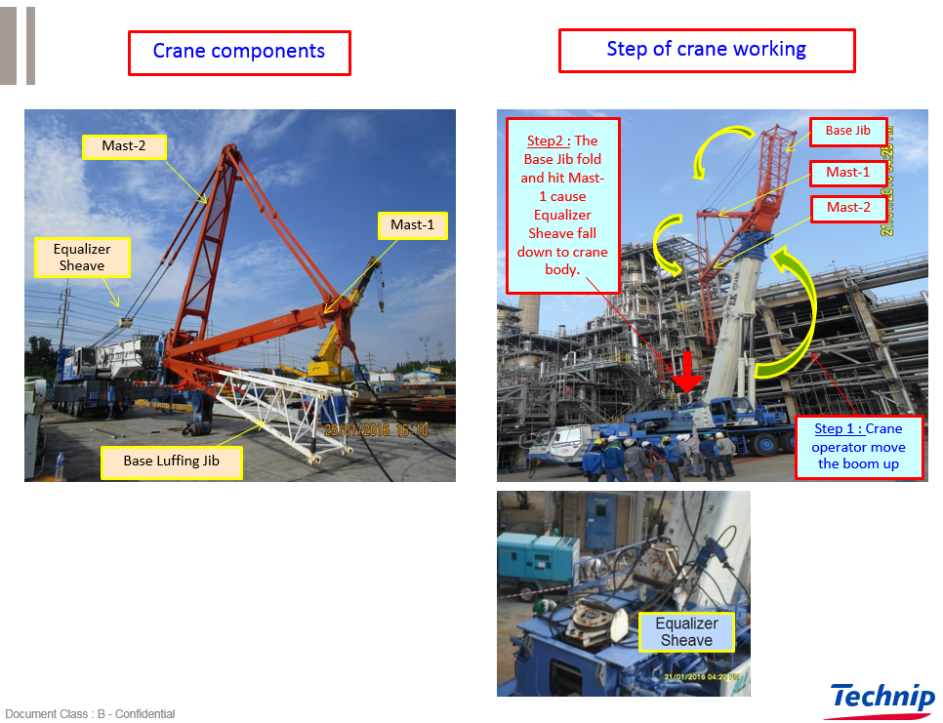

Define the scope and purpose of the investigation

Scope of the investigation : 160 Ton of Crane Assembly activities in Construction area A on 21 January 2016 including all people that involve with this activities and people who were at the scene and include all equipment that were used for Crane Assembly Activities.
All training record of all people involved and inspection records/certificate of all involved equipment are required for the investigation.

Purpose and Objective of the investigation :
- To investigate issues associated with, and leading up to, the crane incident (Property Damage Incident) that occurred during works being carried out on 21 January 2016
- To identify root causes of the incident and provide recommendations to prevent recurrence of such incidents

- INVESTIGATION FINDINGS
Construct a timeline of events leading up to the incident
21 Jan 2016;
7:00 AM Work permit was approved for Lifting Work by 160ton Crane from 8AM-7PM
7:30 AM EK Crane(Crane contactor company) conducted safety tool box talk
8:00 AM EK Cane’s safety officer(Mr.S) check for compliance with work permit requirement
8:10AM – 3:30 PM EK Crane start working at location E-1020 (Launch during 12:00 – 13:00)
3:30-3:40PM EK Crane operator(Mr.A) move the carne from location E-1020 to P-1104A
(before moving crane, the boom have to be vertical position)
3:40-3:55PM – The Crane was at the location P-1104A, and Crane rigger(Mr.B)) to assembly the crane.
3:55PM - After finished assembly the crane, Crane supervisor(Mr.C) give signal to Crane operator(Mr.A) to up the boom (Change boom degree from horizontal position to vertical position. While increasing the boom’s degree, the Base jib fell hit Mast-1, as the result the Equalizer Sheave fell down to the crane body. No one hot injured but crane body itself and crane’s Base Luffing jib were damage as show in picture below;
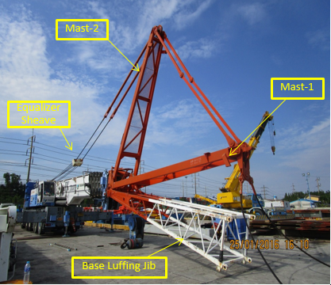

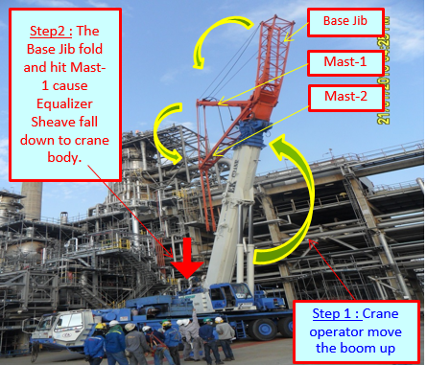

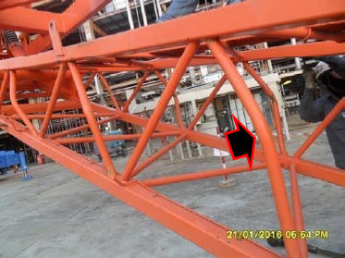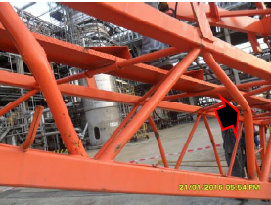

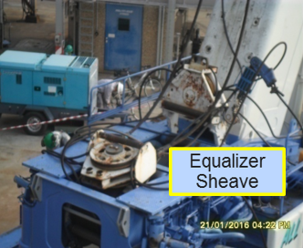
Remark : The reason why the Base jib fell and hit Mast-1 is because “the Base jib locking device” was not installed
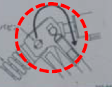

3:55-4:10PM EK Crane safety officer barricade the incident area and notified Technip
Safety supervisor and Construction supervisors via walky-talky
4:15-5:00PM Technip Safety supervisor and construction manager arrived the incident
scene to check and evaluation the damage and to ensure there was no other
potential hazards and then Technip Safety supervisor called the Incident
Investigation team to investigate incident area which include Project Client
management team, area owner, Technip construction manager and
supervisors, contactor safety manager and supervisors .
5:00-20:00PM Incident investigation team investigate incident the scene including gathering necessary information.
20:00PM Finished the Scene Investigation.
22 Jan 2016;
8:00 – 11:30 Investigation team and Project Working Team meeting workshop to find out the root causes and corrective actions as show in figures below;
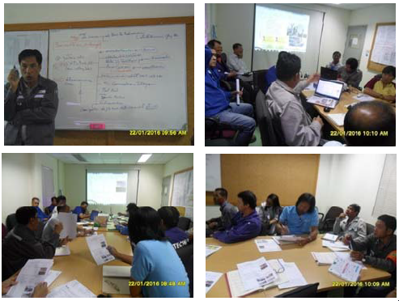

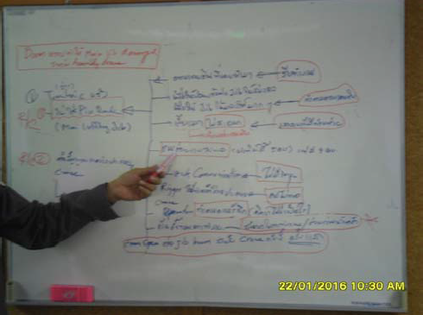

Describe the scope of the investigation
Scope of the investigation : 160 Ton of Crane Assembly activities in Construction area A on 21 January 2016 including all people that involve with this activities and people who were at the scene and include all equipment that were used for Crane Assembly Activities.
All training record of all people involved and inspection records/certificate of all involved equipment are required for the investigation.

The investigation team is included Project Client management team, area owner, Technip construction manager and supervisors, contactor safety manager and supervisors as show in below figure

Investigation Team;
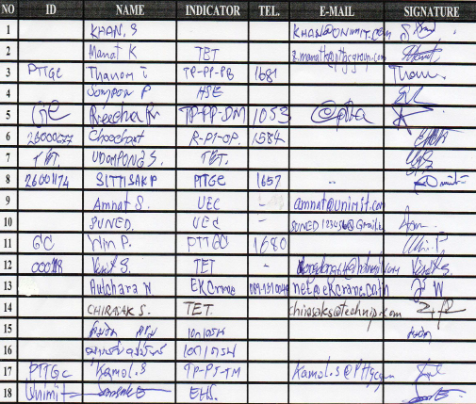

Sources of information and data are work permit, JSA, Method statement, Crane Work manual, crane working procedure, inspection record, training record, lifting plan and interview witness who were in the scene.
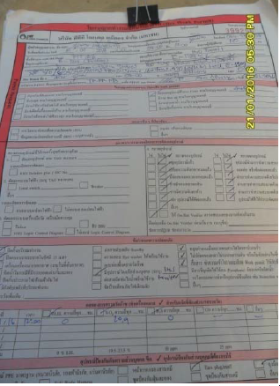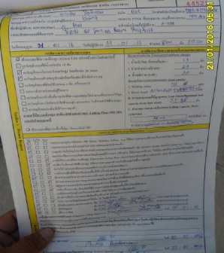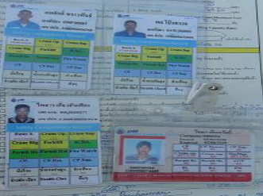

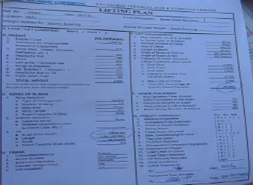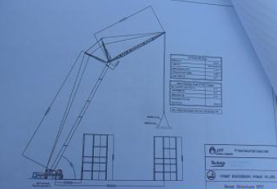

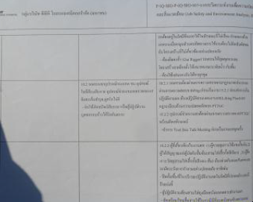

The Direct Cause of the incident: the Base jib locking device was not installed before changing the degree of the boom (Crane Assembly worker forgot to install the lock device).

The root causes of the incident:
- Lack of Assembly Crane Inspection process before operate the crane
- Lack of Crane Working procedures and manual
- Lack of Manpower resource on Crane Assembly Assistant

- RECOMMENDED PREVENTION MEASURES
Recommended prevention measures
No. | Recommended Prevention Measure | By Who | Target Date | Remark
1. | Crane Assembly Inspection Check List shall be provided | EK Crane HSE Manager | 26 Jan 2016
2. | Crane Assembly Manual shall be provided | EK Crane Construction Manager | 26 Jan 2016
3 | At least one person of Crane Assembly Assistant shall be provide to assist the Crane assembly workers. | EK Crane Project Manager | 26 Jan 2016
4 | Crane assembly workers and assistant shall assembly the crane according to assembly manual | EK Crane Construction Supervisor | 26 Jan 2016 | Continuous actions
5 | Crane supervisor shall inspect the Crane by using the Crane Assembly Inspection Check List and record into the checklist before giving the signal to Crane operator to operate the crane | EK Crane Construction Supervisor | 26 Jan 2016 | Continuous actions
6 | Add all above 5 items into daily HSE inspection Checklist to ensure all 5 items are implementation | Technip Site HSE Lead | 26 Jan 2016

- CONCLUSION
As the health and safety of our people is a core value and an absolute commitment, then we shall implement all risk control measures and preventive / corrective actions to prevent reoccurrence on an incidents. Doing the right thing is fundamental to achieving HSE excellence, then all above recommended prevention measures shall be implemented and maintained.

Outcome for Activity 4 | ☐ Satisfactory  ☐ Not satisfactory
Trainer/Assessor comments

QUIZ

QUESTIONS | CORRECT
- Which of the following matters are considered as initial responses to an incident? Select all that apply.  ☒ First aid  ☒ Evaluation of response  ☒ Preserving the incident site  ☒ Evacuation | ☐
- Under Part 3 of the Work Health and Safety Act 2011 (Qld), a PCBU must notify Work Health and Safety Queensland about all incidents that occur in the workplace, even if there is no injury or damage caused.  ☐ True  ☒ False | ☐
- Which of the following should be considered when developing an investigation plan? Select all that apply.  ☒ WHS legislation  ☒ Workplace policies, procedures, processes and systems  ☒ Appropriate selection of a team for the scope of the investigation  ☒ Consultation and participation of individuals/parties with planning  ☒ Obtaining necessary resources for investigation, including expert advice | ☐
- Under Part 9 of the Work Health and Safety Act 2011 (Qld), which of the following rights and powers does a WHS inspector possess?  Select all that apply.  ☒ To provide information and advice about WHS compliance  ☒ To assist in resolving WHS issues in the workplace  ☒ To inspect a workplace, including investigation of WHS incidents  ☒ Enter a workplace with or without the PCBU’s permission | ☐
- Which of the following factors would be considered barriers to an incident investigation? Select all that apply.  ☒ Availability of witnesses due to organisational structure  (e.g. casual employees, shift work)  ☒ Differences in understanding due to diversity (e.g. cultural background, low language, literacy and numeracy levels)  ☒ Attitudes of investigators (e.g. negative views of opposite gender)  ☒ An extended time passing since the incident occurred | ☐

- Under Part 10 of the Work Health and Safety Act 2011 (Qld), which of the following types of notices may be issued by a WHS inspector?  Select all that apply.  ☒ Improvement notices  ☒ Non-disturbance notices  ☒ Prohibition notices  ☐ Time out notice | ☐

Outcome for Quiz | ☐ Satisfactory  ☐ Not satisfactory
Trainer/Assessor comments

PRACTICAL TASK

You are required to have a suitable observer verify your ability to complete the following tasks. These tasks may be simulated or real.

TASKS | VERIFIED
- Work with others to carry out initial responses to a notifiable incident:  - Ensure incident site is safe and secured, addressing the immediate needs of those involved  - Ensure workplace policies, procedures, processes and systems are followed (e.g. evacuation procedures, providing support, requesting information from those involved)  - Ensure WHS regulator is notified | ☒
- Take a leadership role when consulting with others to develop and document an investigation plan:  - Determine scope and purpose of investigation, including timelines  - Form an appropriate investigation team and assign responsibilities and roles  - Identify and evaluate alternative strategies and resources for investigation process  - Obtain necessary resources for investigation  - Ensure requirements of WHS legislation and workplace policies, procedures, processes and systems are met by the plan | ☒
- Work in investigation team to collect information and data:  - Inspect incident site, equipment and other evidence (e.g. witnesses)  - Extract mathematical information, as required  - Gather information and data in ways that ensure objectivity, confidentiality, validity and accuracy  - Electronically document outcome of inspection | ☒
- Work with others to analyse information and data:  - Construct a timeline of events leading up to the incident  - Analyse numerical data, key events, conditions and/or circumstances  - Demonstrate and open-minded and objective approach  - Analyse policies, procedures, processes and systems in place at the time of the incident  - Focus on the ‘how’, ‘what’ and ‘why’ of the incident, using models of causation and occurrence rather than focussing on individual behaviour or fault | ☒
- Consult with others to determine prevention measures:  - Develop and detail actions, interventions and practical measures to address root causes and prevent the reoccurrence of the incident  - Identify how solutions will be measured and evaluated to determine effectiveness | ☒
- Prepare and verbally present an electronic investigation report to relevant parties (e.g. PCBU, Trainer/Assessor):  - Identify the events leading up to the incident, immediate and underlying causes and points at which the incident could have been prevented  - Explain recommendations arising from the investigation  - Cite evidence and basis for conclusions and recommendations  - Develop appropriate report for audience and use objective language | ☒

Name of observer | Mr. Faezal Ibrahim
Role of observer  (Confirm their suitability to sign) | ☐ Trainer/Assessor  ☒ Other (specify):
Phone number of observer | +668-3000-5747
Email address of observer | fibrahim@technip.com
Signature of observer | 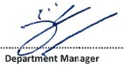
Date | 9/03/2016
Comments | Meet Expectation

Outcome for Practical Task | ☐ Satisfactory  ☐ Not satisfactory
Trainer/Assessor comments

