
BSBWHS507
Contribute to managing WHS information systems

Copyright © 2016 CSTC Pty Ltd

All rights reserved. No part of the contents of this publication may be reproduced or used in any form or by any means – graphic, electronic, or mechanical including photocopying, digitising, recording, or information storage-and-retrieval systems – without the written permission of CSTC Pty Ltd.
ASSESSMENT FOR BSBWHS507

Student name | Watchara L.
Date of assessment submission | 24/03/2016

Trainer/Assessor’s name
Date of assessment marking | Click here to enter a date.
Outcome for unit | ☐ Competent  ☐ Not Yet Competent

TASK INSTRUCTIONS

- The assessment for this unit of competency consists of the following:
  - A series of activities: Some of these activities will require you to provide a response within this document, others will require you to gather evidence to demonstrate your knowledge and skills (overview below)
  - Quiz: You will be required to complete a series of questions to demonstrate your knowledge and skills.
  - Practical task: You will be required to have an observer attest to your knowledge and skills and sign a report to this effect.
- At times, you will be provided with a specific business context to which you must respond, otherwise it is anticipated that you will use a workplace of your choosing (your own, or hypothetical) to provide the context to the task.
- At all times, the responses in your assessment must reference Australian (Queensland or Federal) documentation, including legislation, regulations, codes of practice, standards and guidance publications.

ACTIVITY OVERVIEW | REQUIRED FOR SUBMISSION
- Documents supporting WHSIS | - Workbook response (below)
- Use and operation of WHSIS | - Workbook response (below)
- WHSIS supporting job role | - Workbook response (below)
- Monitoring, evaluating and improving WHSIS | - Workbook response (below)

ACTIVITIES

For the following activities, you will assume the role of a workgroup supervisor in a workplace of your choosing (see example organisational chart below).

Name a workplace and workgroup that you are (or hypothetically are) the supervisor for:

Name of workplace | Technip
Workgroup | Thailand

Summarise what the following documents address with respect to a WHSIS (i.e. requirements of duty holders, due diligence obligations, incident reporting requirements, function/purpose of WHSIS, WHS information necessary for effective WHS management):
- Work Health and Safety Act 2011 (Qld)
- Work Health and Safety Regulations 2011 (Qld)
- Work Health and Safety Consultation, Co-operation and Co-ordination Code of Practice 2011
- Australian Standard AS/NZS 4804:2001
- Guidance material
- Workplace policies
- Workplace procedures
- Workplace systems

 | Summary of contents
- Work Health and Safety Act 2011 (Qld) | Location of document:  www.legislation.qld.gov.au/legisltn/current/w/workhsa11.pdf  Summary of contents:  The Work Health and Safety Act 2011(the WHS Act) provides a framework to protect the health, safety and welfare of all workers at work. It also protects the health and safety of all other people who might be affected by the work.  All workers are protected by the WHS Act, including:  • employees  • contractors  • subcontractors  • outworkers  • apprentices and trainees  • work experience students  • volunteers  • employers who perform work.  The WHS Act also provides protection for the general public so that their health and safety is not placed at risk by work activities.  The WHS Act places the primary health and safety duty on a person conducting a business or undertaking (PCBU). The PCBU must ensure, so far as is reasonably practicable, the health and safety of workers at the workplace. Duties are also placed on officers of a PCBU, workers and other persons at a workplace.  All duties under the WHS Act are qualified by the term 'reasonably practicable'.  The WHS Act also sets out the requirements for the following:  • incident notification  • consultation with workers  • issue resolution  • inspector powers and functions  • offences and penalties.  The key principles of the laws, detailed in the Work Health and Safety Act 2011 are consistent with long established workplace safety standards in that they:  - establish health and safety duties, including the primary duty to protect any person from exposure to hazards and risks that arise from work  - provide for worker representation, consultation and participation including through Health and Safety Representatives and Health and Safety Committees  - enable compliance and enforcement through SafeWork SA, the regulator, and  provide for the creation of Regulations and Codes of Practice
- Work Health and Safety Regulations 2011 (Qld) | Location of document:  www.legislation.qld.gov.au/LEGISLTN/CURRENT/W/WorkHSR11.pdf  Summary of contents:  The Work Health and Safety Regulation 2011 (the WHS Regulation) identify the control measures that must be applied to specific work activities and hazards, for example machine guarding and noise exposure and describes how to prevent or minimise a risk at your workplace. We must do what the regulation says.  If a risk at the workplace is not covered by the regulation or code of practice then we must choose an appropriate way to manage exposure to the risk.  A person conducting a business or undertaking must, where there is no regulation or code of practice about a risk, eliminate or minimise risks so far as is reasonably practicable
- Work Health and Safety Consultation, Co-operation and Co-ordination Code of Practice 2011 | Location of document:  https://www.safework.sa.gov.au/uploaded_files/CoPWorkHealthSafetyConsultationCooperationCoordination.pdf  Summary of contents:  This Code of Practice provides practical guidance to persons conducting a business or undertaking on how to effectively consult with workers who carry out work for the business or undertaking and who are (or are likely to be) directly affected by a health and safety matter. It includes information on mechanisms to facilitate worker participation and representation.  This Code also provides guidance to duty holders who share responsibility for the same work health and safety matter on how to consult, co-operate and co-ordinate activities with each other.  The contents of this Code of Practice are included;  - Who has duties in relation to consultation, co-operation and co-ordination?  - Why is consultation important?  - When to consult with workers  - What is effective consultation?  - How to consult with workers  - How to consult, co-operate and co-ordinate activities with other duty holders  - Examples of consultation arrangements  - Consultation checklist  - Consulting, co-operating and co-ordinating activities
- AS/NZS 4804:2001 | Location of document:  https://www.saiglobal.com/PDFTemp/Previews/OSH/as/as4000/4800/4804.pdf  Summary of contents:  The objective of this standard is to provide guidance on how an occupational health and safety management system (OHSMS) may be set up; how it can be continually improved; and what resources may be used to do this.  This standard will help you to establish, implement, and continually improve your occupational health and safety management systems. The benefits of an effective occupational health and safety management system include:  - meeting legal requirements  - being ethical  - meeting industrial relations requirements  - reducing workplace illness and injury  - minimising the costs associated with workplace accidents.  This Standard provides general guidance on:  • How to set up an OHSMS.  • How to continually improve an OHSMS.  • The resources required to set up and continually improve an OHSMS.  The guidelines in this Standard describe a systematic management approach as  -OHS policy,  -Planning, -Implementation,  -Measurement and evaluation  - Management review  That can assist in both meeting legal requirements and lead to sustained improvement in OHS performance. These guidelines can assist organizations establish their own OHSMS and they also apply to any existing OHSMS. The guidelines do not prescribe the type or format or style of OHSMS that should be used. Rather, this Standard contains guidance for organizations of any size or type seeking to develop and implement an OHSMS, or improve an existing system  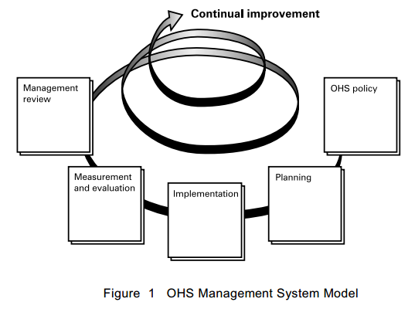
- Guidance material | Location of document:  http://www.worksafe.act.gov.au/publication/view/2121  Summary of contents:  WHS Management Plans :  Model Work Health and Safety (WHS) legislation was developed as a result of a comprehensive national review into work health and safety laws across Australia, which involved substantial public consultation. This initiative provided a framework to protect the health, safety and welfare of all workers at work and of all other people who might be affected by the work. The Australian Capital Territory [ACT] has enacted the provisions of the model WHS Legislation and WorkSafe ACT has developed this guidance document to provide assistance and guidance to construction contractors to allow them to satisfactorily develop a WHS Management Plan and meet the WHS law requirements in relation to such plans.  This guidance was developed to assist contractors in the effective application of WHS management systems for construction projects. This guide can be used by a PC to facilitate the application of these processes, and lead to a more comprehensive understanding of requirements.  In essence, a WHS Management Plan should outline the PC’s WHS structure, roles, responsibilities and authorities, methods of consultation, induction and training, risk management process, subcontractor’s management, injury management and continuous monitoring and review.
- Policies | Location of document:  Technip Health Safety and Environmental Policy located in Technip’s intranet systems : http://thelink.exnet.technip.com/sites/thailand/HSE/Pages/Policy.aspx  Summary of contents:  At no time will Technip compromise the health and safety of its employees or those engaged on our activities and will always seek business solutions that recognise and respect the environment. This is consistent with the principles set out in the global agreement to which Technip subscribes.  Establishing sustainable solutions is an integral part of Technip's planning process and it will continue to work with its clients, contractors and suppliers to reduce waste and emissions, conserving natural resources, through the development of environmentally friendly technologies.  Technip will ensure that appropriate arrangements are in place to protect the health and safety of its employees and all those that are affected by its activities.  Technip will comply with all the legislative requirements that are appropriate to its business and will apply relevant industry standards.  In areas it operates that may lack such controls, or have controls that do not realise Technip's internal standards, Technip will apply its own standards. Technip Engineering (Thailand) Ltd. will provide encouragement and support to those with which it interacts to achieve these standards.  This is in line with Technip's commitment to continuous improvement and social responsibility.  To this end Technip Engineering (Thailand) Ltd. will:  - Promote a climate and focus in the organisation that demands a positive and proactive HSE response from its employees or those engaged on our activities. Every person has the right to stop the work if they consider that an HSE risk exists  - Utilise meaningful leading and lagging performance indicators to improve performance  - Maintain an effective HSE management system  Consideration for the health and safety of its employees and those who may be affected by its business and the protection of the environment, will remain an integral part of its business planning and decision making process.
- Procedures | Location of document:  Technip WHS procedures located in Technip’s intranet systems : http://thelink.exnet.technip.com/sites/kualalumpur/QHSES/Pages/APAC-GWP-HSE.aspx  Summary of contents:  This Health, Safety & Environment Management Manual (HSEMM) provides the framework and strategy for the management of HSE within the Technip APAC region. It is designed to provide an overview of HSE systems and processes utilised across the region so as to promote a consistent and uniform approach.  The contents of this WHS procedure are included;  3 HSE Management  3.1 HSE Management at Technip Group and TP APAC  3.2 Certification of Operating Centres’ HSE Management Systems  4 TP APAC Management Responsibilities  4.1 Management Responsibilities  4.2 Management Commitment and Reviews  4.3 Customer Focus and Satisfaction  4.3.1 Customer Satisfaction Index  4.4 Objectives and Key Performance Indicators (KPI’s)  4.5 HSE Leading and Lagging Indicators  4.6 Accountability for HSE  4.7 Technip Key Risk Conditions  4.8 Just Culture  4.9 Environmental Management  4.10 HSE Incident Classification, Notification, Investigation and Reporting  4.10.1 Incident Notification  4.10.2 Incident Investigation  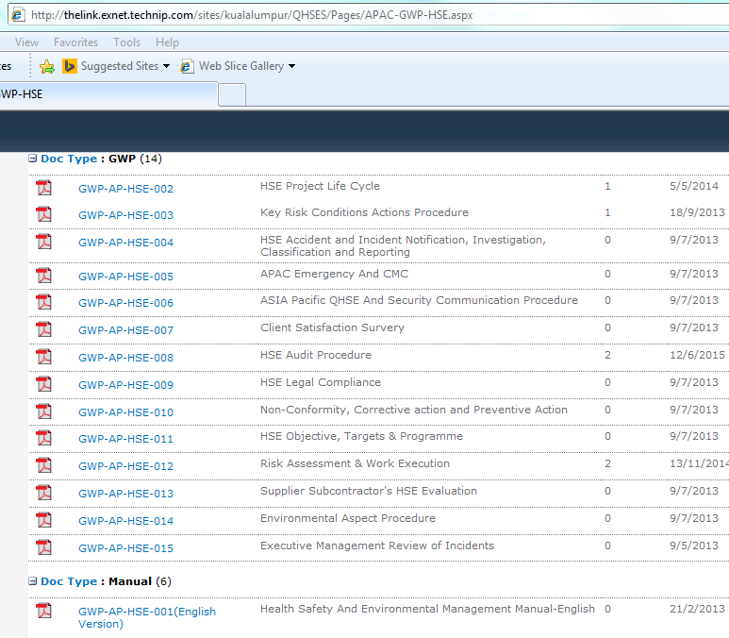
- Systems | Location of document:  BS OHSAS 18001 - Occupational Health and Safety Management (OHS) located in : http://www.bsigroup.com/en-GB/ohsas-18001-occupational-health-and-safety/  Summary of contents:  This OHSAS Standard specifies requirements for an OH&S management system to enable an organization to develop and implement a policy and objectives which take into account legal requirements and information about OH&S risks. It is intended to apply to all types and sizes of organizations and to accommodate diverse geographical, cultural and social conditions. The basis of the approach is shown in Figure 1. The success of the system depends on commitment from all levels and functions of the organization, and especially from top management. A system of this kind enables an organization to develop an OH&S policy, establish objectives and processes to achieve the policy commitments, take action as needed to improve its performance and demonstrate the conformity of the system to the requirements of this OHSAS Standard.  The overall aim of this OHSAS Standard is to support and promote good  OH&S practices, in balance with socio-economic needs. It should be noted that many of the requirements can be addressed concurrently or revisited at any time.  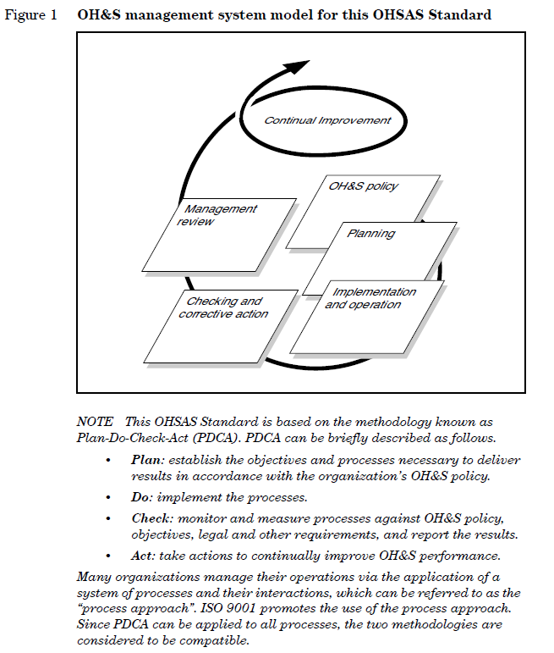

Outcome for Activity 1 | ☐ Satisfactory  ☐ Not satisfactory
Trainer/Assessor comments

Describe the use and operation of the WHSIS:
- Identify the WHSIS users you would consult with to determine requirements of the WHSIS.
- Describe which aspects of the WHSIS each user would need to access.
- What training, advice and support could you offer to users to assist with using the WHSIS more effectively and to meet their WHS responsibilities and objectives?
- Name workplace factors that may impact on the design, development and use of the WHSIS.
- Consider the impact of language, literacy and cultural factors.
- Provide recommendations for dealing with such factors.

Consulting WHSIS users
WHSIS users | Aspects of the WHSIS | Training, advice and support
Health and safety representatives | Roles, duties, rights and responsibilities :  - to represent the workers in the work group in matters  relating to work health and safety; and  - to monitor the measures taken by the person conducting  the relevant business or undertaking or that person’s  representative in compliance with this Act in relation to  workers in the work group; and  - to investigate complaints from members of the work  group relating to work health and safety; and  - to inquire into anything that appears to be a risk to the  health or safety of workers in the work group, arising  from the conduct of the business or undertaking.  - inspect the workplace or any part of the workplace at  which a worker in the work group works—  - accompany an inspector during an inspection of the  workplace or part of the workplace at which a worker in  the work group works; and  -with the consent of a worker that the health and safety  representative represents, be present at an interview  concerning work health and safety  - request the establishment of a health and safety  committee; and  - receive information concerning the work health and safety of workers in the work group; and  - whenever necessary, request the assistance of any person. | - Provide the Company WHS procedures Induction  - Provide Health and safety representatives Training course  - Conduct Monthly Meeting for  Health and safety representatives to get the two ways communication and what supports they need.  - Provide technical WHS training courses to them such as Electrical safety, Working at height safety, scaffolding, HSE leadership, Internal Auditor, working in confine space, ect.
Health and safety committees | Roles, duties, rights and responsibilities :  - to facilitate cooperation between the person conducting a business or undertaking and workers in instigating,  developing and carrying out measures designed to  ensure the workers’ health and safety at work; and  - to assist in developing standards, rules and procedures  relating to health and safety that are to be followed or  complied with at the workplace; and  - any other functions prescribed under a regulation or  agreed between the person conducting the business or undertaking and the committee. | - Provide the Company WHS procedures Induction  - Provide Health and safety committee Training course  - Conduct Monthly Meeting for  Health and safety committees to get the two ways communication and what supports they need.  - Provide technical WHS training courses to them such as Electrical safety, Working at height safety, scaffolding, HSE leadership, Internal Auditor, working in confine space, ect.
Workers | Roles, duties, rights and responsibilities :  - A worker who carries out work for a business or undertaking  may ask the person conducting the business or undertaking to  facilitate the conduct of an election for 1 or more health and  safety representatives to represent workers who carry out  work for the business or undertaking.  - take reasonable care for his or her own health and  safety; and  - take reasonable care that his or her acts or omissions do  not adversely affect the health and safety of other  persons; and  - comply, so far as the worker is reasonably able, with any  reasonable instruction that is given by the person  conducting the business or undertaking to allow the  person to comply with this Act; and  - co-operate with any reasonable policy or procedure of the person conducting the business or undertaking relating to health or safety at the workplace that has  been notified to workers | - Provide the Company WHS Basic Induction  - Provide Health and safety Hazard and Risk Training course  - Conduct Safety Tool box talk to get the two ways communication and what supports they need.  - Attend their monthly department meeting to promote WHS awareness and get consultation to them  - Communicate their job register and risk control measures to them and get information feedback from them or any comments  - Provide technical WHS training courses to them such as Electrical safety, Working at height safety, scaffolding, HSE leadership, Internal Auditor, working in confine space, ect.
Managers and Supervisors | - to identify hazard and Risk assessment of their own work activities  -to involve the incident investigation | - Establish Training Plan and Training Budget for basic understanding of risk management process  and Incident Investigation techniqe such as TOPSET

Design, development and use of WHSIS
Identify barrier | Measure to remove barrier | Contribution to development of measure | Contribution to implementation of measure | Contribution to evaluation of measure
Language - Due to all of Technip WHS procedures are English but most of our staffs are local ( Thai) and they may not well understand the meaning in the procedure | Conduct WHS Induction for all staffs using local language .  - Provide English Class for all staffs to improve English Skill | Establish WHS Training Procedure and Prepare WHS induction Material  - Prepare budget for English class and organize English class schedule for English Class service provider to conduct the class in the Company | Organize the WHS Training schedule as Weekly basis for new staffs to attend  - Organize English class schedule as daily basis for difference classes in the week, Each of staffs has once a week for their class. | - Conduct test after induction to ensure they have well undertanding.  - Conduct pre and post test for English class  - Conduct WHS Audit to ensure all stafffs / workers comply with WHS procedures
Shift Work | Provide communication, consultation and participation for worker night shif | Identify communication needed for the night shift | - Conduct tool box talk for the night shift every day before start work to ensure two-way communication and consultation an participation  - Provided HRS for the night shift work | - Conduct WHS Audit to ensure all staffs / workers comply with WHS procedures  - Provide Online Feedback on intranet and Consultation & participation Boxes for hard copy which night ship worker can submit their feedback
Diversity | Create Workplace WHS culture | Establish Workplace WHS culture training program | Conduct Workplace WHS culture training according to the schedule | Conduct Questionnaire to survey the improvement before and after workplace WHS culture implementation

Outcome for Activity 2 | ☐ Satisfactory  ☐ Not satisfactory
Trainer/Assessor comments

The WHSIS supports job roles in a number of ways:
- Consider the role of the WHSIS with regards to hazards and risk management.
- What information might a WHSIS hold to assist with recording data collected about hazards and risks? Who should receive such information and in what timeframe? What legislation needs to be considered when recordkeeping (e.g. privacy, secure storage of data)?
- What information might a WHSIS hold with regards to previously reported hazards and risks?
- How can such data be used to evaluate WHS performance and identify areas for WHS improvement? Who should be consulted as part of this analysis? Is this an on-going requirement?
- Consider the role of the WHSIS with regards to industrial relations.
- What information might a WHSIS hold to assist with industrial relations matters (e.g. grievance procedures)?
- What legislation should be referenced in such information?
- Consider the role of the WHSIS with regards to equal employment opportunity.
- What information might a WHSIS hold to assist with equal employment opportunity matters?
- What legislation should be referenced in such information?
- Consider the role of the WHSIS with regards to workers’ compensation and rehabilitation.
- What information might a WHSIS hold to assist with workers’ compensation and rehabilitation matters?
- What legislation should be referenced in such information?

Hazards and risks
1. Information that WHSIS might hold to assist with recording data collected and with regards to previously reported about hazards and risks are included :
- WHS legislative certifications, registrations and licensing
- Workplace policies, procedures, processes and systems
- Notices and other documents from WHS inspectors
- Ergonomic information and data, such as job and task analyses
- Incident reports, including reports on near misses, hits, incidents, injuries, first aid, illness, disease, dangerous occurrences
- Internal inspections
- Lost time injury and other WHS outcome performance indicator reports and summaries
- Worker training records
- Plants maintenance and servicing records
- Records relating to plant, equipment and tools,
- Registers relating to hazards, risks, hazardous chemicals, dangerous goods, safety data sheets and confined spaces
- Internal audit reports
- Results of WHS test, measurements, monitoring and analyses
- Worker health screening and surveillance
- Risk assessment and risk-management records
- Safety manuals for plant and tools
- Sickness absence records
- Compensation claims management and return to work programs
2. All relevant staffs should receive information on hazards, risk and controls measures before they start works by conducting toolbox talk, or hazard and risk workshop, WHS training, etc.
3. The Legislation needs to be considered when recordkeeping (e.g. privacy, secure storage of data) ; The use or disclosure of personal information obtained under this
section is regulated under the Privacy Act 1988 of the Commonwealth and also for Work Health and Safety Regulation 2011 Chapter 7 Hazardous chemicals that required (378-1)A person conducting a business or undertaking must ensure that health monitoring reports in relation to a worker carrying out work for the business or undertaking are kept as a confidential record—

(378-2) The person must ensure that the health monitoring report and results of a worker are not disclosed to another person without the worker’s written consent.
To compliance with those requirements we will keep the health monitoring report as confidential by keeping in the secure area with access control system, only authorized person can access to the report.

The authorized person name list will be reviewed every 6 months.

Access Control system will have preventive maintenance plan to ensure the functional.

4.The data mentioned in item 1 can be used to evaluate WHS performance and identify areas for WHS improvement in meeting objectives as following
- Comply with WHS legislative requirements
- Identify trends and make comparisons over time and across locations
- Identify hazards
- Prioritise risk and allocate resources
- Evaluate effectiveness of risk controls
- Evaluate effectiveness of the WHS management approach and identify areas for improvement
- Support strategic plaining and internal and external accountability
- Feedback from the users of the information on the usefulness and usability of the data is vital in ensuring that the objective are being met

All staffs who under scope of WHIS should be consulted as part of this analysis by following methods
- Interview the staffs / workers
- Conduct a survey or questionnaire
- Evaluated people’s ability to accurately read and interpret graphs, tables and others presentations of data and information

Industrial relations
To consider the role of the WHSIS with regards to industrial relations as The main object of the Work Health and Safety Act 2011 external link, opens in a new window (the WHS Act) is:“... to provide for a balanced and nationally consistent framework to secure the health and safety of workers and workplaces ...”The WHS Act also states that:
“... regard must be had to the principle that workers and other persons should be given the highest level of protection against harm to their health, safety and welfare from hazards and risks arising from work as is reasonably practicable.”

Work health and safety regulators, federally and in the states and territories, administer their respective work health and safety laws. They can respond to and prosecute breaches of work health and safety laws.

The Fair Work Commission also has some responsibilities under the WHS Act. Under the Work Health and Safety Act 2011 (Qld) (WHS Act) health and safety representatives (HSRs) currently have the power to direct that unsafe work cease.
A HSR may direct a worker in their work group to cease work "if the representative has a reasonable concern that to carry out the work would expose the worker to a serious risk to the worker's health or safety, emanating from an immediate or imminent exposure to a hazard". This power supplements other powers of HSRs including the ability to issue provisional improvement notices (PINs) for contraventions of the WHS Act.
In practice the question of whether or not a risk is one giving rise to a "serious risk" from "imminent exposure" is often at the heart of a dispute. HSRs and unions have been able to raise an issue and stop work immediately with what appears to be limited evidence in support of their view to establish what is a "reasonable concern". In response, businesses are forced put together a scientific case to demonstrate the adequacy of their operational controls in such a way as to satisfy a regulator or a court that work should not cease. This can leave a business legacy of disruption and associated cost. When safety concerns are raised in conjunction with other industrial issues, the potential for misuse of these HSR powers exists.
The Bill would remove these powers of HSRs, leaving their main enforcement avenues as consultation or the issue of a PIN. In theory the issue of a PIN allows HSRs a powerful way to control valid safety concerns: it is an offence not to comply. However they do not offer HSRs the same immediate control over operations, because a PIN must allow the recipient a timeframe of eight days within which to comply. This means that any HSR wanting an immediate response in case of dispute will need to either engage with the business through its own consultation and risk systems, or call upon the safety regulator to intervene.
This does not mean workers have no protection where they are exposed to imminent risk. Under the WHS Act workers still individually have the right to cease work if they have a reasonable concern that they will be exposed to a serious risk to their health or safety emanating from an imminent exposure to a hazard. Similarly, under the Fair Work Act 2009 (Cth) it will still not constitute unlawful industrial action for workers to cease work under those conditions.

Under the WHS Act currently, permit holders may also enter a workplace for the purpose of consulting and advising workers on WHS issues. There is already a requirement to give at least 24 hours prior notice of entry to the employing business. They also will allow head contractors and principals an increased ability to prevent the spread of raised concerns throughout workforces of multiple sub-contractors, where notice has been given only to one of several undertakings operating at that workplace.
As with the stop work provisions, the effect of these changes will be to push the role to manage urgent safety issues which cannot be resolved by internal consultation onto the regulator rather than unions, and to introduce a cooling-off period before union interventions can follow.

Businesses should view these reforms as an opportunity to enhance operational control, build better direct relationships with their workforce through safety and risk consultation, and ensure that unions and representatives raising safety issues do so in a valid way.
Unions will have reduced opportunities to introduce safety concerns inequitably, and businesses can ensure that their own safety and risk hazard and incident investigation systems provide a reliable alternative when issues first arise. Ultimately the aim to produce enhanced safety outcomes and build stronger direct relationships with workers can go hand in hand.

Equal employment opportunity
To consider the role of the WHSIS with regards to equal employment opportunity. In Australia, national and state laws cover equal employment opportunity and anti-discrimination in the workplace. We're required by these laws to create a workplace free from discrimination and harassment. It's important that as an employer, staffs shall understand their rights and responsibilities under human rights and anti-discrimination law. By putting effective anti-discrimination and anti-harassment procedures in place in our business we can improve productivity and increase efficiency.
The Fair Work Act 2009 prohibits an employer from taking 'adverse action' against an employee (and in some cases independent contractors or prospective employees) for certain reasons. In summary, the general protections deal with:
- workplace rights;
- industrial rights (including industrial activities and freedom of association);
- protection from discrimination;
- protection from unlawful termination;
- protection from sham arrangements (relating to the engagement of independent contractors).

Workers’ compensation and rehabilitation
To consider the role of the WHSIS with regards to workers’ compensation and rehabilitation as In the event of a work-related accident or illness, occupational health and safety (OH&S) and work health and safety (WHS) laws require that injured workers have access to first aid, fair workers' compensation and return to work rehabilitation.
It's employer responsibility to:
- maintain a safe workplace
- maintain current workers' compensation insurance
- protect workers from financial hardship in the event of a workplace injury.
Workers’ compensation arrangements should aim to achieve a reasonable balance between the interests of employers and workers, while at the same time:
- supporting effective and early return to work
- providing fair compensation for work-related injuries, illnesses and deaths
- reducing the overall social and economic costs to the community of work-related injuries, illness and fatalities, and
- ensuring that employer costs are equitably distributed and contained within reasonable limits.
The legislation should be referenced in such information is The Workers’ Compensation and Rehabilitation Regulation 2014, The 2014 Regulation retains the existing policy intent, protections of injured workers’ rights and entitlements, and efficient processes for insurers and employers. The 2014 Regulation streamlines these protections and requirements by removing any obsolete processes, requirements and unnecessary duplication.

Outcome for Activity 3 | ☐ Satisfactory  ☐ Not satisfactory
Trainer/Assessor comments

As with the data contained within the WHSIS, it is important to monitor, evaluate and improve the WHSIS itself:
- How would you, as the workgroup supervisor, facilitate the review process?
- Outline processes for monitoring the effectiveness of the WHSIS.
- Who should be consulted to determine how frequently reviews should occur?
- Explain how users can assist to monitor, evaluate and improve the WHSIS.
- What records need to be kept to show consultation has taken place?
- How can recommended WHSIS improvements be implemented?
- What processes should be implemented to ensure that information within the WHSIS is current?
- Name the individuals/parties within the workplace management structure who would be involved with implementing change?
- What training should occur when information changes?
- What records need to be kept to provide evidence of compliance with legislation?

Monitor and evaluate
- For the processes for monitoring the effectiveness of the WHSIS, the organization shall establish, implement and maintain a procedure(s) to monitor and measure OH&S performance on a regular basis. This procedure(s) shall provide for:
- both qualitative and quantitative measures, appropriate to the needs of the organization;
- monitoring of the extent to which the organization’s OH&S objectives are met;
- monitoring the effectiveness of controls (for health as well as for safety); d) proactive measures of performance that monitor conformance with the OH&S programme(s), controls and operational criteria;
- reactive measures of performance that monitor ill health, incidents (including accidents, near-misses, etc.), and other historical evidence of deficient OH&S performance;
- recording of data and results of monitoring and measurement sufficient to facilitate subsequent corrective action and preventive action analysis.
If equipment is required to monitor or measure performance, the organization shall establish and maintain procedures for the calibration and maintenance of such equipment, as appropriate. Records of calibration and maintenance activities and results shall be retained.

- Who should be consulted to determine how frequently reviews should occur?
Individuals and parties that I will consult when identifying and conditions in the workplace as following;
- Site manager ( to obtain the permission to undertake the monitoring and take photographs )
- Workers and WHS representatives for advising of impending monitoring work)
- All people who involved in the workplace activities in the period leading up to the monitoring ( to communicate to them)
- The person who will be subjects in the sampling exercise such as workers who work in area where the hazard is present, including supervisors, maintenance personnel and cleaners
The persons I will consult with when collecting information and data about the requirements, nature and purpose of the monitoring will be WHS representatives, supervisors and workers to find out who will be subjects in the sampling exercise, what do we need to monitoring (the hazards and exposures), when is it necessary to sample and when should samples be collected, where measurements should be taken.

- Explain how users can assist to monitor, evaluate and improve the WHSIS.
We should compare the results with a recognised standard to ensure the safety of all workers in the work place, examples of recognised standards are American Conference of Governmental Industrial Hygienists (ACGIH®), The National Institute for Occupational Safety and Health (NIOSH) and The Occupational Safety and Health Administration (OSHA).
I will assist with preparing reports on the monitoring process as following;
- the purpose of the report is to identify the monitoring result are met with the regulatory requirement and a recognised standard or not and recommend for improvement on the areas that can be improved.
- The target audience should be included are the site managers, management team, WHS representatives and all workers in the workplace
- the report should be presented as soon as possible then the workplace to be able to improve the areas immediacy to ensue health and safety of all workers involed with the hazard.
- I would consider other's privacy in the delivery of the results by keeping records, both electronic and in hard copy will in a secure environment that only authorized person can access to the data.

The monitoring and evaluation result be used to identify areas for WHS improvement in meeting objectives as following
- Comply with WHS legislative requirements
- Identify trends and make comparisons over time and across locations
- Identify hazards
- Prioritise risk and allocate resources
- Evaluate effectiveness of risk controls
- Evaluate effectiveness of the WHS management approach and identify areas for improvement
- Support strategic plaining and internal and external accountability
- Feedback from the users of the information on the usefulness and usability of the data is vital in ensuring that the objective are being met

- What records need to be kept to show consultation has taken place?
The results and records will be kept in electronic format (scan file) in the folder that controlled by access right as allow only authorized person to access. The data will be back up by the IT back-up system and can be re-covered. For the hard copy will be kept the office area with secure by the access control system. We will kept the log book record document in-out and this record is the one of document and record control in the OHSAS 18001 requirements.

Implementing improvements
1.What processes should be implemented to ensure that information within the WHSIS is current?
To ensure that information within the WHSIS is current, we should implement the Audit process to see the effectiveness of WHSIS and seek areas for improvement, then sent process shall be implemented is corrective and preventive actions to ensure the continuous improvement of WHSIS.

- Name the individuals/parties within the workplace management structure who would be involved with implementing change?
The individuals/parties within the workplace management structure who would be involved with implementing change shall be include;
- Project Managers/ Site Managers
- Supervisors / Foreman
- All workers who relevant to implementing change
- WHS Representatives
- WHS Committees

- What training should occur when information changes?
Training should occur when information changes shall be included;
- Identified hazards, risk assessment and control measures regrading to changing
- The reason why we have to changing
- What is changing
- What are benefit of changing
- Role and responsibility of relevant persons

- What records need to be kept to provide evidence of compliance with legislation?
Records need to be kept to provide evidence of compliance with legislation shall be included:
- Training records
- Hazards and Risk Register updated
- Chang register or history of change
- Communication and Consultation records
- Internal Audit, WHS inspection Records

Outcome for Activity 4 | ☐ Satisfactory  ☐ Not satisfactory
Trainer/Assessor comments

QUIZ

QUESTIONS | CORRECT
- The function and purpose of a WHSIS includes which of the following? Select all that apply.  ☒ To document and communicate WHS and other relevant policies, procedures, processes and systems  ☒ To facilitate keeping track of legal requirements and compliance  ☒ To facilitate and support consultation and participation  ☐ To provide a system that is for management use only  ☒ To provide an easy way to put information back into the system | ☐
- Which of the following types of WHS information may be obtained from a WHSIS? Select all that apply.  ☒ JSA, SWMS and SDS  ☒ Incident reports  ☒ Internal and external inspection results  ☒ Safety manuals for plant and tools  ☒ Rehabilitation and return-to-work programs  ☒ Records of meetings (e.g. training, consultation) | ☐
- Which of the following factors may impact on a WHSIS?  Select all that apply.  ☒ Workplace commitment to WHS (including management)  ☒ Organisational structure (e.g. size, multiple sites, shift work)  ☒ Required level of security for WHSIS (e.g. access security level)  ☒ Available resources  ☒ Staff profile (e.g. language, literacy, numeracy, cultural diversity) | ☐
- WHSIS users should be consulted to assist with designing, developing, monitoring, evaluating and improving the WHSIS.  ☒ True  ☐ False | ☐

Outcome for Quiz | ☐ Satisfactory  ☐ Not satisfactory
Trainer/Assessor comments

PRACTICAL TASK

You are required to have a suitable observer verify your ability to complete the following tasks. These tasks may be simulated or real.

TASKS |  | VERIFIED
- Work with others to determine WHSIS requirements from:  - Legislation  - Workplace policies, procedures, processes and systems  - Consulting with WHSIS users |  | ☒
- Support a user to access WHSIS to obtain the following forms and determine if they are current copies from the regulator:  - Incident notification form  - Hazardous chemicals health monitoring report |  | ☒
- Outline the legislated reporting requirements for the forms (e.g. time requirements for submission to regulator). |  | ☒
- Work with others to evaluate WHSIS and offer feedback including:  - Improvements for identified issues, ensuring legislative and organisational requirements are met  - Requirements for review processes (e.g. frequency, method, scope)  - Prevention strategies (e.g. training needs) |  | ☒
- Present improvements and prevention strategies to duty holders (e.g. PCBU or Trainer/Assessor) for implementation. |  | ☒
Name of observer | Faezal Ibrahim
Role of observer  (Confirm their suitability to sign) | ☐ Trainer/Assessor  ☒ Other (specify):
Phone number of observer | +6683-000-5747
Email address of observer | fibrahim@technip.com
Signature of observer | 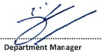
Date | 24/03/2016
Comments | Satisfactory

Outcome for Practical Task | ☐ Satisfactory  ☐ Not satisfactory
Trainer/Assessor comments

