
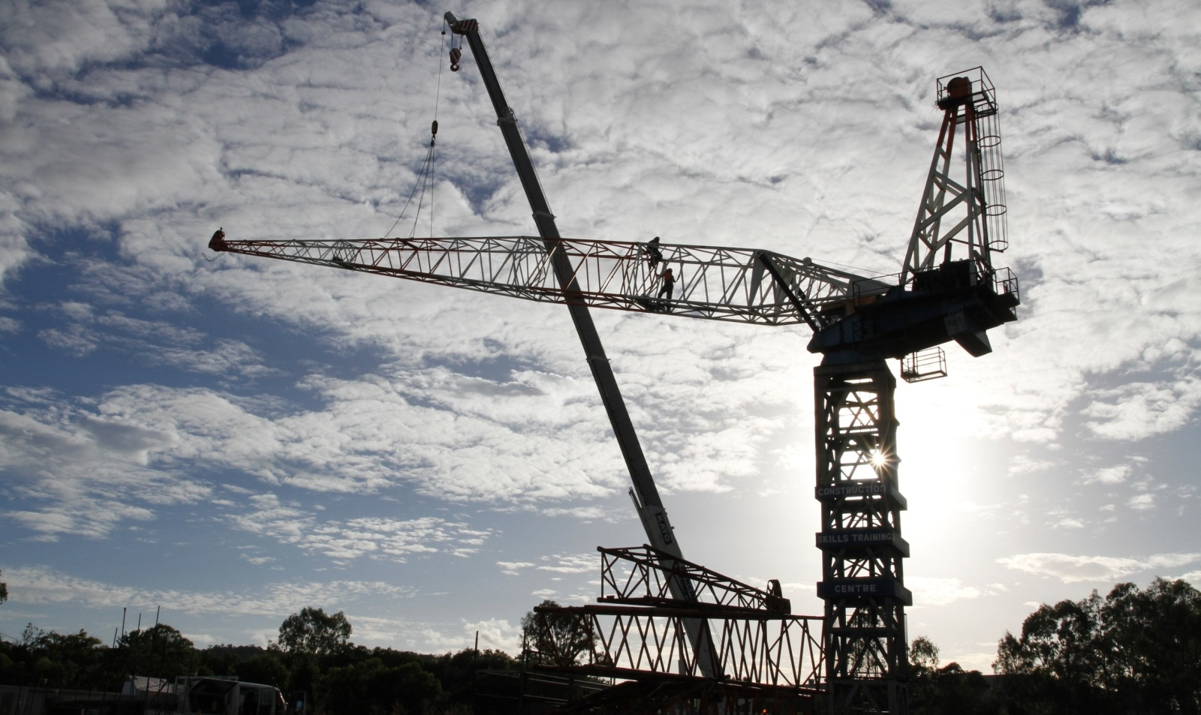

BSBWHS409A
Assist with workplace monitoring processes
For information on the courses the CSTC offer, please contact:
Brisbane, PO Box 51, Moorooka QLD 4105
Phone: 07 3373 8888, Fax: 07 3373 8899 or Email: brisbane@cstc.org.au

Construction Skills Training Centre
We are here to improve your future
Quality instruction, service, fairness
and integrity - always

Our Purpose
CSTC's purpose is to ensure the building and construction industry's long term investment in the workforce through maintaining a commitment to the training and ongoing development of industry workers. CSTC encourages individuals to achieve the highest level of skill and knowledge possible in their chosen vocational area, therefore resulting in improved self esteem, personal growth, employment opportunities, safety into the workplace and quality of life.

Vision
CSTC strives to be recognised as a learning centre of excellence for vocational education and training. We are an organisation that continually strives to achieve the highest possible standards of education, training and consultancy services specific to the building, construction and other related industries.
CSTC provides training in the following areas:
- Occupational Health and Safety | - Road Construction
- High Risk Work Licenses – Scaffolding, Dogging, Rigging, Forklift, Crane operation | - Bridge Construction
- Plant Operations | - Tunnel Construction
- Confined Spaces | - Pipe Laying
- First Aid | - Trenchless Technology
- Asbestos Removal | - Bitumen Surfacing
- Concreting | - And much more!
- Steelfixing



Copyright © 2015 CSTC Pty Ltd

All rights reserved. No part of the contents of this publication may be reproduced or used in any form or by any means – graphic, electronic, or mechanical including photocopying, digitizing, recording, or information storage-and-retrieval systems – without the written permission of CSTC Pty Ltd.

This learning product could only be made possible because of the dedicated CSTC team.
ASSESSMENT FOR BSBWHS409A

Student name | Damian Wilson
Date of assessment submission | 21/05/2015

Trainer/Assessor’s name
Date of assessment marking | Click here to enter a date.
Outcome for unit | ☐ Competent  ☐ Not Yet Competent

TASK INSTRUCTIONS

- The assessment for this unit of competency consists of the following:
  - A series of activities: Some of these activities will require you to provide a response within this document, others will require you to gather evidence to demonstrate your knowledge and skills (overview below)
  - Quiz: You will be required to complete a series of questions to demonstrate your knowledge and skills.
  - Third Party Report: You will be required to have a third party attest to your knowledge and skills and sign a report to this effect.
- At times, you will be provided with a specific business context to which you must respond, otherwise it is anticipated that you will use a workplace of your choosing (your own, or hypothetical) to provide the context to the task.
- At all times, the responses in your assessment must reference Australian (Queensland or Federal) documentation, including legislation, regulations, codes of practice, standards and guidance publications.

ACTIVITY OVERVIEW | REQUIRED FOR SUBMISSION
- Regulatory requirements and standards | - Workbook response (below)
- Characteristics of agents and conditions | - Workbook response (below)
- Consultation with others | - Workbook response (below)
- Documenting and evaluating results | - Workbook response (below)

ACTIVITIES

For the following activities, name a workplace that you wish to examine.

Name of workplace | QUT Kelvin Grove Construction Site Kelvin Grove - Fredon Electricians

Identify examples from the following areas that outline requirements that apply to monitoring.
- Act
- Regulation
- Code of practice
- Standard
- Guidance publication
- Workplace policy
- Workplace procedure

Document type | Name of relevant document  (e.g. Work Health and Safety Act 2011 (Qld) found at www.legislation.qld.gov.au) | Relevant section for chosen workplace  (e.g. Section 7: A person is a worker if the person carriers out work in any capacity for a PCBU, including work as a contractor or subcontractor)
Act | The Work Health and Safety Act 2011 | Section 49 When consultation is required  (e) When making decisions about the procedures for monitoring the health of workers or monitoring the conditions at any workplace under the control of the PCBU.
Regulation | The Work Health and Safety Regulation 2011 | Section 482 WHS Regulation  Asbestos related work- Air Monitoring  Air Monitoring is required to the work area where the asbestos related work is being carried out.
Code of practice | Managing The Risks of Chemicals in The Workplace | Section 5 Monitoring and Review  5.1 Health monitoring  5.2 Reviewing control measures
Standard | Standards Australia | AS/NZS 60079.29.2.2008  Gas detectors- selection , use and maintenance.
Guidance publication | Health Monitoring for Exposure to Hazardous Chemicals (a guide for workers) | (P2) What is health monitoring  Health monitoring is means monitoring of a person to identify changes in the persons health status due to exposure to certain substances.
Policy | Fredon Hazardous Substance Handling Policy | Sets out the key goals and aims for the safe use and monitoring of hazardous substances.
Procedure | Fredon Hazardous Substance Handling Policy | Provides the exact process and steps to support the aims in the policy.

Outcome for Activity 1 | ☐ Satisfactory  ☐ Not satisfactory
Trainer/Assessor comments

- Select one (1) chemical agent, one (1) physical agent and one (1) biological agent.
- Identify and a condition (i.e. symptom) that would be associated with each agent.
- Identify the characteristics of the chemical agent. You should refer to a Safety Data Sheet (SDS).
- Explain how you would determine the area where the measurements should be taken for the agent.
- Identify one (1) type of equipment that would be used to measure the agent.
  - Explain why you have selected this measuring equipment and its appropriateness for the environment, the activities being carried out and the level of risk.
  - Explain how you would calibrate, adjust and check the operability of the equipment selected. Does the equipment contain any in-built alarms?
  - Explain how the equipment is used. Be mindful of how health and safety are to be maintained and any limitations on the use and output of the equipment.
  - Identify the scale/units this equipment measures in and how results are recorded.
  - Explain how the equipment should be maintained and stored, including dismantling, cleaning and disposal requirements.
- Determine a sampling plan/process for monitoring the agent.
  - Determine when, where and how the sampling will take place
  - Identify work permits and written authorities you would need to obtain when conducting the monitoring activities. How do these aim to ensure safety and address privacy concerns?
  - Determine who is responsible for the monitoring and how you would assist with conducting the tests.

 | Chemical agent | Physical agent | Biological agent
Name of agent and associated condition | Carbon Monoxide  Respiratory Problems  Asphyxiation | Noise  Damage to or loss of hearing | Mould  Respiratory Problems
Characteristics of chemical agent | Cannot be detected by odor or colour  Physical state is gas  Extremely flammable  Forms an explosive mixture when mixed with air.
Area for measurements for chemical agent | Area sampling to give a big picure view of the area.  Personal sampling device worn on a person for accurate reading in real time of where the work is being conducted.
Measuring equipment for chemical agent | Dreager Model 190 CO Data Logger.  Provides direct reading and stored data to be downloaded later ensuring the worker can monitor the levels regularly while working to reduce the risk of exposure or explosion when conducting work.  Calibration- Bump test. Calibration done by way of hooking up to company software.This would normally be done by a trained person prior to every use of the monitor.The unit has an inbuilt alarm for when levels get high.  To be kept on the worker as it is a personal detector.  The detector measures in PPM Parts Per Million.  Storage - Check the standards to see if their is a requirement for periodic calibration or checks.  Store in a dry , dust free environment to protect it from damage or contamination.  Store in a secure location to prevent tampering.  Remove batteries if storing for a long time.  Clean and replace filters regularly.
Sampling process for chemical agent | Sampling is to take place prior to work starting and to be ongoing as the work is being conducted. Area and personal sampling should be in place.  The PCBU, any relevant safety comittees or people in the affected area should be notified prior to the monitoring taking place. Permits, and permission from PCBU , Council Safety comittee etc should be in place prior.  The PCBU and the workers directly involved as well as their supervisors and management are all responsible for the monitoring. I would assist by obtaining the relevant safety information, permits, and equipment. Also by ensuring that the personnel are adequately trained to conduct both the monitoring and the work.

Outcome for Activity 2 | ☐ Satisfactory  ☐ Not satisfactory
Trainer/Assessor comments

- Which individuals and parties might you consult when identifying agents and conditions in the workplace?
- Who might you consult with when collecting information and data about the requirements, nature and purpose of the monitoring?
- Describe a situation where you might need to seek expert advice and equipment, due to limits in your own expertise and available equipment.

 | Response
a) | Workers , HSR's , and Management when identifying the agent and why it is a concern.  Tell them the reasons for the monitoring and the outcomes that you hope to acheive.  Ask for their input.  Effective communication is required throughout the whole process , don't just assume that people will be told. Communicate face to face wherever possible.
b) | Expert advice in confirming the Agents makeup.  Expert advice when choosing monitoring equipment and area to be monitored.  Consult with others involved with the monitoring process and previous monitoring processes.  All stakeholders when planning the monitoring.
c) | When monitoring a situation for example air monitoring when removing contaminated soil. You would use an expert due to their knowledge of the acceptable levels , sophisticated equipment not owned by the company and not readily accessible to hire.  When you are not trained in the methods for monitoring or in the use of the equipment.

Outcome for Activity 3 | ☐ Satisfactory  ☐ Not satisfactory
Trainer/Assessor comments

- When interpreting and evaluating results you have collected, why should you compare them against a recognised standard?
  - Are there any limitations with exposure standards?
- Explain how you might assist with preparing reports on the monitoring process and ensure that regulatory requirements have been met.
- What would be the purpose of the report?
- Who would be included in the target audience?
- How soon should such information be presented? Justify your response.
- Explain how you would consider others’ privacy in the delivery of the results
- Explain how presenting information and data in a graph can assist with identifying trends.
- Identify a format that would allow you to retain results and records.
  - Explain how the results and records can be readily retrieved
  - Explain how the results would be securely kept for privacy purposes.

 | Response
a) | To ensure that the results are correct and to see where the levels lie in comparison with the acceptable limits.  Limitations can be due to the time of day , temperature , wind or other external influences.
b) | Purpose- to have a clear goal of what the report wishes to acheive.  Audience- The workers involved, Authorities, PCBU, Safety commitee, Unions.  Information should be presented as soon as an informed report can be made. After repeated testing and results are verified to ensure accurate reporting.  Dont identify specific people to their piers in the report in respect of their privacy.
c) | Presenting information in a graph can assist in better illustrating trends eg Levels of the agent are significantly higher during certain times of day or in certain weather conditions.
d) | Enter the results into an excel spreadsheet. Provide copies of the the findings to accredited stakeholders for efficient retrieval if required.  Privacy - Section 378 of the Workplace Health and Safety regulation 2011- Confidential records are to be kept for at least 30 years and identified as record in relation to the worker.

Outcome for Activity 4 | ☐ Satisfactory  ☐ Not satisfactory
Trainer/Assessor comments

QUIZ

QUESTIONS | CORRECT
- Could an inspector enter a workplace, under section 354 of the Industrial Relations Act 1999 (Qld), for the purpose of undertaking monitoring processes and collating data?  x Yes  ☐ No | ☐
- Section 10 of the Anti-Discrimination Act 1991 (Qld) outlines that if a capable job candidate suffers an impairment due to the presence of an agent and/or condition in the workplace (and thus requires special services or facilities), they cannot be discriminated against during an employment interview.  x True  ☐ False | ☐
- As part of ensuring a workplace is ready for a return-to-work program, developed in conjunction with the Workers’ Compensation and Rehabilitation Act 2003 (Qld), a PCBU may be required to monitor agents, assist with their removal and document this.  x True  ☐ False | ☐
- When determining the area where measurements are to be taken, which of the following should be taken into consideration? Select all that apply  x Movements of people  x Tasks or activities occurring the in the workplace  x When work is undertaken and when lunch time is  x Whether the equipment emits something (e.g. light and sound) | ☐
- In which circumstances may you be required to consult with another party during the monitoring process? Select all that apply.  x When determining the agent and/or condition to be monitored  x For advice on which equipment to select  x When recording readings  x To determine the nature of the problem | ☐
- Which of the following information and data must be presented to relevant parties? Select all that apply.  x Interpretation of results  x The process undertaken  ☐ Information about equipment that was not used  x Effects for workers and the workplace | ☐

- If it is discovered during the monitoring process that a worker is exposed to serious risk due to an uncontrolled leakage of a substance, the PCBU can choose to control the leakage, rather than notifying the WHS regulator.  ☐ True  x False | ☐

Outcome for Quiz | ☐ Satisfactory  ☐ Not satisfactory
Trainer/Assessor comments

THIRD PARTY REPORT

You are required to have a suitable third party to verify your ability to complete the following:

SKILLS |  | VERIFIED
- Consult with relevant individuals and parties to identify agent and/or condition to be measured. |  | x
- Determine the area where measurements are to be taken and appropriate equipment (seeking assistance and gaining permits where required). |  | x
- Plan and undertake sampling processes and plans in a logical and timely manner. |  | x
- Appropriately use equipment to conduct tests and record information and data. |  | x
- Clean, dismantle and store equipment, as required. |  | x
- Interpret and evaluate results, presenting information clearly and logically (including graphs). |  | x
- Prepare evaluation reports and other communications for a range of target groups, including:  - Health and safety committees  - Health and safety representatives  - Managers  - Supervisors  - Persons Conducting Businesses or Undertakings (PCBUs) or their officers |  | x
- Assist with filing or results and records, as per requirements (including WHS, privacy and other legislative requirements). |  | x
Name of third party | Andrew Campbell
Role of third party  (Confirm their suitability to sign report) | Fredon State HSEQ Manager
Date of report completion | 21/05/2015
Phone number of third party | 0408 096 170
Email address of third party | acampbell@fredon.com.au

Outcome for Third Party Report | ☐ Satisfactory  ☐ Not satisfactory
Trainer/Assessor comments

