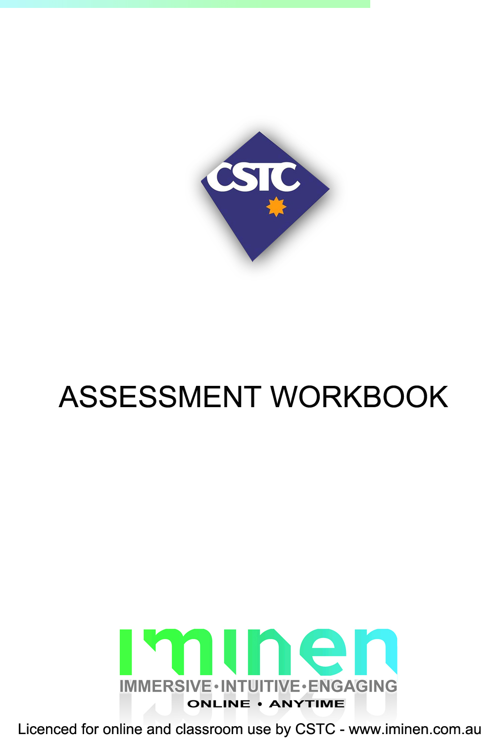
TAEASS301B
Contribute to Assessment

Table of Contents

Table of Contents 2
Candidate Details 3
Assessment – TAEASS301B – Contribute to Assessment 3
Competency Record to be completed by Assessor 4
Observation/Demonstration 5
Activities 6
Activity 1.1.1 6
Activity 1.2.1 8
Activity 1.3.1 9
Activity 1.4.1 10
Activity 2.1.1 11
Activity 2.2.1 12
Activity 2.3.1 13
Activity 2.4.1 14
Activity 3.1.1 - 3.2.1 15
Activity 4.1.1 16
Activity 4.2.1 17
Activity 4.3.1 19
Skills and Knowledge Activity 21
Major Activity 22
Appendices 23
Sample Assessor Checklist 24

ASSESSMENT FOR TAEASS301B

Student name
Date of assessment submission | Click here to enter a date.

Trainer/Assessor’s name
Date of assessment marking | Click here to enter a date.
Outcome for unit | ☐ Competent  ☐ Not Yet Competent

Candidate Details

Assessment – TAEASS301B – Contribute to Assessment

Please complete the following activities and hand in to your trainer for marking. This forms part of your assessment for TAEASS301B – Contribute to Assessment.

Name: Ben-James Katay _____________________________________________________________

Address: 3 illawong street Loganholme 4129 Qld _____________________________________________________________

_____________________________________________________________

Email: BJ_Kat@hotmail.com _____________________________________________________________

Employer: Benjamin Katay _____________________________________________________________

Declaration

I declare that no part of this assessment has been copied from another person’s work with the exception of where I have listed or referenced documents or work and that no part of this assessment has been written for me by another person.

Signed: BJ Katay____________________________________________________________

Date: 21/01/15____________________________________________________________

If activities have been completed as part of a small group or in pairs, details of the learners involved should be provided below;

This activity workbook has been completed by the following persons and we acknowledge that it was a fair team effort where everyone contributed equally to the work completed. We declare that no part of this assessment has been copied from another person’s work with the exception of where we have listed or referenced documents or work and that no part of this assessment has been written for us by another person.

Learner 1: ____________________________________________________________

Signed: ____________________________________________________________

Learner 2: ____________________________________________________________

Signed: ____________________________________________________________

Learner 3: ____________________________________________________________

Signed: ____________________________________________________________

Competency Record to be completed by Assessor

Learner Name: _______________________________________________________
Date of Assessment: _______________________________________________________

The learner has been assessed as competent in the elements and performance criteria and the evidence has been presented as;
Assessor Initials
Authentic
Valid
Reliable
Current
Sufficient

Learner is deemed: COMPETENT NOT YET COMPETENT (Please circle)

If not yet competent, date for re-assessment: ____________________________________

Comments from Trainer / Assessor:
__________________________________________________________________________________________________________________________________________________________________________________________________________________________________________________________________________________________________________________________________________________________________________________________________________________________
Assessor Signature: ________________________________________________________

Observation/Demonstration
Throughout this unit, you will be expected to show your competency of the elements through observations or demonstrations. Your instructor will have a list of demonstrations you must complete or tasks to be observed. The observations and demonstrations will be completed as well as the activities found in this workbook. An explanation of demonstrations and observations:
Demonstration is off-the-job
A demonstration will require:
- Performing a skill or task that is asked of you
- Undertaking a simulation exercise
Observation is on-the-job
The observation will usually require:
- Performing a work based skill or task
- Interaction with colleagues and/or customers
Your instructor will inform you of which one of the above they would like you to do. The demonstration/observation will cover one of the unit’s elements.
The observation/demonstration will take place either in the workplace or the training environment, depending on the task to be undertaken and whether it is an observation or demonstration. Your instructor will ensure you are provided with the correct equipment and/or materials to complete the task. They will also inform you of how long you have to complete the task.
You will need to be able to demonstrate you can:
- Clarify roles and responsibilities in the assessment process
- Confirm organisational arrangements for evidence gathering
- Collect evidence in accordance with the assessment plan
- Record and report findings
You will also need to show your:
- Literacy skills
- Communication skills
- Observation skills
Activities

Activity 1.1.1
Estimated Time | 20 Minutes
Objective | To provide you with an opportunity to identify stakeholders for your assessments.
Activity | - As a group, ask the learners to discuss who the relevant stakeholders will be for their future learning programs.  - How are you going to make sure you can consult with the stakeholders in relation to the assessment process?  - What could be the different purposes for taking training or assessments and where could these purposes be identified?
  Relevant stakeholders will involve:
  Managers
  Learners
  Other Trainers and Assessors
  Company clients
  Communication is vital; the relevant stakeholders need to be notified of the assessment process. If there is a procedure in place then later down the track they will be able to consult with the stakeholders at different points.
  They will either verbally be able to communicate to convey the message clearly or through other methods that relates at the time.
  A good opportunity to tell the learners what is to be expected of them is just before they are about to start, possibly when they are enrolling.
  Purpose of it:
  To give the learner a formal qualification.
  To provide a statement of attainment
  To determine the level of competence of the learner

Activity 1.2.1
Estimated Time | 10 Minutes
Objective | Discuss and confirm benchmarks for assessment with qualified assessor
Activity  Group/Pair Activity | In pairs or groups:  Identify the purpose of benchmarks or the trainer.  Identify the importance for the trainer to consult with a qualified assessor.
  Benchmarks help the trainer to assess the learner on a specific task/unit to see if they are competent or not. They will have criteria for that unit that is specified in the desired field that will outline requirements or standards that the learner/ trainee needs to meet. This will help them gather the right evidence that would be needed from the learner to show that they are competent in that field.
  A qualified assessor has great knowledge, understanding and experience in the related industry. It would be wise to consult with them because they would be more in a position to know about the industries practice, standards and procedures. This will ultimately assist the trainer make an assessment plan, setting a benchmark and contextualising the assessment so that it is achievable and applicable for the learner.

Activity 1.3.1
Estimated Time | 10 Minutes
Objective | Access, read and clarify assessment plan with qualified assessor.
Activity  Group/Pair Activity | In pairs or groups:  Identify crucial points that to be included in the assessment plan.  Why is it relevant to clarify an assessment plan with a qualified assessor?
  . Developing lesson plan
  . Looking at the benchmarks that need to be met in accordance with ASQA.
  . Put an objective in place for the learners
  . Timeline
  . Assessment tasks that will take place
  With the knowledge they have accumulated in the industry, they are able to look at an assessment plan and see if it is practical for the related industry. They’ll also tell if it harmonizes with the regulations, standards or any legal requirements there may be. This will benefit the trainer in making sure that the plan they have in place will achieve the desired result, and that the trainee will learn what is necessary for the job at hand and meet any benchmarks.

Activity 1.4.1
Estimated Time | 10 Minutes
Objective | Discuss and agree with qualified assessor the specific responsibilities in gathering evidence and types of evidence to be gathered
Activity  Group/Pair Activity | In pairs or groups:  What responsibilities does the trainer have during the process of evidence gathering?  Why is it relevant to clarify the assessment plan with a qualified assessor?
  Trainers have to make sure first of all, that the learners understand what is required of them. If the trainers have established the methods that they will use to gather the evidence through training, it will direct them in the specific tasks they will use. They would have to take in considerations, like the size of the class, the needs of different trainees, or cost for materials. This will also help when the evidence will be gathered. Whatever methods they use, it has to meet the requirements of the Australian Skills Quality Authority. By carefully examining the methods use, they will be able to gather evidence through the assessment that follows the rules of evidence being, Valid, Current, Sufficient and Authentic.
  To follow the rules of evidence being, Valid, Current, Sufficient and Authentic. A trainer would need to consult a qualified assessor to help them understand the scope of the industry. This would influence the methods of gathering evidence from the trainees and it would give them greater understanding of what would apply to the trade being trained.

Activity 2.1.1
Estimated Time | 15 Minutes
Objective | Access and confirm relevant assessment system policies and procedures; organisational, legal and ethical requirements; and other relevant advice on assessment
Activity | Where can trainers seek advice on assessment system policies and procedures?
  The organisation the trainers are with would have to a copy of the assessment policies and procedures that are in place. The trainer would have to consult this document in order to follow all legal requirements set out. They must follow it; they have a legal obligation to do so. So because it’s so important to get the right advice, they can talk to their managers or other experienced trainers.

Activity 2.2.1
Estimated Time | 15 Minutes
Objective | Clarify nominated assessment methods and tools for collecting evidence with qualified assessor, to ensure that procedures to be followed and instruments to be used are clear
Activity  Group/Pair Activity | In pairs or groups:  Discuss how consultation with a qualified assessor may improve the trainer’s assessment methods and tools?
  Consultation with a qualified assessor would give good guidance in what assessment methods and tools to use since they are already familiar with the process. They will assist you in making sure that it’s conveyed properly to the trainees. Because assessors have good understanding in procedures that we must follow in that industry which will help us to be current. Depending on the job/industry the course is on, we can establish different methods with the assessor.

Activity 2.3.1
Estimated Time | 20 Minutes
Objective | Discuss and confirm with relevant people assessment context, including candidate’s characteristics and any need for reasonable adjustments.
Activity  Group/Pair Activity | In pairs or groups:  Discuss adjustments that may be necessary to clarify assessment instructions, methods and tools.
  As time goes on there may be changes to health and safety requirements in the industry being taught in. This would affect the methods and tools you use to teach. Assessment pieces would need to be revised as well. This would be good to discuss with any training managers so that they are aware of the changes needed to be made to the assessment process. By talking to an individual candidates in the class you would get to know them, there characteristics, strengths and weaknesses. Trying to do this with all the candidates at the very start will give you an overview on what adjustments might need to be made so that the learner can fully benefit and give the needed evidence to show they are competent. We are not bias and by showing this to all in the class will help to get the best result as you see there learning styles and then tailor to it.

Activity 2.4.1
Estimated Time | 20 Minutes
Objective | Confirm and arrange resource requirements in consultation with relevant people.
Identify resources you might need as a trainer for a course you will be teaching in the future and who you will have to confirm them with at your RTO.
There are a few things that come to mind, resources such as books on the relevant course, notepads for the students to drop notes in, a whiteboard, a projector. Tools that might be used in the industry that they would need to understand how to use. All these things are good to be prepared for beforehand. Most classrooms these days have whiteboards and some have short throw projectors. If training in a classroom at a RTO’s premises this would be good to discuss with the managers on how we could get these resources at our disposal. If we are teaching somewhere else on-site we would need to discuss with the relevant managers or departments to be able to organize all of the resources needed for the class.

Activity 3.1.1 - 3.2.1
Estimated Time | 30 Minutes
Objective | To provide you with an opportunity to develop your own assessment instrument.
Activity  Project | Individually or in small groups, develop an assessment tool in the space provided below to use as part of your training process. The tool should incorporate the following;  How you can prove the Rules of Evidence have been followed.  How you can prove that legal and ethical considerations have been taken into account.  How you plan on communicating the requirements to the learners.
  Obtaining your white card for the construct industry is a must. The unit CPCCOHS1001A – Work safely in the construction industry relates closely to the National Code of Practice for Induction for Construction Work (ASCC 2007)(Ref. Training.gov.au) Looking at this unit you have to set through specific tasks that they understand the basics of Health and Safety. We want them to know the two major documents that are like law for safety. They have to comply with these in the workplace. The two major documents are Work Health and Safety Act 2011 which in terms explains what you should be doing and Work Health and Safety Regulation 2011 on how you can apply it. Over the day we will use illustrations that help them get used to different work scenarios. They will learn to follow duty of care, looking out for the safety of themselves and others. Once they have learnt a bit through questioning and discussion, they will be able to apply it in a simple simulation. Like in an actual workplace the simulation will involve us if possible going to a chosen designated area where we assess any hazards and risks involved that could harm us or other workers. Then once a hazard is established they will need to document this on Job Safety Analysis. This document we would of discussed and shown how to us throughout the day. Once they understood it. This bed in their training as they find hazards they will learn to document it. Once we have the document in hand this will be added to the evidence we gathered to assess if they are competent or not in this unit.

Activity 4.1.1
Estimated Time | 20 Minutes
Objective | To provide you with an opportunity to develop your own Assessor Checklist.
Activity  Project | Individually or in small groups, you will be asked to develop an Assessor Checklist in the space below that could be used by a qualified assessor to give you feedback on your assessment processes.  Note that the checklist should relate directly to the type of training you plan on undertaking.

“It’s at the bottom of this assessment”

Activity 4.2.1
Estimated Time | 20 Minutes
Objective | Organise and provide evidence to the qualified assessor in a format suitable for analysis according to assessment system policies and procedures.
Activity  Research | Individually or in small groups, you will be asked to develop an Assessor Checklist in the space below that could be used by a qualified assessor to give you feedback on your assessment processes.  Note that the checklist should relate directly to the type of training you plan on undertaking.  Individually or in small groups, you will be asked to:  - Develop an Assessor Checklist in the space below that could be used by a qualified assessor to give you feedback on your assessment processes.  Note that the checklist should relate directly to the type of training you plan on undertaking.  - Organise the assessment developed through this unit and provide the evidence gathered to the qualified assessor in a format that will allow the assessor to easily review the organised materials. If you are employed in a training organisation, you will be required to work according to assessment system policies and procedures.  - Provide your assessor the developed checklist and organised assessment tools for feedback.
  “It’s at the bottom of this assessment”
  “It’s at the bottom of this assessment”
  “It’s at the bottom of this assessment”
  “It’s at the bottom of this assessment”

Activity 4.3.1
Estimated Time | 30 Minutes
Objective | Document areas for improvement in collecting evidence, for future assessment activities.
Activity | In pairs or in small groups, discuss the following;  - What are the principles of assessment?  - What continuous improvement processes are in place at your RTO or Training Consultancy?  - If there is no process in place, how can you as a trainer develop one that will be suitable to the industry you work in?  - What can you do to constantly improve the assessment process?  - Use the feedback form you developed to obtain feedback from your classmate.  Document below areas for improvement you identified from the feedback received about your assessment instructions:
  Valid – Must follow what the assessment asks, evidence should be in harmony with it.
  Reliable - Throughout the assessment it has to be consistent, right down to the the end.
  Flexible – Reasonable adjustments can be made to tailor to the students specific learning style
  Fair – There is no partiality in the assessment, it has to be fair, taking in consideration the needs of each learner and making sure they know what’s required of them
  Feedback forms
  Have meetings managers and qualified assessors that will give good feedback and be able to discuss the gathering of evidence and if in any way we can improve/moderate it.
  Moderate it, over constant use you will see where you can improve. There is always something that you can improve in when it comes to assessment processes. It’s variable to change. If you are new to it, it’s wise to talk to a qualified assessor who will give guidance and council that is appropriate to your industry. Another thing that could be helpful is to talk to the trainees who could give you feedback on it since they just when through it.
  N/A because I’m the only one in this course.

Skills and Knowledge Activity
Estimated Time | 30 Minutes
Objective | To use the required skills, knowledge and critical aspects of assessment.
Activity | Carry this activity out individually or in small groups.  Where possible, you should use actual assessments, either using candidates of your own or working alongside a qualified assessor.  N/A Because I’m the only learner on this online course  - Carry out a minimum of three evidence gathering activities, with different candidates for each activity  - Present documentation of the evidence in a clear and concise manner  - Present documented feedback from others involved in the assessment  - What assessment methods were used?  - What are the advantages and disadvantages of the various assessment methods?  - Why will some assessment methods be suitable for some candidates but not others?  - What OHS considerations are necessary within your workplace and when collecting evidence?  - What relevant policy, legislation, codes of practice and national standards, including Commonwealth and State or Territory legislation, may affect training and assessment in the vocational education and training sector?

Major Activity
Estimated Time | 1 Hour
Objective | To provide you with an opportunity to demonstrate your knowledge of the entire unit.
Activity | This is a major activity – your instructor will let you know whether you will complete it during class or in your own time.  You must individually, answer the following questions in full to show your competency of each element;  - What could the possible purpose of assessment be?  To provide a learner a formal qualification by assessing their competency in the unit.  - What are the possible benchmarks for assessment?  Benchmarks that relate back to the industry expectations.  Procedures set out by the organisation  Policies and processes that should be followed  - What are the main requirements of an assessment plan?  To set out the process and evidence needed to be gathered from the learner.  - What types of evidence can be gathered and in what ways?  Third party reports, Scenario’s, written exam, Observation checklist. Gather it either on-site, off-site through those simulations and sessions.  - Where can you access relevant assessment system policies and procedures; organisational, legal and ethical requirements; and other relevant advice on assessment?  You can access your organisational policies and procedures, ASQA as well as NVR.  - What assessment methods and tools for collecting evidence are there?  Direct Observation – Observation checklist  Questioning – Written exam  Third party report – A report from assessor/ supervisor  - Why is it important to consider assessment context, including candidate’s characteristics and any need for reasonable adjustments?  Because there may be a need to contextualise the material to the learner’s needs/ environment that he/she works in. Also to discuss the context with relevant stakeholders like their supervisors.  - What possible resources could be required for assessment?  Projectors, workbooks, internet, work simulated activities ready at your disposal.  - What different people could be involved in the assessment process?  Qualified assessors, managers, supervisors, learners. Validating it and moderating it.  - What is the most suitable way to organise and provide evidence to ensure it can be clearly analysed? To follow assessment policies and procedures. You can find those policies and procedures in each organisation, they should have one that you read through thoroughly.  - Why is it important to seek feedback from a qualified assessor on evidence-gathering activities?  To see if it’s effective and relevant to the work environment the learners will be coming from.  - Why is it important to document areas for improvement in collecting evidence?  So that you can continue moderating the assessment process, keeping up to date with NVR standards and improving the way you train and the way evidence will be gathered.

Appendices
Congratulations! You have now finished TAEASS301B – Contribute to Assessment.
Appendices of the templates included in this unit have been included for your own reference on the following pages.

Sample Assessor Checklist
Name of Trainer: BJ Katay |  | Training Program: CPCCOHS1001A - Work safely in the construction industry
Date of Program: 15/01/15 |  | Location: CSTC Salisbury
Please read the statements below and tick the one that you feel best describes the situation outlined.
 | Strongly Agree |  | Agree | Neutral | Disagree
The assessment instrument is relevant to the target group |  |  | X
The assessment process meets the Rules of Evidence | X
The assessment process meets the Principles of Assessment | X
The instrument has the ability to be easily contextualised and customised |  |  | X
The instrument can be adapted at short notice |  |  | X
The instrument does not require too many extra resources |  |  | X
Comments and suggestions for improvement:
Need to look at that the instruments so that they are able to be contextualised. Look into some of the work-related scenarios and written tests to see if it does harmonize with the benchmarks set in the criteria. Review the resources that are be used, and then validate the resources with a qualified assessor.

