
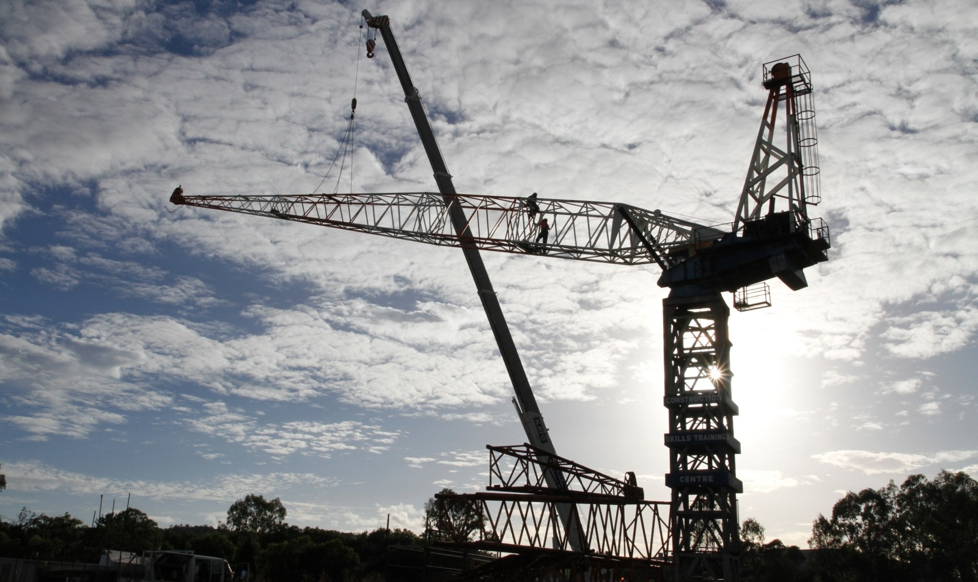

BSBWHS406A
Assist with responding to incidents
For information on the courses the CSTC offer, please contact:
Brisbane, PO Box 51, Moorooka QLD 4105
Phone: 07 3373 8888, Fax: 07 3373 8899 or Email: brisbane@cstc.org.au

Construction Skills Training Centre
We are here to improve your future
Quality instruction, service, fairness
and integrity - always

Our Purpose
CSTC's purpose is to ensure the building and construction industry's long term investment in the workforce through maintaining a commitment to the training and ongoing development of industry workers. CSTC encourages individuals to achieve the highest level of skill and knowledge possible in their chosen vocational area, therefore resulting in improved self esteem, personal growth, employment opportunities, safety into the workplace and quality of life.

Vision
CSTC strives to be recognised as a learning centre of excellence for vocational education and training. We are an organisation that continually strives to achieve the highest possible standards of education, training and consultancy services specific to the building, construction and other related industries.
CSTC provides training in the following areas:
- Occupational Health and Safety | - Road Construction
- High Risk Work Licenses – Scaffolding, Dogging, Rigging, Forklift, Crane operation | - Bridge Construction
- Plant Operations | - Tunnel Construction
- Confined Spaces | - Pipe Laying
- First Aid | - Trenchless Technology
- Asbestos Removal | - Bitumen Surfacing
- Concreting | - And much more!
- Steelfixing



Copyright © 2015 CSTC Pty Ltd

All rights reserved. No part of the contents of this publication may be reproduced or used in any form or by any means – graphic, electronic, or mechanical including photocopying, digitizing, recording, or information storage-and-retrieval systems – without the written permission of CSTC Pty Ltd.

This learning product could only be made possible because of the dedicated CSTC team.
ASSESSMENT FOR BSBWHS406A

Student name | Damian Wilson
Date of assessment submission | 8/05/2015

Trainer/Assessor’s name
Date of assessment marking | Click here to enter a date.
Outcome for unit | ☐ Competent  ☐ Not Yet Competent

TASK INSTRUCTIONS

- The assessment for this unit of competency consists of the following:
  - A series of activities: Some of these activities will require you to provide a response within this document, others will require you to gather evidence to demonstrate your knowledge and skills (overview below)
  - Quiz: You will be required to complete a series of questions to demonstrate your knowledge and skills.
  - Third Party Report: You will be required to have a third party attest to your knowledge and skills and sign a report to this effect.
- At times, you will be provided with a specific business context to which you must respond, otherwise it is anticipated that you will use a workplace of your choosing (your own, or hypothetical) to provide the context to the task.
- At all times, the responses in your assessment must reference Australian (Queensland or Federal) documentation, including legislation, regulations, codes of practice, standards and guidance publications.

ACTIVITY OVERVIEW | REQUIRED FOR SUBMISSION
- Duty holders and duties | - Workbook response (below)
- Policies, procedures and processes | - Workbook response (below)
- Providing first aid | - Workbook response (below)
- Collecting information and data for investigations | - Workbook response (below)
- Assist incident investigations | - Workbook response (below)
- Implementing measures and actions | - Workbook response (below)

ACTIVITIES

For the following activities, you will assume the role of a workgroup supervisor in a workplace of your choosing (see example organisational chart below).

Name a workplace and workgroup that you are (or hypothetically are) the supervisor for:

Name of workplace | QUT Site Kelvin Grove
Workgroup | Fredon Electricians

Identify two (2) parties (apart from yourself) who hold a duty within your workplace regarding notification, reporting and documentation of incidents.
- Identify relevant section of WHS legislation which imposes the obligation.
- Explain what they are obliged to do under the legislation.
- Explain the method by which you, as a workgroup supervisor, would communicate the legislated requirements to the individuals and parties.
- Explain how you have accommodated the audience’s range of abilities and backgrounds.
- Explain how you would assist with meeting the legislative requirements in your role as a workgroup supervisor.

 | Party 1 | Party 2
Name of individual or party | PCBU | Workers
Name and relevant section of WHS legislation | Section 19 of the Workplace Health and Safety Act 2011 QLD | Section 28 of the Workplace Health and Safety Act 2011 QLD
Obligations | In holding the duty of care the PCBU should ensure ,so far as reasonably practicable, the health and safety of workers affected by the business or undertaking. This would extend to responding to incidents (eg. providing first aid and responding to emergencies), investigations and implementation of risk control measures. | Comply so far as reasonably able , with any reasonable instruction given by the PCBU to comply with WHS laws, and Cooperate with any reasonable policy or procedure of the PCBU relating to health or safety at the workplace that has been notified to workers. This would extend to responding to incidents (eg. providing first aid and responding to emergencies), investigations and implementation of risk control measures.
Method for communicating requirements | Arrange meetings to discuss company requirements. Email suggestions, potential issues and areas that the company needs to improve in order to comply with their responsibilities. | Toolbox Talks  Company and site inductions  Written reminders  Posters on notice boards
Your role in meeting requirements | Implement and monitor the compliance with policies, procedures, processes and systems. Provide feedback to the PCBU. | Ensure workers are complying with their duty under the Act.

Outcome for Activity 1 | ☐ Satisfactory  ☐ Not satisfactory
Trainer/Assessor comments

Identify one (1) of each of the following within your chosen organisation which deals with notification, reporting and documentation of incidents:
- WHS policy
- WHS procedure
- WHS process
- WHS system

For each:
- Summarise its requirements regarding notification, reporting and documentation of incidents.
- Explain how you assist with notifying, reporting and documenting incidents in line with these requirements.

 | Name of document | Summary of requirements | Your role with notifying, reporting and documenting incidents
WHS policy | Incident and Accident Investigation and Reporting Flowchart | Shows the order that investigations are to be conducted and how they are to be reported, in what timeframe and to who. | Depending on the severity of the incident different levels of notification and documents are to be completed and forwarded to the appropriate parties. This can range from simple in-house report up to criminal investigations.
WHS procedure | Incident/Accident reporting and Investigating Procedure | All incidents and near misses no matter how minor are to be documented and reported to management. More serious incidents may need further reporting and require input from authorities. | Notify immediate and HSEQ manager s ASAP.  Complete company incident/accident paperwork and forward to HSEQ manager
WHS process | Incident/Accident Reporting Form | Template of what details are required to be documented. Where, Who, When, Why  Witness statements  Nature of injuries/incident  Initial Treatment | Complete form and forward to management and HSEQ Manager
WHS system | Company Management System Manual | Where an incident has occurred , management is to be notified at the first possible opportunity.  Notification is to be done as per the investigation procedure.  Incidents are to be documented on the Incident report form.  Investigations are to be conducted on the Investigation procedure and non conformances dealt with appropriately.  Immediate action is to be taken to make the workplace safe.  Corrective action is to be taken in accordance with the hierachy of control. | Complete all required paperwork and notify relevant parties. Identify corrective actions and implement. Notify all stakeholders of changes.

Outcome for Activity 2 | ☐ Satisfactory  ☐ Not satisfactory
Trainer/Assessor comments

Identify one (1) of each of the following within your chosen organisation which deals with providing first aid:
- WHS procedure
- WHS process

For each:
- Summarise its requirements regarding providing first aid.
- Explain how you assist with meeting the requirements.

 | Name of document | Summary of requirements | Your role in meeting requirements
WHS procedure | Management System Manual | Must be done in accordance with code of practice.  First Aiders Trained and Refreshed.  Names and contacts posted around site.  Log of treatment kept.  Supervisor to be notified.  First Aid supplies to be inspected regularly and restocked accordingly.  First aid is reviewed in response to workplace changes. | Identify first aid trained personnel to workers.  Post notices of first aiders and procedures.  Keep first aid log.  Maintain supplies.  Keep up to date with changes to legislation and First Aid needs on site as staff numbers and needs change.
WHS process | Incident/Accident reporting and Investigation Procedure | Ensure own safdety first before helping others.  Administer First Aid if you are qualified.  Ensure correct medical Responses have been initiated. | Ensure First Aid Supplies and trained Personnel are identified to all workersfor fast access.  Administer First Aid to the level of my training.  Ensure all workers are aware of the correct people and procedures to contact and follow in the event of a first aid emergency.

Outcome for Activity 3 | Satisfactory  ☐ Not satisfactory
Trainer/Assessor comments

Identify two (2) types of information and data that would be collected regarding actions and events leading up to (or occurring during or after) an incident. For each:
- Identify the person from who you would collect the information and data.
- Explain the data-collection technique you would use to collect the information and data.
- Explain why the collection of this information is necessary.
- Consider incident causation and injury processes.
- Explain what type of additional information and data you may access to supplement it and where you would obtain it.

 | Data Type 1 | Data Type 2
Type of information or data | Inspections and Photo records of undisturbed scene. | Witness Statement
Collected from | Photo's taken of scene undisturbed for future reference. Inspect undisturbed scene for evidence of what happened and why. | The people who either witnessed the event or the period leading up to or following the incident.
How it is collected | Take Photo's  Collect items relating to the incident. Preservation of the scene.  Create a reinactment to gain an insight. | Interviewing witness's and filling out witness statements.
Necessity | To assess why the incident happened and how to prevent it from happening again. | To establish if a culture of unsafe work exists.  To collect information to be used in discipline of safety breaches.  To give to investigators.
Additional information | Statistics about similar incidents.  Workplace records.  Risk assessments.  Risk Control measures.  Maintenance records.  Training records. | Speak to management and other workers about the reliability of the witness.  Interview further witness's and compare the information gathered. Compare witness statements against other investigation findings.

Outcome for Activity 4 | ☐ Satisfactory  ☐ Not satisfactory
Trainer/Assessor comments

In your role as workgroup supervisor, explain your role in incident investigations:
- Explain how you assist investigators and provide relevant information during investigations.
- Identify and explain techniques that you would use in workplace investigations.
Justify why they are appropriate techniques.
- Explain why you would review reports on incidents, injuries and illnesses.
- Identify responsible persons and relevant authorities you may contact and why you would contact them.

 | Explanation
a) | Barricade scene and preserve evidence.  Take Photo's  Collect data and statements from witness's and those involved in the incident.  Provide insight as to attitude and previous safety incidents on the site.  Fill out company investigation paperwork and carry out own investigation.
b) | Take photo's to preserve evidence.  Create a reinactment to better understand how and why it happened.  Conduct Risk based investigation to allow all stake holders to put ideas forward and have input into how and why the incident happened and how to prevent it happening again.  Interviews to gain satements from witness and those involved.
c) | To ensure accuracy of the information provided.  To ensure fairness to all parties involved.  To develop ways of stopping it from happening again.  To ensure the health of workers does not suffer as a result of the incident/injury and that they don’t pose an extra risk as a result.
d) | Principal contractors safety team.(Contractually Obliged) and to prevent a repeat of the incident.  Workplace Health and Safety QLD- to investigate serious incidents and to discipline seriuos safety breaches. To prevent it from happening again.  Police- To report criminal negligence.

Outcome for Activity 5 | ☐ Satisfactory  ☐ Not satisfactory
Trainer/Assessor comments

Identify two (2) hazards that may occur in your workplace. For each hazard:
- Identify and justify possible recommended measures and actions that may arise from an investigation in order to resolve the hazard.
- Identify regulations, codes of practice, standards and guidance material you used as the basis for the recommendation.
- Explain where these controls sit within the hierarchy of control.
- Explain how these controls affect workplace processes (work flow and planning).
- Explain how you, as a workgroup supervisor, would communicate recommendations arising from investigations to relevant others.
- Explain how you have accommodated the audience’s range of abilities and backgrounds.
- Identify possible inadequacies of the risk controls identified.
- Explain how organisational culture may inhibit the implementation of the recommended measures and actions.
- List methods that you would use to assist with implementing the measures and actions.

 | Hazard 1 | Hazard 2
Describe hazard | Fall from Height | Electric Shock
Measures and actions | Install handrail around potential fall hazards.(engineering)  Use Correct Mechanical aids ie EWP instead of ladder.(Substitution) | Permit to isolate to be filled out with supervisor when the works happen.  Correct Lock Out Tag Procedure to be followed when isolating before starting work.
Communication | Email Management and hold meetings with workers. Post on notice boards and display pictures for those who may respond better than in writing or verbal. | Show pictures and satistics of workers that have had electric shock.  Notify workers that non conformance could lead to instant dismissal.
Possible inadequacies | EWP's not available  Handrail too expensive  Ladders easier and Quicker. | Workers performing live works without notifying supervisors so isolation can be arranged.
Effect of culture | Worker thinking that it wont happen to them , they have done it many times before. | They have worked live many times before and don’t believe they need to isolate to perform the works.
Assisting with implementation | Order the correct gear  Get handrails installed  Mark out on floors ares that are out of bounds for ladders. | Toolbox Meetings  Write SWMS  Train workers on correct Lockout Tagout Procedures.

Outcome for Activity 6 | ☐ Satisfactory  ☐ Not satisfactory
Trainer/Assessor comments

QUIZ

QUESTIONS | CORRECT
- The Work Health and Safety Regulations 2011 (Qld) are more industry-specific and outline requirements for WHS for a range of types of work. Which of the following types of work are referenced under the Regulations? Select all that apply.  x Diving  x Demolition  x Asbestos  ☐ Decorating | ☐
- Legislation requires that in some circumstances, it is mandatory to notify the regulator about an incident, as well as preserve the incident site.  x True  ☐ False | ☐
- Identify the elements of the hierarchy of control, using the labels 1 – 6 below. | ☐
  Label (1 – 6) | Element
  3 | Isolate the hazard
  6 | Provide and use Personal Protective Equipment (PPE)
  1 | Eliminate the hazard
  4 | Control the hazard by engineering means
  5 | Control the hazard by administrative means
  2 | Substitute the hazard
- What might you consider when choosing between different risk controls?  Select all that apply.  x Cost  x Fit for organisational culture  x Effect on work flow of organisation  x View of workers  x Guidance from codes of practice, standards and WHS regulator | ☐

Outcome for Quiz | ☐ Satisfactory  ☐ Not satisfactory
Trainer/Assessor comments

THIRD PARTY REPORT

You are required to have a suitable third party to verify your ability to complete the following:

SKILLS |  | VERIFIED
- Assist investigators and provide relevant information during investigations. |  | x
- Use appropriate techniques when participating in workplace investigations. |  | x
- Review reports on incidents, injuries and illnesses. |  | x
- Contact responsible persons and relevant authorities when required. |  | x
- Communicate recommendations arising from investigations to relevant others. |  | x
- Assist with measures and actions appropriate to own job role and work area. |  | x
Name of third party | Andrew Campbell
Role of third party  (Confirm their suitability to sign report) | Fredon State HSEQ Manager
Date of report completion | 8/05/2015
Phone number of third party | 0408 096 170
Email address of third party | acampbell@fredon.com.au

Outcome for Third Party Report | ☐ Satisfactory  ☐ Not satisfactory
Trainer/Assessor comments

