
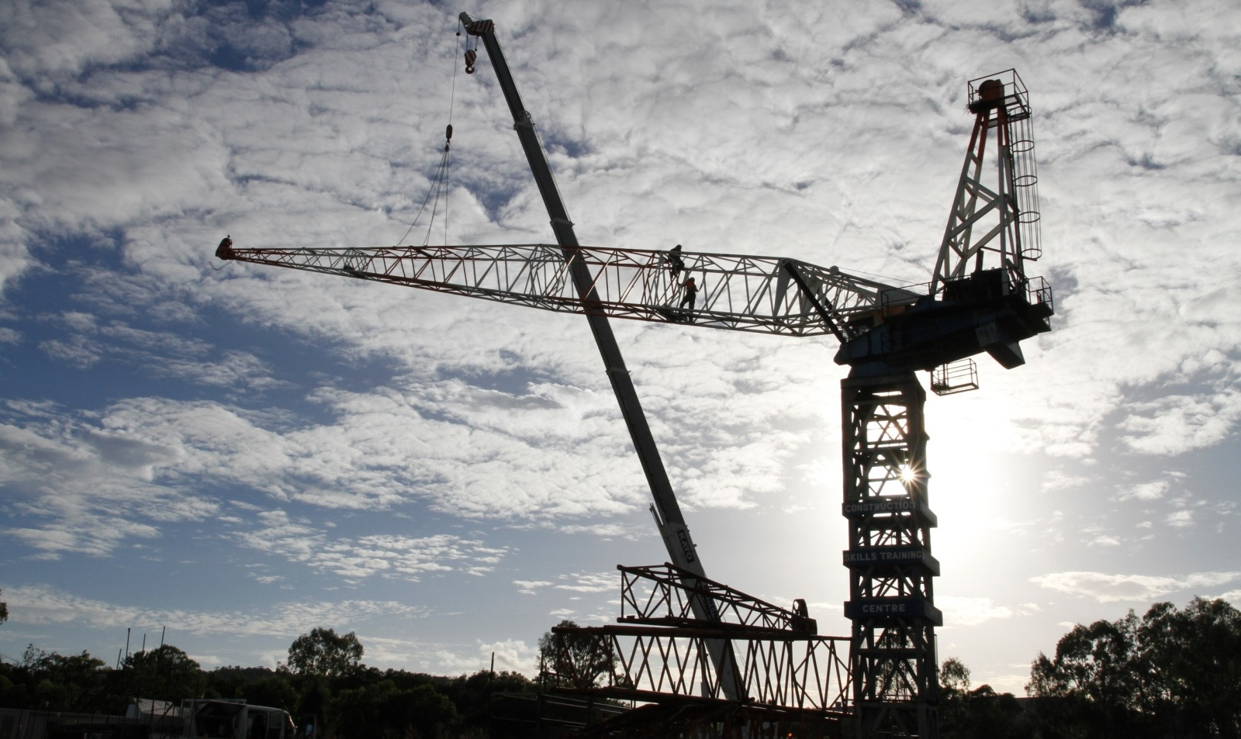

BSBWHS404A
Contribute to WHS hazard identification, risk assessment and risk control
For information on the courses the CSTC offer, please contact:
Brisbane, PO Box 51, Moorooka QLD 4105
Phone: 07 3373 8888, Fax: 07 3373 8899 or Email: brisbane@cstc.org.au

Construction Skills Training Centre
We are here to improve your future
Quality instruction, service, fairness
and integrity - always

Our Purpose
CSTC's purpose is to ensure the building and construction industry's long term investment in the workforce through maintaining a commitment to the training and ongoing development of industry workers. CSTC encourages individuals to achieve the highest level of skill and knowledge possible in their chosen vocational area, therefore resulting in improved self esteem, personal growth, employment opportunities, safety into the workplace and quality of life.

Vision
CSTC strives to be recognised as a learning centre of excellence for vocational education and training. We are an organisation that continually strives to achieve the highest possible standards of education, training and consultancy services specific to the building, construction and other related industries.
CSTC provides training in the following areas:
- Occupational Health and Safety | - Road Construction
- High Risk Work Licenses – Scaffolding, Dogging, Rigging, Forklift, Crane operation | - Bridge Construction
- Plant Operations | - Tunnel Construction
- Confined Spaces | - Pipe Laying
- First Aid | - Trenchless Technology
- Asbestos Removal | - Bitumen Surfacing
- Concreting | - And much more!
- Steelfixing



Copyright © 2015 CSTC Pty Ltd

All rights reserved. No part of the contents of this publication may be reproduced or used in any form or by any means – graphic, electronic, or mechanical including photocopying, digitizing, recording, or information storage-and-retrieval systems – without the written permission of CSTC Pty Ltd.

This learning product could only be made possible because of the dedicated CSTC team.
ASSESSMENT FOR BSBWHS404A

Student name | Damian Wilson
Date of assessment submission | 22/04/2015

Trainer/Assessor’s name
Date of assessment marking | Click here to enter a date.
Outcome for unit | ☐ Competent  ☐ Not Yet Competent

TASK INSTRUCTIONS

- The assessment for this unit of competency consists of the following:
  - A series of activities: Some of these activities will require you to provide a response within this document, others will require you to gather evidence to demonstrate your knowledge and skills (overview below)
  - Quiz: You will be required to complete a series of questions to demonstrate your knowledge and skills.
- At times, you will be provided with a specific business context to which you must respond, otherwise it is anticipated that you will use a workplace of your choosing (your own, or hypothetical) to provide the context to the task.
- At all times, the responses in your assessment must reference Australian (Queensland or Federal) documentation, including legislation, regulations, codes of practice, standards and guidance publications.

ACTIVITY OVERVIEW | REQUIRED FOR SUBMISSION
- Identifying hazards | - Workbook response (below)
- Techniques, tools and processes for hazard identification | - Workbook response (below)
- Assessing and controlling risks | - Workbook response (below)
- Techniques, tools and processes for risk assessment | - Workbook response (below)
- Development, implementation and evaluation of risk control | - Workbook response (below)
- Policies, procedures, processes and systems | - Workbook response (below)
- Legislation, codes of practice and guidelines | - Workbook response (below)
- Duty holders and their duties | - Workbook response (below)
- Relevance for WHSMS | - Workbook response (below)

ACTIVITIES

For the following activities, name a workplace that you wish to examine.

Name of workplace | Fredon Electrical QUT Site

Identify two (2) hazards that may occur in your workplace. For each hazard identified, find information to explain:
- The nature and scope of the hazard
- The nature and scope of the harms caused by the hazard and how they happen

Also explain:
- How you advise others of this information in a way that address peoples’ range of abilities and backgrounds. Be sure to also consider the timeframes in which you should advise others.
- The techniques, tools and processes used to identify each hazard. Try to select tools appropriate for the workplace and select different tools for each hazard.

Hazard 1 | Nature and scope of hazard | Harms caused and how they happen | How you advise others | Techniques, tools and processes
Electricity | Physical Hazard  Electrical Energy (Volts), Electromagnetic Vibrations, Electrostatic Charge | Electric Shock, Burns, Death | Advise Immediately for alerts.  Advise all workers when inducted and Refresh regularly eg in toolbox meetings. | JSA  Input of managers,OHS reps,OHS commitee and others through consultation.
Electricity | Source of information  (e.g. website address) | Source of information  (e.g. website address)
Electricity | Hazard as a Concept | First Aid Training
Hazard 2 | Nature and scope of hazard | Harms caused and how they happen | How you advise others | Techniques, tools and processes
Fall From Height | Physical Hazard  Gravitational potential energy due to height above a datum. | Broken Bones, Crushing, death due to sudden Impact. | Advise Immediately for alerts.  Advise all workers when inducted and Refresh regularly eg in toolbox meetings also posters in crib huts, and through guidance onsite to use less hazardous methods. | Review of OHS records, Investigations from breaches of OHS protocol.
Fall From Height | Source of information  (e.g. website address) | Source of information  (e.g. website address)
Fall From Height | Hazard as a concept | Company SWMS

Outcome for Activity 1 | ☐ Satisfactory  ☐ Not satisfactory
Trainer/Assessor comments

For the two (2) hazards identified in Activity 1:
- Explain how you contribute to applying the techniques, tools and processes identified
- Explain how you contribute to documenting the use of (and results of) hazard identification.
- Be sure to identify the audience for the information and how you meet their ability/background requirements.
- Also note the timeframes in which you communicate this information.

Hazard | Applying techniques, tools and processes | Contribute to documenting hazard identification
1 | Conduct Site Inductions  Present alerts on noticeboards | Present alerts from Principal Contractor to both workers and company management. Send emails, present in toolbox meetings and post on notice boards to ensure all understand the alerts.
2 | Conduct Site toolbox meetings  Review SWMS with worker consultation | Complete company paperwork from weekly toolbox meetings and submit to Principal Contractor and to Fredon management. Modify SWMS and ensure workers are notified at next available prestart or toolbox meeting. Forward ammended documents to management.

Outcome for Activity 2 | ☐ Satisfactory  ☐ Not satisfactory
Trainer/Assessor comments

Identify two (2) risks that may exist in your workplace. For each risk identified, find information to explain:
- The nature and scope of the risk
- Risk controls that may be implemented to address the risk. Explain the time frames in which these risk control options should be implemented.

Also explain:
- Risk assessment techniques, tools and processes used for workplace hazards. Try to select tools appropriate for the workplace and select different tools for each risk.

Risk 1 | Nature and scope of risk | Risk controls | Techniques, tools and processes
Working in an area with moving plant | Risk of being crushed by moving plant | Permits In Place for plant.  Exclusion zones set up and regularly maintained/adjusted.  Communication with operators.  Spotters used. | Permits for excavation etc  Take 5's  Prestart to held in work area with all affected parties.
Working in an area with moving plant | Source of information  (e.g. website address) | Source of information  (e.g. website address)
Working in an area with moving plant | Code of Practice- Managing Risks in Construction work | Site Excavation Permits
Risk 2 | Nature and scope of risk | Risk controls | Techniques, tools and processes
Manual Handling | Sprains and Strains due to repetative motion or overloading of the Body | Mechanical Aids  Team Lifts  Correct lifting procedures | Manual Handling Training  Take 5's  Pre planning the availability of adequate staffing and mechanical aids.
Manual Handling | Source of information  (e.g. website address) | Source of information  (e.g. website address)
Manual Handling | www.worksafe.vic.gov.au | www.worksafe.vic.gov.au

Outcome for Activity 3 | ☐ Satisfactory  ☐ Not satisfactory
Trainer/Assessor comments

For the two (2) risks identified in Activity 3:
- Explain how you contribute to applying the techniques, tools and processes identified to assess the hazard
- Explain how you contribute to documenting the results of risk assessment
- Explain how the controls identified for each risk would consider the results of risk assessments

Risk | Applying techniques, tools and processes | Contribute to documenting the results of risk assessment | Consideration of results in risk control options
1 | Produce Permits.  Chair and document group prestarts on site.  discuss the risks in company prestarts and toolbox meetings. | Make company risk assessment widely available to all, assist with the completion of paperwork, file paperwork. | Permits ensure work is approved and all others in the area are notified of the works prior to starting.  Group Prestarts discuss potential issues with all involved and establish plans for coordination etc  These keep the current risks fresh in the minds of workers every day.
2 | Arrange mechanical Aids.  Ensure workers are trained in Manual Handling techniques by arranging suitable training. | Send reports/ requests to management advising what materials and training are required for workers to do manual handling safely. | Training gives workers the correct tools to do their work safely.  Take 5's break down the steps of the task to consider, eliminate or substitute all possible risks.  Pre ordering of extra staff and mechanical aids reduces risks.

Outcome for Activity 4 | ☐ Satisfactory  ☐ Not satisfactory
Trainer/Assessor comments

For the two (2) risks (and associated risk controls) identified in Activity 3:
- Explain how you would contribute to developing and implementing a risk control plan
- Describe the process you would undertake to evaluate the risk controls that had been implemented

Risk | Develop and implement risk control plan | Evaluation of risk controls
1 | Produce a risk control plan using company paperwork template, and compare an industry standard plan for compliance. | Assess Reports  Compare OHS Statistics with Site statistics  Assess the results of investigations.
2 | Consult management, OHS experts and rescources when compiling a plan. Facilitate consultation with workers and OHS reps etc to establish the plans compliance with the workers needs. | Assess worker Safety and wellbeing  Assess whether controls exceed industry standards.  Coduct Audits.

Outcome for Activity 5 | ☐ Satisfactory  ☐ Not satisfactory
Trainer/Assessor comments

Explain the requirements of your organisation regarding hazard identification, risk assessment and risk control activities by identifying the requirements found in:
- WHS policy
- WHS procedure
- WHS process
- WHS system

Explain how you comply with the requirements of these documents.

 | WHS policy | WHS procedure | WHS process | WHS system
Hazard identification | To identify potential Hazards for workers | To consult with workers on potential hazards before starting work. | Explain Hazards that will be encountered in that days work. | Ensure workers are given the appropriate tools and enough time and encouragement to use them.
How you comply | By learning from History and other similar businesses | SWMS | Daily Prestarts | Take 5's
Risk assessment | To assess the potential that a Hazard could occur. | Use risk matrix to rank potential risks and their severity. | Provide adequate risk matrix to be filled out on the workfront. | Provide training to workers on how to identify riks and rank their severity.
How you comply | Carry out Risk assessments | Carry out Risk Assessments | Take 5 | WHS training and support
Risk control | To eliminate,substitute, redesign or administer PPE. | To select which of the controls in the policy to implement for the best results. | To implement the change and monitor if it is still the correct control to be using. | Ensure that workers feel that it is ok to come forward and say that a task is unsafe if the controls cannot sufficiently reduce the risk.
How you comply | Ensure all options to change to where possible. | Training | Supporting the worker and guiding them if they need to make changes to the controls | By having a good safety culture and the workers having confidence in managements commitment to safety.

Outcome for Activity 6 | ☐ Satisfactory  ☐ Not satisfactory
Trainer/Assessor comments

Explain the requirements of your organisation regarding hazard identification, risk assessment and risk control activities by identifying the requirements found in:
- WHS Acts
- WHS Regulations
- Codes of practice
- Guidelines

Explain how you comply with the requirements of these documents.

 | WHS Acts | WHS Regulations | Codes of practice | Guidelines
Hazard identification | Identify reasonably foreseeable Hazards that could give rise to risk. | To ensure that workers are not unduly exposed to Hazards. | To meet or exceed industry standards | Review and revise Hazards identified if necessary.
How you comply | managements identification of hazards | Hazards identified in company Inductions | Comparing historical Data | Regular consultation with workers
Risk assessment | Assess the potential that a Hazard could occur | Provide workers with risk assessment facilities. | Provide workers with formal or informal training as to how to implement risk assessments . | Consult with workers regarding relevance of risks identified compared with the work to be assessed.
How you comply | Assessing risks and substituting before workers are exposed. | Take 5's | Guidance provided in company induction. | Tool box meetings
Risk control | Eliminate risk so far as reasonably practicable. | Provide workers with alternate methods , plant, equipment etc to substitute for riskier options. | Provide workers with up to date information and strategies to control risk | Consult with workers as to how well risk control measures are working and ways risk could be better controlled.
How you comply | Elimination of all risk possible. | Alternatives available where suitable | ongoing training and information provided through workplace meetings, noticeboards and alerts | Regular worker consultation.

Outcome for Activity 7 | ☐ Satisfactory  ☐ Not satisfactory
Trainer/Assessor comments

Identify two (2) parties who hold a duty within your workplace regarding hazards and risk control.
- Explain what they are obliged to do under the legislation
- Name the Act and relevant section of WHS legislation which imposes this obligation

 | Name of individual or party | Obligations | Relevant section of WHS legislation
1 | PCBU Designer | Designer of a plant substance or structure that is to be or could reasonably be expected to be used at a workplace must ensure that all activity relating to it, to be as far as reasonably practicablewithout risks to health or safety when used for its intended purpose. | WHS Act 2011 section 22
2 | WHS Officer | An officer must exercise due diligence to ensure that the organisation complies with its health and safety duties. They must ensure that the organisation has appropriate work systems in place and they must actively monitor and evaluate health and safety management within the organisation. | Safe Work Australia  Guidance material, Information Sheets and fact sheets

Outcome for Activity 8 | ☐ Satisfactory  ☐ Not satisfactory
Trainer/Assessor comments

Explain how the following fit into, and are addressed in a WHS management system (WHSMS):
  - Hazard identification
  - Risk assessment
  - Risk control

Aspect | Place in WHSMS
Hazard identification | Management system should identify all foreseeable hazards but should also provide facility for consultation from workers and tools for workers to further identify Hazards in the workplace.
Risk assessment | Risk assessment Matrix and training should be provided for in WHS management system. Risk assessment should be listed as a step in all WHS procedures.
Risk control | Management system should identify all foreseeable risk controls but also provide tools and training for workers to further control risk at the workfront.

Outcome for Activity 9 | ☐ Satisfactory  ☐ Not satisfactory
Trainer/Assessor comments

QUIZ

QUESTIONS | CORRECT
- Which of the following can be causes of workplace hazards?  Select the most appropriate responses from the list below.  x Noise  x Physical layout of the workplace  x Temperature  x Stress | ☐
- Which of the following individuals and parties may require information about workplace hazards? Select the most appropriate responses from the list below.  x Health and Safety Committees (HSCs)  x Suppliers  ☐ Family members of workers  x Contractors | ☐
- Which of the following are appropriate techniques, tools and processes for identifying hazards? Select all that apply.  x Workplace inspections  ☐ Compensation claim information  x Safe Work Method Statements  x Information issued by WHS regulators | ☐
- Risk control options can come from both internal sources (e.g. policies and procedures) and external sources (e.g. codes of practice and standards).  x Yes  ☐ No | ☐
- Which of the following should be considered when developing a risk control plan? Select all that apply.  x How and when controls will be implemented  x Evaluation processes for implemented controls  x Consultation with individuals and parties  x Responsibilities for implementation | ☐

Outcome for Quiz | ☐ Satisfactory  ☐ Not satisfactory
Trainer/Assessor comments

