BSBPMG407A
Apply risk management techniques
ASSESSMENT SUMMARY

The assessment activities for BSBPMG407A Apply risk management techniques cover all aspects of the unit of competency required. To demonstrate competence in this unit, a participant must undertake all tasks and complete them satisfactorily and consistently. For Apprentices and Trainees, this includes employer completion of the Employer Record Book (ERB).

Participants must read all the information given before starting any assessment task. The assessment tasks are intended to be equitable, fair and flexible. If a participant has any questions or requires alternative arrangements to be made such requests should be directed to their Trainer/Assessor, who should note such arrangements in the ‘Assessor Comments’ on the affected assessment. If a participant feels they are not yet ready to be assessed, they should discuss their options with their Trainer/Assessor.

To satisfactorily complete the assessment, the participant is required to answer all questions correctly and demonstrate their skills to industry standards. If a participant does not answer some questions or perform some tasks, they will be deemed ‘Not Satisfactory’ for the task and ‘Not Yet Competent’ for the unit of competency. The Trainer/Assessor is able to provide the participant with additional information on interpreting the assessment outcomes and provide guidance on the participant’s options. Should a participant still be deemed ‘Not Satisfactory’ they will have the opportunity to undertake a supplementary assessment or appeal the result.

By signing the cover page for each assessment item, the participant acknowledges they understand the assessment instructions and requirements and consent to being assessed. The participant also verifies and assures the RTO that the work submitted is their own work.

Participant Name | Nathan Weiss

Task | Assessment Results
Theory Exam | Satisfactory | Not Yet Satisfactory
Practical Assessment | Satisfactory | Not Yet Satisfactory
Outcome for Unit of Competency | Competent | Not Yet Competent

Assessor Name
Assessor Signature | 
Unit Competence Determination Date | Click here to enter a date.

BSBPMG407A
Apply risk management techniques

THEORY EXAM INSTRUCTIONS

- This exam will occur under standard assessment conditions.
  - An oral examination may be allowed under certain circumstances, whereby the Participant’s answers will be documented by a party other than the Participant. This must be acknowledged in writing (e.g. FT001 and Assessor Comments)
- Participants must provide enough detail in their responses to demonstrate their knowledge and skills.
- Please fill in the details below, providing your name, signature and date of assessment.
  - Your signature acknowledges that this is your own work.
- Assessors are to complete marking in pen of a different colour to the Participant.
- If a Participant initially answers a question incorrectly but modifies their response, they must follow the instructions below:
  - If a Participant changes their response in writing, they must put their initials next to the written change.
  - If a Participant changes their response verbally, this must be noted on the exam paper by the assessor.

Participant name | Nathan Weiss
Participant signature | 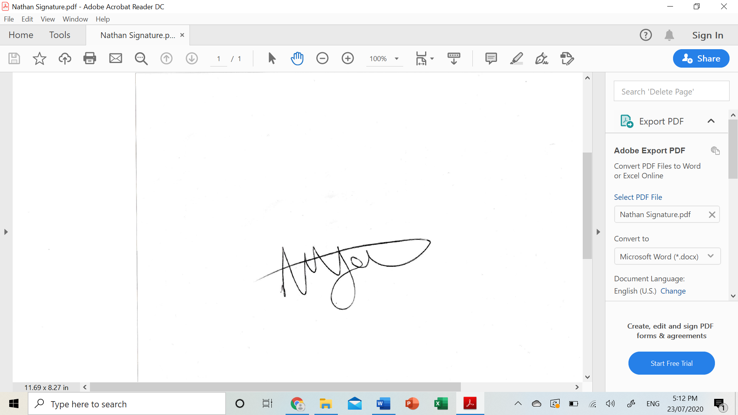
Date | 21/07/2020

Assessor name
Assessor signature
Date | Click here to enter a date.

Number of questions | Number of questions answered correctly | Task outcome (Tick)
16 |  | Satisfactory | Not Yet Satisfactory

ASSESSOR Comments
- Describe a project below. Conduct a SWOT analysis for the project. Identify at least two (2) points per area.

Project description | To errect a set of roof trusses on a standard roof on a two story house.

Answer | Area | Detail
 | S | -One advantage is the team has a lot of experience in roof trusses  -Also it should be relatively easy to work out the time frame required to complete the task, hence easier to budget.
 | W | -As the house is two storeys it requires extra scaffold to complete the task  -Team may feel more uncomfortable working at heights
 | O | -Be organised before the crane arrives to ensure theres no wasted time when the crane is onsite  -Ensure everyone knows their job roles so there is no confusion throughout the day and the job runs smoothly
 | T | -Trusses made wrong by the truss plant  -Bond beam incorrect requiring extra truss cleats to be drilled into concrete bond beam which takes a lot of time

- Consider the project you identified in Q1. For each of the areas identified in the table below, identify one (1) risk that may arise.

Answer | Area | Project risk
 | Environmental | Rubbish throughout the day blowing away into nearby drains
 | Finance | -Extra scaffold required, along with potentially requiring a bigger crane if poor access to site
 | Human resources | -Not having enough team members on site meaning the job will take longer
 | Legal | Team member falling off trusses and seriously injuring themselves requiring an investigation from workplace health and safety.
 | Technology | Crane malfunctioning

- Using ticks, identify whether each of the risk analysis methods listed below is either ‘qualitative’ or ‘quantitative’.
Answer | Qualitative | Quantitative | Method
 |  |  | Analyses expected monetary value
 |  |  | Considers likelihood of occurrence and impact on projective objectives
 |  |  | Ranks risks

Refer to the Risk Matrix below when responding to Q4.

Matrix | A:  Catastrophic | B:  Major | C:  Moderate | D:  Minor | E:  Insignificant
1: Almost certain | E | E | H | H | M
2: Likely | E | H | H | M | M
3: Occasionally | H | H | M | M | L
4: Unlikely | H | M | M | L | L
5: Rare | M | M | L | L | L

E: Extreme | H: High | M: Medium | L: Low

- Referring to your responses in Q2. rate each of the risks you identified using the Risk Matrix shown above. Identify the Likelihood and Impact you have determined, plus the overall risk rating.
Prioritise each risk from 1 to 5 (1 = highest priority, 5 = lowest priority).

Answer | Area | Risk rating | Priority
 | Environmental | Likelihood: Likely  Impact: Moderate  Risk rating: High | 3
 | Finance | Likelihood: Occasionally  Impact: Major  Risk rating: High | 2
 | Human resources | Likelihood: Occasionally  Impact: Moderate  Risk rating: Medium | 4
 | Legal | Likelihood: Occasionally  Impact: Catastrophic  Risk rating: High | 1
 | Technology | Likelihood: rare  Impact: moderate  Risk rating: Low | 5

- Order the elements of the hierarchy of control, from 1 to 6 (i.e. most effective to least effective).

Answer | Label (1 – 6) | Element
 | 3 | Isolate the hazard
 | 6 | Provide and use Personal Protective Equipment (PPE)
 | 1 | Eliminate the hazard
 | 4 | Control the hazard by engineering means
 | 5 | Control the hazard by administrative means
 | 2 | Substitute the hazard

- Referring to your responses in Q2. propose one (1) risk control for the risk identified in each of the areas listed below.

Answer | Area | Risk control
 | Environmental | -Ensure regular clean ups throughout the day
 | Finance | Check in advance that there is site access for the crane and whether a bigger crane is required
 | Human resources | Check with the team to help work out how many team members are required to complete the task efficiently and effectively
 | Legal | Complete a safety talk at start of the day and reinforce safety measures and ensure everyone is being careful when working at heights
 | Technology | Ask the crane company to check their crane is fully operational before it arrives on site

- Which of the following parties should be consulted and agree to proposed risk managed strategies, plans and reporting mechanisms? Tick all that apply.

Answer | Choice | Possible Answers
 |  | Project manager
 |  | Project specialist
 |  | Team members

- True or False (Tick your response): Organisations all use the same risk analysis methods, techniques and tools.

Answer |  | True
 |  | False

- Identify the four (4) options that may be followed once you have established the revised risk level.

Answer | -Do nothing  -Implement risk controls  -Reassess the risk  -Accept the risk

- What is the name of the risk level measured after risk controls have been implemented? Tick all that apply.

Answer | Choice | Possible Answers
 |  | Initial risk
 |  | Revised risk
 |  | Residual risk
 |  | Updated risk

- On what document should incidents be recorded?

Answer | Issues register

- What is to be completed when a variation is to be made to the project?

Answer | A change request

- True or False (Tick your response): You should report opportunities for action in the same way as risks.

Answer |  | True
 |  | False

- Identify two (2) types of documents that may be referred to when conducting a review of a risk management plan.

Answer | -Project files and records  -Risk diaries

- Explain the relevance of evaluating project outcomes (e.g. agreed major milestones) as part of reviewing risk management activities.

Answer | Because it can help with future risk management activities. It can ensure future incidents are better managed along with maintaining similar mistakes aren’t made again.

- True or False (Tick your response): You may refer to past projects for lessons learned regarding risk management, even when the past projects are not identical to the current one.

Answer |  | True
 |  | False

BSBPMG407A
Apply risk management techniques

PRACTICAL ASSESSMENT INSTRUCTIONS

- The following practical assessment will require the Participant to complete work related activities.
- The Assessor will conduct observations of the Participant’s work to determine whether they display sufficient practical skills and knowledge.
- Please fill in the details below – providing your name, signature and date of assessment.
  - The Participant’s signature acknowledges that the Assessor provided clear instructions and the Participant understood what was required to complete this assessment.
- The Assessor may substitute a Practical Task with an alternate task of equal value.
  - Alternate tasks must be fully documented by the assessor in the Assessor Comments area.

Participant name | Nathan Weiss
Participant signature
Date | 21/07/2020

Assessor name
Assessor signature
Date | Click here to enter a date.

Task | Task outcome (Tick)
Task | Satisfactory | Not Yet Satisfactory
Task 1 (Occasion 1)
Task 1 (Occasion 2)

Assessor Comments
BSBPMG407A
Apply risk management techniques

Practical Task 1 (2X)
Description of task:
On two (2) occasions, a suitable observer is to verify the participant’s ability to apply risk management techniques to complex projects– including, assisting with risk analysis, risk management planning and undertaking a review of risk management outcomes.

A complex project is defined as a project which involves:
- The need for a comprehensive and multi-faceted project plan
- The need for a formal internal or external communications strategy
- A dedicated and diverse project budget
- Multiple administrative components
- Multiple operational components
- A wide range of stakeholders
- A project operations team

The participant is to gather evidence of how they have completed each component of the Practical Task, which is to be submitted with this Practical Assessment sheet. Evidence to be submitted may include:
- SWMS review checklist completed by the Participant
- Task JSA completed by the Participant
- SWMS signed by the Participant
- Design risk assessment completed by the Participant

The observer is to outline the details of each project observed in the ‘Observer comments’ section. The assessor is to verify the observer’s comments and provide the outcome for the practical task on the front cover of the Practical Assessment.
Resources required:
Project records.
Assessment of task
Name of participant:
Name of observer:
Role of observer
(Confirm suitability to sign)
Email address of observer
Signature of observer:
Date: | Click here to enter a date.
When completing the task, did the participant: |  | Tick if satisfactorily completed.  Provide comments if left unticked.
 |  | 1st  Occasion | 2nd  Occasion
- Contribute to identifying and prioritising potential risks throughout the project life cycle.
- Within delegated authority, provide input to develop risk management strategies and risk management plans within established guidelines.
- Establish risk analysis methods, techniques and tools to assist in the analysis of risks.
- Ensure reporting mechanisms for risks were planned for and agreed to.
- Undertake control activities in accordance with agreed project and risk management plans to achieve project objectives.
- Measure progress and act on perceived, potential or actual risks within authority – or report to others for response.
- Contribute to the implementation of agreed risk approaches and the amendment of plans to reflect the changing environment.
- Identify and report opportunities for action in the same way as risks.
- Contribute to the ongoing review of project outcomes to determine the effectiveness of risk management activities, accessing project records and other available information.
- Report risk management issues and responses to others for lessons learned or application in future projects.
The Participant’s performance was: Satisfactory Not Satisfactory

observer Comments

