
Northshore, Hamilton - Cedar Rd & MacArthur Ave﻿
﻿

Quality Management Plan
Job Name: | Northshore, Hamilton - Cedar Rd & MacArthur Ave﻿
Job No.: | 4857 ﻿
Principal: | MINISTER FOR ECONOMIC DEVELOPMENT QUEENSLAND﻿

Document Version Control

Version No. | Effective Date | Details Document History /  Change Trigger | Prepared By | Approved By
1 | 18/06/2021 | First Issue | Kyle Carlson | Kieran Madgwick

Quality Management Plan (QMP)
Business Management Systems (BMS) Plan
Document No.: HEQ-TPE-00355

Table of Contents
1. Introduction 4
2. Project Overview 5
3. Management 7
4. Planning and Process Control 10
5. Identification and Traceability 10
6. Inspection and Testing 12
7. Purchasing and Subcontract Controls 14
8. Design Controls 16
9. Control of Non-Conformances 17
10. Document Control 18
11. Records 19
12. Survey Management 20
13. Monitoring and Review 20
Appendix A Project Quality Schedule 22

Introduction

Purpose
The purpose of this Quality Management Plan (QMP) is to provide a complete management document for onsite project staff to use on a day-to-day basis. The QMP is part of BMD’s Integrated Project Management Plan (IPMP), which is a dynamic, working document that is subject to ongoing reviews due to potential changes to the contract, management practices, legislation, industry best practice, international standards and internal review. The IPMP is a working document to ensure changes are implemented as necessary to improve the efficiency and quality of the project as it progresses. The BMD Group (BMD) is committed to meeting the needs and expectations of its clients, legal and regulatory bodies. This commitment to quality and continual improvement is documented in the BMD Quality Policy and Management Systems Policy.
This QMP has been developed to provide a framework for the management of all quality aspects and impacts associated with the construction of Northshore, Hamilton - Cedar Rd & MacArthur Ave﻿.

Scope
BMD adopts an integrated management approach with the aim to produce work to a high quality, in an environmentally conscientious manner and with the health and safety of all staff and public considered.

Management System
BMD Constructions Pty Ltd has a documented management system meeting the requirements of:
- AS/NZS ISO 9001:2015 (Quality Management Systems);
- AS/NZS ISO 14001:2015(Environmental Management Systems); and,
- AS/NSZ ISO 45001:2018 (Occupational Health and Safety Management Systems).
The BMD integrated management system has been designed in accordance with HB 139: 2003 “Guidance on Integrating the Requirements of Quality, Environment and Health and Safety Management System Standards”.
BMD has third party certification to AS/NZS ISO 9001:2015, AS/NZS ISO 14001:2015, AS/NZS 45001: 2018 and accreditation with State and Territory authorities, including the Office of the Federal Safety Commissioner (OFSC). Details of BMD’s accreditations are documented on the BMD Certifications Register.
This QMP should be read in conjunction with the following documents:
- Business Management Systems Framework
- Integrated Project Management Plan (IPMP)
- Environmental Management Plan (EMP)
- Safety Management Plan (SMP)
- Community Liaison Plan (CLP)

Project Overview

Project Overview
This document has been prepared for contract number DSDTI-EDQ-2395-20.
Project Start: 14-06-2021
Project Completion: 22-12-2021
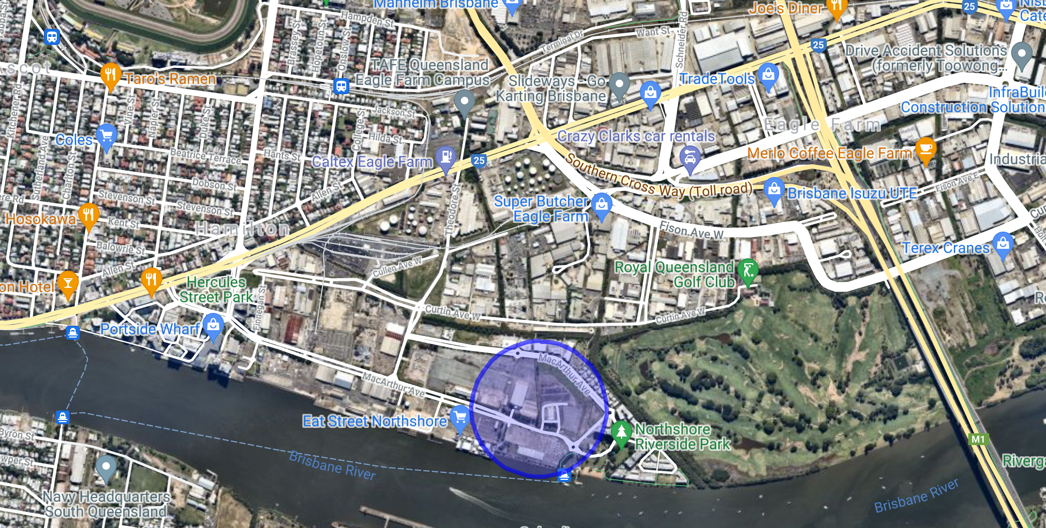Figure 1: Location Map

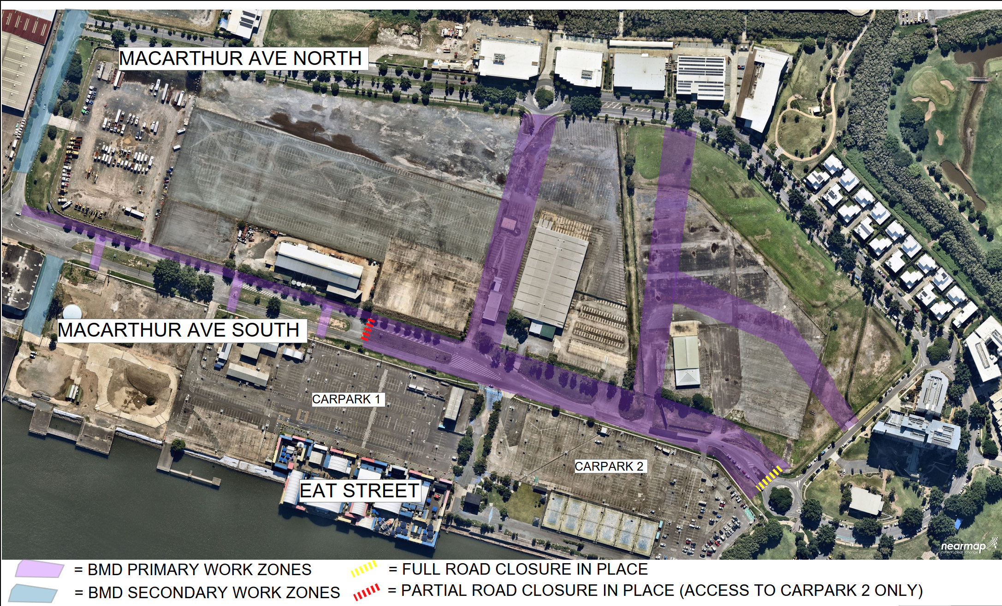Figure 2: Approximate Site Boundary (construction Works only)

Project Information Overview
BMD have been contracted to undertake upgrade works of existing MacArthur Avenue, Bincote Street & Theodore Street and undertake new works on Cedar Road, Barcham Street and Karakul Street at Northshore, Hamilton.

Description of Works
The work required to be carried-out by BMD under the contract includes, but is not limited to, the following elements:
- Clearing and demolition
- Bulk earthworks
- Underground service installation including sewer, water, stormwater
- Electrical reticulation, both HV & LV
- PUP relocations and installations
- Pavements, footpath, bike paths
- Soft scape landscaping

Management

Project Management Team
The project manager for this project is ﻿. Quality responsibilities of staff are described in the following section.

Staff Responsibilities
Quality responsibilities for all key sit-based project staff are defined as follows. Day and night shifts will have a changeover period where quality issues will be discussed and coordinated to ensure continuity of work and quality is maintained throughout the entire length of the project.

Project Manager
The responsibilities of the Project Manager are as follows:
- Successful completion of the project, including the exercise of contract management and cost control functions.
- Formal communication with the principal and the principal’s Representative, ﻿for the contract.
- Obtaining the principal’s agreement for all nominated activities or actions.
- Detailed project planning.
- Communication to all staff, suppliers, subcontractors, adjoining landholders and the general public of the relevant aspects of project management arrangements.
- Review of the Integrated Project Management Plan (IPMP) and supporting management plans, and seek approval from the Construction Manager.
- Ensure the project team perform to the quality set and monitor the quality of that performance.
- Ensuring that adequate resources are available to each project discipline, including appropriately qualified and experienced staff.
- Assessments of training needs for all project staff and to ensure adequate training is provided.
- Ensuring documents and records are stored and managed as per the Documents and Records Management standard.
- Review of all project related non-conformances and subsequent remedial actions and the corrective and preventive actions initiated by (or instigated by) the non-conformance.
- Negotiation of contract variations with the Superintendent.
- Review of all project related non-conformances and subsequent remedial actions and, the corrective and preventive actions initiated by (or instigated by) the non-conformance.

Project Engineer / Site Engineer
The responsibilities of the project engineer / site engineer are as follows:
- Responsible to the project manager for all site operations and management.
- Undertakes all the functions and responsibilities of the Project Quality Representative (PQR).
- Establishment and maintenance of the IPMP.
- Document and drawing control, as per the Document and Records Management Standard.
- Establishment and maintenance of project identification and traceability procedures including the Lots Management System and other controls to be implemented by project staff, subcontractors and testing service providers.
- Establishment and maintenance of Inspection and Test Plans (ITPs) including the management of inspection and test functions.
- Supply notification to the Principal’s Representative of upcoming Hold Point’s required for the project.
- Monitoring performance of all suppliers of products and services including Subcontractors.
- Prepare recommendations for project variations including work processes, cost estimates and contract variation negotiations.
- Be the point of contact for any internal or external audits and to ensure that any issues found as a result of the audit are dealt with in an appropriate and timely manner.
- Assessment of project non-conformances including recommendations for corrective and preventative actions and the review of these actions.
- Verify implementation of solutions.
- Control further processing/delivery/installation of non-conforming product until deficiencies or unsatisfactory conditions have been corrected.
- To assess the project resource requirements.
- Liaise with the Regional Business Management Systems Coordinator on issues concerned with the management system.

Site Manager / Foreman
The responsibilities of the site manager / foreman are as follows:
- Responsible to the site superintendent for all on-site construction operations.
- Direction of sub-foreman and Leading Hands as well as the direct labour force.
- Communication to the workforce.
- Assisting with review and subsequent awarding of subcontractors, supply agreements and plant hire agreements.
- Monitoring and maintaining construction programs which have been set by the project manager or project engineer.
- Directing and monitoring of subcontractors, suppliers and plant hirers.
- Direction and monitoring of project survey resources.
- Under direction from the project engineer, assist site engineers in monitoring and maintaining relevant process control plans.
- Assist with assessment of project resource requirements including the training of staff and engaging specially qualified personnel.
- Reporting of all project non-conformances and suggestion of recommendations for corrective and preventive action.
- Assist in the preparation of project variations including work processes, cost estimates and contract variation negotiations.

Leading Hand / Worker
The responsibilities of the Leading Hand / Worker are as follows:
- To assist project management staff in carrying out the quality objectives of the project.

Subcontractor
The responsibilities of subcontractors are as follows:
- To assist project management staff in carrying out the quality objectives of the project.
- Perform works in accordance with the contract requirements.
- Complete the applicable BMD inductions and comply with system requirements.
- Provide the relevant documentation and/or records, as required.

Project Quality Representative/s
The Project Quality Representative (PQR) is responsible for ensuring that the quality requirements outlined in the IPMP and associated management system procedures are implemented and maintained on the project. The PQR has the authority to take whatever actions are necessary to fulfil this responsibility. The PQR will be a full-time member of the project management team. The minimum required qualifications and experience for the PQR are:
- A Degree in Civil Engineering; and,
- Three (3) years’ experience.
﻿ are the PQR’s for this project. Copies of each Curriculum Vitae’s (CVs) is available upon request. The PQR’s for the project have gained significant previous industry experience.
If the resource level appears to be insufficient for the effective implementation of the IPMP, the project manager and/or PQR will raise their concerns with regional management. Regional management will then assign other resources as appropriate to the circumstances. If the principal or principal’s representative is concerned as to the appropriateness of resource levels, the first point of contact is the project manager. The PQR and/or regional management may be contacted if the principal considers it appropriate.

Group Business Systems Manager
The Group Business Systems Manager (GBSM) has the authority and responsibility for ensuring that the requirements of the Management System are implemented and maintained. The GBSM is Patrick Pearl, available on telephone 0419 728 118 or e-mail Patrick.pearl@bmd.com.au. The GBSM will ensure that periodical audits of the project are scheduled, and conducted, to ensure that the systems are complying with the standards and legislation that affect the project. Monthly reports will be forwarded from the project manager to the Business Management Systems Coordinators for reporting to regional and systems management, the GBSM will report accordingly at the Senior Leadership Group (SLG) meeting.

Planning and Process Control

Construction Program
A construction program will be developed to help plan and monitor the progress of the project. This program will generally be held with the project manager who will track the progress of the project and make amendments to the program as required. The Principal will receive a copy of the amendments as they are prepared.

Construction Method Statement
Where activities have been identified as complex or high risk by the project team, a Construction Method Statement (CMS) will be generated. This is to be done at the discretion of the project team as CMS’s are not a requirement for every project. The CMS’s shall be developed in consultation with the project manager, engineering team, field supervision and HSEQ representatives.
A Construction Method Statement (CMS) shall consist of, but not limited to:
- methodology
- timing
- plant and equipment
- risks and hazards, introduced and inherent
- chain of responsibility requirements
- commercial risk
- resources
- safety
- legal compliance
- environmental
- training
- materials
- associated WMS and BMD Core Operating Procedures.
Hazards and aspects identified on the Construction Method Statement will be recorded in the project risk register.

Identification and Traceability

Lots
All items of work are to be subdivided into Lots or discrete work areas. A Lot will consist of any part of the works, which BMD considers to be a continuous portion of homogenous and/or representative material or end product produced under essentially constant conditions. The project manager or project engineer will determine the extent of each Lot. Clearly marked drawings may be used, where considered appropriate, by the project manager or project engineer.
The bounds of each Lot will be determined before sampling and will be set so that each Lot is represented by a single tested sample, except where statistical methods, which require several tested samples to represent a Lot, are used. Each acceptance criteria may have different Lot boundaries.
Work on a Lot will not commence until the Lot identification has been established and is understood by relevant staff.
Discrete portions of a Lot which are visually non-homogenous and/or non-representative will be excluded from the Lot and will either be treated as separate Lots or reworked to the satisfaction of the principal. The principal has the right to reject a Lot that is visually non-homogenous and/or non-representative.
Where the non-conforming Lot is reworked and subjected to a fresh compliance testing program or is subdivided into smaller Lots, a new Lot number, or numbers, will be allocated to the reworked/subdivided Lot(s).

Lots Management System
The Lots Management System in the project site will be used to track the status and record details of each Lot. Each Lot will be given a unique Lot number. Each Lot number will start with a specific series number in relation to the type of activity; new Lots will be assigned the next sequential number to identify the elements that make up the Lot.
Any items related to a particular Lot shall be linked and referenced against each individual database entry. This includes, but is not limited to: Request for Information (RFI) correspondence; transmittals; Inspection and Test Plans (ITPs); test requests and results; Hold/Witness Points; non-conformance; corrective or improvement actions.

Completed Lots
Information relating to a conforming Lot will be submitted to the principal at the completion of works via a Lot Conformance Report and supporting documentation. Where a Lot is subject to delayed testing, these Lots shall be submitted to the principal with preliminary results. The final test results will follow as they become available. Non-conforming results will be processed in accordance with the Non-Conformances section of this document.
If a Lot does not achieve the specified characteristic value, the project engineer or appropriate delegate will investigate the Lot with a view to determine why the characteristic value was not obtained. This process may involve a review of test results to determine if it is a material problem (e.g. excess or deficient moisture), and/or checking with the foremen and operators as to the actual process and circumstances applicable to that Lot. A corrective action will be raised in the project site NCR system and either an internal or contract, depending on criteria previously defined, will be filled out and the procedures for non-conforming product and corrective action then followed.
The project manager will ensure all Lots are closed out and signed off.

Traceability
All materials, samples and test results will be identified by a Lot number and field location to which they relate; records will be stored in the Project Site Lots Management system.

Inspection and Testing

Inspection and Test Plans
Inspection and Test Plans (ITPs) will be prepared for all manufacturing and construction activities. ITP’s will include controls for receiving, in process and final inspection, and testing. The sequence of all activities identified in an ITP will be concisely described in technical procedures or by a process flow diagram.
Unless otherwise specified, the foreman will be responsible for arranging all inspections and tests on work in progress. This may be coordinated through the project engineer for soil tests, etc. ITP’s are to be progressively signed off as works are completed, signed and closed out.

Sampling and Testing
The project manager or delegate will be responsible for arranging tests of materials at source or in stockpile. Inspection and testing status for a particular Lot can be determined by reference to the checklist for the Lot.
Tests shall be arranged using the Test Requests System in the project site.

Frequency of Testing
Appropriate frequencies for inspection and testing will be detailed on the ITP. Frequencies will be in accordance with the specification or applicable Australian Standard.
The Project Quality Representative (PQR) will review the appropriateness of the frequency of testing nominated in the ITP’s. Such review will take into account the frequency of non-conformity detected, including non-conformities remedied by simple reworking.

Inspection and Test Status
The inspection and test status of any Lot may be determined by reference to the Lots Management System, completed or partially completed checklists, and associated measurements or test results. Items required to have inspection or test status labelling include:
- (e.g. Storm-water pipes delivered to site for inclusion in the permanent works will be clearly labelled by the manufacturer to identify class and grade of pipe).

Inspection and Test Records
Records for each Lot will clearly show or reference the actual results obtained for any inspection and/or test and demonstrate conformity with the specified requirements. Records will include the frequency of testing (or number of tests) required and the actual frequency of testing (or number of tests) to confirm that the required frequency has been achieved.
Records will be made available for evaluation by the principal at the completion of a Lot.

Measuring and Testing Equipment
Measuring and test equipment shall include measuring equipment for production purposes such as a concrete or asphalt batching plant.
The project engineer shall identify all inspection, measuring and test equipment (other than laboratory equipment) maintained and calibrated by subcontractors, which is used or proposed to be used for work on the contract. For all onsite activities where inspection, measuring and test equipment is maintained and calibrated by a subcontractor, the project engineer will ensure that the subcontractor holds a valid calibration certificate, or a copy of the subcontractor’s equipment register showing the calibration status of the equipment. This documentation will be stored electronically as per the Project Filing Structure – Constructions and a hard copy held at the location where the subcontracted work is being carried out.
Measurements for specific environmental compliance criteria such as noise levels, dust levels, vibration levels, water pH, etc. will be taken as applicable. Equipment used for such measurement will be of suitable precision, in good working order and recorded in the HSEQ Monitoring Equipment Register.

Hold Points
Work shall not proceed past a HOLD POINT until the principal has released that Hold Point.
The foreman and/or project engineer will ensure that the principal is given adequate advance notice of Hold Points. The required notice period shall be included in the ITPs.
Hold Points will be released by:
- via the electronic Hold Points system on the Project site
- written release on the relevant ITP
- separate written Hold Point Release
- written site instruction etc. approving the release.

All Hold Points are to be recorded in the project site electronic Hold Points system.
Where a verbal release is given, but there is no written record provided by the principal, the foreman or project engineer will ensure that written confirmation of the Hold Point Release is sent or given to the principal at the earliest opportunity. Such confirmation will include: details of the date; time; location; item and stage of work; what was approved; who approved it; and, who was present from BMD and/or BMD’s subcontractors.

Samples
BMD will submit sufficient samples to identify the range and mean of variation, as required. BMD will notify the principal’s representative that the sample is available for inspection at BMD’s site office. Samples will be matched throughout the works. Prototypes and samples will be either the first item of the relevant kind or, items additional to the works and subsequently disposed of. Procedures will be established to ensure correct ordering of materials, to verify conformance on delivery and ensure conformance of the works.
Sample submissions, where required, will be coordinated as to not cause delays by making late submissions or submitting inadequate samples. A sample of each designated item will be submitted with supporting documentation. Ancillary items such as fasteners, flashings, seals, colour, etc. will be included. All samples will be kept in good condition onsite until completion.
The samples that have any variance in texture or colour will be rectified immediately and reported to the principal’s representative.

External Quality Audits
The principal’s representative and/or MEDQ﻿ may, from time to time, undertake an external audit of BMD’s quality system. All audit records should be entered into the Audits database, as per the Audit Management Standard.

Purchasing and Subcontract Controls

Products and Materials

Product Selection
Products and services will be selected on the quality of the product or service, past experience with BMD or associated companies, those materials required by the specification and the product or services risk to health and safety, and/or the environment.

Material Supplied by the Client
Material supplied by the client shall be inspected and stored to prevent undue damage or deterioration. The principal will be informed of any defects noticed at the time of inspection.

Materials Handling
All precautions shall be taken to protect products from abuse, misuse, damage, deterioration and unauthorised use.
The foreman shall ensure that all employees are adequately trained for safe execution of activities assigned to them. The foreman shall provide any safety equipment or personal protective equipment to workers to safely carry out the task.
Materials subject to segregation and/or contamination, for example road base gravel, shall be handled to prevent segregation or contamination, namely materials will be stockpiled on prepared slabs and suitably separated.
The project manager is responsible for ensuring that all lifting equipment is properly maintained and rated for the loads placed on them. This requirement also applies to equipment used by BMD’s subcontractors and hired machinery.

Materials Storage
Materials subject to deterioration, or likely to be damaged if left unprotected, shall be stored in containers, sheds or in other secured storage areas in accordance with client and supplier specifications and/or recommendations.
All chemicals and waste materials shall be handled and stored in a manner that ensures potential hazards or environmental damage is avoided, as defined in this document and relevant Material Safety Data Sheet (MSDS). To detect deterioration, the condition of material being stored shall be assessed by the foreman or the appropriate delegate at regular intervals or as nominated in the contract.
The project manager, foreman, site supervisor, project engineer or appropriate delegate shall have authority to receive goods into, or dispatch goods from, secure storage areas.

Use of Purchased Product
The foreman will ensure that materials and purchased products that are handled, stored and combined with other products, are installed and used in accordance with the manufacturers’ recommendations. The foreman and/or the project engineer will ensure that the materials are compatible with the other products and works.
Material in storage will be checked by the employee responsible for the work prior to installation for signs of deterioration. The site foreman shall be notified of any material subject to deterioration for the appropriate corrective action.
Any supplier product non-conformities will be recorded in the Project Site NCR system and managed as per the Control of Non-Conformances Section of this document.

Purchase and Use of Products with Recycled Content
Recycled content products and materials may be used where these are cost and performance competitive and where their environmental performance is at least equivalent to the non-recycled product(s). The cost competitiveness of a product or material will be assessed by the project manager on a project lifecycle basis, considering issues such as impacts on construction practices, future maintenance and disposal requirements.

Subcontractors

Subcontractor and Supplier Pre-Award Evaluations
Prior to commencing onsite, a subcontractor and supplier evaluation must be undertaken utilising the BMD Subcontractor Pre-award Evaluation and Supplier Pre-Award Evaluation forms and uploaded to the BMD Company database, as stated in the Subcontractor HSEQ Management Standard. This will be used to determine if the contractor is operating under the project’s, or their own, HSEQ systems.
Where the subcontractor or supplier has approval to use their own HSEQ system, it is also acceptable for their own documentation to be used. Records must be retained and produced upon request.

Quality Control
Subcontractors requiring the principal’s approval will include the subcontract requirements given in the contract as applicable. Applications for approval of subcontractors shall include that part(s) of the proposed subcontract document showing the applicable subcontract requirements, and, when requested, BMD’s evaluation of the subcontractor’s ability to meet subcontract requirements. This is in accordance with the BMD Subcontractor HSEQ Management Standard.
Where a client pre-qualified subcontractor is required by the specification, BMD will ensure that pre-qualified subcontractors are used and their health and safety, environment and quality system implemented. To ensure the subcontractor meets the requirements of the contract and relevant State legislation, BMD will conduct an audit of the subcontractors’ management plans.

Subcontractor Close-out Evaluations
A Subcontractor Close-out Evaluation is to be completed for all subcontractors and suppliers whose value was greater than $150,000 or whose work was deemed high risk. It is also to be completed for any subcontractors and suppliers who have performed very well, very poorly or who have had incidents, corrective actions or other issues onsite. The evaluation should be completed together with the supplier / subcontractor, however if they are unable to be present, the evaluation is still to be completed. Once saved the evaluation will be available in the Company Database. This evaluation may include, but is not limited to:
- commercial performance
- timeliness
- work ethic
- HSEQ performance
- general project compliance.

Design Controls

General
Design works that are subject to control include design in respect of:
- temporary structures and the checking of permanent structures for construction loadings
- lifting devices for manufactured items requiring transport
- any alternative permanent structure or structural component proposed for the Works
- concrete mixes for structures and pavements and, asphalt mixes for permanent Works
- traffic control, temporary roadways and detours
- permanent works where the design control is nominated in the specifications.

Design Plans
Design plans will include the activities of all consultants or subcontractors engaged for the design work. Where a consultant or design subcontractor does not have a quality system conforming to the contract requirements, the method of control and verification of the consultant/design subcontractor’s activities will be included in this document. Design plans will be included as appropriate.
All design plans, including amendments, will be assessed to ensure that the risk profile for the project and site has not changed. Where this is not the case, the Risk Register will be updated and necessary mitigation controls will be circulated to relevant employees and subcontractors.

Control of Non-Conformances

Non-Conformances
Where conformity can be achieved by simple reworking or repair, without reference to the principal, the non-conformity details will be recorded in the project site NCR system as an internal non-conformity. Where conformity cannot be achieved by simply reworking with the original process, the project engineer will notify the principal.
All non-conformances will be recorded in the project site NCR system. Any non-conforming product reports issued by the principal shall be dealt with in the same manner as if the non-conformity had been identified by BMD.
Any supplier product non-conformities will be recorded and tracked in the BMD project site NCR system. The supplier may be notified verbally of this non-conformance, however, a formal record will be created in the electronic system and transmitted to the supplier. This system allows all correspondence, documents and records relating to this non-conformance to be stored in a central location and available to relevant parties on request.

Corrective Action
Work involving non-conforming items will not be authorised to continue unless the corrective action has been approved by the principal and implemented by BMD or the relevant subcontractor.
Any Corrective Action Request (CAR) raised by the principal will be actioned, completed and returned within seven (7) days of the CAR being issued to BMD.
The corrective action will be entered in the Corrective and Improvement Action database.

Preventive Action
Suitable analysis of the non-conformance and the implemented corrective action will be undertaken by site management to determine appropriate measures that could be implemented to prevent a repeat of the non-conformance.

Review of Non-Conformances
Each non-conformance and the corrective measure implemented to control the non-conformance will be reviewed at a suitable time, where possible no more than 14 days after the non-conformance has occurred. Only after a suitable review of the non-conformance has been carried out can the CAR be considered closed out.

Corrective Action Database
The Corrective or Improvement Action database will track the status of the non-conformance and implemented corrective action. The project manager will ensure all actions are closed within one month of raising.

Document Control

Control of Project Documents and Records
All documents and records will be managed as per the Document and Records Management standard and stored in accordance with the Project Filing Structure – Constructions.
Any formal project documents, internal or external, are to be issued via the Transmittal System within the project site. This system records: a unique identification number for each transmittal; the reason for the transmittal; the date issued; document title, description and revision of each file; the recipients of the documents; and, who issued the transmittal. Any amendments to documents will be redistributed to the relevant recipients.
Changes to this document and/or the Management System will be implemented as soon as practical if this document and associated Management System documents:
  - do not adequately address the specification requirements;
  - are causing non-conformity;
  - must be changed as a result of an audit;
  - must be changed as a result of variations to the contract;
  - no longer represent the current and/or appropriate practice.
When whole documents are superseded, the project manager or delegate will ensure that all superseded documents are destroyed, recalled and/or clearly marked as ‘SUPERSEDED’.
The project manager or delegate will ensure that relevant project personnel who are not holders of a controlled document are advised of any changes to this document and/or the management system either verbally or in writing.

Drawing Management
All drawings shall be uploaded to the drawings library in the SharePoint project site. Each file shall be uploaded individually in accordance with the Project Filing Structure – Constructions.
The drawings library requires the following data to be recorded against each file:
- File Name *
- Title
- Discipline *
- Category *
- Stage *
- Document Number *
- Revision *
- Date *
- Retired
- Comments
Note: * denotes a mandatory metadata field in the library.
SharePoint will store every occurrence of a document as a separate version of the file and allows each of the versions to be viewed and restored where necessary.
Drawings that are printed and circulated must have the date received clearly marked on the drawing. When a drawing is superseded, the project manager or delegate will ensure that the printed hard copy is destroyed, recalled and/or clearly marked as ‘SUPERSEDED’.

Change Control Documentation, Request for Information and Minutes
Where BMD requests to depart from the approved scope of works, approval will be sought from the principal’s representative prior to commencing the departure. This will typically be communicated through the Request for Information (RFI) system. Where the principal directs a change to the works under the contract, BMD will respond as to whether the change can be affected, in accordance with the contract documentation.
Throughout the course of the project, regular meetings will be held between the principal’s representative, the design representatives and BMD. It is anticipated that the principal’s representative will keep minutes and distribute for the regular meetings. These minutes will then be saved and collated by BMD and made available if requested by the principal.

Records
Records will be stored in an electronic format within a SharePoint Project site environment, unless otherwise agreed by the Business Unit General Manager and Group Business Systems Manager. The file naming convention and location for these records will be saved in accordance with the Project Filing Structure – Constructions.
Records which will be kept as applicable include, however, are not limited to:
- commercial components
- records of quality compliance
- test results
- technical specification(s)
- drawings
- environmental and safety monitoring/inspection reports
- internal audit reports
- external audit reports
- correspondence
- reports of health and safety, environment and quality incidents, non-conformances, complaints and follow-up actions
- minutes of management review meetings
- evidence of action taken as a result of such meetings/events
- induction and training records
- Records of monitoring by Subcontractors against compliance limits.
BMD will provide the principal access to project records and will allow the principal to copy records if requested:
- (e.g. Within 28 days after the issue of the Certificate of Completion, BMD will provide to the principal any commissioning records and operation, and maintenance manuals relevant to the Works); and
- (e.g. Within 60 days after the issue of the Certificate of Completion, BMD will provide to the principal an index of all quality records. Following the provision of that register, BMD will provide to the principal copies of any quality records within 14 days of a request by the principal).
At the completion of the project, all site records will be managed in accordance with the Documents and Records Management Standard.

Survey Management
Survey works will be conducted and managed in accordance to with the External Survey Requirements and Internal Survey Requirements Core Operating Procedures.
All survey equipment used onsite must be calibrated and within test date. Copies of calibration certificates must be available upon request with details recorded in the project HSEQ Monitoring Equipment Register.

Monitoring and Review

Audits
Audits will be conducted, stored and circulated as stipulated in the Audit Management Standard.

Audit Schedule
The Project Audit Schedule will be developed and maintained by the project manager, or delegate, in conjunction with the systems representative.
Audits will be undertaken in accordance with the minimum frequency requirements stipulated in the Audit Management Standard, with additional audits conducted upon request of the client.
Audits will also include the activities of all key subcontractors engaged on the project.

Adjustment to Audit Schedule
The audit schedule will be adjusted when one (1) or more of the following conditions exist:
- when the results of previous audits indicate the need for a higher/lower audit frequency
- when significant changes are made to functional areas of the quality system, including reorganisations and revisions to procedure(s)
- when safety, performance or reliability of the product is in jeopardy, or suspected to be in jeopardy, due to non-conformity in the quality system
- when necessary to verify that the required corrective/preventive action has been taken
- when required due to changes in BMD’s construction programme.

Unplanned Audits
Specific components of the management system may be audited more frequently where the general manager, group business systems manager, project manager or systems representative determines that:
- deterioration in performance of the system may occur rapidly if not audited more frequently
- any deterioration in functioning is found to have significant effect on work output
- significant system modification warrants particular attention to its performance.
The group business systems manager or management systems coordinator may also initiate unscheduled audits where non-conformances suggest that a special review of a segment of the Management System is warranted.

Project Review
A management review will be conducted by the project manager and relevant project stakeholders annually or at least once during the project life cycle.
On completion of the project a formal review will be carried out by the project manager to evaluate the effectiveness of the health and safety, environment and quality measures onsite. The review shall also address construction techniques, subcontractors, materials, costs and staff performance with minutes kept providing a record.

Audit / Inspection / Monitoring Topic | Responsibility | Jan | Feb | Mar | Apr | May | Jun | Jul | Aug | Sep | Oct | Nov | Dec
Worksite / Field ITP Reviews | PQR |  |  |  |  |  |  | X | X | X | X | X | X
Quality Performance Monitoring: Monthly Report / Monthly Management Review | PM |  |  |  |  |  |  |  |  | X |  | X
Internal QA Audit (full) | Corporate Business Systems Manager with Quality Engineers | Refer to the Project Audit Schedule for details.
Regulatory Authority and/or Certification Audit |  | Refer to the Project Audit Schedule for details.
Unscheduled Audit/Inspection |  | Refer to the Project Audit Schedule for details.

Appendix A Project Quality Schedule



