CHCECE016
Establish and maintain a safe and healthy environment for children
Learner Guide


Table of Contents

Unit of Competency 6
Application 6
Performance Criteria 7
Foundation Skills 9
Assessment Requirements 10
1. Support each child’s health needs 12
1.1 – Discuss individual children’s health requirements and routines with families at enrolment and then on a regular basis 13
Children’s health requirements and routines 13
Health requirements form (example) 15
Activity 1A 16
1.2 – Ensure that any concerns or questions about a child’s health needs are conveyed to their family 17
Concerns about child’s health needs 17
Activity 1B 18
1.3 – Consult with relevant authorities to ensure that health information is current 19
Checking health information 19
Activity 1C 21
1.4 – Ensure that individual medical management plans for children with a specific health care need are in place and readily available at the service 22
Medical management plans 22
Activity 1D 23
2. Provide for each child’s comfort 24
2.1 – Ensure that groupings of children are configured to provide for each child’s comfort and to minimise the risk of overcrowding 25
2.2 – Make sure physical spaces are available for children to engage in rest and quiet activities 25
Grouping children 25
Making space for rest 26
Activity 2A 27
2.3 – Offer a range of active and restful experiences to children and support them to make appropriate decisions regarding participation 28
Active experiences 28
Restful experiences 29
Activity 2B 30
3. Promote and implement effective hygiene practices 31
3.1 – Ensure that the service accesses information on current hygiene practices 32
3.2 – Maintain written procedures and schedules to ensure a regular regime of washing children’s toys and equipment 32
3.3 – Provide families with information and support that helps them to follow the service’s hygiene procedures 32
3.4 – Ensure that information about correct hand washing procedures are displayed in relevant areas of the service 32
Scheduling washing of children’s toys and equipment 32
Encouraging children to follow hygiene practices 33
Hand washing procedure 34
Activity 3A 35
4. Take steps to control the spread of infectious diseases 36
4.1 – Configure groupings of children to minimise the risk of illness and injuries 37
Configuring groups of children 37
Common childhood diseases 38
Activity 4A 39
4.2 – Source information about recognised health and safety guidelines 40
Health and safety guidelines 40
National Quality Framework (NQF) 41
Activity 4B 42
4.3 – Ensure that service procedures are followed, in relation to notifying families of illness or injuries that affect children while in education and care 43
4.4 – Advise families and public health authorities where necessary of cases of infectious diseases at the service and provide them with relevant information 43
Notify families of illness and injuries 43
Advising families and public health authorities 43
Notifiable diseases 44
Activity 4C 48
4.5 – Ensure current records of children’s immunisation status are up-to-date and a procedure is in place to maintain the currency 49
4.6 – Provide information to families and educators about child and adult immunisation recommendations 49
Immunisation status 49
Activity 4D 52
5. Ensure adequate supervision of children 53
5.1 – Arrange equipment, furniture and activities to ensure effective supervision while also allowing children to access private and quiet spaces 54
Arrange equipment, furniture and activities 54
Activity 5A 56
5.2 – Ensure new or relief educators are informed of supervision arrangements and of what they are required to do in relation to supervising children 57
Supervision arrangements 57
Activity 5B 60
5.3 – Undertake a risk assessment for each excursion including implications for supervision 61
Excursion risk assessments 61
Risk assessment template 62
Risk Matrix 63
Activity 5C 64
6. Take precaution to protect children from harm 65
6.1 – Ensure safety checks are consistently implemented and action is taken as a result of the checks 66
Safety checks 66
Activity 6A 68
6.2 – Check risk minimisation plans are in place for children enrolled at the service who have a specific health care need, allergy or relevant medical condition 69
Risk minimisation plans 69
Risk control template (for schools) 71
Activity 6B 72
6.3 – Ensure simple warning signs are located where potentially dangerous products are stored 73
Warning signs 73
Activity 6C 76
6.4 – Confirm safety of any drinks, food and cooking utensils and appliances used as part of the program 77
Safety of any drinks, food and cooking utensils and appliances 77
Activity 6D 80
6.5 – Ensure that basic training and testing on how to move and fit car seats, restraints and booster seats (applicable to the age of relevant child) is available to all educators 81
Moving and fitting car seats, restraints and booster seats 81
Where to fit child seats 82
Types of child seat to use 82
Activity 6E 83
6.6 – Keep records of pest/vermin inspections and/or eradications 84
Records of pest/vermin inspections and/or eradications 84
Keep pests/vermin out of the workplace 84
Signs of pest/vermin presence 85
Activity 6F 86
6.7 – Develop and maintain a written process for monitoring who enters and leaves the premises at all times 87
Monitoring who enters and leaves the premises 87
Activity 6G 88
6.8 – Provide detailed information to families regarding any excursion being undertaken 89
Informing families of excursions 89
Activity 6H 91
7. Develop plans to effectively manage incidents and emergencies 92
7.1 – Ensure emergency procedures are displayed prominently throughout the premises 93
Displaying emergency procedures 93
Fire safety 93
First Aid 94
Activity 7A 95
7.2 – Make certain that all educators have ready access to a phone or similar means of communication 96
7.3 – Ensure emergency numbers are located near telephones 96
Phoning in emergencies 96
Activity 7B 97
7.4 – Communicate information to families about the service’s emergency procedures and incident management plans 98
Communicate emergency information to families 98
Activity 7C 99
7.5 – Discuss and practise emergency drills with children, educators and any other people on the premises 100
7.6 – Ensure that emergency equipment is available and tested and staff are trained in the use of it 100
Emergency drills 100
Emergency equipment 100
Activity 7D 102
7.7 – Maintain a portable record of children’s emergency contacts in case of emergencies 103
Maintain a portable record of children’s emergency contacts 103
Activity 7E 104
References 105

Unit of Competency

Application

The unit describes the skills and knowledge to establish and maintain a safe and healthy environment for children.
This unit applies to educators working in a range of education and care services.
The skills in this unit must be applied in accordance with Commonwealth and State/Territory legislation, Australian/New Zealand standards and industry codes of practice.
Unit Mapping Information

No equivalent unit.

Performance Criteria
Element  Elements describe the essential outcomes. | Performance Criteria  Performance criteria describe the performance needed to demonstrate achievement of the element.
- Support each child’s health needs | - Discuss individual children’s health requirements and routines with families at enrolment and then on a regular basis  - Ensure that any concerns or questions about a child’s health needs are conveyed to their family  - Consult with relevant authorities to ensure that health information is current  - Ensure that individual medical management plans for children with a specific health care need are in place and readily available at the service
- Provide for each child’s comfort | - Ensure that groupings of children are configured to provide for each child’s comfort and to minimise the risk of overcrowding  - Make sure physical spaces are available for children to engage in rest and quiet activities  - Offer a range of active and restful experiences to children and support them to make appropriate decisions regarding participation
- Promote and implement effective hygiene practices | - Ensure that the service accesses information on current hygiene practices  - Maintain written procedures and schedules to ensure a regular regime of washing children’s toys and equipment  - Provide families with information and support that helps them to follow the service’s hygiene procedures  - Ensure that information about correct hand washing procedures are displayed in relevant areas of the service
- Take steps to control the spread of infectious diseases | - Configure groupings of children to minimise the risk of illness and injuries  - Source information about recognised health and safety guidelines  - Ensure that service procedures are followed, in relation to notifying families of illness or injuries that affect children while in education and care  - Advise families and public health authorities where necessary of cases of infectious diseases at the service and provide them with relevant information  - Ensure current records of children’s immunisation status are up-to-date and a procedure is in place to maintain the currency  - Provide information to families and educators about child and adult immunisation recommendations
- Ensure adequate supervision of children | - Arrange equipment, furniture and activities to ensure effective supervision while also allowing children to access private and quiet spaces  - Ensure new or relief educators are informed of supervision arrangements and of what they are required to do in relation to supervising children  - Undertake a risk assessment for each excursion including implications for supervision
- Take precaution to protect children from harm | - Ensure safety checks are consistently implemented and action is taken as a result of the checks  - Check risk minimisation plans are in place for children enrolled at the service who have a specific health care need, allergy or relevant medical condition  - Ensure simple warning signs are located where potentially dangerous products are stored  - Confirm safety of any drinks, food and cooking utensils and appliances used as part of the program  - Ensure that basic training and testing on how to move and fit car seats, restraints and booster seats (applicable to the age of relevant child) is available to all educators  - Keep records of pest/vermin inspections and/or eradications  - Develop and maintain a written process for monitoring who enters and leaves the premises at all times  - Provide detailed information to families regarding any excursion being undertaken
- Develop plans to effectively manage incidents and emergencies | - Ensure emergency procedures are displayed prominently throughout the premises  - Make certain that all educators have ready access to a phone or similar means of communication  - Ensure emergency numbers are located near telephones  - Communicate information to families about the service’s emergency procedures and incident management plans  - Discuss and practise emergency drills with children, educators and any other people on the premises  - Ensure that emergency equipment is available and tested and staff are trained in the use of it  - Maintain a portable record of children’s emergency contacts in case of emergencies

Foundation Skills
The Foundation Skills describe those required skills (language, literacy, numeracy and employment skills) that are essential to performance.

- Reading - in order to interpret and apply relevant legislative and regulatory requirements, including National Quality Standards, required for ensuring safety in a service.
The remaining foundation skills essential to performance are explicit in the performance criteria of this unit.

Assessment Requirements
Performance Evidence

The candidate must show evidence of the ability to complete tasks outlined in elements and performance criteria of this unit, manage tasks and manage contingencies in the context of the job role. There must be demonstrated evidence that the candidate has completed the following tasks:
- Established and maintained an environment that is safe and healthy for children in at least once service, including:
- communicating hazards and safety issues to appropriate persons within the service
- coordinating emergency responses including evacuation plans
- planning and coordinating supervision of children
- promoting and monitoring safety practices, including administration of medicines and safe handling of food
- coordinating appropriate procedures for handling infections and illnesses, including communicating with families
- enacting strategies to support children to take increasing responsibility for their own health and physical wellbeing.

Knowledge Evidence

The candidate must be able to demonstrate essential knowledge required to effectively do the task outlined in elements and performance criteria of this unit, manage the task and manage contingencies in the context of the work role. These include knowledge of:
- How to access:
- the National Quality Framework
- the National Quality Standards
- the relevant approved learning framework
- How to navigate through framework and standards documents to find areas relevant to this unit of competency
- Common childhood illnesses and appropriate responses
- Strategies for minimising risk
- Notifiable diseases
- Organisational standards, policies and procedures.
Assessment Conditions

Skills must be demonstrated in a regulated education and care service.
In addition, simulations and scenarios must be used where the full range of contexts and situations cannot be provided in the workplace or may occur only rarely. These are situations relating to emergency or unplanned procedures where assessment in these circumstances would be unsafe or is impractical.
Simulated assessment environments must simulate the real-life working environment where these skills and knowledge would be performed, with all the relevant equipment and resources of that working environment.
Assessment must ensure use of:
- National Quality Framework for Early Childhood Education and Care
- The relevant approved learning framework under the National Quality Framework for Early Childhood Education and Care
- Evacuation plans
- Health and safety procedures and policies, including food-handling, travel and medication administration.
Assessors must satisfy the Standards for Registered Training Organisations (RTOs) 2015/AQTF mandatory competency requirements for assessors.

Links

Companion volumes are available from the CS&HISC website - http://www.cshisc.com.au/
Companion Volume implementation guides are found in VETNet - https://vetnet.education.gov.au/Pages/TrainingDocs.aspx?q=5e0c25cc-3d9d-4b43-80d3-bd22cc4f1e53

1. Support each child’s health needs
1.1. Discuss individual children’s health requirements and routines with families at enrolment and then on a regular basis
1.2. Ensure that any concerns or questions about a child’s health needs are conveyed to their family
1.3. Consult with relevant authorities to ensure that health information is current
1.4. Ensure that individual medical management plans for children with a specific health care need are in place and readily available at the service



1.1 – Discuss individual children’s health requirements and routines with families at enrolment and then on a regular basis

By the end of this chapter, the learner should be able to:
- Communicate with child’s family to collect information out:
- health requirements (e.g. allergies, disabilities, medical conditions)
- routines.

Children’s health requirements and routines
When caring for children, you must make sure that you are aware of individual health requirements and routines. Do not assume that all children will have the same requirements, as this could be dangerous and is irresponsible.
Examples of individual health requirements may include:
- Nut allergies
- Medication allergies

- Medication administration
- Asthma
- Nutritional requirements
- Nutritional intolerances
- Physical disabilities
- Mental disabilities.
Routines may include:
- Taking medication
- Meal times
- Sleep times
- Physical activity
- Mental activity.
In order to be aware of the above, you will need to enter into a discussion with the child’s family about such matters. This should happen during the enrolment process. It should also be an ongoing process, with scheduled meetings to discuss any changing requirements.
You should also encourage the parents of the child to be forthcoming with information on changes, if they occur between scheduled meetings. This will enable you to plan things better and ensure the child’s health needs and routines are continually met.
It may be useful to have the child’s family fill out a health requirements form, or at least leave a space on the enrolment form for it.
An example of this is shown on the next page.

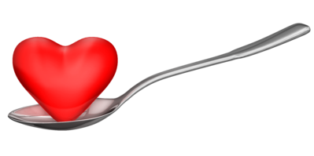

Health requirements form (example)
Name of child: | D.O.B.:
Name(s) of guardian(s): | Contact number:
Address: | Emergency contact number:
Details of special health requirements:

Details of special health-related routines (include times, where necessary):

Additional information:

Signature of guardian: | Date:
Signature of carer: | Date:

Activity 1A


1.2 – Ensure that any concerns or questions about a child’s health needs are conveyed to their family

By the end of this chapter, the learner should be able to:
- Raise concerns or questions about child’s health with family. These may relate to:
- nourishment
- allergies
- medication.

Concerns about child’s health needs

In the event that you develop a concern or have a question about a child’s health needs, you should notify the family at the first suitable opportunity, once you’ve had a chance to evaluate and analyse the situation properly.
Concerns about the child’s health needs may include:
- Being unable to provide nutritional requirements
- Child is malnourished
- Medication appears excessive
- Medication administration procedures.
You must ask questions if you are unsure on a child’s health needs. For instance, if they have a food allergy, how severe is it? Will they have an adverse reaction from being in the presence of a certain food or does this only happen if they ingest it?
This type of information will affect eating arrangements if you are caring for multiple children simultaneously. You may have to separate them if one of them has a severe allergy to food the other children are eating.
These questions and their responses should be appropriately documented, according to organisational procedures.
Make sure that you raise any concerns in a sensitive manner; understand that the family may not be aware of the situation and may take offence if you question their child’s health. If you raise a concern that a child is suffering from malnutrition, this can indirectly be taken as an insult to their parenting, if not done sensitively.
It is in these cases that active listening and empathy are important, in order to find out information about a child’s health requirements and routines.

Activity 1B

1.3 – Consult with relevant authorities to ensure that health information is current

By the end of this chapter, the learner should be able to:
- Communicate with relevant authorities to confirm health information. Authorities may include:
- health professionals
- Department of Health
- GPs.

Checking health information
Once you have obtained the child’s information for the family, you must now check it with the relevant authorities to ensure it is accurate. This will ensure you are promoting the child’s health, in line with Standard 2.1 of the National Quality Standards.
The appropriate authorities may include:
- Health professionals
- Department of Health
- GPs.
The types of health information you may need to confirm include:
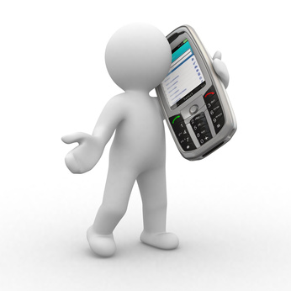
- Immunisation
- Nutrition and physical activity
- Asthma
- Diabetes
- Arthritis
- Mental health
- Injury prevention
- Food allergies.

National quality standards
Quality area 2 – Children’s health and safety

 | Concept | Descriptor
2.1 | Health | Each child’s health and physical activity is supported and promoted
2.1.1 | Wellbeing and comfort | Each child’s wellbeing and comfort is provided for, including appropriate opportunities to meet each child’s need for sleep, rest and relaxation.
2.1.2 | Health practices and procedures | Effective illness and injury management and hygiene practices are promoted and implemented
2.1.3 | Healthy lifestyle | Healthy eating and physical activity are promoted and appropriate for each child.
2.2 | Safety | Each child is protected
2.2.1 | Supervision | At all times, reasonable precautions and adequate supervision ensure children are protected from harm and hazard.
2.2.2 | Incident and emergency management | Plans to effectively manage incidents and emergencies are developed in consultation with relevant authorities, practised and implemented.
2.2.3 | Chid protection | Management, educators and staff are aware of their roles and responsibilities to identify and respond to every child at risk of abuse or neglect.

Source: https://www.acecqa.gov.au/sites/default/files/acecqa/files/NQF/RevisedNQSHandoutA4_2.pdf. Accessed: 5th February 2018
Navigating documents
Often during your work, you may find you have to navigate documents to find relevant standards, like the ones above. Rather than reading the entire thing, there are ways to speed up the process.
These are:
- Using contents and index for relevant topics
- Using search functions on websites (pressing Ctrl and F simultaneously for PCs)
- Performing Internet searches to find relevant passages
- Skim reading until you see keywords.

Activity 1C

1.4 – Ensure that individual medical management plans for children with a specific health care need are in place and readily available at the service

By the end of this chapter, the learner should be able to:
- Confirm existence and standard of medical management plans for children.

Medical management plans
Medical management plans are provided by doctors and give details of the specific actions to be taken to deal with certain medical conditions.
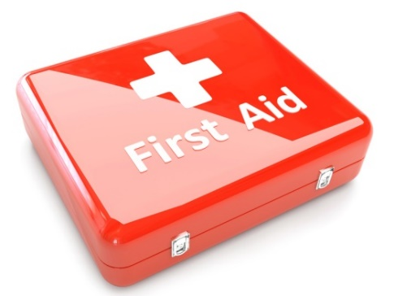
Examples of conditions that may require a medical management plan include:
- Anaphylaxis
- Asthma
- Diabetes
- Epilepsy
- Allergic reactions.
You must have any necessary medications and equipment available at the place where your service is administered. For example, with anaphylaxis, Anapens and Epipens would be the medications you would need available.
You should ensure you are trained in First Aid and can attend to any minor injuries, and that you are capable of dealing with emergencies, should they arise.
You will need an authorisation form for the plan itself, a medical authorisation form (if medication is required to be administered) – to be completed by the parent – and a medical management form, to be completed by a doctor.
General sample forms can be found at: http://www.acecqa.gov.au/sample-forms-and-templates-now-available
The following table gives links to some example medical management plans. There are many templates available as well as these on the internet.
Condition | Medical management plan template
Anaphylaxis | http://www.allergy.org.au/health-professionals/ascia-plans-action-and-treatment
Asthma | http://www.nationalasthma.org.au/asthma-tools/asthma-action-plans
Diabetes | http://www.shesugar.com/wp-content/uploads/2012/07/Sample-Type-1-Diabetes-Medical-Management-Plan-grades-K-1.pdf
Epilepsy | http://www.epinet.org.au/articles/epilepsy_management_plans_emp_1

Activity 1D

2. Provide for each child’s comfort
2.1. Ensure that groupings of children are configured to provide for each child’s comfort and to minimise the risk of overcrowding
2.2. Make sure physical spaces are available for children to engage in rest and quiet activities
2.3. Offer a range of active and restful experiences to children and support them to make appropriate decisions regarding participation

2.1 – Ensure that groupings of children are configured to provide for each child’s comfort and to minimise the risk of overcrowding

2.2 – Make sure physical spaces are available for children to engage in rest and quiet activities

By the end of this chapter, the learner should be able to:
- Configure groups to children’s needs. These may include:
- overcrowding
- safety
- personality
- Research and comply with requirements for physical spaces for children. These may include:
- organisational
- legislative.

Grouping children
When you group children together, you should endeavour to put personalities together that complement one another and do not clash. This will avoid conflict and ensure the group of children are manageable.
When creating groups, you don’t want to have too many children per carer at one time. This will present problems in managing behaviour and can present a risk in emergency situations (as you are unable to attend to multiple children in the required time).
The size of groups will depend on the amount of staff you have and the space you have in your facility.
A good guide is:

- Two-year-olds – Six children per adult
- One-year-olds and below – Four children per adult.
Overcrowding can be dangerous, as it increases the risk of accidents occurring and the chance of children clashing and competing for space.
The minimum amount of floor space required indoors per child may vary between states and according to legislation. For example, in North Sydney, there needs to be a minimum of 3.25m² of unobstructed floor space per child, with 4.5m² considered to be best practice. Also, a minimum of 10m² of unencumbered floor space is required per adult.

Making space for rest
Children may not be active the entire time, so they will need an adequate physical space, with soft blankets/bedding available for comfort.
This space should be separate from the play area and be quiet, so children are not disturbed and can get adequate rest.
You must also ensure there is adequate sunlight, fencing (for dangerous areas) and that children are not exposed to excessive noise, pollution and wind. This will ensure their comfort and safety.
You must ensure that any hazardous areas are fenced off or covered, e.g. cover electrical outlets with childproof covers.
You must also ensure there is easy and safe access to fire exits, in the event that you need to evacuate children from your facility in an emergency.
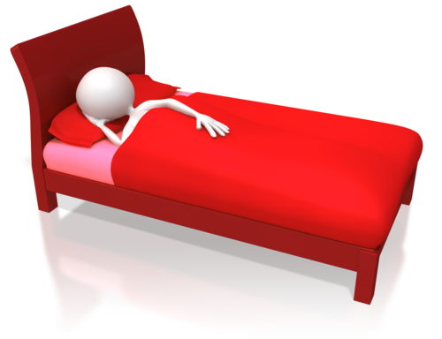

Activity 2A

2.3 – Offer a range of active and restful experiences to children and support them to make appropriate decisions regarding participation

By the end of this chapter, the learner should be able to:
- Schedule appropriate active and restful experiences for children
- Support decisions regarding participation.

Active experiences
Your childcare facility should offer variety of experiences to suit the needs of a range of children. These should cover both active and restful experiences. Children will need to participate in both during their time in your care.
Active experiences will keep children’s minds and bodies engaged and require more energy to participate in than restful experiences.
They can be individual or group activities, depending on the nature of them. You will need to supervise these activities closely, to minimise the risk of any hazards occurring and to manage any conflict that may occur when children are playing together.
Examples of active experiences include:
- Group games
- Sharing activities
- Dramatic play
- Water table
- Sandbox

- Building blocks/Legos
- Outdoor play
- Arts and crafts
- Songs
- Learning activities.

Restful experiences
Restful experiences are less engaging and don’t require as much mental or physical engagement from the child – they are a chance for the children to regain energy lost from their participation in active experiences.
Examples of restful experiences are:
- Napping
- Story time
- Drawing
- Colouring
- Puzzles
- Eating.
You must ensure that the timing of active and restful experiences is scheduled efficiently. For example, you don’t want children to engage in the most active experiences immediately after eating. You will also need to consider how many children can engage in any one activity at once.
Imagine you have four children in your care. It may be more effective if you have two engaging in restful activities while two are doing active things. This will make it easier to manage the children engaged in active experiences, and ensures they will have more space in which to play and interact.
Decisions about participation
The children should have the ability to make decisions about participation that is appropriate to their age or mental development. The older they are, the more freedom to decide they should have.
You could ask them what they would like to do or get them to point to their desired activity. It may be helpful to use closed questions to limit the answers (e.g. “Would you like to do colouring or puzzles?”) as opposed to open ones (e.g. “What would you like to do?”)
If the child doesn’t wish to participate in any, you may need to look for other alternatives or look at underlying reasons for this. For example, are they sad, ill or tired?
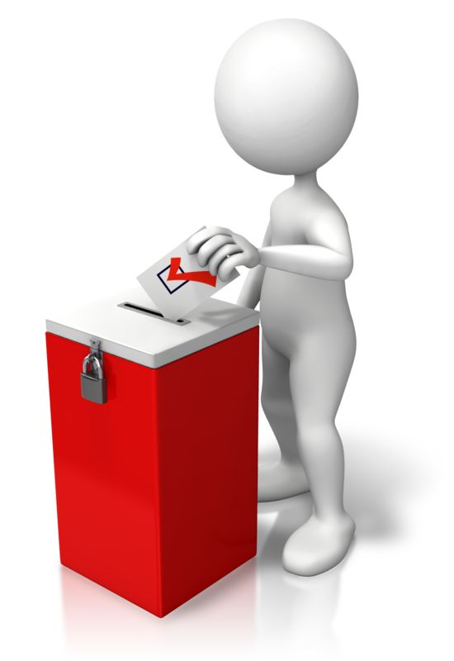

Activity 2B

3. Promote and implement effective hygiene practices
3.1. Ensure that the service accesses information on current hygiene practices
3.2. Maintain written procedures and schedules to ensure a regular regime of washing children’s toys and equipment
3.3. Provide families with information and support that helps them to follow the service’s hygiene procedures
3.4. Ensure that information about correct hand washing procedures are displayed in relevant areas of the service

3.1 – Ensure that the service accesses information on current hygiene practices

3.2 – Maintain written procedures and schedules to ensure a regular regime of washing children’s toys and equipment

3.3 – Provide families with information and support that helps them to follow the service’s hygiene procedures

3.4 – Ensure that information about correct hand washing procedures are displayed in relevant areas of the service

By the end of this chapter, the learner should be able to:
- Access current hygiene information from an appropriate source
- Complete schedules of washing toys/equipment
- Communicate hygiene information to families. This could be done by:
- verbal communication
- written information
- digital technology
- Check necessary information is displayed near toilets and kitchens.

Scheduling washing of children’s toys and equipment
You should ensure there is a written procedure of washing children’s toys and equipment, including when they should be cleaned and correct procedures. This should be always be current; outdated standards can affect your organisation’s hygiene. To ensure the information is up-to-date, you could make a point to check monthly, quarterly or yearly.
Possible sources of information include:
- Hand Hygiene Australia: http://www.hha.org.au/

- National Childcare Accreditation Council: http://ncac.acecqa.gov.au/family-resources/factsheets/hygiene.pdf.
When children have finished playing with a toy, you need to remove it from the play area and place it in a box for dirty toys (which needs to be out of reach from the children). Once they have been washed, they can be returned to the box full of clean toys.
Written schedules will help you to determine how long it has been since particular toys have been washed. Make sure you complete these; otherwise they will be pointless.

Washing of hard plastic toys can be the following way:
- Scrub the toy in warm, soapy water, using bush to reach more difficult to access places
- Rinse the toy in clean water
- Place the toy a solution of mild bleach and water
- Leave to soak for 10 minutes
- Rinse the toy in cool, clean water and leave to air dry.
Hard plastic toys can also be washed in a dishwasher and cloth toys can be washed in a hot water cycle of a washing machine.
Toys should not be shared between groups. Separate groups should have their own collection of toys.
Toys used by older children who don’t put them in their mouths should be washed weekly and whenever they are obviously dirty. The same applies to stuffed toys used by all children. Disinfection is not required, though.
You will need adequate supplies of cleaning equipment on hand to deal with cleaning toys and equipment.
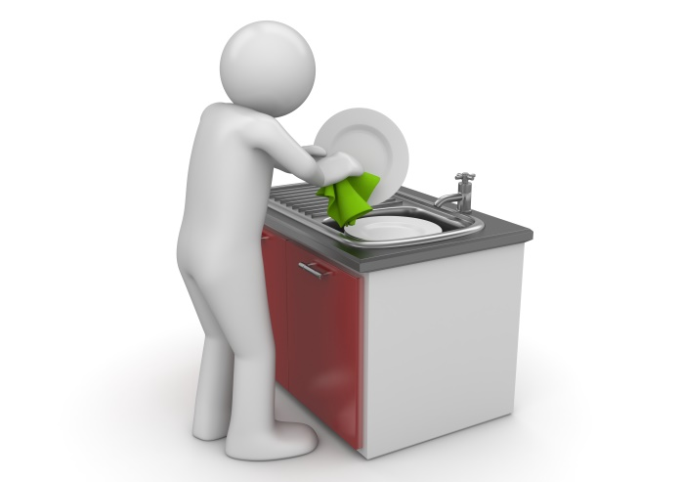
These may include:
- Mild bleach
- Liquid soap
- Disinfectant wipes
- Disposable paper towels
- Sorbolene cream
- Cleaning brushes
- Disposal bags.

Encouraging children to follow hygiene practices
Children should be encouraged to follow hygiene practices, as well as adults. These can be reinforced at certain event/times – for instance: at mealtimes, toileting and changing nappies. This will help children to become self-sustainable for hygienic practices. You should provide positive feedback for children when they perform hygienic practices, to reinforce good habits.
You could also provide this information to the child’s family so they can maintain good standards at home. The information could be communicated through a leaflet, email or talking. Try to answer any further questions they have. If they need further support, try to refer them to someone who can help.
A simple practice is to wash hands on arrival and departure of the child. This minimises the chances of external infections entering the child care facility.
Hand washing should also be practised in these situations:
- Before eating
- After using the toilet
- After touching an animal.
Parents should be encouraged to supply a spare set of clothes, in case of food, liquid and toilet-related accidents.

Hand washing procedure
The following is recommended by the National Health and Medical Research Council:
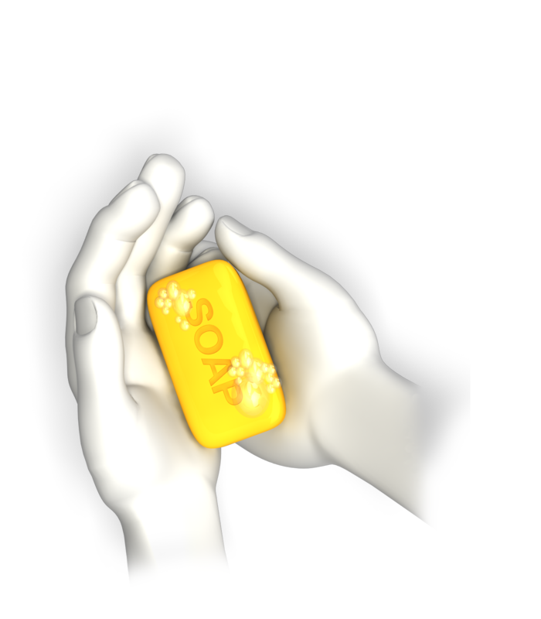
- Wet hands with running water
- Spread liquid soap over hands (use Sorbolene cream for sensitive hands)
- Rub hands all over
- Wash hands all over, including wrists, palms, back of hands, under fingernails and between fingers
- Rinse hands all over to remove all suds from soap
- Turn off tap using disposable paper towel
- Pat hands dry using a new paper towel.
This procedure should be clearly displayed on signage and in an organisation handbook, if applicable.
Families should be informed of all hygiene procedures clearly and encouraged to practice them at home, as well as when they leave their children for care. This can be done verbally, or in writing, as well as through leaflets.
You need to make it clear what is expected, in order to minimise the transfer of external infections into your facility and to other children. You should also be explicit that ill children will not be permitted for care, as it is a health risk and infections would be too hard to contain.

Activity 3A

4. Take steps to control the spread of infectious diseases
4.1. Configure groupings of children to minimise the risk of illness and injuries
4.2. Source information about recognised health and safety guidelines
4.3. Ensure that service procedures are followed, in relation to notifying families of illness or injuries that affect children while in education and care
4.4. Advise families and public health authorities where necessary of cases of infectious diseases at the service and provide them with relevant information
4.5. Ensure current records of children’s immunisation status are up-to-date and a procedure is in place to maintain the currency
4.6. Provide information to families and educators about child and adult immunisation recommendations

4.1 – Configure groupings of children to minimise the risk of illness and injuries

By the end of this chapter, the learner should be able to:
- Configure groups to children’s needs. These may include:
- age-appropriate toys
- ability to explore environment
- illnesses.

Configuring groups of children
As outlined in Chapter 2.1 of this unit, you will need to take care when grouping children. As well as comfort, this minimises the risk of illness and injuries.
Ensure that you have groupings of children of similar ages, so there is a limited chance of younger children being injured by bigger children. Bigger children may unintentionally knock babies over or tread on their fingers during their play.
A good guide for group size is:
- Two-year-olds – Six children per adult
- One-year-olds and below – Four children per adult.
This allows you to control infections and clean up after children effectively, as and when spills happen. This ensures the chance of illness from infection is kept as small as possible.
It also allows you spot developing hazards and remove them before children are exposed to them.
Age-appropriate toys
Children will also need age-appropriate toys and materials to play with. Children under three years of age are still learning through oral exploration of items and may be tempted to put things in their mouths. Some toys and materials are not suitable for chewing and can pose a choking hazard.

For example:
- Buttons
- Cotton wool
- Sequins
- Beads
- String
- Small toys with removable parts
- Marbles
- Small cars.
Configuring groupings, so that the children who are still exploring through their mouths can do so safely, is very important to prevent this.
Empowering children
Grouping children means that each group of children can safely explore their environment in an empowering way. This is because it reduces the amount of time that you have to step in and take items away from children.

Common childhood diseases
Illness | Response
Chickenpox | - Calamine lotion/antihistamines  - Isolate child from other children who haven’t previously had the disease  - Avoid those with compromised immune systems
Whooping cough | - Antibiotics  - Fresh air  - Feed small meals (to minimise risk of vomiting)  - Keep child away from children under one year old  - Exclusion from school until five days of antibiotics have been completed.
Erythema infectiosum (‘fifth’ disease) | - Isolate child until rash disappears
Roseola infantum (three-day-fever) | - Keep child cool by removing clothing layers  - Paracetamol and ibuprofen to reduce fever  - Avoid contact with children under three until temperature has returned to normal
Hand, foot and mouth disease | - Ensure child has plenty to drink  - Mash up food, if mouth ulcers are severe
Scarlet fever | - Antibiotics for ten days  - Avoid contact with other children

Activity 4A

4.2 – Source information about recognised health and safety guidelines

By the end of this chapter, the learner should be able to:
- Source relevant information. This could be from:
- National Quality Frameworks
- local or national health and safety organisations.

Health and safety guidelines
You will need to source information about recognised health and safety guidelines when dealing with childcare.
You will need to know about:
- Infection control
- Infectious diseases
- Immunisation
- Administering medications and procedures
- Managing children with conditions, including:
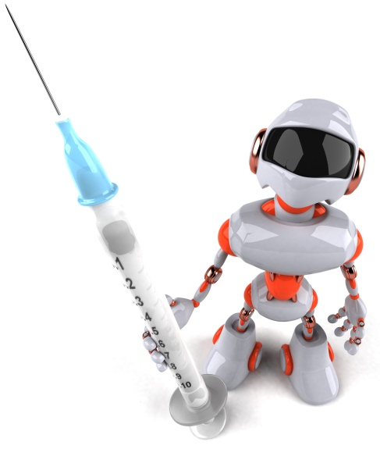
- asthma
- diabetes
- epilepsy
- food allergies
- anaphylaxis
- Dealing with other medical conditions
- Managing emergencies
- Indoor safety
- Outdoor safety
- Environmental hazards
- Travel/excursions
- Child protection
- Staff health and safety
- Pregnant child care health and safety.

National Quality Framework (NQF)
The National Quality Standard (NQS) is part of the National Quality Framework (NQF). It sets a national benchmark for childhood education and care, including that outside of school hours. This includes those factors which affect health and safety.
The benefits of the NQS are:
- Improved educator to child ratios
- Greater individual care and attention for children
- Educators with increased skills and qualifications
- Better support for children’s learning and development
- A national register to help parents assess the quality of education and care services in their area.
More information on the NQS can be found at: http://www.acecqa.gov.au/national-quality-framework/the-national-quality-standard
As a whole, the NQF can be found at: http://www.acecqa.gov.au/national-quality-framework
The information that can be accessed includes:
- Introducing the National Quality Framework
- The National Quality Standard

- National Law and regulations
- Assessment and ratings
- Key changes
- National Quality Framework Snapshots
- Information sheets
- NQF Library
- NQF video resources
- National Quality Framework FAQs
- Excellent rated services.

Activity 4B

4.3 – Ensure that service procedures are followed, in relation to notifying families of illness or injuries that affect children while in education and care

4.4 – Advise families and public health authorities where necessary of cases of infectious diseases at the service and provide them with relevant information

By the end of this chapter, the learner should be able to:
- Carry out procedures relating to illnesses. This may include:
- notifying families of illness or injury
- advising families of infectious disease
- providing information related to infectious disease.

Notify families of illness and injuries
When a child has an illness or is injured in your care, you must be upfront and notify their family about it. Tell them how this illness or injury might affect their ability to be in education or care.
You must include details of when the incident occurred, the circumstances surrounding it and the outcome. You can do this when the families collect their child, as long as it’s not an emergency.
If the incident is an emergency that threatens the child’s/other children’s immediate health, you will then need to inform the family using the emergency contact number they supplied when they registered with you. You should also contact emergency services, where it is a medical emergency. (This should be your first phone call in this scenario).
Ensure you document any illnesses and injuries appropriately.

Advising families and public health authorities
If there is an infectious disease present in your facility, you need to advise families and public health authorities of this.
The information you need to communicate includes:
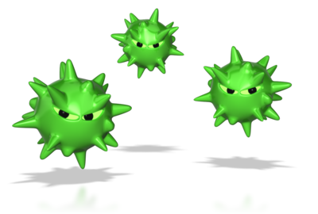
- Origin of infection (if known)
- When the case occurred
- Where it occurred
- Who was affected
- Date of diagnosis
- The type of infection
- The severity of the infection
- The symptoms/consequences of infection
- Measures to contain it
- Exclusion periods of those affected
- Expected time where the facility will be clear from infection
- Contact numbers for those affected
- Travel history of those affected.

Notifiable diseases
There are certain diseases that must be reported to government by law if they occur. This allows the government to monitor the disease and prevent outbreaks from occurring.
Bloodborne diseases may include:
- Hepatitis (NEC)

- Hepatitis B (newly acquired)
- Hepatitis B (unspecified)
- Hepatitis C (newly acquired)
- Hepatitis C (unspecified)
- Hepatitis D.
Gastrointestinal diseases may include:
- Botulism
- Campylobacteriosis
- Cryptosporidiosis
- Haemolytic uraemic syndrome (otherwise known as HUS)
- Hepatitis A
- Hepatitis E
- Listeriosis
- Salmonellosis
- Shiga Toxin-producing E. Coli or Verotoxin-producing E. Coli (otherwise known, respectively, as STEC or VTEC)
- Shigellosis
- Typhoid fever.
Quarantinable diseases may include:
- Cholera
- Highly pathogenic avian influenza (human)
- Plague
- Rabies
- Severe acute respiratory syndrome (otherwise known as SARS)
- Smallpox
- Viral haemorrhagic fever
- Yellow fever.
Sexually transmissible infections may include:
- Chlamydia
- Donovanosis
- Gonococcal infection
- Syphilis-congenital
- Syphilis-less than 2 years’ duration
- Syphilis-more than 2 years’ duration or unspecified duration.
Vaccine preventable diseases may include:
- Diphtheria
- Haemophilus influenza type b

- Influenza (laboratory confirmed)
- Measles
- Mumps
- Pertussis
- Pneumococcal disease-invasive
- Poliomyelitis
- Rubella
- Rubella-congenital
- Tetanus
- Varicella zoster infection-Chickenpox
- Varicella zoster infection-Shingles
- Varicella zoster infection-unspecified.
Vectorborne diseases may include:
- Barmah Forest virus infection
- Chikungunya virus infection
- Dengue virus infection
- Flavivirus infection (unspecified)
- Japanese encephalitis virus infection
- Kunjin virus infection
- Malaria
- Murray Valley encephalitis virus infection
- Ross River virus infection.
Note: Vectorborne means transmitted by an insect or other organism.

Zoonoses may include:
- Anthrax
- Australian bat lyssavirus infection
- Brucellosis
- Leptospirosis
- Lyssavirus infection (NEC)
- Ornithosis (otherwise known as Psittacosis)
- Q fever
- Tularaemia.
Note: The term Zoonoses refers to diseases which are communicable to humans from another animal species.
Other bacterial diseases may include:
- Legionellosis
- Leprosy
- Meningococcal disease-invasive
- Tuberculosis.
Diseases under national surveillance performed by surveillance bodies other than the Department of Health
- Creutzfeldt-Jakob disease (otherwise known as CJD)
- Variant Creutzfeldt-Jakob disease (otherwise known as vCJD)
- Human immunodeficiency virus (otherwise known as HIV)
- Acquired immune deficiency syndrome (otherwise known as AIDS).
Note: The term ‘surveillance bodies other than the Department of Health’ refers to the following non-government bodies:
- Australian National Creutzfeldt-Jakob Disease Registry
- Kirby Institute for infection and immunity in society.
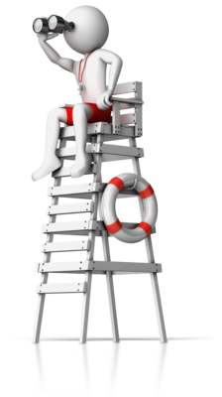
Source: Department of Health, Australian national notifiable diseases by disease type, www.livelonger.health.gov.au/internet/main/publishing.nsf/Content/cda-surveil-nndss-casedefs-distype.htm (accessed 24th May 2017).

Activity 4C

4.5 – Ensure current records of children’s immunisation status are up-to-date and a procedure is in place to maintain the currency

4.6 – Provide information to families and educators about child and adult immunisation recommendations

By the end of this chapter, the learner should be able to:
- Update children’s immunisation records
- Develop procedures to obtain current immunisation records
- Provide information to families about immunisation recommendations.

Immunisation status
You need to keep immunisation records of children up-to-date, to ensure you are aware of infectious diseases they may be liable to catch.
The following table outlines the ages recommended for certain vaccines:
Age | Disease vaccine required for
At birth | - Hepatitis B
Two months | - Diphtheria  - Tetanus  - Pertussis  - Polio  - Hib  - Hepatitis B  - Pneumoccocal  - Rotavirus
Four months | - Diphtheria  - Tetanus  - Pertussis  - Polio  - Hib  - Hepatitis B  - Pneumoccocal  - Rotavirus

Six months | - Diphtheria  - Tetanus  - Pertussis  - Polio  - Hib  - Hepatitis B  - Pneumoccocal  - Rotavirus
Twelve months | - Measles  - Mumps  - Rubella  - Hib  - Meningococcal C
Eighteen months | - Measles  - Mumps  - Rubella  - Varicella
Four years | - Diphtheria  - Tetanus  - Pertussis  - Polio  - Measles (part of MMR vaccine)  - Mumps (part of MMR vaccine)  - Rubella (part of MMR vaccine)

The MMR vaccine is only required at four years if the MMRV vaccine was not given at 18 months.
(Source: http://www.immunise.health.gov.au/internet/immunise/publishing.nsf/Content/national-immunisation-program-schedule)
You should provide information of these vaccination dates to families and educators as standard.
You need to have a process for keeping the currency of your records up-to-date. This could be a form for parents to fill in when they have taken their child for immunisation. You will then record these in your organisation’s files on the applicable children.
You could also set up a system on a computer where an alert is displayed when children in your care reach the ages specified in the table above. This would then prompt you to ask the child’s family whether they have had said vaccinations, and update your records accordingly.
Recommendations
Although immunisations can be a sensitive topic for some families, it is your responsibility as a carer of children to ensure that they receive the necessary ones whenever possible. Therefore, you can provide recommendations to the parents.
Parents may have questions about vaccines. Some of the possible responses to them are listed here: https://www.cdc.gov/vaccines/hcp/conversations/downloads/talk-infants-color-office.pdf. For example, if a parent says: “I’m really not comfortable with my 2-month-old getting so many vaccines at once”, you could respond: “There’s no proven danger in getting all the recommended 2-month vaccines today. Any time you delay a vaccine you leave your baby vulnerable to disease. It’s really best to stay on schedule. But if you’re very uncomfortable, we can give some vaccines today and schedule you to come back in two weeks for the rest, but this is not recommended.”
You may also have to make recommendations to families if they haven’t completed their immunisation either. Emphasise that this is for the child’s safety.


Activity 4D

5. Ensure adequate supervision of children
5.1. Arrange equipment, furniture and activities to ensure effective supervision while also allowing children to access private and quiet spaces
5.2. Ensure new or relief educators are informed of supervision arrangements and of what they are required to do in relation to supervising children
5.3. Undertake a risk assessment for each excursion including implications for supervision

5.1 – Arrange equipment, furniture and activities to ensure effective supervision while also allowing children to access private and quiet spaces

By the end of this chapter, the learner should be able to:
- Arrange furniture in a suitable manner. They should consider:
- quiet and private areas
- hazards that are minimised
- size and layout of furniture.

Arrange equipment, furniture and activities
The arrangement of equipment, furniture and activities is important, as it will affect your ability to monitor children competently.
The following guidelines are useful:
- Ensure that hazardous equipment and items are kept of reach of children
- Ensure fire escapes are unobstructed by furniture and equipment
- Ensure you have a clear view of play and rest areas, removing/rearranging obstructing furniture
- Ensure sharp edges of furniture are covered with soft padding
- Ensure tripping hazards (e.g. wires) are kept out of play and rest areas
- Ensure strangulation hazards (e.g. wires) are kept out of play and rest areas
- Make sure accessible furniture is the right height – e.g. children’s feet should touch the floor when sitting in a chair (otherwise they can fall off and hurt themselves)

- Ensure any electrical outlets are covered
- Hold activities in adequately-spaced areas.
Be aware that children may need to access private and quiet spaces, where they may be temporarily out of sight.
You must ensure these areas are free from hazards, including:
- Choking hazards
- Sharp objects
- Exposed electrical outlets
- Open window
- Unlocked doors into hazardous areas
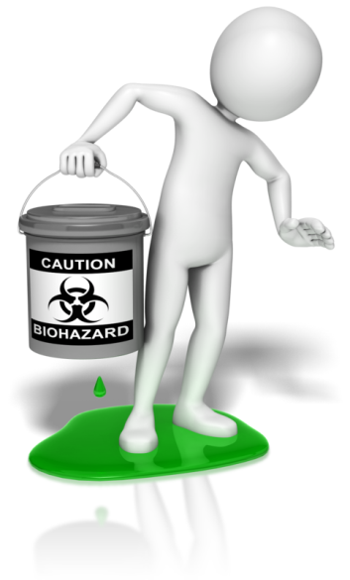
- Tripping hazards
- Low, open windows
- Stairs/steps
- Protruding sharp edges
- Splintered wood
- Storage cabinets that can be opened without locks
- Unstable furniture (e.g. bookshelves)
- Strangulation hazards
- Slippery surfaces
- Poisonous objects (e.g. certain plants, cleaning agents)
- Loose fittings on walls and ceilings.
Ensure that children are always within audible distance when they are out of your sight. It is a good idea to keep a device like a baby monitor in rest areas, so you can hear and attend to any situations that develop.
When children are engaged in certain activities, they will require a greater degree of supervision.
For example, when exposed to any body of water (e.g. swimming pool, water table, bath, etc.), children need constant, close supervision – young children can drown easily, even in just a few inches of water.
When planning activities, ensure you have adequate space and that no hazards are present. While you are conducting these activities, be aware of who is present, as you will need to keep all children within monitoring distance.

Activity 5A

5.2 – Ensure new or relief educators are informed of supervision arrangements and of what they are required to do in relation to supervising children

By the end of this chapter, the learner should be able to:
- Develop systems to inform new or relief educators of arrangements. These may include:
- medical issues and responses
- activities and schedules
- eating and toilet requirements.

Supervision arrangements
In an education settings, new or relief teachers will need to be informed of supervision arrangements and the requirements for specific children, so their care is kept consistent.
The supervision arrangements you may need to inform them of include:
- Normal rest times
- Health and safety guidelines
- Allergies
- Medication
- High-risk activities
- Location of activities
- Location of toilet facilities
- Emergency contact numbers
- Play schedules
- Any disabilities of children (if applicable)
- Amount of adults required to supervise children
- Areas that are off-limits to children
- Children must be within sight or hearing of educators at all times
- Children must be supervised while eating
- Children must be supervised during toileting and nappy change
- Emergency and evacuation procedures
- The abilities and needs of individual children.
There are also various legislative requirements that educators must be aware of:
Children (Education and Care Services National Law Application) Act 2010
Education and Care Services National Regulations 2011:
115 Premises designed to facilitate supervision
(1) The approved provider of a centre-based service must ensure that the education and care service premises (including toilets and nappy change facilities) are designed and maintained in a way that facilitates supervision of children at all times that they are being educated and cared for by the service, having regard to the need to maintain the rights and dignity of the children.
120 Educators who are under 18 to be supervised
(1) The approved provider of a centre-based service must ensure that any educator at the service who is under 18 years of age
a) does not work alone at the service; and
123 Educator to child ratios—centre-based services
(1) The minimum number of educators required to educate and care for children at a centre-based service is to be calculated in accordance with the following ratios;
a) for children from birth to 24 months of age—1 educator to 4 children;
271 Educator to child ratios—children aged 36 months or more but less than 6 years
(1) The educator to child ratio for children aged 36 months or more but less than 6 years of age is 1 educator to 10 children.
275 Educator to child ratio—centre-based service—children aged over 24 months and less than 36 months
(2) The educator to child ratio for a centre-based service for children aged over 24 months but less than 36 months is 1 educator to 8 children.

National Quality Standards relating to supervision

 | Concept | Descriptor
2.2 | Safety | Each child is protected
2.2.1 | Supervision | At all times, reasonable precautions and adequate supervision ensure children are protected from harm and hazard.
2.2.2 | Incident and emergency management | Plans to effectively manage incidents and emergencies are developed in consultation with relevant authorities, practised and implemented.
2.2.3 | Chid protection | Management, educators and staff are aware of their roles and responsibilities to identify and respond to every child at risk of abuse or neglect.

Other relevant elements on the NQS include:
 | Concept | Descriptor
3.2.1 | Inclusive environment | Outdoor and indoor spaces are organised and adapted to support every child's participation and to engage every child in quality experiences in both built and natural environments.
4.1.1 | Organisation of educators | The organisation of educators across the service supports children's learning and development.
5.1.2 | Dignity and rights of child | The dignity and rights of every child are maintained.

(Source: https://www.acecqa.gov.au/sites/default/files/acecqa/files/NQF/RevisedNQSHandoutA4_2.pdf)



Activity 5B

5.3 – Undertake a risk assessment for each excursion including implications for supervision

By the end of this chapter, the learner should be able to:
- Undertake a risk assessment for an excursion. This may include:
- hazards
- transport
- changes in duties.

Excursion risk assessments
For each excursion children are taken on in your care, you will need to conduct a risk assessment and take the necessary precautions to control or prevent identified risks. This can be done by using the risk assessment and risk matrix templates on the following pages.
Think of the implications for supervision; high-risk activities will inevitably justify a higher degree of supervision and fewer children per adult.
As an example, let’s look at taking a group of five children under six-years-old to the local park’s outdoor play area.
The sorts of risks you will need to consider include:
- Transport – how will you get there? Is it a high flow traffic route?
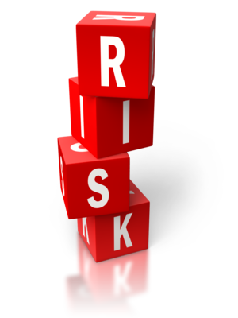
- The presence of strangers
- The presence of animals
- The safety of the play equipment
- Tripping hazards
- Presence of sharp edges
- Sand pits (if applicable)
- Water tables (if applicable)
- Sharp objects on the ground/in sand pits
- Animal waste on the ground/in sand pits
- Slippery surfaces
- Falls from high surfaces.
To deal with this, you should carry out an inspection of the site before you take the children and remove the hazards you spot. For those hazards that are beyond your control, you should set out control measures. You may need to bring an extra adult with you to help supervise the outing.

Risk assessment template
Excursion name |  |  | Location |  |  |  | Persons at risk
Tasks for excursion | Hazards | Risks | Risk rating |  |  |  | Control measures
Tasks for excursion | Hazards | Risks | Likelihood | Impact |  | Risk rating | Control measures
Risk assessment completed by:  Signature:  Date: |  |  |  |  | Risk assessment approved by:  Signature:  Date:

Risk Matrix

 | Impact
Likelihood |  | Insignificant | Minor | Moderate | Major | Severe
Likelihood | Almost certain | Medium | High | High | Very high | Very high
Likelihood | Likely | Medium | Medium | High | High | Very high
Likelihood | Possible | Low | Medium | High | High | Very high
Likelihood | Unlikely | Low | Low | Medium | Medium | High
Likelihood | Rare | Low | Low | Medium | Medium | Medium

Activity 5C

6. Take precaution to protect children from harm
6.1. Ensure safety checks are consistently implemented and action is taken as a result of the checks
6.2. Check risk minimisation plans are in place for children enrolled at the service who have a specific health care need, allergy or relevant medical condition
6.3. Ensure simple warning signs are located where potentially dangerous products are stored
6.4. Confirm safety of any drinks, food and cooking utensils and appliances used as part of the program
6.5. Ensure that basic training and testing on how to move and fit car seats, restraints and booster seats (applicable to the age of relevant child) is available to all educators
6.6. Keep records of pest/vermin inspections and/or eradications
6.7. Develop and maintain a written process for monitoring who enters and leaves the premises at all times
6.8. Provide detailed information to families regarding any excursion being undertaken

6.1 – Ensure safety checks are consistently implemented and action is taken as a result of the checks

By the end of this chapter, the learner should be able to:
- Develop systems to ensure safety checks are implemented
- Develop systems to ensure action is taken following checks.

Safety checks
In relation to risk assessment, you must regularly assess the safety of the environment for children. Be aware that just because the environment was safe last time children were there, it may not stay this way.
For example, there may be new objects in the area since you were last there. There may be external forces that have changed the nature of the environment. For example, if you have a hard floor and have just mopped it, this has increased the risk of slipping.
The following is an example checklist that you can use to perform a safety check of the environment:
Check | Yes/no | Corrective action (if applicable)
Are there any slippery surfaces?
Are there exposed electrical outlets?
Are there loose wires?
Are there any tripping hazards?
Are there any sharp edges exposed?
Are there any sharp objects within children’s reach?
Are there any hazardous chemicals within children’s reach?
Is there any splintered wood?
Is there a fully-stocked First Aid kit on-site?
Are hygiene standards clearly displayed on the premises?
Are hygiene facilities clean?
Are hygiene products adequately stocked?
Are hazardous areas accessible to children?
Are fire exits clearly signed and accessible?
Are there smoke and carbon monoxide detectors on-site?
Are children in care tracked for entering and leaving the facility?
Do you have contact and emergency contact numbers for all children in care?
Are details of allergies recorded?
Are details of required medications recorded?
Is required medication well-stocked on-site?
Are low windows shut or guarded?
Are heating systems well ventilated?
Is sunlight and fresh air accessible in designated area?
Are there any choking hazards within reach of children?
Are open bodies of water accessible to children?
Are stairs or climbable objects accessible to children?
Is designated area obstructed from view?

It is important to carry safety checks out whenever necessary, such as when you enter a new area. Having a system will reduce the likelihood of you missing anything.
You should ensure appropriate action is taken as a result of the checks. For example, if you identify any hazards, make sure you remove them. It can be useful to record the actions that were taken in case anything goes wrong.

Activity 6A

6.2 – Check risk minimisation plans are in place for children enrolled at the service who have a specific health care need, allergy or relevant medical condition

By the end of this chapter, the learner should be able to:
- Ensure risk minimisation plans are in place where required
- Create a risk minimisation plan if necessary.

Risk minimisation plans
Risk minimisation plans are those which outline identified and unavoidable risks and detail the appropriate actions to take to minimise risks.
In the field of child care and early education, you will need to have risk minimisation plans in place for children with specific health care needs, allergies or relevant medical conditions. Check they are in place for all children who need them, and that they contain the relevant information. If they aren’t, you will need to take prompt action to create one.
The templates on the following pages can be used to create risk minimisation strategies for these children.
Name of service provider:
Name of guardian: |  | Phone number of guardian:
Name of child: |  | Date of birth:
Details of medical/health condition(s):

Action plan provided by guardian:
Medication required:

Contact details of guardians: | Name:  Relationship:  Home phone:  Work phone:  Mobile phone:  Address: |  | Name:  Relationship:  Home phone:  Work phone:  Mobile phone:  Address:
Emergency contact: | Name:  Relationship:  Home phone:  Work phone:  Mobile phone:  Address:
GP contact: | Name:  Phone:  Address:
Emergency First Aid/care procedures:

Storage details of medication:

Date of risk minimisation plan review:
Signature of parent/guardian |  | Date:
Signature of principal/carer: |  | Date:

Risk control template (for schools)
Student’s name:
Date of birth: |  | School level/year:
Triggers of condition:

Risk: | Control strategy: |  | Person responsible for strategy:

Activity 6B

6.3 – Ensure simple warning signs are located where potentially dangerous products are stored

By the end of this chapter, the learner should be able to:
- Identify simple warning signs commonly used in childcare. This may include:
- chemicals
- heat
- slippery floor
- Check whether signs are adequately used in childcare locations and make changes if not.

Warning signs
It is important that warning signs are displayed by areas where potentially dangerous products are stored.
The following outline some basic warning signs and symbols you can use:
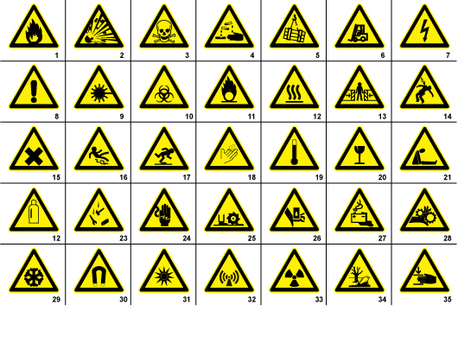
(Source: https://signsanddisplays.wordpress.com)
These signs represent:
- Flammable materials sign or symbol
- Explosion risk sign or symbol
- Toxic sign or symbol
- Corrosive sign or symbol
- Overhead crane sign or symbol
- Fork lift in operation sign or symbol
- High voltage sign
- General warning sign or symbol
- Laser radiation sign or symbol
- Biohazard sign or symbol

- Oxidising sign or symbol
- Hot surface sign or symbol
- Entrapment risk sign or symbol
- Electrocution risk sign or symbol
- Irritant sign or symbol
- Slippery floor sign or symbol
- Watch your step sign or symbol
- Cutting risk sign or symbol
- High temperature sign or symbol
- Glass hazard sign or symbols
- Suffocation sign or symbol
- Gas bottle sign or symbol
- Falling objects sign or symbol
- Electricity sign or symbol
- Cutter sign or symbol
- Hand hazard sign or symbol
- Battery hazard sign or symbol
- Rotating parts sign or symbol
- Low temperature sign or symbol
- Magnetic field sign or symbol
- Optical radiation sign or symbol
- Non-ionising radiation sign or symbol
- Radiation sign or symbol
- Environmental hazard sign or symbol
- Crushing hazard sign or symbol
Simple ‘do not enter’, ‘keep out’, ‘keep locked at all times’ and ‘keep out of reach of children’ signs are also useful when dealing with potentially dangerous products around children.

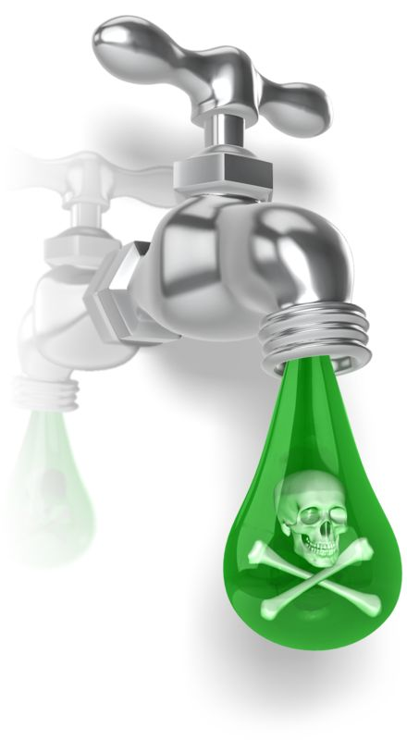

Activity 6C

6.4 – Confirm safety of any drinks, food and cooking utensils and appliances used as part of the program

By the end of this chapter, the learner should be able to:
- Confirm safety of relevant food, drink and equipment. This may include:
- cleaning schedule
- lack of contamination
- storage away from children.

Safety of any drinks, food and cooking utensils and appliances
All drinks, food and cooking utensils and appliances used as part of your program must be safe to use for both adults and children.
You need to be aware of cross-contamination issues when dealing with food and drinks, as well as the utensils and appliances used to prepare them.
Ensure that appliances are electrically tested and that they are out of reach of children. Make sure that carbon monoxide and fire alarms are fitted nearby all cooking station, in the event that a fire starts or there is a gas leak.
Ensure that cooking utensils and appliances are regularly cleaned, as they can be excellent places for harmful bacteria to congregate and multiply (especially when they have come into contact with raw food).
When cooking raw food, make sure any surfaces it comes into contact with are properly cleaned, as well as any skin and clothing that has come into contact with it, before you touch any other food. Ensure that raw food does not come into contact with other food also.
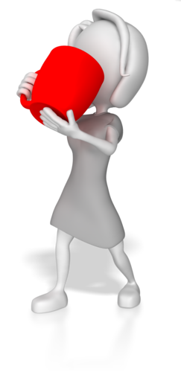
Ensure that the food and drinks you are using don’t contain any substances children (or staff) are allergic to. If you have a child who is allergic to one ingredient, yet other children are having food with this in, ensure you prepare the allergic child’s food separately, on cleaned surfaces, using cleaned utensils and hands; if possible, prepare the items in a separate area entirely.
For food and drink utensils, ensure that utensils have no sharp edges for small children and that they are cleaned. Children must not share utensils between washes.
You should have special cutlery for small children. These are smaller (so easier to handle) and have rounded blades on the knife and fork, to minimise the risk of injury. Note that you may need to cut some food for children that cannot handle these utensils.
The following are food safety hygiene requirements, which you should adhere to when dealing with food.
Personal hygiene requirements
Minimum personal hygiene requirements are specified by the food safety program and must, at a minimum, meet legal requirements as set out in Food Safety Standard 3.2.2, Division 4:13 and/or state legislation/regulations. The Australia New Zealand Food Safety Standards Code sets out guidelines for working safely with food.
Section 3.2.2, Division 4:13 states:
“A food handler must take all reasonable measures not to handle food or surfaces likely to come into contact with food in a way that is likely to compromise the safety and suitability of food.”
Your hygiene requirements
When working with food, it is important that you are clean, your clothes or uniform are clean and appropriate, and that you work hygienically with food. Make sure that you wash regularly to avoid contamination of food and your workplace.
You may need to:
- Tie long hair back, or wear a hair net
- Remove all jewellery
- Remove false nails and eyelashes
- Remove all makeup
- Wear rubber gloves when handling some food products.
Further hygiene requirements
The below requirements will also be expected of you when working with food and should be strictly followed.
Personal hygiene requirements set out in Food Safety Standard 3.2.2, Division 4:15 includes:
- Taking all practicable measures to ensure that a food handlers body, and anything they are wearing does not contaminate food or surfaces
- Taking all practicable measures to prevent contact with ready-to-eat food
- Ensuring level of outer clothing is appropriate for food handling
- Using only waterproof bandages and dressings on exposed body parts
- Not eating over unprotected food or surfaces likely to come into contact with food
- Not sneezing, blowing or coughing over unprotected food or surfaces likely to come into contact with food
- Not spitting, smoking or using tobacco or similar preparations in areas in which food is handled
- Not urinating or defecating except in the toilet
- Washing hands:
  - whenever hands are likely to be a source of contamination
  - immediately before working with ready-to-eat food after handling raw food
  - immediately after using the toilet
  - before commencing or recommencing food handling
  - immediately after smoking, coughing, sneezing, using a handkerchief or disposable tissue, eating, drinking or using tobacco or similar substances
- When washing hands:
  - use hand washing facilities provided
  - thoroughly clean hands using soap or other effective means, and warm running water
  - thoroughly dry hands on a single use towel or other way that is not likely to transfer pathogenic micro-organisms to the hands.


Activity 6D

6.5 – Ensure that basic training and testing on how to move and fit car seats, restraints and booster seats (applicable to the age of relevant child) is available to all educators

By the end of this chapter, the learner should be able to:
- Ensure that training on car seats is available. This may include:
- researching local training providers
- acquiring funds from organisation
- determining type and extent of training required.

Moving and fitting car seats, restraints and booster seats
You need to ensure that educators are trained in how to move and fit car seats, restraints and booster seats. Therefore, you will need to provide access to basic training and testing. You may need to organise this by containing a local training provider and acquiring funds from your organisation. It is also important to determine the type and extent of training needed.
More information on child car seats and the legal requirements can be found at: https://www.childcarseats.com.au
There is also a handy guide, produced by Which? that gives ten fitting checks, to ensure safety and efficiency of the seat: http://www.which.co.uk/documents/pdf/10-child-car-seat-checks-pdf-363028.pdf
You must ensure that:
- The seatbelt/harness is secure and untwisted
- Rearward facing seats have handlebars facing in the correct direction
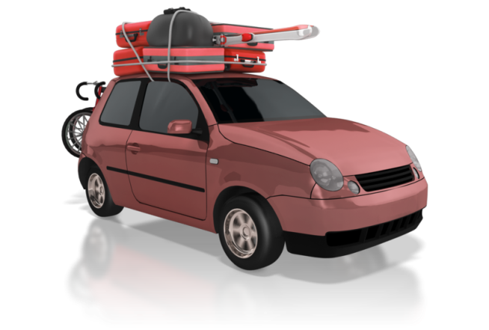
- The child seat is sitting squarely on the car seat
- The headrest is in the correct position
- The seatbelt follows the correct route guides
- The seatbelt buckle is in the correct place
- Isofix seat visual indicators show seat is correctly fitted to the car
- Isofix drop-down foot is securely on the floor
- Isofix top tether is firmly attached
- Thick clothes are removed on child in seat
- Shoulder pads are level with younger children’s shoulders
- Harness is not excessively tight or loose
- Seatbelt is across shoulder and hips for older children.

Where to fit child seats
Car seats should be fitted on a back seat in a rear-facing position – the middle seat is usually the best, if fitting allows.
If the car has side airbags, the child should be positioned correctly in the car seat and nor leaning close to or against the car window or door. You must never use a rear-facing seat on a car seat that has a front airbag, unless the airbag has been deactivated. This is illegal and unsafe practice.

Types of child seat to use
Children must stay in a rear-facing child seat until they are six months old. However, you should ideally use a rear-facing seat for as long as possible, as this is the safest option.
A child has outgrown a seat when their eye-line is level with the top of the seat. At this point, you will need to upgrade to a larger one.
A forward-facing seat is suitable for children who can hold their heads up independently for at least 30 minutes.
Legally, these are the following requirements in Australia:
- Up to six months – The child must be restrained in an approved rear-facing child restraint, specially designed for new-born babies e.g. an infant capsule or a convertible car seat
- Six months to four years old – The child must sit in a rear-facing or forward-facing child restraint, e.g. a child safety seat
- Four years old to seven years old – The child must sit in either a forward-facing child restraint or a booster seat; they must be secured by a correctly adjusted and fastened seatbelt or child safety harness
- Seven years old to 16 years old – The child must use a booster seat or a seatbelt, correctly adjusted and fastened.

(Source: http://roadsafety.transport.nsw.gov.au/)

Activity 6E

6.6 – Keep records of pest/vermin inspections and/or eradications

By the end of this chapter, the learner should be able to:
- Keep records of pest/vermin control. This may include:
- previous inspections and their results
- eradication attempts, use of pesticides and the results
- current infestations.

Records of pest/vermin inspections and/or eradications
In the event that you have pest/vermin inspections and/or eradications, you will need to document them.
The types of information required are:
- Date of inspection
- Areas inspected
- Pests/vermin discovered (if applicable)
- Site of infestations
- Methods of eradication
- Methods of pest/vermin disposal
- Use of any pesticides.
Pests/vermin should never be encouraged into your premises as, once they establish themselves, it can be hard to eliminate them. Pests/vermin can be attracted by food, and also the prospect of a safe home for nesting.


Keep pests/vermin out of the workplace
Make sure you remove all food waste and rubbish each day and check that your premises are protected from pests/vermin regularly.
You will need to thoroughly clean floors and the places where food has been prepared and cooked within your workplace through the working day. Check for spillages of food stuffs in and around doors, fridges and store areas and make sure that any spills are cleaned to avoid attracting pests/vermin. Remember that most pests/vermin searching for food will have a far keener sense of smell and ability to locate food sources than humans. What may seem to be an insignificant amount of flour or crumbs in a storage area will be a veritable feast for pests/vermin.
Pests/vermin can include:
- Insects
- Arachnids
- Mice
- Rats
- Birds
- Any unwanted animal that can contaminate food or the workplace.
Pest-proofing the workplace
Your employer may need to place fine wire meshing across certain windows, check that all external pipe, guttering and ventilation does not allow easy access into the building, and that doors have suitable flashing to deter pests/vermin, or are self-closing. The addition of an internal fly-mesh door may also be useful.
Check to see if there are any small holes in brickwork and walls, both inside and outside. If there are, inform your supervisor/employer as these should be blocked to prevent access into the work area. Be vigilant and keep an eye out for any signs of pest/vermin activity within the workplace.

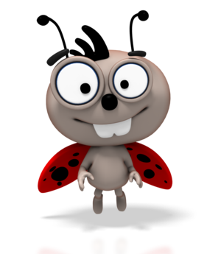
Signs of pest/vermin presence
Signs to look out for include:
- Animal droppings
- Gnawing or chewing of food packaging or equipment
- New holes within the workplace
- Visible sightings of pests/vermin
- Noise of pest activity within and around the work premises.
If you notice any signs of pests/vermin or any evidence of pest activity, you should report this to your supervisor immediately. Your supervisor will assess the risk and determine the best course of action for your place of work.
It may be that the pest problem can be sorted directly and quickly, without difficulty to the workplace. Alternatively, if the pests/vermin are not easy to eliminate or control, it may be that your employer will need to use a pest-control company to eradicate the problem.

Activity 6F

6.7 – Develop and maintain a written process for monitoring who enters and leaves the premises at all times

By the end of this chapter, the learner should be able to:
- Develop a written process for monitoring visitors if not already include. This may include:
- name of parent and child
- arrival/departure time and date
- Use the written process consistently.

Monitoring who enters and leaves the premises
You will need to develop a process for monitoring people entering and leaving your premises.
This can be a simple sign in sheet that requires people to enter their details when leaving and entering the premises.
The below is a simple template you can use:
Name of child | Name of guardian/parent | Date | Arrival time | Signature | Departure time | Signature

This sign in sheet can be located at the entrance to the premises, with a pen attached.
This data will help resolve any attendance disputes and is useful for a roll call situation – for example, if there is an evacuation due to a fire.

Activity 6G

6.8 – Provide detailed information to families regarding any excursion being undertaken

By the end of this chapter, the learner should be able to:
- Provide excursion information to families. This may include:
- dates, times and schedules
- destination and transport
- potential hazards and safety precautions.

Informing families of excursions
The excursions you intend to take children must be discussed in detail with parents and guardians.

You will need to inform them of details such as:
- Where you intend to go
- When you intend to go
- When you intend to return
- Methods of transport
- Reason(s) for the excursion
- The total amount of children on the excursion
- The amount of adults supervising the excursion
- Any risks/hazards that may occur
- Any clothing/equipment children will need to bring with them
- Cost of the excursion (if applicable).
If necessary, you should create a permission slip for parents and guardians to sign. This will be accompanied by a letter explaining all of the above. This ensures you are covered for liability and that parents/guardians are fully aware of the situation.

Example permission slip:
Your organisation’s address:

Date:
Dear parent/guardian,

Details of the excursion, including:
- Where you intend to go
- When you intend to go
- When you intend to return
- Methods of transport
- Reason(s) for the excursion
- The total amount of children on the excursion
- The amount of adults supervising the excursion
- Any risks/hazards that may occur
- Any clothing/equipment children will need to bring with them
- Cost of the excursion (if applicable)
I (name of parent/guardian) ………………………………… hereby give permission for (name of child)

………………………………………….. on (date of excursion) ………………………

Signature of parent/guardian: ………………………………………………….. Date: ………………………..
Signature of teacher/carer: ………………………………………………………. Date: ………………………..

Activity 6H

7. Develop plans to effectively manage incidents and emergencies
7.1. Ensure emergency procedures are displayed prominently throughout the premises
7.2. Make certain that all educators have ready access to a phone or similar means of communication
7.3. Ensure emergency numbers are located near telephones
7.4. Communicate information to families about the service’s emergency procedures and incident management plans
7.5. Discuss and practise emergency drills with children, educators and any other people on the premises
7.6. Ensure that emergency equipment is available and tested and staff are trained in the use of it
7.7. Maintain a portable record of children’s emergency contacts in case of emergencies

7.1 – Ensure emergency procedures are displayed prominently throughout the premises

By the end of this chapter, the learner should be able to:
- Display emergency procedures and other relevant information where required in premises. These may include:
- fire evacuation
- first aid.

Displaying emergency procedures
Emergency procedures may include:
- Fire evacuation
- First Aid.
You should ensure they are displayed in prominent places (e.g. near exits) and communicated verbally to children who are unable to read.

Fire safety
In the event of a fire:
- Sound the fire alarm
- Gather all children from every room and proceed to the nearest Fire Exit and congregate at the Assembly Point – this should be as far from the building as possible
- Ensure the nominated person checks the building and closes any doors (only leave doors open for bomb threats)
- Call the emergency services and ask for the Fire Services
- Take a register of all children and staff at the Assembly Point
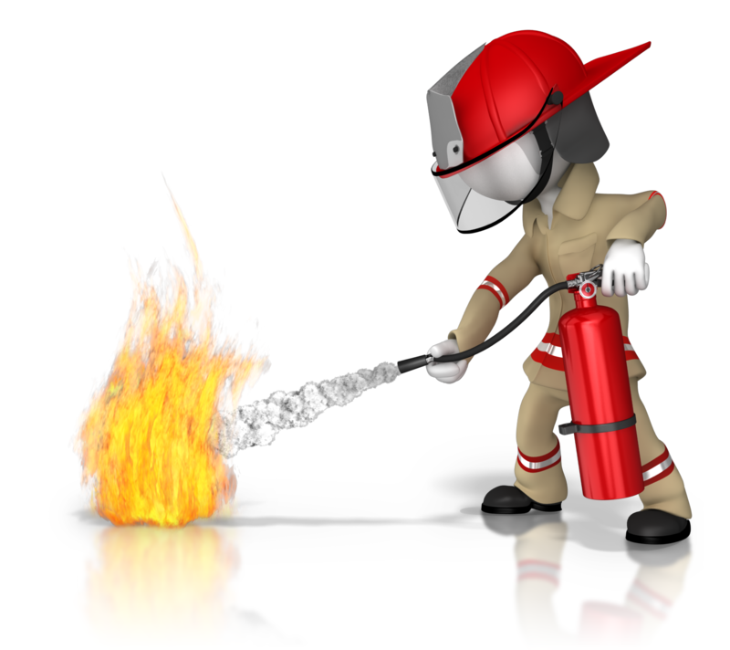
- The person in charge will decide if the building is safe to re-enter, after consulting with the Emergency Services
- Record all details in a Fire Log Book.

First Aid
In some instances, you may need to provide basic First Aid to children in your care. You will need to assess the casualty in this instance.
Assess the casualty
It’s important to be clear on whether a person needs help and what type of help is required, and then whether you can give it on your own, or if you need to call for emergency response services as well. Oftentimes, your first aid response can reduce the harm and discomfort that a casualty will experience before receiving help from a professional.
There are many situations that require first aid response from educators:
- Allergic reactions

- Anaphylaxis
- Asthma
- Basic wound care
- Severe bleeding
- Burns
- Cardiac arrest
- Choking and airway obstruction
- Convulsions, including febrile convulsions
- Envenomation (using pressure immobilisation)
- Epilepsy and seizures
- Fractures, sprains and strains (using arm slings, roller bandages or other appropriate immobilisation techniques)
- Head injuries
- Poisoning
- Respiratory distress
- Shock.
Full details of First Aid procedures can be found in unit HLTAID004: Provide an emergency first aid response in an education and care setting.
The procedures for both fire safety and First Aid should be prominently displayed to staff, so they can easily be referred to when needed.

Activity 7A

7.2 – Make certain that all educators have ready access to a phone or similar means of communication

7.3 – Ensure emergency numbers are located near telephones

By the end of this chapter, the learner should be able to:
- Ensure phone or communication access for all educators
- Display relevant emergency numbers. These may include:
- emergency services (e.g. police, fire, ambulance)
- family and guardians.

Phoning in emergencies
Educators should have ready access to a phone on the premises. This is to be used to phone in emergencies and to contact parents, when necessary. When they leave the premises (for example, for an excursion), make sure they have a phone on them then. Verbally check with them before they go out.
If for some reason phones aren’t possible, similar devices like pagers or walkie talkies could also be used.
Emergency numbers should be located near telephones. This includes the emergency services number (000), for Police, Fire and Ambulance services. You should also have the emergency contact numbers of parents and guardians for all of the children in your care.
It is a good idea to have emergency numbers displayed on a sign and to keep a book of all emergency guardian contacts next to the phone, as this means easy access when required.

Activity 7B

7.4 – Communicate information to families about the service’s emergency procedures and incident management plans

By the end of this chapter, the learner should be able to:
- Communicate emergency procedure/incident management information to families. These may include:
- what the procedures are
- when they will need to be used
- what incident management plans are.

Communicate emergency information to families
Families should be made aware of the service’s emergency procedures and incident management plans.
This can be done in a letter that you send out to all families and can also be displayed on your organisation’s website, if you have one. Ensure it is kept up to date.
The type of information you need to communicate about emergency procedures includes:
- What the procedures are
- When they will need to be used
- What incident management plans are.
Incident management plans outline the identification, analysis and correction of hazards, in order to prevent future reoccurrences.
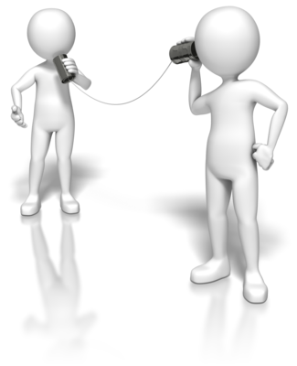

Activity 7C

7.5 – Discuss and practise emergency drills with children, educators and any other people on the premises

7.6 – Ensure that emergency equipment is available and tested and staff are trained in the use of it

By the end of this chapter, the learner should be able to:
- Make children and others aware of emergency drills through discussion
- Carry out emergency drills and test equipment
- Ensure staff training for emergency drills is at necessary level.

Emergency drills
You will need to discuss and practice emergency drills with children, educators and any other people on the premises. This will ensure they are competent in the event of an actual emergency, which will minimise the risk.
The Building Fire Safety Regulation 2008 requires one fire drill to be conducted per year – however, once per term at a school is a good guide. These fire drills should be kept as realistic as possible, so as to create the best preparation environment possible.
As mentioned previously, the procedure for fire drills is as follows:
- Sound the fire alarm
- Gather all children from every room and proceed to the nearest Fire Exit and congregate at the Assembly Point. This should be as far from the building as possible
- Ensure the nominated person checks the building and closes any doors
- Call the emergency services and ask for the Fire Services
- Take a register of all children and staff at the Assembly Point
- Decide if the building is safe to re-enter, after consulting with the Emergency Services

- Record all details in a Fire Log Book.

Emergency equipment
The emergency equipment required to deal with actual emergencies should be on-site and tested, with all staff trained in its use.
Types of emergency equipment include:
- Fire extinguishers, which may contain:
  - powder
  - water
  - foam
  - CO₂, for electrical fires
- Fire blankets
- First Aid kit.
When using any emergency equipment, always ensure you read the instructions and follow them exactly.
Fire extinguishers
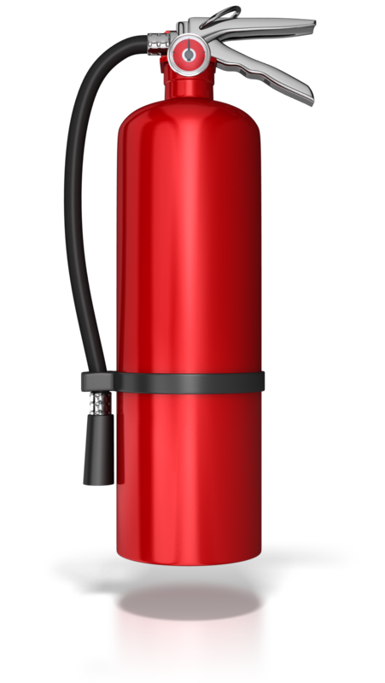
Fire extinguishers should be placed away from heaters or fires, fixed on a wall where it is out-of-reach of children. They should be serviced once a year, or according to manufacturer’s recommendations.
You should always operate a fire extinguisher on the escape route side of the fire.
Fire blankets
These are used to cover fires and cut out their source of oxygen, or to wrap around people whose clothes are alight.
To use them, you need to get close to the fire, so there is a risk of burning; therefore, they should only be used on small, contained fires, such as chip pan fires.
Be aware that, once the blanket has been placed over the fire, you cannot retrieve it if you fail to extinguish the fire.
Storage instructions are the same as for fire extinguishers.
Sprinklers
You can fit sprinklers in your premises if you wish. These will severely limit the risk of death from fire.
They are heat activated and can be fitted in as many rooms as you wish, with operation automatic and an alarm sounding during their activation.

Activity 7D

7.7 – Maintain a portable record of children’s emergency contacts in case of emergencies

By the end of this chapter, the learner should be able to:
- Ensure children’s emergency contact information is recorded portably. This could be on a:
- phone book
- sheet of paper
- phone or laptop.

Maintain a portable record of children’s emergency contacts
As previously mentioned, children’s emergency contacts should be recorded on your premises.
It is also a good idea to keep a portable record of this information – for instance, this will be useful to take with you on excursions and use if there are any emergencies.
This portable record can be kept in a small phone book, a sheet of paper or on some form of digital device, like a phone or laptop, depending on how many children you have in your care.
The information you need to know will be the name, phone number, relation and address of the emergency contact.

Ensure that emergency contacts are kept up-to-date and that you give parents and guardians regular prompts and opportunities to update these, especially before excursions and high-risk activities.

Activity 7E

References

These suggested references are for further reading and do not necessarily represent the contents of this unit.
Websites

Best Practice Guideline for the Planning and Development of Child Care Facilities: https://docs.education.gov.au/system/files/doc/other/uts-clg-final-report_0.pdf
Education and Care Services National Law Act 2010: http://www.legislation.vic.gov.au/Domino/Web_Notes/LDMS/PubStatbook.nsf/51dea49770555ea6ca256da4001b90cd/B73164FE5DA2112DCA2577BA0014D9ED/$FILE/10-069a.pdf
Guide to the Education and Care Services National Law and the Education and Care Services National Regulations 2011: http://www.ecrh.edu.au/docs/default-source/resources/guide-2-guide-to-the-national-law-and-the-national-regulations.pdf?sfvrsn=2
Health & Safety in Children’s Centres – Model Policies & Practices: http://ccccnsw.org.au/wp-content/uploads/CCModelPoliciesFinal.pdf
Hygiene in child care: http://ncac.acecqa.gov.au/family-resources/factsheets/hygiene.pdf
Links to child care-related information: http://www.australia.gov.au/topics/family-home-and-community/child-care
North Sydney Development Control Plan – Section 5: Child Care Centres: https://www.northsydney.nsw.gov.au/Building_Development/LEP_DCP/Development_Control_Plan
Sample forms and templates: http://www.acecqa.gov.au/sample-forms-and-templates-now-available
The National Quality Standard: http://www.acecqa.gov.au/national-quality-framework/the-national-quality-standard
Notifiable diseases: http://www.health.gov.au/
National Quality Framework: https://www.acecqa.gov.au/sites/default/files/acecqa/files/NQF/RevisedNQSHandoutA4_2.pdf
Anaphylaxis: http://www.allergy.org.au/health-professionals/ascia-plans-action-and-treatment
Asthma: http://www.nationalasthma.org.au/asthma-tools/asthma-action-plans
Diabetes: http://www.shesugar.com/wp-content/uploads/2012/07/Sample-Type-1-Diabetes-Medical-Management-Plan-grades-K-1.pdf
Epilepsy: http://www.epinet.org.au/articles/epilepsy_management_plans_emp_1
Child car seats: https://www.childcarseats.com.au
Car seats: http://www.which.co.uk/reviews/child-car-seats/article/fitting-a-child-car-seat/10-essential-child-car-seat-fitting-checks
Hand Hygiene Australia: http://www.hha.org.au/
National Childcare Accreditation Council: http://ncac.acecqa.gov.au/family-resources/factsheets/hygiene.pdf.
Immunisation: https://www.cdc.gov/vaccines/hcp/conversations/downloads/talk-infants-color-office.pdf
Immunisation recommendations: http://www.immunise.health.gov.au/internet/immunise/publishing.nsf/Content/national-immunisation-program-schedule
Warning signs: https://signsanddisplays.wordpress.com

All references accessed on and correct as of 23rd May 2017, unless other otherwise stated.

