Super-sets | Super sets is a form of strength training where the client or person training is required to move quickly from one excercises to another without break in between, e.g after performing a set of benchpress this would be quickly followed by push-ups. That example of a superset targets the same muscle groups which ultimately is the goal of super setting training.
Pre-fatigue | The pre- fatigue principle essentially is training or tiring out a smaller muscle group directly before you go to workout a larger muscle group, or training with single joint excercises before training multi joint excercises. This ensures that the targeted muscle receives the maximum growth stimulus during the multi join excercises.
Interval training | Interval training is alternating short bursts roughly 30s of high intensity training with longer intervals for longer durations of less intense activity. For e.g interval training can be seen if your excercises is walking you might add short bursts of jogging and have walking as your long interval training

Define the following terms, identifying their importance to fitness training and programming.

It is integral that a thorough screening and testing process is undertaken prior to the writing of an exercise program.
- Why is this an important process?
- What is the most important factor when beginning the program creation process?
Why is this an important process?
1.
To see if the client has any contradictions/ injury that will effect they’re training
2.
Screening will allow us to see they physical strengths and what the client might need to work more on in able to reach they’re goals
3.
Age and gender is taken into consideration in screening as this can also effect the way we train them, e.g we wouldn’t include a barbell squat into a 70 year olds program as it could cause injury etc.
What is the most important factor when beginning the program creation process?
After screening the client the most important factor would be creating a program that align with they’re excercises this means including excercises that would help them reach they’re goals, taking into consideration they’re contradictions etc.

Group Activity – In groups of 4 make an infographic promoting the benefits of exercise on your selected system. Links must be made to Resistance and Cardiovascular training.
Activity 5
Explain the effects of different exercises on the following major body systems:
- Nervous
- Skeletal

Nervous
The effect of resistance training on the nervous system:
Resistance training may cause adaptive ch ages within the nervous system that allow a trainee to more fully activate prime movers in specific movements and to better coordinate the activation of all relevant muscles, thereby effecting a greater net force in the intended direction of movement.

The effect of cardio training on the nervous system:
A large body of research in humans has demonstrated that consistent aerobic excercises (e.g 30 mins everyday) induces persistent improvements in certain cognitive functions, healthy alterations in gene expression in the brain, and beneficial forms of neuroplasticity and behavioural plasticity; some of these long.
Skeletal
Your bones adjust to frequent exercise by growing more bone and becoming denser , good nutrition, especially appropriate calcium and vitamin D, is required for bone improvement. Excercises might also help improve your balance and coordination.

Mark is an 18 year old who has some experience (less than 6 months) with resistance training. He is not interested in cardiovascular training, but has listed in his goals that he wants to reduce body fat and improve his general feeling of wellbeing. Mark is a non-smoker, but drinks most weekends. His other listed goals include improve strength and growth.

Mark is interested in training three (3) times per week for up to 90 minutes per session. He will be training with a training partner, who is of similar experience. Mark is currently working as an apprentice carpenter, and complains of tightness in his lower back.

Respond to the following points:
  - Consider what you should do with Mark before he even enters the gym:
- Identify some general advice you could give Mark with regards to meeting his goals.
- Would you recommend Mark to an Allied Health Professional (AHP) before commencing work with him?
  - Consider the most appropriate training style for Mark:
- Is it a good idea for Mark to completely ignore cardiovascular training?
- With his listed goals, is resistance training alone going to be the best method to achieve them?
- Suggest a basic circuit training session that Mark could use to keep up his cardiovascular fitness while still suiting his preferences.
  - With Mark’s goals in mind, create a program that best suits his current experience and time commitment to training. Use the Fit to Learn Program Card template.
a) Identify some general advice you could give Mark about meeting his goals.

1. An AHP I would recommend is a physio for his back pain
2. Advice I would suggest to Mark is to reduce his alchol intake
3. Mark shouldn’t ignore cardiovascular training as it is the fastest solution to him reaching his goals
Would you recommend Mark to an Allied Health Professional (AHP) before commencing work with him?
The recommended allied health professional (AHP) I would refer mark to is a dietitian as the dietitian would be able to inform Mark on his bad eating choices and the effect on up his body, as his diet is a key factor to losing weight.
b) Is it a good idea for Mark to completely ignore cardiovascular training?

No, it is not a good idea to avoid cardiovascular training as cardio based training as this is a fast and effective training method to lose fat.
With his listed goals, is resistance training alone going to be the best method to achieve them?

Although resistance training is a key role in losing weight and building muscle the only real benefit mark would see is that this would improve his overall feelings and wellbeing, resistance training alone wouldn’t be the best method to lose weight. Other methods of training that would help mark reach his goals is circuit training, TABABTA and AMRAPS.

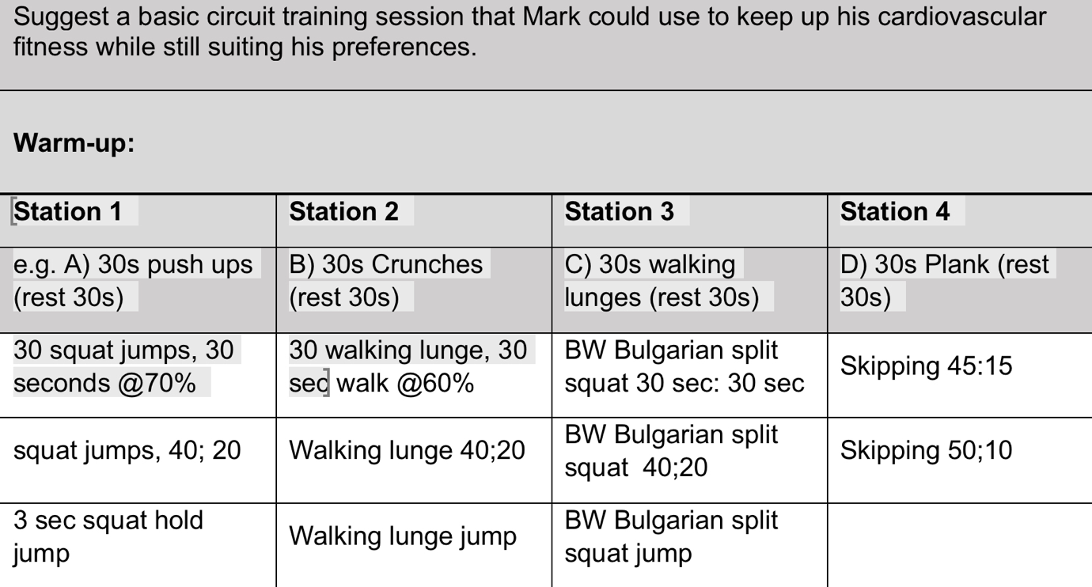
Skipping 60s

FIT TO LEARN PROGRAM CARD |  |  |  | Client Name: mark
Trainer: | Genesis Iuli |  |  |  | Date:
Goals/Aims | HYP/ Fat loss
Contraindications | Back pain
Session length | 45mins – 1hour
Warm up | Burpees 30:30  Star jumps 45:15  High knees 45:15  Bear crawls 10m x 2
Exercise | EPC | Sets | Reps |  | %1RM/Weight |  | Rest
Squat  Mountain climbers | 201  X | 3 | 10  30s |  | 75%  - |  | 60s
Plank  Burpees | X  X | 3 | 20s |  | -  - |  | 45s
Trap bar deadlift  Skipping | 301  X | 3 | 8  30s |  | 70%  - |  | 60s
Shoulder press  Upright row | 201  301 | 4 | 10  10 |  | 50%  60% |  | 60s
Pushups  Bicycle crunches | X  X | 2 | 25  20s |  | -  - |  | 60s
Plank | X | 1 | 60s |  | - |  | Done
Other training methods: AMRAP / INTERVAL / TABATA
Cardio circuit/ TABATA/ AMRAP

Cardiovascular training method |  | Time/Distance |  |  | Level/Resistance/Intensity
Circuit attached |  | 45minutes |  |  | 5
Cool down | 2 minute light slow walk (focussing on breathing and resuming to normal state bringing heart rate down)
Stretches | Hand on wall chest stretch 45secs each arm  Arm across chest whilst other arm is holding 45 secs each arm  Hip flexor stretch 30 secs each leg  Leg out hamstring stretch 45 secs each  Scorpions x10 each side

