CPCCBC4013A
Prepare and evaluate tender documentation

THEORY EXAM INSTRUCTIONS

- This exam will occur under standard assessment conditions.
  - An oral examination may be allowed under certain circumstances.
Answers will be documented and FT003 (Oral examination declaration form) must be completed.
- Participants must provide enough detail in their responses to demonstrate their knowledge and skills.
- Please fill in the details below, providing your name, signature and date of assessment.
  - Your signature acknowledges that this is your own work.
- If a participant initially answers a question incorrectly but modifies their response, they must follow the instructions below:
  - If a participant changes their response in writing, they must put their initials next to the written change.
  - If a participant changes their response verbally, this must be noted on the exam paper by the assessor.

Participant name | Justin Skehan
Participant signature | 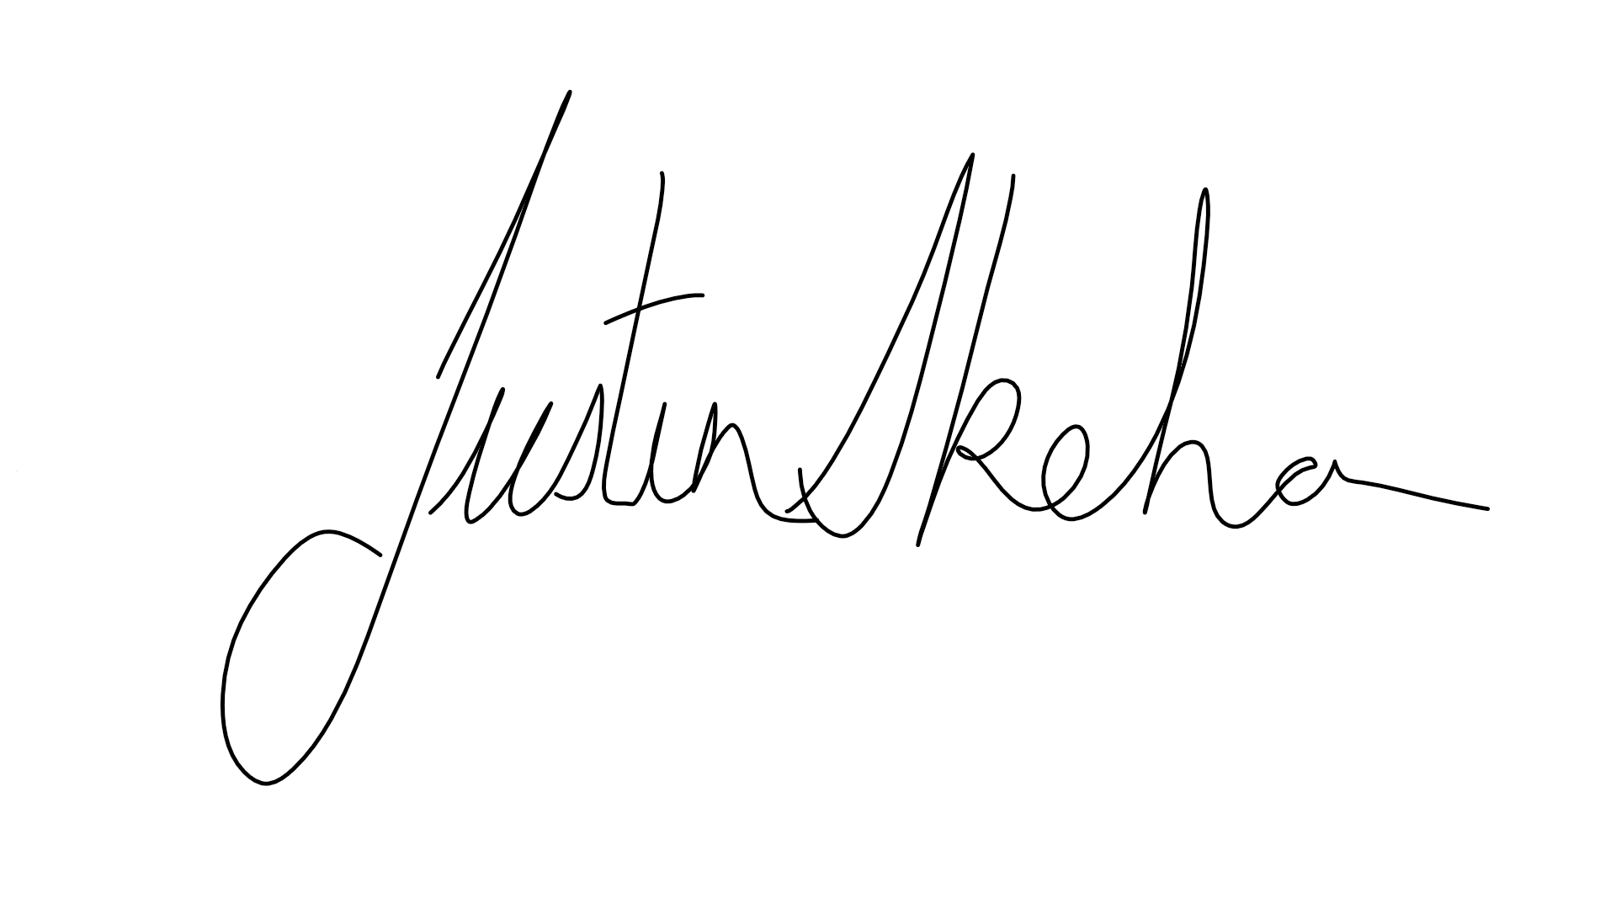

Assessor name
Assessor signature | 

Date | 15/09/2018

Number of questions | Number of questions answered correctly | Satisfactory?
26 |  | Yes | No
Assessor Comments
- Describe each of the listed types of building contract.

Answer | Contract | Description
 | Cost-plus | The builder is entitled to be paid the cost of the work plus a commission  The builder is paid the cost plus a fixed fee (which also may be reduced if the estimated cost of the work is exceeded by the actual cost)
 | Lump sum | Where the builder is to complete the works according to specification, within an agreed timeframe and for an agreed sum. Lump-sum contracts can be of two types:  ‘Fixed’ or ‘firm’ price – which have no provision for variation on price due to cost fluctuations  ‘Subject to rise and fall’ – which allows for price variations
 | Nominated subcontract | A subcontract within the scope of the main contract for works, whereby the subcontractor is chosen by the architect.
 | Schedule of rates | The cost of the work is calculated by applying an agreed schedule of rates to the work actually performed, which is measured

- Name and describe four (4) documents that may be referred to by a builder considering submitting a tender.

Answer | Tender document | Description
 | Drawings and specifications | These will show the builder the actual structure and how it is to be built
 | Bill of quantities | Formal quantities determined by a professional quantity surveyor using the architect’s specifications and drawings
 | Project parameters | Such as cost schedules, time frames
 | Scope of works | This outline what is required for the overall project

- Identify five (5) risks that should be considered by a builder interested in submitting a tender.

Answer | Five of the risks that should be considered are,  - Breach of Contract  - Disputes over payments  - Failure to adequately anticipate labour or materials costs  - Inappropriate funding levels and funding shortfalls  - Risk of default or non-performance of key players

- Describe two (2) company policies that may impact on whether a contract is selected for tender.

Answer | Policy | Description
 | 1 | Financial guidelines
 | 2 | Administrative guidelines

- Identify two (2) financial guidelines and two (2) administrative guidelines that must be observed when considering a tender.

Answer | Guidelines | Description
 | Financial | Check your calculations  Be sure to verify costs
 | Administrative | Ensure that the documentation meets the quality standards established by the organisation  Check the tender documents against the contract

- Which of the following are considered direct costs? Tick all that apply.

Answer | Choice | Possible Answers
 |  | Labour costs
 |  | Material costs
 |  | Office overheads
 |  | Plant costs
 |  | Profit
 |  | Site overheads
 |  | Subcontract costs

- Which of the following are considered indirect costs? Tick all that apply.

Answer | Choice | Possible Answers
 |  | Labour costs
 |  | Material costs
 |  | Office overheads
 |  | Plant costs
 |  | Profit
 |  | Site overheads
 |  | Subcontract costs

- Explain how labour costs are established, referring to:
- Labour constant
- Labour quantities
- Labour rates

Answer | Labour constant:  - Anticipated time required for a particular item of work (e.g. 2 hours/m3 to excavate trench)  Labour quantities:  - Quantity of work required for the item of work in question (e.g. 20m3 to be excavated)  Labour rates:  - Monetary rate for work performed (e.g. $x per m3 of trench excavated or $y per hour  )

- Explain the following types of direct material waste that must be considered when calculating material costs.

Answer | Type | Description
 | Design | Caused by having to purchase a particular amount, but not all is needed
 | Rejection | Quality of material
 | Mishandling | Damage due to poor handling of materials

- Explain the following types of indirect material waste that must be considered when calculating material costs.

Answer | Type | Description
 | Substitution | Waste cause by the material being used for purposes other than intended
 | Production | Caused by having to use a construction technique different from originally planned
 | Negligence | Caused by mistakes in production or estimating
 | Criminal actions | Caused by theft or vandalism

- Identify three (3) costs that must be considered when calculating plant costs.

Answer | Three costs that should be consider with plant are,  - Plant purchase or hire costs  - Running and maintenance  - Labour or operator costs

- List the two ways in which subcontractors may provide a price for their work.

Answer | The two ways are,  - An all-inclusive price  - A schedule of unit rates

- Identify ten (10) trades that may be required for a residential or commercial building project.

Answer | - Form worker  - Concreter  - Carpenter  - Electrician  - Plumber  - Water proofer  - Tiler  - Painter  - Block-Brick Layer  - Plasterer

- True or False (Tick your response): Each subcontractor is individually responsible to the client for a job tendered by a builder.

Answer |  | True
 |  | False

- Name one (1) type of project costing software.

Answer | Databuild

- True or False (Tick your response): Using costing software can assist builders undertake calculations in short timeframes during the tendering process.

Answer |  | True
 |  | False

- True or False (Tick your response): Profit is usually calculated as a percentage of the total, rather than on each item throughout the tender.

Answer |  | True
 |  | False

- True or False (Tick your response): Each level of government (i.e. federal, state and local) has its own rules regarding tender submissions.

Answer |  | True
 |  | False

- Identify one (1) example of each of the following documents that impacts on building work conducted in Queensland.

Answer | Type | Description
 | Building and Construction Code | National Code of Compliance
 | Standard | AS1684 Residential Timber Framed Construction
 | Government regulation | Queensland Building Regulation 2006

- Identify four (4) types of supporting documentation that you may include with a tender submission.

Answer | Four supporting documents you may include are,  - Termite Management Documentation  - Engineering Specification Confirmation  - Foundation Maintenance Declarations  - Organisational information

- Explain the importance of checking the accuracy of a tender.

Answer | It is important to check the accuracy of the tender to insure you have observed all relevant building and construction codes, standards and regulations relevant to the form of building and to ensure you have covered all the aspects of the project

- Identify an appropriate staff member within an organisation who may approve/endorse/modify a tender prior to submission to the client.

Answer | This would generally be the manager or a designated person such as your contracts administrator

- True or False (Tick your response): There is a general rule for how long tenders are called for, so specific due dates are not listed.

Answer |  | True
 |  | False

- You have a formwork job that will take three (3) weeks to complete.
You are required to hire a range of materials, according to the Bill of Quantities listed below. Allow 15% for loss and damage.
Complete the calculations to determine the costs for the required materials.

Materials | Quantity | Hire rate per week
Frame 1 | 18 | $0.60
Frame 2 | 18 | $0.55
Brace | 2 x 30 | $0.20
Base plate | 36 | $0.10
‘U’ plate | 36 | $0.30
Pin | 36 | $0.10
Bearer | 39.6m | $0.20
Joints | 165m | $0.15

Answer | Frame 1. 18 x $0.60 x 3 + 15% = $37.26  Frame 2. 18 x $0.55 x 3 + 15% = $34.15  Brace. (2x 30 = 60) 60 x $0.20 x 3 + 15% = $41.40  Base Plate. 36 x $0.10 x 3 + 15% = $12.42  U Plate. 36 x $0.30 x 3 + 15% = $37.26  Pin. 36 x $0.10 x 3 + 15% = $12.42  Bearer. 39.6 x $0.20 x 3 + 15% = $27.32  Joints. 165 x $0.15 x 3 + 15% = $85.39  Total Cost = $287.62

- For the job in Q24. you must also hire workers to install the plywood for the formwork, at a rate of $15/hour. There is 70m² of plywood to be installed. Assume the labour constant is 1.10hrs/m².
Complete the labour calculations.

Answer | 70 x 1.1 x $15.00 = $1155.00

- For the job in Q24. and Q25. you have determined that the overheads and profit will constitute 10% of the materials and labour cost.
Calculate the total project cost.

Answer | Materials $287.62  Labour $1155.00  Total $1442.62  Profit (10%) $144.26  Total Cost 1586.88

