

BSBWRT301
Write simple documents
Learner Workbook

Table of Contents

1
Table of Contents 2
Candidate Details 3
Assessment – BSBWRT301: Write simple documents 3
Competency Record to be completed by Assessor 4
Activities 6
Activity 1.1 6
Activity 1.2 7
Activity 1.3 8
Activity 1.4 9
Activity 1.5 10
Activity 1.6 11
Activity 2.1 12
Activity 2.2 13
Activity 3.1 14
Activity 3.2 - 3.5 15
Activity 4.1 16
Activity 4.2 - 4.3 17
Skills and Knowledge Activity 18
Major Activity 19

Candidate Details

Assessment – BSBWRT301: Write simple documents
Please complete the following activities and hand in to your trainer for marking. This forms part of your assessment for BSBWRT301: Write simple documents.
Name: Rani Doyle
Address: 94 Bald Hills Road
Bald Hills, QLD 4036
Email: rani_doyle@hotmail.com
Employer: Securcom
Declaration
I declare that no part of this assessment has been copied from another person’s work with the exception of where I have listed or referenced documents or work and that no part of this assessment has been written for me by another person.
Signed: ____________________________________________________________
Date: 5/12/2017
If activities have been completed as part of a small group or in pairs, details of the learners involved should be provided below;
This activity workbook has been completed by the following persons and we acknowledge that it was a fair team effort where everyone contributed equally to the work completed. We declare that no part of this assessment has been copied from another person’s work with the exception of where we have listed or referenced documents or work and that no part of this assessment has been written for us by another person.
Learner 1: ____________________________________________________________
Signed: ____________________________________________________________
Learner 2: ____________________________________________________________
Signed: ____________________________________________________________
Learner 3: ____________________________________________________________
Signed: ____________________________________________________________

Competency Record to be completed by Assessor
Learner Name: _______________________________________________________
Date of Assessment: _______________________________________________________
The learner has been assessed as competent in the elements and performance criteria and the evidence has been presented as;
Assessor Initials
Authentic
Valid
Reliable
Current
Sufficient

Learner is deemed: COMPETENT NOT YET COMPETENT (Please circle)

If not yet competent, date for re-assessment: ____________________________________

Comments from Trainer / Assessor:
__________________________________________________________________________________________________________________________________________________________________________________________________________________________________________________________________________________________________________________________________________________________________________________________________________________________
Assessor Signature: ________________________________________________________
Observation/Demonstration

Throughout this unit, you will be expected to show your competency of the elements through observations or demonstrations. Your instructor will have a list of demonstrations you must complete or tasks to be observed. The observations and demonstrations will be completed as well as the activities found in this workbook. An explanation of demonstrations and observations:
Demonstration is off-the-job
A demonstration will require:
- Performing a skill or task that is asked of you
- Undertaking a simulation exercise
Observation is on-the-job
The observation will usually require:
- Performing a work based skill or task
- Interaction with colleagues and/or customers
Your instructor will inform you of which one of the above they would like you to do. The demonstration/observation will cover one of the unit’s elements.
The observation/demonstration will take place either in the workplace or the training environment, depending on the task to be undertaken and whether it is an observation or demonstration. Your instructor will ensure you are provided with the correct equipment and/or materials to complete the task. They will also inform you of how long you have to complete the task.
You should be able to demonstrate you can:
- Plan document
- Draft document
- Review document
- Write final document
You should also demonstrate the following skills:
- Reading
- Writing
- Oral Communication
- Navigate the world of work
- Interact with others
- Get the work done
Activities

Activity 1.1
Estimated Time | 15 Minutes
Objective | To provide you with an opportunity to determine audience and purpose for the document
Activity | In pairs, groups or individually, complete the following;  Your manager has asked you to provide a copy of a report to them that you send to your client. Do you supply the information the way the manager prefers or the way your primary recipient requests?  To send a copy of a report to the manager, I would provide more information in the report for them to make a decision or to inform them of your findings, therefore the report would be the way the manager prefers.  What is the difference between a statement of fact and straight forward advice?  Statements of fact is information that is correct and true such as law whereas straightforward advice is usually based on the opinion of personnel.

Activity 1.2
Estimated Time | 15 Minutes
Objective | To provide you with an opportunity to determine the format and structure
Activity | In pairs, groups or individually, complete the following;  Format an email using the structure that you use in your organisation. Use a hyperlink to explain a WHS issue and attach a WHS document that you have completed as part of your training. Write a brief message to let your supervisor know the results of a recent meeting that they were unable to attend.  Use three different types of signposts in the email.  Print the email and attach it to this Learner Workbook. Write Assessment Activity on the Page.  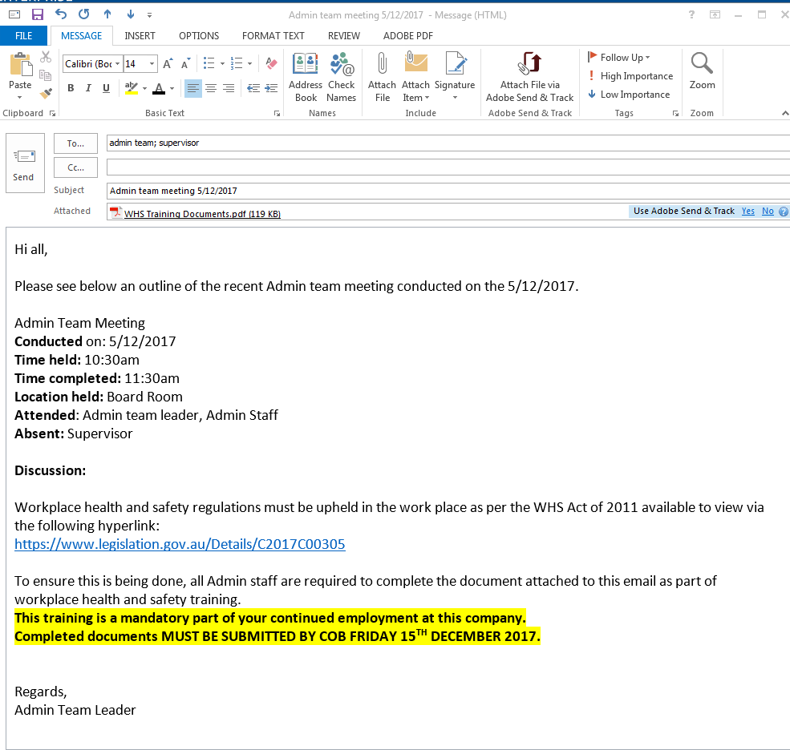

Activity 1.3
Estimated Time | 15 Minutes
Objective | To provide you with an opportunity to establish key points for inclusion
Activity | In pairs, groups or individually, complete the following;  What is the purpose of using inclusions in your communication?  The purpose of using inclusions in communication is to ensure that you are clear on the information that you provide and the structure of that information.  You have booked a training session with your workgroup about the changes to WHS legislation, especially the Consultation Process. Use your understanding of consultation to provide your workgroup with some of the items that will be covered. Use different inclusions to provide the information to your workgroup.  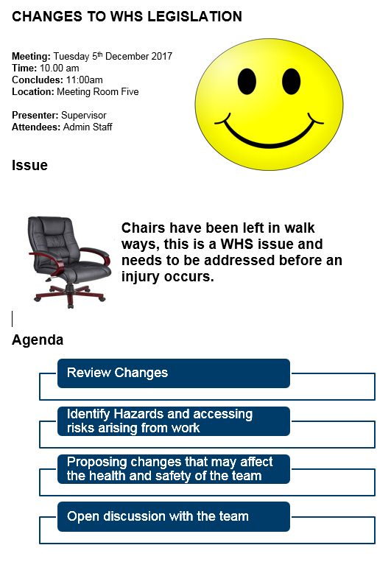

Activity 1.4
Estimated Time | 15 Minutes
Objective | To provide you with an opportunity to identify organisational requirements
Case Study | In pairs, groups or individually, complete the following;  Research your organisation’s procedures and see if you can find any procedures that ensure that you do not breach any discriminatory language or copyright laws? What are they and why do you have them?  Current copyright laws exist by ways of intellectual property. Copyright is a legal right by Australian law that the creator has exclusive rights for the use and distribution. Furthermore, Employees and Service Providers’ are required to sign an agreement to ensure the brands and products are to be used appropriately in accordance with these laws.  Research the organisational requirements in the communication process. List the inclusion communication protocols that you are required to follow. Briefly explain those protocols.  Securcom Inclusion communication protocol states that all employees must use the official company logo on all documents including:  - Signature line for emails  - Official Company Documents (manuals, contracts, etc.)  - Letters to clients and Suppliers.  Summary of Protocol:  This protocol is in place to protect the integrity of the name and logo of the company, its’ clients, providers and employees.

Activity 1.5
Estimated Time | 15 Minutes
Objective | To provide you with an opportunity to establish a method of communication
Activity | In pairs, groups or individually, complete the following;  Use the Consultation process to explain why it is an inclusive form of communication.  An inclusive communication strategy is one in which explicit steps are taken to ensure that all employees feel they are involved in decisions that affect their day-to-day work. The consultation process that forms part of the harmonisation of the new work health and safety legislation is an important part of ensuring that all employees actively participate in WHS in the workplace.

Activity 1.6
Estimated Time | 15 Minutes
Objective | To provide you with an opportunity to establish a means of communication
Activity | In pairs, groups or individually, complete the following;  Before you write a document, it is important that you plan the document first.ff  For this activity, you will determine what needs to be done and who needs to do it. The activity requires that you communicate information to your team, including management about changes made to WHS in the workplace. You choose the topic and it is recommended that you use a topic that you are familiar with.  Who is the audience? (Remember when you choose the audience, the rest of these answers must target the audience to ensure that the audience receives the message in a format that you can understand).  Target audience is staff members of the admin team and management  What is the purpose of the document?  Topic will be Changes made WHS within the workplace in relation to the chairs being left in walk way.  How will you format the document?  Microsoft Word  How will the document be structured?  The document will be structured with Headings, sub headings and dot points to make the readability of document easier and not overwhelming with a lot of text.  What inclusions will you use to communicate the purpose of the communication?  I will include illustrations and various shapes as inclusions in this document.  What organisational requirements will you need to use?  Organisation requirements that will need to be included when creating this document will include:  - Approval from appropriate personnel  - Document access for relevant recipients  - Appropriate use of company name, logo and inclusions  - suitable methods of filing and saving business document  What is the appropriate method of communication?  Written method of communication is most appropriate.  What is the means of communication?  Formal Communication will be used

Activity 2.1
Estimated Time | 15 Minutes
Objective | To provide you with an opportunity to develop a draft document to communicate key points
Activity | In pairs, groups or individually, complete the following;  Prepare a draft of a letter for your supervisor. In Activity 1.6, you completed all of the preparation work for a letter. Use the information in the preparation to write an appropriate letter that will contact your expected audience. The letter should be no more than one page long.  Dear All  This letter is to advise that we are conducting a meeting to discuss additional Policies and procedures put in place regarding workplace health and safety. This will be a formal, interactive meeting and you are all required to attend and contributions during the meeting is encouraged.  This meeting will be conducted on the 5th of January 2018 at 10:00am and will conclude at 11:00am. The meeting will take place in the board room. All participants are required to bring a notepad and pen for recording purposes.  If you have any concerns, please do not hesitate to contact myself.  Yours Sincerely,  Rani.  Email: rani.d@hotmail.com  Phone: 3248 5599

Activity 2.2
Estimated Time | 15 Minutes
Objective | To provide you with an opportunity to obtain and include any additional information that may be required
Activity | In pairs, groups or individually, complete the following;  Using the preparation you completed in Activity 1.6, write a draft of a letter. While you are writing the letter, consider what additional information you should provide? Who would you need to consult with? What information do you require and what source of information would you need to access to find the information that you require?  Dear All  This letter is to advise that we are conducting a meeting to discuss additional policys and procederes put in place regarding workplace health and safety. This will be a formal, interactiv meeting that you are all required to attend and contributions during this meeting is encouraged.  DRAFT  SPELLING ERRORS  Please see below a list of the topics that will be discussed:  - Reviewing of changes that will be made  - Identifing hazards and assessing risks arising from work  - Proposing changes that may affect the health and safety of the team  - Open discussion from the team  For more information on these topics, please following the link below.  https://www.qldWHS.com.au  This meeting will be conducted on the 5th of January 2018 at 10:00am and will conclude at 11:00am. The meeting will take place in the board room. All participants are required to bring a notepad and pen for recording purposes.  If you have any concerns, please do not hesitate to contact myself.  Yours Sincerely,  Rani.  Email: rani.d@hotmail.com  Phone: 3248 5599  If you are unable to consult with another member of staff, what do you need to do?  If you do not have the advantages of another person who you can consult with, then check your organisations historical records to determine whether the information that you gathered is relevant and to check that the tone of the letter matches the tone that you have used.

Activity 3.1
Estimated Time | 15 Minutes
Objective | To provide you with an opportunity to check draft for suitability of tone for audience, purpose, format and communication style
Activity | In pairs, groups or individually, complete the following;  Using the draft that you developed from Activity 2.2, review your draft and analyse:  For suitability of tone for audience, purpose, format and communication style  Purpose – I have achieved my goal, the communciation is clear  Format – all workgroups has access and understanding of the communication  Communication - style is passive  Tone - The tone of the document will affect how the reader will interpret what is said. I have determined the purpose of the document, I needed to make sure that I expressed the message that I wanted to convey and wanted to reach my audience and obtain some kind of action in response to the message.  Make recommendations about how you believe that you can improve the communication.  Maybe I could adopt a more assertive communication style so that I can clearly state my opinion and firmly advocated the rights of others without violating them.

Activity 3.2 - 3.5
Estimated Time | 15 Minutes
Objective | To provide you with an opportunity to check draft for readability, grammar, spelling, and sentence and paragraph construction
Activity | In pairs, groups or individually, complete the following;  Using the document that you have developed in Activities 1.1 – 1.6, 2.2 and 3.1, Check your draft for:  - Readability,  - Grammar,  - Spelling, and sentence and paragraph construction  - Sequencing and structure  Make sure the draft meets its organisational requirements and get someone to proofread, where appropriate, by supervisor or colleague  Readability: Letter is worded well making readability of document easy for the reader.  Grammar: Correct grammar has been used consistently throughout letter.  Spelling and sentence and paragraph constructing: Spelling was inconsistent as errors were picked up. Sentence and paragraph constructing was efficient.  Sequencing and structure: Sequencing and structure was efficient.

Activity 4.1
Estimated Time | 15 Minutes
Objective | To provide you with an opportunity to make and proofread necessary changes
Activity | In pairs, groups or individually, complete the following;  Update the changes to the document that you have identified. Keep a print out of the original document, a copy of the corrections on the document and the final document.  Dear All  This letter is to advise that we are conducting a meeting to discuss additional policies and procedures put in place regarding workplace health and safety. This will be a formal, interactive meeting that you are all required to attend and contributions during this meeting is encouraged.  Please see below a list of the topics that will be discussed:  - Reviewing of changes that will be made  - Identifying hazards and assessing risks arising from work  - Proposing changes that may affect the health and safety of the team  - Open discussion from the team  For more information on these topics, please following the link below.  https://www.qldWHS.com.au  This meeting will be conducted on the 5th of January 2018 at 10:00am and will conclude at 11:00am. The meeting will take place in the board room. All participants are required to bring a notepad and pen for recording purposes.  If you have any concerns, please do not hesitate to contact myself.  Yours Sincerely,  Rani.  Email: rani.d@hotmail.com  Phone: 3248 5599

Activity 4.2 - 4.3
Estimated Time | 15 Minutes
Objective | To provide you with an opportunity to ensure the document is sent to the intended recipient and file a copy of the document in accordance with organisational policies and procedures
Activity | In pairs, groups or individually, complete the following;  Research  When you process a document for WHS in your workplace, what procedures do you need to follow before the information is shared with the intended recipients?  When you send a document, it is essential that you double check the documents address to make sure that the document is addressed to the correct party.  How are WHS files filed and secured with in your organisation?  WHS files are filed and secured in a common area in the workplace which all employees have access to.

Skills and Knowledge Activity
Estimated Time | 45 Minutes
Objective | To provide you with an opportunity to demonstrate your knowledge of the foundation skills, knowledge evidence and performance evidence.
Activity | Complete the following individually and attach your completed work to your workbook.  The answers to the following questions will enable you to demonstrate your knowledge of:  - Reading  - Writing  - Oral communication  - Navigating the world of work  - Interacting with others  - Getting the work done  - The process for checking basic grammar, spelling and punctuation  - Different communication methods  - How audience, purpose and method of communication influence the tone of a document  Answer each question in as much detail as possible, considering your organisational requirements for each one.  - For your organisation, plan, draft and finalise three different simple documents that are used commonly in your organisation for internal use. Ensure you accurately convey the required basic information in a format suitable for use. Take into account your organisational policies and procedures for document production.

Major Activity
Estimated Time | 60 – 120 Minutes
Objective | To provide you with an opportunity to demonstrate your knowledge of the entire unit.
Activity | This is a major activity – your instructor will let you know whether you will complete it during class or in your own time.  Attach your completed answers to the workbook.  You must individually, answer the following questions in full to show your competency of each element:  - Plan document  - Draft document  - Review document  - Write final document  Using the document that you have developed for Assessment Activities, write a report to your supervisor about the information that you have found. Use at least two different software programs to communicate a meeting so that you can present your findings.  Your intended recipients are your class or work group. You must ask another member of your team to proof read the document before you complete the final draft. Once the final draft is prepared your trainer, team leader or supervisor should sign off on the document.  You should negotiate a time, date and intended venue with your trainer to use for the intended meeting with you workgroup or class with your trainer/team leader/manager.  - Who is the audience? (Remember when you choose the audience; the rest of these answers must target the audience to ensure that the audience receives the message in a format that you can understand.  - What is the purpose of the document?  - How will you format the document?  - How will the document be structured?  - What inclusions will you use to communicate the purpose of the communication?  - What organisational requirements will you need to use?  - What is the appropriate method of communication?  - What is the means of communication?  - Write a draft of the document using the skills you have learnt. The letter should be no more than one page long and must reflect the answers from question 1.  - While you were writing the letter, you identified that you required two additional pieces of information. How did you source this information and why did you need it? Add this information to the draft of the letter.  - Proof read document and review for suitability, readability, structure and sequencing, and whether it would meet the organisations needs. What resources did you use to assist you with spelling? Who is the intended recipient?  - How is information stored and secured in your workplace?

