CPCCBC4003A Select and prepare a construction contract,
CPCCBC4016A Administer a construction contract &
CPCCBC4032A Apply contract law to sales processes

PRACTICAL ASSESSMENT INSTRUCTIONS

- The following practical assessment will require the participant to complete work related activities.
- Observations will be conducted of the participant’s work to determine whether they display sufficient practical skills and knowledge.
- Please fill in the details below, providing your name, signature and date of assessment.
  - Your signature acknowledges that the assessor provided clear instructions and the participant understood what was required to complete this assessment.
- The assessor may substitute a Practical Task with another task of equal value.
  - Alternate tasks must be fully documented by the assessor.

Participant name | Juliane Kiessig
Participant signature | 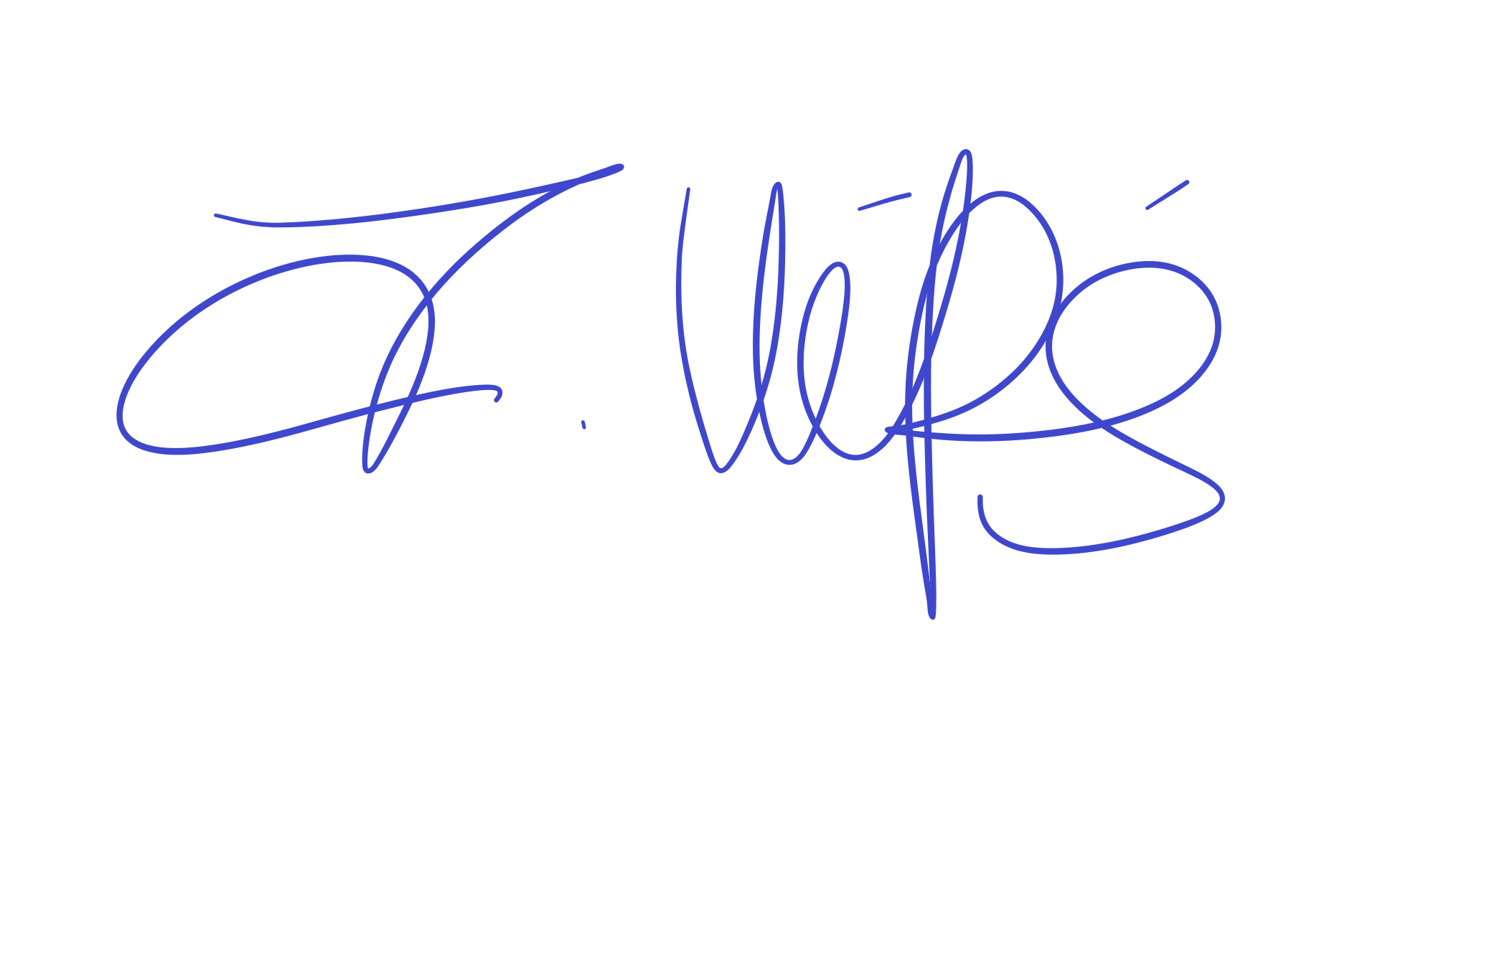

Assessor name | Brett Stoward
Assessor signature | 

Date | 17/09/2019

Number of tasks | Number of tasks completed | Satisfactory?
1 (2X) |  | Yes | No

Assessor Comments
CPCCBC4003A Select and prepare a construction contract,
CPCCBC4016A Administer a construction contract &
CPCCBC4032A Apply contract law to sales processes

Practical Task 1 (2X)
Description of task:
On two (2) occasions, a suitable observer is to verify the participant’s ability to apply contract law to residential and/or commercial construction sales processes. These tasks may be simulated or real.

The assessor is to verify the observer’s comments and provide the outcome for the practical task on the front cover of the Practical Assessment.
Resources required:
Two (2) pre-contract agreements; two (2) sales contracts (e.g. QBCC contracts), telephone, facsimile machine, computer.
Assessment of task
Name of participant: | Juliane Kiessig
Name of observer: | Brett Stoward
Role of observer  (Confirm suitability to sign) | Training Manager
Email address of observer | brett@successiontraining.com
Signature of observer:
Date: | 17/09/2019
When completing the task, did the participant: |  | Tick if satisfactorily completed.  Provide comments if left unticked.
 |  | 1st  Occasion | 2nd  Occasion
- Explain to the client:
- Essential terms and elements of a valid contract
- Types and purposes of agreements employed with the industry (including sales contracts and pre-contract agreements)
- The range of documents that collectively make up a contract (including construction schedules, reports, specifications)
- The importance of the contract to sales process
- Implications of legislation, regulations and codes of practice (including Australian Consumer Law)
- Discuss and agree upon clauses of a pre-contract agreement, including payment or deposit.
- Ensure the pre-contract agreement is signed and processed according to organisational requirements.
- Select appropriate contract and seek expert advice in the preparation of the contract, considering:
- Contract rise and fall amounts
- Schedule of progress payments
- Processes for applying of extensions of time
- Break down contract clauses/terms/conditions with the client, including:
- Rights, liabilities and potential penalties of parties under the contract
- Definitions of building work, common contract terms and procedures, considering –
  - Practical completion and issuing a final certificate
  - Defects liability and completion at the cost of the contractor
  - Effect of ousting the contractor from the building or site
- Cooling off periods
- Provisional sum and prime cost allowances
- Measures to be taken in the event of an anomaly in the rendering of the contract, considering –
  - Variations
- Circumstances that bring about a breach and termination of contract, considering –
  - Unreasonable/vexatious notice
  - Abandonment of a contract
  - Methods for resolving contractual disputes
- Effectively communicated with clients, subcontractors, colleagues and external parties using the following methods:
- Verbally using language/concepts appropriate to cultural differences
- Non-verbal communication
- Using technology (including telephone, facsimile, email)
- In writing (including drafting responses to queries about contracts)
The participant’s performance was: Satisfactory Not Satisfactory

observer Comments
In-class assessment

