Practical Task 1 (2X)
Description of task:
On two (2) occasions, a suitable observer is to verify the participant’s ability to plan on-site activities, including the employment of physical and human resources and the development of documentation and advice for relevant authorities:
- Occasion 1: Residential projects
- Occasion 2: Commercial projects

The participant is to gather evidence of how they have completed each component of the Practical Task, which is to be submitted with this Practical Assessment sheet. Evidence to be submitted may include:
- A construction program/schedule for a project showing:
  - The sequencing of the trades, etc.
  - Working and non-working days, etc.
- Local authority construction commencement notices
- Pre-construction site inspection reports or dilapidation reports
- WHS policy

The observer is to provide detailed comments on the tasks completed by the participant. The assessor is to verify the observer’s comments in the Assessor Comments section, and provide the Practical Assessment outcome on the front cover of this document.

Below is a spreadsheet of original programme dates and how they have changed throughout the project. I conducted an experiment to compare programmed dates to actual dated and how far off programme we are to determine a new practical completion date. Then with the price of materials increasing I was able to calculate out when the price increase would hit and how many floors we had left, how much exta per floor the materials would now cost us and if It was worth to pre buy the materials in bulk and store them until the end of the project to save money.

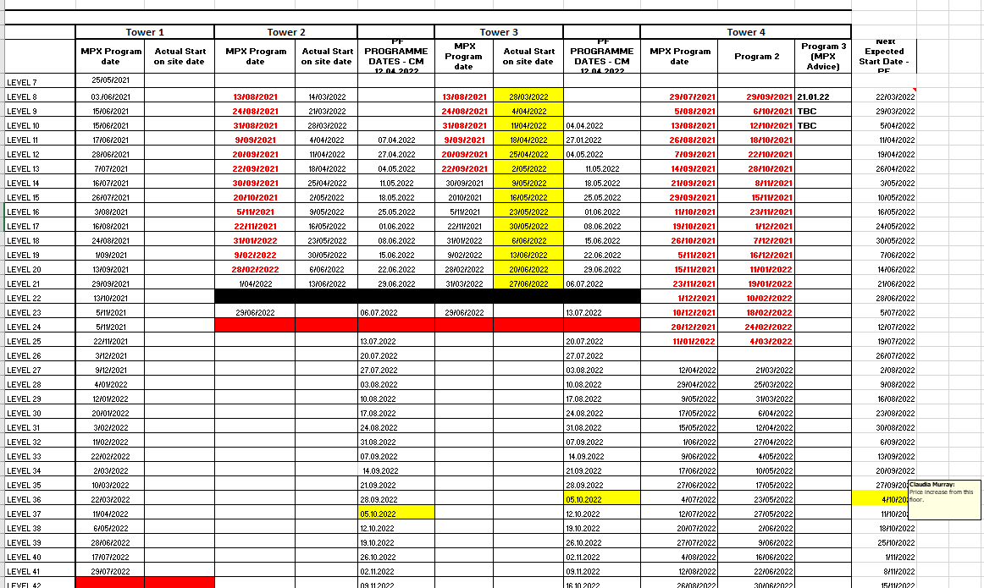

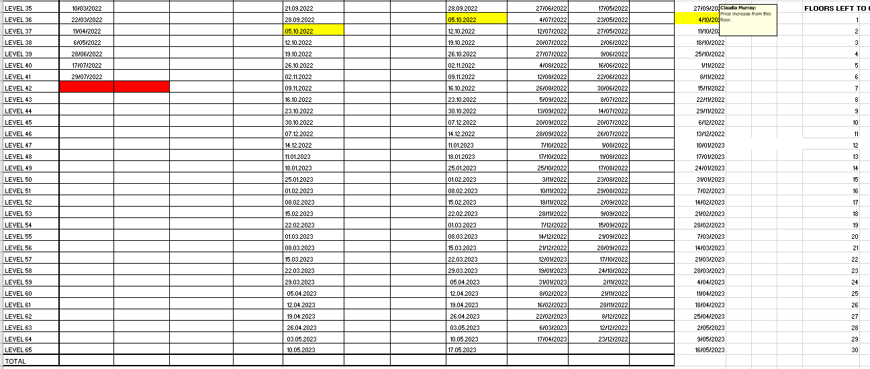

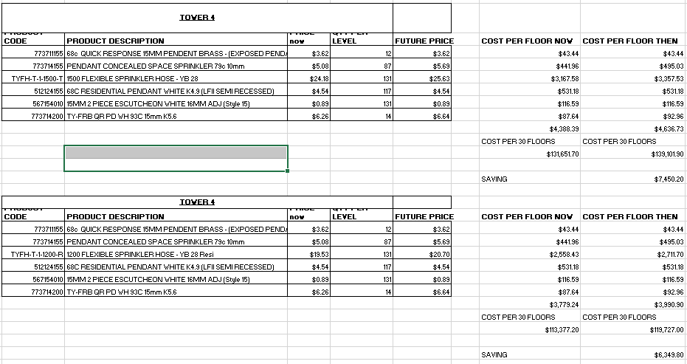

Below are short range programmes in which we have to work off due to delays on site being COVID, inclement weather and safety issues.
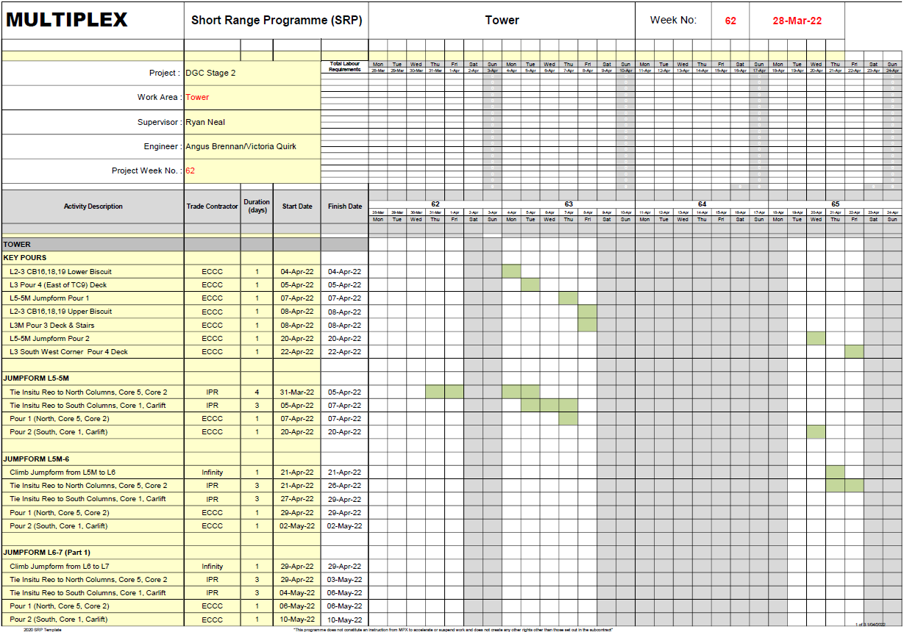

A copy of programmes to show different trades and the sequence in where our trade falls in line.
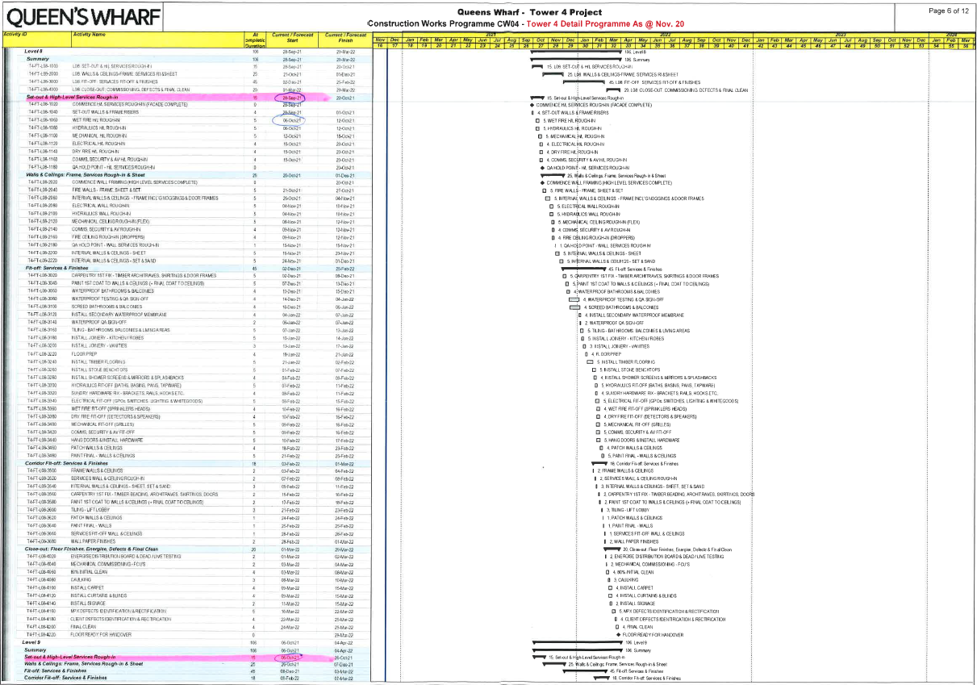

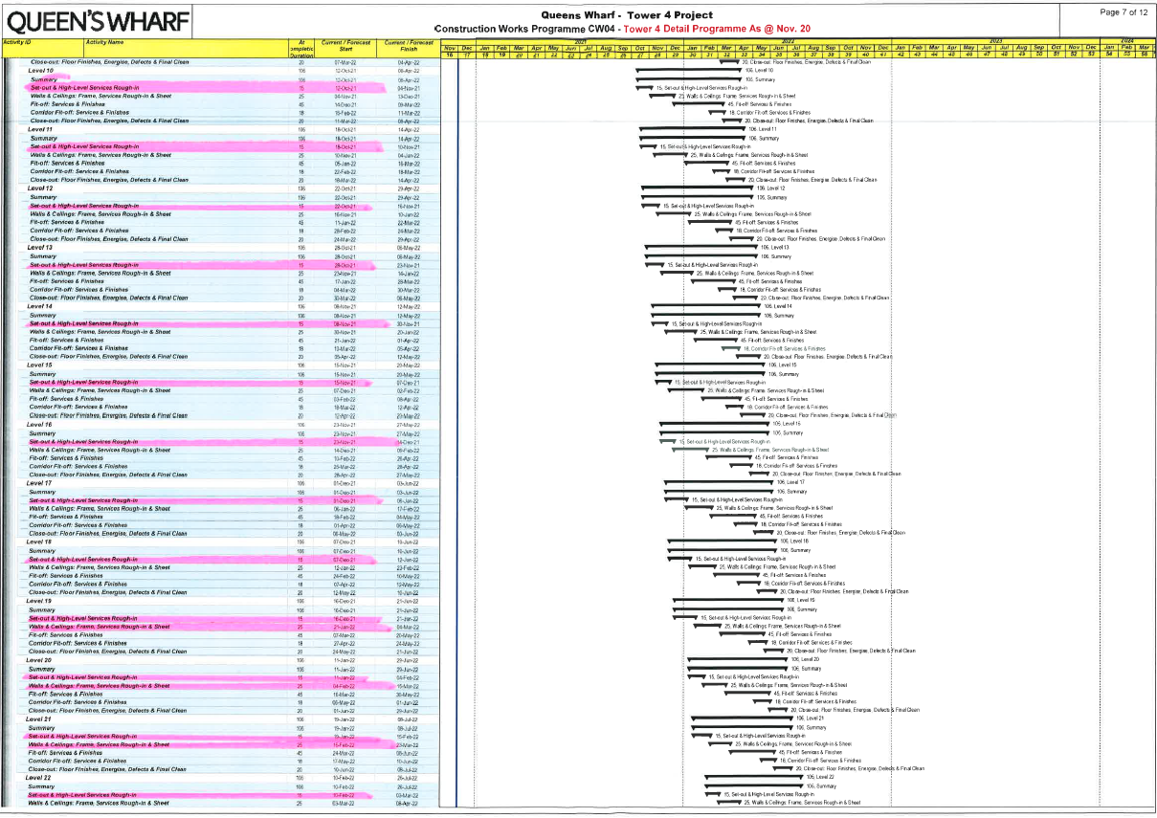

A copy of our WHS Policy
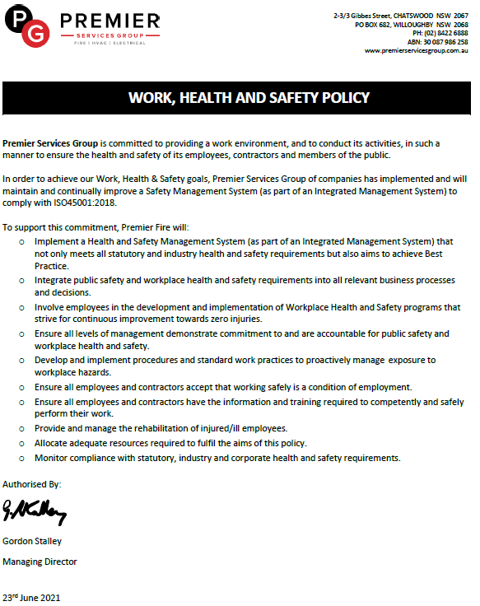

Safety walks are conducted to ensure the safety of the site and a report is created to show any non-compliances. Trades then need to rectify these issues.


