Chris Dittmer
28 November 2020
Review of Health & Safety Policy
On behalf of CCA Winslow

Contents
1. Introduction 2
2. Health & Safety Policy 3
3. Findings 4
3.1 Occupational Health & Safety (OH&S) 4
3.2 Employee vs Workers 4
3.3 Primary Duty of Care 4
3.4 Consultation vs Communication 5
3.5 Hazard identification and risk management 5
4. Recommendations 7
5. Conclusion 7

1. Introduction
Under the Workplace Health and Safety legislation for Queensland, CCA Winslow have obligations and duties to meet, as a Person Conducting a Business or Undertaking (PCBU).
This review was requested by the PCBU to consider the PCBUs alignment with the legislation and its intent within the company’s Health and Safety Management system. The Health & Safety Policy dated August 2019 was considered as part of this review.

2. Health & Safety Policy
CCA Winslow’s policy dated August 2019 was signed by the Chief Executive Officer, Trevor Lockwood.

3. Findings

3.1 Occupational Health & Safety (OH&S)
The Policy refers to OH&S legislation, while it is a minor detail, Queensland as a jurisdiction introduced the harmonised legislation in 2011 which is now known as the Workplace Health & Safety (WHS) legislation.

3.2 Employee vs Workers
The Workplace Health & Safety Act 2011 no longer reflects that an employer or Principal Contractors’ obligations are only to employees. The 2011 legislation defines the obligations for a PCBU and their primary duty of care, WHS Act 2011 Section 19 states;
19 Primary duty of care
(1) A person conducting a business or undertaking must ensure, so far as is reasonably practicable, the health and safety of—
(a) workers engaged, or caused to be engaged by the person; and
(b) workers whose activities in carrying out work are influenced or directed by the person;
while the workers are at work in the business or undertaking.

Section 7 of the WHS Act 2011 defines who is considered a worker;
7 Meaning of worker
(1) A person is a worker if the person carries out work in any capacity for a person conducting a business or undertaking, including work as—
(a) an employee; or
(b) a contractor or subcontractor; or
(c) an employee of a contractor or subcontractor; or
(d) an employee of a labour hire company who has been assigned to work in the person’s business or undertaking; or
(e) an outworker; or
(f) an apprentice or trainee; or
(g) a student gaining work experience; or
(h) a volunteer; or
(i) a person of a prescribed class.

3.3 Primary Duty of Care
Under the WHS Act Section 19 (3) defines what a PCBU must ensure to meet the expectations of duty of care;
The CCA Winslow Health & Safety Policy does not identify the need to ensure all elements identified under Section 19(3).

(3) Without limiting subsections (1) and (2), a person conducting a business or undertaking must ensure, so far as is reasonably practicable—
(a) the provision and maintenance of a work environment without risks to health and safety; and
(b) the provision and maintenance of safe plant and structures; and
(c) the provision and maintenance of safe systems of work; and
(d) the safe use, handling and storage of plant, structures and substances; and
(e) the provision of adequate facilities for the welfare at work of workers in carrying out work for the business or undertaking, including ensuring access to those facilities; and
(f) the provision of any information, training, instruction or supervision that is necessary to protect all persons from risks to their health and safety arising from work carried out as part of the conduct of the business or undertaking; and
(g) that the health of workers and the conditions at the workplace are monitored for the purpose of preventing illness or injury of workers arising from the conduct of the business or undertaking.

3.4 Consultation vs Communication
The CCA Winslow Health & Safety Policy depicts that the PCBU will communicate with workers, however there is little reflection on consultation processes.
Section 47 (1) dictates the requirement for the PCBU;
47 Duty to consult workers
(1) The person conducting a business or undertaking must, so far as is reasonably practicable, consult, as required under in this division and any regulation, with workers who carry out work for the business or undertaking who are, or are likely to be, directly affected by a matter relating to work health or safety.
While Section 48 describes the expectation of consultation;
48 Nature of consultation
(1) Consultation under this division requires—
(a) that relevant information about the matter is shared with workers; and
(b) that workers be given a reasonable opportunity—
(i) to express their views and to raise work health or safety issues in relation to the matter; and
(ii) to contribute to the decision-making process relating to the matter; and
(c) that the views of workers are taken into account by the person conducting the business or undertaking; and
(d) that the workers consulted are advised of the outcome of the consultation in a timely way.
(2) If the workers are represented by a health and safety representative, the consultation must involve that representative.
Work health and safety consultation, co-operation and co-ordination Code of Practice 2011, Section 3 depicts what is required to be implemented to achieve clear consultation and meet the expectations of Section 48 of the WHS Act 2011.

3.5 Hazard identification and risk management
For some time now, the Queensland Workplace Health & Safety Regulator has focused on psychosocial hazards and risk factors. Data from Comcare and WorkCover Qld are showing increasing trends towards psychological injuries and illness.
Psychosocial hazards are defined in the WHSQ paper Preventing and managing risks to work-related psychological health – published September 2020.

Psychosocial hazards include:
• high and low job demands
• low job control
• poor support
• poor workplace relationships (includes work-related bullying)
• low role clarity
• poor organisational change management
• low reward and recognition
• poor organisational justice
• poor environmental conditions
• remote and isolated work
• violent or traumatic events.

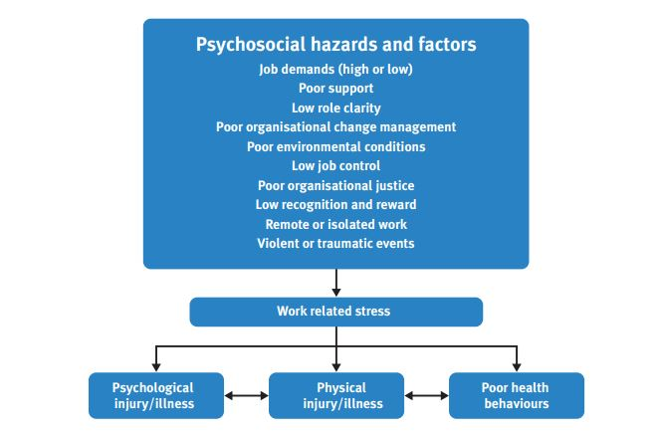
Figure below from the WHSQ paper reflects how the demands of a job can impact the worker.

4. Recommendations
Having reviewed the CCA Winslow Health and Safety Policy, the below recommendations are made to the PCBU to ensure the intent of the legislation is met, the Policy aligns with the legislation and the safety management system continues to improve
1. Change the reference to Occupational Health and Safety (OHS) to Workplace Health and Safety (WHS).
2. Update the Policy to include the reference to workers where relevant.
3. Update the Policy to include all elements to ensuring Primary Duty of Care, including; the provision of safe plant and structures; the provision of safe storage of plant, structures and substances; the provision of adequate facilities.
4. Reflect in the Policy that workers will be consulted with – not just communicated with.
5. Include reference to managing psychosocial hazards that may impact workers.

5. Conclusion
In conclusion, implementing the mentioned recommendations in section 4 will ensure that CCA Winslow will be more aligned with the Queensland legislation and its intent, as well as showing progression and continual improvement in its approach to safety management within its business.

