BSBSMB406A
Manage small business finances
ASSESSMENT SUMMARY

The assessment activities for BSBSMB406A Manage small business finances cover all aspects of the unit of competency required. To demonstrate competence in this unit, a participant must undertake all tasks and complete them satisfactorily and consistently. For Apprentices and Trainees, this includes employer completion of the Employer Record Book (ERB).

Participants must read all the information given before starting any assessment task. The assessment tasks are intended to be equitable, fair and flexible. If a participant has any questions or requires alternative arrangements to be made such requests should be directed to their Trainer/Assessor, who should note such arrangements in the ‘Assessor Comments’ on the affected assessment. If a participant feels they are not yet ready to be assessed, they should discuss their options with their Trainer/Assessor.

To satisfactorily complete the assessment, the participant is required to answer all questions correctly and demonstrate their skills to industry standards. If a participant does not answer some questions or perform some tasks, they will be deemed ‘Not Satisfactory’ for the task and ‘Not Yet Competent’ for the unit of competency. The Trainer/Assessor is able to provide the participant with additional information on interpreting the assessment outcomes and provide guidance on the participant’s options. Should a participant still be deemed ‘Not Satisfactory’ they will have the opportunity to undertake a supplementary assessment or appeal the result.

By signing the cover page for each assessment item, the participant acknowledges they understand the assessment instructions and requirements and consent to being assessed. The participant also verifies and assures the RTO that the work submitted is their own work.

Participant Name | Yixu zhang

Task | Assessment Results
Theory Exam | Satisfactory | Not Yet Satisfactory
Practical Assessment | Satisfactory | Not Yet Satisfactory
Outcome for Unit of Competency | Competent | Not Yet Competent

Assessor Name
Assessor Signature | 
Unit Competence Determination Date | Click here to enter a date.

BSBSMB406A
Manage small business finances

THEORY EXAM INSTRUCTIONS

- This exam will occur under standard assessment conditions.
  - An oral examination may be allowed under certain circumstances, whereby the Participant’s answers will be documented by a party other than the Participant. This must be acknowledged in writing (e.g. FT001 and Assessor Comments)
- Participants must provide enough detail in their responses to demonstrate their knowledge and skills.
- Please fill in the details below, providing your name, signature and date of assessment.
  - Your signature acknowledges that this is your own work.
- Assessors are to complete marking in pen of a different colour to the Participant.
- If a Participant initially answers a question incorrectly but modifies their response, they must follow the instructions below:
  - If a Participant changes their response in writing, they must put their initials next to the written change.
  - If a Participant changes their response verbally, this must be noted on the exam paper by the assessor.

Participant name | Yixu zhang
Participant signature | 
Date | 12/12/2021

Assessor name
Assessor signature
Date | Click here to enter a date.

Number of questions | Number of questions answered correctly | Task outcome (Tick)
45 |  | Satisfactory | Not Yet Satisfactory

ASSESSOR Comments
- What does a financial plan enable you to do in your business?

Answer | Measure the business’s success  Control the finances of the business  Evaluate the success of the business to make profit or loss  Forecast your profitability, financial needs and financial viability

- List five (5) types of financial information you might need to profitably operate and extend your business in accordance with the business plan.

Answer | -Superannuation  -Secession planning  -Risk management  -Taxation

- Match the following specialists and the services they can provide to a business by writing the appropriate letter next to each number in the centre column.

Answer | Specialist |  | Answers | Services
 | 1 | Accountant | 1 - D | A | Provides assistance and direction across a variety of business areas, working closely with management.
 | 2 | Broker | 2 - B | B | Works with clients to determine their borrowing needs and ability, selects a loan suited to their circumstances.
 | 3 | Financial advisor | 3 - C | C | Provides advice and services in the form of investment and capital raising advice, insurance and income protection.
 | 4 | Legal advisor | 4 - E | D | Keeps financial records for a business, traditionally in the form of ledgers and journals.
 | 5 | Mentor | 5 - A | E | Can draft contract, provide advice of regulatory issues or protection of intellectual property.

- Briefly explain how personal net worth calculated. Give an example.

Answer | Personal net worth = Assets – Liabilities  If I have $50,000 assets currently, and I have $25,000 liabilities currently, then my Personal Net Worth is $50,000-$25,000=$25,000.

- Identify the information required when calculating a budget.

Answer | Time frame for a budget  Fixed costs, Variable costs, Expected income to record the actual income and expenses during the budget period

- Explain the process for preparing a cash flow forecast.

Answer | - Starting cash  This will depend on a number of things:  If your business is existing, your cash balance will be that of the existing business at the time the forecast is taken from.  If your business is new, your balance may be zero, or you may have decided to borrow an amount of capital to get up and running. These borrowings will be your starting cash balance.  Consider other start-up moneys, such as government allowances used to assist business  - Cash in  Prepare a forecast of the income the business have over the forecast period, considering:  Income (referring to preceding year’s sales, inflation, marketing plans, economy)  Interest – income that you receive from invested money, shares or bank accounts  Capital contributions or loans received  - Cash out  Determine all the expenses that the business will incur over the same period, including: Operating expenses, cost of goods sold, major purchases, external debt payments. Estimate your regular expenses (e.g. wages/salaries, electricity, stationery, motor vehicle expenses) as well as cash outflow necessary to pay your accounts payable  4.Ending cash  This is the difference between income received and expenses paid

- True or False (Tick your response): Cash flow forecasts are usually carried out at least once during a twelve month period.

Answer | þ | True
 |  | False

- Refer to the anticipated figures in the table below to calculate the break even sales amount. Determine whether this business is viable.

Total sales | $180,000
Fixed costs | $ 64,800
Variable costs | $ 78,300
Total costs | $143,100

Answer | The contribution margin would be:  [180,000 (Total sales) – 78,300 (Variable costs)]/180,000 (Total sales) = 0.565 or 56.5 cents in each dollar  The break even sales would be:  64,800 (Fixed costs) /0.565 (Contribution margin)  = $114,690  Therefore, we can conclude that the anticipated total sales of $180,000 will by far exceed the break even sales of $114,690.  The business is viable.

- Refer to the anticipated figures in the table below to calculate the break even sales amount. Determine whether this business is viable.

Total sales | $ 800,000
Fixed costs | $ 559,800
Variable costs | $ 243,300
Total costs | $ 803,100

Answer | The contribution margin would be:  [800,000 (Total sales) – 243,300 (Variable costs)]/800,000 (Total sales) = 0.696 or 69.6 cents in each dollar  The break even sales would be:  559,800 (Fixed costs) /0.696 (Contribution margin)  = $804,310  Therefore, we can conclude that the anticipated total sales of $800,000 will by far exceed the break even sales of $804,310  This business is not viable.

- The cost of goods sold (COGS) is the total expense associated with the goods sold in a reporting period.
James has a business selling books on eBay. An inventory count at the beginning of November shows that he has $50,000 worth of inventory on hand. Over the month, he purchases another $14,000 worth of books. His inventory count at the end of November shows that he has $22,000 of inventory on hand.
Using the calculation for COGS (Beginning Inventory + Purchases - Ending Inventory = Cost of Goods Sold) determine the cost of goods sold for James’ business.

Answer | $50000+$14000-$22000=$42000  The cost of goods sold for James’ business is $42000

- Identify the three (3) main methods of pricing products/services by writing the appropriate letter next to each number in the centre column.

Answer | Structure |  | Answers | Taxation requirements
 | 1 | Competition-based pricing | 1 - c | A | Adding together direct costs, indirect costs, profit margin and market price.
 | 2 | Cost-based pricing | 2 - a | B | Consider how much customers are prepared to pay.
 | 3 | Demand-based pricing | 3 - b | C | Charging a price as per market price.

- Name three (3) individuals/parties who should receive financial budgets/projections.
Answer | Accountants  Financial advisor  Industry/trade associations

- Provide three (3) reasons why you may need to raise business capital.
Answer | Purchase more inventories to promote productivity.  New technologies to increase production capacity.  Developing and marketing new products and ideas.

- Which of the following could be a potential financial backer?
Tick all that apply.

Answer | Choice | Possible Answers
 | þ | Banks
 | þ | Family and friends
 | þ | Private investors
 | þ | Shareholders

- Which of the following are relevant when negotiating, securing and managing business capital? Tick all that apply.

Answer | Choice | Possible Answers
 | þ | Contingency plans
 | þ | Necessary experience
 | þ | Tested business model
 | þ | Tested marketing approach

- True or False (Tick your response): Tax obligations will differ depending on your business structure.

Answer | þ | True
 |  | False

- Identify two (2) strategies that could be implemented to make sure your taxation liabilities are met when they are due.
Answer | Regular and accurate accounting process.  PAYG installments

- Tax obligations will differ, depending on the business’s structure. Match the structures and their taxation requirements by writing the appropriate letter next to each number in the centre column.

Answer | Structure |  | Answers | Taxation requirements
 | 1 | Company | 1 - B | A | Declare business income (or loss) in their personal income tax return and pay tax at individual tax rates.
 | 2 | Partnership | 2 - C | B | A separate legal entity with its own income tax liability. No tax-free threshold.
 | 3 | Sole Trader | 3 - A | C | Must lodge a tax return, but doesn’t pay tax. Those involved pay tax on their share of the income according to individual tax rates.
 | 4 | Trust | 4 - D | D | Holds income for the benefit of others. Generally has no tax liability where the whole of the net income is distributed to adult resident beneficiaries. Each beneficiary pays tax on their share of the income according to individual tax rates.

- What is a credit policy? Identify three (3) points that may be included in a credit policy.
Answer | A credit policy is to set the terms and conditions of supplying goods/services before payment and the steps taken in the even of default.  It may include the following:  Payment options;  Payment terms;  Debt collections;

- Explain how a credit policy can maximise cash flow.
Answer | A credit policy encourages customers to speed up or increase the amount of their spending.  For some client or customer, they have the demand of consumption but they may chose not buying because of the financial problems. A credit policy give them a buffer on time and it could let them receive the products or services first without a direct paying. Then it is easily for them to consume and that is how the credit policy can maximize cash flow.

- Describe one (1) method you may use to address debtors in default.
Answer | If the client doesn’t pay me on time, I will stop working until they pay.

- What purpose do Key Performance Indicators (KPIs) play in managing and monitoring a business?
Answer | KPIs are predetermined measurement that reflect the critical success factors of a company

- True or False (Tick your response): Financial plans, strategies and objectives develop over time, so it is inappropriate to continue reporting on the same KPIs as in previous periods.

Answer |  | True
 | þ | False

- Explain the seven (7) general characteristics of an effective KPI.
Answer | Characteristic | Explanation
 | Non-Financial | Non-financial measures, not expressed in dollars
 | Timely | Measured frequently
 | Management Focus | Acted upon by management
 | Simplicity | All staff understand the KPI and what corrective action is required
 | Team Orientated | Responsibility can be assigned to a team who work closely together
 | Significant Impact | Has a noteworthy effect on the business’s outcomes
 | Encourage Appropriate Action | Has been tested to ensure it has a positive impact on performance

- Why should you consult with relevant stakeholders when developing financial procedures?
Answer | Consult with all relevant stakeholders to ensure the procedures are relevant and understood

- Explain how you should communicate financial procedures to facilitate implementation of the business plan.
Answer | Consider how you will communicate the procedures to all relevant people and how you will ensure they are used and followed. It is best to put them in writing and make them readily available to all. You may also develop training programs for such procedures

- True or False (Tick your response): The best way to maintain control of your business is to continuously monitor its financial performance targets.

Answer | þ | True
 |  | False

- Identify four (4) points that a financial report should be able to address.
Answer | A financial report should answer certain basic financial questions:  -Is the business making a profit or suffering a loss, and how much?  -How do assets stack up against liabilities?  -Where did the business get its capital, and is it making good use of the money?  -Did the business reinvest all its profit?

Refer to the following financial report to respond to Q29. to Q31.

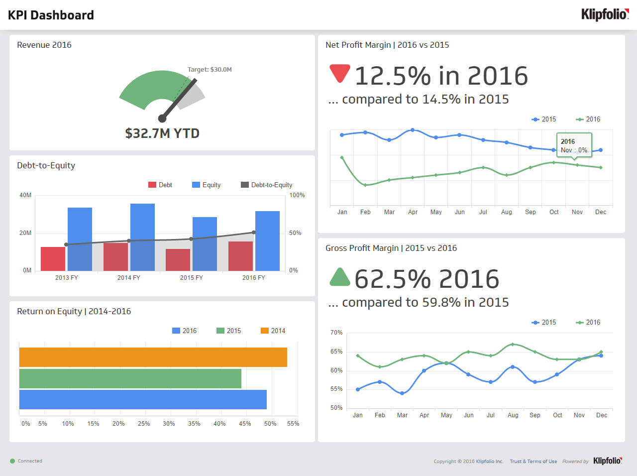
Source: https://www.klipfolio.com/resources/dashboard-examples/executive/kpi-dashboard

- True or False (Tick your response): The target revenue in 2016 was met.
Answer | þ | True
 |  | False

- True or False (Tick your response): The gross profit margin for 2016 is better than 2015.
Answer | þ | True
 |  | False

- True or False (Tick your response): The net profit margin for 2016 is better than 2015.
Answer |  | True
 | þ | False

- How is gross profit determined for a profit and loss statement?
Answer | Gross profit is the total sales less cost of goods sold

- Name six (6) expenses considered in a profit and loss statement.
Answer | Accountant fees  Advertising and marketing  Bank fees and charges (including credit cards)  Bank interest  Utilities (electricity, gas, water, telephone)  Property fees (lease/loan payments, rent, rates)

- How is net profit calculated on a profit and loss statement?
Answer | Net profit is gross profit minus total expenses

- Name two (2) current assets and two (2) fixed assets that would be considered when compiling a balance sheet.
Answer | Asset | Examples
 | Current | Cash  Petty cash
 | Fixed | Leasehold  Property and land

- Name two (2) long-term liabilities and two (2) short-term liabilities that would be considered when compiling a balance sheet.
Answer | Liability | Examples
 | Long-term | Loans  Hire-purchase liabilities
 | Short-term | Credit cards payable  Accounts payable  Interest payable  Accrued wages  Income tax

- How are net assets calculated on a balance sheet?
Answer | Net assets is the total assets minus total liabilities

- True or False (Tick your response): You may be legally obligated to perform an annual stocktake based on the stock and size of your business.
Answer | þ | True
 |  | False

- You should be able to track in item in your stock by which of the following details? Tick all that apply.

Answer | Choice | Possible Answers
 | þ | Applicable tax
 | þ | Cost
 | þ | Point-of-sale details
 | þ | Quantity
 | þ | Selling price
 | þ | Source of supply
 | þ | Stock number
 | þ | Stored location
 | þ | Unique item number

- Describe the effects that marketing strategies can have on the financial plan.
Answer | Identify your target market and understand how your product or service meets their needs  Identify your competitors and what your target customers think about your competitors' strengths and weaknesses  Position your brand, products and services so that your target market sees your business as better than, or different from, the competition  Set specific, measurable goals and time frames for your marketing activities  Map out a strategy to reach your target audience, including the messages, channels and tools you will use

- Describe the effects that operational strategies can have on the financial plan.
Answer | Operations strategies drive a company’s operations, the part of the business that produces and distributes goods and services. Operations strategy underlies overall business strategy, and both are critical for a company to compete in an ever-changing market. With an effective operations strategy, you can optimise the use of resources, people, processes, and technology.

- There are some common financial ratios used which allow the financial position of a business to be compared over time. Three (3) of these are working capital, current ratio and quick ratio (or acid test ratio).
The equations and explanations for these follow in the table below:
Financial ratio | How to calculate It | What it tells you
Working Capital | = Current Assets - Current Liabilities | An indicator of whether the company will be able to meet its current obligations (i.e. pay its bills & meet its payroll, make a loan, etc.) If a company has current assets exactly equal to current liabilities. The greater the amount of working capital the more likely it will be able to make its payment on time
Current Asset Ratio | = Current Assets ÷ Current Liabilities | This tells you the relationship of current assets to current liabilities. A ratio of 3:1 is better than 2:1. A 1:1 ratio means there is no working capital
Quick Asset Ratio  (Acid Test) | = (Cash + Temp. Investments + Accounts Receivable) ÷ Current Liabilities : 1 | This ratio is similar to the Current Asset Ratio except that Inventory, Supplies and Prepaid Expenses are excluded. This indicates the relationship between the amount of assets that can be quickly turned to cash versus the amount of liabilities
Using the example company balance sheet on the following page, determine:
- Working Capital
- Current Asset Ratio
- Quick Asset Ratio (Acid Test)

Answer | Item | Calculations
 | Working Capital | 89000-61000=$28000
 | Current Asset Ratio | 89000/61000=1.459
 | Acid Test | ((2100+100)+10000+40500)/61000=0.864

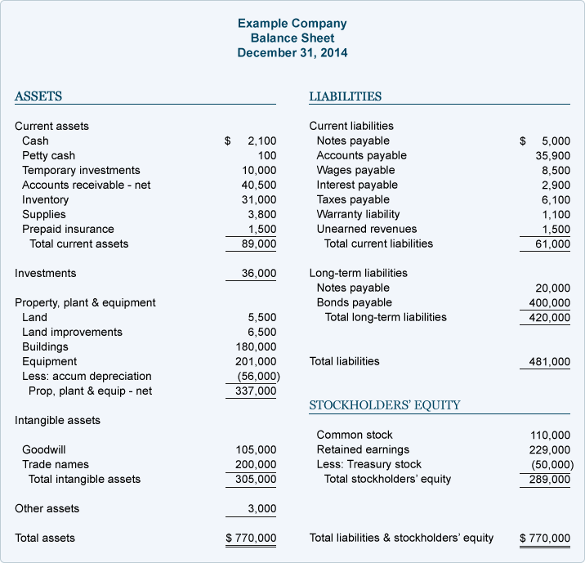

- Name and describe the two (2) types of benchmarks provided by the Australian Tax Office.
Answer | Benchmark | Explanation
 | Performance benchmarks | These are financial ranges for your industry to help you work out how you compare to other businesses in your industry and if you need to make any improvement
 | input benchmarks | These shows an expected range of income for tradespeople based on the labour and materials they use to undertake domestic project. They are developed using information provided by industry participants and trade associations

- True or False (Tick your response): Comparing your ratios to the benchmark will give you a better idea of how your business is tracking and whether change might be required.

Answer | þ | True
 |  | False

- Provide two (2) reasons that might cause you to alter your financial plan.
Answer | Change in markets  Change in customers

BSBSMB406A
Manage small business finances

PRACTICAL ASSESSMENT INSTRUCTIONS

- The following practical assessment will require the Participant to complete work related activities.
- The Assessor will conduct observations of the Participant’s work to determine whether they display sufficient practical skills and knowledge.
- Please fill in the details below – providing your name, signature and date of assessment.
  - The Participant’s signature acknowledges that the Assessor provided clear instructions and the Participant understood what was required to complete this assessment.
- The Assessor may substitute a Practical Task with an alternate task of equal value.
  - Alternate tasks must be fully documented by the assessor in the Assessor Comments area.

Participant name | Yixu zhang
Participant signature
Date | 12/12/2021

Assessor name
Assessor signature
Date | Click here to enter a date.

Task | Task outcome (Tick)
Task | Satisfactory | Not Yet Satisfactory
Task 1 | ¨

ASSESSOR Comments
BSBSMB406A
Manage small business finances

Practical Task 1
Description of task:
A suitable observer is to verify the participant’s ability to implement, monitor and review strategies for the ongoing management of a small business’s finances. The participant is to gather evidence of how they have completed each component of the Practical Task, which is to be submitted with this Practical Assessment sheet.

Evidence to be submitted may include:
- A cash flow forecast or budget
- Evidence of bookkeeping and transaction recording processes including accounting system/s used, for example MYOB, QuickBooks, Excel.
- Copies of transaction records
- Business loan agreements or Lease agreements
- Supplier account notices with trading terms
- Copy of invoice noting trading terms
- A letter from their accountant, etc. that acknowledges their association
- Copy of a Business Activity Statement
- A copy of a Profit and Loss Statement or Balance Sheet
- A copy of a financial plan if available

The observer is to provide detailed comments on the tasks completed by the participant. The assessor is to verify the observer’s comments and provide the outcome for the practical task on the front cover of the Practical Assessment.
Resources required:
Business financial data, business plan.
Assessment of task
Name of participant: | Yixu zhang
Name of observer: | Manjinder Singh
Role of observer  (Confirm suitability to sign) | builder
Email address of observer | saab.builders@gmail.com
Signature of observer: | 
Date: | 12/12/2021
When completing the task, did the participant: |  | Tick if satisfactorily completed.  Provide comments if left unticked.
- Collate/prepare documentation of existing business financial information, including:  - Balance sheets  - Profit and loss statements  - Stock records |  | þ
- Identify financial information requirements and obtain specialist services, as required, to profitably operate the business in accordance with the business plan. |  | þ
- Produce financial budgets or projections, including cash flow estimates, as required for each forward period, and distribute to relevant people in accordance with legal requirements. |  | þ
- Verbally negotiate, secure and manage business capital to best enable implementation of the business plan to meet requirements of financial backers. |  | þ
- Develop and maintain strategies to enable adequate financial provision for taxation in accordance with legal requirements. |  | þ
- Develop, monitor and maintain client credit policies, including contingencies for debtors in default, to maximise cash flow. |  | þ
- Select key performance indicators to enable ongoing monitoring of financial performance. |  | þ
- Record and verbally communicate financial procedures to relevant people to facilitate implementation of the business plan, confirming audience understanding through questioning and listening. |  | þ
- Regularly monitor and report (verbally and in writing) on financial performance targets, and analyse data to establish the extent to which the financial plans has been met. |  | þ
- Monitor marketing and operational strategies for their effects on the financial plan. |  | þ
- Calculate and evaluate financial ratios according to own or industry benchmarks. |  | þ
- Assess financial plan to determine whether variations or alternative plans were needed, and changed as required. |  | þ
The Participant’s performance was: þ Satisfactory Not Satisfactory

observer Comments

