CPCCBC4006B
Select, procure and store construction materials for low rise projects

PRACTICAL ASSESSMENT INSTRUCTIONS

- The following practical assessment will require the participant to complete work related activities.
- Observations will be conducted of the participant’s work to determine whether they display sufficient practical skills and knowledge.
- Please fill in the details below, providing your name, signature and date of assessment.
  - Your signature acknowledges that the assessor provided clear instructions and the participant understood what was required to complete this assessment.
- The assessor may substitute a Practical Task with another task of equal value.
  - Alternate tasks must be fully documented by the assessor.

Participant name | Ante Begic
Participant signature | 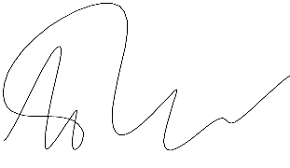

Assessor name
Assessor signature | 

Date | Click here to enter a date.

Number of tasks | Number of tasks completed | Satisfactory?
1 (2X) |  | Yes | No

Assessor Comments
CPCCBC4006B
Select, procure and store construction materials for low rise projects

Practical Task 1 (2X)
Description of task:
On two (2) occasions, a suitable observer is to verify the participant’s ability to supervise systems through which materials are selected, acquired and stored on site for the following projects:
- Occasion 1: Construction classified as Class 1 and 10 construction
- Occasion 2: Construction classified in Classes 2 to 9 with a gross floor area not exceeding 2000 square metres, not including Type A or Type B construction

These tasks may be simulated or real. The participant is to gather evidence of how they have completed each component of the Practical Task, which is to be submitted with this Practical Assessment sheet. The observer is to provide detailed comments on the tasks completed by the participant. The assessor is to verify the observer’s comments in the Assessor Comments section, and provide the Practical Assessment outcome on the front cover of this document.
Resources required:
Computer, Building Contract, Drawings, Specifications, Building materials (including timber, and ferrous and non-ferrous metal).
Assessment of task
Name of participant: | Ante Begic
Name of observer: | Henry Erratt
Role of observer  (Confirm suitability to sign) | Site Engineer
Email address of observer | Henry.Erratt@sydneymetro2.com.au
Signature of observer: | 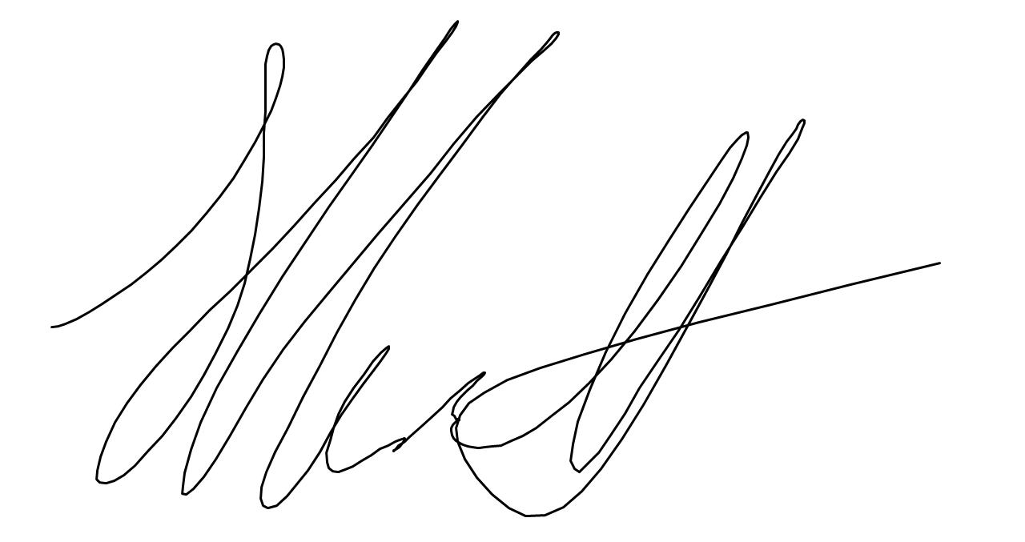
Date: | 17/07/2019.
When completing the task, did the participant: |  | Tick if satisfactorily completed.  Provide comments if left unticked.
 |  | 1st  Occasion | 2nd  Occasion
1 Evaluate building materials
- Identify suitability of materials commonly used in the region for low rise buildings.
- Through research and testing, identify properties of different materials, their quality and compatibility and non-compatibility and maintain effective sampling and organisational record-keeping processes.
- Identify the environmental impacts of different materials.
- Identify the impact of allowable tolerances on the conversion of naturally occurring materials.
- Identify and check tolerances for installing and assembling materials with regard to the nature of the work being performed and the requirements of relevant construction industry Australian standards.
2 Material selection
- Select materials structurally adequate and appropriate for the building system specified in the contract, drawings and specifications.
- Select materials after considering:
- Safety
- Required fire resistance rating
- Suitability to the application
- Durability
- Serviceability and cost effectiveness
- Compliance with NCC, legislation, regulations and Australian Standards
- Consider short and long-term degradation of materials in relation to the building’s proposed life cycle.
- Select and evaluate alternative materials, if specified materials were unavailable or unsuitable – justifying decisions to regulatory authorities, as necessary
- Finalise selection of materials in accordance with contractual requirements and in consultation with relevant professionals and the client, compiling results in a report.
- Effectively communicate using the following methods:
- Language/concepts appropriate to cultural differences
- Non-verbal communication
3 Supervising materials on site
- Determine limitations and effects of transportation on material and components, taking action in potentially damaging circumstances.
- Ensure materials were correctly and safely handled on site using appropriate equipment and safe work practices.
- Communicate with manufacturers and suppliers to ensure materials are stored in accordance with specifications and Australian standards.
- Implement processes for inspecting all materials delivered on site for naturally occurring and/or manufactured defects before installation.
- Ensure personnel were aware of actions to be taken in the case of defects caused by incorrect installation, application or placement.
- Preserve and protect timber and ferrous and non-ferrous metal used in the construction process.
The participant’s performance was: Satisfactory Not Satisfactory

observer Comments
Occasion1
A simulated residential scenario was carried out that involved Ante producing material schedules for a shed slab that was to be built in his back yard. Throughout this scenario Ante was able to demonstrate that he was able to select materials structurally adequate with considerations such as; short- and long-term degradation, serviceability and cost effectiveness. Lead time on materials was also a consideration in addition to the location the materials were to be stored on site .

Occasion2
Ante was responsible for the construction of the water treatment plant at the Victoria Cross North Shaft excavation site. These works included scheduling material such as steel and other consumable required to construct the water treatment plant. The steel schedules were reviewed and approved prior to being delivered to site. Upon delivery to site, the materials need to be checked off an incoming materials inspection checklist. Once all the material was delivered to site, Ante was responsible for ensuring the materials were installed on site as per specified in the design drawings.

