BSBPMG521
Manage project integration

PRACTICAL ASSESSMENT INSTRUCTIONS

- The following practical assessment will require the participant to complete work related activities.
- Observations will be conducted of the participant’s work to determine whether they display sufficient practical skills and knowledge.
- Please fill in the details below, providing your name, signature and date of assessment.
  - Your signature acknowledges that the assessor provided clear instructions and the participant understood what was required to complete this assessment.
- The assessor may substitute a Practical Task with another task of equal value.
  - Alternate tasks must be fully documented by the assessor.

Participant name | Rue Grimston
Participant signature | 

Assessor name
Assessor signature | 

Date | 7/03/2021

Number of tasks | Number of tasks completed | Satisfactory?
1 |  | Yes | No

Assessor Comments
BSBPMG521
Manage project integration

Practical Task 1
Description of task:
A suitable observer is to verify the participant’s ability to:
- Integrate and balance overall project management functions of scope, time, cost, quality, human resources, communications, risk and procurement across the project life cycle; and
- Align and track project objective to comply with organisational goals, strategies and objectives

These tasks may be simulated or real. The participant is to gather evidence of how they have completed each component of the Practical Task, which is to be submitted with this Practical Assessment sheet. The observer is to provide detailed comments on the tasks completed by the participant. The assessor is to verify the observer’s comments in the Assessor Comments section, and provide the Practical Assessment outcome on the front cover of this document.
Resources required:
Project documentation, Organisational documentation.
Assessment of task
Name of participant: | Rue Grimston
Name of observer: | Bruce Young
Role of observer  (Confirm suitability to sign) | Safety Manager
Email address of observer | Bruce.Young@seymourwhyte.com.au
Signature of observer: | 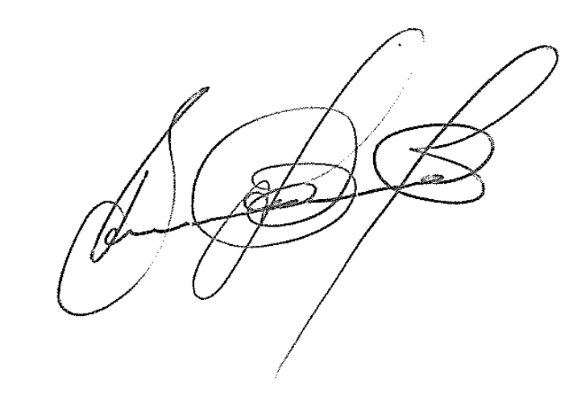
Date: | 7/03/2021
When completing the task, did the participant: |  | Tick if satisfactorily completed.  Provide comments if left unticked.
1 Establish project
- Identify, clarify and prepare project initiation documentation.
- Identify relationship between the project and broader organisational strategies and goals.
- Negotiate and document project objectives, outcomes and benefits.
- Negotiate project governance structure with relevant authorities and stakeholders.
- Prepare and submit project charter for approval by relevant authorities.
2 Undertake project planning and design processes
- Establish and implement a methodology to disaggregate project objectives into achievable project deliverables.
- Identify project stages, phases and structures – considering key requirements for stage completion against client requirements and project objectives.
- Analyse project management functions to identify interdependencies and impacts of constraints.
- Develop a project management plan integrating all project-management functions with associated plans and baselines.
- Establish designated mechanisms to monitor and control planned activity.
- Negotiate approval of project plan with relevant stakeholders and project authority.
3 Execute project in work environment
- Mange the project in an established internal work environment, ensuring effective work throughout the project.
- Maintain established links to align project objectives with organisational objectives throughout the project.
- Within authority levels, resolve conflicts negatively affecting attainment of project objectives.
4 Manage project control
- Ensure project records remained updated against project deliverables and plans at required intervals.
- Analyse and submit status reports on project progress and identified issues with stakeholders and relevant authorities.
- Analyse and submit impact analysis of change requests for approval, where required.
- Maintain relevant project logs and registers accurately and regularly to assist with project audit.
- Ensure associated plans remained updated to reflect project progress against baselines and approved changes.
5 Manage project finalisation
- Identify and allocate project finalisation activities.
- Ensure project products and associated documentation were prepared for handover to client in a timely manner.
- Finalise financial, legal and contractual obligations.
- Undertake project review assessments as input to future projects.
The participant’s performance was: Satisfactory Not Satisfactory

observer Comments
Rue is currently working on developing additional safety software for our organisation. She has been able to clearly demonstrate her knowledge and understanding the authority of the project and detail how the project shall be resourced and the delegation and authorities in project governance arrangements. The project sponsors are the HSEQ General Manager and Group IT Manager. Resourcing will include the HSEQT Lead, a software developer, a review panel including herself and nominated project safety personnel. A final review will be completed by the HSEQ General Manager on completion of the project including authorisation for the realise of the software to project personnel.
The boundaries of the project are transforming a paper-based process into an incident module to be completed directly into a software project. During the project there will be no alterations to the paper-form information, but an additional workflow will be created to all authorisation of the incidents from Project Safety Manager through to CEO.

Rue was clearly able to define the project stages, including development of IT process map, review of process development, development of workflows and finally publishing the new incident module. She gained project plan approval from the relevant key stakeholders, HSEQ General Manger and Group IT Manager. The objectives of the project were created in consultation with the HSEQ team, who would ultimately be the end users.

Rue maintained status reports and regularly review of the Gantt Chart. While there was amendment to end of project date, due to COVID 19 restrictions (noted documented in the project risk register – unforeseen) the project was able to be finalised with no impact to everyday operations.

Handover included users instruction, training PowerPoint presentation and project plan. While this project is the first of several module that will be developed, there has been a documented process developed to ensure all lessons learnt will be compiled in a central report and these will be used on the development of the “monthly data module” which will be next to be developed.

