Define the following terms, identifying their importance to fitness training and programming.

In groups of 5 – Create a infographic 1 slide (per concept) presentation with definition and a practical example of how this relates to our job
Specificity | Definition: The principle of specificity derives from the observation that the adaptation of the body or change in physical fitness is specific to the type of training undertaken.  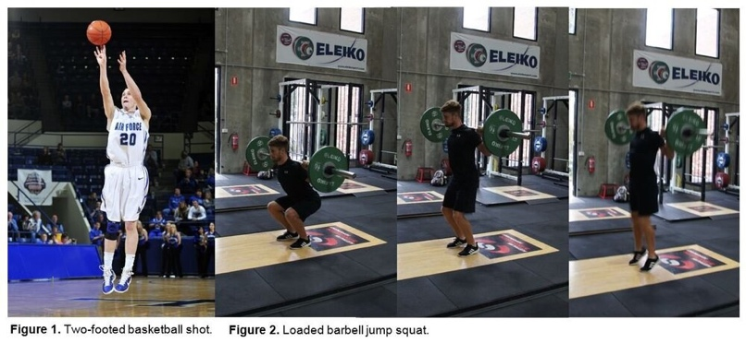  Training specific to the needs of your client e.g. Loaded barbell jump squat to benefit a two footed basketball shot.
Progressive overload | Definition: Progressive overload is when you gradually increase weight or the frequency of reps/ sets in your strength training routine. This challenges your body and allows muscle skeletal system to get stronger  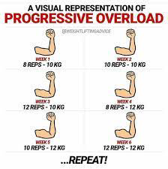  This relates to our job as progressive overload is a training method commonly used for strength training and muscle building
Contraindications |   Definition: contradictions is a statement that can effect the way you train a client, contradictions are often injuries, imbalances or outlines a problem the client faces which will effect the way we train them
Isolation exercise | 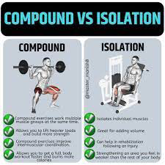  Definition: isolation excercises referees to excercises which target one singular muscle group or muscle compare to compound excercises which include various muscle groups in one exercise. This is key when training as it focus on training one muscle group in case the client may have a contradiction where that muscle is injured etc we are able to perform isolation excercises
Split programming | 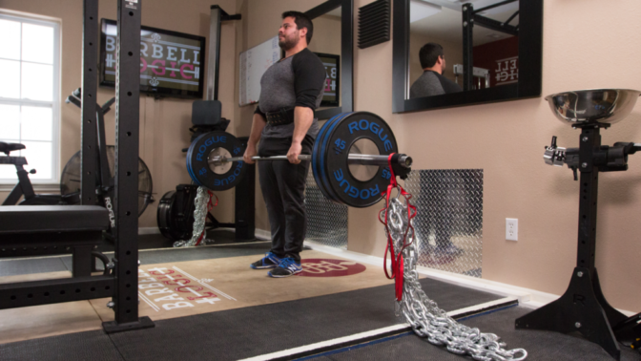  Definition: split programming divides training sessions to target different muscle groups, common split programming include upper and lower body. This is efficient especially if clients want to workout full body however has less time or session to do so.

Case Study 2
You will be assigned a partner from the class teacher. Screen them for their general

Respond to the following points:
Use this information to create an exercise training program that suits the needs and goals of the individual. Use the Fit to Learn Program Card template.

This program will be part of a 2 day split.

FIT TO LEARN PROGRAM CARD |  |  |  | Client Name: Siale
Trainer: | Genesis |  |  |  | Date: | 19/10/21
Goals/Aims | Gain strength and muscle
Contraindications | N/a
Session length | 45mins - 1 hour
Warm up | Push-ups x10  Burpees x10  Lunges x8 each leg  Air squats x10
Exercise | EPC | Sets | Reps |  | %1RM/Weight |  | Rest
Bench press |  | 4 | 10 |  | 70% |  | 90s
Dumbell incline bench press |  | 4 | 10 |  | 70%
Bent over row |  | 3 | 10 |  | 60%
Lat pull down |  | 4 | 10 |  | 80%
Barbell Squat |  | 3 | 8 |  | 70%
Leg press |  | 3 | 10 |  | 80%
Other training methods: AMRAP / INTERVAL / TABATA
Fartlek, continuous training, circuit, plyometric
Cardiovascular training method |  | Time/Distance |  |  | Level/Resistance/Intensity
LSD  Mode: Run  Distance/ time: 3km  Intensity: @6RPE |  | 15 minutes |  |  | Moderate
Cool down | Slow walk 2 minutes
Stretches | Hand against wall chest stretch 30s each arm x2  Side reaches 40secs each arm x2  Hamstring and glute stretch 40s

From the exercise program created, select five (5) movements to examine further (include at least one body weight movement). Identify the muscles targeted by the movement as well as the joint action the movement encompasses.

Exercise | Muscles targeted | Joint action
Example:  Calf raise | Gastrocnemius, Soleus, Tibialis Anterior | Ankle: Dorsi and Plantar Flexion
Single arm pulldown | Latissimus dorsi  Rhomboid  Biceps | Vertical shoulder aduction and abduction  Elbow flexion and extension
Military press | Anterior and medial deltoid  Tricep | Vertical shoulder aduction and abduction  Elbow flexion and extension
Trap bar shrugs | Trapezium | Shoulder vertical aduction and abduction
Banded db bench | Pectoralis majoris  Triceps  Anterior deltoid | Horizontal shoulder aduction and abduction  Elbow flexion extension
Dips | Pectoralis majoris  Triceps  Anterior delt | Shoulder flexion  Elbow flexion

Plot the progressive overload that will exist for your client in both their cardiovascular and resistance training, using the table provided. Begin with Week 1 information and show how, over the course of six (6) weeks, you will adapt this training to ensure the client is continually going to improve their fitness and be challenged by your program.

RESISTANCE EXERCISE
Exercise | Week 1 | Week 2 | Week 3 | Week 4 | Week 5 | Week 6
Example:  Calf Raise | Reps: 10  Sets: 3  %1RM: 70% | Reps: 12  Sets: 3  %1RM: 75% | Reps: 8  Sets: 3  %1RM: 75% | Reps: 10  Sets: 3  %1RM: 80% | Reps: 12  Sets: 3  %1RM: 85% | Reps: 8  Sets: 4  %1RM: 80%
Shoulder press db | Reps: 10  Sets: 4  @60% | Reps 12  Sets 4  @75% | Reps 12  Sets 4  @75% | Reps 10  Sets 3  @80% | Reps 10  Sets 3  @85% | Reps 10  Sets 3  @80%
Military press | Reps: 12  Sets: 3  @40% | Reps:12  Sets: 4  @50% | Reps: 10  Sets: 3  @60% | Reps: 10  Sets: 3  @70% | Reps: 8  Sets: 3  @80% | Reps: 10  Sets: 3  @80%
Trap bar deadlift | Reps: 10  Sets: 3  @40% | Reps: 10  Sets: 3  @50% | Reps:12  Sets: 4  @50% | Reps: 12  Sets 4  @50% | Reps :15  Sets 3  @50% | Reps: 15  Sets: 3  @60%
Bent over row | Reps: 8  Sets: 4  @60% | Reps: 8  Sets:4  @60% | Reps: 10  Sets: 3  @60% | Reps:10  Sets:3  @70% | Reps: 10  Sets: 4  @70% | Rep:12  Sets: 4  @70%
Dips | Reps: 12  Sets: 4  @70% | Reps:12  Sets:4  @70% | Reps: 10  Sets:5  @70% | Reps:10  Sets:5  @70% | Reps:10  Sets:4  @75% | Reps:10  Sets: 4  @75%
CARDIOVASCULAR EXERCISE
Exercise | Week 1 | Week 2 | Week 3 | Week 4 | Week 5 | Week 6
Example:  Treadmill | Time: 20 minutes  Level: 4  Incline: 0% | Time: 25 minutes  Level: 4  Incline: 3% | Time: 30 minutes  Level: 5  Incline: 3% | Time: 15 minutes  Level: 6  Incline:3% | Time: 20 minutes  Level: 6  Incline: 3% | Time: 30 minutes  Level: 7  Incline: 0%
Rowing machine | Distance: 2km  Level: 4  Intensity: 50% | Distance: 2.5km  Level: 4  Intensity:  60% | Distance: 3km  Level: 5  Intensity: @60% | Distance 1.5km  Level: 6  Intensity:  @60% | Distance: 2km  Level: 6  Intensity:  @60% | Distance: 3km  Level: 7  Intensity:  @30%
LSD (HIIT) | Mode: Run  Time: 15 minutes  Intensity Ratio: 8RPE ; 2RPE  Time ratio: 40:20 | Mode : Run  Time: 20 minutes  Intensity Ratio: 8RPE;  3RPE  Time ratio:  30:30 | Mode:  Run  Time: 25 minutes  Intensity ratio: 9:RPE ;  3RPE  Time ratio: 30:30 | Mode:  Run  Time: 10 minutes  Intensity ratio: 9 RPE; 1 RPE  Time ratio:  45:15 | Mode: Run  Time: 15 minutes  Intensity Ratio:  9RPE; 2RPE  Time ratio:  50:10 | Mode: Run  Time: 20 minutes  Intensity ratio: 9RPE ;  3RPE  Time ratio:  50:10

Day 2 Program

FIT TO LEARN PROGRAM CARD |  |  |  | Client Name: siale
Trainer: | Genesis |  |  |  | Date: | 20/10/21
Goals/Aims | Gain strength and muscle
Contraindications | N/a
Session length | 45mins
Warm up | Row machine 3 minutes  High knees 45s  15x push-ups
Exercise | EPC | Sets | Reps |  | %1RM/Weight |  | Rest
Shoulder press |  | 4 | 10 |  | 60% |  | 60s
Military press |  | 3 | 12 |  | 40% |  | 90s
Trap bar deadlift |  | 3 | 10 |  | 40% |  | 45s
Bent over row barbell |  | 4 | 8 |  | 60% |  | 60s
Bench Dips |  | 4 | 12 |  | 70% |  | 45s
Push-ups |  | 3 | 10 |  | 50% |  | 30s
Other training methods: AMRAP / INTERVAL / TABATA
Weight, flexibility, interval

Cardiovascular training method |  | Time/Distance |  |  | Level/Resistance/Intensity
Bicycle |  | 10minutes |  |  | 50%
Cool down | Slow walk 2minutes
Stretches | Arm across body stretch 45s each arm  Arm behind body stretch 45s each arm  Cat stretch 30s up 10s rest x2  Crucifixes 10xeach leg

