CPCCBC4012B
Read and interpret plans and specifications

THEORY EXAM INSTRUCTIONS

- This exam will occur under standard assessment conditions.
  - An oral examination may be allowed under certain circumstances.
Answers will be documented and FT003 (Oral examination declaration form) must be completed.
- Participants must provide enough detail in their responses to demonstrate their knowledge and skills.
- Please fill in the details below, providing your name, signature and date of assessment.
  - Your signature acknowledges that this is your own work.
- If a participant initially answers a question incorrectly but modifies their response, they must follow the instructions below:
  - If a participant changes their response in writing, they must put their initials next to the written change.
  - If a participant changes their response verbally, this must be noted on the exam paper by the assessor.

Participant name | Sheena Christine Reyes Mania
Participant signature | 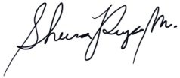

Assessor name
Assessor signature | 

Date | Click here to enter a date.

Number of questions | Number of questions answered correctly | Satisfactory?
77 |  | Yes | No
Assessor Comments
- What does the term ‘plan’ mean when referencing plans and drawings for construction purposes?

Answer | A plan is a view which shows the location of the walls and doors, layout and dimensions of the rooms, and other part of the interior and exterior of the building.

- Name the people and organisations who will have an interest in plans and drawings for a construction project.

Answer | 1. Contractor and subcontractor  2. Owner, client and lending body  3. local council  4. supply authorities (water, sewerage, drainage)  5. electrical, gas and cable supply companies  6. engineers  7. real estate agents  8. neighbors  9. kitchen manufacturers  10. landscapers  11. various material or product suppliers  12. environmental agencies  13. mechanical service installers (air conditiong, fire alarms)

- What will plans show to the interested parties?

Answer | 1. Location of specific / different trades (joinery, white goods, doors, windows, location of appliances for power outlet and switches)  2. Dimensions, size of the structure

- What types of plans is it necessary to be familiar with for building and construction projects?

Answer | 1. key plan  2. Site plan / block plan  3. Floor plan

- All plans and drawings give a compass direction.
Which compass direction is always shown and on which drawings is it likely to be found?

Answer | The point of the arrow is drawn to face nor  1. Site plan  2. Key plan  3. Block plan  4. floor plan

- What does a location plan contain?

Answer | 1. lot number  2. deposit plan numbers  3.north point  4. scale (usually 1:5,000)

- What does a site or block plan contain?

Answer | 1. datum - reference height to other site levels  2. building orientation to north point  3. outline of site boundaries showing location of proposed building and existing dwellings  4. plan page number, client name, project address, scale, reference numbers and dates  5. major geological and topographic features (trees and vegetation  6. contours and slopes at 500mm intervals  7. depths of contours where they may occur  8. distance from the boundaries to the building footprint  9. driveways, stormwater drainage to the building footprint  10. soil and surface water drains, pipe sizes  11. service runs from the house to mains - utility services location (sewer, water, gas, electricity)  12. New levels on the site in connection with the new house  13. paving and retaining walls

- What features would you expect to look for and find on plans and drawings for a construction project?

Answer | 1. ceiling height and variations  2. doors and windows  3. light fittings and power supplies  4. services  5. wall penetrations  6. walls

- What do floor plans identify?

Answer | 1. the location of various features on the site and illustrate details about the buildiing, like construction details for specific trades people  2. height, position and bulk of the building so that council can determine compliance to its codes  3. allow builders and trades people to prepare written quotations.  4. provide the surveyor with the details "to set out"  5. Illustrate to trades people the structure to be built

- What are elevation views? What do they provide to the plan reader?

Answer | An elevation is a view seen when standing in front of that wall, usually drawn to a scale of 1:100.  Most councils require an elevation from each side of the proposed development and the view is indicated by north, south, east or west elevation. It indicates finish to external walls, and size of windows, doors and balconies.

- What is a section?

Answer | A section is a vertical view, sliced through the building.  The direction of section lines or arrows is usually shown on the plan to help interpret the sectional view. Its key features are height of building, position of beams and openings, floor to ceiling heights, finish floor and ground level distances, construction details. It's scale is usually the same as the floor plan.

- What are detailed drawings?

Answer | Detailed drawings may include:  1. Traffic and parking assessment report provided for all residential, commercial and industrial developments that seek to vary Council’s traffic and parking requirements and other developments involving a change to traffic  2. Site plan showing the critical adjoining parts of surrounding properties and the locality  3. stormwater drainage concept plan required to show how stormwater will be managed on the site and at a minimum show how it will be collected, conveyed and disposed from the site

- What are specifications?

Answer | It contains full description of work, precise list of materials, details of all fittings, fixtures and finishes, precise list of products (types, brands, grades, thickness, colour, and model), levels and survey information, material lists, performance data and material technical data, schedule of quanitites, stress / load and bearing calculations.

- What information will you find in a title block to a drawing?

Answer | 1. Project Name  2. Client  3. Architect / engineer  4. drawing number / sheet  5. scale, and size of drawing sheet1.

- What is the significance of the Australian Architectural Standards?

Answer | to help ensure the safety, reliability and performance of a range of products, services and systems.  To have a unified understanding of the construction drawings / drawings for the proposed development or structure.  1. standard symbols for drawings (plans and elevation, ex: doors, windows)  2. commonly used symbols and lines  3. standard symbols / orientation symbols  4. architectural and building services symbols  5. standard hatch for building materials  6. commonly used abbreviations  7. construction terms

- What will you find in the Waste Management Plans & Site Management plans?

Answer | Waste Management Plan:  1. Key activities, risks, and impacts  2. Mitigation measures  3. Responsibility for implementation and monitoring  4. Trigger, Action, Response Plan (TARP)  Site Management Plan:  1. Building schedule/timeframe of construction;  2. Location of site storage sheds and offices;  3. Location of hoarding and or gantry;  4. Location of site toilets;  5. Location of rubbish receptacles (please note; Littering is an offence and can result in an infringement)  6. preference is given to steel bins that fully contain rubbish and prevent it from blowing away; Location of building materials i.e. Bricks, sand, timber etc.;  7. Traffic management including, vehicle access and parking i.e. Tradesman vehicles,  8. delivery drop off areas etc.; Fully dimensioned site plans must accompany the Site management plan;  9. Adjacent owner consent will be required if it is intended to utilise their property for the  10. storage of materials etc

- What is a landscape plan?

Answer | A landscape design is like a floor plan for an outdoor area. Like a floor plan, a landscape design creates a visual representation of a site using scaled dimensions. Landscape plans include natural elements like flowers, trees, and grass as well as man-made elements such as lawn furniture, fountains, and sheds. Landscape designs may also include overlays for irrigation and lighting.

- What is the purpose of a shadow diagram? Who primarily would seek one?

Answer | A shadow diagram allows us to view and calculate the amount of shadow cast by the proposed development. It contributes in determining the shading effect of the adjacent structures as well as those casts by the proposed structure which helps in shaping the sustainability of the development. This is usually seeked by architects / engineers for evaluation of design, and calculation /preparation of the Energy Efficiency Report usually provided for Glazing, roof, external wall cladding contractor.

- What is a bracing schedule?

Answer | A bracing schedule is a tabulation of members allowed (minimum size and specs) based on calculation in line with earthquake, wind, and other outside pressures affecting the rigidity of the building / structure.

- What must we do with plans and drawings in our on-site environments? How often should plans and drawings be viewed on site?

Answer | Plans on site should always be updated, documented and stamped as to what date received, and marked-out as "superseded" when there is new drawing / drawing sheets. Construction drawings must always be readily available for review by foreman, supervisors, subcontractors, project manager, construction manager, and other people on site.

- Explain the meaning of the abbreviations in the table below.

Answer | Abbreviation | Meaning
 | ACRYL | Acrylic
 | AS | Australian Standards
 | ASSD | Assumed Datum
 | B | Basin
 | BN | Bull Nose
 | BTH | Bath
 | BWK | Brickwork
 | CB | Concrete Block
 | CF | Concrete Floor
 | CG | Clear Glass
 | CJ | Ceiling Joist
 | CORR | Corrugated
 | CWT | Cold Water Tank
 | DG | Double Glazing
 | DH | Double Hung
 | DPC | Damp Proof Course
 | DSB | Distribution Switch Board
 | DW | Dishwasher
 | EJ | Expansion Joint
 | FPBD | Fibrous Plaster Board
 | FFL | Finished Floor Level
 | FHR | Fire Hose Reel
 | GPO | General Purpose Outlet
 | HBD | Hardboard
 | HTR | Heater
 | HWD | Hardwood

- Why and when would you use presentation drawings?

Answer | Presentation drawings contain basic concepts of the design for a structure / building, relayed from the designer to client.  It is important to have a presentation drawing if a client is government as it is used during public hearings as to how it will affect the community.  If a proposed structure is a residential, presentation drawings are important to show / review for compliance with the board standards, as well as it is used for marketing / advertisement of existing stock plans. .

- Service drawings provide information about a variety of different components and equipment. In order to identify individual items, it is usual to give them a reference number on drawings such as services layout drawings and location plans.
What details might we expect to see from service drawings?

Answer | 1. hot and cold water supplies for above and below ground drainage  2. sanitary appliances  3. refuse disposal  4. heating, ventilation, and air conditioning  5. electrical installation: lighting, telecommunications, gas installations, fire protection, mechanical conveyors, and security systems

- What are working drawings? What do they record?

Answer | Working drawings are complete set of drawings that can be used for actual construction of a building. These includes complete dimensions, details, and notes. It is a complete record / explanation of the sketch / presentation drawings that has been completed / sumbitted on an earlier stage. It also serves as preliiminary construction plans to clarify on-site details that are not made clear by the previous drawings such as sketches and presentation drawings.

- What is an isometric view?

Answer | Isometric drawing is a method of presentation where 3 faces of the object or view is shown (usually top, front, and side). There are 3 lines / faces that are used as reference: 30 deg angle to thr right, 30 deg angle to the left, and a vertical line. The scale of an isometric is usually the same as the plans, elevations, and sections.

- Sketch a concrete block in isometric view.

Answer

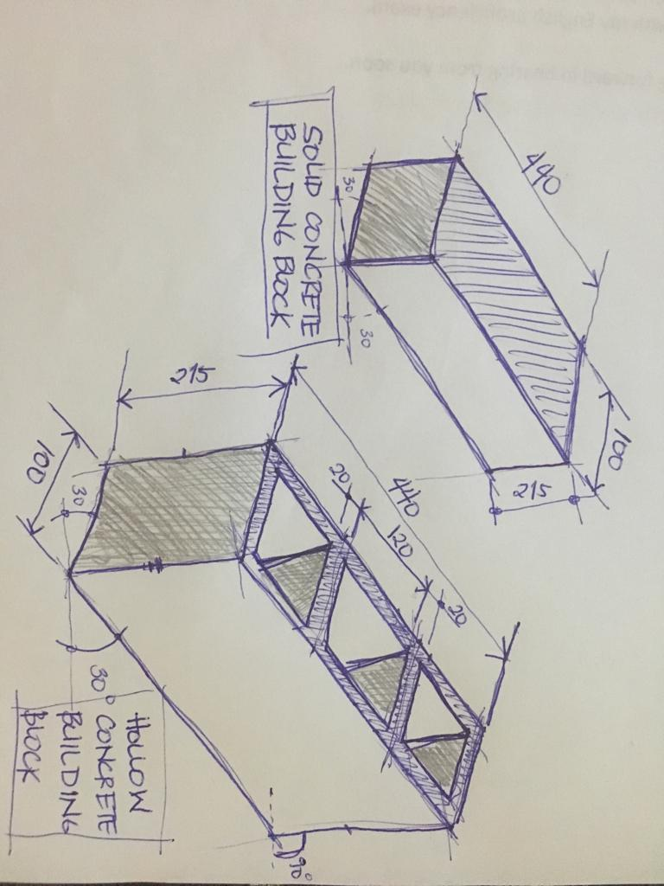

- What is the purpose of perspective projection and representation in drawing of architectural buildings and edifices?

Answer | Perspective drawings are used to perceive the building / structure in an a more realistic form either on a normal eye view or camera, where lines are defined either to 1 vanishing point, 2, or 3 vanishing points..

- What is a topographical survey?

Answer | It includes a laser scanning, or lidar that provides a strong method for surveying to set-out the exact points of the legal boundary of the property for proposed structure, preventing future disputes.

- What is an ecological survey?

Answer | Ecological survey is an examination / assessment of an area identifying habitats, and / or species that exists at the time of the survey. Ecological surveys are important as most of the proposed structures have impact on the local biodiversity and habitat, and its early identification ensures that development proposals are not delayed and appropriate mitigation or compensation is incorporated as early as the design stage.

- What is significant to keep in mind when developing the Schedule of Quantities (also known as a Bill of Quantities)?

Answer | Bill of quanitites are included during the tender stage and also during contract period, and are use to itemized the works for billing purposes / variation orders that occurs thereafter. It is always important to have a proper BOQ or Bill of Quanitities to a safe reason that any additional works, proper monetary claim for additional or deduction of works will be in order. For tendering purposes, Bill of Quantities are important, quantities as determined by a quantity surveyor for a competitive pricing for tendering and estimate.

- What should be applied in consideration of stress, load and bearing calculations in the design, the drawings and the building of a structure?

Answer | Building code, and other authority requirements should always be considered in the calculation of stress, load, and bearing calculations for the design.

- What is a prime cost (PC) item? Give an example.

Answer | An amount agreed and included in a contract sum for the material supply that will be selected by the client. Under the Home Building Contracts Act of 1991, the estimated cost the contractor can provide is at or above the lowest reasonable cost. Cost variation if there will be, is to be settled after the actual material has been decided by the client.  Ex: client provided a Prime Cost of $55,000 for all the special hardwares. The amount of $55,000 will be used, and included to the overall amount during the tender and contract signing to whichever stage. However, when the client has already decided for which brand and model for the hardwares are to be used, and apparently the hardware cost has been changed to $85,000, there would be a cost variation of $30,000 to be added on top of the contract cost.

- What is a provisional sum (PS) item? Give an example.

Answer | A Provisional Sum (PS) are costs of works not detailed but included in the contract sum. These are contingency costs perceived by the contractor.  Example of which is a provisional sum by the contractor for special trade workers and engineers' board and lodging for a project out of town.

- Suggest when you would need to provide ‘additional’ plans.
Give some examples of such plans.

Answer | Additional drawings / plans are required when there are changes or additional information that may result to work, or cost variation.  Examples of these drawings / specifications are (1) Hardware Schedule, (2) Reflected Ceiling Plans where there are changes on the ceiling extent, ceiling height, termination details, (3) Stair details where there are changes on the riser and tread height, or railing details (4) door schedule and details, (4) light fittings and power supplies (5) service plans (6) wall penetrations (6) wall setting-out and details.

- How do you identify and record customer variations?

Answer | 1. All changes in the drawings / specification whether in regards to work, or cost variation has to be recorded with proper stamp for dated received, and 'superseded'. Transmittal, and how it has been received must also be recorded properly.  2. Variations must be put in writing (ex. email or transmittal with receiving copy). Client, subbies, and other parties must all agree (recorded in writing) before work starts. In some cases where practically it is better to proceed with the works or coordination for the variation. This case, the documentation must be done within 24 hours. All subsequent documentation must be completed by all parties (client / subbies) within 5 business days when the variation has been agreed to with all documentation recorded in writing.  3. Changes to any terms, including the cost, must be dated and signed by all the parties to the contract.  4. Contractor has to submit an 'extension of time' and / or 'cost variation' for significant changes that cause delay, and / or price adjustment due to increase or changes on the scope of works.  5. Variation payments should be made in accordance with the time stated in the variation document

- When reading and interpreting (or amending) variations project specifications, what documentation should you also refer to?

Answer | When analysing a variation, the reference drawings that are to be used are the most recent drawings and specifications before variation came out. These has to be compared to the recent ones that has just came out.

- So you don’t end up in a dispute what strategies can you employ with your customer/client/home owners?

Answer | 1. It is their responsibility to put variations in writing to you (the builder) as early as possible on paper or by email  2. Always put variations in writing  3. Changes to any terms, including the cost, must be dated and signed by all the parties to the contract  4. Submit an extension of time for significant change, such as delays caused by owner increasing scope of works)  5. Variation payments should be made in accordance with the time stated in the variation document

- Name each of the drawing symbol images shown in the table below.

Answer | Name | Image
 | 2-layer brick wall with air gap in between | 
 | 2-layer wall with air gap  Concrete block with brick cladding | 
 | 1-layer concrete block | 
 | Window in general | 
 | Window Sill | 
 | Single panel door that opens 90 deg | 
 | Door with 2 equal leaves, each opening at 90 deg. | 
 | Straight sliding, door leaf rest inside the walll | 
 | Straight sliding, door leaf rest on wall surfacel | 
 | General Power Outlet (GPO) | 

- Draw symbols for the following items.

Answer | Item | Drawing
 | Basin | 
 | Bidet | 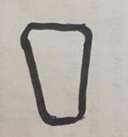
 | Bath | 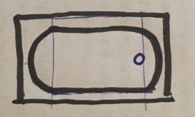
 | Drinking fountain | 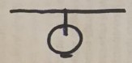
 | Sink: Single bowl | 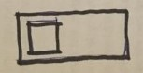
 | Sink: Double bowl | 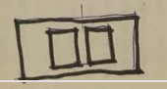
 | Tub: Double | 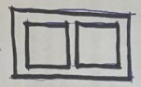
 | Tub: Single | 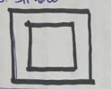
 | Drinking trough | 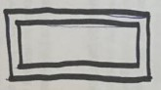
 | Hotplates | 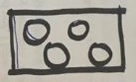
 | Shower | 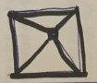
 | Shower bath | 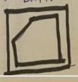
 | Urinal stall | 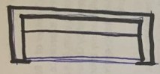
 | Vanity basin | 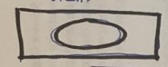
 | Water Closet (Toilet) | 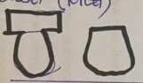

- Draw the following window symbols in elevation.

Answer | Item | Drawing
 | Hinged at side | 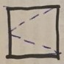
 | Hinged at top | 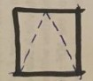
 | Sliding horizontally | 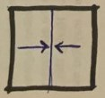
 | Fixed | 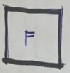

- Draw symbols for the following items.

Answer | Item | Drawing
 | Brickwork | 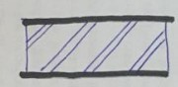
 | Blockwork | 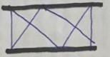
 | Concrete | 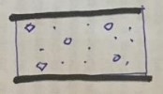
 | Plaster/Render | 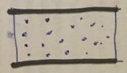

- Provide a description of the residence shown in the plan drawing below.

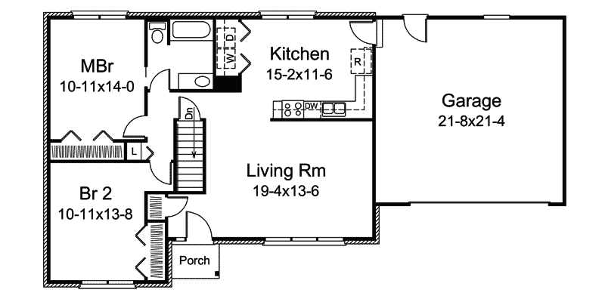

Answer | 1 Storey Residence with 2 Bedroom and 1 Toilet and Bath

Refer to the sectional drawing below to respond to Q43. to Q63.


- Give a brief description about the building from the detail available in the sectional drawing.

Answer | 2-storey residence with at least 4 bedrooms and a bath. The 1st storey is generally common area / family area with side Verandas.

- Who is the client?

Answer | H&M Smith

- Where is this project to be built?

Answer | Lot 6 Glenvalley Road, Richmond

- What are the contact details for the draftsman?

Answer | Name: Joe Forman  Phone: 03 9514 2311  Mobile: 0413 113 113  Address: 18 Fairview Road, Richmond 3216

- What sheet number is this drawing?

Answer | Sheet 5 of 7

- What timber is required for loading and non-load bearing walls?

Answer | Load Bearing: F5 timber 45x90  Non-load bearing: F5 timber 35x90

- What spacing is recommended for common studs?

Answer | 600mm maximum spacing

- What type of roof truss is to be installed?

Answer | Scissor trusses are to be installed at 900mm spacing, top cord at 30deg, and bottom chord at 20deg.

- What centres are the trusses positioned at?

Answer | The truss center is positioned at exactly the middle / center of the structure..

- What size are the veranda posts?

Answer | The veranda posts are 90x90mm size

- What timber species are the veranda posts to come from?

Answer | The veranda posts are DAR OREGON timber

- What pitch is the roof?

Answer | The roof has a 30deg roof pitch

- What size are the noggings and at what spacing?

Answer | The roof noggings are 35x70mm in size, and are spaced at 1350mm maximum.

- What size are the ceiling joists?

Answer | The ceiling joists are HJ 240 in size

- What timber is used for roof battens and what spacing?

Answer | FG pine is used as roof battens at 900mm spacing

- What thickness is the plasterboard sheeting?

Answer | The plasterboard sheeting is 10mm thick

- What type of flooring is to be installed?

Answer | The flooring is 15mm plywood.

- What is the roof cladding material?

Answer | The roof material is colorbond corrugated metal roofing.

- Where will you find information about the footings?

Answer | Information about the footings can be found in the structural drawings

- What do the letters DAR refer when timber ordering?

Answer | DAR is the acronym for "Dressed All Round'. For ordering, this indicates the size (width and height) of the the timber section.

- Explain 240 x 63 LVL. What does it refer to on the section?

Answer | LVL stands for Laminated Veneer Lumber. It means in the section that the starting joist is size 243x63 in sectional dimension in continuous length.

Refer to the drawing overleaf to respond to Q64. to Q75.

- What is the number of the drawing?

Answer | Drawing No. 2

- What is the Job Number?

Answer | Job No: 00R-112

- What is the scale of the drawing?

Answer | Scale 1:100

- What does the drawing show?

Answer | The drawing sheet shows Elevation (North, South, East, West), and Section drawing. It shows the material to be used as shown on the facade and section detail. It shows:  1. roof material finish, and roof structure  2. doors and window material and indicate the sliding doors / windows  3. Approximate height of the structure from ground level to roof apex finish

- Which view shows the front of the house?

Answer | East Elevation

- How many motor vehicles can be parked in the garage?

Answer | 2 motor vehicles can be parked in the garage

- What are the window and doors made from?

Answer | 1. Aluminium framed door and windows  2. timber at entrance door

- What is the size of the eaves?

Answer | 150mm

- What are the eaves lined with?

Answer | Hardiflex

- What type of roof structure is the roof built from?

Answer | Timber framed roof structure

- What is the roof cladding materials made from?

Answer | Concrete roof tiles

- What is the roof pitch?

Answer | 22.5 degree slope

- You have spoken with a client on the phone and they are seeking to make amendments to some plans. They wish to add two more bedrooms to extend their home from the current four bedrooms to six bedrooms.
The two new bedrooms are to both have ensuites (including single shower in each, double bowl vanity unit and under cupboard and toilet) with walk in robes, including the extension of the existing hallway with built-ins for the existing Bed 1 and Bed 2. The Family Room is to be extended to the rear wall in line with kitchen rear wall.
The client has faxed through the image below. Re-sketch and redesign the drawing and add the two new bedrooms along with extended hallway, ensuites, walk-in robes and the Family Room extension for consideration by the client.
SKETCH
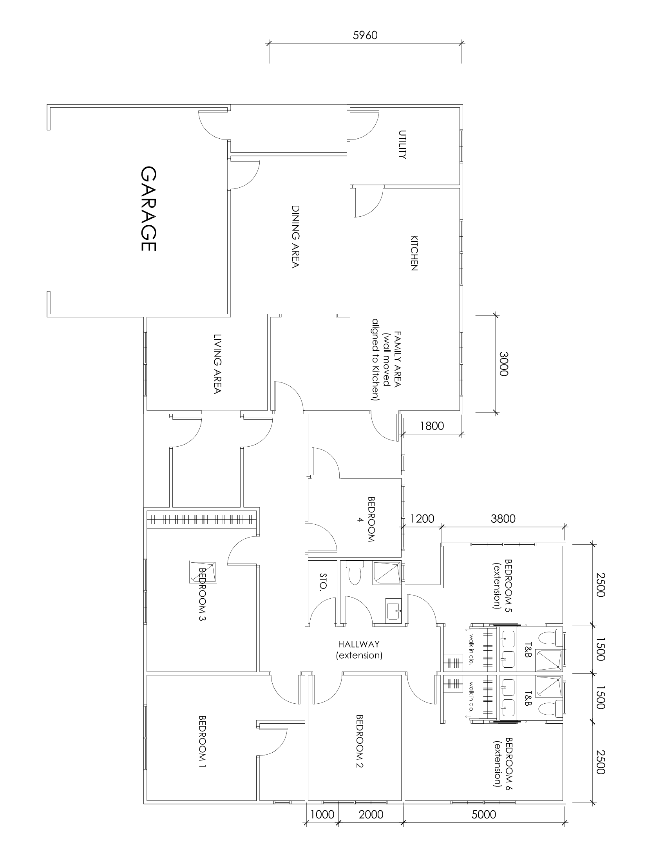

Answer

- Referring to Q76. compose an email to the client, providing an estimate of the additional labour hours/costs and material quantities/costs that have resulted from the their request.

Answer | Monday , 02 October 2018  RE: Renovation of a Single-Storey Residence  We submit for your consideration our quotation as follows  - Extension of Family Area  - Extension of Hallway  - Addition of 2 Bedrooms with Walk-in Closet and en-suite toilet and bath for each new bedroom  All at a cost of $46,227.50 (GST excluded)  We trust you find our offer of interest and assure you of our every co-operation.  Sincerely,  Sheena R. Mania
  Family Area / Kitchen
  Demolition Works | 15m² (5Lm) | $ 880.00
  Additional Concrete Slab and Reo Supply and Install | 1.5m³ (5.5m²) | $ 577.50
  Blockworks and Window Installation (existing window is salvaged) | 6m² | $ 1,650.00
  Hallway Extension
  Demolition of Storage Wall | 9m² (3Lm) | $ 550.00
  Blockwork supply and Installation for Storage / bath | 6m² (2Lm) | $ 550.00
  Timber Door Supply and Installation | 1 no. | $ 330.00
  Additional Bedrooms
  Concrete Slab and Reo | 10m³ (40m²) | $ 3,850.00
  Blockwork Supply and Installation | 123m² (41Lm) | $ 550.00
  Supply and Installation of doors (2 pocket doors, 2 swing) | 4 nos. | $ 880.00
  Supply and Installation of Aluminium Windows | 4 nos. | $ 550.00
  Tiling and Waterproofing for bathrooms (floor and wall in full height) | 100m² | $ 1,210.00
  Plumbing |  | $ 2,200.00
  Electrical |  | $ 4,400.00
  Toilet Fixtures Supply and Installation |  | $ 7,150.00
  -double bowl vanity unit and under cupboard (2 sets)
  -single shower (2 sets)
  -water closer (2 sets)
  Wardrobe Cabinet Supply and Install (2 sets), similar to existing |  | $ 2,200.00
  Roof Demolition, Installation of New, Storm Drainage |  | $ 5,500.00
  Painting Works (including roof) |  | $ 13,200.00
  total excluding GST |  | $ 46,227.50
  total w/ GST |  | $ 50,850.25

