ASSESSMENT FOR

Student name | Kevin Larney
Date of assessment submission

Trainer/Assessor’s name | Tui
Date of assessment marking
Outcome for unit | Competent  Not Yet Competent

TASK INSTRUCTIONS

- As part of the assessment for this unit of competency, you are required to complete a series of activities.
- Some of these activities will require you to provide a response within this document, others will require you to gather evidence to demonstrate your knowledge and skills.
- At all times, the responses in your assessment must reference Australian (Queensland or Federal) documentation, including legislation, regulations, codes of practice, standards and guidance publications.

ACTIVITIES

Identify/list the scope of the work to be carried out from the concept plan shown.

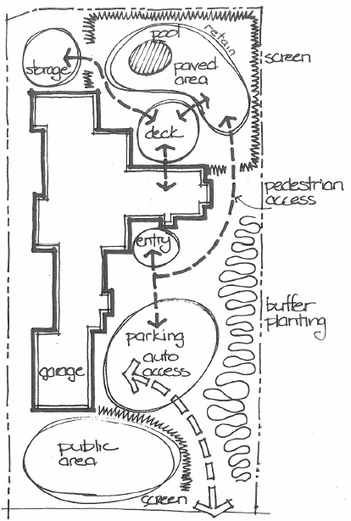

Response
Storage, deck, paved area, pod, screen, pedestrian access, entry, buffer planting, parking auto access, garage, public area and screen.

Outcome for Activity 1 | Satisfactory  Not satisfactory
Trainer/Assessor comments

Identify/list the detail on the landscape plan shown.

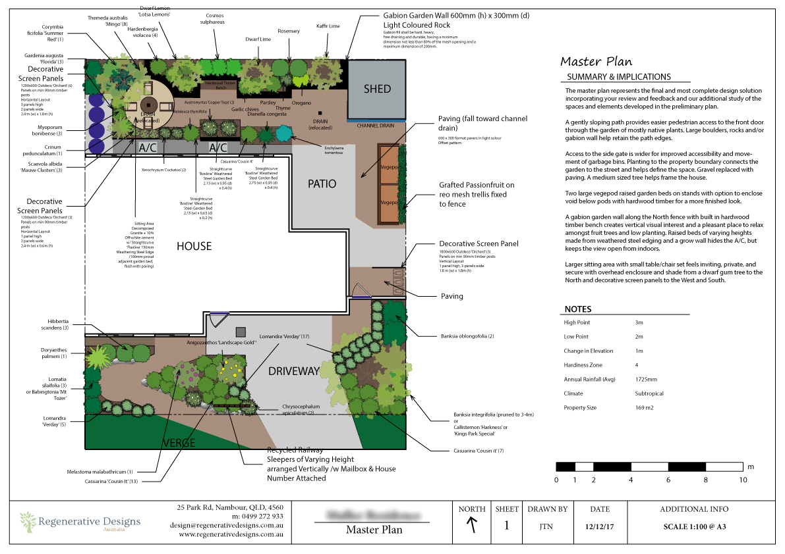

Response
Summary and implications, scale, notes, date, north direction and map.

Outcome for Activity 2 | Satisfactory  Not satisfactory
Trainer/Assessor comments

Using the graphics shown, create a simple plan that details a paved path through a garden with grass, trees, shrubs, rocks and steps.

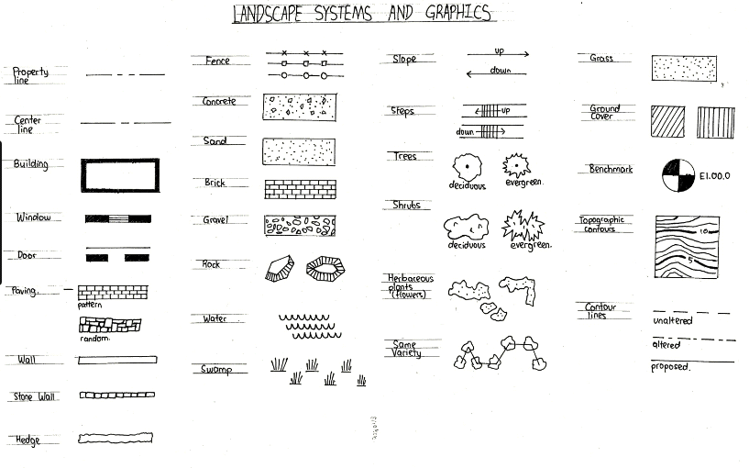

Response
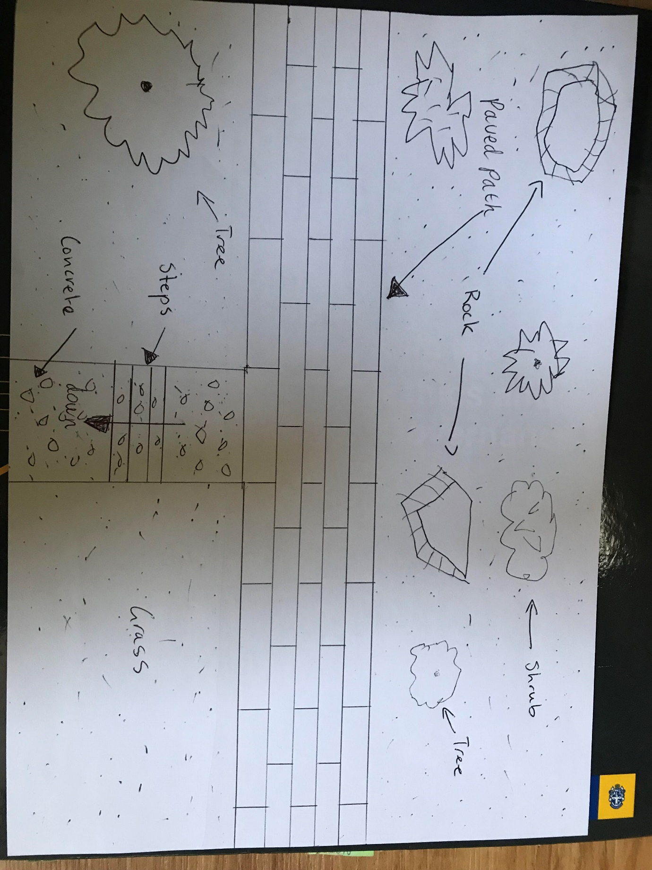

Outcome for Activity 3 | Satisfactory  Not satisfactory
Trainer/Assessor comments

Research the advantages and disadvantages of concrete, clay and stone pavers.

For each material, provide one (1) example of a project where it would be most appropriate to use the material and one (1) example of a project where it would not be appropriate to use the material. Explain your responses.

Concrete pavers
Appropriate
Versatility, low material and installation cost, many shapes and colours.
Areas with extreme temperature changes or heavy foot traffic.
Not appropriate
It is porous and is susceptible to stains if not resealed regularly.

Clay pavers
Appropriate
Natural, don't fade in the sun, slip resistant, strong and recyclable.
Garden pathways, driveways sidewalks, patios and garden walls

Not appropriate
High cost, durability issues and maintenance requirements.

Stone pavers
Appropriate
Provide enhanced aesthetic value, versatile and long lasting durability.
Any area requiring a hardscape that needs to be both beautiful and permeable.
Not appropriate
Pavers become uneven over time, not suitable for use around a swimming pool.

Outcome for Activity 4 | Satisfactory  Not satisfactory
Trainer/Assessor comments

Obtain photographs of common landscaping materials and finished landscapes (both soft and hard).

Explain the differences between your emotions/feelings when you see each photograph in black and white and in colour.

Photograph 1
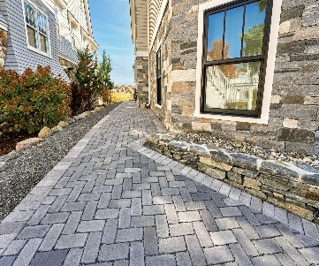
Black and white: Emotions and feelings
Simplicity: In black and white, the photograph may evoke a sense of simplicity and minimalism. Without the distraction of colour, the focus shifts to the textures, patterns, and shapes of the pavers. This simplicity can evoke feelings of clarity and calmness.
Colour: Emotions and feelings
Realism: Colour photography provides a more realistic representation of the pavers, allowing the viewer to perceive the materials as they would appear in real life. The colours convey a sense of authenticity and depth, immersing the viewer in the scene.

Photograph 2
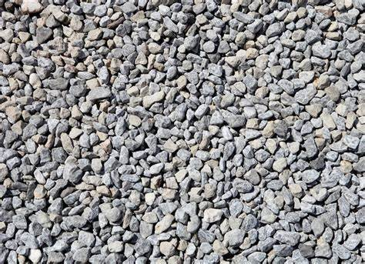

Black and white: Emotions and feelings
Texture and Contrast: In black and white, the texture of the gravel becomes more pronounced, and the contrast between light and dark areas can be heightened. This emphasis on texture and contrast can evoke feelings of depth and tactility, as the viewer's attention is drawn to the varying shapes and sizes of the gravel particles.
Colour: Emotions and feelings
Naturalism and Realism: Colour photography provides a more realistic representation of the gravel, allowing the viewer to perceive the nuances of colour and texture as they would appear in real life. This sense of naturalism can evoke feelings of connection to nature and an appreciation for the beauty of the outdoors.

Photograph 3
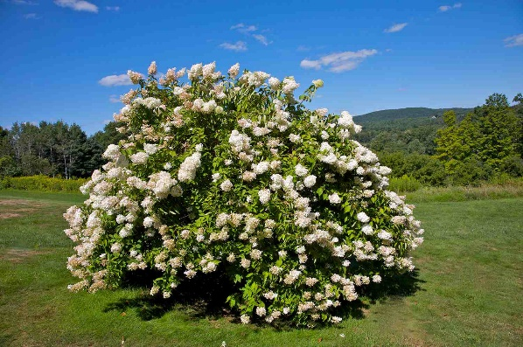

Black and white: Emotions and feelings
Simplicity and Elegance: The absence of colour in black and white photography can create a sense of simplicity and elegance. Without the distraction of colour, the focus is on the forms and shapes of the plants, fostering a contemplative mood and a sense of sophistication.
Colour: Emotions and feelings
Naturalism and Realism: Colour photography provides a more realistic representation of the plants, allowing the viewer to perceive the nuanced colours and textures as they would appear in real life. This sense of naturalism can evoke feelings of connection to nature and an appreciation for the beauty of the outdoors.

Photograph 4
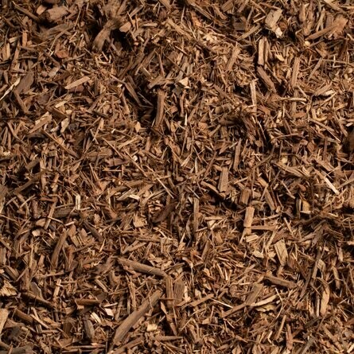

Black and white: Emotions and feelings
Texture and Contrast: In black and white photography, the texture of the mulch becomes more pronounced, and the contrast between light and dark areas can be heightened. This emphasis on texture and contrast can evoke feelings of depth and tactility, as the viewer's attention is drawn to the varying shapes and sizes of the mulch particles.
Colour: Emotions and feelings
Naturalism and Realism: In contrast to black and white, a colour photograph of mulch presents the scene with naturalism and realism. The various hues and tones within the mulch, ranging from warm browns to earthy reds and greys, add depth and richness to the image, enhancing its visual appeal and creating a more lifelike representation of the material.

Outcome for Activity 5 | Satisfactory  Not satisfactory
Trainer/Assessor comments

Research and identify eight (8) different paving patterns, including the common usage, advantages and disadvantages for each pattern.

Pattern 1 name | Stack bond
Common usage
Used for paving feature sections such as entertaining areas and patios.
Advantages
It can look excellent and act as a focal point for the eye.
Disadvantages
Not as strong as other paving methods.

Pattern 2 name | Running bond
Common usage
Used for basic wall construction found in walls and buildings of all kinds.
Advantages
Simple, straightforward and strong.
Disadvantages
Alignment issues, cracking and shifting and uneven visual flow.

Pattern 3 name | Circular Pattern
Common usage
Used for creating focal points in landscaping, including patios, garden pathways, and decorative areas.
Advantages
Adds visual interest and breaks the monotony of straight lines, suitable for enhancing the aesthetic appeal of outdoor spaces.
Disadvantages
Requires careful planning and precise cutting, can be challenging to install properly, may not be practical for large areas.

Pattern 4 name | Random stone pattern
Common usage
Mimics the appearance of natural stone, commonly used for patios, pool decks, and garden pathways.
Advantages
Provides a natural and rustic look, hides imperfections well, offers flexibility in design.
Disadvantages
Requires careful selection and arrangement of stones, can be time-consuming to install, may be more expensive than other patterns.

Pattern 5 name | Herringbone
Common usage
Often used for driveways, pathways, and patios, especially in areas with heavy foot traffic.
Advantages
Provides better interlocking, increasing stability, visually appealing with its diagonal arrangement, hides imperfections well.
Disadvantages
Requires more precise cutting during installation, can be more time-consuming and expensive, not ideal for large areas due to complexity.

Pattern 6 name | Hexagonal
Common usage
Suitable for pathways, sidewalks, and outdoor areas where a geometric design is desired.
Advantages
Offers a visually striking and modern appearance, provides good stability and interlocking, allows for creative design variations.
Disadvantages
Requires precise cutting to achieve proper alignment, can be labour-intensive to install, may not suit all architectural styles.

Pattern 7 name | Basketweave
Common usage
Popular for patios, walkways, and small to medium-sized outdoor spaces.
Advantages
Offers a unique and visually interesting design, provides good traction due to its interlocking nature.
Disadvantages
May not be as strong as some other patterns, requires regular maintenance to prevent weeds from growing in the open areas.

Pattern 8 name | Irregular pattern
Common usage
Offers a natural and organic look, often used for pathways, garden walkways, and rustic outdoor spaces.
Advantages
Mimics the randomness of natural stone formations, hides imperfections well, allows for creative and unique designs.
Disadvantages
Requires careful planning to achieve a balanced appearance, may result in uneven surfaces if not installed properly, can be more challenging to maintain over time.

Outcome for Activity 6 | Satisfactory  Not satisfactory
Trainer/Assessor comments

Select a paver type (with known specifications) and calculate the material costs for a straight path that measures 6m long by 900mm wide.

Response
Let's choose a common paver type: concrete pavers. Typically, concrete pavers come in standard sizes such as 200mm x 100mm x 50mm.

Given the dimensions of the path (6m long by 900mm wide), we need to calculate the number of pavers required.

Convert dimensions to meters:

Length: 6 meters
Width: 0.9 meters
Determine paver coverage area:

Each paver covers an area of (0.2m x 0.1m) = 0.02 square meters.
Calculate the total area of the path:

Total area = Length x Width = (6m x 0.9m) = 5.4 square meters.
Determine the number of pavers needed:

Number of pavers = Total area / Paver coverage area = 5.4 sqm / 0.02 sqm = 270 pavers.
Now, let's calculate the material costs:

Cost of Concrete Pavers:

Prices for concrete pavers can vary depending on quality, brand, and location. Let's assume a cost of $3 per paver.
Total Cost of Pavers = Number of Pavers × Cost per Paver
= 270 pavers × $3/paver
= $810

So, the material cost for a straight path measuring 6m long by 900mm wide using concrete pavers would be approximately $810.

Outcome for Activity 7 | Satisfactory  Not satisfactory
Trainer/Assessor comments

Research the advantages and disadvantages of installing edging before and after laying pavers.

Installing edging before laying pavers
Advantages
Guidance and Stability: Installing edging beforehand provides a clear boundary for laying pavers, ensuring they stay in place and preventing shifting over time.
Ease of Installation: It can be easier to install the edging before laying the pavers, as there's more space to work with and adjust the placement of the edging.
Disadvantages
Limited Flexibility: Installing edging before laying pavers may limit flexibility in the design or layout adjustments, as the edging determines the boundary of the paved area.
Increased Planning Required: Precise planning is necessary to ensure the edging is properly aligned and leveled before laying the pavers, which can add time to the project's preparation phase.

Installing edging after laying pavers
Advantages
Flexibility in Design: Installing edging after laying pavers allows for more flexibility in adjusting the layout or design, as the pavers can be arranged first and the edging can be customized to fit the specific shape and size of the paved area.
Easier Alignment: It can be easier to align and adjust the edging to fit the contours of the paved area once the pavers are already in place.
Disadvantages
Potential for Shifting: Without edging in place during paver installation, there's a risk of pavers shifting or spreading out of place over time, especially in areas with heavy foot traffic or vehicle loads.
Weed Growth: Delaying the installation of edging may allow for weed growth between the pavers before edging is installed, requiring additional maintenance to address weed issues.

Outcome for Activity 8 | Satisfactory  Not satisfactory
Trainer/Assessor comments

List environmentally safe products for cleaning.

Response
Vinegar: Vinegar is a natural and versatile cleaner that can effectively dissolve grease, soap scum, and mineral deposits. It's safe for most surfaces except for marble and other sensitive stones.
Baking Soda: Baking soda is a mild abrasive that can be used to scrub surfaces, deodorize carpets, and neutralize odours in refrigerators and other areas. It's non-toxic and safe for the environment.
Castile Soap: Made from vegetable oils, castile soap is gentle on the skin and safe for the environment. It can be used for general cleaning, dishwashing, laundry, and even personal hygiene.
Hydrogen Peroxide: Hydrogen peroxide is a natural disinfectant and bleach alternative that can be used to kill germs, whiten laundry, and remove stains. It breaks down into water and oxygen, making it safe for the environment.
Lemon Juice: Lemon juice is acidic and has natural antibacterial properties, making it effective for cutting through grease and disinfecting surfaces. It also leaves a fresh citrus scent.

Outcome for Activity 9 | Satisfactory  Not satisfactory
Trainer/Assessor comments

Have team members take photos and videos of your involvement with paving projects.

Identify each photo / video with a letter label and describe each photo / video in the table below. Submit the photo / video files along with this workbook.

Advantages
A
B
C
D
E
F
G
H
I
J
K
L
M
N
O
P
Q
R
S
T
U
V
W
X
Y
Z

Outcome for Activity 10 | Satisfactory  Not satisfactory
Trainer/Assessor comments

