
AHCLSC308
Erect metal structures and features

Copyright © 2021 CSTC Pty Ltd

All rights reserved. No part of the contents of this publication may be reproduced or used in any form or by any means – graphic, electronic, or mechanical including photocopying, digitising, recording, or information storage-and-retrieval systems – without the written permission of CSTC Pty Ltd.
ASSESSMENT FOR AHCLSC308

Student name | Lopeti Lauaki
Date of assessment submission | 16/02/2021

Trainer/Assessor’s name
Date of assessment marking | Click here to enter a date.
Outcome for unit | ☐ Competent  ☐ Not Yet Competent

TASK INSTRUCTIONS

- As part of the assessment for this unit of competency, you are required to complete a series of activities.
  - Some of these activities will require you to provide a response within this document, others will require you to gather evidence to demonstrate your knowledge and skills.
- At all times, the responses in your assessment must reference Australian (Queensland or Federal) documentation, including legislation, regulations, codes of practice, standards and guidance publications.

ACTIVITIES

Draw a simple concept plan for a proposed landscape design which includes metal structures/features.

Response
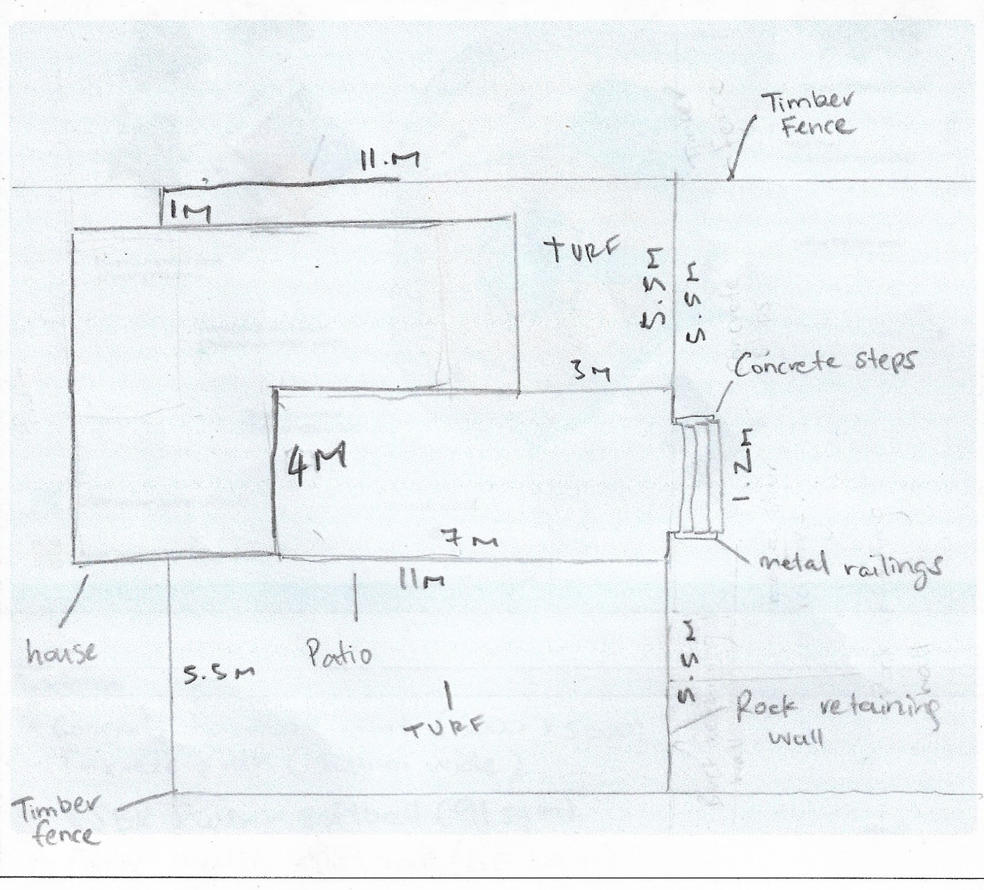

Outcome for Activity 1 | ☐ Satisfactory  ☐ Not satisfactory
Trainer/Assessor comments

Identify/list the detail on the landscape plan shown.

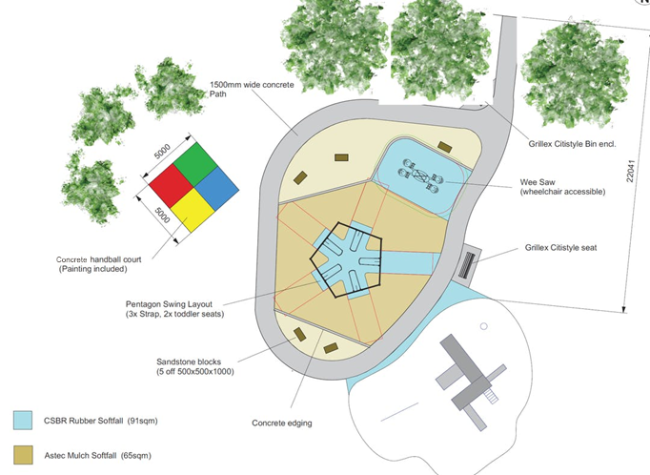

Response
Concrete handball court (5000x5000)
Concrete path (1500wide)
CSBR rubber softball (91sqm)
Astec Mulch Softball (65sqm)
5 x sandstone blocks (500x500x1000)
Concrete edging
Grillex citistyle seat
Grillex Citistyle bin end
Wee saw (wheel chair accessible)
Pentagon swing layout
6 trees (3 large + 3 small)
Concrete edging

Outcome for Activity 2 | ☐ Satisfactory  ☐ Not satisfactory
Trainer/Assessor comments

List the materials required to complete the metal structure in the construction plan shown.

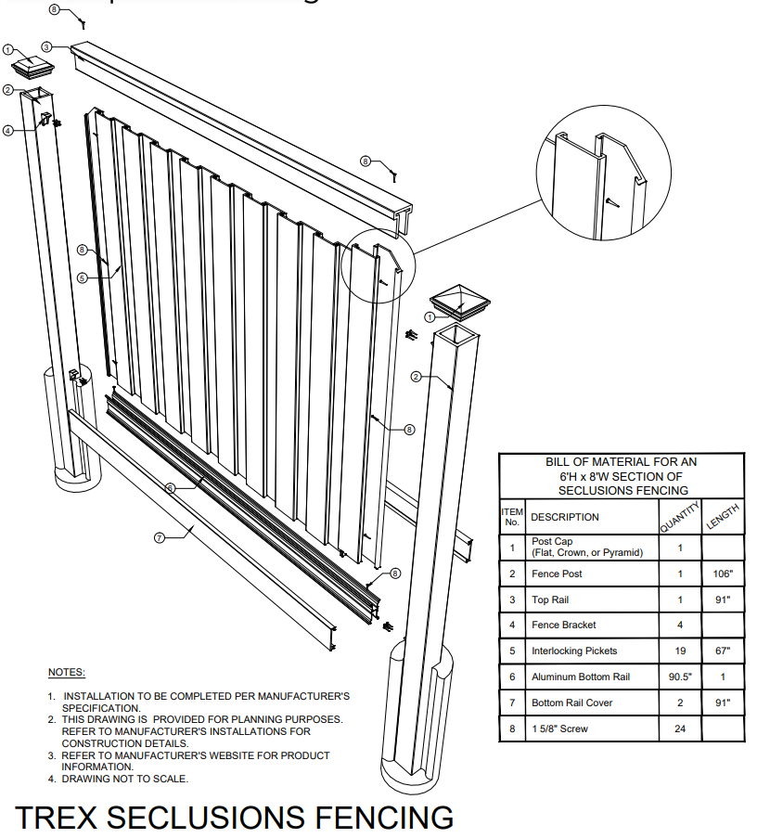

Response
2 x post cap
2 x fence posts
1 x top rail
4 x fence bracket
19 x interlocking pickets
1 x bottom rail
2 x bottom rail cover
24 x 1 5/8 screws

Outcome for Activity 3 | ☐ Satisfactory  ☐ Not satisfactory
Trainer/Assessor comments

Have team members take photos and videos of your involvement with metal structures and features.

Identify each photo / video with a letter label and describe each photo / video in the table below. Submit the photo / video files along with this workbook.

Advantages
A | 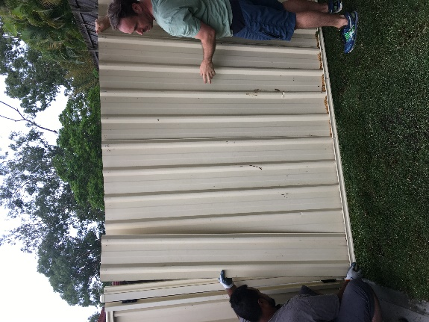  Posts and bottom railings have been inserted. Now we are attaching the panels to create the fence
B | 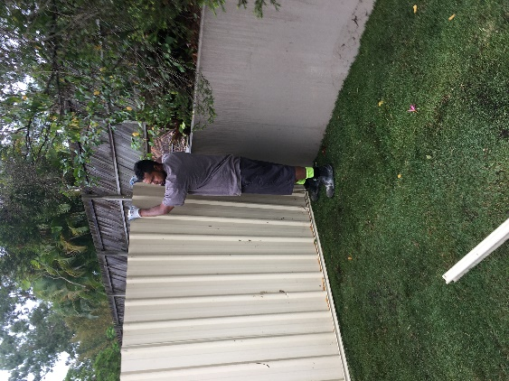  Ensuring each part of the panel is attached properly to the post and bottom rail
C | 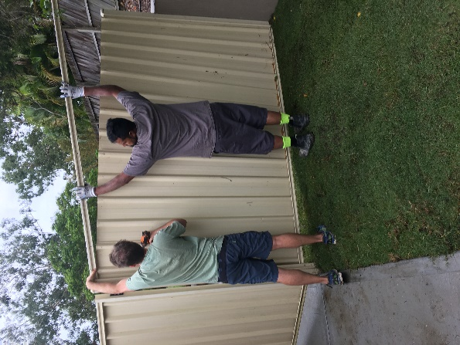  Attaching the top rail and ensuring we are using screws to attach each part of the fence.
D
E
F
G
H
I
J
K
L
M
N
O
P
Q
R
S
T
U
V
W
X
Y
Z

Outcome for Activity 4 | ☐ Satisfactory  ☐ Not satisfactory
Trainer/Assessor comments

