BUILDING REPORT Practical activity 2
Paul Newton
12 April 2021

- Building Class- The building class For - Palm Beach state school New prep Classroom is a 9b, a school being an assembly building in which people may gather, is a Class 9b Building.
- Total Floor Area- 208m2
- Type of construction – non-combustible 11; Type C construction

- Method of construction-The method of construction is elevated steel posts and footing.
- Required FRL 60/60/60

- Boundary distance is 4m to nearest boundary. Trees on this boundary are to remain but pose little potential fire threat as they back onto 19th Avenue.

- Types of passive fire protection used in this construction include-Exterior cladding and roofing -non-combustible Colourbond CGI roofing.
-Windows and doors all aluminium framed
-Posts and handrails all Galvanised steel

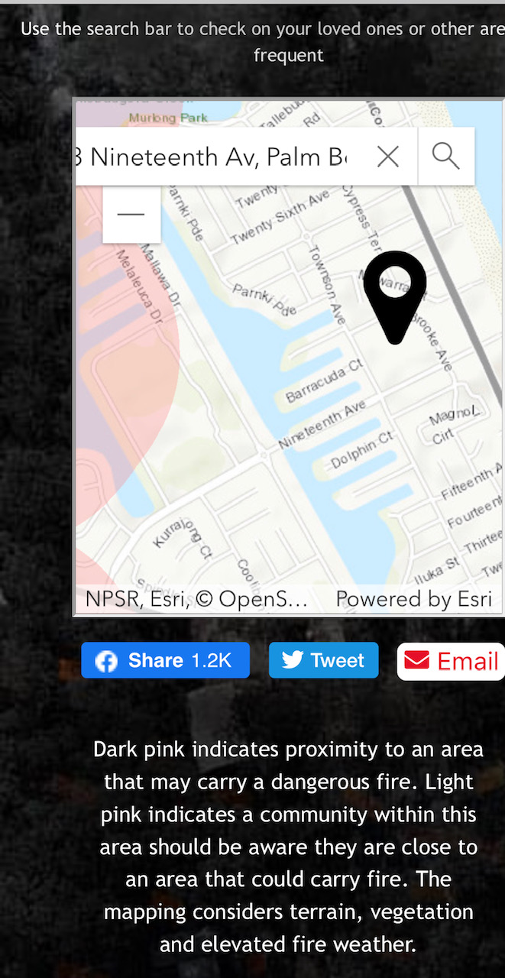
- Property in relation to fire prone areas.

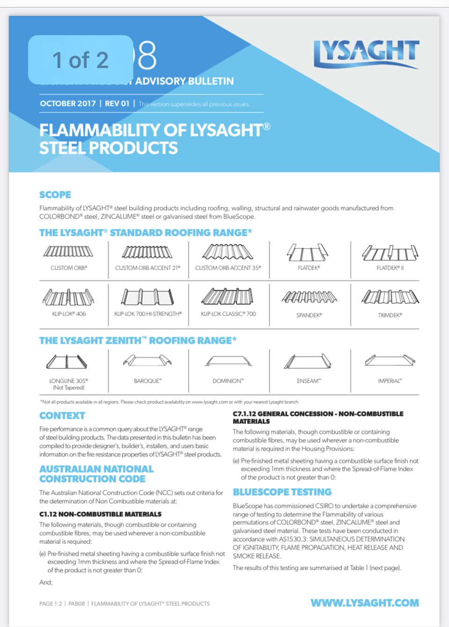
- External cladding details

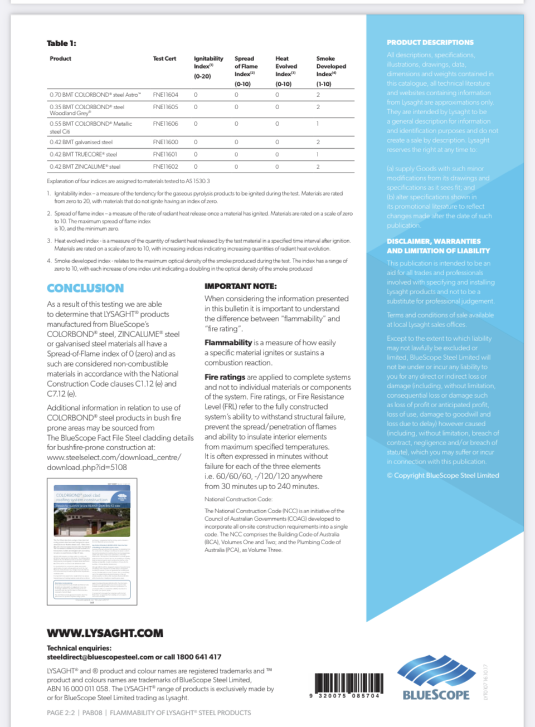

- Types of Active fire protection required on this construction must include-
-The Building must comprise its own fire compartment
-Free to egress door hardware
-Fire extinguishers
-Emergency lighting
-Smoke alarms
-Fire blankets

