
AHCLSC307
Implement a retaining wall project

Copyright © 2022 CSTC Pty Ltd

All rights reserved. No part of the contents of this publication may be reproduced or used in any form or by any means – graphic, electronic, or mechanical including photocopying, digitising, recording, or information storage-and-retrieval systems – without the written permission of CSTC Pty Ltd.
ASSESSMENT FOR AHCLSC307

Student name
Date of assessment submission | Click here to enter a date.

Trainer/Assessor’s name
Date of assessment marking | Click here to enter a date.
Outcome for unit | ☐ Competent  ☐ Not Yet Competent

TASK INSTRUCTIONS

- As part of the assessment for this unit of competency, you are required to complete a series of activities.
  - Some of these activities will require you to provide a response within this document, others will require you to gather evidence to demonstrate your knowledge and skills.
- At all times, the responses in your assessment must reference Australian (Queensland or Federal) documentation, including legislation, regulations, codes of practice, standards and guidance publications.

ACTIVITIES

Draw a simple concept plan for a proposed landscape design which includes a retaining wall.

Response
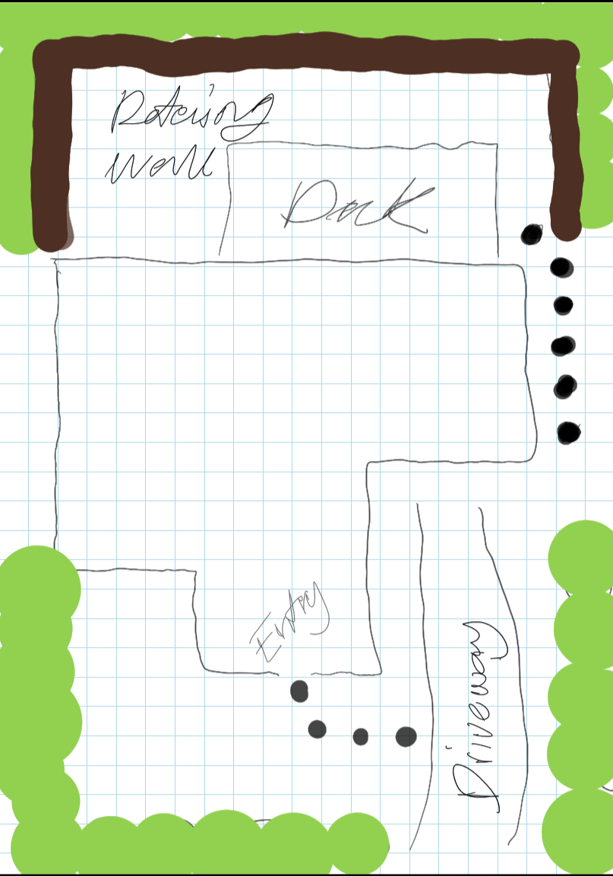

Outcome for Activity 1 | ☐ Satisfactory  ☐ Not satisfactory
Trainer/Assessor comments

Identify/list the detail on the landscape plan shown.

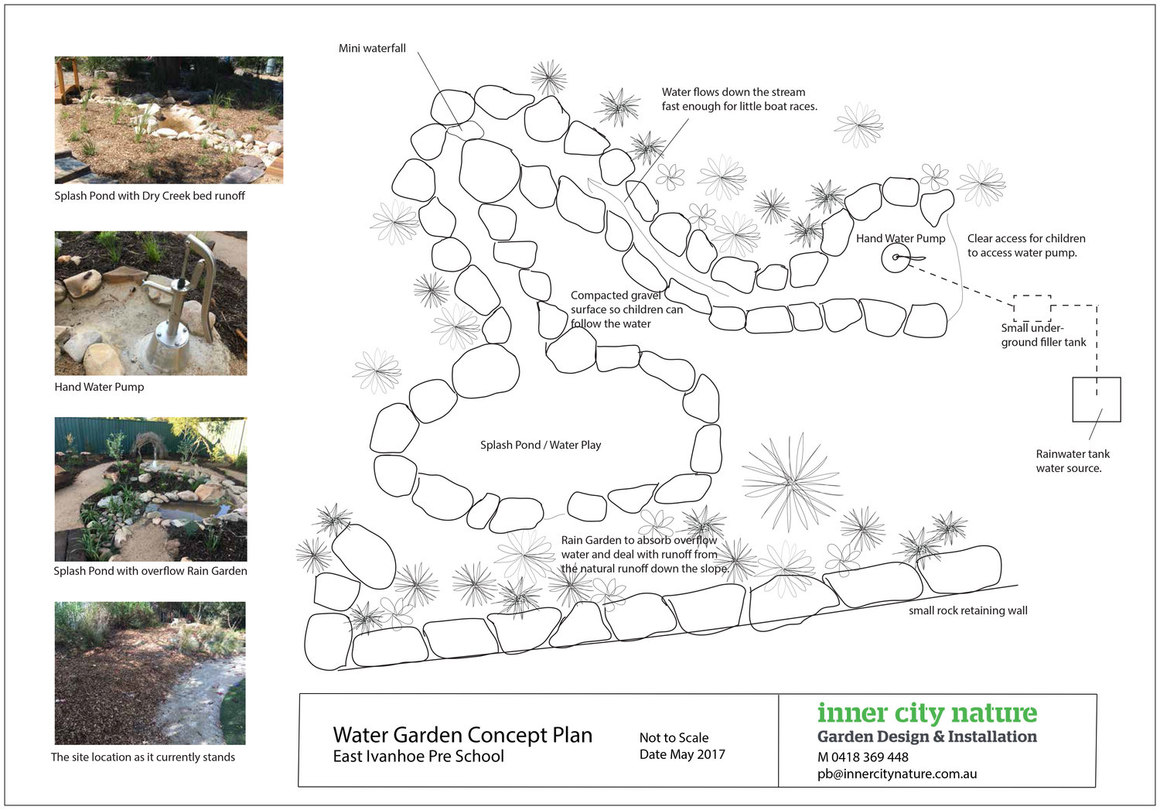

Response
Mini waterfall, hand water pump, function of pond, compacted gravel, rain garden

Outcome for Activity 2 | ☐ Satisfactory  ☐ Not satisfactory
Trainer/Assessor comments

List the materials required to complete the retaining wall, by using the wall and water feature construction plan shown.

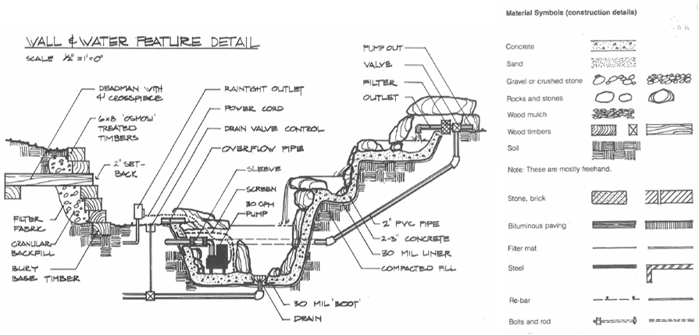

Response
Concrete, sand, gravel, rocks, wood mulch, wood timber, soil, stone brick, paving, filter mat, steel, rebar, bolts and rods

Outcome for Activity 3 | ☐ Satisfactory  ☐ Not satisfactory
Trainer/Assessor comments

Identify the requirements of your local council with regards to retaining walls.

Response
Permit required to build, cannot be within 1.5metres of another structure, does not form a fence for a pool, cannot be 1m higher then natural ground level

Outcome for Activity 4 | ☐ Satisfactory  ☐ Not satisfactory
Trainer/Assessor comments

What strategies could you implement to address environmental impacts, including:
- Spillages
- Dust
- Site cleanliness
- Noise

Impact | Strategy
- Spillages | Make sure if anything is spilled the area is hosed and if tipping something out make sure nothing is around like plants or grass
- Dust | Using a hose while cutting to prevent dust
- Site cleanliness | Keep site constantly clean to avoid impact on enviroment
- Noise | Keep noise down near existing animal habitat if possible

Outcome for Activity 5 | ☐ Satisfactory  ☐ Not satisfactory
Trainer/Assessor comments

List the components for four (4) common surface drainage systems used in landscape construction.

System | Components
- Spoon
- Channel and grate
- Pit
- Contour

Outcome for Activity 6 | ☐ Satisfactory  ☐ Not satisfactory
Trainer/Assessor comments

List the advantages and disadvantages of drainage behind and through the built wall (as shown).

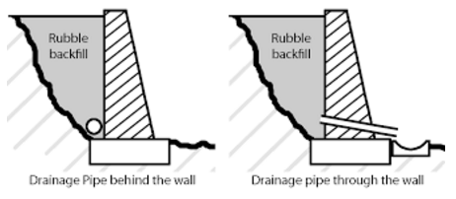

Drainage pipe behind the wall
Advantages
Disadvantages

Drainage pipe through the wall
Advantages
Disadvantages

Outcome for Activity 7 | ☐ Satisfactory  ☐ Not satisfactory
Trainer/Assessor comments

Explain the following terms:
- Batter
- Angle of repose

Term | Definition
- Batter | Batter is the shaping of the land between two different levels and used when there is adequate space available.
- Angle of repose | An angle of repose is commonly defined as the angle between a horizontal plate and a heap surface of a powder formed by natral discharge onto the horizontal plate

Outcome for Activity 8 | ☐ Satisfactory  ☐ Not satisfactory
Trainer/Assessor comments

Describe what is happening the in sketched diagram and the photograph shown below.

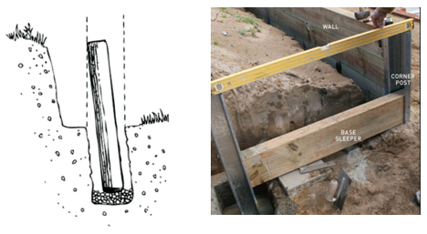

 | Description
- Sketched diagram | Erosion around the post has led to the post moving in the ground therefore making it no longer level.
- Photograph | They are making sure the top of the post are level which will allow the top rail of the retaining wall to sit flush with the top of the post.

Outcome for Activity 9 | ☐ Satisfactory  ☐ Not satisfactory
Trainer/Assessor comments

Have team members take photos and videos of your involvement with retaining wall projects.

Identify each photo / video with a letter label and describe each photo / video in the table below. Submit the photo / video files along with this workbook.

Advantages
A
B
C
D
E
F
G
H
I
J
K
L
M
N
O
P
Q
R
S
T
U
V
W
X
Y
Z

Outcome for Activity 10 | ☐ Satisfactory  ☐ Not satisfactory
Trainer/Assessor comments

