


Project Budget Estimate
Project Name:
Kingsgate Offices

Project No: 800729

Client:
Apollo Builders
Document Control
Rev # | Date | Revision Details | Prepared | Checked | Reviewed | Approved
A | 24.6.2020 | Issued for evaluation | D.Moller | P.Ballie | P.Ballie

Project Manager | Claim Coordinator | Supervisor
Daniel Moller | Alicia Carcach | Jesse Ace
0436 017 341 | 0417 600 985 | 0438 396 718
Daniel.moller@remeed.com.au | Alicia.carcach@remeed.com.au | Jesse.ace@remeed.com.au

This document is the property of Remeed Solutions and shall not be copied, distributed or used without written consent.


Introduction
The Kingsgate offices project requires significant rectification works following a recent water ingress from a weather event which has caused Mould and water damage to 90% of the structural components along with all content’s items throughout.
The Kingsgate offices project is estimated to cost $470,130.00.
Apollo builders are paying a fixed sum of $550,000 for the project.
Should additional costs be required due to additional works and/or additional products or services be required, Strict change request procedures have been put in place along with variation procedures to prevent irrelevant additional costs from occurring.
- Estimating Methodology

  - Primary Works
The Remeed Solutions schedule of rates has been used to calculate the Mold remediation and/or Structural drying component of the project including tasks as follows:

- Identify and inventory all affected contents items in offices 1-3
- Document & Removal of non-restorable contents items
- Document, process & Store any restorable contents items
- Installation of containment to office entries to prevent escape of contaminants to exterior areas
- Installation of Air monitoring equipment to control airborne contaminants
- Removal of all wall and ceiling coverings throughout offices 1-3
- Disposal of all removed building materials
- Carry out initial “bulk” clean of rubble from building material removal
- Carry out mold remediation to internal steel framework, fittings & Fixtures
- Installation of mechanical drying equipment to remove excess moisture from structure, primarily sub flooring
- Carry out moisture surveys as required until dry standards are obtained
- Conduct air & surface testing to confirm removal all of contaminants has been successful
- Removal of drying equipment once dry standards have been met on all building materials
- Coordination and/or project management or supervision costs in relation to reinstatement works to be carried out by sub-contractors.
- Containment will be left in place until reinstatement works are completed to control dust & Particulates
- Removal of containment upon completion of reinstatement works
- Return contents to premises

  - Sub-Contractor rates

All sub-contractor costs have been calculated with the utilization of quotes as requested prior to the development of this budget estimate, all contractors have been advised of the change management procedure in relation to additional costs incurred, all rates provided are final until such time a change request is required.

  - Purchasing
- As per the project plan all purchasing has been pre-approved through the Remeed Solutions or RCR purchasing approval procedure prior to the commencement of this project, as per project procedure any additional costs would require approval from Remeed Solutions management followed by a changed request.
- All required purchases have been pre quoted or pre purchased leading up to the project to prevent incurring any additional cost
  - Financial Reporting

All financial report must be correlated by the Remeed Solutions project manager and provided to Remeed Solutions management prior to submission to client and/or relevant stakeholders.
Reports must be supplied aligned with project management meetings as per project schedule.

  - Source of Funds

Remeed solutions accounts processing generally takes up to 1 Week to process payments received, the 1st payment upon commencement of the project as stated below must be received prior to commencement on the phase, the date indicated in the latest the payment can be processed to allow for 1 week to process.

Funds will be paid by Apollo builders in increments as shown below:

Payment 1: 10% Payment – Must be paid prior to commencement of Pre-Restoration phase of the project
- Payment due: 22/06/2020, Amount: $55,000

Payment 2: 10% Payment – Payable on commencement of Phase 1 of the project
- Payment Due: 01/07/2020, Amount: $55,000

Payment 3: 25% Payment – Payable on commencement of Phase 2 of the project
- Payment Due: 08/7/2020, Amount: $137,500

Payment 4: 10% Payment – Payable on commencement of Phase 3 of the project
- Payment Due: 07/8/2020, Amount: $55,000

Payment 5: 45% Payment – Payable on completion of Phase 4 of the project
- Payment Due: 16/09/2020, Amount $247,500

2.0 – Project Cost Summary
Phase Labour Procurement Purchase Total
Pre-Resto $ 8,560.00 $ 22,678.00 $ 50,458.00 $ 81,696.00
Phase 1 $ 32,566.00 $ 24,568.00 $ 15,200.00 $ 72,334.00
Phase 2 $ 34,578.00 $ 23,200.00 $ 12,200.00 $ 69,978.00
Phase 3 $ 33,788.00 $ 18,900.00 $ 9,800.00 $ 62,488.00
Phase 4 $ 56,320.00 $ 78,354.00 $ 48,960.00 $ 183,634.00

2.1- Cashflow
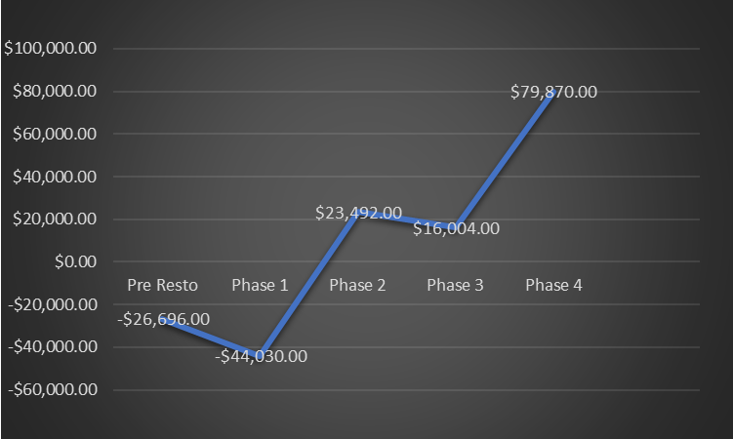

Cashflow Summary

Incoming Outgoing Cashflow
Pre-Resto $ 55,000 Pre-Resto $ 81,696 Pre- Resto -$ 26,696.00
Phase 1 $ 55,000 Phase 1 $ 72,334 Phase 1 -$ 44,030.00
Phase 2 $ 137,500 Phase 2 $ 69,978 Phase 2 $ 23,492.00
Phase 3 $ 55,000 Phase 3 $ 62,488 Phase 3 $ 16,004.00
Phase 4 $ 247,500 Phase 4 $ 183,634 Phase 4 $ 79,870.00

