BSBWHS414
Contribute to WHS risk management
ASSESSMENT SUMMARY

The assessment activities for BSBWHS414 Contribute to WHS risk management cover all aspects of the unit of competency required. To demonstrate competence in this unit, a participant must undertake all tasks and complete them satisfactorily and consistently. For Apprentices and Trainees, this includes employer completion of the Employer Record Book (ERB).

Participants must read all the information given before starting any assessment task. The assessment tasks are intended to be equitable, fair and flexible. If a participant has any questions or requires alternative arrangements to be made such requests should be directed to their Trainer/Assessor, who should note such arrangements in the ‘Assessor Comments’ on the affected assessment. If a participant feels they are not yet ready to be assessed, they should discuss their options with their Trainer/Assessor.

To satisfactorily complete the assessment, the participant is required to answer all questions correctly and demonstrate their skills to industry standards. If a participant does not answer some questions or perform some tasks, they will be deemed ‘Not Satisfactory’ for the task and ‘Not Yet Competent’ for the unit of competency. The Trainer/Assessor is able to provide the participant with additional information on interpreting the assessment outcomes and provide guidance on the participant’s options. Should a participant still be deemed ‘Not Satisfactory’ they will have the opportunity to undertake a supplementary assessment or appeal the result.

By signing the cover page for each assessment item, the participant acknowledges they understand the assessment instructions and requirements and consent to being assessed. The participant also verifies and assures the RTO that the work submitted is their own work.

Participant Name | Alison Radford

Task | Assessment Results
Workbook | Satisfactory | Not Yet Satisfactory
Quiz | Satisfactory | Not Yet Satisfactory
Practical Assessment | Satisfactory | Not Yet Satisfactory
Outcome for Unit of Competency | Competent | Not Yet Competent

Assessor Name
Assessor Signature | 
Unit Competence Determination Date | Click here to enter a date.

BSBWHS414
Contribute to WHS risk management

WORKBOOK INSTRUCTIONS

- This workbook will occur under standard assessment conditions.
  - An oral assessment may be allowed under certain circumstances, whereby the Participant’s answers will be documented by a party other than the Participant. This must be acknowledged in writing (e.g. FT001 and Assessor Comments)
- Participants must provide enough detail in their responses to demonstrate their knowledge and skills.
- Please fill in the details below, providing your name, signature and date of assessment.
  - Your signature acknowledges that this is your own work.
- Assessors are to complete marking in pen of a different colour to the Participant.
- If a Participant initially answers a question incorrectly but modifies their response, they must follow the instructions below:
  - If a Participant changes their response in writing, they must put their initials next to the written change.
  - If a Participant changes their response verbally, this must be noted on the document by the assessor.

Participant name | Alison Radford
Participant signature | 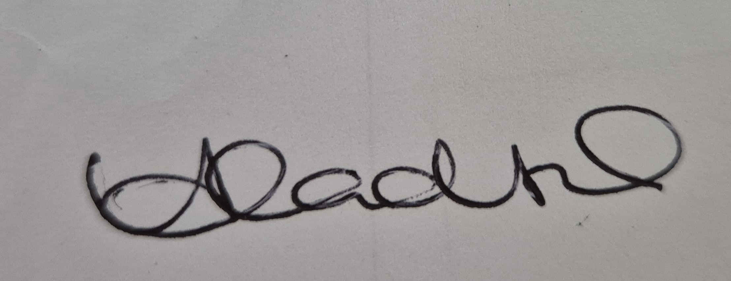
Date | 22/07/2024

Assessor name
Assessor signature
Date | Click here to enter a date.

Number of activities | Number of activities answered correctly | Task outcome (Tick)
4 |  | Satisfactory | Not Yet Satisfactory

ASSESSOR Comments
NOTE

At times, you will be provided with a specific business context to which you must respond, otherwise it is anticipated that you will use a workplace of your choosing (your own, or hypothetical) to provide the context to the task.

At all times, the responses in your assessment must reference Australian (Queensland or Federal) documentation, including legislation, regulations, codes of practice, standards and guidance publications.

For the following activities, name a workplace that you wish to examine.

Name of workplace | Lendlease BAC ITB

Identify the duty holders and their range of duties regarding hazard identification, risk assessment and risk control activities by explaining the requirements found in:
- WHS Acts
- WHS Regulations
- Codes of practice
- Guidelines

Explain how you comply with the requirements of these documents.

Hazard identification
WHS Acts
WHS Act 2011 QLD S19 CH3 S20-26

The PCBU must ensure as reasonably practicable to provide and maintain a safe work environment without risks to health and safety inclusive of safe plant and structures, safe systems of work, safe use, handling and storage of plant, structures and substances, adequate facilities and access to them, information, training, instruction and supervision to protect all from risks to their health and safety arising from the work they carry out and the environment works are conducted in. They must continue to monitor regularly workers health and safety conditions to prevent illness or injury arising from the business undertaking.
WHS Regulations
WHS Regulation 2011 QLD CH3 Part 3.1 S34 Duty to Identify Hazards

Duty holder in managing risks to health and safety must identify as reasonably foreseeable hazards that could give rise to risk health and safety.

Codes of practice
COP QLD 2011 – CH 2 – 2.1 Pg 11-12
CH2 How to identify hazards involves finding things and situations that could potentially cause harm to people.
2.1 Inspect the workplace. Regular observations can help predict what could or might go wrong eg how people work, use equipment, housekeeping, chems use, safe work practice
Guidelines
WorkSafe QLD states PCBU must have signage identifying themselves displayed. including site rules. Inform all persons before commencement, obtain swms for high risk works, comply and put in place amenities and manage risks associated with waste, materials, plant, traffic and essential services.
How you comply
Assist in site management plan, research, investigate and inspect work areas. Obtain SWMS procedures, review policies and procedures from industry, regulators, unions, technical specialists etc. Check training records and licences. Documenting use of and results of hazard identification. Talk to workers, review and monitor site / information and COMMUNICATE outcomes.

Risk assessment
WHS Acts
WHS Act 2011 QLD S17-18

Do what is reasonably practicable to ensure health and safety, taking into account and weighing up matters such as the likelihood of the hazard or risk occurring, the degree of harm likely, what was known about the hazard/risk, ways to eliminate/minimise the hazard/risk and does the cost outweigh the risk.
WHS Regulations
3.1 S33-35
Duty to assess risk
- Eliminate risks to health and safety as far as is reasonably practicable and
- If it is not reasonably practicable to eliminate risks to health and safety, minimise those risks as far as is reasonably practicable.

Codes of practice
CH 3 Step 2 How to access risks
Involves considering what could happen if someone is exposed to a hazard and the likelihood of it happening.
3.1 Risk assessment should be done when there is uncertainty about how a hazard may result in injury or illness. It is mandatory under high risk activity.
Guidelines
WorkSafe QLD
Managing risks is an ongoing process. Best practice is to complete a full risk assessment process when layout or practices have changed, new equipment, materials or processes are introduced or when there is an injury, incident or near miss.

How you comply
Risk assessments are mandatory in some situations eg confined space, electrical work soi I must do my duty under legislation.
Conduct inspections, and investigations, review information, guidelines, audits, site plans, safety procedures, SWMS, JSAS, training information etc.
Identify the severity of harm it could cause and the likelihood of it occurring, review what controls are already in place and the urgency of additional action. Communicate.

Risk control
WHS Acts
WHS Act 2011 (QLD) S19, S20-S26
Must ensure
-Health and safety of all workers.
-The means of entering and exiting site are without risk to health and safety.
-The safety of fixtures, fittings and plant.
-Safe use of plant, e.g. training and ensure plant maintenance, cleaning, inspections etc.
-That it is fit for purpose and being used as it’s designed.
-The safety of those at or in the vicinity of a workplace, that may be affected by any site activity.

WHS Regulations
WHS Regulations 2011 (QLD) CH3 3.1 S36
(2) A duty holder, in minimising risks to health and safety must implement risk control measures under this section. This could be done by substituting, isolating, implementing controls.

Codes of practice
CH4 Step 3 How to control risk
The most important step in managing risks involves eliminating them so far as reasonably practicable. As a PCBU you must consul your workers and their representation who will be affected by this decision. Consider various options and choose the most effective control. Prioritise those with the highest level of risk.
Guidelines
WorkSafe QLD
-You need to protect workers by controlling risks effectively.
-A control is any measure that reduces risk.
-Choose the most effective control that reduces the risk. Use a hierarchy of controls

How you comply
The law requires an implementation of controls that minimise risks so far as reasonably practicable.
Implement a risk control action plan (Evaluate data, compare risk analysis) consult with workers/ supervisors/PCBU, develop and maintain a risk register, follow up on implemented controls (has the job been made safer) , assist with new work practices e.g. training and safe work procedures, to ensure procedures are being followed.

Satisfactory Outcome

Explain the requirements of your organisation regarding hazard identification, risk assessment and risk control activities by identifying the requirements found in:
- WHS policy
- WHS procedure
- WHS process
- WHS system

Explain how you comply with the requirements of these documents.

Hazard identification
WHS policy
GMR Framework, EHS Risk Management Procedure
The identification process for health and safety hazards as well as the environmental aspects and impacts of all Lendlease Construction workplaces, must when identifying impacts and hazards consider normal and abnormal activities such as production increases, decreases and emergency situations. Many workplace incidents occur during non-routine and changed activities.
WHS procedure
Establish an EHS Risk Assessment Plan.
These include project details, people involved in establishing the plan, applicable Lendlease global EHS alerts or Lendlease Construction alerts, industry and regulatory incident alerts, GMRs for health and safety, Legislation, Codes of Practice and standards.
WHS process
Consideration of the work premises and its surroundings, work practices and work systems, plant, equipment and machinery, hazardous substances (use, storage, disposal etc)hazardous materials, high risk tasks, layout of works (access, lighting) the physical working environment including electrocution, falls etc, workplace violence. Carry out regular inspections,evaluate/investigate incidents, monitor when there are design changes
WHS system
Setting objectives and targets within the EHS framework.
Eliminating work related impacts and incidents.
Complying with legislation, codes of practice, standards, obligations and guidelines.
Defining roles and responsibility, accountability for clarity, consistency and predictability across the workforce. Understanding the needs and expectations of the workers and other parties e.g. subcontractors, suppliers, regulators etc.
How you comply
Carry out inspections, participate in audits, assisting with providing documentation by reviewing SWMS, Acts, Codes, Regulations, Guidelines. Documenting and communicating outcomes.

Risk assessment
WHS policy
GMR 3, EHS Policy and EHS Risk Management Procedure

All impacts and hazards and their associated risks and imapacts are assessed to determine the level of control required to eliminate or minimise the potential risk to workers or the environment.
WHS procedure
EHS risks are assessed by using consequence/impacts and likelihood.

The Lendlease Construction methodology for risk ranking is outlined in the following 3 steps.
WHS process
- Identify the worst consequence for each potential risk event.
- Using a risk management table rating risk events and finding the consequence/result.
- Using a matrix to identify risk ranking.

WHS system
Step 1 e.g. A fall from heights of 3M while window cleaning may result in permanent injury.
Step 2 e.g. It is possible that a person who falls from 3M without fall protection could fall and result in the consequence selected in the table i.e. permanently disabling injury OR
Step 3 e.g. using the matrix is it possible that this would provide a ranking score of high possibility.

How you comply
Assist with guidance of level of risk vs control measures applied to the tasks ranking from critical, high, moderate, low, negligible. Monitor, plan and implement control measures consistent with legal and operational standards consistent with the hierarchy of control.

Risk control
WHS policy
GMR4, Hierarchy of Risk Control p31

Eliminating risks is the primary objective of this process where it is reasonably practicable to achieve this outcome.
Before a control is selected, it is important to apply the hierarchy of control to ensure the highest priority is selected.
WHS procedure
The impacts and hazards review document, (whether a Project Risk Opportunity Assessment or Investment, H&S, Risk and Assurance) must detail the specific control measures related to each impact and hazard ID column allocated by key control measures. Any reference to a third-party document as a key control measure in documenting e.g. a SWMS is not acceptable.
WHS process
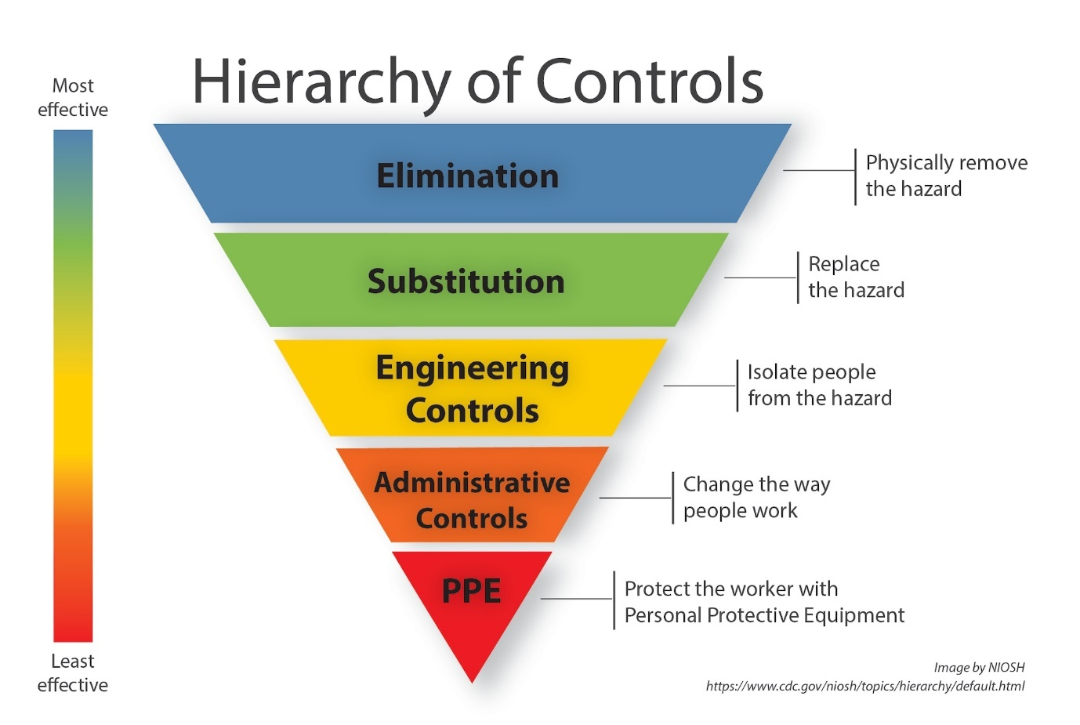
WHS system
There are 20 GMR risk events outlined in GMR 4. Where these apply, activities must be managed by implementing the controls and performance standards prescribed against each risk previously outlined in this procedure.
At least one preventative control level or above must be in place for each identified activity. In addition, to the one preventative control, at least one mitigating control must be in place.
How you comply
Ensuring appropriate high-risk licences, SWMS procedures outlining controls for specific high-risk work, inclusive of protection requirements. Evaluating and implanting the risk management procedures, conducting inspections, observations, audits, incident reporting within the risk management plan.

Satisfactory Outcome

In meeting the legal and organisational requirements noted in Activities 1 and 2, identify two (2) hazards that may occur in your workplace. For each hazard identified, find information to explain:
- The nature and scope of the hazard
- The range of harms caused by the hazard and how they are caused
- The techniques, tools and processes used to identify each hazard
- Select tools appropriate for the workplace and identify different tools for each hazard
- Describe how you contribute to applying these selected techniques, tools and processes and document the results
- Determine the level of risk for the hazard within your workplace
- How you advise others of this information
- Identify the individuals and parties who should be notified (i.e. because they are at risk or are required to implement controls)
- Consider how best to addresses peoples’ range of abilities and backgrounds
- Be sure to also consider the timeframes in which you should advise others
- Risk controls that may be implemented to address the hazard and risk assessment results
- Consider the hierarchy of control and any legal requirements
- Offer at least two (2) risk controls and justify why one (1) is more appropriate than the other
- Explain the timeframes in which these risk control options should be implemented

Name of Hazard 1
GMR 4.3

Vehicle and Plant Incident
Nature and scope of hazard
Controls and performance standards apply to the operation and movement of all vehicles in defined construction zones and include heavy equipment, fixed and mobile plant, where impacts could result in fatality.
The range of harms caused and how they are caused
Persons being hit, plant roll over, mechanical failure, inadequate planning, environmental factors etc
Operator error, unsafe work, distractions.
Tyres/ Brakes failing
Weather conditions, unstable ground
Lack of maintenance
Misuse/ Improper assembly/ Disassembly

Techniques, tools and processes to identify hazard
Consultation with workers, HSCs, HSRs, WHS advisors, managers etc to gather input. Consider that not all parties will be involved throughout the process.

Carry out inspections – Looking for things like planning of works, traffic management, training and licences for competency, lighting conditions, weather conditions, maintenance logs, exclusion zones, overhead works etc

Look at external sources for knowledge such as legislation, SWMS reports, publications such as the WHS regulator, union documentation, compensation claims etc

Documentation of risk assessments, keeping a risk register. Communicating findings and information, considering your audience when sharing information.
Determine the level of risk
HIGH

Potential impacts – What’s the worst that could happen?

People – Death (Single/Multiple)
Permanent disablement
Community and social damage

Financial/ Commercial damage, Insurance/Return to work claims

Business continuity and disruption

Legal/ Regulatory damage

Environmental costs e.g. spilt fuels

How you advise others about hazards, harms and associated risk
Site inductions, training, training logs, revising and reviewing SWMS procedures regularly, safety walks, inspections, audits, safety meetings involving all workers, HSRS, HSCS, supervisors, the PCBU prior to/ during/ and ongoing works.
Risk controls
High visibility clothing. All people working on site areas and operating vehicles must have sufficient high visibility clothing and reflective visibility markings.
Traffic management
Pedestrian and vehicle segregation
Parking and traffic routes
Maintenance of all Light vehicles and plant machinery
Effective recovery measures in place
These controls should/must be in place prior to commencement of works.

Name of Hazard 2
GMR 4.2

Fall of material/object
Nature and scope of hazard
Any event caused by work from an exposed edge, inadequate design or installation, high wind, working outside of edge protection, inappropriate storage, failure of a load, includes works on penetrations, voids, building maintenance works, temporary work platforms such as scaffolds, any works demolition where fall of materials can be identified.
The range of harms caused and how they are caused
Fatality, Permanent injury/ disablement e.g. brain damage, paralysis, Broken bones, crushed limbs, neck and back injuries.
Worker drops an object from elevated work area
Object knocked from an elevated work area
Non fixed object airborne by wind event
Unplanned/ uncontrolled fall or topple of material
Fall due to improper design, installation, storage, maintenance or use.
Demolition causes an uncontrolled fall of material

Techniques, tools and processes to identify hazard
Consultation with workers, HSCs, HSRs, WHS advisors, managers etc to gather input. Consider that not all parties will be involved throughout the process.

Carry out inspections, audits, review SWMS, site set up plans etc – Ensuring things are in place like perimeter protection, elevated work areas must be enclosed with robust material to prevent a fall impacting people below, ensuring use of tethers and lanyards, where the works cannot be fully enclosed, any objects that cannot be fixed and could be blown or uplifted from any location be moved to an unexposed area or secured properly.
Adjustment to any structures MUST assess the fall of material risk.

Look at external sources for knowledge such as legislation, SWMS reports, publications such as the WHS regulator, union documentation, compensation claims etc

Documentation of risk assessments, keeping a risk register. Communicating findings and information, considering your audience when sharing information.

Determine the level of risk
HIGH

Potential impacts – What’s the worst that could happen?

People – Death (Single/Multiple)
Permanent disablement
Community and social damage

Financial/ Commercial damage, Insurance/Return to work claims

Business continuity and disruption

Legal/ Regulatory damage

Environmental costs e.g. spilt fuels.
How you advise others about hazards, harms and associated risk
Site inductions, training and training logs, revising and reviewing SWMS procedures regularly, safety walks, inspections, safety meetings, involving all workers, supervisors, HSRS, PCBUs. Must be done prior to/during/ongoing works.

Risk controls
Adequate exclusion zones MUST be in place where overhead works has potential for a fall.
Secondary protection/ catch measures.
Enclosure of work areas including stair towers, voids, risers etc.
Using tethers or lanyards where works are required outside of the perimeter protection.
Any objects that can be uplifted where they are not fixed, must be secured properly or relocated to an unexposed area.
Any adjustment to structure must first assess the fall of material risk.

This must be considered and in place prior to any works commencing.

Satisfactory Outcome

For the two (2) risks (and associated risk controls) identified in Activity 3:
- Explain how you would contribute to developing and implementing a risk control plan to meet your legal and organisational obligations
- Describe the process you would undertake to evaluate the risk controls that had been implemented

Hazard/Risk 1
Develop and implement risk control plan
Vehicle and Plant Incident

Identify the hazards using consultation, reviewing of regulations, technical specs, SWMS etc. Consider
Environment – weather, ground conditions, visibility, unstable ground, fuel spills, overhead works, hazardous chemical handling and cleanup, safe access/egress/ emergency access,
Equipment – load conditions, maintenance, mechanical failure, tyres and brakes, correct machine for task.
Operator – Knowledge of and licence to operate machines, training, plant/pedestrian separation, exclusion zones, driver fatigue, logbooks, D&A impairment

Develop a risk register to assist with determining the likelihood of the event and potential outcomes, continually reviewing and prioritise using a risk matrix to define the highest level of risk. Utilising all the information to implement the control measures following up to ensure compliance and effectiveness of the controls. Assisting with training, reviewing safe work practices.

Evaluation of risk control
Control measures to be considered prior to/during/continuous works.
PPE Hi-visibility clothing, reflective markings, hardhats so workers are easily seen and visible within the operating site.
Put traffic control in place, plant and pedestrian separation, exclusion zones, spotters.
Assess the weather conditions, visibility and ground conditions. Is there a need for dust suppression, additional lighting (nightworks) poor/ unstable ground from rain events, considering moving loads in high wind.
Maintenance of machinery is the plant fit for purpose, adequate operator training and licences. Ensure controls are evaluated against others considering its affect in implementation. Consistent communication/training/documentation/assessment.
Ensure emergency plans are in place.

Hazard/Risk 2
Develop and implement risk control plan
Fall of material.

Identify the hazards using consultation, reviewing safe work practices, WHS regulator information, past incident reports, site safety plans etc

Consider where works are being carried out such as exposed edges, works are outside the edge protection, environmental factors such as high winds, storage, failure of loads, using EWPs, scaffolds, penetrations and voids etc

Consider types of incidents such as a worker dropping/ knocking of object from an EWP or elevated work area, non-fixed object airborne in high winds, considering weather when using plant or vehicle, unplanned falls/ topple of material, storage, installation maintenance or use, demolition causes fall.

Develop a risk register to assist with determining the likelihood of the event and potential outcomes, continually reviewing and prioritise using a risk matrix to define the highest level of risk. Utilising all the information to implement the control measures following up to ensure compliance and effectiveness of the controls. Assisting with training, reviewing safe work practices.

Evaluation of risk control
Consider the range of harms that could be caused on a risk matrix and use hierarchy of controls when evaluating and putting control measures in place. Control measures should be considered prior to/during/continuous works.

Use of Tethers/Lanyards, edge/perimeter protection, securing unfixed objects or relocating them, exclusion zones, spotters, any adjustment to structure must assess the fall of material risk, PPE. Considering if one control could adversely affect another.
Consistent communication, assessment, training and documentation. Ensure emergency plans are in place.

Satisfactory Outcome

BSBWHS414
Contribute to WHS risk management

QUIZ INSTRUCTIONS

- This quiz will occur under standard assessment conditions.
  - An oral assessment may be allowed under certain circumstances, whereby the Participant’s answers will be documented by a party other than the Participant. This must be acknowledged in writing (e.g. FT001 and Assessor Comments)
- Participants must provide enough detail in their responses to demonstrate their knowledge and skills.
- Please fill in the details below, providing your name, signature and date of assessment.
  - Your signature acknowledges that this is your own work.
- Assessors are to complete marking in pen of a different colour to the Participant.
- If a Participant initially answers a question incorrectly but modifies their response, they must follow the instructions below:
  - If a Participant changes their response in writing, they must put their initials next to the written change.
  - If a Participant changes their response verbally, this must be noted on the document by the assessor.

Participant name | Alison Radford
Participant signature
Date | 25/07/2024

Assessor name
Assessor signature
Date | Click here to enter a date.

Number of questions | Number of questions answered correctly | Task outcome (Tick)
6 |  | Satisfactory | Not Yet Satisfactory

ASSESSOR Comments
- Match the terms and definitions by writing the appropriate letter next to each number in the centre column.

Answer | Terms |  |  | Definitions
 |  | Hazard | 1 - C |  | Taking action to eliminate health and safety risks
 |  | Risk | 2 - B |  | The possibility that harm might occur when exposed to a hazard
 |  | Risk control | 3 - A |  | A situation or thing that has the potential to harm a person

- Which of the following can be causes of workplace hazards?
Tick all that apply.

Answer | Choice | Possible Answers
 |  | Noise
 |  | Physical layout of the workplace
 |  | Temperature
 |  | Stress

- Which of the following individuals and parties may require information about workplace hazards? Tick all that apply.

Answer | Choice | Possible Answers
 |  | Health and Safety Committees (HSCs)
 |  | All members of the public
 |  | Contractors
 |  | Workers
 |  | Managers
 |  | Technical specialists who can assist with determining control measures

- Which of the following are appropriate techniques, tools and processes for identifying hazards and risks? Tick all that apply.

Answer | Choice | Possible Answers
 |  | Workplace inspections
 |  | Compensation claim information
 |  | Safe Work Method Statements
 |  | Information issued by WHS regulators

- True or False (Tick your response): Risk control options can come from both internal sources (e.g. policies and procedures) and external sources (e.g. codes of practice and standards).

Answer |  | True
 |  | False

- Which of the following should be considered when developing a risk control plan? Tick all that apply.

Answer | Choice | Possible Answers
 |  | How and when controls will be implemented
 |  | Evaluation processes for implemented controls
 |  | Consultation with individuals and parties
 |  | Responsibilities for implementation

BSBWHS414
Contribute to WHS risk management

PRACTICAL ASSESSMENT INSTRUCTIONS

- The following practical assessment will require the Participant to complete work related activities.
- The Assessor will conduct observations of the Participant’s work to determine whether they display sufficient practical skills and knowledge.
- Please fill in the details below – providing your name, signature and date of assessment.
  - The Participant’s signature acknowledges that the Assessor provided clear instructions and the Participant understood what was required to complete this assessment.
- The Assessor may substitute a Practical Task with an alternate task of equal value.
  - Alternate tasks must be fully documented by the assessor in the Assessor Comments area.

Participant name | Alison Radford
Participant signature
Date | 18/08/2024

Assessor name
Assessor signature
Date | Click here to enter a date.

Task | Task outcome (Tick)
Task | Satisfactory | Not Yet Satisfactory
Task 1

Assessor Comments
BSBWHS414
Contribute to WHS risk management

Practical Task 1
Description of task:
The participant is to identify two (2) different WHS hazards, assess and control the risk relating to those identified hazards. For each hazard, the participant is required to:
- Apply legal and organisational requirements when selecting and applying techniques, tools and processes for hazard identification, risk assessment and risk control
- Document the processes undertaken in the form of a presentation, for delivery to workers, contract workers, managers and PCBU (e.g. PowerPoint presentation slides with accompanying face-to-face delivery or real-time video, as arranged with your assessor)
- Identify the responsibilities of your audience with regards to their legal duties in controlling the identified risks

The participant is to submit the following evidence with this Practical Assessment sheet. There should be two (2) of each of the following documents submitted (i.e. one for each hazard):
- Workplace checklists for monitoring effectiveness of risk control measures
- Presentation materials with included graphics (e.g. PowerPoint)

The assessor is to provide detailed comments on the tasks completed by the participant. Detail should be recorded in the Assessor’s Comments (e.g. questions asked by assessor during presentation).
Resources required:
Computer.
Assessment of task
Name of participant:
Name of assessor:
Location:
Date:
When completing the task, did the participant: |  | Tick if satisfactorily completed.  Provide comments if left unticked.
1 Hazard identification
- Confirm and apply legal and organisational requirements with regards to hazard identification.
- Select and apply hazard identification tools and techniques.
- Analyse information and data to determine each hazard’s nature and scope.
2 Risk assessment
- Confirm and apply legal and organisational requirements with regards to risk assessment.
- Analyse information and data when conducting risk assessments.
- Select and apply tools, techniques and processes to assess risk – determining those affected, as well as the nature, severity and likelihood of potential harm.
3 Risk management and controls
- Confirm and apply legal and organisational requirements with regards to risk controls.
- Analyse information and data when identifying, evaluating and selecting risk control options.
- Identify potential risk controls according to the hierarchy of control and evaluate most appropriate options for action.
- For each hazard, develop a checklist to enable evaluation of effectiveness of risk controls.
4 Presenting findings
- Develop and deliver presentation (in person/via live stream video).
- Review processes undertaken, including:
- Tools used for hazard identification, risk assessment and risk control processes
- Hazard identification results – including two (2) workplace hazards and the harms they may cause
- Risk assessment results – including those affected and the nature, severity and likelihood of potential harm
- Risk management plan – including the selected risk controls and activities requiring joint responsibility and accountability (considering time and resource constraints)
- Identify duty holders and their roles and responsibilities according to risk management requirements including:
- Explaining legal and organisational requirements
- Identifying requirements to ensure effectiveness of risk controls
- Outline plan for monitoring effectiveness of risk controls (i.e. using checklist)
The Participant’s performance was: Satisfactory Not Satisfactory

