CPCCBC4018
Apply site surveys and set-out procedures to building and construction projects

ASSESSMENT SUMMARY

The assessment activities for CPCCBC4018 Apply site surveys and set-out procedures to building and construction projects cover all aspects of the unit of competency. For Apprentices/Trainees, this includes supervisor completion of the Apprentice/Trainee Record (ATR).

Participants must read all the information given before starting any assessment task. The assessment tasks are intended to be fair, flexible, valid and reliable. If a Participant has any questions or requires alternative arrangements to be made such requests should be directed to their Trainer/Assessor, who should note such arrangements in the ‘Assessor Comments’ on the affected assessment. If a Participant feels they are not yet ready to be assessed, they should discuss their options with their Trainer/Assessor.

To satisfactorily complete the assessment, the Participant is required to answer all questions correctly and demonstrate their skills to industry standards. If a Participant does not answer all questions or perform all tasks, they will be deemed ‘Not Satisfactory’ for the task and ‘Not Yet Competent’ for the unit of competency.

The Trainer/Assessor can provide the Participant with additional information on interpreting the assessment outcomes and guide the Participant’s options. If a Participant is still deemed ‘Not Satisfactory’ they will have the opportunity to undertake a supplementary assessment or appeal the result as per the process in the Student Handbook.

By signing below, the Participant acknowledges:
- They understand the assessment instructions and requirements, and consent to being assessed.
- The work submitted is to be their own work – with the work of/with others needing to be clearly acknowledged and documented.
- They consent to any photo/video recording of their work that occurs during assessment.

Participant name | Justin Matheson
Participant signature | 

Pre-requisite unit(s) to be achieved and authenticated prior to undertaking assessment
Not applicable

Task | Date completed | Assessment Results
Theory Exam | Select Date. | Satisfactory | Not Satisfactory
Workbook | Select Date. | Satisfactory | Not Satisfactory
Practical Assessment | Select Date. | Satisfactory | Not Satisfactory
Outcome for CPCCBC4018 | Select Date. | Competent | Not Yet Competent

Evidence requirements checklist (ticked by assessor and evidence supplied to RTO)
Theory Exam  Workbook | Practical Assessment  Booking sheet  Topographic contour plan from grid lines  Calculations sheets

Assessor name
Assessor signature

CPCCBC4018
Apply site surveys and set-out procedures to building and construction projects

THEORY EXAM

Participant name | Justin Matheson

FOR THE PARTICIPANT
Instructions
- You will complete written questions as outlined on the following pages. You must attempt all questions and provide enough detail in your responses to demonstrate your knowledge.
- It is anticipated that you should complete this assessment within two (2) hours, but additional time may be allowed upon negotiation with the Assessor.
- You must complete all questions unassisted by the Assessor or other personnel but may refer to reference material as needed. All questions must be answered correctly for a ‘Satisfactory’ assessment outcome to be awarded.
  - An oral examination may be allowed under certain circumstances, whereby your answers will be documented by another party.
  - Any written questions that are incomplete, or not answered satisfactorily will need to be completed again after further training support.
    - If you answer a question incorrectly but modify your response, put your initials next to the written change (or the Assessor must initial a verbal change).
Resources required
Pen

FOR THE ASSESSOR
Instructions
- Where oral examination has occurred, ensure that this is acknowledged in writing (e.g. FT001 and Assessor Comments)
- All questions must be satisfactorily demonstrated by the Participant for a Satisfactory determination (indicated by an Assessor tick to the right of the question).
- Assessors are to complete marking in pen of a different colour to the Participant.
- If the Participant verbally modifies their response, write in the modified response verbatim and put your initials next to the written change.

ASSESSOR COMMENTS
As necessary, outline:
- Details on reattempts, alternative arrangements or reasonable adjustments made.
- Where a Participant is deemed ‘Not Satisfactory’, provide recommendations for future training.

- Explain why we should determine the orientation of the building according to the plans.

Answer | The orientation of a building refers to its positioning on the site in relation to the cardinal directions. Determining the orientation of a building according to the plans is a crucial aspect of architectural and construction design.  There are several reasons why determining the orientation is important, including:  *Solar Exposure and Energy Efficiency  *Daylighting  *Thermal Comfort  *Sustainable Design  *Views and Site Integration  *Compliance with Building Codes  *Aesthetics and Architectural Design  *Cultural and Environment Context

- Discuss the information you can source from the specifications.

Answer | Specifications provide essential information about the materials, workmanship, standards, and quality requirements for the project. Key types of information that can be sourced from specifications can include: -  *Material Requirements – Material types and quality standards  *Construction Methods and Techniques – Installation guidelines and sequence of work  *Performance Criteria – Functional requirements and safety standards  *Quality Assurance and Control – Inspection and testing and quality control measures  *Workmanship Standards – Craftmanship expectations and acceptable deviations  *Codes and Standards Compliance – Building codes and environmental standards  *Documentation and submittal requirements – Drawings and schedules and submittal requirements  *Warranty and Maintenance Requirements – Warranty periods and maintenance recommendations  *Contractual and Legal Considerations – Contractual obligations  *Special Requirements – Unique project requirements

- The construction project must comply with the National Construction Code (NCC). What does this mean.

Answer | A construction project must comply with the NCC because the NCC has a set of regulations and standards that outlines the minimum requirements for the design, construction, and performance of buildings and structures.  Compliance with the National Construction Code is essential to ensure the safety, health, and welfare of the public, as well as to uphold legal and regularity standards. It establishes a framework for best practices in the construction industry, promoting the construction of safe, durable, and environmentally responsible buildings and structures.

- Describe the principles of establishing control during set-out surveys.

Answer | There are 5 principles to ensure that surveying goes smoothly.  Working from Whole to Part – The survey work must be done from whole to part. Establishing points of reference must be done starting from the widest scope possible to the smallest points.  Location of Point by Measurement from Two Points of Reference – The relative position of the desired points to be surveyed must be located by taking measurements from at least two points of reference.  Consistency of Work – All methods and instruments must be used according to instructions provided.  Independent Check – Every measurement taken must be re-checked by using a suitable method of independent tests and observations so that any mistake, if present, is not overlooked.  Accuracy Required – Similar to the principle of consistency of work, all methods and instruments must be followed according to the instructions provided.

- What is linear measurement in surveying?

Answer | Linear measurement in surveying is the determination of the distance between two points on the surface of the earth is one of the basic operations of surveying.

- Provide two (2) examples of surveying that uses linear measurements.

Answer  1.  2. | Chain surveying.  Traverse surveying

- Listed below are principles of linear measurement for small surveys. Briefly explain what each principle means.

Answer | Principle | Explanation
 | Working from whole to the part | Treat the area as a whole, then break it down into several triangles rather than the reverse.
 | Form well-conditioned triangles | Form angles preferably between 30 degrees and 120 degrees. Aim for equilateral figures, based on at least one long backbone line.
 | Economy of lines | Use as few measured lines as necessary, wile avoiding obstacles and steep slopes, but using sufficient check lines to minimise errors.

- Listed below are two (2) methods of linear measurements. Briefly explain each.

Answer | Type of linear measurement | Explanation
 | Direct method | In this method, the distance is measured during the actual fieldwork using a chain or a measuring tape.
 | Optical method | In this method, the distance is computed indirectly using the tacheometer.

- What is horizontal angular measurement in surveying?

Answer | Horizontal angular measurements in surveying refers to the measurement of angles in the horizontal plane. Surveying involves the measurement and mapping of the Earth’s surface, and angular measurements play a crucial role in determining directions, distances, and boundaries. Horizontal angles are typically measured in a clockwise or counterclockwise direction from a reference line, usually the north or south direction.

- Why are the linear and angular measurements necessary in surveying?

Answer | Linear and angular measurements are fundamental components of surveying, playing a crucial role in accurately defining and representing the physical features of the Earth’s surface. These measurements are essential for a variety of purposes in surveying and related fields. Some key reasons why both linear and angular measurements are necessary are: -  Defining boundaries, mapping and cartography, land subdivision, construction layout, geodetic surveys, topographic surveys, construction and engineering design and construction quality control.

- Why is it relevant to have knowledge of geometry when conducting surveying activities?

Answer | It is relevant to have knowledge of geometry when conducting surveying activities because surveyors need to measure distances, angles, and directions between points of using geometric principle of measurements.

- Why is it relevant to have knowledge of trigonometry when conducting surveying activities?

Answer | It is relevant to have knowledge of trigonometry when conducting surveying activities because it is used when measuring heights and angles of land or the elevations of certain points of a mountain.

- What components are needed when using an optical level and how are these used?

Answer | An optical level is a surveying instrument commonly used to measure height differences or elevations on the Earth’s surface. The main components of an optical level include the following:=  1.Telescope – The telescope is the primary sighting component of the optical level and is used for aiming at the leveling staff or other surveying targets.  2.Leveling Base – They leveling base allows the telescope to rotate horizontally. It is equipped with leveling screws that are adjusted to ensure the telescope is perfectly horizontal, providing accurate measurements.  3.Crossharis or Reticle – The crosshairs or reticle is a set of perpendicular lines (cross) visible through the telescope. Surveyors use the crosshairs to precisely target points on the leveling staff or other surveying targets.  4.Objective Lens – The objective lens is located at the end of the telescope closest to the surveyor. It gathers light and forms an image of the target on the eyepiece side of the telescope.  5.Eyepiece – The eyepiece is located at the end of the telescope farthest from the surveyor. It allows the surveyor to view the magnified image formed by the objective lens and crosshairs.  6.Bubble Level – A bubble level is mounted on the telescope and is used to check the instrument’s vertical orientation. The surveyor adjusts the levelling screws until the bubble is centred, ensuring the telescope is horizontal.  7. Leveling Staff – The leveling staff is a graduated rod with markings in feet or meters. It is placed at the point where elevation measurements are needed. The surveyor reads the staff through the telescope to determine the height difference between the instrument and the staff.

- What is the difference between a dumpy level and a theodolite?

Answer | A dumpy level is primarily used for determining horizontal levels and differences in elevation. It is commonly employed in construction, land leveling, and setting benchmarks for leveling.  A theodolite is used for measuring both horizontal and vertical angles with precision. They can be used for a wide range of surveying and engineering applications, including setting out angles, measuring horizontal and vertical angles, and conducting traverse surveys.

- Describe a two-peg test.

Answer | For a two-peg test, you must establish two points on level instrument ground approximately 50 metres apart. You then set the level halfway between the two points of the instrument. From the level instrument, take the two staff readings. If the line of sight does not coincide with the line of collimation, an error would occur. The amount is okay if the gap in height is the same. If it is not, the level device needs to be serviced.

- Discuss benefits of using electronic distance measuring (EDM) equipment.

Answer | The EDM is able to measure the azimuth (angle from north) and elevation of a point. The comparison of the returning signal to that emitted by the EDM allows the unit to determine the distance between the unit and the target surface.  Some benefits of using the EDM include – accuracy, speed and efficiency, remote measurement, versatility, real-time data, long measurement ranges, reduced personnel requirements, and improved safety.  Data obtained through the EDM is stored in a data collector, which can then be downloaded for processing.  .

- Identify one operational and one functional feature for each of the levelling and surveying devices listed below.

Answer | Device | Operational features | Levelling features
 | Laser level: manual-levelling laser | Emission of laser beam, self-leveling mechanism, manual leveling option, rotary functionality, single or dual grade capability, variable rotational speed, remote control operation, visual and audible alerts, and dual laser capability/. | Self leveling, manual leveling, horizontal and vertical leveling, dual-axis leveling, remote control, tilt or out-of-level indications, rotating laser beams, grade or slope capability, battery and power options.
 | Laser level: dot laser levels | Dot protection, visible laser dots, adjustable dot position, self-leveling mechanism, manual leveling option, horizontal and vertical dots, multiple dots or points, pulse mode, laser detector compatibility, fine adjustment, and durability. | Single or multiple dots, point accuracy, self-leveling, manual leveling, horizontal and vertical levelling, adjustable brightness, range and visibility, battery and power options, mounting options, compact design.

- Describe features of the water level.

Answer | Water level utilises the surface of liquid water to establish a local horizontal plane of reference, which determines the apparent inclination of a surface. It utilises two litres of water, at times, dyes can be used so that the water is more visible in the tube. The water level device is connected by a transparent plastic tubing, 6-10 millimetres inside in diameter and about 14 metres long.

- You are responsible for checking levels in an excavation.
From the drawings for the job you know the floor level is RL 12.000. The floor of the excavation is level (0% grade).
You find a peg, which identifies the RL as 14.50.
The plane of collimation measures 0.65m above the peg.
On what level would you set the receiver on the stave to achieve the desired FL of the excavation? Show your calculations.

Answer | 1.Floor level (FL) of the excavation = RL 12.000  2.Peg RL = 14.50  3.Height of the plane of collimation above the peg = 0.65 metres  The difference in RL between the peg and the desired FL is:  RL difference = RL desired – RL peg  RL difference = 12.000 - 14.50  RL difference = - 2.50  When considering the height of the plane of collimation above the peg, the level at which you should set the receiver on the stave is given by:  RL receiver = RL peg + Height of Collimation  RL receiver = 14.50 + 0.65  RL receiver = 15.15  However, the RL difference is negative, indicating that the receiver needs to be set lower than the peg to achieve the desired FL.  Therefore, the level at which you should set the receiver on the stave to achieve the desired FL of the excavation is RL 15.15, and you would set the receiver 2.50 metres below the peg to compensate for the negative RL difference.

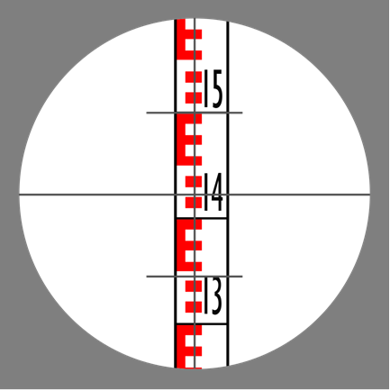
- Using the picture above, what distance is the staff from the instrument? Show workings.

Answer | To calculate the distance between the staff from the instrument, you take the readings between the 2 stadia lines.  The stadia lines are at 1.500 and 1.344  Calculating the distance between the 2 stadia lines.  1.5 – 1.344 =0.156mm  0.156mm x 100mm = 15.6 m  The distance equals 15.6 metres

- Discuss errors in measured distances due to site characteristics and measurement methods.

Answer | There can be errors in measurements of setting out a construction site because of the site characteristics themselves. These include:  -position of the site  -shape of the site  -size of the site  -site personnel  Changes, unpredictability, and uncertainty of these factors cause errors in measurements when setting out a site. Measurements are important when designing a building or project. Some variables will influence measurements on some sites. The following are some of these elements:  -slopes  -wind  -vegetation  -other impediments

- Discuss the purpose of setting out gridlines for the construction project.

Answer | Setting out gridlines is a crucial step in the early stages of a construction project, and it involves establishing a reference system of horizontal and vertical lines on the construction site. These gridlines serve several important purposes:  -alignment and orientation  -spatial organization  -dimensional control  -reference points for layout  -coordination among teams  -quality control  -ease of documentation  -phasing and progress monitoring  -spatial control during excavation  -accuracy in as-built documentation

- Discuss situations where you need to draw up a contour plan.

Answer | Some situations where you might need to draw up a contour plan include –  Land development, infrastructure projects, urban planning, environmental impact assessment, landscape design, water management and drainage design, slope stability analysis, mining and quarrying, and floodplain mapping.

- When do you draw longitudinal sections from RLs.

Answer | Longitudinal sections from RLs are drawn to show a pipeline in sections, showing the grades, chainage, and other details. These show what the reduced level is a the chainage or distances taken in the survey readings, and where the pipes or drains will be in relation to these levels.

- How do you determine the tolerances when determining levels and clearances from given grades for underground pipework?

Answer | The construction plans usually indicate acceptable tolerance levels and must be followed. One of the most important aspects is deciding how large the tolerances can be without affecting other variables or the process’s outcome. Implementing scientific concepts, engineering skills and professional experience can achieve this. To examine the effects of tolerances, an experimental investigation is instrumental design of tests, formal engineering assessments, and so on.

- How do you calculate elevation slope as a decimal or a percentage?

Answer | The elevation slope can be expressed as a decimal or a percentage, providing different ways to represent the same information. The slope as a decimal is a ratio of the vertical change in elevation to the horizontal distance, while the slope as a percentage is the same ratio multiplied by 100.

- How do you calculate elevation slope in degrees?

Answer | To calculate the slope or gradient of elevation in degrees, you can use the arctangent function (also known as the inverse tangent or tan^(-1)). The formula is as follows:  Slope (degrees) = arctan(rise/run)  - Determine Vertical Change: This is the difference in elevation between two points. It’s the “rise” in the slope.  - Determine Horizontal Change: This is the horizontal distance between the two points. It’s the “run” in the slope.  - Calculate the Ratio: Divide the vertical change by the horizontal change.

CPCCBC4018
Apply site surveys and set-out procedures to building and construction projects

WORKBOOK

Participant name | Justin Matheson

FOR THE PARTICIPANT
Instructions
- You will complete written activities as outlined on the following pages. You must attempt all questions and provide enough detail in your responses to demonstrate your knowledge.
- The timeframe for these tasks will be established by your Assessor or Training Plan, but additional time may be allowed upon negotiation with the Assessor.
- You must complete all questions unassisted by the Assessor or other personnel but may refer to reference material as needed. All questions must be answered correctly for a ‘Satisfactory’ assessment outcome to be awarded.
  - An oral examination may be allowed under certain circumstances, whereby your answers will be documented by another party.
  - Any written questions that are incomplete, or not answered satisfactorily will need to be completed again after further training support.
    - If you answer a question incorrectly but modify your response, put your initials next to the written change (or the Assessor must initial a verbal change).
Resources required
Pen

FOR THE ASSESSOR
Instructions
- Where oral examination has occurred, ensure that this is acknowledged in writing (e.g. FT001 and Assessor Comments)
- All questions must be satisfactorily demonstrated by the Participant for a Satisfactory determination (indicated by an Assessor tick to the right of the question).
- Assessors are to complete marking in pen of a different colour to the Participant.
- If the Participant verbally modifies their response, write in the modified response verbatim and put your initials next to the written change.

ASSESSOR COMMENTS
As necessary, outline:
- Details on reattempts, alternative arrangements or reasonable adjustments made.
- Where a Participant is deemed ‘Not Satisfactory’, provide recommendations for future training.

NOTE

At times, you will be provided with a specific context to which you must respond, otherwise it is anticipated that you will use a workplace of your choosing (your own, or hypothetical) to provide the context to the task.

At all times, the responses in your assessment must reference Australian (Queensland or Federal) documentation, including legislation, regulations, codes of practice, standards and guidance publications.

Access and review the working drawings and specifications contained in the project plan below:
Case Study: Curtin, Australian Capital Territory

Answer the following questions:
- What is the size of the land?
- What is the size of the house, excluding the garage and laundry?
- How many bedrooms does the house have on the ground floor?
- Based on the working drawings, in which cardinal direction is the terrace oriented?
- What was used to replace bricks that were removed?

- What is the size of the land?
825m2
- What is the size of the house, excluding the garage and laundry?
185m2
- How many bedrooms does the house have on the ground floor?
Two
- Based on the working drawings, in which cardinal direction is the terrace oriented?
East
- What was used to replace bricks that were removed?
Reconstituted timber weatherboards

Satisfactory Outcome

Review the plans and elevations linked below and answer the questions that follow.

YourHome Design For Place - 3BR + Study All plans and elevations

For the purpose of this assessment, this case study scenario is based in your state/territory.
- What is the building classification for this project?
- In which volume of the NCC 2019 can you find the building codes and standards for this building classification?
- What climate zone is applicable to your work area according to the NCC? Specify your state/territory for your assessor’s reference.
- List state/territory laws used in your state/territory as reference in determining the additions to these building codes.

- What is the building classification for this project?
Class 1
- In which volume of the NCC 2019 can you find the building codes and standards for this building classification?
Volume 2
- What climate zone is applicable to your work area according to the NCC? Specify your state/territory for your assessor’s reference.
Zone 2
Gold Coast, QLD
- List state/territory laws used in your state/territory as reference in determining the additions to these building codes.
Building Act 1975
Building Regulations 2021

Satisfactory Outcome

Determine the value of x in each of the following trigonometric problems. Calculators are permitted.

- Answer: 3460.32 (2dp)
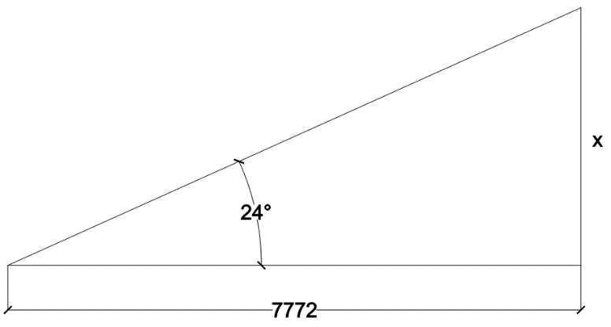
- Answer: 8210.26 (2dp)
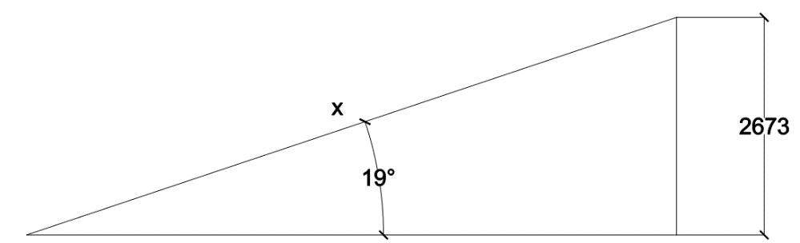
- Answer: 5777.29 (2dp)
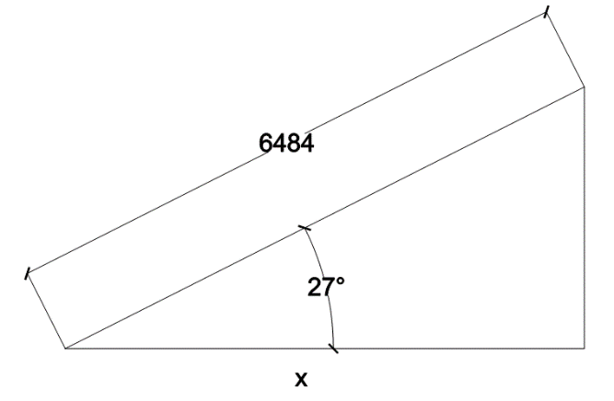

Satisfactory Outcome

Show all working out and calculations.
A. Tangent (theta) = x/adjacent
Tangent (24 degrees) = x / 7772
7772tangent(24degrees) = x
X = 3460.32

B. Sine (theta) = opposite/x
Sine (19 degrees) = 2673 / x
X = 2673 / sine (19 degrees)
X = 8210.26

C. Cosine (theta) = x/hyptonuse
Cosine (27 degrees) = x / 6484
6484cosine(27degrees) = x
X = 5777.29
- Using the grid pattern below, complete the table to calculate how much soil is needed to be removed from the highlighted section of the grid (represents the intended building) to a given RL of 11.000. Grid measurements = 5m x 5m. (first row has been completed for you)
- Suggest a new RL for the site that will require no spoil removal, only cut and fill.

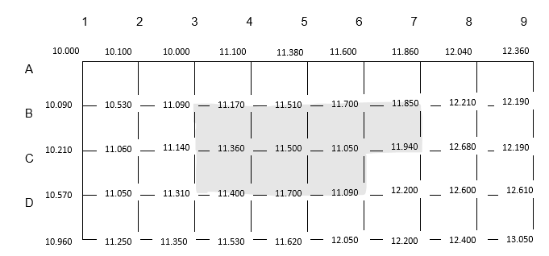

Volume of excavation- Grid method |  | Formation level RL | RL =11.000
Ground level | Corner Height “H” | No. of Squares occurring “N” | Product H & N
B3 | 11.009 -11.000 = 0.090 | 1 | 0.090
B4 | 11.170- 11.000 = 0.170 | 2 | 0.170
B5 | 11.510 – 11.000 = 0.510 | 2 | 0.510
B6 | 11.700-11.000=0.700 | 2 | 0.700
B7 | 11.850-11.000=0.850 | 1 | 0.850
C3 | 11.140-11.000=0.140 | 2 | 0.140
C4 | 11.360-11.000=0.360 | 4 | 0.360
C5 | 11.500-11.000=0.500 | 4 | 0.500
C6 | 11.050-11.000=0.050 | 3 | 0.050
C7 | 11.940-11.000=0.940 | 1 | 0.940
D3 | 11.050-11.000=0.310 | 1 | 0.310
D4 | 11.400-11.000=0.400 | 2 | 0.400
D5 | 11.500-11.000=0.500 | 2 | 0.500
D6 | 11.090-11.000=0.090 | 1 | 0.090
Volume = | Grid x Grid x Total Product ÷ 4
 |  | 5.61
- Calculate how much soil is needed to be removed from the highlighted section of the grid (represents the intended building) to a given RL of 11.000. Original grid measurements = 5m x 5m.
Not comprehending how to calculate the answer from the information given.

I have researched this to no avail. I have never had to use this system in my career.

I did try to contact your office for an email or phone number for an assessor, but was told I could just email Melissa and she would forward it on to you. I mentioned that this wouldn’t really work for me as I was on a tight deadline and needed direct communication with someone (as stated in the signing up information). I did not want to use a third party as that defeated the purpose of having support from an assessor.
- Suggest a new RL for the site that will require no spoil removal, only cut and fill.

Satisfactory Outcome

CPCCBC4018
Apply site surveys and set-out procedures to building and construction projects

PRACTICAL ASSESSMENT

Participant name | Justin Matheson

FOR THE PARTICIPANT
Instructions
- The tasks outlined on the following pages will require performance of normal workplace activities, as a result of a structured activity set by an Observer in the workplace or a simulated activity set by your Assessor/Observer.
- The timeframe for these tasks will be established by your Assessor/Observer, in consideration of location conditions and industry requirements.
- You must complete all tasks unassisted by the Assessor or other personnel, unless the steps note this assistance.
- You must attempt all tasks (and itemised steps) for a ‘Satisfactory’ assessment outcome to be awarded.
  - For any observation conducted that is incomplete, or without satisfactory performance, the observation will need to be completed again after further training support.

FOR THE ASSESSOR/OBSERVER
Instructions
- The following observation record should be used to judge and record your observations of the Participant as they complete the task(s) set. You must record your observations of the Participant’s performance.
  - For each occasion, indicate the task performed and whether it was a simulation or workplace-based task.
    - Any simulated assessment must ensure the Participant still performs under workplace conditions which reflect industry standards.
  - In the comments, provide clear detail regarding the task that the Participant was required to do (e.g. PPE used, materials handled, attachments connected, plant types).
- All steps must be satisfactorily demonstrated by the Participant for a ‘Satisfactory’ determination (indicated by an Assessor tick to the right of each itemised step, or an Observer tick to the right of each itemised step, and confirmation by an Assessor in the Assessor Comments).
  - Where you have determined that one or more task steps have not been satisfactorily demonstrated, provide the Participant with additional support and outline details of such assistance in the Assessor/Observer Comments. Allow the Participant two (2) further opportunities to demonstrate the task again to allow an opportunity for a ‘Satisfactory’ assessment outcome to be achieved.
  - If after three (3) attempts the Assessor determines that the Participant cannot demonstrate the required steps, a ‘Not Satisfactory’ outcome is to be determined.

TASK OUTCOME
Task | Date | Task Type (Tick) | Location | Task outcome (Tick)
 |  |  |  | Satisfactory | Not Satisfactory
Task 1 (Occasion 1) | 20/01/2024 | Workplace  Simulation | Gold Coast, QLD

ASSESSOR COMMENTS: GENERAL
As necessary, outline:
- Details on reattempts, alternative arrangements or reasonable adjustments made.
- Where a Participant is deemed ‘Not Satisfactory’, provide recommendations for future training.

ASSESSOR COMMENTS: PRACTICAL TASK 1: OCCASION 1
Individual student (as named on cover page)
Multiple students [ All from Attendance Report, Specific students involved – identify students]
Task | Provide detail
1.1A. | Specify how participant identified current plans:  By looking at the date of the drawings. Checking emails for any updated drawings.
1.1B. | Specify() surveying device collected and operated:  Electronic distance measuring (EDM) equipment Laser level: manual-levelling laser  Laser level: dot laser level Optical (Dumpy) level Water level Theodolite Other (please specify):
1.1B. | Specify() levelling device collected and operated:  Electronic distance measuring (EDM) equipment Laser level: manual-levelling laser  Laser level: dot laser level Optical (Dumpy) level Water level Theodolite Other (please specify):
1.1D. 1.1E. 1.1F. | Specify site RL calculations were made:  Student was not familiar with this type of calculation and as a builder, I myself do not use this system and would hire a surveyor to work out the cut and fill calculations.
1.1G. | Specify errors explained due to site characteristics:  Please see above.
1.1H. | Specify() digital tools operated to communicate with others:  Mobile phone UHF/ 2-way PC via intranet PC or mobile for email  Other (please specify):
1.3A. 1.3B. 1.3C. 1.3D. 1.3E. | Specify drainage and pipeline situations where calculations were made to determine grades.  Stormwater drainage  Sewer systems  Sanitary drainage inside building
CPCCBC4018
Apply site surveys and set-out procedures to building and construction projects

Practical Task 1
Description of task:
This assessment applies to National Construction Code (NCC) classifications:
- Residential - Class 1 and 10 buildings, maximum two storeys
- Commercial - Class 2 to 9, Type C only constructions

The participant must demonstrate the skills and knowledge to correctly apply site surveys and set-out procedures to a residential or commercial building on site. Demonstration must include:
- Prepare for and conduct site set-out.
  - Locate, read and adhere to the current plans and site set-out procedures.
  - Select and operate one surveying and one levelling device in accordance with SOPs (copy of booking sheet required as evidence).
  - Check accuracy of instrument by conducting a ‘two peg test’.
  - Carry out reduction in a closed level run by rise and fall method (copy of booking sheet required as evidence).
  - Carry out reduction in a closed level run by height of plane collimation (HPC) method (copy of booking sheet required as evidence).
  - Calculate accurate staff readings to enable a specific reduced level (RL) set-out.
  - Identify and explain errors in measured distances due to site characteristics and measurement methods.
  - Use digital tools to communicate with others.
- Develop a contour grid.
  - Determine set-out grid and levels.
  - Prepare a topographic contour plan from grid levels to specified tolerances and stated contour intervals (copy required as evidence).
  - Determine surface area being levelled and calculate cut and fill volumes.
  - Calculate and record trigonometric and geometric calculations commonly used with grid lines, off sets and right-angle triangles without error (copy of calculations required as evidence).
  - Calculate cut and fill quantities including: (copy of calculations required as evidence).
    - area and volume of land to be levelled.
    - area of land to be filled.
    - volume of fill required.
- Determine grades and levels
  - Draw longitudinal sections from RLs.
  - Determine levels and clearances from given grades and distances to specified tolerances.
  - Express calculation angles, percentages and run ratios in grades.
  - Determine calculations for batter levels from grades and distances.
  - Construct longitudinal sections and determine associated grades and levels in typical drainage and pipeline situations.

These tasks may be simulated or real. The Participant is to gather evidence of how they have completed each component of the Practical Task, which is to be submitted with this Practical Assessment sheet. The Observer is to provide detailed comments on the tasks completed by the Participant (on the Observer Comments, overleaf). The Assessor is to verify the Observer’s comments, noting their findings in the Assessor Comments (on the back of the Practical Assessment cover page) and provide the assessment outcome.

Resources required:
Work site, plans, procedures, one surveying device, one levelling device, access to computer and software, booking sheet, grid paper, pencil, calculator, communication equipment.
Observer details
Name of observer:
Role of observer
(Confirm suitability to sign)
Email address of observer
Signature of observer:
Date: | Select Date.

When completing the task, did the Participant: | Tick if satisfactorily completed.  Provide comments if left unticked.
1 Prepare for and conduct site set-out.
- Locate, read and adhere to the current plans and site set-out procedures.
- Select and operate one surveying and one levelling device in accordance with SOPs (copy of booking sheet required as evidence).
- Check accuracy of instrument by conducting a ‘two peg test’.
- Carry out reduction in a closed level run by rise and fall method (copy of booking sheet required as evidence).
- Carry out reduction in a closed level run by height of plane collimation (HPC) method (copy of booking sheet required as evidence).
- Calculate accurate staff readings to enable a specific reduced level (RL) set-out.
- Identify and explain errors in measured distances due to site characteristics and measurement methods.
- Use digital tools to communicate with others.
- Use equipment software to collect information and develop relevant documentation.
2 Develop a contour grid.
- Determine set-out grid and levels.
- Prepare a topographic contour plan from grid levels to specified tolerances and stated contour intervals (copy required as evidence).
- Determine surface area being levelled and calculate cut and fill volumes.
- Calculate and record trigonometric and geometric calculations commonly used with grid lines, off sets and right-angle triangles without error (copy of calculations required as evidence).
- Calculate cut and fill quantities including:.(copy of calculations required as evidence).
- area and volume of land to be levelled.
- area of land to be filled and volume of fill required.
3 Determine grades and levels.
- Draw longitudinal sections from RLs.
- Determine levels and clearances from given grades and distances to specified tolerances.
- Express calculation angles, percentages and run ratios in grades (copy of calculations required as evidence).
- Determine calculations for batter levels from grades and distances (copy of calculations required as evidence).
- Construct longitudinal sections and determine associated grades and levels in typical drainage and pipeline situations.

Observer comments:

