




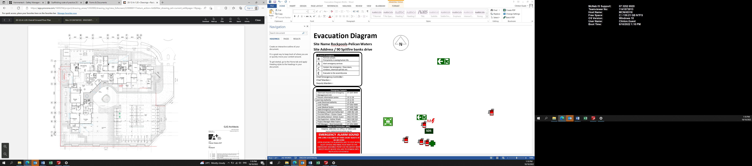
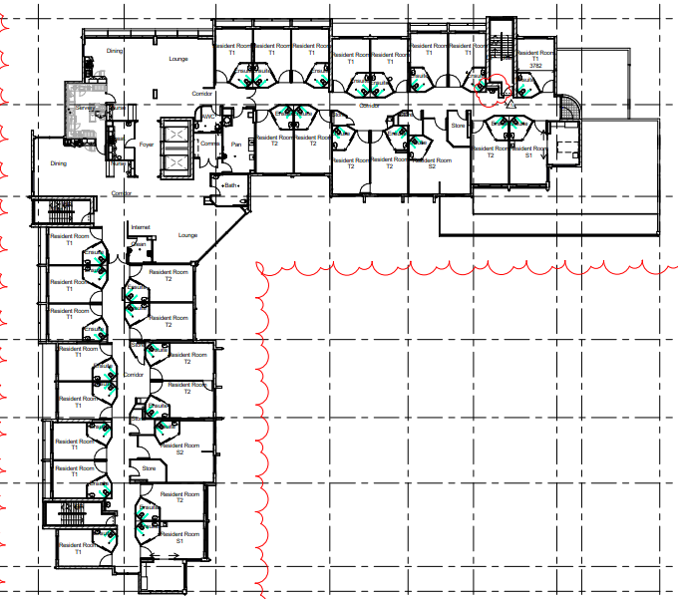
LEVEL 2
Evacuation Diagram
Site Name Rockpools-Pelican Waters
Site Address / 90 Spitfire banks drive 
 | Emergency Contacts
 | Chemicals hazards and Emergency Management Unit | 07 3247 8444
 | Poisons information centre | 13 11 26
Local Gas Authority |  | 13 11 53
 | Local Electrical Authority | 13 10 46
 | Local Hospital | 07 5202 0000
 | Local Medical Centre | 07 5439 7100
 | State Emergency Services (SES) | 07 3403 8888
 | Workplace Health and Safety QLD | 1300 362 128
 | First Aid Officer – Clinton Guest | 0421 972 020
 | Site Safety Advisor- Clinton Guest | 0421 972 020
 | Site Supervisor –Adrian Wyatt | 0421 618 310
 | Project Manager-Matt Hyams | 0411 733377
 | HSE Manager – Nick Economidis | 07 3252 6900
 | Mates in Construction (MIC)
Helpline: 1300 642 111 Office: 07 3833 1140
www.matesinconstruction.org.au
EMERGENCY ALARM SOUND
MEGA PHONE SIREN PRIMARY
3 BLASTS OF AIR HORN SECONDARY
UPON HEARING THE ALARM YOU ARE TO STOP WORK, ALERT OTHERS AND MAKE YOUR WAY TO THE EMERGENCY ASSEMBLY POINT VIA THE SAFEST MOST DIRECT ROUTE WHERE YOU ARE TO REMAIN UNTIL INSTRUCTED OTHERWISE.
ASSEMBLY POINT:
Vacent Block Opposite Site Carpark

In an emergency dial 000
In case of emergency
R | Remove people.  First priority is saving human life.
A | Alert emergency services
C | Contain the emergency. Close doors, windows, chemical spill kits etc.
E | Evacuate to the assembly area
Chief Emergency Controller – Adrian Wyatt
Chief Warden – Clinton Guest
Deputy Warden – Josh Macpherson
Date | 23.11.2022
Revision | 1
Author | Clinton Guest
Location | Level 2

Assembly Area – Block next to site carpark.

Fire Extinguisher

Emergency Exit
First Aid Kit in Office

STAIR 1.
STAIR 3.
STAIR 2.

