CHCECE016
Establish and maintain a safe and healthy environment for children
Learner Guide

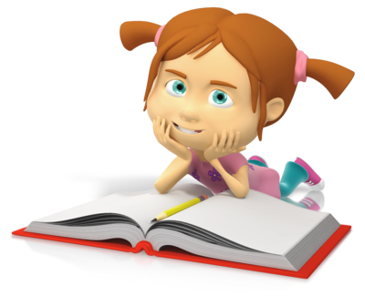

CHCECE016
Establish and maintain a safe and healthy environment for children

Table of Contents

Table of Contents 2
Unit of Competency 3
Performance Criteria 4
Foundation Skills 6
Assessment Requirements 7
Housekeeping Items 9
Objectives 9
National Quality Framework for Early Childhood Education and Care (NQF) 10
National Quality Standard 11
National laws and regulations 12
Guide to the Education and Care Services National Law and the Education and Care Services National Regulations 2011 13
1. Support each child’s health needs 19
1.1 – Discuss individual children’s health requirements and routines with families at enrolment and then on a regular basis 20
Children’s health requirements and routines 20
Health requirements form (example) 21
Activity 1A 22
1.2 – Ensure that any concerns or questions about a child’s health needs are conveyed to their family 23
Concerns about child’s health needs 23
Activity 1B 24
1.3 – Consult with relevant authorities to ensure that health information is current 25
Checking health information 25
National quality standards 25
Activity 1C 26
1.4 – Ensure that individual medical management plans for children with a specific health care need are in place and readily available at the service 27
Medical management plans 27
Activity 1D 29
2. Provide for each child’s comfort 30
2.1 – Ensure that groupings of children are configured to provide for each child’s comfort and to minimise the risk of overcrowding 31
2.2 – Make sure physical spaces are available for children to engage in rest and quiet activities 31
Grouping children 31
Making space for rest 31
Activity 2A 32
2.3 – Offer a range of active and restful experiences to children and support them to make appropriate decisions regarding participation 33
Active experiences 33
Restful experiences 33
Activity 2B 35
3. Promote and implement effective hygiene practices 36
3.1 – Ensure that the service accesses information on current hygiene practices 37
3.2 – Maintain written procedures and schedules to ensure a regular regime of washing children’s toys and equipment 37
3.3 – Provide families with information and support that helps them to follow the service’s hygiene procedures 37
3.4 – Ensure that information about correct hand washing procedures are displayed in relevant areas of the service 37
Scheduling washing of children’s toys and equipment 38
Encouraging children to follow hygiene practices 39
Hand washing procedure 39
Activity 3A 40
4. Take steps to control the spread of infectious diseases 41
4.1 – Configure groupings of children to minimise the risk of illness and injuries 42
Configuring groupings of children 42
Common childhood diseases 43
Activity 4A 44
4.2 – Source information about recognised health and safety guidelines 45
Health and safety guidelines 45
National Quality Framework (NQF) 46
Activity 4B 47
4.3 – Ensure that service procedures are followed, in relation to notifying families of illness or injuries that affect children while in education and care 48
4.4 – Advise families and public health authorities where necessary of cases of infectious diseases at the service and provide them with relevant information 48
Notify families of illness and injuries 48
Advising families and public health authorities 48
Notifiable diseases 49
Activity 4C 53
4.5 – Ensure current records of children’s immunisation status are up-to-date and a procedure is in place to maintain the currency 54
4.6 – Provide information to families and educators about child and adult immunisation recommendations 54
Immunisation status 54
Activity 4D 56
5. Ensure adequate supervision of children 57
5.1 – Arrange equipment, furniture and activities to ensure effective supervision while also allowing children to access private and quiet spaces 58
Arrange equipment, furniture and activities 58
Activity 5A 60
5.2 – Ensure new or relief educators are informed of supervision arrangements and of what they are required to do in relation to supervising children 61
Children (Education and Care Services National Law Application) Act 2010 62
National Quality Standard: 62
Activity 5B 63
5.3 – Undertake a risk assessment for each excursion including implications for supervision 64
Risk assessment template 65
Risk Matrix 66
Activity 5C 67
6. Take precaution to protect children from harm 68
6.1 – Ensure safety checks are consistently implemented and action is taken as a result of the checks 69
Safety checks 69
Activity 6A 71
6.2 – Check risk minimisation plans are in place for children enrolled at the service who have a specific health care need, allergy or relevant medical condition 72
Risk minimisation plans 72
Risk control template (for schools) 74
Activity 6B 75
6.3 – Ensure simple warning signs are located where potentially dangerous products are stored 76
Warning signs 76
Activity 6C 78
6.4 – Confirm safety of any drinks, food and cooking utensils and appliances used as part of the program 79
Safety of any drinks, food and cooking utensils and appliances 79
Personal hygiene requirements 80
Further hygiene requirements 81
Activity 6D 82
6.5 – Ensure that basic training and testing on how to move and fit car seats, restraints and booster seats (applicable to the age of relevant child) is available to all educators 83
Moving and fitting car seats, restraints and booster seats 83
Where to fit child seats 83
Types of child seat to use 84
National child restraint laws 84
Activity 6E 86
6.6 – Keep records of pest/vermin inspections and/or eradications 87
Records of pest/vermin inspections and/or eradications 87
Keep pests/ vermin out of the workplace 87
Signs of pest/vermin presence 88
Activity 6F 89
6.7 – Develop and maintain a written process for monitoring who enters and leaves the premises at all times 90
Monitoring who enters and leaves the premises 90
Activity 6G 91
6.8 – Provide detailed information to families regarding any excursion being undertaken 92
Informing families of excursions 92
Activity 6H 94
7. Develop plans to effectively manage incidents and emergencies 95
7.1 – Ensure emergency procedures are displayed prominently throughout the premises 96
Displaying emergency procedures 96
Fire safety 96
First Aid 97
Activity 7A 98
7.2 – Make certain that all educators have ready access to a phone or similar means of communication 99
7.3 – Ensure emergency numbers are located near telephones 99
Phoning in emergencies 99
7.4 – Communicate information to families about the service’s emergency procedures and incident management plans 100
Communicate emergency information to families 100
Activity 7B 101
7.5 – Discuss and practise emergency drills with children, educators and any other people on the premises 102
7.6 – Ensure that emergency equipment is available and tested and staff are trained in the use of it 102
Emergency drills 102
Emergency equipment 102
Activity 7C 104
7.7 – Maintain a portable record of children’s emergency contacts in case of emergencies 105
Maintain a portable record of children’s emergency contacts 105
Skills and Knowledge Activity 106
Major Activity – An opportunity to revise the unit 107
References 109

Unit of Competency

Application

The unit describes the skills and knowledge to establish and maintain a safe and healthy environment for children.

This unit applies to educators working in a range of education and care services.

No licensing, legislative or certification requirements apply to this unit at the time of publication.

Unit Sector

None stated

Performance Criteria
Element  Elements describe the essential outcomes. | Performance Criteria  Performance criteria describe the performance needed to demonstrate achievement of the element.
- Support each child’s health needs | - Discuss individual children’s health requirements and routines with families at enrolment and then on a regular basis  - Ensure that any concerns or questions about a child’s health needs are conveyed to their family  - Consult with relevant authorities to ensure that health information is current  - Ensure that individual medical management plans for children with a specific health care need are in place and readily available at the service
- Provide for each child’s comfort | - Ensure that groupings of children are configured to provide for each child’s comfort and to minimise the risk of overcrowding  - Make sure physical spaces are available for children to engage in rest and quiet activities  - Offer a range of active and restful experiences to children and support them to make appropriate decisions regarding participation
- Promote and implement effective hygiene practices | - Ensure that the service accesses information on current hygiene practices  - Maintain written procedures and schedules to ensure a regular regime of washing children’s toys and equipment  - Provide families with information and support that helps them to follow the service’s hygiene procedures  - Ensure that information about correct hand washing procedures are displayed in relevant areas of the service
- Take steps to control the spread of infectious diseases | - Configure groupings of children to minimise the risk of illness and injuries  - Source information about recognised health and safety guidelines  - Ensure that service procedures are followed, in relation to notifying families of illness or injuries that affect children while in education and care  - Advise families and public health authorities where necessary of cases of infectious diseases at the service and provide them with relevant information  - Ensure current records of children’s immunisation status are up-to-date and a procedure is in place to maintain the currency  - Provide information to families and educators about child and adult immunisation recommendations
- Ensure adequate supervision of children | - Arrange equipment, furniture and activities to ensure effective supervision while also allowing children to access private and quiet spaces  - Ensure new or relief educators are informed of supervision arrangements and of what they are required to do in relation to supervising children  - Undertake a risk assessment for each excursion including implications for supervision
- Take precaution to protect children from harm | - Ensure safety checks are consistently implemented and action is taken as a result of the checks  - Check risk minimisation plans are in place for children enrolled at the service who have a specific health care need, allergy or relevant medical condition  - Ensure simple warning signs are located where potentially dangerous products are stored  - Confirm safety of any drinks, food and cooking utensils and appliances used as part of the program  - Ensure that basic training and testing on how to move and fit car seats, restraints and booster seats (applicable to the age of relevant child) is available to all educators  - Keep records of pest/vermin inspections and/or eradications  - Develop and maintain a written process for monitoring who enters and leaves the premises at all times  - Provide detailed information to families regarding any excursion being undertaken
- Develop plans to effectively manage incidents and emergencies | - Ensure emergency procedures are displayed prominently throughout the premises  - Make certain that all educators have ready access to a phone or similar means of communication  - Ensure emergency numbers are located near telephones  - Communicate information to families about the service’s emergency procedures and incident management plans  - Discuss and practise emergency drills with children, educators and any other people on the premises  - Ensure that emergency equipment is available and tested and staff are trained in the use of it  - Maintain a portable record of children’s emergency contacts in case of emergencies

Foundation Skills
The foundation skills described those required skills (language, literacy and numeracy) that are essential to performance.

- Reading – in order to interpret and apply relevant legislative and regulatory requirements, including National Quality Standards, required for ensuring safety in a service.

The remaining foundation skills essential to performance are explicit in the performance criteria of this unit.

Assessment Requirements
Performance Evidence

The candidate must show evidence of the ability to complete tasks outlined in elements and performance criteria of this unit, manage tasks and manage contingencies in the context of the job role.

There must be demonstrated evidence that the candidate has completed the following tasks:

- Established and maintained an environment that is safe and healthy for children in at least once service, including:
- Communicating hazards and safety issues to appropriate persons within the service
- Coordinating emergency responses including evacuation plans
- Planning and coordinating supervision of children
- Promoting and monitoring safety practices, including administration of medicines and safe handling of food
- Coordinating appropriate procedures for handling infections and illnesses, including communicating with families
- Enacting strategies to support children to take increasing responsibility for their own health and physical wellbeing.

Knowledge Evidence

The candidate must be able to demonstrate essential knowledge required to effectively do the task outlined in elements and performance criteria of this unit, manage the task and manage contingencies in the context of the work role. These include knowledge of:

- How to access:
- the National Quality Framework
- the National Quality Standards
- the relevant approved learning framework
- How to navigate through framework and standards documents to find areas relevant to this unit of competency
- Common childhood illnesses and appropriate responses
- Strategies for minimising risk
- Notifiable diseases
- Organisational standards, policies and procedures.

Assessment Conditions

Skills must be demonstrated in a regulated education and care service.
In addition, simulations and scenarios must be used where the full range of contexts and situations cannot be provided in the workplace or may occur only rarely. These are situations relating to emergency or unplanned procedures where assessment in these circumstances would be unsafe or is impractical.

Simulated assessment environments must simulate the real-life working environment where these skills and knowledge would be performed, with all the relevant equipment and resources of that working environment.

Assessment must ensure use of:

- National Quality Framework for Early Childhood Education and Care
- The relevant approved learning framework under the National Quality Framework for Early Childhood Education and Care
- Evacuation plans
- Health and safety procedures and policies, including food-handling, travel and medication administration.

Assessors must satisfy the NVR/AQTF mandatory competency requirements for assessors.

Links

Companion volumes are available from the CS&HISC website - http://www.cshisc.com.au/

Housekeeping Items
Your trainer will inform you of the following:
- Where the toilets and fire exits are located, what the emergency procedures are and where the breakout and refreshment areas are.
- Any rules, for example asking that all mobile phones are set to silent and of any security issues they need to be aware of.
- What times the breaks will be held and what the smoking policy is.
- That this is an interactive course and you should ask questions.
- That to get the most out of this workshop, we must all work together, listen to each other, explore new ideas, and make mistakes. After all, that’s how we learn.
- Ground rules for participation:
  - Smile
  - Support and encourage other participants
  - When someone is contributing everyone else is quiet
  - Be patient with others who may not be grasping the ideas
  - Be on time
  - Focus discussion on the topic
  - Speak to the trainer if you have any concerns

Objectives
- Discover how to support each child’s health needs
- Know how to provide for each child’s comfort
- Learn how to promote and implement effective hygiene practices
- Understand how to take steps to control the spread of infectious diseases
- Comprehend how to ensure adequate supervision of children
- Ascertain how to take precaution to protect children from harm
- Find out how to develop plans to effectively manage incidents and emergencies
- Gain skills and knowledge required for this unit

National Quality Framework for Early Childhood Education and Care (NQF)
The NQF was founded in 2012 by the government as a measure to raise the quality and standards of early childhood education and care across the whole of the Commonwealth, by introducing consistency in the regulation and assessment of Australian education and care services.

The NQF applies to most of the following services:
- Long day care
- Family day care
- Preschool/kindergarten
- Outside school hours care.
The need for a national approach is to ensure that all children in the early stages of childhood access quality education and care in their formative years in order to give them the best possible start in development and learning. Research shows that the higher the quality of education and care in these early years, the higher the quality of health, educational attainment, and employment in later life.
The NQF focuses on the belief that all children need quality care that is tailored to meet their individual and specific needs.
It aims to raise the quality of education and care services via two methods:
- Improved caregiver qualifications – the higher the qualification of the caregiver, the more in depth their knowledge and understanding of the development and learning of children. These higher qualifications improve the effectiveness of the educator, as they take an holistic approach to the education of the whole child
- Lower educator to child ratios – fewer children in an educator’s care allows the educator to spend more time with each child, focusing on their individual learning and development needs and promotes the establishment and reinforcement of positive relationships. Happy children who feel safe are more likely to engage in learning, taking risks to think for themselves and trying new skills without the fear of failure or embarrassment.
The NQF is comprised of three elements:
- National Quality Standard that determines the benchmark for the quality of education and care services across Australia
- National legislative framework that provides a consistent approach to the regulation and assessment of education and child care services
- National quality rating and assessment process that rates education and care providers against the National Quality Standard.
The NQF is overseen by The Australian Children’s Education and Care Quality Authority (ACECQA), which works in conjunction with the regulatory authorities of each state/territory.
More information on the NQF can be found on the government’s website for education and training at: http://education.gov.au/national-quality-framework-early-childhood-education-and-care

National Quality Standard
The NQS is the benchmark for quality in early years education and child care provision. The plan is that every early years education and care service throughout Australia will be assessed against this standard and rated accordingly. The ratings will then be placed on a national register that can be viewed by all.
Each provider will be assessed in seven different areas and also given an overall rating.
The seven areas of assessment are:
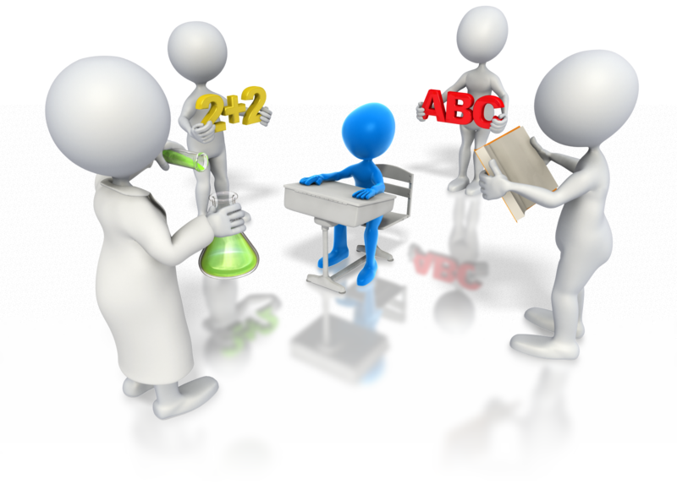
- Educational program and practice
- Children’s health and safety
- Physical environment
- Staffing arrangements
- Relationships with children
- Collaborative partnerships with families and communities
- Leadership and service management.
Each quality area will be rated with one of the five following levels defined by the NQS:
- Excellent rating – awarded by ACECQA
- Exceeding National Quality Standard
- Meeting National Quality Standard
- Working Towards National Quality Standard
- Significant Improvement Required.
More information on the NQS can be found on the ACECQA website at: http://acecqa.gov.au/national-quality-framework/the-national-quality-standard
The assessment criteria of the NQS is intrinsically linked to the two national learning frameworks:
- Belonging, Being and Becoming: The Early Years Learning Framework for Australia – this framework outlines the principles, practices and outcomes for successful development and learning of a child from birth to five-years-old, and includes the transition to school. All education and child care services are expected to use this framework to develop and implement their own provision
- My Time, Our Place: Framework for School Age Care in Australia – this framework supports the continued development of learning and development of children during school age, using best practices of learning through play and leisure based activities that are appropriate to the individual’s needs, abilities and interests.
Belonging, Being and Becoming can be found at: http://education.gov.au/early-years-learning-framework
My Time, Our Place can be found at: http://education.gov.au/my-time-our-place-framework-school-age-care-australia

National laws and regulations
The National Quality Framework is governed by a combination of the Education and Care Services National Law and the Education and Care Services National Regulations. The legislation and regulations vary in each state/territory. To find out more information about the legislation in your region visit the links below:
State/territory | Web address
Victoria | http://www.legislation.vic.gov.au/Domino/Web_Notes/LDMS/PubStatbook.nsf/51dea49770555ea6ca256da4001b90cd/b73164fe5da2112dca2577ba0014d9ed!OpenDocument
New South Wales | http://www.legislation.nsw.gov.au/sessionalview/sessional/act/2010-104.pdf
Australian Capital Territory | http://www.legislation.act.gov.au/a/2011-42/default.asp
Queensland | http://www.legislation.qld.gov.au/LEGISLTN/ACTS/2011/11AC038.pdf
Northern Territory | http://notes.nt.gov.au/dcm/legislat/Acts.nsf/5504d78eee675d6e6925649e001bb652/95724bfed2b632c96925792e007cb5c1?OpenDocument
South Australia | http://www.legislation.sa.gov.au/LZ/C/A/EDUCATION%20AND%20EARLY%20CHILDHOOD%20SERVICES%20(REGISTRATION%20AND%20STANDARDS)%20ACT%202011.aspx
Tasmania | http://www.thelaw.tas.gov.au/tocview/index.w3p;cond=;doc_id=48%2B%2B2011%2BAT%40EN%2B20120522120000;histon=;prompt=;rec=;term=
Western Australia | http://www.slp.wa.gov.au/legislation/statutes.nsf/main_mrtitle_12929_homepage.html

Guide to the Education and Care Services National Law and the Education and Care Services National Regulations 2011
The following information is taken directly from the official government Guide to the Education and Care Services National Law and the Education and Care Services National Regulations 2011, and the whole document can be found at: http://files.acecqa.gov.au/files/National-Quality-Framework-Resources-Kit/2014/NQF02%20Guide%20to%20ECS%20Law%20and%20Regs_web.pdf
The objectives of the NQF under section 3(2) of the National Law are to:
- Ensure the safety, health and wellbeing of children attending education and care services
- Improve the educational and developmental outcomes for children attending education and care services
- Promote continuous improvement in the provision of quality education and care services
- Establish a system of national integration and shared responsibility between participating jurisdictions and the commonwealth in the administration of the national quality framework
- Improve public knowledge, and access to information, about the quality of education and care services
- Reduce the regulatory and administrative burden for education and care services, by enabling information to be shared between participating jurisdictions and the Commonwealth.
The following guiding principles under section 3(3) of the National Law should be applied when making decisions about the operation of education and care services:

- The rights and best interests of the child are paramount
- Children are successful, competent and capable learners
- The principles of equity, inclusion and diversity underpin the national law
- That Australia’s Aboriginal and Torres Strait Islander cultures are valued
- That the role of parents and families is respected and supported
- That best practice is expected in the provision of education and care services.

The National Law sets out:
- Approval processes for the operation of education and care services

- The assessment and rating system
- Key operational requirements
- Compliance, monitoring and enforcement powers
- Review of decisions made by regulatory authorities
- The functions and powers of the Standing Council
- The functions and powers of the Australian Children’s Education and Care Quality Authority (ACECQA)—the national body that oversees the system
- The functions and powers of regulatory authorities in each jurisdiction
- Creation of a nationally consistent freedom of information and privacy framework to apply to ACECQA and regulatory authorities
- Publication of information, including registers
- Key transitional arrangements.
Services covered by the National Quality Framework
Section 5 of the National Law states that the NQF covers the majority of long day care, family day care, preschool (kindergarten) and outside school hours care services. In Western Australia the NQF also covers home-based care.
Given that the NQF was only introduced in 2012, not all service providers are covered. It has commenced its assessment and quality rating of the services that provide for the largest number of children but the intention is to extend it to all providers of education and care over the forthcoming years.
Services excluded from the NQF under National Law include:
- A school providing full-time education to children, including children in the year before Grade 1, but not including a preschool program delivered in a school or a preschool that is registered as a school (as these are within scope)
- A preschool program delivered in a school if the program is delivered in a class or classes where a full-time education program is also being delivered to school children, and the program is delivered to fewer than six children in the school (a composite class)
- A personal arrangement
- A service principally conducted to provide instruction in a particular activity (for example, a language class or ballet class)
- A service providing education and care to patients in a hospital or patients of a medical or therapeutic care service
- Care provided under a child protection law of a participating jurisdiction.
These services excluded by National Law are not likely to be brought into the scope of the NQF in the future.
Services excluded from the NFQ under National Regulations include:
- Disability services defined under state or territory law, and early childhood intervention services for children with additional needs
- Except in WA, education and care in a residence, other than as part of a family day care service
- Occasional care services (for example, offered at short notice or on a casual basis)
- Education and care provided by a hotel or resort to children of short-term guests at the hotel or resort
- Education and care that is provided on an ad hoc basis to children of a guest, visitor or patron where the person who is responsible for the children is readily available at all times
- Education and care where it is primarily provided or shared by parents or family members
- Education and care provided at a secondary school to a child of a student attending the school, where the parent retains responsibility for the child
- Mobile services

- Services that provide education and care for no more than four weeks per calendar year during school holidays
- Transition to school programs provided by a school to orient children to that school
- Budget-based funded services, other than where they receive Child Care Benefit
- Playschools licensed in the Australian Capital Territory
- Standalone services in Queensland
- Playcentres in South Australia
- Services licensed as centre-based Class 4 or 5 services under the Child Care Act 2001 in Tasmania
- Licensed limited hours or short-term services in Queensland or Victoria
- Government-funded services under the Children and Community Services Act 2004 of Western Australia.
Services excluded under the National Regulations may become an inclusive part of the NQF in the future.
Educational program
The National Law and Regulations determine that all approved services provide an educational program that:
- Is based on an approved learning framework:
  - the two nationally approved learning frameworks:
    - Belonging, Being and Becoming—The Early Years Learning Framework for Australia
    - My Time, Our Place—Framework for School Age Care in Australia
  - jurisdiction specific approved learning frameworks:
    - Australian Capital Territory: Every Chance to Learn—Curriculum Framework for ACT Schools Preschool to Year 10
    - Victoria: Victorian Early Years Learning and Development Framework, Department of Education and Victorian Curriculum and Assessment Authority
    - Western Australia: Curriculum Framework for Kindergarten to Year 12 Education in Western Australia
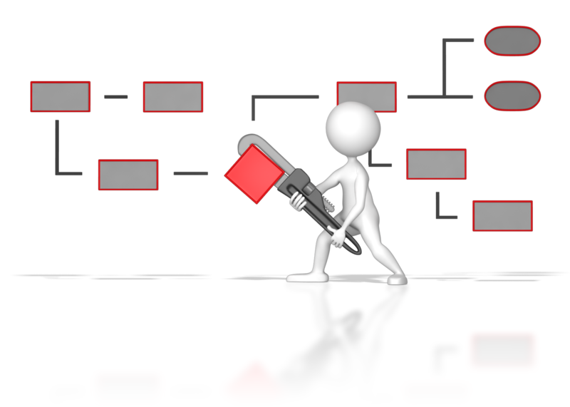
    - Tasmania: Tasmanian Curriculum, Department of Education of Tasmania, 2008
- Is delivered in accordance with that framework
- Is based on the developmental needs, interests and experiences of each child
- Takes into account the individuality of each child.

The educational program must make a contribution to each of the following outcomes:
- Children have a strong sense of identity
- Children are connected with and contribute to his or her world
- Children have a strong sense of wellbeing
- Children are confident and involved learners
- Children are effective communicators.
Further information regarding the National Quality Framework and how it relates to you and your role in education and care provision will be included in the relevant chapters of the unit.
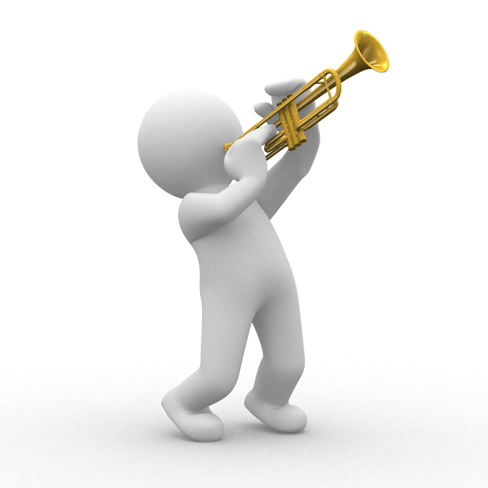

1. Support each child’s health needs
1.1. Discuss individual children’s health requirements and routines with families at enrolment and then on a regular basis
1.2. Ensure that any concerns or questions about a child’s health needs are conveyed to their family
1.3. Consult with relevant authorities to ensure that health information is current
1.4. Ensure that individual medical management plans for children with a specific health care need are in place and readily available at the service


1.1 – Discuss individual children’s health requirements and routines with families at enrolment and then on a regular basis

Children’s health requirements and routines
When caring for children, you must make sure that you are aware of individual health requirements and routines. Do not assume that all children will have the same requirements, as this could be dangerous and is irresponsible.
Examples of individual health requirements may include:
- Nut allergies
- Medication allergies

- Medication administration
- Asthma
- Nutritional requirements
- Nutritional intolerances
- Physical disabilities
- Mental disabilities.
Routines may include:
- Taking medication
- Meal times
- Sleep times
- Physical activity
- Mental activity.
In order to be aware of the above, you will need to enter into a discussion with the child’s family about such matters – this should happen during the enrolment process. It should also be an ongoing process, with scheduled meetings to discuss any changing requirements.
You should also encourage the parents of the child to be forthcoming with information on changes, if they occur between scheduled meetings. This will enable you to plan things better and ensure the child’s health needs and routines are continually met.
It may be useful to have the child’s family fill out a health requirements form, or at least leave a space on the enrolment form for it.
An example of this is shown on the next page.

Health requirements form (example)
Name of child: | D.O.B.:
Name(s) of guardian(s): | Contact number:
Address: | Emergency contact number:
Details of special health requirements:

Details of special health-related routines (include times, where necessary):

Additional information:

Signature of guardian: | Date:
Signature of carer: | Date:


Activity 1A

1.2 – Ensure that any concerns or questions about a child’s health needs are conveyed to their family

Concerns about child’s health needs

In the event that you develop a concern or have a question about a child’s health needs, you should notify the family at the first suitable opportunity, once you’ve had a chance to evaluate and analyse the situation properly.
Concerns about the child’s health needs may include:
- Being unable to provide nutritional requirements
- Child is malnourished
- Medication appears excessive
- Medication administration procedures.
You must ask questions if you are unsure on a child’s health needs. For instance, if they have a food allergy, how severe is it? Will they have an adverse reaction from being in the presence of a certain food, or does this only happen if they ingest it?
This type of information will affect eating arrangements if you are caring for multiple children simultaneously. You may have to separate them if one of them has a severe allergy to food the other children are eating.
These questions and their responses should be appropriately documented, according to organisational procedures.
Make sure that you raise any concerns in a sensitive manner – understand that the family may not be aware of the situation and may take offence if you question their child’s health. If you raise a concern that a child is suffering from malnutrition, this can indirectly be taken as an insult to their parenting, if not done sensitively.
It is in these cases that active listening and empathy are important, in order to find out information about a child’s health requirements and routines.

Activity 1B

1.3 – Consult with relevant authorities to ensure that health information is current

Checking health information
Once you have obtained the child’s information for the family, you must now check it with the relevant authorities to ensure it is accurate. This will ensure you are promoting the child’s health, in line with standard 2.1 of the National Quality Framework.
The appropriate authorities may include:
- Health professionals
- Department of Health
- GP.
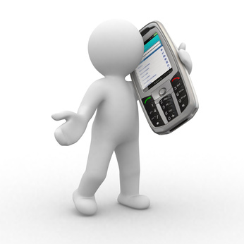
The types of health information you may need to confirm include:
- Immunisation
- Nutrition and physical activity
- Asthma
- Diabetes
- Arthritis
- Mental health
- Injury prevention
- Food allergies.

National quality standards
Quality Area 2 – Children’s health and safety

Source: http://www.earlychildhoodaustralia.org.au/nqsplp/wp-content/uploads/2013/11/Resources-guide.pdf

Activity 1C

1.4 – Ensure that individual medical management plans for children with a specific health care need are in place and readily available at the service

Medical management plans
Medical management plans are provided by doctors and give details of the specific actions to be taken to deal with certain medical conditions.
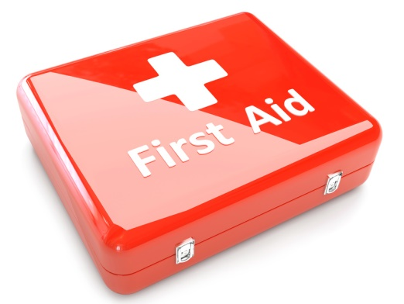
Examples of conditions that may require a medical management plan include:
- Anaphylaxis
- Asthma
- Diabetes
- Epilepsy
- Allergic reactions.
You must have any necessary medications and equipment available at the place where your service is administered.
So, if we take anaphylaxis as an example, Anapens and Epipens would be the medications you would need available.
You should ensure you are trained in First Aid and can attend to any minor injuries, and that you are capable of dealing with emergencies, should they arise.
You will need an authorisation form for the plan itself, a medical authorisation form (if medication is required to be administered) – to be completed by the parent – and a medical management form, to be completed by a doctor.
General sample forms can be found at: http://www.acecqa.gov.au/sample-forms-and-templates-now-available
The following table gives links to some example medical management plans. There are many templates available as well as these on the internet.
Condition | Medical management plan template
Anaphylaxis | http://www.allergy.org.au/health-professionals/ascia-plans-action-and-treatment
Asthma | http://www.nationalasthma.org.au/asthma-tools/asthma-action-plans
Diabetes | http://www.shesugar.com/wp-content/uploads/2012/07/Sample-Type-1-Diabetes-Medical-Management-Plan-grades-K-1.pdf
Epilepsy | http://www.epinet.org.au/articles/epilepsy_management_plans_emp_1

Activity 1D

2. Provide for each child’s comfort
2.1. Ensure that groupings of children are configured to provide for each child’s comfort and to minimise the risk of overcrowding
2.2. Make sure physical spaces are available for children to engage in rest and quiet activities
2.3. Offer a range of active and restful experiences to children and support them to make appropriate decisions regarding participation

2.1 – Ensure that groupings of children are configured to provide for each child’s comfort and to minimise the risk of overcrowding

2.2 – Make sure physical spaces are available for children to engage in rest and quiet activities

Grouping children
When you group children together, you should endeavour to put personalities together that complement one another and do not clash – this will avoid conflict and ensure the group of children are manageable.
When creating groups, you don’t want to have too many children per carer at one time – this will present problems in managing behaviour and can present a risk in emergency situations (as you are unable to attend to multiple children in the required time).
The size of groups will depend on the amount of staff you have and the space you have in your facility.
A good guide is:
- Two year olds – six children per adult
- One-year-olds and below – four children per adult.
Overcrowding can be dangerous, as it increases the risk of accidents occurring and the chance of children clashing and competing for space.
The minimum amount of floor space required indoors per child may vary between states and according to legislation. For example, in North Sydney, there needs to be a minimum of 3.25m² of unobstructed floor space per child, with 4.5m² considered to be best practice. Also, a minimum of 10m² of unencumbered floor space is required per adult.


Making space for rest
Children may not be active the entire time, so they will need an adequate physical space, with soft blankets/bedding available for comfort.
This space should be separate from the play area and be quiet, so children are not disturbed and can get adequate rest.
You must also ensure there is adequate sunlight, fencing (for dangerous areas) and that children are not exposed to excessive noise, pollution and wind. This will ensure their comfort and safety.
You must ensure that any hazardous areas are fenced off or covered, e.g. cover electrical outlets with childproof covers.
You must also ensure there is easy and safe access to fire exits, in the event that you need to evacuate children from your facility in an emergency.

Activity 2A

2.3 – Offer a range of active and restful experiences to children and support them to make appropriate decisions regarding participation
Your childcare facility should offer variety of experiences to suit the needs of a range of children. These should cover both active and restful experiences – children will need to participate in both during their time in your care.

Active experiences
Active experiences will keep child’s minds and bodies engaged and require more energy to participate in than restful experiences.
They can be individual or group activities, depending on the nature of them. You will need to supervise these activities closely, to minimise the risk of any hazards occurring and to manage any conflict that may occur when children are playing together.
Examples of active experiences include:
- Group games

- Sharing activities
- Dramatic play
- Water table
- Sandbox
- Building blocks/Legos
- Outdoor play
- Arts and crafts
- Songs
- Learning activities.

Restful experiences
Restful experiences are less engaging and don’t require as much mental or physical engagement from the child – they are a chance for the children to regain energy lost from their participation in active experiences.
Examples of restful experiences are:
- Napping
- Story time
- Drawing
- Colouring
- Puzzles
- Eating.
You must ensure that the timing of active and restful experiences is scheduled efficiently – for example, you don’t want children to engage in the most active experiences immediately after eating. You will also need to consider how many children can engage in any one activity at once.
Imagine you have four children in your care – it may be more effective if you have two engaging in restful activities while two are doing active things. This will make it easier to manage the children engaged in active experiences, and ensures they will have more space in which to play and interact.


Activity 2B

3. Promote and implement effective hygiene practices
3.1. Ensure that the service accesses information on current hygiene practices
3.2. Maintain written procedures and schedules to ensure a regular regime of washing children’s toys and equipment
3.3. Provide families with information and support that helps them to follow the service’s hygiene procedures
3.4. Ensure that information about correct hand washing procedures are displayed in relevant areas of the service

3.1 – Ensure that the service accesses information on current hygiene practices

3.2 – Maintain written procedures and schedules to ensure a regular regime of washing children’s toys and equipment

3.3 – Provide families with information and support that helps them to follow the service’s hygiene procedures

3.4 – Ensure that information about correct hand washing procedures are displayed in relevant areas of the service
You need to ensure that your child care practice is compliant with the very latest hygiene standards; therefore, you need access to the latest information.
The National Childcare Accreditation Council has certain standards for hygiene that should be followed. This will reduce the risk of cross-infection between children and adults – it also teaches children good hygiene practices from an early age.
Imagine how much contact children and adults have with surfaces, objects and other people. Think of what happens when a person sneezes – airborne droplets are spread on surrounding objects and on skin. Children have to interact with toys, furniture, food and various utensils, so the potential for cross-contamination is huge.
Therefore, effective hygiene is essential to preventing the spread of infectious diseases.

Hygiene practices should be based on standards recommended by the National Health and Medical Research Council, Food Standards Australia, as well as state and territory health departments.
Effective hygiene practices include:
- Hand washing and drying
- Cleaning equipment and toys
- Dental care
- Cleaning facilities clean (bathroom, rest areas, play areas, kitchens)
- Wiping children’s noses and other skin parts hygienically
- Hygienic toileting and nappy change procedures
- Keeping unwell children away from child care
- Keeping food preparation handling, storage and disposal a hygienic process
- Displaying written signs about hygiene procedures clearly
- Communicating hygiene practices to children’s families
- Communicating immunisation schedules for children
- Having clear procedures for disposal of bodily fluids/contaminated items, including handling.

Scheduling washing of children’s toys and equipment
You should ensure there is a written procedure of washing children’s toys and equipment, including when they should be cleaned and correct procedures.
When children have finished playing with a toy, you need to remove it from the play area and place it in a box for dirty toys (which needs to be out of reach from the children). Once they have been washed, they can be returned to the box full of clean toys.
Washing of hard plastic toys can be the following way:
- Scrub the toy in warm, soapy water, using bush to reach more difficult to access places
- Rinse the toy in clean water
- Place the toy a solution of mild bleach and water – leave to soak for 10 minutes
- Rinse the toy in cool, clean water and leave to air dry.
Hard plastic toys can also be washed in a dishwasher and cloth toys can be washed in a hot water cycle of a washing machine.
Toys should not be shared between groups – separate groups should have their own collection of toys.
Toys used by older children who don’t put them in their mouths should be washed weekly and whenever they are obviously dirty. The same applies to stuffed toys used by all children – disinfection is not required, though.
You will need adequate supplies of cleaning equipment on hand to deal with cleaning toys and equipment.
These may include:
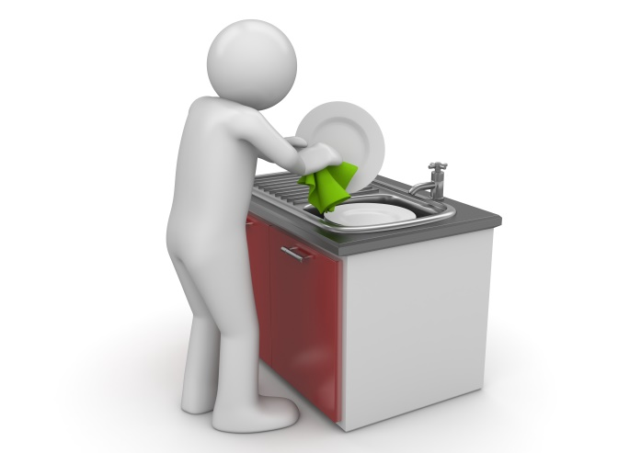
- Mild bleach
- Liquid soap
- Disinfectant wipes
- Disposable paper towels
- Sorbolene cream
- Cleaning brushes
- Disposal bags.

Encouraging children to follow hygiene practices
Children should be encouraged to follow hygiene practices, as well as adults. These can be reinforced at certain event/times – for instance: at mealtimes, toileting and changing nappies. This will help children to become self-sustainable for hygienic practices. You should provide positive feedback for children when they perform hygienic practices, to reinforce good habits.
A simple practice is to wash hands on arrival and departure of the child – this minimises the chances of external infections entering the child care facility.
Hand washing should also be practised in these situations:
- Before eating
- After using the toilet
- After touching an animal.
Parents should be encouraged to supply a spare set of clothes, in case of food, liquid and toilet-related accidents.

Hand washing procedure
The following is recommended by the National Health and Medical Research Council:
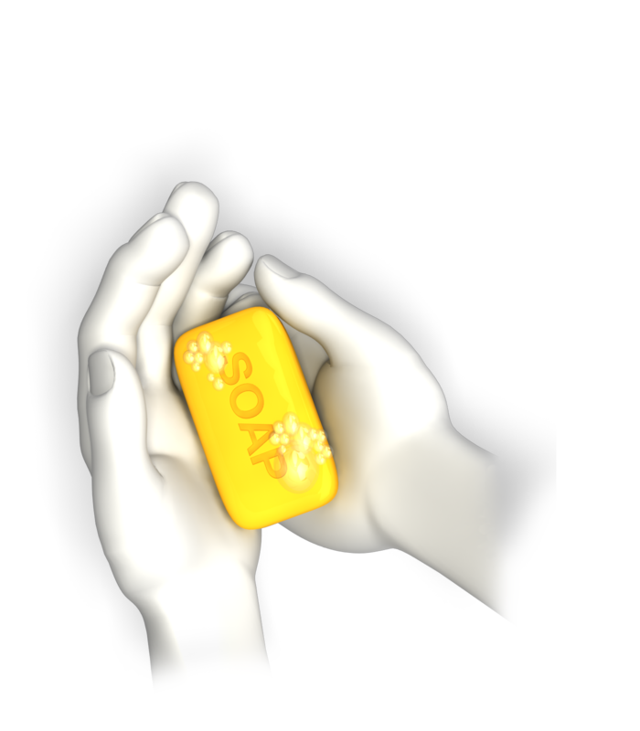
- Wet hands with running water
- Spread liquid soap over hands (use Sorbolene cram for sensitive hands)
- Rub hands all over
- Wash hands all over, including wrists, palms, back of hands, under finger nails and between fingers
- Rinse hands all over to remove all suds from soap
- Turn off tap using disposable paper towel
- Pat hands dry using a new paper towel.
This procedure should be clearly displayed on signage and in an organisation handbook, if applicable.
Families should be informed of all hygiene procedures clearly and encouraged to practice them at home, as well as when they leave their children for care. This can be done verbally, or in writing, as well as through leaflets.
You need to make it clear what is expected, in order to minimise the transfer of external infections into your facility and to other children. You should also be explicit that ill children will not be permitted for care, as it is a health risk and infections would be too hard to contain.

Activity 3A

4. Take steps to control the spread of infectious diseases
4.1. Configure groupings of children to minimise the risk of illness and injuries
4.2. Source information about recognised health and safety guidelines
4.3. Ensure that service procedures are followed, in relation to notifying families of illness or injuries that affect children while in education and care
4.4. Advise families and public health authorities where necessary of cases of infectious diseases at the service and provide them with relevant information
4.5. Ensure current records of children’s immunisation status are up-to-date and a procedure is in place to maintain the currency
4.6. Provide information to families and educators about child and adult immunisation recommendations

4.1 – Configure groupings of children to minimise the risk of illness and injuries

Configuring groupings of children
As outlined in section 2 of this unit, you will need to take care when grouping children – as well as comfort, this minimises the risk of illness and injuries.
Ensure that you have groupings of children of similar ages, so there is a limited chance of younger children being injured by bigger children. Bigger children may unintentionally knock babies over or tread on their fingers during their play.
A good guide for group size is:
- Two year olds – six children per adult
- One-year-olds and below – four children per adult.
This allows you to control infections and clean up after children effectively, as and when spills happen. This ensures the chance of illness from infection is kept as small as possible.
It also allows you spot developing hazards and remove them before children are exposed to them.
Age-appropriate toys
Children will also need age-appropriate toys and materials to play with. Children under three years of age are still learning through oral exploration of items and may be tempted to put things in their mouths. Some toys and materials are not suitable for chewing and can pose a choking hazard.

For example:
- Buttons
- Cotton wool
- Sequins
- Beads
- String
- Small toys with removable parts
- Marbles
- Small cars.
Configuring groupings, so that the children who are still exploring through their mouths can do so safely, is very important to prevent this.
Empowering children
Grouping children means that each group of children can safely explore their environment in an empowering way. This is because it reduces the amount of time that you have to step in and take items away from children.

Common childhood diseases
Illness | Response
Chickenpox | - Calamine lotion/antihistamines  - Isolate child from other children who haven’t previously had the disease  - Avoid those with compromised immune systems
Whooping cough | - Antibiotics  - Fresh air  - Feed small meals – to minimise risk of vomiting)  - Keep child away from children under one year old  - Exclusion from school until five days of antibiotics have been completed.
Erythema infectiosum (‘fifth’ disease) | - Isolate child until rash disappears
Roseola infantum (three-day-fever) | - Keep child cool by removing clothing layers  - Paracetamol and ibuprofen, to reduce fever  - Avoid contact with children under three until temperature has returned to normal
Hand, foot and mouth disease | - Ensure child has plenty to drink  - Mash up food, if mouth ulcers are severe
Scarlet fever | - Antibiotics for ten days  - Avoid contact with other children

Activity 4A

4.2 – Source information about recognised health and safety guidelines

Health and safety guidelines
You will need to source information about recognised health and safety guidelines when dealing with childcare.
You will need to know about:
- Infection control
- Infectious diseases
- Immunisation
- Administering medications and procedures
- Managing children with conditions, including:
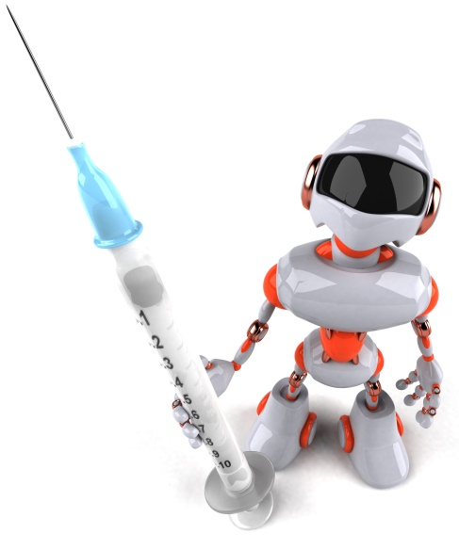
  - asthma
  - diabetes
  - epilepsy
  - food allergies
  - anaphylaxis
- Dealing with other medical conditions
- Managing emergencies
- Indoor safety
- Outdoor safety
- Environmental hazards
- Travel/excursions
- Child protection
- Staff health and safety
- Pregnant child care health and safety.
For more information on the above topics, visit: http://www.community.nsw.gov.au/docswr/_assets/main/documents/childcare_model_policies.pdf

National Quality Framework (NQF)
The National Quality Standard (NQS) is part of the National Quality Framework (NQF) – it sets a national benchmark for childhood education and care, including that outside of school hours. This includes those factors which effect health and safety.
The benefits of the NQS are:
- Improved educator to child ratios
- Greater individual care and attention for children
- Educators with increased skills and qualifications
- Better support for children’s learning and development
- A national register to help parents assess the quality of education and care services in their area.
More information on the NQS can be found at: http://www.acecqa.gov.au/national-quality-framework/the-national-quality-standard
As a whole, the NQF can be found at: http://www.acecqa.gov.au/national-quality-framework
The information that can be accessed includes:
- Introducing the National Quality Framework
- The National Quality Standard

- National Law and regulations
- Assessment and ratings
- Key changes
- National Quality Framework Snapshots
- Information sheets
- NQF Library
- NQF video resources
- National Quality Framework FAQs
- Excellent rated services

Activity 4B

4.3 – Ensure that service procedures are followed, in relation to notifying families of illness or injuries that affect children while in education and care

4.4 – Advise families and public health authorities where necessary of cases of infectious diseases at the service and provide them with relevant information

Notify families of illness and injuries
When a child has an illness or is injured in your care, you must be upfront and notify their family about it. Tell them how this illness or injury might affect their ability to be in education or care.
You must include details of when the incident occurred, the circumstances surrounding it and the outcome. You can do this when the families collect their child, as long as it’s not an emergency.
If the incident is an emergency that threatens the child’s/other children’s immediate health, you will then need to inform the family using the emergency contact number they supplied when they registered with you. You should also contact emergency services, where it is a medical emergency (this should be your first phone call in this scenario).
Ensure you document any illnesses and injuries appropriately.

Advising families and public health authorities
If there is an infectious disease present in you facility, you need to advise families and public health authorities of this.
The information you need to communicate includes:
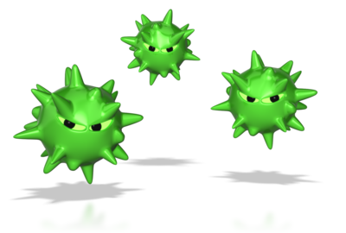
- Origin of infection (if known)
- When the case occurred
- Where it occurred
- Who was affected
- Date of diagnosis
- The type of infection
- The severity of the infection
- The symptoms/consequences of infection
- Measures to contain it
- Exclusion periods of those affected
- Expected time where the facility will be clear from infection
- Contact numbers for those affected
- Travel history of those affected.

Notifiable diseases
There are certain diseases that must be reported to government by law if they occur. This allows the government to monitor the disease and prevent outbreaks from occurring.
These include:

Bloodborne diseases
- Hepatitis (NEC)
- Hepatitis B (newly acquired)
- Hepatitis B (unspecified)
- Hepatitis C (newly acquired)
- Hepatitis C (unspecified)
- Hepatitis D
Gastrointestinal diseases
- Botulism
- Campylobacteriosis
- Cryptosporidiosis
- Haemolytic uraemic syndrome (otherwise known as HUS)
- Hepatitis A
- Hepatitis E
- Listeriosis
- Salmonellosis
- Shiga Toxin-producing E. Coli or Verotoxin-producing E. Coli (otherwise known, respectively, as STEC or VTEC)
- Shigellosis
- Typhoid fever
Quarantinable diseases
- Cholera
- Highly pathogenic avian influenza (human)
- Plague
- Rabies
- Severe acute respiratory syndrome (otherwise known as SARS)
- Smallpox
- Viral haemorrhagic fever
- Yellow fever
Sexually transmissible infections
- Chlamydia
- Donovanosis
- Gonococcal infection
- Syphilis-congenital
- Syphilis-less than 2 years duration
- Syphilis-more than 2 years duration or unspecified duration
Vaccine preventable diseases

- Diphtheria
- Haemophilus influenzae type b
- Influenza (laboratory confirmed)
- Measles
- Mumps
- Pertussis
- Pneumococcal disease-invasive
- Poliomyelitis
- Rubella
- Rubella-congenital
- Tetanus
- Varicella zoster infection-Chickenpox
- Varicella zoster infection-Shingles
- Varicella zoster infection-unspecified
Vectorborne diseases
- Barmah Forest virus infection
- Chikungunya virus infection
- Dengue virus infection
- Flavivirus infection (unspecified)
- Japanese encephalitis virus infection
- Kunjin virus infection
- Malaria
- Murray Valley encephalitis virus infection
- Ross River virus infection
Note: Vectorborne means transmitted by an insect or other organism.

Zoonoses
- Anthrax
- Australian bat lyssavirus infection
- Brucellosis
- Leptospirosis
- Lyssavirus infection (NEC)
- Ornithosis (otherwise known as Psittacosis)
- Q fever
- Tularaemia
Note: The term Zoonoses refers to diseases which are communicable to humans from another animal species.
Other bacterial diseases
- Legionellosis
- Leprosy
- Meningococcal disease-invasive
- Tuberculosis
Diseases under national surveillance performed by surveillance bodies other than the Department of Health
- Creutzfeldt-Jakob disease (otherwise known as CJD)
- Variant Creutzfeldt-Jakob disease (otherwise known as vCJD)
- Human immunodeficiency virus (otherwise known as HIV)
- Acquired immune deficiency syndrome (otherwise known as AIDS)
Note: The term ‘surveillance bodies other than the Department of Health’ refers to the following non-government bodies:
- the Australian National Creutzfeldt-Jakob Disease Registry; and
- the Kirby Institute for infection and immunity in society.
Source: http://www.health.gov.au/

Activity 4C

4.5 – Ensure current records of children’s immunisation status are up-to-date and a procedure is in place to maintain the currency

4.6 – Provide information to families and educators about child and adult immunisation recommendations

Immunisation status
You need to keep immunisation records of children up-to-date, to ensure you are aware of infectious diseases they may be liable to catch.
The following table outlines the ages recommended for certain vaccines:
Age | Disease vaccine required for
At birth | - Hepatitis B
Two months | - Diphtheria  - Tetanus  - Pertussis  - Polio  - Hib  - Hepatitis B  - Pneumoccocal  - Rotavirus
Four months | - Diphtheria  - Tetanus  - Pertussis  - Polio  - Hib  - Hepatitis B  - Pneumoccocal  - Rotavirus

Six months | - Diphtheria  - Tetanus  - Pertussis  - Polio  - Hib  - Hepatitis B  - Pneumoccocal  - Rotavirus
Twelve months | - Measles  - Mumps  - Rubella  - Hib  - Meningococcal C
Eighteen months | - Measles  - Mumps  - Rubella  - Varicella
Four years | - Diphtheria  - Tetanus  - Pertussis  - Polio  - Measles (part of MMR vaccine)  - Mumps (part of MMR vaccine)  - Rubella (part of MMR vaccine)

The MMR vaccine is only required at four years if the MMRV vaccine was not given at 18 months.
Source: http://www.humanservices.gov.au/customer/enablers/medicare/australian-childhood-immunisation-register/your-childs-immunisation-schedule
You should provide information of these vaccination dates to families and educators as standard.
You need to have a process for keeping the currency of your records up-to-date – this could be a form for parents to fill in when they have taken their child for immunisation. You will then record these in your organisation’s files on the applicable children.
You could also set up a system on a computer where an alert is displayed when children in your care reach the ages specified in the table above – this would then prompt you to ask the child’s family whether they have had said vaccinations, and update your records accordingly.

Activity 4D

5. Ensure adequate supervision of children
5.1. Arrange equipment, furniture and activities to ensure effective supervision while also allowing children to access private and quiet spaces
5.2. Ensure new or relief educators are informed of supervision arrangements and of what they are required to do in relation to supervising children
5.3. Undertake a risk assessment for each excursion including implications for supervision

5.1 – Arrange equipment, furniture and activities to ensure effective supervision while also allowing children to access private and quiet spaces

Arrange equipment, furniture and activities
The arrangement of equipment, furniture and activities is important, as it will affect your ability to monitor children competently.
The following guidelines are useful:
- Ensure that hazardous equipment and items are kept of reach of children
- Ensure fire escapes are unobstructed by furniture and equipment
- Ensure you have a clear view of play and rest areas, removing/rearranging obstructing furniture
- Ensure sharp edges of furniture are covered with soft padding
- Ensure tripping hazards (e.g. wires) are kept out of play and rest areas
- Ensure strangulation hazards (e.g. wires) are kept out of play and rest areas
- Make sure accessible furniture is the right height – e.g. children’s feet should touch the floor when sitting in a chair (otherwise they can fall off and hurt themselves)
- Ensure any electrical outlets are covered
- Hold activities in adequately-spaced areas
Be aware that children may need to access private and quiet spaces, where they may be temporarily out of sight.

You must ensure these areas are free from hazards, including:
- Choking hazards
- Sharp objects
- Exposed electrical outlets
- Open window
- Unlocked doors into hazardous areas
- Tripping hazards
- Low, open windows
- Stairs/steps
- Protruding sharp edges
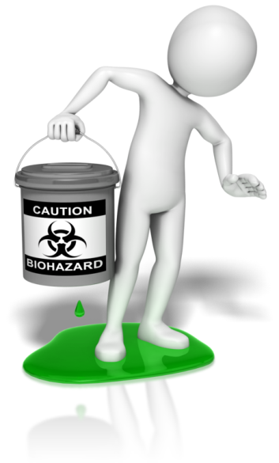
- Splintered wood
- Storage cabinets that can be opened without locks
- Unstable furniture (e.g. bookshelves)
- Strangulation hazards
- Slippery surfaces
- Poisonous objects (e.g. certain plants, cleaning agents)
- Loose fittings on walls and ceilings.
Ensure that children are always within audible distance when they are out of your sight – it is a good idea to keep a device like a baby monitor in rest areas, so you can hear and attend to any situations that develop.
When children are engaged in certain activities, they will require a greater degree of supervision.
For example, when exposed to any body of water (e.g. swimming pool, water table, bath etc.), children need constant, close supervision – young children can drown easily, even in just a few inches of water.
When planning activities, ensure you have adequate space and that no hazards are present. While you are conducting these activities, be aware of who is present, as you will need to keep all children within monitoring distance.

Activity 5A

5.2 – Ensure new or relief educators are informed of supervision arrangements and of what they are required to do in relation to supervising children
In an education settings, new or relief teachers will need to be informed of supervision arrangements and the requirements for specific children, so their care is kept consistent.
The supervision arrangements you may need to inform them of include:
- Normal rest times
- Health and safety guidelines
- Allergies
- Medication
- High risk activities
- Location of activities
- Location of toilet facilities
- Emergency contact numbers
- Play schedules
- Any disabilities of children (if applicable)
- Amount of adults required to supervise children
- Areas that are off limits to children
- Children must be within sight or hearing of educators at all times
- Children must be supervised while eating
- Children must be supervised during toileting
- Children must be supervised during nappy change
- Emergency and evacuation procedures
- The abilities and needs of individual children
- Removal of hazards from the environment.

There are also various legislative requirements that educators must be aware of:

Children (Education and Care Services National Law Application) Act 2010
Education and Care Services National Regulations 2011:
115 Premises designed to facilitate supervision

(1) The approved provider of a centre-based service must ensure that the education and care service premises (including toilets and nappy change facilities) are designed and maintained in a way that facilitates supervision of children at all times that they are being educated and cared for by the service, having regard to the need to maintain the rights and dignity of the children.
120 Educators who are under 18 to be supervised
(1) The approved provider of a centre-based service must ensure that any educator at the service who is under 18 years of age
a) does not work alone at the service; and
123 Educator to child ratios—centre-based services
(1) The minimum number of educators required to educate and care for children at a centre-based service is to be calculated in accordance with the following ratios;
a) for children from birth to 24 months of age—1 educator to 4 children;
271 Educator to child ratios—children aged 36 months or more but less than 6 years
(1) The educator to child ratio for children aged 36 months or more but less than 6 years of age is 1 educator to 10 children.
275 Educator to child ratio—centre-based service—children aged over 24 months and less than 36 months
(2) The educator to child ratio for a centre-based service for children aged over 24 months but less than 36 months is 1 educator to 8 children.

National Quality Standard:
Standard 2.3 Each child is protected.
Element 2.3.1 Children are adequately supervised at all times.
Element 2.3.2 Every reasonable precaution is taken to protect children from harm and any hazard likely to cause injury.
Element 3.1.3 Facilities are designed or adapted to ensure access and participation by every child in the service and to allow flexible use, and interaction between indoor and outdoor space.
Element 4.1 Staffing arrangements enhance children’s learning and development and ensure their safety and wellbeing.
Element 4.1.1 Educator-to-child ratios and qualification requirements are maintained at all times.
Element 5.2.3 The dignity and rights of every child are maintained at all times.
Source: http://www.communities.wa.gov.au/education-and-care

Activity 5B

5.3 – Undertake a risk assessment for each excursion including implications for supervision
For each excursion children are taken on in your care, you will need to conduct a risk assessment and take the necessary precautions to control or prevent identified risks.
This can be done by using the risk assessment and risk matrix templates on the following pages.
Think of the implications for supervision – high risk activities will inevitably justify a higher degree of supervision and fewer children per adult.
As an example, let’s look at taking a group of five children under six-years-old to the local park’s outdoor play area.
The sorts of risks you will need to consider include:
- Transport – how will you get there? Is it a high flow traffic route?
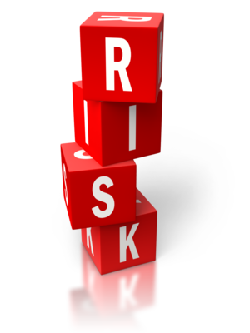
- The presence of strangers
- The presence of animals
- The safety of the play equipment
- Tripping hazards
- Presence of sharp edges
- Sand pits (if applicable)
- Water tables (if applicable)
- Sharp objects on the ground/in sand pits
- Animal waste on the ground/in sand pits
- Slippery surfaces
- Falls from high surfaces.
To deal with this, you should carry out an inspection of the site before you take the children and remove the hazards you spot. For those hazards that are beyond your control, you should set out control measures – you may need to bring an extra adult with you to help supervise the outing.

Risk assessment template
Excursion name |  |  | Location |  |  |  | Persons at risk
Tasks for excursion | Hazards | Risks | Risk rating |  |  |  | Control measures
Tasks for excursion | Hazards | Risks | Likelihood | Impact |  | Risk rating | Control measures
Risk assessment completed by:  Signature:  Date: |  |  |  |  | Risk assessment approved by:  Signature:  Date:

Risk Matrix

 | Impact
Likelihood |  | Insignificant | Minor | Moderate | Major | Severe
Likelihood | Almost certain | Medium | High | High | Very high | Very high
Likelihood | Likely | Medium | Medium | High | High | Very high
Likelihood | Possible | Low | Medium | High | High | Very high
Likelihood | Unlikely | Low | Low | Medium | Medium | High
Likelihood | Rare | Low | Low | Medium | Medium | Medium

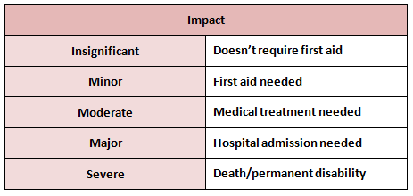
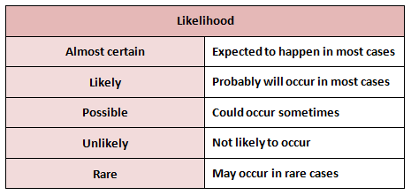

Activity 5C

6. Take precaution to protect children from harm
6.1. Ensure safety checks are consistently implemented and action is taken as a result of the checks
6.2. Check risk minimisation plans are in place for children enrolled at the service who have a specific health care need, allergy or relevant medical condition
6.3. Ensure simple warning signs are located where potentially dangerous products are stored
6.4. Confirm safety of any drinks, food and cooking utensils and appliances used as part of the program
6.5. Ensure that basic training and testing on how to move and fit car seats, restraints and booster seats (applicable to the age of relevant child) is available to all educators
6.6. Keep records of pest/vermin inspections and/or eradications
6.7. Develop and maintain a written process for monitoring who enters and leaves the premises at all times
6.8. Provide detailed information to families regarding any excursion being undertaken

6.1 – Ensure safety checks are consistently implemented and action is taken as a result of the checks

Safety checks
In relation to risk assessment, you must regularly assess the safety of the environment for children. Be aware that, just because the environment was safe last time children were there, it may not stay this way.
For example, there may be new objects in the area since you were last there. There may be external forces that have changed the nature of the environment.
For example, if you have a hard floor and have just mopped it, this has increased the risk of slipping.
The following is an example checklist that you can use to perform a safety check of the environment:
Check | Yes/no | Corrective action (if applicable)
Are there any slippery surfaces?
Are there exposed electrical outlets?
Are there loose wires?
Are there any tripping hazards?
Are there any sharp edges exposed?
Are there any sharp objects within children’s reach?
Are there any hazardous chemicals within children’s reach?
Is there any splintered wood?
Is there a fully-stocked First Aid kit on-site?
Are hygiene standards clearly displayed on the premises?
Are hygiene facilities clean?
Are hygiene products adequately stocked?
Are hazardous areas accessible to children?
Are fire exits clearly signed and accessible?
Are there smoke and carbon monoxide detectors on-site?
Are children in care tracked for entering and leaving the facility?
Do you have contact and emergency contact numbers for all children in care?
Are details of allergies recorded?
Are details of required medications recorded?
Is required medication well-stocked on-site?
Are low windows shut or guarded?
Are heating systems well ventilated?
Is sunlight and fresh air accessible in designated area?
Are there any choking hazards within reach of children?
Are open bodies of water accessible to children?
Are stairs or climbable objects accessible to children?
Is designated area obstructed from view?

Activity 6A

6.2 – Check risk minimisation plans are in place for children enrolled at the service who have a specific health care need, allergy or relevant medical condition

Risk minimisation plans
Risk minimisation plans are those which outline identified and unavoidable risks and detail the appropriate actions to take to minimise risks.
In the field of child care and early education, you will need to have risk minimisation plans in place for children with specific health care needs, allergies or relevant medical conditions.
The templates on the following pages can be used to create risk minimisation strategies for these children.
Name of service provider:
Name of guardian: |  | Phone number of guardian:
Name of child: |  | Date of birth:
Details of medical/health condition(s):

Action plan provided by guardian:
Medication required:

Contact details of guardians: | Name:  Relationship:  Home phone:  Work phone:  Mobile phone:  Address: |  | Name:  Relationship:  Home phone:  Work phone:  Mobile phone:  Address:
Emergency contact: | Name:  Relationship:  Home phone:  Work phone:  Mobile phone:  Address:
GP contact: | Name:  Phone:  Address:
Emergency First Aid/care procedures:

Storage details of medication:

Date of risk minimisation plan review:
Signature of parent/guardian |  | Date:
Signature of principal/carer: |  | Date:

Risk control template (for schools)
Student’s name:
Date of birth: |  | School level/year:
Triggers of condition:

Risk: | Control strategy: |  | Person responsible for strategy:

Activity 6B

6.3 – Ensure simple warning signs are located where potentially dangerous products are stored

Warning signs
It is important that warning signs are displayed by areas where potentially dangerous products are stored.
The following outline some basic warning signs and symbols you can use:
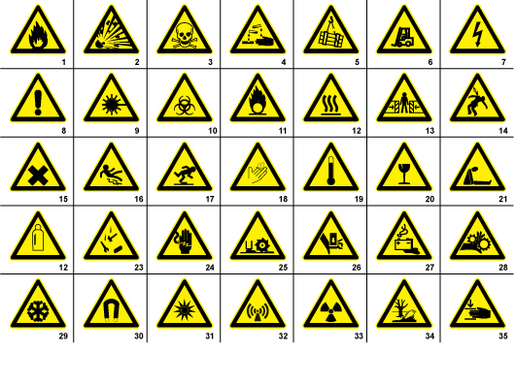
Source: https://signsanddisplays.wordpress.com
- Flammable materials sign or symbol
- Explosion risk sign or symbol
- Toxic sign or symbol
- Corrosive sign or symbol
- Overhead crane sign or symbol
- Fork lift in operation sign or symbol
- High voltage sign
- General warning sign or symbol
- Laser radiation sign or symbol
- Biohazard sign or symbol
- Oxidising sign or symbol
- Hot surface sign or symbol
- Entrapment risk sign or symbol
- Electrocution risk sign or symbol
- Irritant sign or symbol
- Slippery floor sign or symbol
- Watch your step sign or symbol
- Cutting risk sign or symbol
- High temperature sign or symbol
- Glass hazard sign or symbols
- Suffocation sign or symbol
- Gas bottle sign or symbol
- Falling objects sign or symbol
- Electricity sign or symbol
- Cutter sign or symbol
- Hand hazard sign or symbol
- Battery hazard sign or symbol
- Rotating parts sign or symbol
- Low temperature sign or symbol
- Magnetic field sign or symbol
- Optical radiation sign or symbol
- Non ionising radiation sign or symbol
- Radiation sign or symbol
- Environmental hazard sign or symbol
- Crushing hazard sign or symbol
Simple ‘do not enter’, ‘keep out’, ‘keep locked at all times’ and ‘keep out of reach of children’ signs are also useful when dealing with potentially dangerous products around children.

Activity 6C

6.4 – Confirm safety of any drinks, food and cooking utensils and appliances used as part of the program

Safety of any drinks, food and cooking utensils and appliances
All drinks, food and cooking utensils and appliances used as part of your program must be safe to use for both adults and children.
You need to be aware of cross-contamination issues when dealing with food and drinks, as well as the utensils and appliances used to prepare them.
Ensure that appliances are electrically tested and that they are out of reach of children. Make sure that carbon monoxide and fire alarms are fitted nearby all cooking station, in the event that a fire starts or there is a gas leak.
Ensure that cooking utensils and appliances are regularly cleaned, as they can be excellent places for harmful bacteria to congregate and multiply (especially when they have come into contact with raw food).
When cooking raw food, make sure any surfaces it comes into contact with are properly cleaned, as well as any skin and clothing that has come into contact with it, before you touch any other food. Ensure that raw food does not come into contact with other food also.
Ensure that the food and drinks you are using don’t contain any substances children (or staff) are allergic to. If you have a child who is allergic to one ingredient, yet other children are having food with this in, ensure you prepare the allergic child’s food separately, on cleaned surfaces, using cleaned utensils and hands – if possible, prepare the items in a separate area entirely.
For food and drink utensils, ensure that there are no sharp edges for small children and that they are cleaned – children must not share utensils between washes.
You should have special cutlery for small children – these are smaller (so easier to handle) and have rounded blades on the knife and fork, to minimise the risk of injury. Note that you may need to cut some food for children that cannot handle these utensils.

The following are food safety hygiene requirements, which you should adhere to when dealing with food:

Personal hygiene requirements
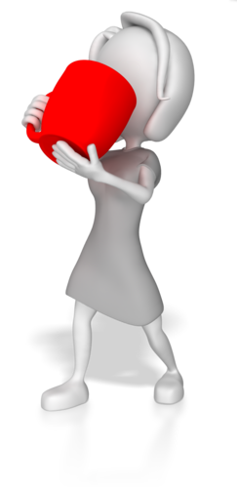
Minimum personal hygiene requirements are specified by the food safety program and must, at a minimum, meet legal requirements as set out in Food Safety Standard 3.2.2, Division 4:13 and/or state legislation/regulations. The Australia New Zealand Food Safety Standards Code sets out guidelines for working safely with food.
Section 3.2.2, Division 4:13 states specific food safety requirements for Australia as below:
“A food handler must take all reasonable measures not to handle food or surfaces likely to come into contact with food in a way that is likely to compromise the safety and suitability of food.”
Your hygiene requirements
When working with food, it is important that you are clean, your clothes or uniform are clean and appropriate, and that you work hygienically with food. Make sure that you wash regularly to avoid contamination of food and your workplace.
You may need to:
- Tie long hair back, or wear a hair net
- Remove all jewellery
- Remove false nails and eyelashes
- Remove all makeup
- Wear rubber gloves when handling some food products.

Further hygiene requirements
The below requirements will also be expected of you when working with food and should be strictly followed.
Personal hygiene requirements set out in Food Safety Standard 3.2.2, Division 4:15 include:
- “Taking all practicable measures to ensure that a food handlers body, and anything they are wearing does not contaminate food or surfaces
- Take all practicable measures to prevent contact with ready-to-eat food
- Level of outer clothing is appropriate for food handling
- Only waterproof bandages and dressings are used on exposed body parts
- Not eating over unprotected food or surfaces likely to come into contact with food
- Not sneeze, blow or cough over unprotected food or surfaces likely to come into contact with food
- Not spit, smoke or use tobacco or similar preparations in areas in which food is handled
- Not urinate or defecate except in the toilet
- Wash hands:
  - whenever hands are likely to be a source of contamination
  - immediately before working with ready-to-eat food after handling raw food
  - immediately after using the toilet
  - before commencing or recommencing food handling
  - immediately after smoking, coughing, sneezing, using a handkerchief or disposable tissue, eating, drinking or using tobacco or similar substances
- When washing hands:
  - use hand washing facilities provided
  - thoroughly clean hands using soap or other effective means, and warm running water
  - thoroughly dry hands on a single use towel or other way that is not likely to transfer pathogenic micro-organisms to the hands.”

Activity 6D

6.5 – Ensure that basic training and testing on how to move and fit car seats, restraints and booster seats (applicable to the age of relevant child) is available to all educators

Moving and fitting car seats, restraints and booster seats
You need to ensure that educators are trained in how to move and fit car seats, restraints and booster seats – therefore, you will need to provide access to basic training and testing.
More information on child car seats and the legal requirements can be found at: https://www.childcarseats.com.au
There is also a handy guide, produced by Which? that gives ten fitting checks, to ensure safety and efficiency of the seat: http://www.which.co.uk/documents/pdf/10-child-car-seat-checks-pdf-363028.pdf
You must ensure that:
- The seatbelt/harness is secure and untwisted
- Rearward facing seats have handlebars facing in the correct direction
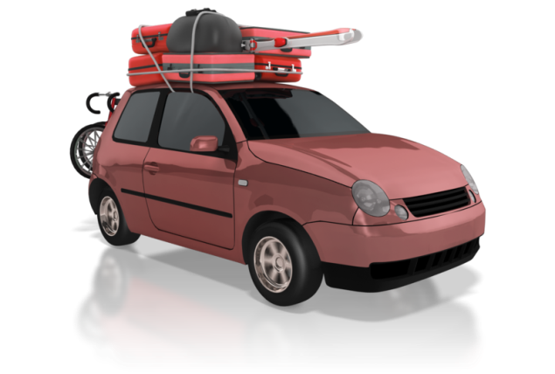
- The child seat is sitting squarely on the car seat
- The headrest is in the correct position
- The seatbelt follows the correct route guides
- The seatbelt buckle is in the correct place
- Isofix seat visual indicators show seat is correctly fitted to the car
- Isofix drop-down foot is securely on the floor
- Isofix top tether is firmly attached
- Thick clothes are removed on child in seat
- Shoulder pads are level with younger children’s shoulders
- Harness is not excessively tight or loose
- Seatbelt is across shoulder and hips for older children.

Where to fit child seats
Car seats should be fitted on a back seat in a rear-facing position – the middle seat is usually the best, if fitting allows.
If the car has side airbags, the child should be positioned correctly in the car seat and nor leaning close to or against the car window or door. You must never use a rear facing seat on a car seat that has a front airbag, unless the airbag has been deactivated – this is illegal and unsafe practice.

Types of child seat to use
Children must stay in a rear-facing child seat until they are six months old. However, you should ideally use a rear-facing seat for as long as possible, as this is the safest option.
A child has outgrown a seat when their eye-line is level with the top of the seat. At this point, you will need to upgrade to a larger one.
A forward-facing seat is suitable for children who can hold their heads up independently for at least 30 minutes.
Legally, these are the following requirements in Australia (not that these are different to regulations in other parts of the world):
- Up to six months – the child must be restrained in an approved rear-facing child restraint, specially designed for newborn babies e.g. an infant capsule or a convertible car seat
- Six months to four years old – the child must sit in a rear-facing or forward-facing child restraint, e.g. a child safety seat.
- Four years old to seven years old – the child must sit in either a forward-facing child restraint or a booster seat; they must be secured by a correctly adjusted and fastened seatbelt or child safety harness.
- Seven years old to 16 years old – the child must use a booster seat or a seatbelt, correctly adjusted and fastened.

National child restraint laws
- Children up to the age of six months must be secured in an approved rearward facing restraint
- Children aged from six months old but under four years old must be secured in either a rear or forward facing approved child restraint with an inbuilt harness
- Children under four years old cannot travel in the front seat of a vehicle with two or more rows
- Children aged from four years old but under seven years old must be secured in a forward facing approved child restraint with an inbuilt harness or an approved booster seat
- Children aged from four years old but under seven years old cannot travel in the front seat of a vehicle with two or more rows, unless all other back seats are occupied by children younger than seven years in an approved child restraint or booster seat
- Children aged from seven years old but under 16 years old who are too small to be restrained by a seatbelt properly adjusted are strongly recommended to use an approved booster seat
- Children in booster seats must be restrained by a suitable lap and sash type approved seatbelt that is properly adjusted and fastened, or by a suitable approved child safety harness that is properly adjusted and fastened.
Source: http://roadsafety.transport.nsw.gov.au/

Activity 6E

6.6 – Keep records of pest/vermin inspections and/or eradications

Records of pest/vermin inspections and/or eradications
In the event that you have pest/vermin inspections and/or eradications, you will need to document them.
The types of information required are:
- Date of inspection
- Areas inspected
- Pests/vermin discovered (if applicable)
- Site of infestations
- Methods of eradication
- Methods of pest/vermin disposal
- Use of any pesticides.
Pests/vermin should never be encouraged into your premises as, once they establish themselves, it can be hard to eliminate them. Pests/vermin can be attracted by food, and also the prospect of a safe home for nesting.

Keep pests/ vermin out of the workplace
Make sure you remove all food waste and rubbish each day and check that your premises are protected from pests/vermin regularly.

You will need to thoroughly clean floors and the places where food has been prepared and cooked within your workplace through the working day. Check for spillages of food stuffs in and around doors, fridges and store areas and make sure that any spills are cleaned to avoid attracting pests/vermin. Remember that most pests/vermin searching for food will have a far keener sense of smell and ability to locate food sources than humans. What may seem to be an insignificant amount of flour or crumbs in a storage area will be a veritable feast for pests/vermin.
Pests/vermin can include:
- Insects
- Arachnids
- Mice
- Rats
- Birds
- Any unwanted animal that can contaminate food or the workplace.

Pest-proofing the workplace
Your employer may need to place fine wire meshing across certain windows, check that all external pipe, guttering and ventilation does not allow easy access into the building, and that doors have suitable flashing to deter pests/vermin, or are self-closing. The addition of an internal fly-mesh door may also be useful.
Check to see if there are any small holes in brickwork and walls, both inside and outside. If there are, inform your supervisor/employer as these should be blocked to prevent access into the work area. Be vigilant and keep an eye out for any signs of pest/vermin activity within the workplace.

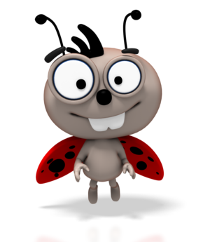
Signs of pest/vermin presence
Signs to look out for include:
- Animal droppings
- Gnawing or chewing of food packaging or equipment
- New holes within the workplace
- Visible sightings of pests/vermin
- Noise of pest activity within and around the work premises.
If you notice any signs of pests/vermin or any evidence of pest activity, you should report this to your supervisor immediately. Your supervisor will assess the risk and determine the best course of action for your place of work.
It may be that the pest problem can be sorted directly and quickly, without difficulty to the workplace. Alternatively, if the pests/vermin are not easy to eliminate or control, it may be that your employer will need to use a pest-control company to eradicate the problem.

Activity 6F

6.7 – Develop and maintain a written process for monitoring who enters and leaves the premises at all times

Monitoring who enters and leaves the premises
You will need to develop a process for monitoring people entering and leaving your premises.
This can be a simple sign in sheet that requires people to enter their details when leaving and entering the premises.
The below is a simple template you can use:
Name of child | Name of guardian/parent | Date | Arrival time | Signature | Departure time | Signature

This sign in sheet can be located at the entrance to the premises, with a pen attached.
This data will help resolve any attendance disputes and is useful for a roll call situation – for example, if there is an evacuation due to a fire.

Activity 6G

6.8 – Provide detailed information to families regarding any excursion being undertaken

Informing families of excursions
The excursions you intend to take children must be discussed in detail with parents and guardians.

You will need to inform them of details such as:
- Where you intend to go
- When you intend to go
- When you intend to return
- Methods of transport
- Reason(s) for the excursion
- The total amount of children on the excursion
- The amount of adults supervising the excursion
- Any risks/hazards that may occur
- Any clothing/equipment children will need to bring with them
- Cost of the excursion (if applicable).
If necessary, you should create a permission slip for parents and guardians to sign – this will be accompanied by a letter explaining all of the above. This ensures you are covered for liability and that parents/guardians are fully aware of the situation.

Example permission slip:
Your organisation’s address:

Date:
Dear parent/guardian,

Details of the excursion, including:
- Where you intend to go
- When you intend to go
- When you intend to return
- Methods of transport
- Reason(s) for the excursion
- The total amount of children on the excursion
- The amount of adults supervising the excursion
- Any risks/hazards that may occur
- Any clothing/equipment children will need to bring with them
- Cost of the excursion (if applicable)
I (name of parent/guardian) ………………………………… hereby give permission for (name of child)

………………………………………….. on (date of excursion) ………………………

Signature of parent/guardian: ………………………………………………….. Date: ………………………..
Signature of teacher/carer: ………………………………………………………. Date: ………………………..

Activity 6H

7. Develop plans to effectively manage incidents and emergencies
7.1. Ensure emergency procedures are displayed prominently throughout the premises
7.2. Make certain that all educators have ready access to a phone or similar means of communication
7.3. Ensure emergency numbers are located near telephones
7.4. Communicate information to families about the service’s emergency procedures and incident management plans
7.5. Discuss and practise emergency drills with children, educators and any other people on the premises
7.6. Ensure that emergency equipment is available and tested and staff are trained in the use of it
7.7. Maintain a portable record of children’s emergency contacts in case of emergencies

7.1 – Ensure emergency procedures are displayed prominently throughout the premises

Displaying emergency procedures
Emergency procedures may include:
- First Aid
- Fire evacuation.

Fire safety
In the event of a fire:
- Sound the fire alarm
- Gather all children from every room and proceed to the nearest Fire Exit and congregate at the Assembly Point – this should be as far from the building as possible
- A nominated person will check the building and close any doors (only leave doors open for bomb threats)
- Call the emergency services and ask for the Fire Services
- Take a register of all children and staff at the Assembly Point
- The person in charge will decide if the building is safe to re-enter, after consulting with the Emergency Services
- All details should be recorded in a Fire Log Book.
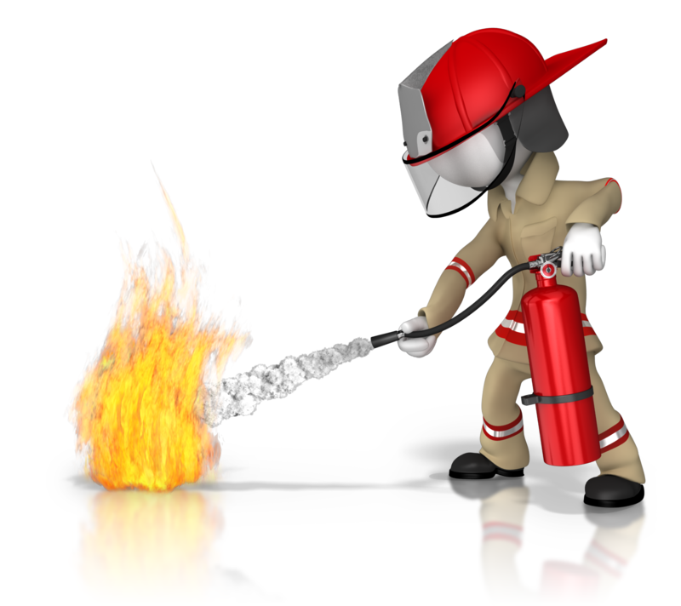

First Aid
In some instances, you may need to provide basic First Aid to children in your care. You will need to assess the casualty in this instance.
Assess the casualty
It’s important to be clear on whether a person needs help and what type of help is required, and then whether you can give it on your own, or if you need to call for emergency response services as well. Oftentimes, your first aid response can reduce the harm and discomfort that a casualty will experience before receiving help from a professional.
There are many situations that require first aid response from educators:

- Allergic reactions
- Anaphylaxis
- Asthma
- Basic wound care
- Severe bleeding
- Burns
- Cardiac arrest
- Choking and airway obstruction
- Convulsions, including febrile convulsions
- Envenomation (using pressure immobilisation)
- Epilepsy and seizures
- Fractures, sprains and strains (using arm slings, roller bandages or other appropriate immobilisation techniques)
- Head injuries
- Poisoning
- Respiratory distress
- Shock.
Full details of First Aid procedures can be found in unit HLTAID004: Provide an emergency first aid response in an education and care setting.
The procedures for both fire safety and First Aid should be prominently displayed to staff, so they can easily be referred to when needed.

Activity 7A

7.2 – Make certain that all educators have ready access to a phone or similar means of communication

7.3 – Ensure emergency numbers are located near telephones

Phoning in emergencies
Educators should have ready access to a phone on the premises – this is to be used to phone in emergencies and to contact parents, when necessary.
Emergency numbers should be located near telephones. This includes the emergency services number (000), for Police, Fire and Ambulance services. You should also have the emergency contact numbers of parents and guardians for all of the children in your care.
It is a good idea to have emergency numbers displayed on a sign and to keep a book of all emergency guardian contacts next to the phone, as this means easy ac cess when required.

7.4 – Communicate information to families about the service’s emergency procedures and incident management plans

Communicate emergency information to families
Families should be made aware of the service’s emergency procedures and incident management plans.
This can be done in a letter that you send out to all families and can also be displayed on your organisation’s website, if you have one.
The type of information you need to communicate about emergency procedures includes:
- What the procedures are
- When they will need to be used
- What incident management plans are.
Incident management plans outline the identification, analysis and correction of hazards, in order to prevent future reoccurrences.
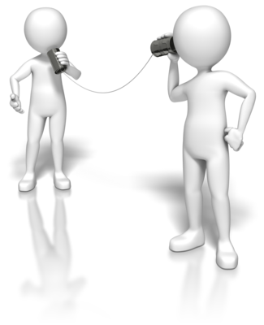

Activity 7B

7.5 – Discuss and practise emergency drills with children, educators and any other people on the premises

7.6 – Ensure that emergency equipment is available and tested and staff are trained in the use of it

Emergency drills
You will need to discuss and practice emergency drills with children, educators and any other people on the premises. This will ensure they are competent in the event of an actual emergency, which will minimise the risk.
The Building Fire Safety Regulation 2008 requires one fire drill to be conducted per year – however, once per term at a school is a good guide. These fire drills should be kept as realistic as possible, so as to create the best preparation environment possible.
As mentioned previously, the procedure for fire drills is as follows:
- Sound the fire alarm
- Gather all children from every room and proceed to the nearest Fire Exit and congregate at the Assembly Point – this should be as far from the building as possible
- A nominated person will check the building and close any doors (only leave doors open for bomb threats)
- Call the emergency services and ask for the Fire Services
- Take a register of all children and staff at the Assembly Point
- The person in charge will decide if the building is safe to re-enter, after consulting with the Emergency Services
- All details should be recorded in a Fire Log Book.

Emergency equipment

The emergency equipment required to deal with actual emergencies should be on-site and tested, with all staff trained in its use.
Types of emergency equipment include:
- Fire extinguishers:
  - powder
  - water
  - foam
  - CO2, for electrical fires
- Fire blankets
- First Aid kit.
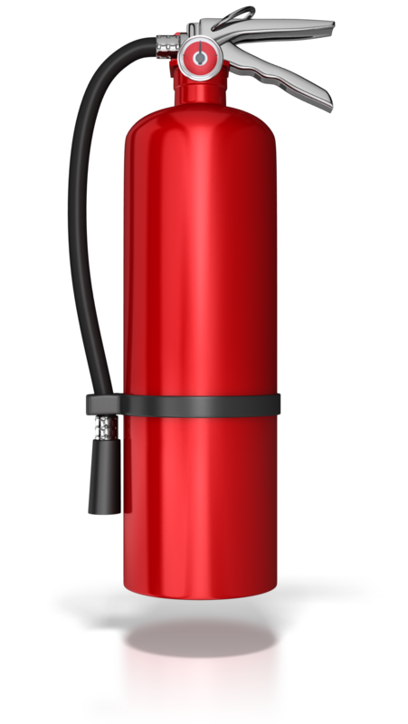
When using any emergency equipment, always ensure you read the instructions and follow them exactly.
Fire extinguishers
Fire extinguishers should be placed away from heaters or fires, fixed on a wall where it is out-of-reach of children. They should be serviced once a year, or according to manufacturer’s recommendations.
You should always operate a fire extinguisher on the escape route side of the fire.
Fire blankets
These are used to cover fires and cut out their source of oxygen, or to wrap around people whose clothes are alight.
To use them, you need to get close to the fire, so there is a risk of burning; therefore, they should only be used on small, contained fires, such as chip pan fires.
Be aware that, once the blanket has been placed over the fire, you cannot retrieve it if you fail to extinguish the fire.
Storage instructions are the same as for fire extinguishers.
Sprinklers
You can fit sprinklers in your premises if you wish – these will severely limit the risk of death from fire.
They are heat activated and can be fitted in as many rooms as you wish, with operation automatic and an alarm sounding during their activation.

Activity 7C

7.7 – Maintain a portable record of children’s emergency contacts in case of emergencies

Maintain a portable record of children’s emergency contacts
As previously mentioned, children’s emergency contacts should be recorded on your premises.
It is also a good idea to keep a portable record of this information – for instance, this will be useful to take with you on excursions and use if there are any emergencies.
This portable record can be kept in a small phone book or a sheet of paper, depending on how many children you have in your care.
The information you need to know will be the name, phone number, relation and address of the emergency contact.

Ensure that emergency contacts are kept up-to-date and that you give parents and guardians regular prompts and opportunities to update these, especially before excursions and high risk activities.

Skills and Knowledge Activity

Nearly there...

Major Activity – An opportunity to revise the unit

At the end of your Learner Workbook, you will find an activity titled ‘Major Activity’. This is an opportunity to revise the entire unit and allows your trainer to check your knowledge and understanding of what you have covered. It should take between and 1-2 hours to complete and your trainer will let you know whether they wish for you to complete it in your own time or during the sessions. Once this is completed, you will have finished this unit and be ready to move onto the next, well done!

Congratulations!
You have now finished the unit ‘Establish and maintain a safe and healthy environment for children’.


References

These suggested references are for further reading and do not necessarily represent the contents of this Learner Guide.

Best Practice Guideline for the Planning and Development of Child Care Facilities: https://www.google.co.uk/url?sa=t&rct=j&q=&esrc=s&source=web&cd=2&cad=rja&uact=8&ved=0CCcQFjAB&url=http%3A%2F%2Fdocs.education.gov.au%2Fsystem%2Ffiles%2Fdoc%2Fother%2Futs-clg-final-report.docx&ei=JhFsVf7qNYi9swHc5YKACA&usg=AFQjCNFPZW4SVaWsiBF_M5Pzam1Rr3oW-g&bvm=bv.94455598,d.ZGU
Education and Care Services National Law Act 2010: http://www.legislation.vic.gov.au/Domino/Web_Notes/LDMS/PubStatbook.nsf/51dea49770555ea6ca256da4001b90cd/B73164FE5DA2112DCA2577BA0014D9ED/$FILE/10-069a.pdf
Guide to the Education and Care Services National Law and the Education and Care Services National Regulations 2011: http://files.acecqa.gov.au/files/national-regulations/NQF02%20Guide%20to%20ECS%20Law%20and%20Regs_web.pdf
Health & Safety in Children’s Centres – Model Policies & Practices: http://www.community.nsw.gov.au/docswr/_assets/main/documents/childcare_model_policies.pdf
Hygiene in child care: http://ncac.acecqa.gov.au/family-resources/factsheets/hygiene.pdf
Links to child care-related information: http://www.australia.gov.au/topics/family-home-and-community/child-care
North Sydney Development Control Plan – Section 5: Child Care Centres: https://www.google.co.uk/url?sa=t&rct=j&q=&esrc=s&source=web&cd=3&cad=rja&uact=8&ved=0CC0QFjAC&url=http%3A%2F%2Fwww.northsydney.nsw.gov.au%2Ffiles%2F5bc15a2b-ed92-4b9b-862a-a23600f2208e%2FPart_B_Section_5_-_Child_care_centres.pdf&ei=JhFsVf7qNYi9swHc5YKACA&usg=AFQjCNGAoWayODhrYgSrFsOb1s5Uj7MUMg&bvm=bv.94455598,d.ZGU
Sample forms and templates: http://www.acecqa.gov.au/sample-forms-and-templates-now-available
The National Quality Standard: http://www.acecqa.gov.au/national-quality-framework/the-national-quality-standard

All references accessed on and correct, as of 25/6/15, unless other otherwise stated.

