CPCCBC4018
Apply site surveys and set-out procedures to building and construction projects

ASSESSMENT SUMMARY

The assessment activities for CPCCBC4018 Apply site surveys and set-out procedures to building and construction projects cover all aspects of the unit of competency. For Apprentices/Trainees, this includes supervisor completion of the Apprentice/Trainee Record (ATR).

Participants must read all the information given before starting any assessment task. The assessment tasks are intended to be fair, flexible, valid and reliable. If a Participant has any questions or requires alternative arrangements to be made such requests should be directed to their Trainer/Assessor, who should note such arrangements in the ‘Assessor Comments’ on the affected assessment. If a Participant feels they are not yet ready to be assessed, they should discuss their options with their Trainer/Assessor.

To satisfactorily complete the assessment, the Participant is required to answer all questions correctly and demonstrate their skills to industry standards. If a Participant does not answer all questions or perform all tasks, they will be deemed ‘Not Satisfactory’ for the task and ‘Not Yet Competent’ for the unit of competency.

The Trainer/Assessor can provide the Participant with additional information on interpreting the assessment outcomes and guide the Participant’s options. If a Participant is still deemed ‘Not Satisfactory’ they will have the opportunity to undertake a supplementary assessment or appeal the result as per the process in the Student Handbook.

By signing below, the Participant acknowledges:
- They understand the assessment instructions and requirements, and consent to being assessed.
- The work submitted is to be their own work – with the work of/with others needing to be clearly acknowledged and documented.
- They consent to any photo/video recording of their work that occurs during assessment.

Participant name | RHYS HOLMES – YASSO
Participant signature | 

Pre-requisite unit(s) to be achieved and authenticated prior to undertaking assessment
Not applicable

Task | Date completed | Assessment Results
Theory Exam | Select Date. | Satisfactory | Not Satisfactory
Workbook | Select Date. | Satisfactory | Not Satisfactory
Practical Assessment | Select Date. | Satisfactory | Not Satisfactory
Outcome for CPCCBC4018 | Select Date. | Competent | Not Yet Competent

Evidence requirements checklist (ticked by assessor and evidence supplied to RTO)
Theory Exam  Workbook | Practical Assessment  Booking sheet  Topographic contour plan from grid lines  Calculations sheets

Assessor name
Assessor signature

CPCCBC4018
Apply site surveys and set-out procedures to building and construction projects

THEORY EXAM

Participant name | RHYS H. YASSO

FOR THE PARTICIPANT
Instructions
- You will complete written questions as outlined on the following pages. You must attempt all questions and provide enough detail in your responses to demonstrate your knowledge.
- It is anticipated that you should complete this assessment within two (2) hours, but additional time may be allowed upon negotiation with the Assessor.
- You must complete all questions unassisted by the Assessor or other personnel but may refer to reference material as needed. All questions must be answered correctly for a ‘Satisfactory’ assessment outcome to be awarded.
  - An oral examination may be allowed under certain circumstances, whereby your answers will be documented by another party.
  - Any written questions that are incomplete, or not answered satisfactorily will need to be completed again after further training support.
    - If you answer a question incorrectly but modify your response, put your initials next to the written change (or the Assessor must initial a verbal change).
Resources required
Pen

FOR THE ASSESSOR
Instructions
- Where oral examination has occurred, ensure that this is acknowledged in writing (e.g. FT001 and Assessor Comments)
- All questions must be satisfactorily demonstrated by the Participant for a Satisfactory determination (indicated by an Assessor tick to the right of the question).
- Assessors are to complete marking in pen of a different colour to the Participant.
- If the Participant verbally modifies their response, write in the modified response verbatim and put your initials next to the written change.

ASSESSOR COMMENTS
As necessary, outline:
- Details on reattempts, alternative arrangements or reasonable adjustments made.
- Where a Participant is deemed ‘Not Satisfactory’, provide recommendations for future training.

- Explain why we should determine the orientation of the building according to the plans.

Answer | Understanding the orientation of the building from plans prior to construction commencing, ensures that the direction of the building is correct, it’s safe orientation from an environmental perspective (safe from dust, smoke, wildlife, or cultural boundaries), and can also add aesthetics to the building. If the building has in the instalment of sola, correct orientation will can align with the sun’s path and maximise energy loads.

- Discuss the information you can source from the specifications.

Answer | This information can consist of all specific information relating to details within a plan/drawing that can’t be shown on the plan itself. This can include details such as the tools, materials that are required to be used, or details regarding work environments, environmental and safety requirements. Attaining this information can be vital, especially when working under project guidelines that require each specification requirement to be strictly met pending on an organisation. Without specifications for a building project, contract documentation would not be completed, and builders would not have sufficient information to commence the construction project.

- The construction project must comply with the National Construction Code (NCC). What does this mean.

Answer | To comply with the NCC you are following the requirements that all building products and materials are ‘fit for purpose’ under the code. These products and materials to be used, must be identified to building regulators to ensure compliance and conformance. Having this evidence can determine whether the construction project meets the performance requirements or DTS Provision. During the identification process there are several Assessment methods that can be utilised. These would include verification methods such as tests, calculations, inspections, or other engaging relevant Authority to ensure they are within compliance. However, they are other aspects that the NCC consist of that Construction projects must cover such as, reference documentation, the classification of buildings that are being construction, and the acceptance of the designs and constructions with evident documentation.

- Describe the principles of establishing control during set-out surveys.

Answer | Main principle is by setting control points during your survey. These can be established by the use of electronic surveying instruments or using GPS, with these control points they can be marked on the ground using either paint, markers or metal pins installed into the ground – Once a pin has been established this becomes a reference point.

- What is linear measurement in surveying?

Answer | Linear measurement is a measurement of length. Linear measurement is implemented through Surveying in different methods, including electromagnetic, optical and fieldwork direct methods. Attaining linear measurements within surveying is generally used by different instruments and equipment (e.g Passometer’s, Pedometers or even pacing certain distances) for an example using linear measurements using a simple method as pacing is walking from one point to another, attaining the total distance will give you the linear measurement.

- Provide two (2) examples of surveying that uses linear measurements.

Answer  1.  2. | 1. Traverse Surveying  2. Chain Surveying

- Listed below are principles of linear measurement for small surveys. Briefly explain what each principle means.

Answer | Principle | Explanation
 | Working from whole to the part | “Treat the area as a whole, then break it down into several triangles rather than the reverse”
 | Form well-conditioned triangles | “Form angles preferably between 30 degrees and 120 degrees. Aim for equilateral digues, based on at least one long backbone line”
 | Economy of lines | “Use as few measured lines as necessary, while avoiding obstacles and steep slopes, but using sufficient check lines to minimise errors”

- Listed below are two (2) methods of linear measurements. Briefly explain each.

Answer | Type of linear measurement | Explanation
 | Direct method | Direct methods are generally done on a worksite / work area, conducting work within the field using methods such as chain surveying, measuring tapes or pacing distances.
 | Optical method | Optical methods are generally the use of electronic equipment to calculate the survey. (Computerized meter’s)

- What is horizontal angular measurement in surveying?

Answer | This form of measurement is the calculation of the total angle (degrees) made by two lines measured horizontally.

- Why are the linear and angular measurements necessary in surveying?

Answer | As surveying revolves around specific location/points using this measurement methods assists in calculating accurate measurements, angles and length of each line/point both in the horizontal and vertical plane.

- Why is it relevant to have knowledge of geometry when conducting surveying activities?

Answer | Having a general understanding of geometry helps with the understanding of relations and properties of lines, points, and surfaces. Generally, all surveying methods and measures come from the principles of geometric measurements.

- Why is it relevant to have knowledge of trigonometry when conducting surveying activities?

Answer | Trigonometry is based around the relationships between the angles and sides of the triangles. Trigonometric formulas, functions and principles are implemented in surveying when located points in different elevations, and angles of land (Surveying high slops, mountain tops, bridges)

- What components are needed when using an optical level and how are these used?

Answer | When using an optical level, you are to set up based of the established level point (specific point). These levels are consistently used in Construction during site work to measure differences in height, measure, transfer heights or set heights of known marks. The level itself requires the precision telescope mounted on top of the tripod to be set on the desired point.

- What is the difference between a dumpy level and a theodolite?

Answer | The dumpy level is restricted to only being used for vertical measurements, where as the theodolite can be operational as both vertical and horizontal measurements. Theodolites also have the ability to auto level with high accuracy.

- Describe a two-peg test.

Answer | A two-peg test can be conducted using a dumpy level and it is conducted to tell you the measurement that your level is out over the distance you test over (if showing error’s, it will need to be recalibrating and serviced by a qualified person(s). Firstly, measure out an exact distance on ground (e.g 80m), once measured out place a timber stake/marker/pin at each end of the 70m line. Once acquiring your dumpy level place this exactly in halfway of the 80m line (40m in from the stakes). Secure and level your dumpy level for an accurate reading then proceed to attain a staff and a secondary person for to assist your recordings after setting your dumpy in an alternate position along the line. Two-Peg tests can also be done remotely for calculations electronically (Two Peg Test online calculator).

- Discuss benefits of using electronic distance measuring (EDM) equipment.

Answer | Other then the instruments being highly dependable, they can also record measures up to 100 kilometres long. Being an electronic device this lowers the work load of manual labour while performing surveying works, as horizontal and vertical angles and distances are measured automatically, then recording can then be downloading through programs/applications with high percentage of accuracy.

- Identify one operational and one functional feature for each of the levelling and surveying devices listed below.

Answer | Device | Operational features | Levelling features
 | Laser level: manual-levelling laser | The operator will have to manually align the level by fixing the thumb screws to a point. | The design of the laser allows it to be accessible within contours of pipe and conduits.
 | Laser level: dot laser levels | Projects two, three or five beams of light. | Allows the user to establish a point from floor to ceiling.

- Describe features of the water level.

Answer | A water level consists of using liquid water, with other materials such as stakes and clear tubes to establish a horizontal plane of reference. Generally, the tube is 5/16 in diameter and can be 50 to 100ft long. TO help gain a better visual on the water level, 1 or 2 drops of food colouring is often used. Once the water has been poured into the tube and stakes have been set at each point of height, the water will then level, and you’ll be able to set your mark on each stake.

- You are responsible for checking levels in an excavation.
From the drawings for the job you know the floor level is RL 12.000. The floor of the excavation is level (0% grade).
You find a peg, which identifies the RL as 14.50.
The plane of collimation measures 0.65m above the peg.
On what level would you set the receiver on the stave to achieve the desired FL of the excavation? Show your calculations.

Answer | To determine the level at which you should set the receiver on the stave to achieve the desired finished floor level of the excavation, you need to consider the difference in RL between the established peg and the desired FL, The difference in RL =PEG RL – FL. Difference in RL = 14.50 – 12.000 = 2.50.  Now since the plane of collimation is 0,65m above the peg, you need to subtract this height to find the level at which to set the receiver on the stave.  Receiver Level = Peg RL – Plane of collimation  Receiver Level = 14.50 – 0.65 = 13.85  So, to achieve the desired finished floor level of the excavation, you should set the receiver on the stave to RL 13.85.

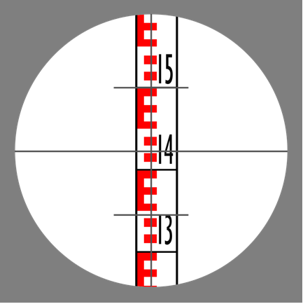
- Using the picture above, what distance is the staff from the instrument? Show workings.

Answer | The staff starts at Zero, on the ground. Every 10cm is a number showing(in meters to on decimal the height of the bottom of what appears to be a stylised E (even numbers) or 3 odd numbers, 5cm high. . The stems of the R or 3 and the gaps between are each 10mm high.  Distance 1.420m high.

- Discuss errors in measured distances due to site characteristics and measurement methods.

Answer | Errors in measured distances can arise from various factors, including site characteristics and measurement methods. Site-Specific challenges may include uneven terrain, obstacles, materials & equipment, and atmospheric conditions affect the accuracy of measurements. Measurement methods such as the use of outdated equipment or incorrect calibration can introduce systematic errors. Additionally, human errors, like misalignment or interpretation can also cause inaccuracies.

- Discuss the purpose of setting out gridlines for the construction project.

Answer | Setting out gridlines assist in the view understanding the outline of primary structural elements of a building within a plan. Having these established gives the reader a greater understanding of scale, main points and helps visualize the building itself and its dimensions. Grid lines are used in section views, plan views, and story level views.

- Discuss situations where you need to draw up a contour plan.

Answer | Contour plans will need to be drawn up when a plan is required to show features on mountains, lakes, rivers etc. Understanding contour plans gives you a visual representation of if the elevation is steep or shallow and gives you an indication of the scale of the feature. (e.g the heights and scale of the mountain shown within the contour plan)

- When do you draw longitudinal sections from RLs.

Answer | These are to be provided for all planned stormwater drainage lines, typically to show the vertical relationship between the designed and existing surfaces. When during the longitudinal sections within the plan these must be compliant with the Australian Height Datum at the same horizontal scale as the plan view.

- How do you determine the tolerances when determining levels and clearances from given grades for underground pipework?

Answer | All clearances from given grades for underground pipework will have to be compliant with The Plumbing Code of Australia, being accord with AS/NSZ 3500 for the plumbing industry. Referring to these standards will give you the information required to ensure that all specified tolerances are met.

- How do you calculate elevation slope as a decimal or a percentage?

Answer | The rule of thumb when calculating change in elevation slope as a decimal is the change in vertical distance divided by the change in horizontal distance – Or also referred to ‘Rise over Run’. To calculate the percentage will be following the same formula then multiply your answer by 100.  (e.g 1,000 divide 2,000 = 0.5 then 0.5 x 100 = percentage of slope.

- How do you calculate elevation slope in degrees?

Answer | Calculation of elevation slope in degrees can be done using a calculator with the following formula. The number of your elevation gain (i.e 1,000ft) as the Rise, and the horizontal distance being (i.e 1,000ft) as the run.  Press the INV button which calculates the inverse of the value.  Then followed by the TAN button which establishes a number for an angle  = your elevation slope in degrees..

CPCCBC4018
Apply site surveys and set-out procedures to building and construction projects

WORKBOOK

Participant name | Rhys H Yasso

FOR THE PARTICIPANT
Instructions
- You will complete written activities as outlined on the following pages. You must attempt all questions and provide enough detail in your responses to demonstrate your knowledge.
- The timeframe for these tasks will be established by your Assessor or Training Plan, but additional time may be allowed upon negotiation with the Assessor.
- You must complete all questions unassisted by the Assessor or other personnel but may refer to reference material as needed. All questions must be answered correctly for a ‘Satisfactory’ assessment outcome to be awarded.
  - An oral examination may be allowed under certain circumstances, whereby your answers will be documented by another party.
  - Any written questions that are incomplete, or not answered satisfactorily will need to be completed again after further training support.
    - If you answer a question incorrectly but modify your response, put your initials next to the written change (or the Assessor must initial a verbal change).
Resources required
Pen

FOR THE ASSESSOR
Instructions
- Where oral examination has occurred, ensure that this is acknowledged in writing (e.g. FT001 and Assessor Comments)
- All questions must be satisfactorily demonstrated by the Participant for a Satisfactory determination (indicated by an Assessor tick to the right of the question).
- Assessors are to complete marking in pen of a different colour to the Participant.
- If the Participant verbally modifies their response, write in the modified response verbatim and put your initials next to the written change.

ASSESSOR COMMENTS
As necessary, outline:
- Details on reattempts, alternative arrangements or reasonable adjustments made.
- Where a Participant is deemed ‘Not Satisfactory’, provide recommendations for future training.

NOTE

At times, you will be provided with a specific context to which you must respond, otherwise it is anticipated that you will use a workplace of your choosing (your own, or hypothetical) to provide the context to the task.

At all times, the responses in your assessment must reference Australian (Queensland or Federal) documentation, including legislation, regulations, codes of practice, standards and guidance publications.

Access and review the working drawings and specifications contained in the project plan below:
Case Study: Curtin, Australian Capital Territory

Answer the following questions:
- What is the size of the land?
- What is the size of the house, excluding the garage and laundry?
- How many bedrooms does the house have on the ground floor?
- Based on the working drawings, in which cardinal direction is the terrace oriented?
- What was used to replace bricks that were removed?

- What is the size of the land?
825m²
- What is the size of the house, excluding the garage and laundry?
185m²
- How many bedrooms does the house have on the ground floor?
Two Bedrooms
- Based on the working drawings, in which cardinal direction is the terrace oriented?
East side of the house design
- What was used to replace bricks that were removed?
Reconstituted timber weatherboards

Satisfactory Outcome

Review the plans and elevations linked below and answer the questions that follow.

YourHome Design For Place - 3BR + Study All plans and elevations

For the purpose of this assessment, this case study scenario is based in your state/territory.
- What is the building classification for this project?
- In which volume of the NCC 2019 can you find the building codes and standards for this building classification?
- What climate zone is applicable to your work area according to the NCC? Specify your state/territory for your assessor’s reference.
- List state/territory laws used in your state/territory as reference in determining the additions to these building codes.

- What is the building classification for this project?
Class 1 Building
- In which volume of the NCC 2019 can you find the building codes and standards for this building classification?
NCC 2019 Volume 1 Part A6
- What climate zone is applicable to your work area according to the NCC? Specify your state/territory for your assessor’s reference.
Queensland:
Climate Zone 2
- List state/territory laws used in your state/territory as reference in determining the additions to these building codes.
“class 1a building means a building that, under the 2004 edition of the BCA, is classified as a class 1a building.” Quoted from Queensland Legislation. (Queensland Building Act 1975)
Ref: https://www.legislation.qld.gov.au/view/whole/html/inforce/current/act-1975-011

Satisfactory Outcome

Determine the value of x in each of the following trigonometric problems. Calculators are permitted.

- Answer:
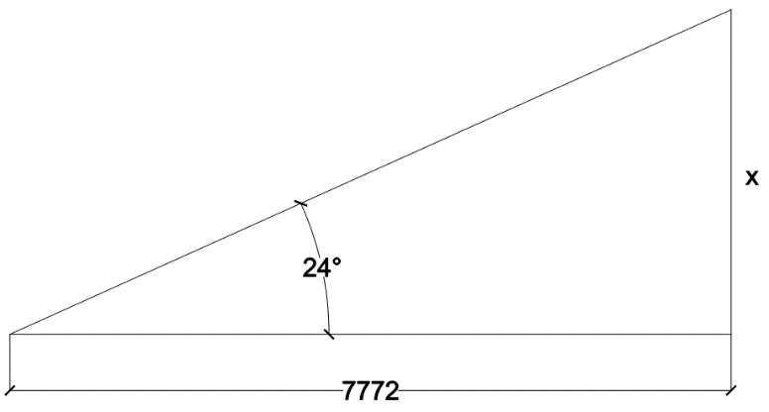
- Answer:
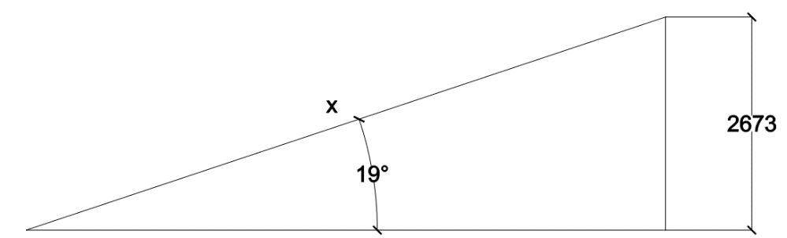
- Answer:
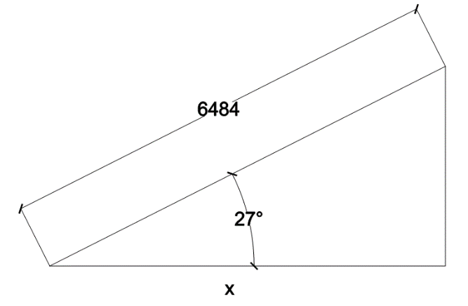

Satisfactory Outcome

Show all working out and calculations.
a)
TAN24 =x/7772
= (x) 3,460.

b)
SIN19 = 2673/x
X = 2673/SIN19
= 8,210.26

c)
COS27 = x/6484
X = 6484xCOS27
= 5777.28
- Using the grid pattern below, complete the table to calculate how much soil is needed to be removed from the highlighted section of the grid (represents the intended building) to a given RL of 11.000. Grid measurements = 5m x 5m. (first row has been completed for you)
- Suggest a new RL for the site that will require no spoil removal, only cut and fill.

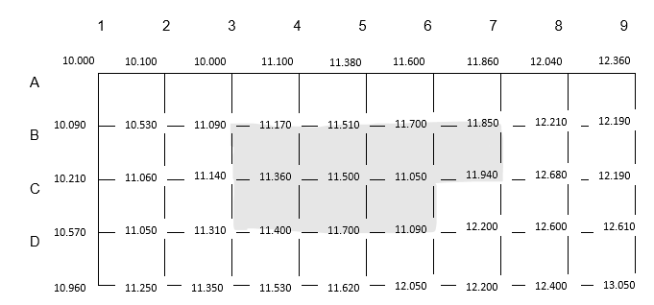

Volume of excavation- Grid method |  | Formation level RL | RL =11.000
Ground level | Corner Height “H” | No. of Squares occurring “N” | Product H & N
B3 | 11.009 -11.000 = 0.090 | 1 | 0.090
Volume = | Grid x Grid x Total Product ÷ 4
- Calculate how much soil is needed to be removed from the highlighted section of the grid (represents the intended building) to a given RL of 11.000. Original grid measurements = 5m x 5m.
- Suggest a new RL for the site that will require no spoil removal, only cut and fill.

Satisfactory Outcome

CPCCBC4018
Apply site surveys and set-out procedures to building and construction projects

PRACTICAL ASSESSMENT

Participant name | Rhys Holmes – Yasso

FOR THE PARTICIPANT
Instructions
- The tasks outlined on the following pages will require performance of normal workplace activities, as a result of a structured activity set by an Observer in the workplace or a simulated activity set by your Assessor/Observer.
- The timeframe for these tasks will be established by your Assessor/Observer, in consideration of location conditions and industry requirements.
- You must complete all tasks unassisted by the Assessor or other personnel, unless the steps note this assistance.
- You must attempt all tasks (and itemised steps) for a ‘Satisfactory’ assessment outcome to be awarded.
  - For any observation conducted that is incomplete, or without satisfactory performance, the observation will need to be completed again after further training support.

FOR THE ASSESSOR/OBSERVER
Instructions
- The following observation record should be used to judge and record your observations of the Participant as they complete the task(s) set. You must record your observations of the Participant’s performance.
  - For each occasion, indicate the task performed and whether it was a simulation or workplace-based task.
    - Any simulated assessment must ensure the Participant still performs under workplace conditions which reflect industry standards.
  - In the comments, provide clear detail regarding the task that the Participant was required to do (e.g. PPE used, materials handled, attachments connected, plant types).
- All steps must be satisfactorily demonstrated by the Participant for a ‘Satisfactory’ determination (indicated by an Assessor tick to the right of each itemised step, or an Observer tick to the right of each itemised step, and confirmation by an Assessor in the Assessor Comments).
  - Where you have determined that one or more task steps have not been satisfactorily demonstrated, provide the Participant with additional support and outline details of such assistance in the Assessor/Observer Comments. Allow the Participant two (2) further opportunities to demonstrate the task again to allow an opportunity for a ‘Satisfactory’ assessment outcome to be achieved.
  - If after three (3) attempts the Assessor determines that the Participant cannot demonstrate the required steps, a ‘Not Satisfactory’ outcome is to be determined.

TASK OUTCOME
Task | Date | Task Type (Tick) | Location | Task outcome (Tick)
 |  |  |  | Satisfactory | Not Satisfactory
Task 1 (Occasion 1) | Select Date. | Workplace  Simulation

ASSESSOR COMMENTS: GENERAL
As necessary, outline:
- Details on reattempts, alternative arrangements or reasonable adjustments made.
- Where a Participant is deemed ‘Not Satisfactory’, provide recommendations for future training.

ASSESSOR COMMENTS: PRACTICAL TASK 1: OCCASION 1
Individual student (as named on cover page)
Multiple students [ All from Attendance Report, Specific students involved – identify students]
Task | Provide detail
1.1A. | Specify how participant identified current plans:
1.1B. | Specify() surveying device collected and operated:  Electronic distance measuring (EDM) equipment Laser level: manual-levelling laser  Laser level: dot laser level Optical (Dumpy) level Water level Theodolite Other (please specify):
1.1B. | Specify() levelling device collected and operated:  Electronic distance measuring (EDM) equipment Laser level: manual-levelling laser  Laser level: dot laser level Optical (Dumpy) level Water level Theodolite Other (please specify):
1.1D. 1.1E. 1.1F. | Specify site RL calculations were made:
1.1G. | Specify errors explained due to site characteristics:
1.1H. | Specify() digital tools operated to communicate with others:  Mobile phone UHF/ 2-way PC via intranet PC or mobile for email  Other (please specify):
1.3A. 1.3B. 1.3C. 1.3D. 1.3E. | Specify drainage and pipeline situations where calculations were made to determine grades.
CPCCBC4018
Apply site surveys and set-out procedures to building and construction projects

Practical Task 1
Description of task:
This assessment applies to National Construction Code (NCC) classifications:
- Residential - Class 1 and 10 buildings, maximum two storeys
- Commercial - Class 2 to 9, Type C only constructions

The participant must demonstrate the skills and knowledge to correctly apply site surveys and set-out procedures to a residential or commercial building on site. Demonstration must include:
- Prepare for and conduct site set-out.
  - Locate, read and adhere to the current plans and site set-out procedures.
  - Select and operate one surveying and one levelling device in accordance with SOPs (copy of booking sheet required as evidence).
  - Check accuracy of instrument by conducting a ‘two peg test’.
  - Carry out reduction in a closed level run by rise and fall method (copy of booking sheet required as evidence).
  - Carry out reduction in a closed level run by height of plane collimation (HPC) method (copy of booking sheet required as evidence).
  - Calculate accurate staff readings to enable a specific reduced level (RL) set-out.
  - Identify and explain errors in measured distances due to site characteristics and measurement methods.
  - Use digital tools to communicate with others.
- Develop a contour grid.
  - Determine set-out grid and levels.
  - Prepare a topographic contour plan from grid levels to specified tolerances and stated contour intervals (copy required as evidence).
  - Determine surface area being levelled and calculate cut and fill volumes.
  - Calculate and record trigonometric and geometric calculations commonly used with grid lines, off sets and right-angle triangles without error (copy of calculations required as evidence).
  - Calculate cut and fill quantities including: (copy of calculations required as evidence).
    - area and volume of land to be levelled.
    - area of land to be filled.
    - volume of fill required.
- Determine grades and levels
  - Draw longitudinal sections from RLs.
  - Determine levels and clearances from given grades and distances to specified tolerances.
  - Express calculation angles, percentages and run ratios in grades.
  - Determine calculations for batter levels from grades and distances.
  - Construct longitudinal sections and determine associated grades and levels in typical drainage and pipeline situations.

These tasks may be simulated or real. The Participant is to gather evidence of how they have completed each component of the Practical Task, which is to be submitted with this Practical Assessment sheet. The Observer is to provide detailed comments on the tasks completed by the Participant (on the Observer Comments, overleaf). The Assessor is to verify the Observer’s comments, noting their findings in the Assessor Comments (on the back of the Practical Assessment cover page) and provide the assessment outcome.

Resources required:
Work site, plans, procedures, one surveying device, one levelling device, access to computer and software, booking sheet, grid paper, pencil, calculator, communication equipment.
Observer details
Name of observer:
Role of observer
(Confirm suitability to sign)
Email address of observer
Signature of observer:
Date: | Select Date.

When completing the task, did the Participant: | Tick if satisfactorily completed.  Provide comments if left unticked.
1 Prepare for and conduct site set-out.
- Locate, read and adhere to the current plans and site set-out procedures.
- Select and operate one surveying and one levelling device in accordance with SOPs (copy of booking sheet required as evidence).
- Check accuracy of instrument by conducting a ‘two peg test’.
- Carry out reduction in a closed level run by rise and fall method (copy of booking sheet required as evidence).
- Carry out reduction in a closed level run by height of plane collimation (HPC) method (copy of booking sheet required as evidence).
- Calculate accurate staff readings to enable a specific reduced level (RL) set-out.
- Identify and explain errors in measured distances due to site characteristics and measurement methods.
- Use digital tools to communicate with others.
- Use equipment software to collect information and develop relevant documentation.
2 Develop a contour grid.
- Determine set-out grid and levels.
- Prepare a topographic contour plan from grid levels to specified tolerances and stated contour intervals (copy required as evidence).
- Determine surface area being levelled and calculate cut and fill volumes.
- Calculate and record trigonometric and geometric calculations commonly used with grid lines, off sets and right-angle triangles without error (copy of calculations required as evidence).
- Calculate cut and fill quantities including:.(copy of calculations required as evidence).
- area and volume of land to be levelled.
- area of land to be filled and volume of fill required.
3 Determine grades and levels.
- Draw longitudinal sections from RLs.
- Determine levels and clearances from given grades and distances to specified tolerances.
- Express calculation angles, percentages and run ratios in grades (copy of calculations required as evidence).
- Determine calculations for batter levels from grades and distances (copy of calculations required as evidence).
- Construct longitudinal sections and determine associated grades and levels in typical drainage and pipeline situations.

Observer comments:

