
State Cashmere Men's 100% Pure Cashmere Jumper Long Sleeve Pullover Crew Neck Sweater
100% Genuine 2-ply Inner Mongolian Cashmere
• Ribbed Crew Neck, cuffs and hem. Superior softness with easy fit comfort
• 100% Pure Sustainable Mongolian Cashmere, 100% Pure Sustainable Mongolian Cashmere, 100% Pure Sustainable Mongolian Cashmere, 100% Pure Sustainable Mongolian Cashmere, 100% Pure Sustainable Mongolian Cashmere, 100% Pure Sustainable Mongolian Cashmere, 100% Pure Sustainable Mongolian Cashmere, 100% Pure Sustainable Mongolian Cashmere, 100% Pure Sustainable Mongolian Cashmere
• The care label may read “dry clean only,” but hand washing a cashmere sweater will actually make it softer over time. Be sure to: wash it Inside out in cold water; use baby or Wool and Cashmere shampoo; press out the excess water, but do not wring the sweater; lay it flat on a towel and reshape it as it dries. Fold to store. Never hang.
• Himmlisch weich, warm und leicht
• Super versatile; Light weight; Relax fit. Classical design. Wearing with shirt shows formal for working, and wearing with jeans shows leisure at home and party.
• Densely knitted with the finest and long staple cashmere which provides best anti-pilling performance
• Model Measurements: height: 6'2"/ waist: 32". Model is wearing size: Large.

Brave Soul Men's Tame Casual Shirt

Heavy brushed checked shirt
• 100% Cotton
• Machine wash - Cold (30° max)
• Fastening: Buttoned
• Collar Style: Classic
• Regular Fit
• Regular Fit

•Long Sleeve

•MSH-69TAME
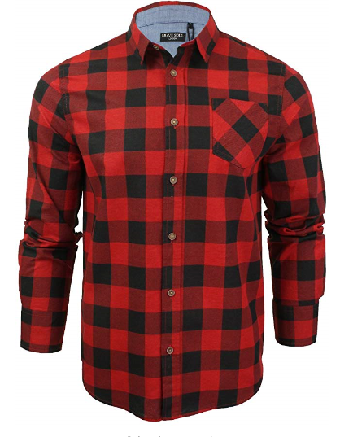

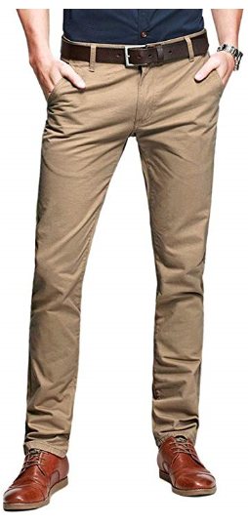
OCHENTA Mens Casual Slim-Tapered Flat-Front Trousers Khaki Lable 33
Breathable, because they are slim fit chino trousers, perhaps slightly tight in the wear and tear of first time, please select a larger size than you normally wear if you prefer more room
• Fleece-lined are now available for the coldest weather, ideal for casual and formal wear
• 100% Cotton
• Fastening: Zip
• Cargo
• Slim Fit
• R8-01-Khaki-33
•2 front slash pockets, 2 back pockets
•Style Slim Fit/Hand/machine wash cold separately
•Kind notice: Belt not included; delivery time: 1-3 days fulfilled by Amazon, 5-12 be met by the seller

