BSBLDR411
Demonstrate leadership in the workplace

ASSESSMENT SUMMARY

The assessment activities for BSBLDR411 Demonstrate leadership in the workplace cover all aspects of the unit of competency. For Apprentices/Trainees, this includes supervisor completion of the Apprentice/Trainee Record (ATR).

Participants must read all the information given before starting any assessment task. The assessment tasks are intended to be fair, flexible, valid and reliable. If a Participant has any questions or requires alternative arrangements to be made such requests should be directed to their Trainer/Assessor, who should note such arrangements in the ‘Assessor Comments’ on the affected assessment. If a Participant feels they are not yet ready to be assessed, they should discuss their options with their Trainer/Assessor.

To satisfactorily complete the assessment, the Participant is required to answer all questions correctly and demonstrate their skills to industry standards. If a Participant does not answer all questions or perform all tasks, they will be deemed ‘Not Satisfactory’ for the task and ‘Not Yet Competent’ for the unit of competency.

The Trainer/Assessor can provide the Participant with additional information on interpreting the assessment outcomes and guide the Participant’s options. If a Participant is still deemed ‘Not Satisfactory’ they will have the opportunity to undertake a supplementary assessment or appeal the result as per the process in the Student Handbook.

By signing below, the Participant acknowledges:
- They understand the assessment instructions and requirements, and consent to being assessed.
- The work submitted is to be their own work – with the work of/with others needing to be clearly acknowledged and documented.
- They consent to any photo/video recording of their work that occurs during assessment.

Participant name | Moses McGoon
Participant signature

Pre-requisite unit(s) to be achieved and authenticated prior to undertaking assessment
Not applicable

Task | Date completed | Assessment Results
Theory Exam |  | Satisfactory | Not Satisfactory
Practical Assessment Task 1 |  | Satisfactory | Not Satisfactory
Practical Assessment Task 2 |  | Satisfactory | Not Satisfactory
Outcome for BSBLDR411 |  | Competent | Not Yet Competent

Evidence requirements checklist (ticked by assessor and evidence supplied to RTO)
Theory Exam | Practical Assessment

Assessor Name
Assessor Signature

BSBLDR411
Demonstrate leadership in the workplace

THEORY EXAM

Participant name | Moses McGoon

FOR THE PARTICIPANT
Instructions
- You will complete written questions as outlined on the following pages. You must attempt all questions and provide enough detail in your responses to demonstrate your knowledge.
- It is anticipated that you should complete this assessment within two (2) hours, but additional time may be allowed upon negotiation with the Assessor.
- You must complete all questions unassisted by the Assessor or other personnel but may refer to reference material as needed. All questions must be answered correctly for a ‘Satisfactory’ assessment outcome to be awarded.
  - An oral examination may be allowed under certain circumstances, whereby your answers will be documented by another party.
  - Any written questions that are incomplete, or not answered satisfactorily will need to be completed again after further training support.
    - If you answer a question incorrectly but modify your response, put your initials next to the written change (or the Assessor must initial a verbal change).
Resources required
Pen

FOR THE ASSESSOR
Instructions
- Where oral examination has occurred, ensure that this is acknowledged in writing (e.g. FT001 and Assessor Comments)
- All questions must be satisfactorily demonstrated by the Participant for a Satisfactory determination (indicated by an Assessor tick to the right of the question).
- Assessors are to complete marking in pen of a different colour to the Participant.
- If the Participant verbally modifies their response, write in the modified response verbatim and put your initials next to the written change.

ASSESSOR Comments
As necessary, outline:
- Details on reattempts, alternative arrangements or reasonable adjustments made.
- Where a Participant is deemed ‘Not Satisfactory’, provide recommendations for future training.
- Discuss the evolution of leadership theories from the ‘Great Man’ theory to ‘Transactional and Transformational’ theories.

Answer | The ‘Great Man’ theory, which maintains that leaders are born to lead thus possessing certain inherent characteristics to lead. Trait theory evolved from Great Man theory and specifies that leaders can be born or made. Behavioural theory states that leaders are largely made, and that behaviours can be learned to ensure effective leadership. The situational era focused on leadership in specific situation, rather than on the traits or behaviour of the leaders suggesting that leaders must be able to assess the context in which they operate and decide what style is best suited. A transformational leadership style creates a vision and inspires subordinates to strive beyond required expectations, whereas transactional leadership focuses more on extrinsic motivation for the performance of job task.

- Describe the ‘Lean Strategy’.

Answer | Lean Strategy focus on producing more with less input. Thus, it seeks to eliminate waste throughout the entire manufacturing process.

- Discuss democratic leadership style and explain why it is often the preferred style used by leaders.

Answer | The democratic leader consults their team before making decisions, while still maintaining overall control. Team leaders decide how tasks will be addressed, and who will perform them while never losing sight of the fact that the manager bears responsibility.  Consultation among teams can identify problems early and good communication benefits staff morale.

- Explain the difference between the Laissez-faire leadership style and the autocratic leadership style.

Answer | A dictatorial style, where the person in charge has total authority and controls decision-making. They control the work of the team and monitor the completion of each task under scrutiny. Where on the other hand with Laissez-faire style it is a hands off approach, leaving the team to do it by themselves.

- Clarify and provide three (3) examples of where your workplace states its values and behavioural standards and explain how this is achieved.

Answer | - Company policies and procedures  - Site induction  - Posters and notices, signs.  Achieved through Code of Conduct

- Describe and provide at least three (3) examples of how your workplace implies its values and behavioural standards.

Answer | The values may be documented or implied during site meetings such as toolbox meetings, documents such JSAs or safety notices.

- Discuss how leaders can ensure their performance behaviour meets the requirements of the organisation.

Answer | Monitoring and regularly undertaking a self-assessment of their own performance against organisational standards.  Objectively assessing their own performance in terms of organisation need and in terms of match with the organisation’s vision, policies, procedures, code of practices/ behaviour/ ethics.

- It is important that the personal values of employees match with those of the organisation. What are the consequences if this is not so?

Answer | Yes it’s important.  When they do not, it may be difficult to guarantee honest or active support from those employees.  When employees do not agree with the values of the organisation, the results may be destructive or disruptive and conflict may result.

- Describe attitudes and work behaviours you display that contribute to the organisation’s integrity and credibility.

Answer | - Operate from a position of accountability, responsibility and ownership  - Respect privacy and confidentiality  - Have a good sense of humour and know how to laugh at themselves  - Demonstrate empathy and patience.  - Act as a coach and mentor.

- Discuss at least three (3) traits you would recognise in a credible leader.

Answer | - Someone who knows the job well.  - Someone who is transparent and honest at all times.  - Someone who challenges others to do better.  - Someone who is fair and trustworthy.  - Someone who is a good listener and good communicator.

- Why is it important for you, as a leader in your workplace, to question standards and values portrayed either by the company you work for, or by others, that could be damaging to your organisation’s reputation? Discuss how you would go about raising your questions and who to.

Answer | Having a clear set of values and standards helps employees and the company understand what you stand for. Your company values and standards also gives them guidance for their work and sense of security. As a result, your employees are most likely to make the right decision. The decision that helps them achieve the company’s vision and goals.

- Explain how you support others at work (including your managers) to behave positively and appropriately and change negative workplace behaviours. Provide an example of your actions.

Answer | By being a role model who inspires those who work for him or her and exhibits leadership in many aspects of the business. Be an example that others could try to follow.  Be patience and supportive while teaching others.

- Discuss your understanding of performance management and developing a performance management plan.

Answer | Where everyone in the organisation come to together with their knowledge, workers and resources to strategic objectives and priorities in order to ensure that the company’s short-term objectives and long-term goals are met in an effective manner.  Performance plans- identify how to best allocate task to team members  Communicate the expectation of the job role and job function to each team member  Utilise the strengths of team members where possible  Allow team member to be self directed

- Describe characteristics of an effective performance management plan and the purpose of KPI’s.

Answer | - Structured so that is supports the team members  - Understood by management and team members  - Able to be monitored effectively

- Clarify key performance indicators you need to meet to achieve the organisation’s (or your team’s) goals and objectives.

ToAnswer | - Timeliness  - Attention to detail  - Creativity and innovation  - Good time management  - Consistency  - Customer satisfaction  - Employee satisfaction

- When holding a pre-start meeting, why is it important that leaders examine options for risk management put forward by team members?

Answer | Because feedback both positive and negative, is very helpful. Feedback is valuable information that will be used to make important decision.

- Informed decisions are made when sourcing information from internal and external sources. Discuss a procedure or policy you have used in the workplace and which relevant external source/s align to this.

Answer | 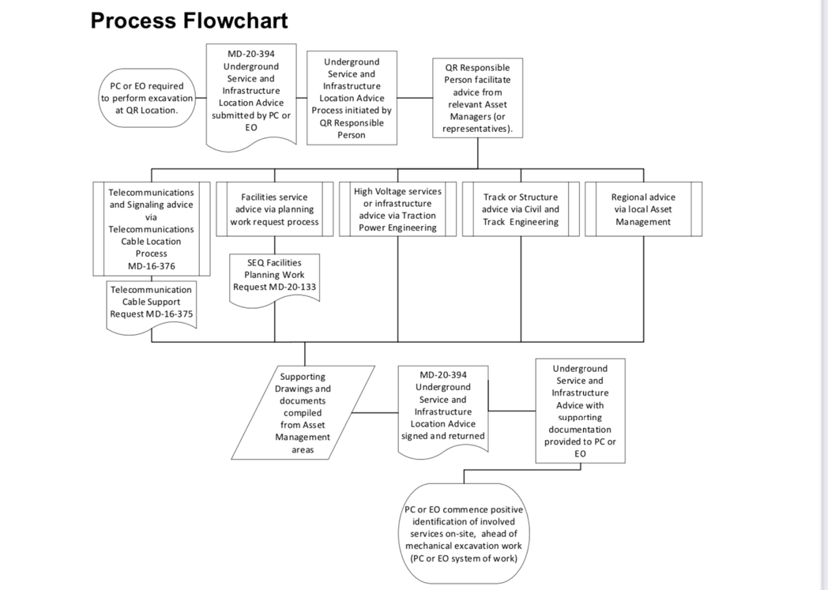  Excavations permit process

- Identify and explain a variety (4-5 ) sources leaders use to ensure they provide correct information as part of their facilitating and communicating processes.

Answer | Code of conduct- is the most common policy within an organisation. Outline of internal practice such as dress code, drug use, or sexual harassment policies.  Safety reports offers a suite of safety software tools that will empower your workers to improve safety performance and be more engaged in the safety process  Australia Standards are published documents setting out specifications and procedures designed to ensure products, service and systems are safe, reliable and consistently perform the way they are intended to.

- Describe feedback processes that can be applied when monitoring the implementation and impact of decisions made to work planning.

Answer | - Identify the decision  - Gather information  - Identify alternatives  - Weigh the evidence  - Choose among alternatives  - Take action  - Review your decision

The following questions are to be verbally answered to the assessor.

- Provide an example of when you have modelled high standards of safety management performance/behaviour in front of other workers. Include in your response, the situation, what your actions were and how you ensured that actions met organisational requirements.

Answer | While delivering the Pre-start safety briefing, everything is discussed and identified for example Assembly area, First Aid personal, Hazards and everyone task for the day. The SWMS is also discussed where the proper safety gear and tools required for completion are mentioned and must be followed. During the duration of the job everything is monitored and reviewed for any sudden change due to unseen circumstance.

- Explain how you would manage a person in your team who you believed was intoxicated.

Answer | If an employee comes to work intoxicated but is not exhibiting violence, have him or her ushered to a safe place at work. Contact the Human Resources department and report the intoxication. Call someone in the employee’s family or local law enforcement to have the employee taken home.

- Provide the assessor with evidence of facilitating individuals and the team to participate in the decision making process.

Answer | During the planning phase of the job we do a site inspection where we identify hazards and discuss the job and everyone involved has an input on. Every job is discussed including plant, number of personal and tools required for completion.

- Discuss mathematical information you need when establishing key performance indicators for the team/task.

Answer | - Structured so that supports the team members  - Understood by management and team members  - Easy to complete, not too complicated or time consuming.

- Your job has been held up due to delays in material delivery and you have just informed contractors and workers. What do you do with the feedback and how do you ensure that the feedback provided contributes to the decision-making process?

Answer | Listen to the feedback given  Be aware of your responses  Be open  Understand the message  Reflect and decide what to do  Follow up

BSBLDR411
Demonstrate leadership in the workplace

PRACTICAL ASSESSMENT

Participant name | Moses McGoon

FOR THE PARTICIPANT
Instructions
- The tasks outlined on the following pages will require performance of normal workplace activities, as a result of a structured activity set by an Observer in the workplace or a simulated activity set by your Assessor/Observer.
- The timeframe for these tasks will be established by your Assessor/Observer, in consideration of location conditions and industry requirements.
- You must complete all tasks unassisted by the Assessor or other personnel, unless the steps note this assistance.
- You must attempt all tasks (and itemised steps) for a ‘Satisfactory’ assessment outcome to be awarded.
  - For any observation conducted that is incomplete, or without satisfactory performance, the observation will need to be completed again after further training support.

FOR THE ASSESSOR/OBSERVER
Instructions
- The following observation record should be used to judge and record your observations of the Participant as they complete the task(s) set. You must record your observations of the Participant’s performance.
  - For each occasion, indicate the task performed and whether it was a simulation or workplace-based task.
    - Any simulated assessment must ensure the Participant still performs under workplace conditions which reflect industry standards.
  - In the comments, provide clear detail regarding the task that the Participant was required to do (e.g. PPE used, materials handled, attachments connected, plant types).
- All steps must be satisfactorily demonstrated by the Participant for a ‘Satisfactory’ determination (indicated by an Assessor tick to the right of each itemised step, or an Observer tick to the right of each itemised step, and confirmation by an Assessor in the Assessor Comments).
  - Where you have determined that one or more task steps have not been satisfactorily demonstrated, provide the Participant with additional support and outline details of such assistance in the Assessor/Observer Comments. Allow the Participant two (2) further opportunities to demonstrate the task again to allow an opportunity for a ‘Satisfactory’ assessment outcome to be achieved.
  - If after three (3) attempts the Assessor determines that the Participant cannot demonstrate the required steps, a ‘Not Satisfactory’ outcome is to be determined.

TASK OUTCOME
Task | Date | Task Type (Tick) | Location | Task outcome (Tick)
 |  |  |  | Satisfactory | Not Satisfactory
Task 1 |  | Workplace  Simulation
Task 2 |  | Workplace  Simulation

ASSESSOR Comments
As necessary, outline:
- Details on reattempts, alternative arrangements or reasonable adjustments made.
- Where a Participant is deemed ‘Not Satisfactory’, provide recommendations for future training.

BSBLDR411
Demonstrate leadership in the workplace

Practical Task 1
Description of task:
The participant is required to complete the following Performance Plan OR workplace performance plan for a team member including:
- establish KPIs that align performance to organisational objectives
Once developed, the participant must demonstrate implementing the plan including:
- demonstration of positive management performance that meet organisational policies & procedures
- aligning own performance with organisations standards and values
- recognising issues to be resolved and gathering information to resolve issue
- involving individual and feedback in decision-making and risk assessment processes
- evaluating the effectiveness of decisions in terms of how well they meet stated goals

Tasks are at the Assessor’s discretion, but detail should be recorded below or in the Assessor Comments.
Resources required:
Workplace Charter, Code of Conduct or Induction document to access Workplace Standards and Values.

When completing the task, did the Participant: | Tick if satisfactorily completed.  Provide comments if left unticked.
- Locate and explain the organisations requirements for management performance.
- Describe the organisational qualities required for positive management performance.
Assessor specify qualities described that align with organisational policies and procedures

- Locate and clarify organisation’s standards and values.
- Describe organisations expectations related to leadership qualities and how own performance meets these expectations.
Assessor specify qualities described

- Determine and document individuals KPIs to enable individual to better meet organisational values
- Gather and organise information to support individual in achieving KPIs
Assessor specify support offered

- Discuss potential plan with individual, make adjustments as relevant following discussion.
- Encourage individual to participate in discussion and agreement of how KPIs are to be achieved and timeframe for achievement. (evidenced by signatures)
- Check in with individual during implementation to determine effectiveness of actions.
- Undertake self-assessment of behaviour and make adjustments as required to meet organisational standards and values.
- Behave in a manner that contributes to the integrity and credibility of the organisation.
- Speak with individuals team member to confirm that individual is achieving KPIs.
- Develop and implement a performance plan for an individual.
- Include key performance indicators in plan that meet organisation’s business objectives.
Individual Performance Plan template

Name of Employee: | Gilbert Osorio
Performance Period: | Monthly
Job Title: | Track worker
Supervisor / Manager Name: | Moses McGoon
Date: | 12/05/2022
Key Result Area:
Organisational Objective: Work is effectively and timely completed *
Key Performance Indicator:  Total Project Time  The number of working hours spent on different aspect of the works |  | Review Date:  13/06/2022
Key Result Area:
Organisational Objective: Create a safe work environment
Key Performance Indicator:  Safety Pre-Start briefing  Number of incidents/ accidents |  | Review Date:  13/06/2022
Key Result Area:
Organisational Objective: Productivity of People and Resources
Key Performance Indicator:  Project progress relative to milestones  Number of complaints |  | Review Date:  13/06/2022
This plan will be implemented by the following actions:
- Identify how to best allocate tasks to team members
- Utilise the strengths of team members where possible
- Encourage team members to be self directed
Agreed and signed:  Employee:  Supervisor: |  | Date:  12/05/2022

BSBLDR411
Demonstrate leadership in the workplace

Practical Task 2
Description of task:
The participant is required to complete the following Performance Plan OR workplace performance plan for a team including:
- establish KPIs that align performance to organisational objectives
Once developed, the participant must demonstrate implementing the plan including:
- demonstration of positive management performance that meet organisational policies & procedures
- aligning own performance with organisations standards and values
- recognising issues to be resolved and gathering information to resolve issue
- involving team members and feedback in decision-making and risk assessment processes
- demonstrating understanding of mathematical information relating to quantities and time
- evaluating the effectiveness of decisions in terms of how well they meet stated goals

Tasks are at the Assessor’s Discretion, but detail should be recorded in the Assessor’s Comments.
Resources required:
Documents to access Workplace Standards and Values.

When completing the task, did the Participant: | Tick if satisfactorily completed.  Provide comments if left unticked.
- Locate and explain the organisations requirements for management performance.
- Describe the organisational qualities required for positive management performance.
- Locate and clarify organisation’s standards and values.
- Describe organisations expectations related to leadership qualities and how own performance meets these expectations.
Assessor specify qualities described

- Determine and document objectives for team improvement to better meet organisational values and requirements
- Gather and organise information to support team in achieving objectives
Assessor specify support offered

- Calculate experience and capability of team members related to action plan and objectives.
- Discuss potential plan with team members, make adjustments as relevant and achieve agreement to proceed.
- Assign employee/s to components of action plan.
- Check in with team members during implementation of action plan to gauge effectiveness of actions.
- Comply with organisational standards and values during interaction, planning and implementation of plan.
- Behave in a manner that contributes to the integrity and credibility of the organisation.
- Develop and implement a performance plan for the team.
- Include key performance indicators/ objectives in plan that meet organisation’s business objectives.
Team Performance Plan template

Start date | 13/05/2022
End date | 13/06/2022
Vision/ Aim of the performance plan | Meeting Deadlines  Team work
Objectives for team improvement
Objective |  | Employee/s | Start date | End date
1. Work completion on time |  | Gilbert | 13/05/2022 | 13/06/2022
2. Improve team work |  | Steve | 13/05/2022 | 13/06/2022
Reviewing and Assessment method (how will you track the plan’s implementation, the team’s progress: through team meetings, reports, etc.)
Weekly meeting with personal and team leader.  Site inspection |  |  |  | Review Date:
Additional support (is there any additional support needed to reach the desired goals: courses, classes, resources?)
Team building meeting
Labour hire for help
Training in plant operators
Expected outcome (supervisor‘s expectations on the outcome based on the data)
Effective work group in terms of deliver tasks on time with no incidents.

Outcome if goals and objectives are not reached (identify the consequences and further steps if the team fails to satisfy the standards set by the performance plan)
Loss of income.
Dismantle of team or integrate with other work groups
Agreed and signed  Employees:  Supervisor: |  |  |  | Date:  13/05/2022

