Cashflow

The below cashflow is from a previous project where we highlighted what was left to be completed ahead and cross hatched out the previous months actually completed.
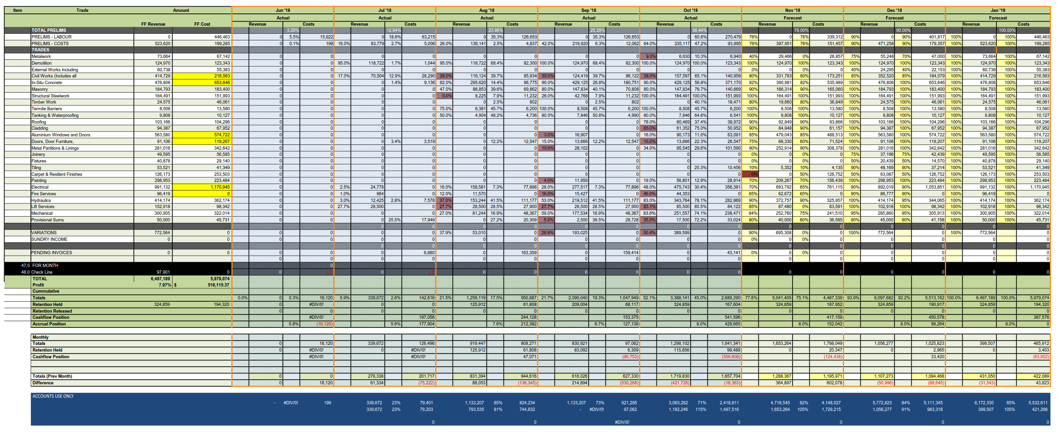

Project Budget
The budget below highlights the estimate for the project highlighting what the tendered budget was and then a revised budget setting a target budget for the project.
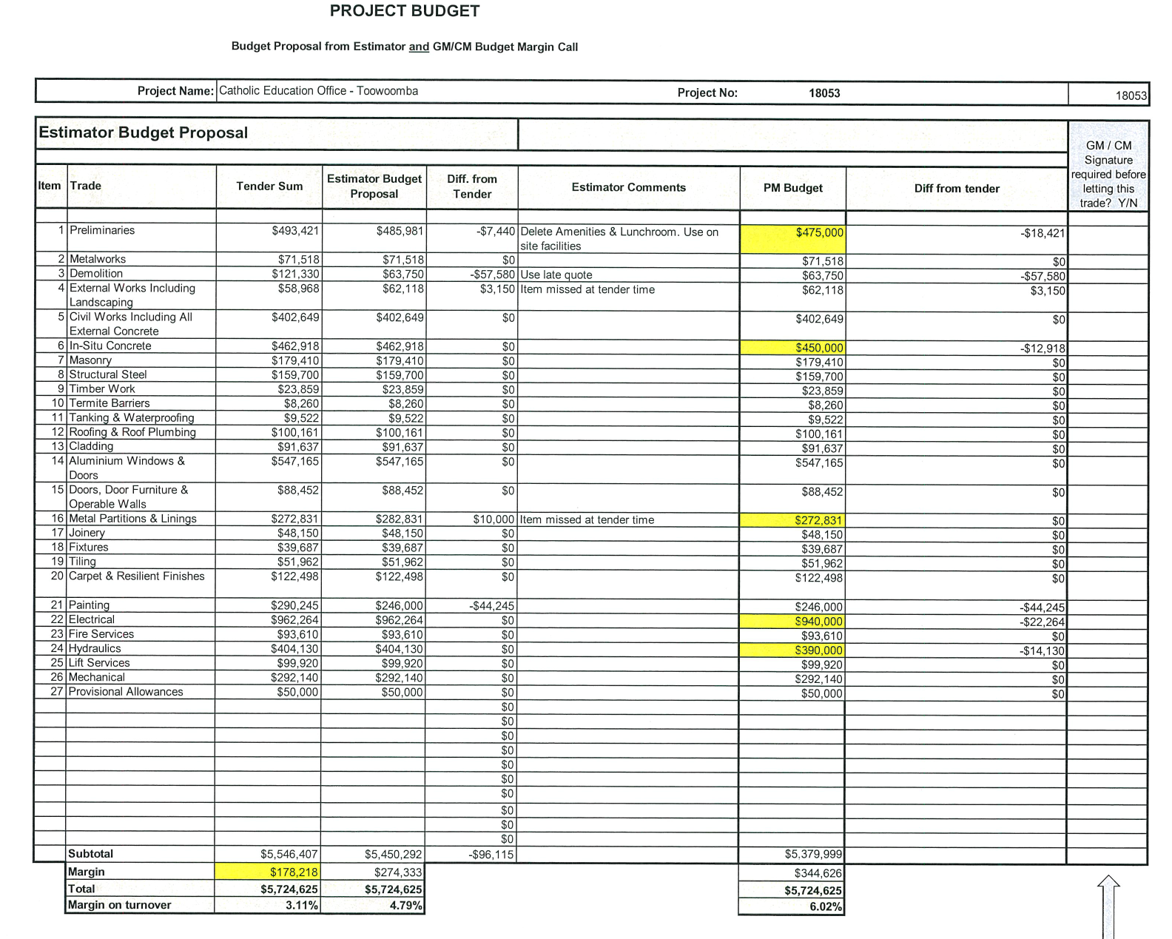
Book Keeping and transaction recording
Below are examples I have pulled from Jobpac our accounting system highlighting;
- Extract from Pending Invoices within the system that have been coded to cost centres.
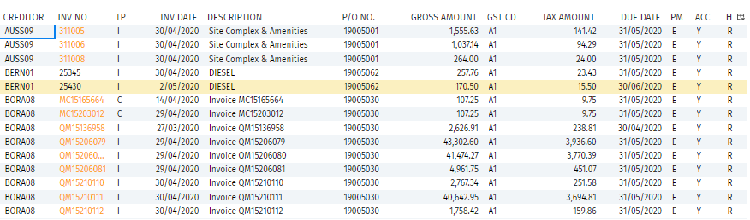
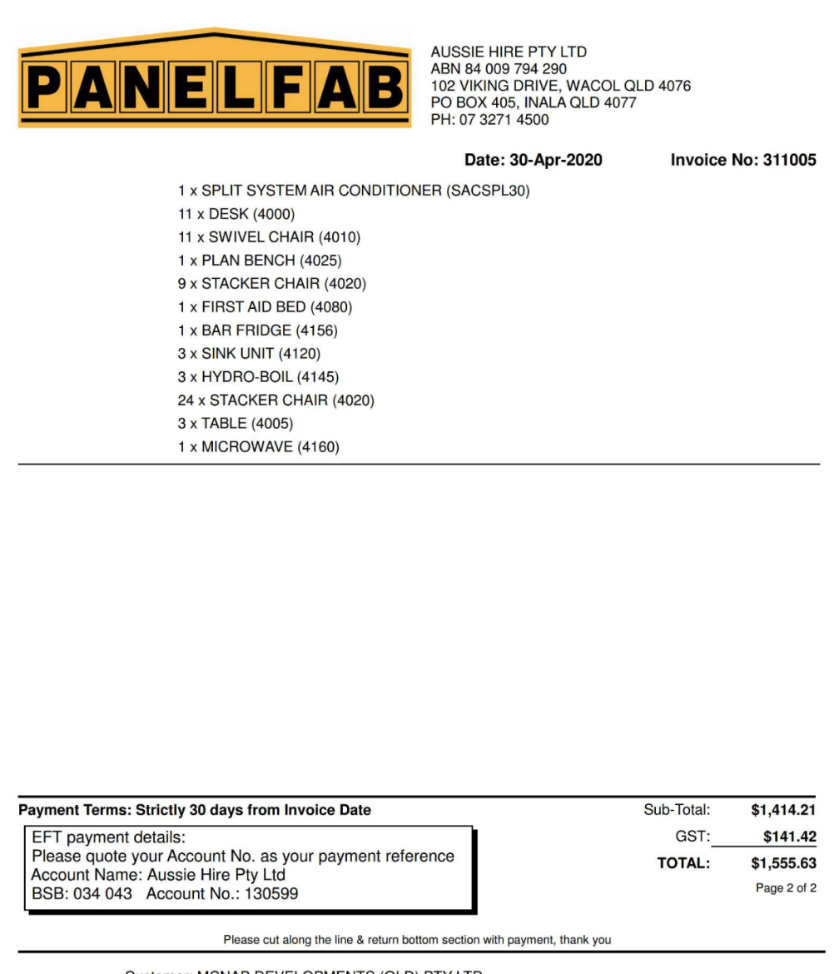
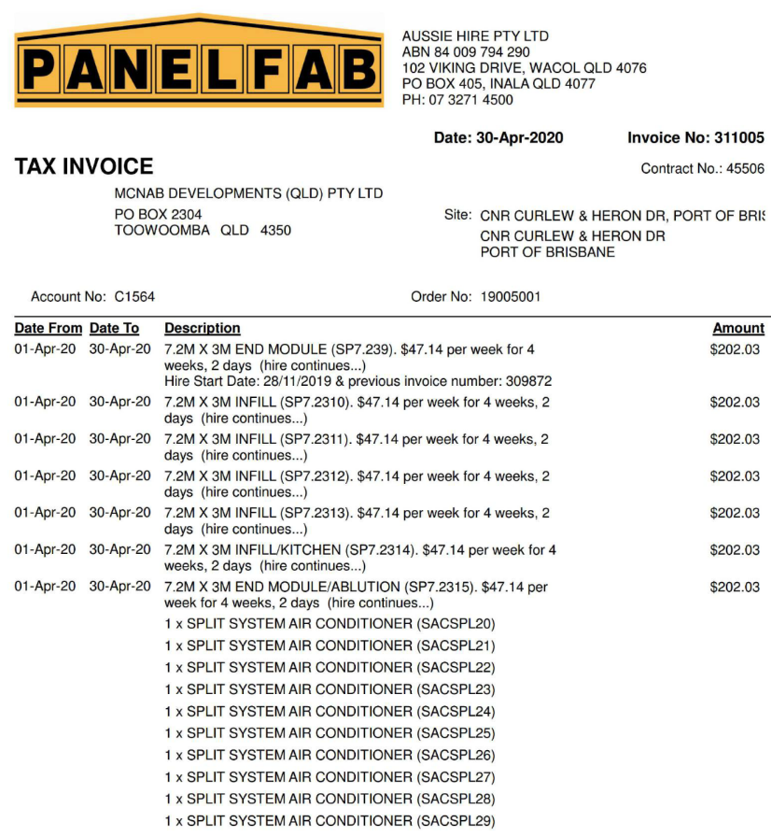
- Invoice below relates to 1st item in the above pending invoice report.

- Transaction confirming payment of a previous invoice (for another project).
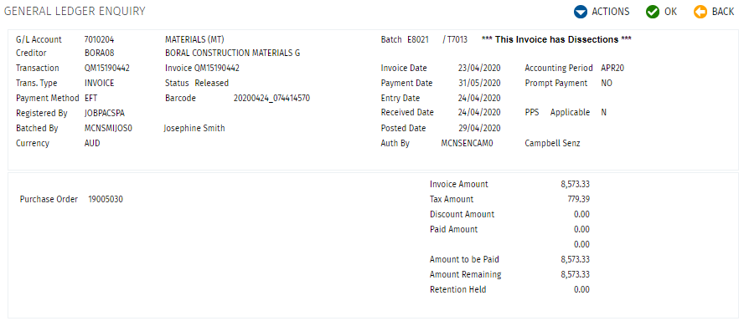

Supplier Account notices with trading terms
Below is an invoice from Boral confirming we have them on a 30 day EOM (End of Month) account and have an extract from the supply agreement highlighting the terms agreed to. We request invoice on the 25th of the month allowing to deal with BCIPA.
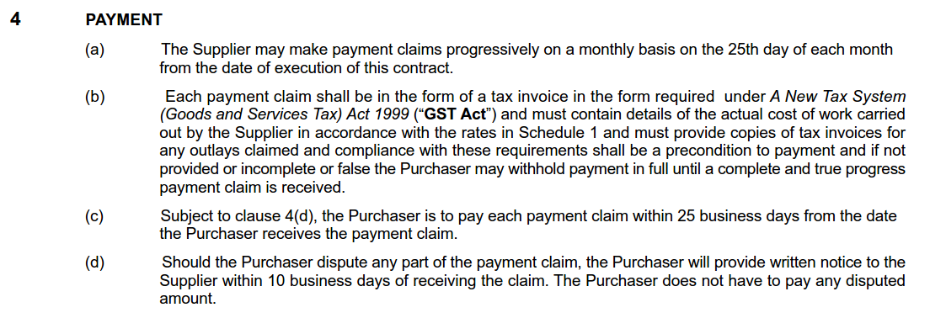
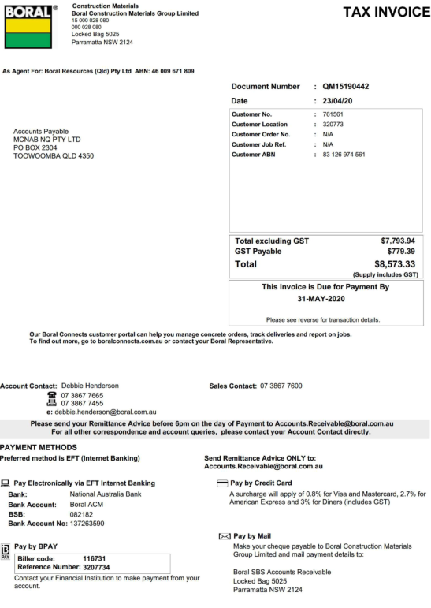

Acknowledgement of Association
I am used to understanding checks about companies / subcontractors and typically we do ABN searches as well as QBCC licence searches as below. This is for WINFAB owned by Andrew Windolf;
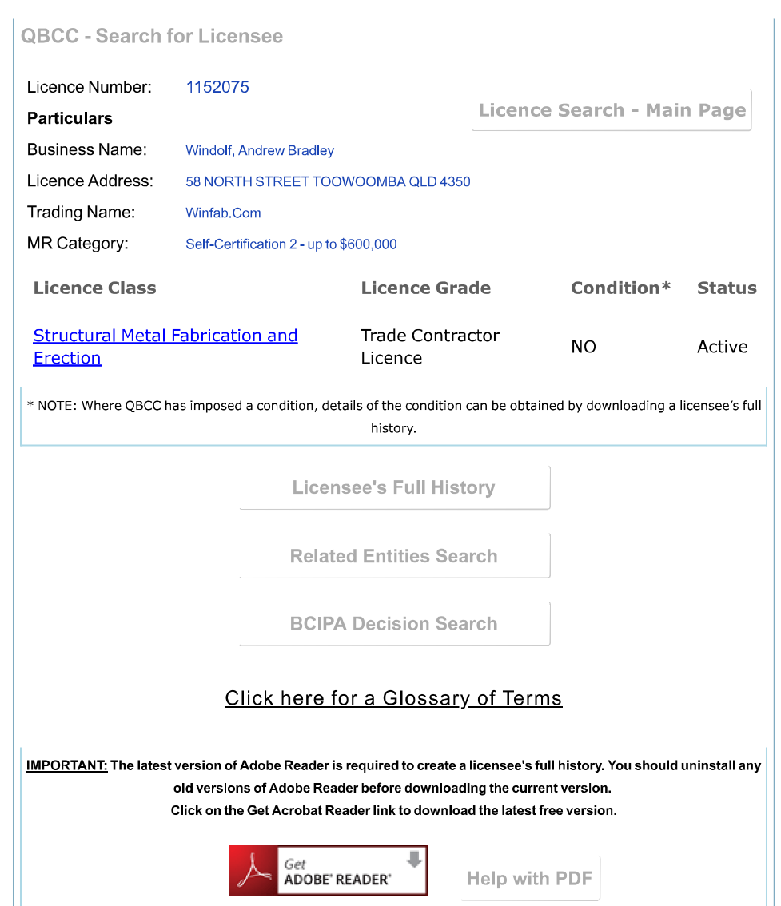
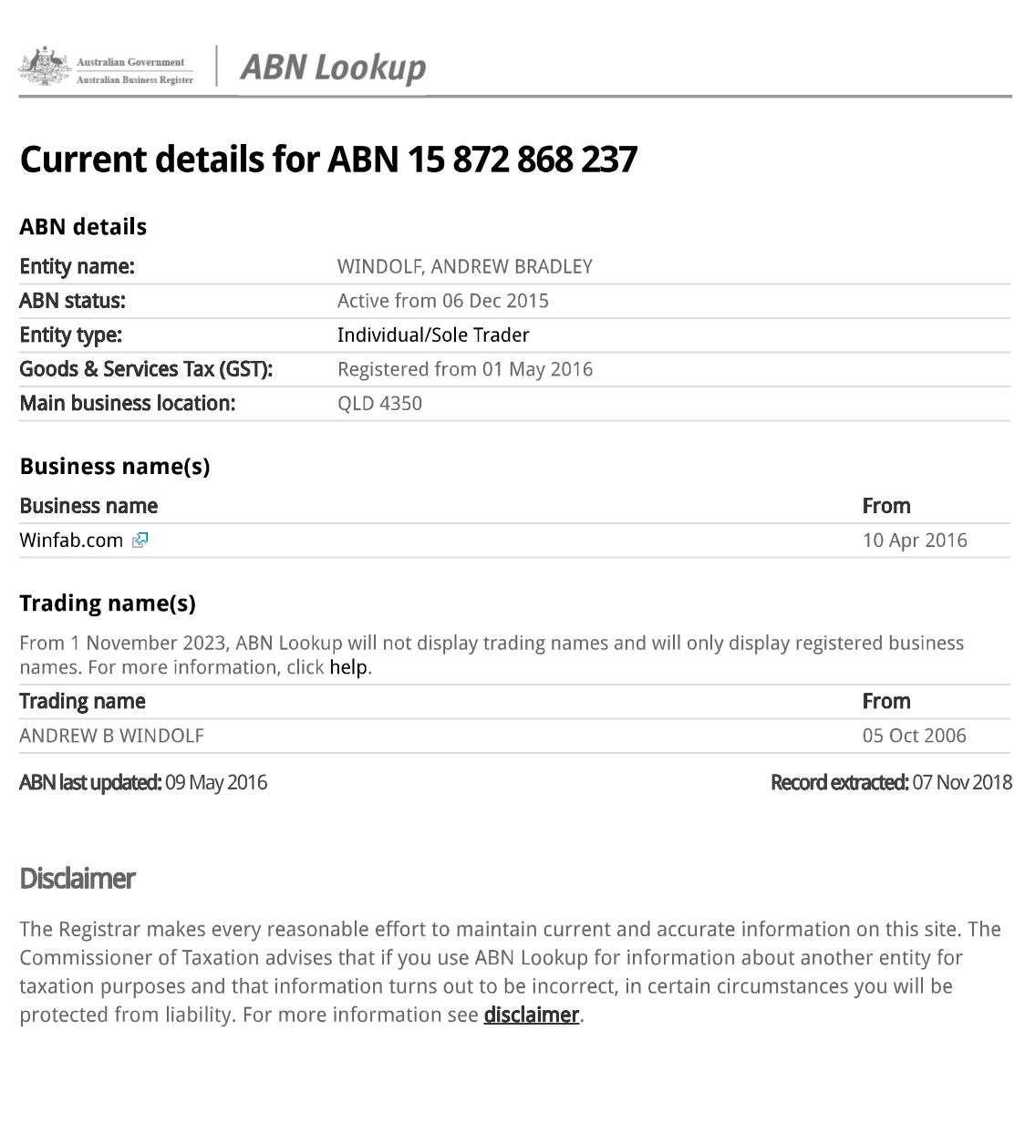
Profit and Loss Statement
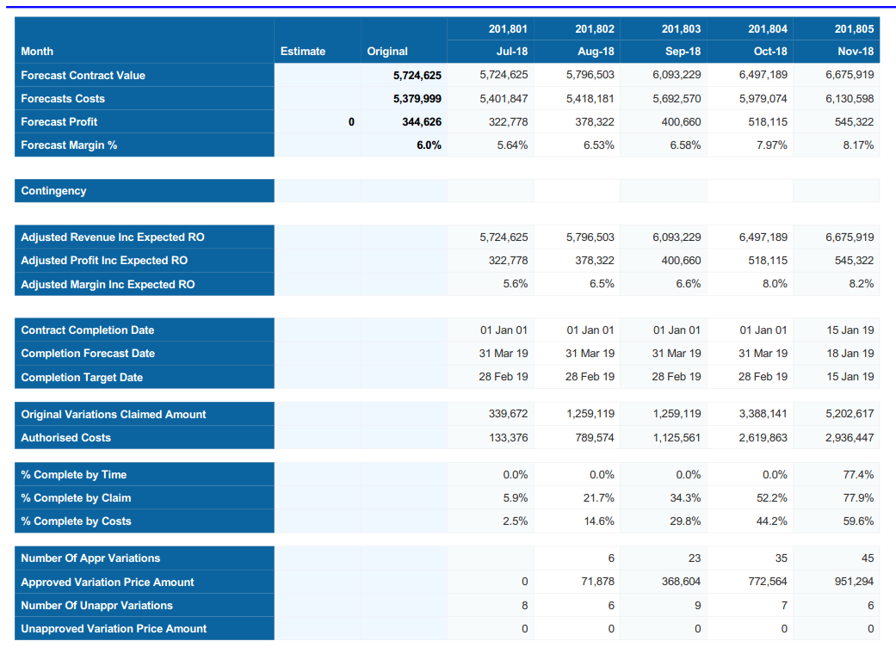

Cost Comparison Report – Highlighting actuals and forecasting against the budget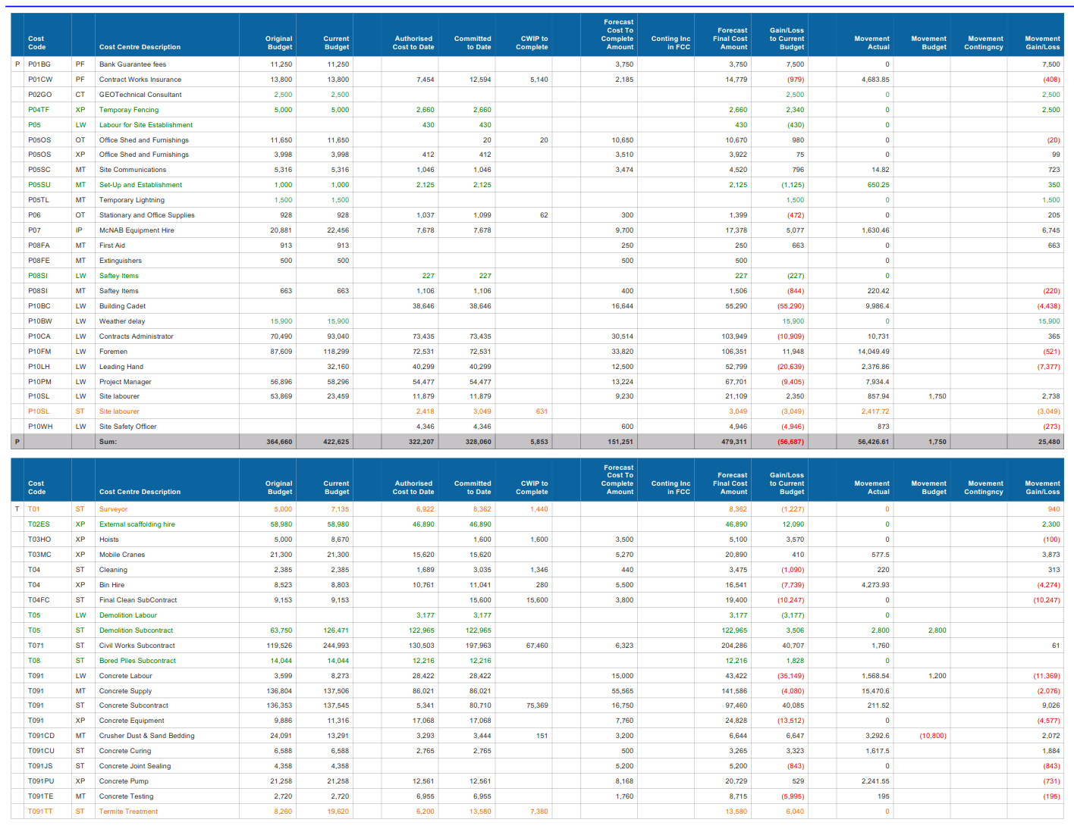
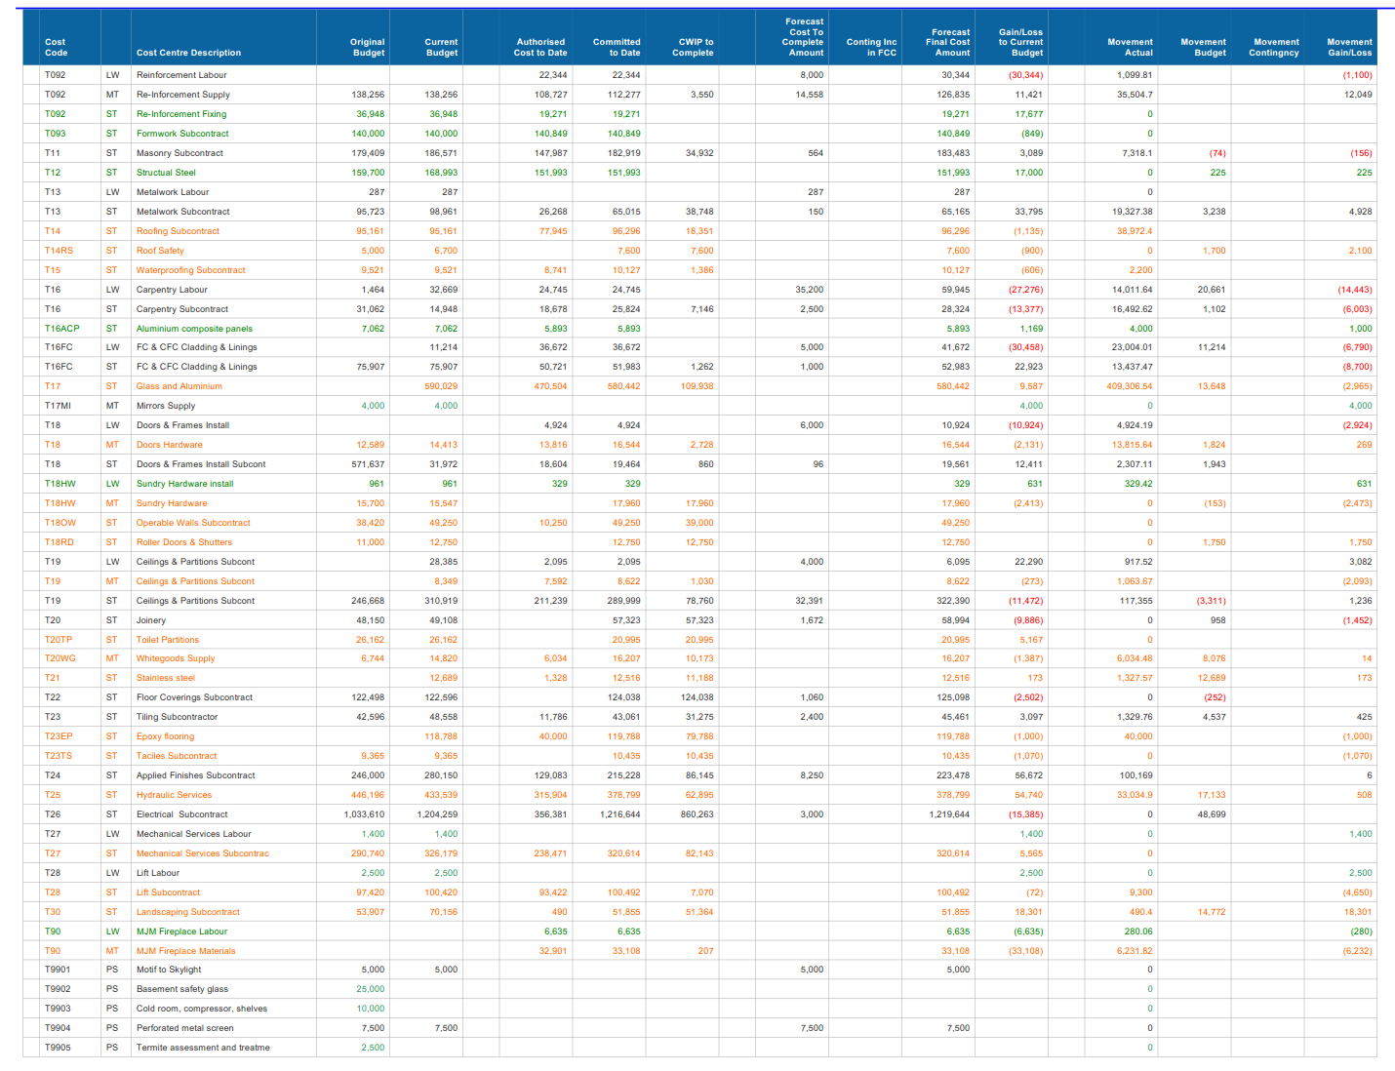
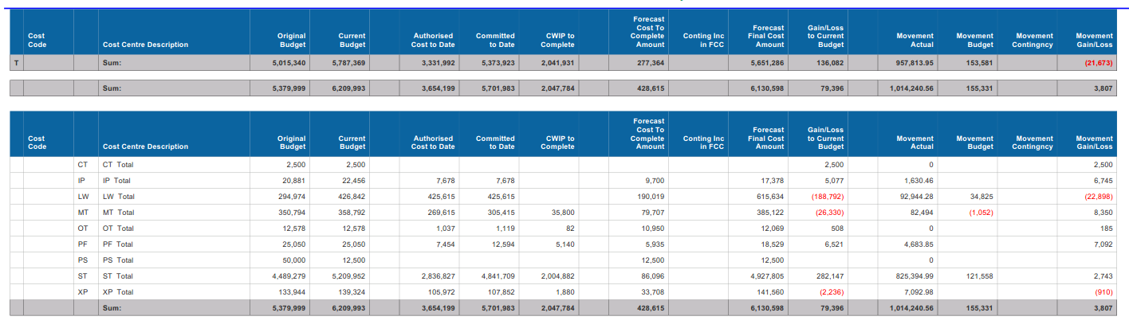

Business Activity Statement


