
SISFFIT004 Incorporate anatomy and physiology principles into fitness programming

Copyright © 2017 CSTC Pty Ltd

All rights reserved. No part of the contents of this publication may be reproduced or used in any form or by any means – graphic, electronic, or mechanical including photocopying, digitising, recording, or information storage-and-retrieval systems – without the written permission of CSTC Pty Ltd.
ASSESSMENT FOR SISFFIT004

Student name
Date of assessment submission | Click here to enter a date.

Trainer/Assessor’s name
Date of assessment marking | Click here to enter a date.
Outcome for units | ☐ Competent  ☐ Not Yet Competent

TASK INSTRUCTIONS

- The assessment for these units of competency consists of the following:
  - Quiz: You are required to complete a series of multiple choice questions to demonstrate your knowledge and skills.
  - Short answer activities: You are required to provide short written responses to a series of activities to demonstrate your knowledge and skills.
  - Case studies: You are required to provide written responses to a series of case study scenarios to demonstrate your knowledge and skills.
  - Practical task: You will be required to put your knowledge and skills into practice, through observed tasks and work experience.
- At times, you will be provided with a specific context to which you must respond, otherwise it is anticipated that you will use a scenario of your choosing to provide context to the task.

QUIZ

QUESTIONS | CORRECT
- What are the planes of body motion?  ☐ Sagittal, Frontal, Reverse  ☐ Sagittarius, Frontal, Transverse  ☒ Transverse, Sagittal, Frontal  ☐ Back, Front, Side | ☐
- What is the term associated with moving towards the midline of the body?  ☐ Superior  ☐ Inferior  ☐ Plantar  ☒ Medial | ☐
- What is the focussed movement in the movement of a shrug?  ☒ Superior and then Inferior  ☐ Anterior and then Medial  ☐ Elevation and Depression  ☐ Protraction and Retraction | ☐
- Which of the following are examples of connective tissue?  ☐ Muscle, Bone, Cartilage, and Skin  ☒ Ligaments, Tendons, Fascia, and Cartilage  ☐ Tendons, Bones, Ligaments, and Muscle  ☐ Muscle, Fascia, Cartilage, and Tendons | ☐
- What are the major muscles required for the flexion and extension of the elbow?  ☐ Quadriceps and Hamstring  ☐ Pectoral and Latissimus Dorsi  ☐ Biceps Femoris and Triceps  ☒ Biceps and Triceps | ☐
- What two (2) sections can the skeleton be divided into?  ☒ Axial and Appendicular  ☐ Axial and Appendages  ☐ Torso and Limbs  ☐ Long bones and Short bones | ☐
- What three (3) sections can joints be classified into?  ☐ Fibrous, Cartilage, Synovial  ☐ Fibre, Cartilaginous, Synovial  ☒ Fibrous, Cartilaginous, Synovial  ☐ Fibro, Hyaline, Symphasis | ☐
- What are fast twitch fibres known as?  ☐ Type I  ☐ Type II  ☒ Type IA and Type IB  ☐ Type III | ☐
- What does the mechanics of breathing involve?  ☐ Breathing in and breathing out  ☐ Inspire and exhale  ☒ Inspiration and expiration  ☐ Respiration and expiration | ☐
- What does ATP stand for?  ☐ Adenosine Two Phosphate  ☒ Adenosine Tri Phosphate  ☐ Adenosine Three Phosphates  ☐ Adrenaline Tri Phosphate | ☐
- True or False: In multicellular organisms, including humans, all cells, tissues, organs, and organ systems of the body work together to maintain the life and health of the organism.  ☒ True  ☐ False | ☐
- What are the four (4) tissue types?  ☐ Isokinetic, Isometric, Concentric, Eccentric  ☒ Connective, Muscle, Nervous, Epithelial  ☐ Superficial, Inferior, Deep, Anterior  ☐ Muscle, Nervous, Connective, Organism | ☐
- Which of the following methods will keep you aware of emerging knowledge of anatomy and physiology relevant to the development of your own professional practice? Select all that apply.  ☒ Reading journal articles  ☒ Newsletters from health professional associations  ☒ Networking within your industry | ☐

- Fill in the blanks for the statements below, selecting the correct option. | ☐
  Statement | Option 1 | Option 2
  The pectoralis major is _____ to the rhomboids. | ☒ Anterior | ☐ Posterior
  The soleus is _____ to the gastrocnemius. | ☒  Deep | ☐ Superficial
  The pectoralis major is _____ to the rhomboids. | ☐  Deep | ☒ Superficial
  The rhomboids are _____ to the trapezius. | ☐ Anterior | ☒ Posterior
  The bicep femoris is _____ to the semimembranosus. | ☐  Lateral | ☒  Medial
  Anterior deltoid is _____ to rectus abdominus. | ☒ Superior | ☐  Inferior
  Rectus abdominus is _____ to the obliques. | ☐  Lateral | ☒  Medial
  The elbow joint is _____ to the shoulder joint. | ☒ Superior | ☐  Inferior
  The wrist joint is _____ to the elbow joint. | ☒  Distal | ☒  Proximal
  The knee joint is _____ to the ankle joint. | ☐  Distal | ☒  Proximal
- Match the terms below with the appropriate movement, placing the corresponding movement letter label next to each term. | ☐
  Letter | Term |  | Movements
  I | Flexion |  | - The movement of a limb sideways direction towards the midline of the body
  B | Extension |  | - Extension at the ankle
  A | Adduction |  | - To allow a joint to perform movement through all possible axes
  K | Abduction |  | - The straightening of a joint. It occurs when the angle at a joint increases and the two opposing surfaces move apart
  G | Pronation |  | - To turn the sole of the foot laterally
  J | Supination |  | - To turn the sole of the foot medially
  H | Dorsiflexion |  | - To turn the palm posterior
  D | Plantarflexion |  | - The bending of a joint. It occurs when the angle of the joint becomes smaller and the two opposing surfaces move together
  C | Circumduction |  | - Flexion at the ankle
  F | Inversion |  | - To turn the palm anterior
  E | Eversion |  | - The movement of a limb in a sideways direction away from the midline of the body
- Identify the type of muscle tension for each listed exercise. | ☐
  Exercise | Isokinetic | Isometric | Isotonic
  Pushing against a wall | ☐ | ☒ | ☐
  Performing a bicep curl | ☐ | ☐ | ☒
  Holding a push up position at the bottom of the movement | ☐ | ☒ | ☐
  Swimming | ☒ | ☐ | ☐
  Holding a shopping bag | ☐ | ☒ | ☐
  Performing a squat | ☐ | ☐ | ☒
  Cycling on a stationary bike | ☒ | ☐ | ☐
- Match the terms below with the appropriate diagram label, placing the corresponding number label next to each term.  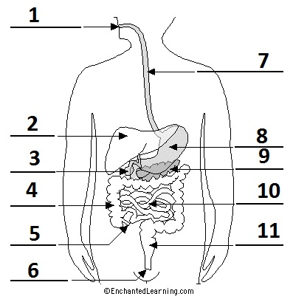 | ☐
  Number | Term
  6 | Anus
  5 | Appendix
  7 | Esophagus
  3 | Gall bladder
  4 | Large intestine
  2 | Liver
  1 | Mouth
  9 | Pancreas
  11 | Rectum
  10 | Small intestine
  8 | Stomach

- What effect does regular cardiovascular exercise have on the following respiratory volumes? Select the correct option. | ☐
  Respiratory volume | Increase in size | Decrease in size
  Vital capacity | ☒ | ☐
  Residual volume | ☒ | ☐
  Total lung capacity | ☒ | ☐

Outcome for Quiz | ☐ Satisfactory  ☐ Not satisfactory
Trainer/Assessor comments

SHORT ANSWER ACTIVITIES

Consider the relevance of the anatomical position.
- Provide a definition of the anatomical position.
- Explain the reason for this body position in relation to health screening.

Definition
The anatomical position is when a person stands erect with the arms on the side and the palms open forward.
Relation of health screening
When health screening the anatomical position serves as a reference point. From there one can see whether a person’s health, movements and positions are healthy or not.

Outcome for Activity 1 | ☐ Satisfactory  ☐ Not satisfactory
Trainer/Assessor comments

Explain the path of an oxygen molecule from the initial phase of inspiration, starting at the nasal cavity.

Path of oxygen molecule
After inhaling through the nose the oxygen molecule goes through the respiratory system, which consists of pharynx, trachea, bronchi. It then goes to the lungs where in the alveoli where the exchange of oxygen from air into the blood stream takes place. It then enters the red blood cells and gets attached to an iron atom. From there it is transported to the body where it gets released and diffuses into a cell

Outcome for Activity 2 | ☐ Satisfactory  ☐ Not satisfactory
Trainer/Assessor comments

Draw and label a sketch of a long bone.

Labelled sketch
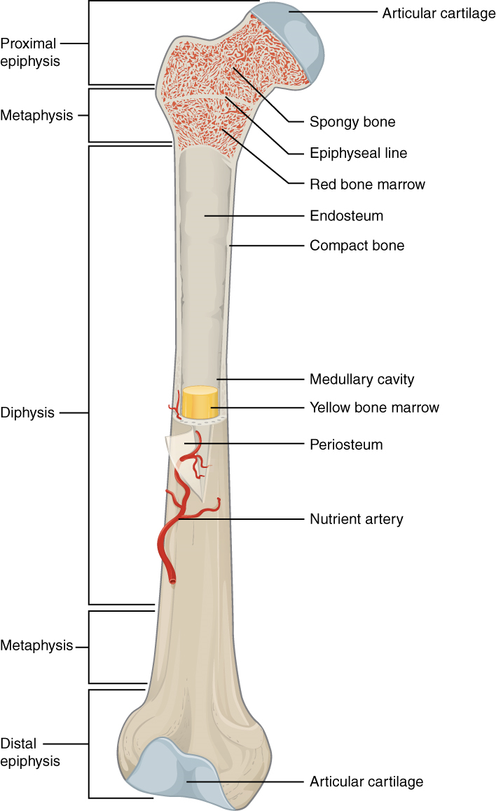

Outcome for Activity 3 | ☐ Satisfactory  ☐ Not satisfactory
Trainer/Assessor comments

Identify three (3) types of muscle. Describe these muscles and explain where they are found in the body.

Muscle 1
Name of muscle | Skeletal
Description and location | Skeletal muscle is also called a voluntary muscle. It is held by tendons to bone. It is used to effect skeletal movement such as locomotion and in maintaining posture. The skeletal muscles are coordinated by the nervous system. It basically helps to perform daily activities.
Muscle 2
Name of muscle | Cardiac
Description and location | Cardiac muscle is also called an involuntary muscle. It is only found in the heart. The cardiac muscles constantly contract and relax. They are coordinated by the sinoatrial node located in the heart. They are not striated and involuntary.
Muscle 3
Name of muscle | Smooth
Description and location | Smooth muscle is also called an involuntary muscle. It is found within the walls of organs such as the esophagus, stomach, intestines, bronchi, uterus, urethra, bladder, blood vessels. They are coordinated by the nervous system.

Outcome for Activity 4 | ☐ Satisfactory  ☐ Not satisfactory
Trainer/Assessor comments

Draw and label a sketch of the cardiovascular system.

Labelled sketch
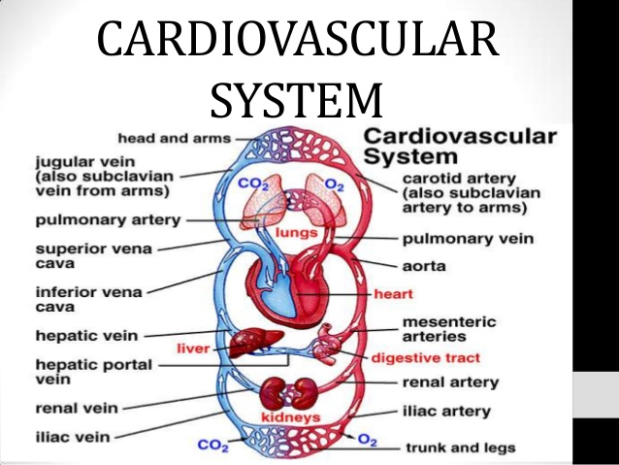

Outcome for Activity 5 | ☐ Satisfactory  ☐ Not satisfactory
Trainer/Assessor comments

Consider the movements in a push up.
- Describe the agonists and antagonists responsible for movement.
- Describe the role synergists play in this movement.
- Describe the role connective tissue plays in this movement.
- Describe the role of a Fixator or Stabilizer during an exercise movement, such as a push up.
- Describe the role of a Prime Mover in muscle movement.

Agonists and antagonists
Antagonist and agonist muscles often occur in pairs, called antagonistic pairs. As one muscle contracts, the other relaxes. An example of an antagonistic pair is the biceps and triceps; to contract - the triceps relaxes while the biceps contracts to lift the arm.
Synergists
Synergist muscles help to create the movement. In the bicep curl the synergist muscles are the brachioradialis and brachialis which assist the biceps to create the movement and stabilise the elbow joint.
Connective tissue
Connective tissue refers to other features which support the body and its movement. Tendons are strong strips which attach the muscles to bones. When a muscle contracts to move a joint, it is the tendon which pulls on the bone.
Fixator or Stablizer
Fixators help hold your body in a certain position so the agonists and sysnergists have a stable base from which to work. Small muscles in your shoulder, called your rotator cuff, keep the head of your humerus firmly located within your shoulder socket while your rectus abdominus, or abs, hold your spine straight. Other fixators of note include your latissimus dorsi muscles on the side of your upper back which aid in shoulder stability and your quadriceps, or thigh muscles which work to keep your legs straight and rigid.
Prime Mover
a muscle that acts directly to produce a desired movement amid other muscles acting simultaneously to produce the same movement indirectly. Most movements of the body require the combined action of numerous muscles

Outcome for Activity 6 | ☐ Satisfactory  ☐ Not satisfactory
Trainer/Assessor comments

Write a description of cross bridging. Include references to the following:
- All or none theory
- Motor units
- CNS
- Structure of a muscle

Description
In the context of muscular contraction, cross-bridging refers to the attachment of myosin with actin within the muscle cell. All muscle types - whether we're talking about skeletal, cardiac, or smooth - contract by cross-bridge - that is, repeated attachment of actin and myosin within the cell. The contractions of a single muscle are coordinated by groups of motor units. A motor unit is made up of motor neuron and the skeletal muscle fibers.

Nerve impulses that originate in the central nervous system (CNS) cause muscles to contract. Both neurons and muscle tissue conduct electrical current by moving ions across cellular membranes. A motor neuron ends in a synapse with a muscle fiber. The neuron releases acetylcholine and transfers the action potential to the muscle tissue. The signal will travel through the tissue and trigger the contraction of individual sarcomeres.

To picture this better, one has to imagine that a skeletal muscle is made up of bundles of muscle fibres; each fibre is several to many centimeters long.

Outcome for Activity 7 | ☐ Satisfactory  ☐ Not satisfactory
Trainer/Assessor comments

Muscle fibres can be classified as either fast twitch or slow twitch.
  - Describe each twitch type.
  - Provide an example of a specific sport where they are most used.

Description
There are 2 types of muscle fibres: fast twitch and slow twitch.
Fast twitch fibres are used when high intensity anaerobic activities takes place. There are also progressively used when at low intensity endurance work fatigue increases.
Low twitch muscle fibres are recruited when low intensity aerobic endurance work takes place. Also they are always used at the start of exercise whatever the intensity.

Sports where most used
Slow twitch: marathon running, endurance sports
Fast twitch : sprints, table tennis.
Some sports require both muscle types.

Outcome for Activity 8 | ☐ Satisfactory  ☐ Not satisfactory
Trainer/Assessor comments

It is important to have a detailed knowledge of the human skeleton as part of fitness programming.
  - Name the labelled parts of the skeleton shown below.
  - Give three (3) examples of bony landmarks from the diagram.

Labelled sketch
ischium
metatarsals
fibula
patella
phalanges
carpals
llium
Lumbar vertebrae
humerus
scapula
phalanges
tarsals
tibia
femur
metacarpals
ulna
sacrum
radius
ribs
sternum
clavicle
mandible
cranium
Bony landmarks

Outcome for Activity 9 | ☐ Satisfactory  ☐ Not satisfactory
Trainer/Assessor comments

Name the labelled muscles shown in the sketches below.

Labelled sketch 1


Pectoralis major
Latissimus dorsi
Biceps
External oblique
Vastus medialis
Vastus lateralis
Tibialis anterior
sternocleidomastoid
deltoid

Rectus abdominis
Rectus abdominis

Labelled sketch 2

Latissimus dorsi
deltoid
Gluteus medius
Gluteus maximus
semitendinosus
semimembranosus
trapezius
Triceps branchii
gastronemius
Peroneus longus

Outcome for Activity 10 | ☐ Satisfactory  ☐ Not satisfactory
Trainer/Assessor comments

Consider the role of thermoregulation.
- Provide a description of this term.
- Outline the role it plays in exercise.
- Describe what a person can do to ensure their body is prepared to undertake the stresses of exercise in relation to body temperature, as well as accounting for environmental conditions.

Description
Thermoregulation is the ability of an organism to keep its body temperature within certain boundaries, even when the surrounding temperature is very different.
Role in exercise
When exercising your body temperature increases. To keep a normal body temperature the sweat glands release sweat, which then cools the skin as it evaporates. This helps lower the internal temperature. The blood vessels under the skin also get wider. This increases blood flow away from the warm inner body to the skin where it is cooler body.
Preparing the body for exercise
When training the body temperature rises. It is important to prepare for this by wearing clothes with fabrics that minimise heat storage and enhance sweat evaporation. Preparation for exercise that rise the body temperature should also include a period of acclimatisation to those conditions, especially if the athlete is travelling from a cool/temperate climate to compete in hot/humid conditions. Furthermore, the intake of fluids is important when preparing for exercise.

Outcome for Activity 11 | ☐ Satisfactory  ☐ Not satisfactory
Trainer/Assessor comments

Explain the difference between motor and sensory neurons. Be sure to refer to afferent and efferent nerves.

Motor and sensory neurons
Neurons are classified according to their function. Neurons that transmit impulses from sensory receptors in the skin or internal organs towards the CNS are called sensory or afferent neurons. Neurons that carry impulses from the CNS to effector organs like muscles are called efferent neurons

Outcome for Activity 12 | ☐ Satisfactory  ☐ Not satisfactory
Trainer/Assessor comments

Why does oxygen demand increase when you are physically active?

Oxygen demand
When exercising the muscles need more energy, so they produce more of the chemical energy molecule ATP. In order to produce ATP one needs more oxygen. So the harder one exercises the more ATP has to be produced, therefore the demand for more oxygen increases..

Outcome for Activity 13 | ☐ Satisfactory  ☐ Not satisfactory
Trainer/Assessor comments

CASE STUDIES

A 39 year old female client, Janice, has shown indications of scoliosis during her exercise pre-screening. The postural problem is causing problems with her work and has been slowly getting worse since she started playing social tennis three (3) nights a week.

Janice has come to you looking for advice on how to relieve these symptoms and improve her overall strength. She has concerns that lifting weights will make her bulky and put her at risk of further injury.

Respond to the following points:
- Write a 200 word response to Janice allaying her concerns and giving suitable advice. Be sure to consider the following:
- What anatomical positioning would indicate these symptoms
- Why the factors indicated would make her muscles imbalanced
- Where to access further information to help you prior to writing Janice’s program
- Any Allied Health Professionals (AHPs) you would recommend Janice visit prior to commencing her training program with you
- Using the template below, write a program from Janice to commence her training with you. Be mindful of the following points:
- Janice has never been to the gym before and intends to come to you three (3) times a week initially
- Janice’s doctor has recommended that she improve her lower back and abdominal strength, as well as improve the balance of strength in her upper back
- Currently, Janice’s right side is much stronger than her left
- Ensure you provide exercises to prevent the development of pathological postures and provide correction of joint alignment
- Explain how both the Golgi tendon reflex and the Stretch reflex will potentially assist Janice. Include a description of how the reflex arc works and the response it will have.

Advice to Janice
A) Scoliosis is a medical condition in which a person's spine has a sideways curve. The curve is usually "S"- or "C"-shaped. In some the degree of curve is stable, while in others it increases over time. Treatment depends on the degree of curve, location, and cause.

If you have scoliosis, it's a good idea to speak first to a healthcare professional – such as a GP, orthopedic, scoliosis specialist or physiotherapist. He is able to identify the nature of the curve. Specifically you want to find the convex (bows out) and concave (bows in) aspects. Being diagnosed the specialist can then give you ‘the green light’ for an exercise program. Muscle imbalances and scoliosis often go hand-in-hand. For scoliosis, exercise often aims at making tight muscles more flexible and weak muscles stronger. Activities that strengthen and stretch your back may help reduce your pain. It is said that exercise can also help you maintain a healthy weight, which can reduce the strain on your back.

In summary I would recommend that you go firstly to a health specialist and let diagnose which kind of scoliosis you have. As it is scientifically proven that exercise will be beneficial to your health and reduce the pain of the scoliosis I will design a fitness plan that takes into account the specialist’s diagnosis. I will also inform myself at various medical journals, fitness- and government health websites about possible treatment plans for scoliosis

B) on doc
C) A Golgi tendon reflex operates as follows: When tension to a tendon increases, the Golgi tendon organ (sensor) is stimulated. Nerve impulses arise and go the CNS. Once the central nervous system receives this signal the Golgi tendon reflex initiates motor neurons which cause muscle relaxation or lengthening. The muscle relaxes and excess tension is relieved.
The stretch reflex acts the same way just in an opposite manner. It therefore causes contraction and prevents of overlengthening.
Both reflexes can be used to relax and strengthen muscles that are usually affected by scoliosis.
.

FIT TO LEARN PROGRAM CARD
Name | Janice
Trainer | Miriam Hochstadt
Date | 23.06.2017
Goals/Aims | Pain management of scoliosis. Strengthening weak muscles and stretching tight muscles in back area. Reducing weight.
Contraindications | No high impact exercises as they can damage the spine and increase the pain,no running.
Session length | Not more than 1 hour
Exercise |  | Sets | Reps | %1RM/Weight |  | Rest
Squat |  | 3 | 8-10 | 70% |  | 60 sec
Plank |  | 3 | 30sec |  |  | 60sec
Hip,roll, bridge |  | 3 | 20 |  |  | 60sec
Leg & arm extension on swiss ball |  | 3 | 10 holding 5sec |  |  | 60sec
Back extension on swiss ball |  | 3 | 10 holding 5sec |  |  | 60sec
Sit-ups on swiss ball |  | 3 | 15 abdominal muscles |  |  | 60sec
Hip bridge |  | 3 | 30sec |  |  | 60sec
3 point dumbbell row |  |  | 12 | 3kg |  | 60sec
Kneeling cable pull down |  |  | 12 | 50% |  | 60sec
Cardiovascular training method |  | Time/Distance |  |  | Level/Resistance/Intensity
Water aerobics |  | 30m |  |  | 70%
Eliptial trainer |  | 30ml |  |  | 70%
Cool down | Walk for 5-10min, pay attention to breathing, light statis stretches
Stretches | Static chest stretch, back stretch, lower back stretch

Outcome for Case Study 1 | ☐ Satisfactory  ☐ Not satisfactory
Trainer/Assessor comments

Steven is a 22 year old athlete who is trying to transition from a junior career as a 100m sprinter into playing state league Australian Rules football. While he is very lean and muscular, he says that he is feeling very tired after the first 10 minutes of each quarter. Also, as a result of moving from a short distance sport to an endurance sport, he is finding the DOMS he is experiencing seem to be lasting longer than the other members of his team.

Steven has always played sport but is wants to better understand how different energy systems and training styles can impact on his health, performance and recovery.

Respond to the following points:
  - Using Steven’s sports and symptoms, describe how understanding muscle types, energy systems and training methods can help to improve sport performance. Include definitions of key terms.
  - What training advice would you give Steven to help make his transition to a new sport easier in the coming months?
  - Explain the role the nervous system plays in Steven’s training.

 | Response
a) | During his career as a former sprinter Steven has developed a greater % of fast twitch muscle fibres than slow twitch muscle fibres. His cardiovascular training as a sprinter emphasised anaerobic training as he does not need much of the ability to produce energy with oxygen (aerobic). Having changed to AFL he naturally has DOMS, because his body has no high aerobic capacity, his maximal oxygen uptake is probably very low, and his muscles are not trained for endurance.
b) | To adapt to his new sport he has to change his training methods. He has now to emphasise on cardiovascular endurance training. That will increase his Maximal Oxygen Intake, his heart rate values, stroke volume. The DOMS effect he experiences is caused by his low aerobic capacity which then produces high lactate levels in his muscles. With the right training he can make his transition easier.
c) | Steven is about to learn new movements in his new sport. For this he does not doesn’t have an established motor patterns to recall. Here knowledge about the CNS helps to understand what to expect when learning something new. It usually does not happen in one go. Learning new moves makes the PNS sending info to my CNS for processing. The CNS sends then information to the motor division of my nervous system. The somatic system is also involved. It sends messages to the muscles. The process might be repeated numerous times as info goes again to the CNS and somatic system.

Outcome for Case Study 2 | ☐ Satisfactory  ☐ Not satisfactory
Trainer/Assessor comments

PRACTICAL TASK

You are required to have a suitable observer verify your ability to complete the following tasks. These tasks may be simulated or real.

TASKS | VERIFIED
- You are to plan for and provide five (5) clients with instruction on the following body systems – cardiovascular, respiratory, musculoskeletal (with attention to bone strength, muscle endurance, muscle strength), nervous and digestive. Your clients will include beginners, intermediate and advanced participants, and will require instruction for low and high impact. During each client session, you are to complete the following:  - Explain and demonstrate:  - The major movements of the body, while identifying major muscles  - Actions of major joints during exercise  - Relevant information regarding structure and function of skeletal muscle, and process of muscle contraction during exercise  - Muscle actions and functions during different types of contractions  - Complete an evaluation of your work (including associated documentation) identifying improvements for your professional practice | ☐

Outcome for Practical Task | ☐ Satisfactory  ☐ Not satisfactory
Trainer/Assessor comments

