
AHCLSC302
Construct landscape features using concrete

Copyright © 2021 CSTC Pty Ltd

All rights reserved. No part of the contents of this publication may be reproduced or used in any form or by any means – graphic, electronic, or mechanical including photocopying, digitising, recording, or information storage-and-retrieval systems – without the written permission of CSTC Pty Ltd.
ASSESSMENT FOR AHCLSC302

Student name
Date of assessment submission | Click here to enter a date.

Trainer/Assessor’s name
Date of assessment marking | Click here to enter a date.
Outcome for unit | ☐ Competent  ☐ Not Yet Competent

TASK INSTRUCTIONS

- As part of the assessment for this unit of competency, you are required to complete a series of activities.
  - Some of these activities will require you to provide a response within this document, others will require you to gather evidence to demonstrate your knowledge and skills.
- At all times, the responses in your assessment must reference Australian (Queensland or Federal) documentation, including legislation, regulations, codes of practice, standards and guidance publications.

ACTIVITIES

Identify/list the scope of the work to be carried out from the concept plan shown.

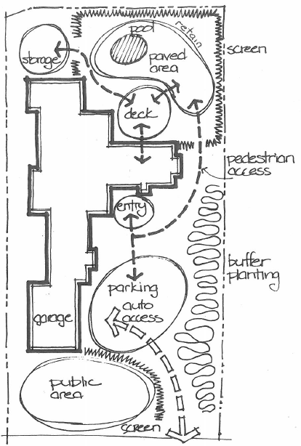

Response
Deck, paved area, planting, pool, retaining wall

Outcome for Activity 1 | ☐ Satisfactory  ☐ Not satisfactory
Trainer/Assessor comments

Identify/list the detail on the landscape plan shown.

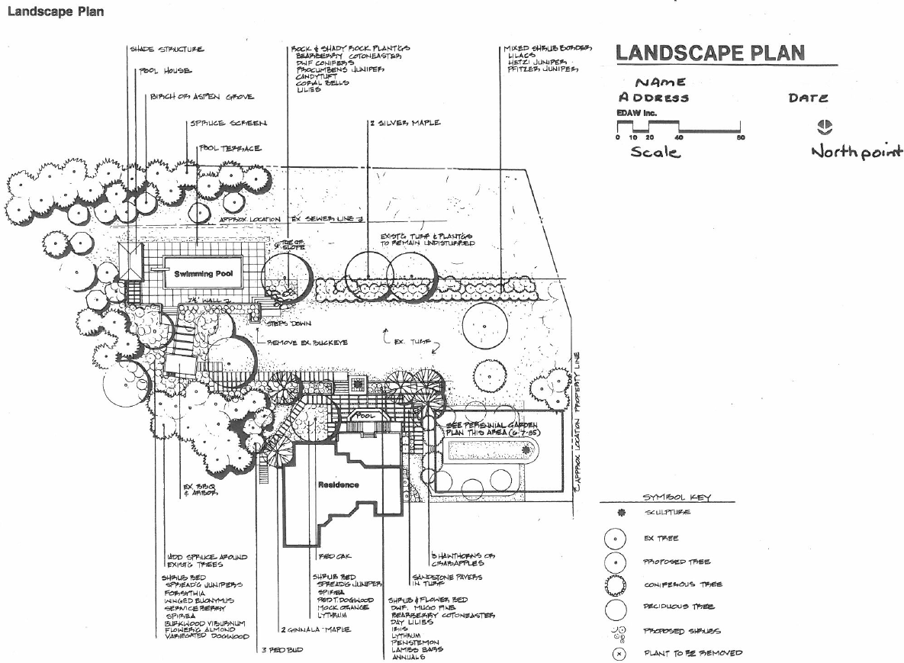

Response
Objects, features, scale, planting,

Outcome for Activity 2 | ☐ Satisfactory  ☐ Not satisfactory
Trainer/Assessor comments

List the materials required to complete the water feature, by using the wall and water feature construction plan shown.

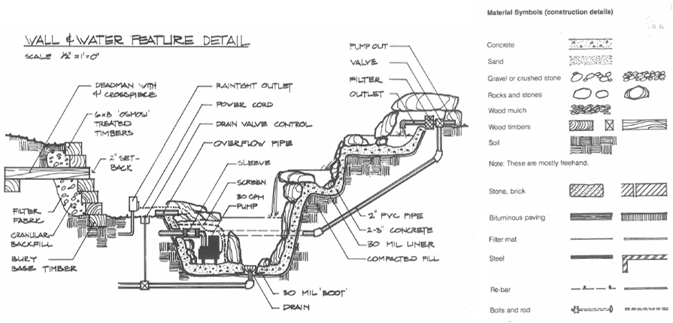

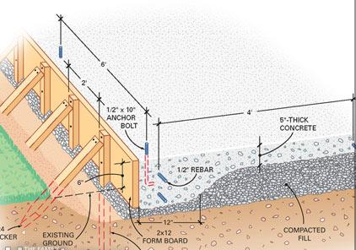

Response
Concrete, sand , gravel, rocks, wood mulch/timbers, soil ,stone blocks, paving , filter mat, steel, rebar, bolts and rods.

Outcome for Activity 3 | ☐ Satisfactory  ☐ Not satisfactory
Trainer/Assessor comments

Research and list relevant laws and standards relating to concreting works
(e.g. Building Codes, Australian Standards, Codes of Practice)

 | Name of document
- Laws | NATIONAL CODE OF PRACTICE FOR PRECAST, TILT-UP AND CONCRETE ELEMENTS IN BUILDING CONSTRUCTION
- Standards | NATIONAL CODE OF PRACTICE FOR PRECAST, TILT-UP AND CONCRETE ELEMENTS IN BUILDING CONSTRUCTION
- Codes | NATIONAL CODE OF PRACTICE FOR PRECAST, TILT-UP AND CONCRETE ELEMENTS IN BUILDING CONSTRUCTION

Outcome for Activity 4 | ☐ Satisfactory  ☐ Not satisfactory
Trainer/Assessor comments

List the components for four (4) common surface drainage systems used in landscape construction.

System | Components
- Spoon
- Channel and grate
- Pit
- Contour

Outcome for Activity 5 | ☐ Satisfactory  ☐ Not satisfactory
Trainer/Assessor comments

List the advantages and disadvantages of drainage behind and through the build wall (as shown).

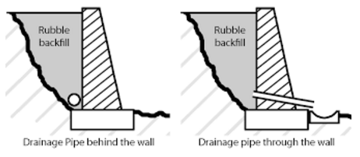

Drainage pipe behind the wall
Advantages
Not noticeable from the outside of the wall. Functions well.
Disadvantages
If clogged or broken you must remove all backfill to access

Drainage pipe through the wall
Advantages
Easy to maintain, very good job of draining water from wall.
Disadvantages
Can be seen from front of the wall.

Outcome for Activity 6 | ☐ Satisfactory  ☐ Not satisfactory
Trainer/Assessor comments

Explain the purpose of a slump test. Describe the process of how such a test is conducted.

Response
- Get a concrete sample.
- Remix the fresh concrete.
- Place the slump cone on a flat surface.
- Filling the cone.
- Lifting the cone.
- Checking the slump.
- Record the distance to the nearest 10mm.

Outcome for Activity 7 | ☐ Satisfactory  ☐ Not satisfactory
Trainer/Assessor comments

Research and list a range of curing compounds and the advantages of using each type

Curing compound | Advantages
- Synthetic resin compound | Synthetic resins will seal the concrete by forming a membrane. If we want to provide plastering, the membrane can be removed by washing it with hot water
- Acrylic compound | Acrylic is made of polymers of acrylic acid. It also seals the concrete in good manner. It is having property of adhesion to the subsequent plaster. No need to wash the surface of acrylic with hot water if we want to provide plastering
- Wax compound | Wax compound have similar properties like resin compound. The wax membrane will lose its efficiency with time increment.
- Chlorinated rubber compound | Chlorinated rubber type curing compound will form thick layer when we applied. It seals the concrete tightly and also fills the minute pores present in the concrete. But the film cannot stay for longer period. It is wear out in the long run.

Outcome for Activity 8 | ☐ Satisfactory  ☐ Not satisfactory
Trainer/Assessor comments

List environmentally safe products for cleaning.

Response
Any chemicals produced by the company green works is listed as environmentally safe.

Outcome for Activity 9 | ☐ Satisfactory  ☐ Not satisfactory
Trainer/Assessor comments

Have team members take photos and videos of your involvement with concrete features.

Identify each photo / video with a letter label and describe each photo / video in the table below. Submit the photo / video files along with this workbook.

Advantages
A
B
C
D
E
F
G
H
I
J
K
L
M
N
O
P
Q
R
S
T
U
V
W
X
Y
Z

Outcome for Activity 10 | ☐ Satisfactory  ☐ Not satisfactory
Trainer/Assessor comments

