Workplace Assessment 12 – Assessor’s Checklist
(This form is for the assessor’s use only)

Purpose
This Assessor’s Checklist lists the specific criteria that the candidate’s submission for Workplace Assessment 12 must satisfactorily meet.
This form is to be completed by the candidate’s assessor to document their assessment of the candidate’s submission in Workplace Assessment 11.

Task Overview
For this task, the candidate is required to prepare the Amendments and Conditions to the Tender/Contract.
In this task, the candidate will be assessed in their:
- Practical knowledge of amendments and conditions to the tender or contract
- Practical skills relevant to preparing amendments and conditions to the tender or contract

Instructions to the Assessor

During the assessment
- Review the candidate’s Amendments and Conditions to the Tender/Contract submission.
- For each criterion listed in this checklist:
  - Tick YES if you confirm the candidate’s submission satisfactorily meets the criterion.
  - Tick NO if you confirm the candidate’s submission does not satisfactorily meet the criterion.
- Write specific comments on the candidate’s performance in each criterion. Your feedback/insights will help address any area/s for improvement.

After the assessment
- Complete all parts of the Assessor’s Checklist, including the Assessor Declaration on the last page of this form. Your signature must be handwritten.

Candidate Details
Candidate name | Dawei Yang

Assessor Details
Candidate is assessed by | Steve Zhu

Context of the Assessment
Workplace/organisation | Dawn construction
Building and construction project | Granny flat and massage shop
Building classification | class1&5

Resources required for the assessment | - Building and construction project  - Residential project, AND  - Commerical project  - Opportunities to prepare any amendments and conditions to the tender or contract  - Template for drafting Amendments and Conditions to the Tender/Contract

Assessor’s Checklist
The candidate’s Amendments and Conditions to the Tender/Contract submission: | YES/NO | Assessor’s comments
- Contains a paragraph introducing the name of the candidate’s organisation | Residential  YES NO  Commercial  YES NO
- Contains a paragraph stating the name of the client’s organisation | Residential  YES NO  Commercial  YES NO
- States the conditions for:
- indemnification | Residential  YES NO  Commercial  YES NO
- dispute resolution | Residential  YES NO  Commercial  YES NO
- termination | Residential  YES NO  Commercial  YES NO
- inspection | Residential  YES NO  Commercial  YES NO
- liquidated damages | Residential  YES NO  Commercial  YES NO
- force majeure | Residential  YES NO  Commercial  YES NO
- States the proposed amendments
- Additions to clauses are underlined | Residential  YES NO  Commercial  YES NO
- Deletions are crossed out (i.e. strikethrough) | Residential  YES NO  Commercial  YES NO
- Specifies that a new clause is provided as a replacement of the original clause (for clauses needing replacement) | Residential  YES NO  Commercial  YES NO
- Explicitly describes the changes incorporated in the tender/contract | Residential  YES NO  Commercial  YES NO
- Contains fields for sign-off from the candidate’s organisation | Residential  YES NO  Commercial  YES NO
- Contains fields for sign-off from client organisation | Residential  YES NO  Commercial  YES NO
- Contains field for sign-off from legal officer | Residential  YES NO  Commercial  YES NO

Assessor Declaration
By signing here, I confirm that I have thoroughly reviewed the candidate’s Amendments and Conditions to the Tender/Contract submission for this workplace assessment task.
I confirm that the information recorded on this Assessor’s Checklist is true and accurately reflects the candidate’s submission for this workplace task.
Assessor’s signature | 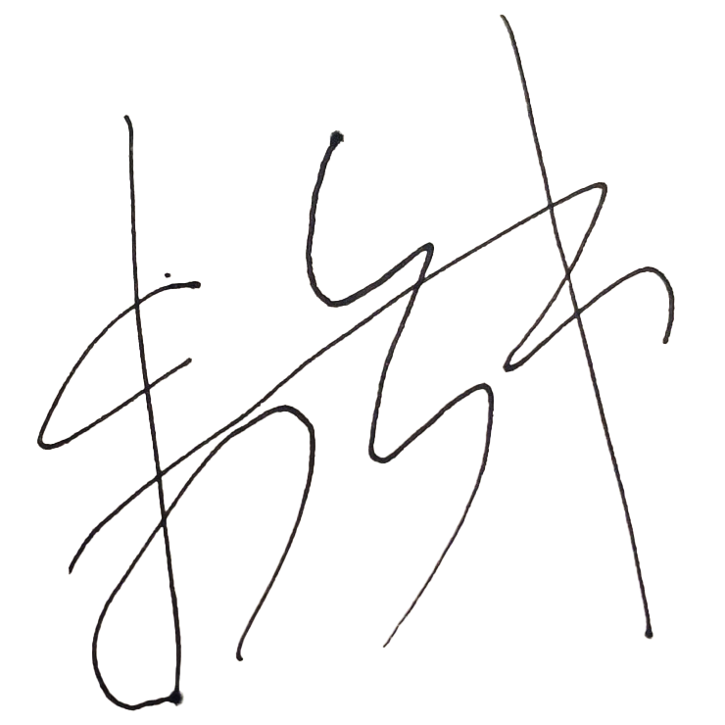
Assessor’s name | Steve Zhu
Date signed | 19/01/2023

End of Workplace Assessment - Assessor’s Checklist

