BSBOHS201A
Participate in OHS processes

THEORY EXAM INSTRUCTIONS

- This exam will occur under standard assessment conditions.
  - An oral examination may be allowed under certain circumstances.
Answers will be documented and FT003 (Oral examination declaration form) must be completed.
- Participants must provide enough detail in their responses to demonstrate their knowledge and skills.
- Please fill in the details below, providing your name, signature and date of assessment.
  - Your signature acknowledges that this is your own work.
- If a participant initially answers a question incorrectly but modifies their response, they must follow the instructions below:
  - If a participant changes their response in writing, they must put their initials next to the written change.
  - If a participant changes their response verbally, this must be noted on the exam paper by the assessor.

Participant name | Leilani Kyle
Participant signature

Assessor name
Assessor signature | 

Date | 29/10/2018

Number of questions | Number of questions answered correctly | Satisfactory?
24 |  | Yes | No
24 |  | ◻ | ◻

Assessor Comments

- Match the terms and definitions by writing the appropriate letter next to each number in the centre column.

Answer | Terms |  | Answers | Definition |  | ◻
 | 1 | PRA | 1 - F | A | Outline the requirements of the work to be undertaken.
 | 2 | JSA | 2 - E | B | Outline what to do in the event of fires and other accidents
 | 3 | Plans and specifications | 3 - A | C | Contains important information about hazardous materials or chemicals.
 | 4 | Manufacturer specifications | 4 - D | D | Outlines how tools and equipment should be used (e.g. lubricant levels, maintenance requirements).
 | 5 | SDS | 5 - C | E | Identifies hazards and potential hazards that may be encountered while working.
 | 6 | Emergency procedures | 6 - B | F | A personal assessment of risk

- For each of the hazards identified below, describe the injuries/damage they may cause (i.e. to fellow workers, other people and/or animals) and suggest a suitable control measure.
Answer | Hazard | Injuries or damage | Control measure | ◻
 | Hazardous chemical | Inhaling or contact with the chemical could cause serious medical issues | PPE, correct storage, labelling, Training.
 | Noise | Hearing damage, distress, disruption, could cause an incident due it being harder to communicate | ear muffs (PPE), noise barriers or mufflers on the source, complete the work in specific hours
 | Manual handling | Sprains, trips and falls | Training, lift restrictions, tools such as trolleys, etc.

- Who should you speak to if you find problems (e.g. hazards, accidents and emergencies)?

Answer | A supervisor, manager or health and safety representative | ◻

- What should you do if you discover a fault with plant, tools or equipment?

Answer | Stop operation/use, report to supervisor or HS representative, fill out required forms/reporting | ◻

- Which legislation relates to safety in the workplace? Tick your response.

Answer | Choice | Possible Answers | ◻
 | X | Occupational Health and Safety Act 2015
 | x | Work Health and Safety Act 2011
 | ☐ | Safety Act 1900
 | ☐ | Safety and Health Act 2011

- True or False (Tick your response): Employers are required by legislation to implement safety measures which are reasonably practicable.

Answer | x | True |  | ◻
 | ☐ | False

- True or False (Tick your response): Workers are required by legislation to follow reasonable employer directives (e.g. to undertake first aid and/or fire safety training).

Answer | x | True |  | ◻
 | ☐ | False

- The following symbols appear under the heading ‘Required PPE’ on an SDS. What do the symbols represent?

Answer | Symbol | Meaning | ◻
 |  | Skin Protection required (long sleeved clothing)
 |  | Hand Protection required
 |  | Eye protection required
 |  | Respiratory Protection required

- Describe the meaning and use of the signs displayed below.

Answer | Sign | Meaning | ◻
 | 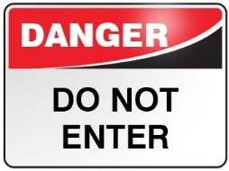 | Means do not enter the area it is posted outside of. Used to restrict areas to help protect the health and safety of others

Refer to the Risk Matrix below when responding to Q10. to Q12.

Matrix | A:  Death or permanent disability | B:  Serious injury | C:  Lost time injury | D:  Casualty Treatment | E:  First Aid
1: Very Likely | E | E | H | H | M
2: Likely | E | H | H | M | M
3: Possible | H | H | M | M | L
4: Unlikely | H | M | M | L | L
5: Very Unlikely | M | M | L | L | L

E: Extreme | H: High | M: Medium | L: Low

- Which rating is designated for the highest risk and which rating is used for the lowest risk?

Answer | Highest risk A1 Extreme  Lowest risk E5 Low | ◻

- What is the risk rating for the following circumstances: An event which is possible and would require low-level hospital treatment.

Answer | D3 - Medium | ◻

- What are the factors that would lead to a risk rating of E: Extreme?

Answer | A high possibility of the hazard causing serious injury or death | ◻

- When should safety checks be undertaken on machinery and equipment? Tick your response.

Answer | Choice | Possible Answers | ◻
 | ☐ | Before operation
 | ☐ | After operation
 | X | Both before and after operation

- Order the elements of the hierarchy of control, from 1 to 6 (i.e. most effective to least effective).

1

2

3

4

5

6

Answer | Label (1 – 6) | Element | ◻
 | 3 | Isolate the hazard
 | 6 | Provide and use Personal Protective Equipment (PPE)
 | 1 | Eliminate the hazard
 | 4 | Control the hazard by engineering means
 | 5 | Control the hazard by administrative means
 | 2 | Substitute the hazard

- Why is elimination the best method of hazard control and PPE considered the least effective?

Answer | Eliminating the hazard means that this particular risk is now completely taken away | ◻

- If you were to replace a flammable solvent with a water-based solvent, what category of control measure would that be under the hierarchy of control?

Answer | Substitution | ◻

- In the diagram below a person is lifting a tool box.
Filling in the table, indicate how each body part should be used/placed.
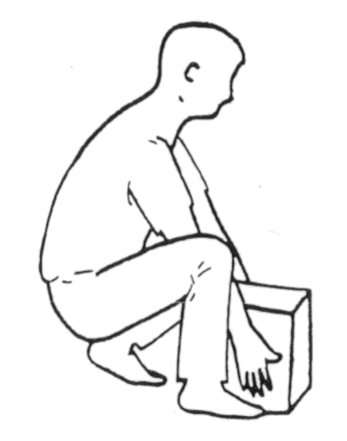
F. Hands
E. Knees
D. Shoulders
C. Feet
B. Back
A. Neck
Answer | Area of body (Letter) | How it should be placed | ◻
 | D | Level
 | A | Upright
 | F | Good grip
 | B | Natural curve
 | E | Bent
 | C | Flat, facing load

- In a medical emergency, what is the first step in the DRSABCD action plan that you need to follow?

Answer | Check for danger - checking if there is still a hazard | ◻

- In the event of a fire emergency, what should you do?
Fill in the table below to explain the acronym R.A.C.E.

Answer | Letter | Meaning | ◻
 | R | Remove people from the area
 | A | Alert
 | C | Confine the fire
 | E | Evacuate

- What should you do as part of the clean up process? Tick all that apply.

Answer | Choice | Possible Answers | ◻
 | ☐ | Store all plant, tools and equipment without cleaning
 | X | Maintain plant, tools and equipment
 | X | Dispose of materials that cannot be reused or recycled
 | X | Report faults in logbook and/or site records
 | X | Clean all plant, tools and equipment before storage

- Read the scenario below and complete the Hazard Report Form.

SCENARIO
Today at 10:45am a delivery truck reversed into a car park (located at 54 Standish Street, Salisbury) to deliver gardening materials. There was nobody in the car park to guide the driver and he backed into a number of drums of diesel located to the left of the photograph (below). One drum was pierced and its contents erupted from the container.

The marked area on the photo represents the diesel spill, measuring 3m x 4m.

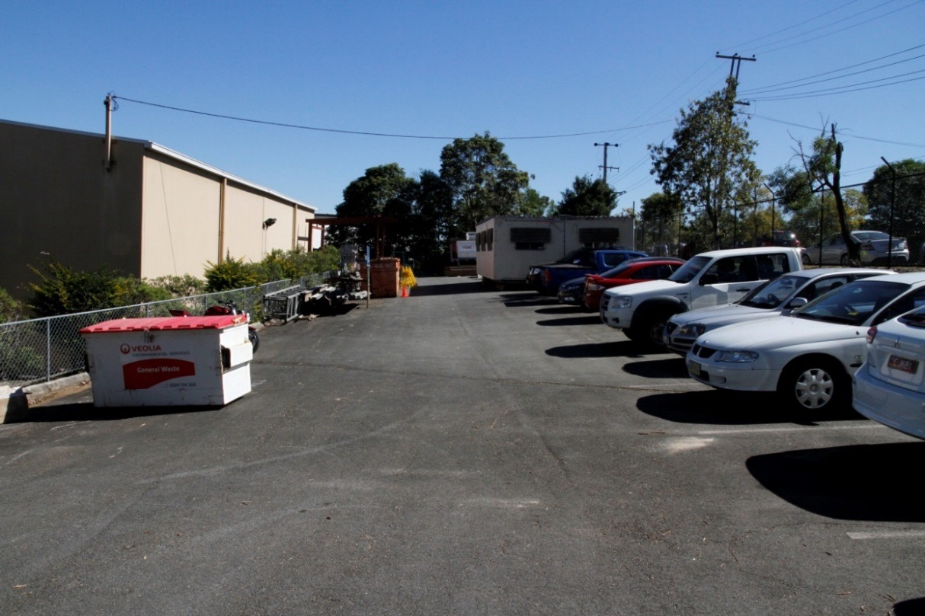
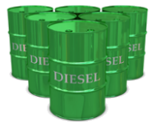

HAZARD REPORT FORM

GENERAL
Date | 29/10/18
Submitted by | Leilani Kyle
HAZARD DETAILS
Location | 54 Standish Street, Salisbury
Description of issue | Diesel spill of 3m x 4m caused by a truck backing in to diesel drums.
Risk class | ☐ Extreme | ☐ High | x Medium |  |  | ☐ Low
CONTROL MEASURES
Corrective action required | Contact site personnel, isolate area, spill kit required to clean up, fill in incident report for the site
Person to action | Site supervisor, manager and/or HS representative |  |  | When | X Immediately  ☐ Within 24 hours  ☐ Within 7 days

Answer |  | ◻

- Who would you submit a hazard report form to?

Answer | Supervisor, manager or HS representative | ◻

- Who would approve proposed risk controls and organise the required resources for implementation of the risk control?

Answer | Supervisor, manager or HS representative | ◻

- Identify one (1) way you can assess if risk controls have been effective.

Answer | If hazard has been eliminated in the requested timeframe | ◻

