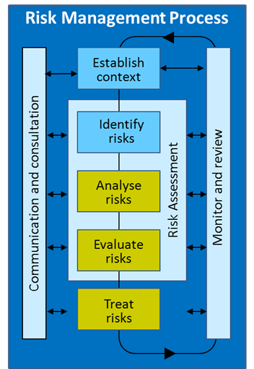Aim of this fact sheet
This fact sheet aims to help DETE staff members engaged in planning and risk management activities to understand:
- the difference between controls and treatments
- how to evaluate controls
- how to treat risks.

What is the difference between controls and treatments
The formal definitions of a control and treatment are:
- controls are measures that modify risk
- treatments are process to modify risk.
These definitions don’t help much in identifying or recognising controls and treatments.
Both controls and treatments:
- are designed to modify the risk by reducing the likelihood of negative risks occurring and/or reducing the consequence of negative risks should they occur (or, conversely, increasing likelihood and consequence if positive risks)
- are targeted to address the root cause of the risk
- may not always exert the intended effect in modifying the risk.
The difference lies in whether they are established at the time of the risk assessment, for example:
Controls | Treatments
- Existing strategies and processes currently in place such as systems, policies, procedures, standard business processes, practices.  - Some examples of controls include: Employee Code of Conduct, budget management, media and public relations protocols, delegation authorities, and security access to buildings.  - A risk may have more than one control, and a control may address more than one risk. | - Additional strategies/activities we need to develop and implement should the risk level be unacceptable after controls are applied.  - Should a control be assessed as ineffective or where there are control gaps to modify the risk, a treatment plan may include strengthening the controls or developing new controls.  - Generally treatments are specific to a risk.  - A treatment only becomes a control after it has been fully implemented and deemed effective in modifying the risk to an acceptable level.

How to evaluate controls
Each control needs to be evaluated to ensure that it is effective, reliable and being applied. When controls are working effectively and as intended, they will reduce the risk level. Too many controls or controls that are too stringent may hamper service delivery (through ‘red tape’) and/or waste resources.
To evaluate a control, consider factors such as:
- Is the control ‘fit for purpose’ for example, design effectiveness?
- Does the control work as practically as intended for example, operational effectiveness?
- Is the control relevant?
- Is the control documented?
- Is the control being used?
- Is the control up to date?
If an existing control is ineffective, then improvement to the control should be included in the treatment plan.
You can find more information on designing and evaluating controls in Queensland Treasury’s Financial Accountability Handbook at http://www.treasury.qld.gov.au/office/knowledge/docs/financial-accountability-handbook/fah-volume-3-complete.pdf.

How to treat risks
Each unacceptable risk will have treatments. Risk treatment involves identifying the options for treating the risk, assessing those options, preparing risk treatment plans, and implementing them. Other than avoiding the risk entirely by terminating the activity, treatment options include:
- reduce the likelihood of the risk occurring
- reduce the consequences of the risk occurring
- share/transfer the risk to another party for example, contracts, insurance, outsourcing, joint ventures etc.
- retain the risk by informed decision – our ability to treat some risks may be limited and the risk is retained. Under these circumstances plans should be put in place to manage/ fund the consequences of the risk should it occur.
The following should be considered when evaluating treatment options:
- How will the treatment modify the level of risk?
- How do costs balance out against benefits?
- How compatible is the treatment with the overall departmental objectives?
- Does it comply with legislation?
- Does it introduce new or secondary risks? (to DETE, its stakeholders)?
For complex treatments, a treatment plan can be developed. Components of a treatment plan may include:
- target risk level
- proposed action
- resource requirements
- responsibility
- timing
- performance measures
- reporting and monitoring requirements.
On a final note, the department has limited or no control over some risks such as natural disasters, the effect of international financial markets, terrorism and pandemic illnesses. The only action we can take is to plan and prepare for such events through business continuity planning (see DETE Business Continuity Management Framework 2011-14).

AS/NZS ISO 31000:2009 Risk management – Principles and guidelines

