CPCCBC6016
Assess construction faults in large building projects

ASSESSMENT SUMMARY

The assessment activities for CPCCBC6016 Assess construction faults in large building projects cover all aspects of the unit of competency. For Apprentices/Trainees, this includes supervisor completion of the Apprentice/Trainee Record (ATR).

Participants must read all the information given before starting any assessment task. The assessment tasks are intended to be fair, flexible, valid and reliable. If a Participant has any questions or requires alternative arrangements to be made such requests should be directed to their Trainer/Assessor, who should note such arrangements in the ‘Assessor Comments’ on the affected assessment. If a Participant feels they are not yet ready to be assessed, they should discuss their options with their Trainer/Assessor.

To satisfactorily complete the assessment, the Participant is required to answer all questions correctly and demonstrate their skills to industry standards. If a Participant does not answer all questions or perform all tasks, they will be deemed ‘Not Satisfactory’ for the task and ‘Not Yet Competent’ for the unit of competency.

The Trainer/Assessor can provide the Participant with additional information on interpreting the assessment outcomes and guide the Participant’s options. If a Participant is still deemed ‘Not Satisfactory’ they will have the opportunity to undertake a supplementary assessment or appeal the result as per the process in the Student Handbook.

By signing below, the Participant acknowledges:
- They understand the assessment instructions and requirements, and consent to being assessed.
- The work submitted is to be their own work – with the work of/with others needing to be clearly acknowledged and documented.
- They consent to any photo/video recording of their work that occurs during assessment.

Participant name | Ethan Wilson
Participant signature | 

Pre-requisite unit(s) to be achieved and authenticated prior to undertaking assessment
Not applicable

Task | Date completed | Assessment Results
Theory Exam | Select Date. | Satisfactory | Not Satisfactory
Practical Assessment | Select Date. | Satisfactory | Not Satisfactory
Outcome for CPCCBC6016 | Select Date. | Competent | Not Yet Competent

Evidence requirements checklist (ticked by assessor and evidence supplied to RTO)
Theory Exam | Practical Assessment  Rectification report with detailed sketches

Assessor name
Assessor signature

CPCCBC6016
Assess construction faults in large building projects

THEORY EXAM

Participant name | Ethan Wilson

FOR THE PARTICIPANT
Instructions
- You will complete written questions as outlined on the following pages. You must attempt all questions and provide enough detail in your responses to demonstrate your knowledge.
- It is anticipated that you should complete this assessment within two (2) hours, but additional time may be allowed upon negotiation with the Assessor.
- You must complete all questions unassisted by the Assessor or other personnel but may refer to reference material as needed. All questions must be answered correctly for a ‘Satisfactory’ assessment outcome to be awarded.
  - An oral examination may be allowed under certain circumstances, whereby your answers will be documented by another party.
  - Any written questions that are incomplete, or not answered satisfactorily will need to be completed again after further training support.
    - If you answer a question incorrectly but modify your response, put your initials next to the written change (or the Assessor must initial a verbal change).
Resources required
Pen

FOR THE ASSESSOR
Instructions
- Where oral examination has occurred, ensure that this is acknowledged in writing (e.g. FT001 and Assessor Comments)
- All questions must be satisfactorily demonstrated by the Participant for a Satisfactory determination (indicated by an Assessor tick to the right of the question).
- Assessors are to complete marking in pen of a different colour to the Participant.
- If the Participant verbally modifies their response, write in the modified response verbatim and put your initials next to the written change.

ASSESSOR COMMENTS
As necessary, outline:
- Details on reattempts, alternative arrangements or reasonable adjustments made.
- Where a Participant is deemed ‘Not Satisfactory’, provide recommendations for future training.

- Explain the purpose of the Building Act 1975.

Answer | plays a role in ensuring that buildings in Queensland are constructed and maintained to high standards of safety, quality, and compliance with regulatory requirements. It aims to protect the interests of property owners, occupants, and the broader community by establishing clear guidelines and responsibilities for all parties involved in building activities

- Explain the purpose of the Plumbing and Drainage Act 2018.

Answer | aims to ensure that plumbing and drainage systems in Queensland are installed and maintained to high standards of safety, efficiency, and environmental responsibility. By regulating these systems, the Act helps protect public health, promote sustainable practices, and uphold the rights and interests of consumers and stakeholders in the plumbing industry.

- a) What is the name of the Environmental Protection Act in your State/Territory?
b) What is the purpose of this Act and its regulations?

Answer  a)  b) | Environmental Protection Act 1994  managing and protecting the environment, including regulations concerning pollution control, waste management, environmental authorities for activities that may impact the environment, and mechanisms for environmental monitoring and enforcement. It outlines responsibilities for individuals, businesses, and government agencies to ensure sustainable environmental practices

- What are the requirements for compliance and conformance according to National Construction Code (NCC)?

Answer | compliance and conformance with the National Construction Code involve meeting Performance Requirements through either Deemed-to-Satisfy Provisions or Alternative Solutions. Documentation, oversight by regulatory authorities, and adherence to updated editions of the NCC are essential for achieving compliance in building design and construction in Australia.

- Discuss the purpose of Work Health and Safety ‘Codes of Practice’.

Answer | Work Health and Safety Codes of Practice play a crucial role in promoting and maintaining safe workplaces by providing clear, practical guidance on how to identify, assess, and control workplace hazards and risks. They support compliance with WHS laws and foster a culture of safety, ultimately aiming to prevent work-related injuries, illnesses, and fatalities.

- The National Construction Code (NCC) Volume Two Amendment 1 – Part 3.0 Structural provisions discusses ‘Resistance to actions’. Explain what is stated.

Answer | ensures that buildings and structures are designed and constructed to safely withstand the loads and forces they are likely to encounter throughout their service life, thus ensuring the safety of occupants and the longevity of the structure.

- What is covered in AS/NZS 1170 series?

Answer | set of standards developed jointly by Standards Australia and Standards New Zealand. These standards cover the structural design actions (loads and forces) that buildings, structures, and other civil engineering works are expected to withstand in Australia and New Zealand.

- Explain why you should review project drawings, details and specifications when assessing construction faults in buildings.

Answer | reviewing project drawings, details, and specifications when assessing construction faults ensures thorough documentation, verification of compliance with standards, identification of discrepancies, and understanding of design intent. This comprehensive review process is essential for accurately diagnosing and addressing construction faults in buildings.

- Discuss the basic principles of structural design that must be considered in any building design.

Answer | Structural design principles form the foundation of ensuring that buildings and structures are safe, functional, and durable throughout their intended lifespan. These principles are fundamental to the process of designing structures that can withstand various loads and forces they may encounter.

- Discuss compressive and tensile stresses on buildings.

Answer | compressive and tensile stresses are critical considerations in the design and construction of buildings. Engineers carefully analyze and design structural elements to ensure they can withstand the specific stresses imposed by various loads and environmental conditions, ensuring buildings are safe, durable, and efficient throughout their lifecycle.

- Discuss the structural significance of building basements in tall buildings.

Answer | basements play a crucial role in the structural design and performance of tall buildings, providing foundation support, enhancing stability against lateral forces, integrating essential services, offering storage and parking, and enhancing overall safety and functionality. Their design and construction are carefully considered to optimize the building's efficiency, safety, and resilience throughout its lifespan.

- What is meant by the term the ‘aesthetics’ of a structural design?

Answer | the aesthetics of structural design go beyond purely functional considerations to encompass the artistic and visual qualities that contribute to a building's overall beauty, character, and appeal. Achieving successful aesthetics in structural design requires collaboration between architects, engineers, and other stakeholders to balance functional requirements with artistic vision and cultural context.

- Explain economic factors and how these affect design.

Answer | economic factors exert a profound influence on the design of buildings and structures. Designers must balance aesthetic, functional, and regulatory considerations with financial constraints to deliver projects that are cost-effective, sustainable, and meet client expectations for return on investment. By integrating economic considerations throughout the design process, architects and engineers can optimize project outcomes and enhance the overall economic viability of the built environment.

- ‘The function of a structure is to resist forces in equilibrium’ - what does this mean?

Answer | the function of a structure to resist forces in equilibrium means that a well-designed and properly constructed structure will distribute and balance external loads through its components in such a way that the structure remains stable, safe, and structurally sound throughout its intended service life. Achieving this equilibrium is essential for ensuring the reliability, durability, and safety of buildings and other engineered structures.

- Why is reinforced concrete commonly used for the construction of high-rise buildings?

Answer | reinforced concrete’s combination of strength, durability, fire resistance, design flexibility, and cost-effectiveness makes it a preferred choice for constructing tall buildings around the world. It provides structural engineers and architects with the tools necessary to create safe, functional, and aesthetically pleasing high-rise structures that meet the demands of urbanization and modern living.

- Discuss why you might need to consult the structural engineer regarding the loads and forces acting on a beam or column.

Answer | consulting a structural engineer regarding loads and forces acting on beams or columns is essential for ensuring the structural safety, performance, and compliance of buildings and structures. Engineers’ expertise in load analysis, material selection, structural design, and compliance with codes ensures that structural elements are appropriately designed to withstand all anticipated forces and conditions.

- Determine the bending behaviour of a column under axial load.

Answer | Understanding the bending behavior of columns under axial load is essential for designing safe and efficient structural systems. It involves considering the interaction between axial compression and bending moments to ensure that columns are designed to withstand all anticipated loading conditions and maintain structural stability throughout their service life.

- Describe the performance characteristics of columns under eccentric load.

Answer | columns subjected to eccentric loads exhibit complex behavior involving combined axial compression and bending moments. Understanding these performance characteristics is essential for designing columns that can safely and effectively support eccentric loads without compromising structural integrity or safety.

- Discuss bending moments, shear forces, deflection and torsion of beams and slabs.

Answer | Beams/Slabs | Response
 | Beams | bending moments result from loads that create a bending effect perpendicular to the longitudinal axis of the beam.  Shear forces are internal forces that cause one part of the beam to slide or shear relative to an adjacent part along the plane of the cross-section. Shear forces act parallel to the longitudinal axis of the beam.  Deflection is the deformation of a beam under applied loads, typically measured as the displacement of a point on the beam’s axis or at its surface.
 | Slabs | Bending moments in slabs are moments that induce curvature or bending along the plane of the slab due to applied loads. These moments result in tensile stresses on the bottom fibers and compressive stresses on the top fibers of the slab.  shear forces in slabs are forces that cause internal shear stresses perpendicular to the plane of the slab. These forces act parallel to the surface and can cause sections of the slab to slide relative to each other.  Deflection in slabs is the deformation or displacement of the slab under applied loads. It is measured as the downward displacement of a point on the slab’s surface or the entire slab itself.

- Discuss how beams are connected to columns. Explain your answer.

Answer | the connection of beams to columns is a critical aspect of structural engineering, ensuring that forces and moments are efficiently transferred while maintaining structural integrity and stability. Proper design, detailing, and construction of these connections are essential to the overall performance and safety of the building or structure

- Describe the slenderness ratio and its effect on columns.

Answer | the slenderness ratio is a crucial parameter in column design that governs the buckling behavior and stability of columns under axial compression. Engineers carefully assess and manage the slenderness ratio to ensure columns can safely resist compressive loads without buckling prematurely or failing structurally.

- Discuss the characteristics of dead loads and live loads. Include how each is calculated.

Answer | Load | Characteristics and calculations
 | Dead load | Dead loads, also known as permanent loads or static loads, are the constant or stationary loads that act on a structure due to its own weight and the weight of its components. These loads do not change over time and are always present, influencing the structural design and stability of buildings and other structures.
 | Live load | Live loads are dynamic forces that act on a structure due to temporary or variable conditions. Unlike dead loads, which are permanent and unchanging, live loads fluctuate over time and can vary in magnitude and location. Understanding live loads is essential for ensuring that structures can withstand both regular and exceptional conditions.

- What is the advantage of using composite floor systems consisting of steel beams, profiled metal decking, and reinforced concrete slabs?

Answer | In a composite floor system, the profiled metal decking acts as a formwork for the concrete slab and provides shear connection between the steel beams and the concrete slab. This results in the combined action of steel and concrete working together to resist Larger loads and reduce costs.

- Discuss the characteristics of the following high performance structural elements.

Answer | Structural element | Characteristics
 | Castellated beams | Castellated beams are a type of structural beam known for their distinctive design and high performance in various engineering applications. These beams are created by cutting a standard I-beam and reassembling it to form a series of geometric openings, typically hexagonal or circular, which provide several advantages over traditional beam designs.
 | Laminated beams | versatile and efficient solution for modern structural challenges, offering a blend of strength, sustainability, and design flexibility suitable for a wide range of construction projects.
 | Pre-stressed concrete beams | Pre-stressed concrete beams are engineered to enhance structural performance by applying internal compressive forces through tensioned steel cables or rods, which increases their load-carrying capacity, reduces deflection, and allows for longer spans with thinner cross-sections compared to traditional concrete beams.
 | Trusses | Trusses are structural frameworks composed of interconnected triangular units that distribute loads efficiently, allowing for long spans and minimal material use while providing high strength, stability, and versatility in applications like bridges and roofs.
 | Waffle slabs | Waffle slabs are a type of concrete floor system characterized by their grid-like pattern of reinforced concrete ribs that provide high strength and durability while allowing for large spans and reduced dead weight compared to traditional flat slabs.

- How does thermal impact affect a load on structure?

Answer | Thermal impact on structures affects loads through expansion and contraction, which can cause internal stresses and alter load distribution. Additionally, temperature changes can modify material properties and structural integrity, potentially leading to deformation, fatigue, and altered load-bearing capacities.

- Describe the process associated with fabricating and installing tilt-up concrete panels.

Answer | The process of fabricating and installing tilt-up concrete panels involves pouring concrete into forms on-site to create large panels, which are then cured, lifted into position, and anchored to the foundation. This method offers efficient construction of walls for commercial and industrial buildings due to its speed and cost-effectiveness.

- What are the impacts of creep and shrinkage on concrete structures?

Answer | Creep and shrinkage in concrete structures lead to gradual deformation over time, with creep causing long-term stretching under sustained loads and shrinkage leading to dimensional reductions as the concrete dries. These phenomena can affect structural stability, load distribution, and the durability of concrete elements.

- Discuss considerations that must be made when using masonry in the construction of high-rise buildings.

Answer | When using masonry in high-rise buildings, considerations must include the structural load capacity of masonry walls and the integration of reinforcement to manage tensile stresses. Additionally, factors such as thermal insulation, weatherproofing, and the impact of seismic forces must be addressed to ensure the building’s durability and safety.

- Explain the differences between structural steel and cold-formed steel.

Answer | Structural steel is hot-rolled and used for large, heavy structural applications like beams and columns, whereas cold-formed steel is manufactured by shaping thin steel sheets at room temperature for lightweight framing and secondary structural elements. Cold-formed steel typically has a thinner gauge and is used for applications like interior partitions and roof trusses, while structural steel provides high strength for primary load-bearing structures.

- Discuss three (3) uses of aluminium in the construction industry and why it is used.

Answer  1.  2.  3.
  Architectural Facades
  Aluminium is used for cladding building exteriors and designing facades.
  Window and Door Frames
  Aluminium is commonly used for frames of windows and
  doors in residential and commercial buildings.
  Structural Components
  Aluminium is used for structural elements like beams, trusses,
  and supports in various types of buildings.

- Briefly discuss the use of the following temporary structures and components in the construction of large and complex buildings.

Answer | Temporary structure | Use
 | Bracing | used during the construction of large and complex buildings to stabilize frameworks, prevent collapse, and ensure safety until permanent supports are installed.
 | Closed Sheeting | used to enclose construction sites to protect workers from environmental conditions, ensure safety, and maintain site cleanliness during the construction of large and complex buildings.
 | Formwork props | used to support and stabilize formwork during the construction of concrete structures until the concrete has cured and gained sufficient strength.
 | Pressure resistant formwork | used to withstand the forces exerted by fresh concrete during pouring and curing, ensuring that concrete elements achieve their designed shape and strength.
 | Scaffolding sole plates | used as base supports to evenly distribute the load of scaffolding structures and ensure stability on uneven or soft ground
 | Shields | used to protect workers and the public from falling debris, excavation hazards, and construction activities
 | Shoring collar set | used to support and stabilize vertical structural elements, such as columns or walls, during construction
 | Soldier set | used as vertical supports in excavation projects to stabilize trench walls and prevent soil collapse during the construction

- How do you determine which document to use when communicating construction problems to relevant personnel?

Answer | Choosing the appropriate document involves understanding the problem’s nature and referring to the relevant procedures or forms specified in the project documentation.

- You are contracted to undertake refurbishment of an inner-city hotel. Explain how this is different from a restoration or renovation.

Answer | Refurbishment is updating and improving a building while preserving its overall structure and historical essence. This is different to the restoration and renovation as these will usually involve returning a building to its original state, often to a historical period or making changes to update or repurpose a building. .

- Discuss why you might suggest refurbishing using fire-resistant building materials where possible.

Answer | Using fire-resistant materials in refurbishment projects offers significant advantages, including enhanced occupant safety, compliance with building codes, and increased building resilience.

- Complete the table below by identifying the type of fire-resisting construction (i.e. Type A, Type B, or Type C) given the following class of building and number of storeys each class of building has.

Answer | Rise in Storeys | Class of building:  2,3,9 | Class of building:  5,6,7,8
 | 4 or more | Type A | Type A
 | 3 | Type A | Type B
 | 2 | Type b | Type C
 | 1 | Type c | Type C

- Describe how you would monitor alternative forms of construction to ensure compliance.

Answer | reviewing design specifications, conducting inspections, implementing quality control, monitoring progress, performing tests, and ensuring thorough documentation. By following these steps and using the referenced resources, you can ensure that alternative construction methods comply with regulatory requirements and maintain high safety and quality standards.

CPCCBC6016
Assess construction faults in large building projects

PRACTICAL ASSESSMENT

Participant name

FOR THE PARTICIPANT
Instructions
- The tasks outlined on the following pages will require performance of normal workplace activities, as a result of a structured activity set by an Observer in the workplace or a simulated activity set by your Assessor/Observer.
- The timeframe for these tasks will be established by your Assessor/Observer, in consideration of location conditions and industry requirements.
- You must complete all tasks unassisted by the Assessor or other personnel, unless the steps note this assistance.
- You must attempt all tasks (and itemised steps) for a ‘Satisfactory’ assessment outcome to be awarded.
  - For any observation conducted that is incomplete, or without satisfactory performance, the observation will need to be completed again after further training support.

FOR THE ASSESSOR/OBSERVER
Instructions
- The following observation record should be used to judge and record your observations of the Participant as they complete the task(s) set. You must record your observations of the Participant’s performance.
  - For each occasion, indicate the task performed and whether it was a simulation or workplace-based task.
    - Any simulated assessment must ensure the Participant still performs under workplace conditions which reflect industry standards.
  - In the comments, provide clear detail regarding the task that the Participant was required to do (e.g. PPE used, materials handled, attachments connected, plant types).
- All steps must be satisfactorily demonstrated by the Participant for a ‘Satisfactory’ determination (indicated by an Assessor tick to the right of each itemised step, or an Observer tick to the right of each itemised step, and confirmation by an Assessor in the Assessor Comments).
  - Where you have determined that one or more task steps have not been satisfactorily demonstrated, provide the Participant with additional support and outline details of such assistance in the Assessor/Observer Comments. Allow the Participant two (2) further opportunities to demonstrate the task again to allow an opportunity for a ‘Satisfactory’ assessment outcome to be achieved.
  - If after three (3) attempts the Assessor determines that the Participant cannot demonstrate the required steps, a ‘Not Satisfactory’ outcome is to be determined.

TASK OUTCOME
Task | Date | Task Type (Tick) | Location | Task outcome (Tick)
 |  |  |  | Satisfactory | Not Satisfactory
Task 1 | Select Date. | Workplace  Simulation

ASSESSOR COMMENTS: GENERAL
As necessary, outline:
- Details on reattempts, alternative arrangements or reasonable adjustments made.
- Where a Participant is deemed ‘Not Satisfactory’, provide recommendations for future training.

ASSESSOR COMMENTS: PRACTICAL TASK 1
Individual student (as named on cover page)
Multiple students [ All from Attendance Report, Specific students involved – identify students]
Task | Provide detail
1.1A. | Specify specific construction fault/s on Type A building requiring rectification.
1.1A. | Specify () construction faults associated with two (2) of:  Structural Installation Refurbishment Renovation Restoration  Other (please specify):
1.1C. 1.1D. 1.5A. 1.5B. | Specify workplace practices adhered to when documenting and communicating construction problems to relevant personnel and external professionals.
1.1E. | Specify problem-solving techniques applied:
1.2A. | Specify existing or designed-in construction common/ not common problems identified.  None Other (please specify):
1.2B. | Specify alternative methods or materials suggested.
1.2C. | Specify equipment and programs accessed to extract information:
1.4C. 1.5C. | Specify how alternative method of construction will be managed and monitored.

CPCCBC6016
Assess construction faults in large building projects

Practical Task 1
Description of task:
The participant must demonstrate the skills and ability to assess construction faults and determine remedial action for construction faults associated with at least two (2) of the following: structural; installation; refurbishment; renovation or restoration on a Type A building project. The assessor will be seeking evidence of:
- Identify and analyse construction faults.
  - Collect information relating to specific construction faults.
  - Analyse original construction project plans and specifications to identify potential causes of construction faults or problems. Use problem-solving techniques to identify typical faults and problems.
  - Adhere to workplace practices when documenting and communicating construction problems to relevant personnel.
  - Make contact with project team members and external professionals to elicit expert analysis and opinions.
  - Use problem-solving techniques to identify typical faults and problems.
  - Develop and document a rectification action that meets the Performance Requirements of the National Construction Code (NCC).
- Analyse construction techniques, methods and materials.
  - Analyse working drawings and specifications to identify any existing or designed-in construction problems.
  - Prepare alternative methods and materials to meet the project specification objectives and comply with the NCC and relevant building legislation.
  - Use equipment and programs to access, extract information and develop relevant documentation.
  - Use building terminology accurately in the communication of issues.
- Evaluate alternative construction solutions.
  - Consider and analyse commonly occurring on-site problems with building materials and their causes.
  - Prepare reports identifying available alternative methods and materials available to meet the construction aims and objectives of the specifications.
  - Prepare detailed sketches of available alternative methods and materials that meet the construction aims and objectives of the specification.
- Resolve construction faults using alternative construction methods.
  - Consider and document solutions and recommend suitable alternative methods to resolve the problem and meet project aims and objectives and organisational processes.
  - Integrate selected methods into the project construction works to align with construction schedules and timeframes.
  - Manage and monitor alternative forms of construction to ensure compliance.
- Communicate preferred solution to construction problem.
  - Use digital tools to document technical resolution in detail of identified problem.
  - Lodge appropriate documentation and communicate with appropriate project and other construction professionals.
  - Determine and implement strategies to monitor corrective action processes and procedures.

These tasks may be simulated or real. The Participant is to gather evidence of how they have completed each component of the Practical Task, which is to be submitted with this Practical Assessment sheet. The Observer is to provide detailed comments on the tasks completed by the Participant (on the Observer Comments, overleaf). The Assessor is to verify the Observer’s comments, noting their findings in the Assessor Comments (on the back of the Practical Assessment cover page) and provide the assessment outcome.
Resources required:
Type A building project; access to equipment, technology and software to assess and remediate construction faults in large building projects and collaborate effectively with external professionals; access to relevant government building legislation codes and standards; access to environmental and sustainability requirements; access to manufacturer specifications and installation instructions; workplace policies, procedures and site safety requirements; project plans and specifications.
Observer details
Name of observer: | Mick Hannan
Role of observer  (Confirm suitability to sign) | Site Manager
Email address of observer | mhannan@besixwatpac.com
Signature of observer:
Date: | 2/07/2024

When completing the task, did the Participant: | Tick if satisfactorily completed.  Provide comments if left unticked.
1 Identify and analyse construction faults.
- Collect information relating to specific construction faults.
- Analyse original construction project plans and specifications to identify potential causes of construction faults or problems. Use problem-solving techniques to identify typical faults and problems.
- Adhere to workplace practices when documenting and communicating construction problems to relevant personnel.
- Make contact with project team members and external professionals to elicit expert analysis and opinions.
- Use problem-solving techniques to identify typical faults and problems.
- Develop and document a rectification action that meets the Performance Requirements of the National Construction Code (NCC).(attach rectification request/ report)
2. Analyse construction techniques, methods and materials.
- Analyse working drawings and specifications to identify any existing or designed-in construction problems.
- Prepare alternative methods and materials to meet the project specification objectives and comply with the NCC and relevant building legislation.
- Use equipm ent and programs to access, extract information and develop relevant documentation.
- Use building terminology accurately in the communication of issues.
3. Evaluate alternative construction solutions.
- Consider and analyse commonly occurring on-site problems with building materials and their causes.
- Prepare reports identifying available alternative methods and materials available to meet the construction schedule and objectives of the specifications.(attach report/s)
- Prepare detailed sketches of available alternative methods and materials that meet the construction aims and objectives of the specification. ).(attach detailed sketches)
4. Resolve construction faults using alternative construction methods
- Consider and document solutions and recommend suitable alternative methods to resolve the problem and meet project aims and objectives and organisational processes. (attach report/s)
- Integrate selected methods into the project construction works to align with construction schedules and timeframes.
- Manage and monitor alternative forms of construction to ensure compliance.
5. Communicate preferred solution to construction problem.
- Use digital tools to document technical resolution in detail of identified problem.
- Lodge appropriate documentation and communicate with appropriate project and other construction professionals.
- Determine and implement strategies to monitor corrective action processes and procedures.

Observer comments:
Ethan successfully identified construction issues and found effective solutions, with clear and detailed documentation of his approach, which will be reviewed for compliance with the NCC and project requirements, Ethan Performs this in his day to day role as a foreman onsite working under other foreman’s and site managers. Currently he is working on a 8 storey hospital building so you can imagine how important this is to do on a daily basis.

Thanks Michae

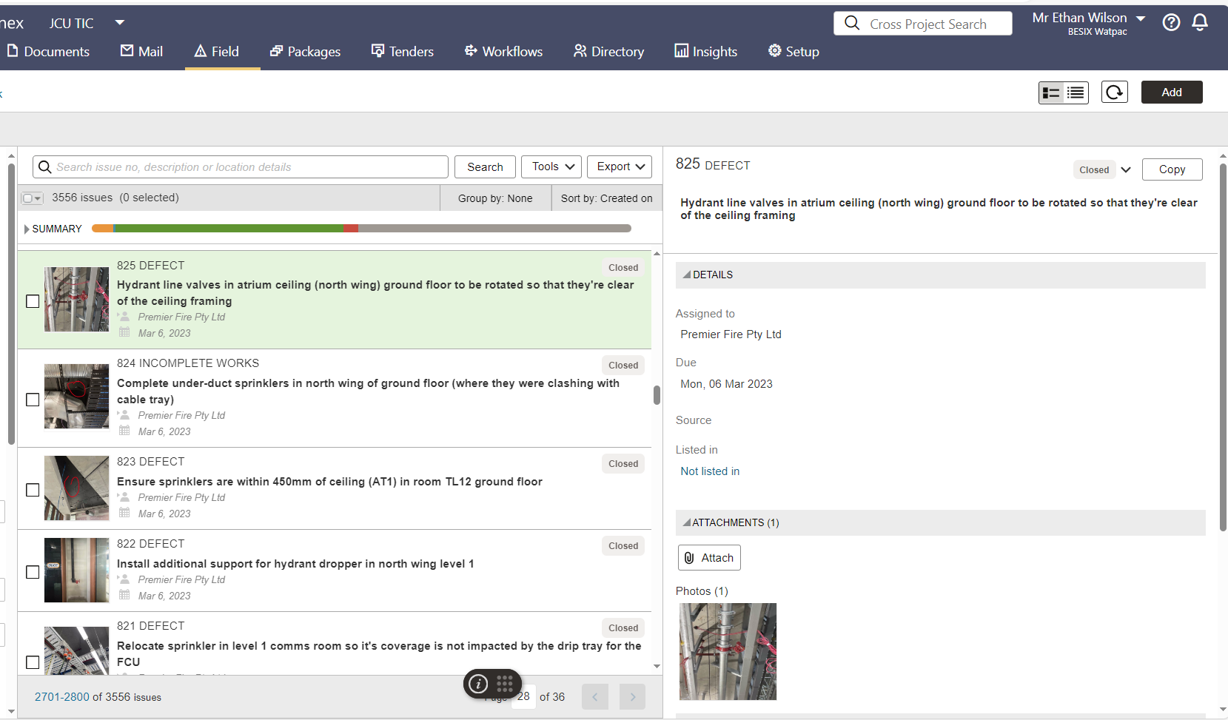
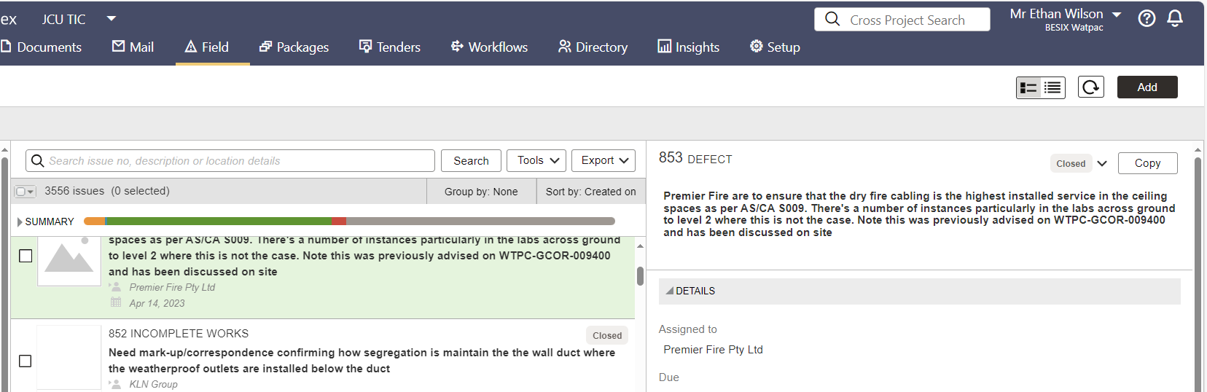l. 

