Presentation for both workers and PCBU.
For both the workers and PCBU, I will be presenting the same paperwork, a “Work Instruction”. By sharing this information to both parties, the PCBU can witness how we are addressing the issue bought up in the site safety meeting.

This work instruction is to give information the importance of wearing seat belts when operating mobile plant on site.


WORK INSTRUCTION 7.013
MOBILE PLANT SEAT BELTS

- Purpose
To give information the importance of wearing seat belts when operating mobile plant on site.
- Scope
For personnel who are the operators of the plant.

3. Responsibility/Qualification
Project Manager/Supervisor has the responsibility of monitoring the safe work behaviours of mobile plant operators.
4. Materials/ Tools/ Equipment
Mobile Plant

5. Pre-requisites/ Safety
The operators of mobile plant must be appropriately licensed, competent to operate or be under supervision of someone who is. Seat belts must be fitted to the plant.
6. Associated Documents
Safe work Method Statement

7. Instruction
Some operators justify not wearing a seat belt when operating mobile plant due to the machine’s slow movement. Even though they do not often reach high speeds on site they can be involved in a rollover. There is no such thing as a slow rollover. When a vehicle overturns the forces are such that you cannot hold on to the steering wheel prevent impacting on the side or roof of the cabin.
All earthmoving machines supplied by CC Group for use on our project sites are fitted with Roll Over Protection Structures (ROPS). This is a metal structure that often sits behind the operator. While it does not prevent a rollover, it will keep the operator from being crushed in the event of one. When an operator is not wearing a seat belt, they are thrown off the machine and crushed, often by the ROPS itself. There are numerous reports available to document the fact that operators in rollovers who were not wearing seatbelts have died while those who performed the simple act of buckling up when involved in a rollover are still alive.
The number one cause of counterbalanced forklift operators dying at work is a tip over. Statistics tell us that if the operator stays inside the overhead guard area in the seat of the truck their chances of survival increase dramatically.
Seat belts are designed to keep you in your seat in the case of tip over. Normal human behaviour says ‘jump’ when a machine starts to tip. In that split second needed to decide, two things motivate the operator in the wrong direction. First, momentum is throwing you to the low side of the machine (direction of tip). And Secondly, in your mind, ground means safety, and the ground is the closest on the low side (direction of tip) the problem is you can’t get away from the machine fast enough, and the overhead guard crushes you at the head, neck shoulders or chest.
Furthermore, you need to keep your hands inside the confines of the operator cabin and ROPS. Humans have another habit and that is to put their arms out to stop a fall. You cannot stop tonnes of machinery in a tip over.

IMS | Document | Author | Issued | Amended | Revision | Page 1 of 2
WI | Mobile Plant Seat Belts | K.C. | 9/8/19 | n/a | 0 | Page 1 of 2

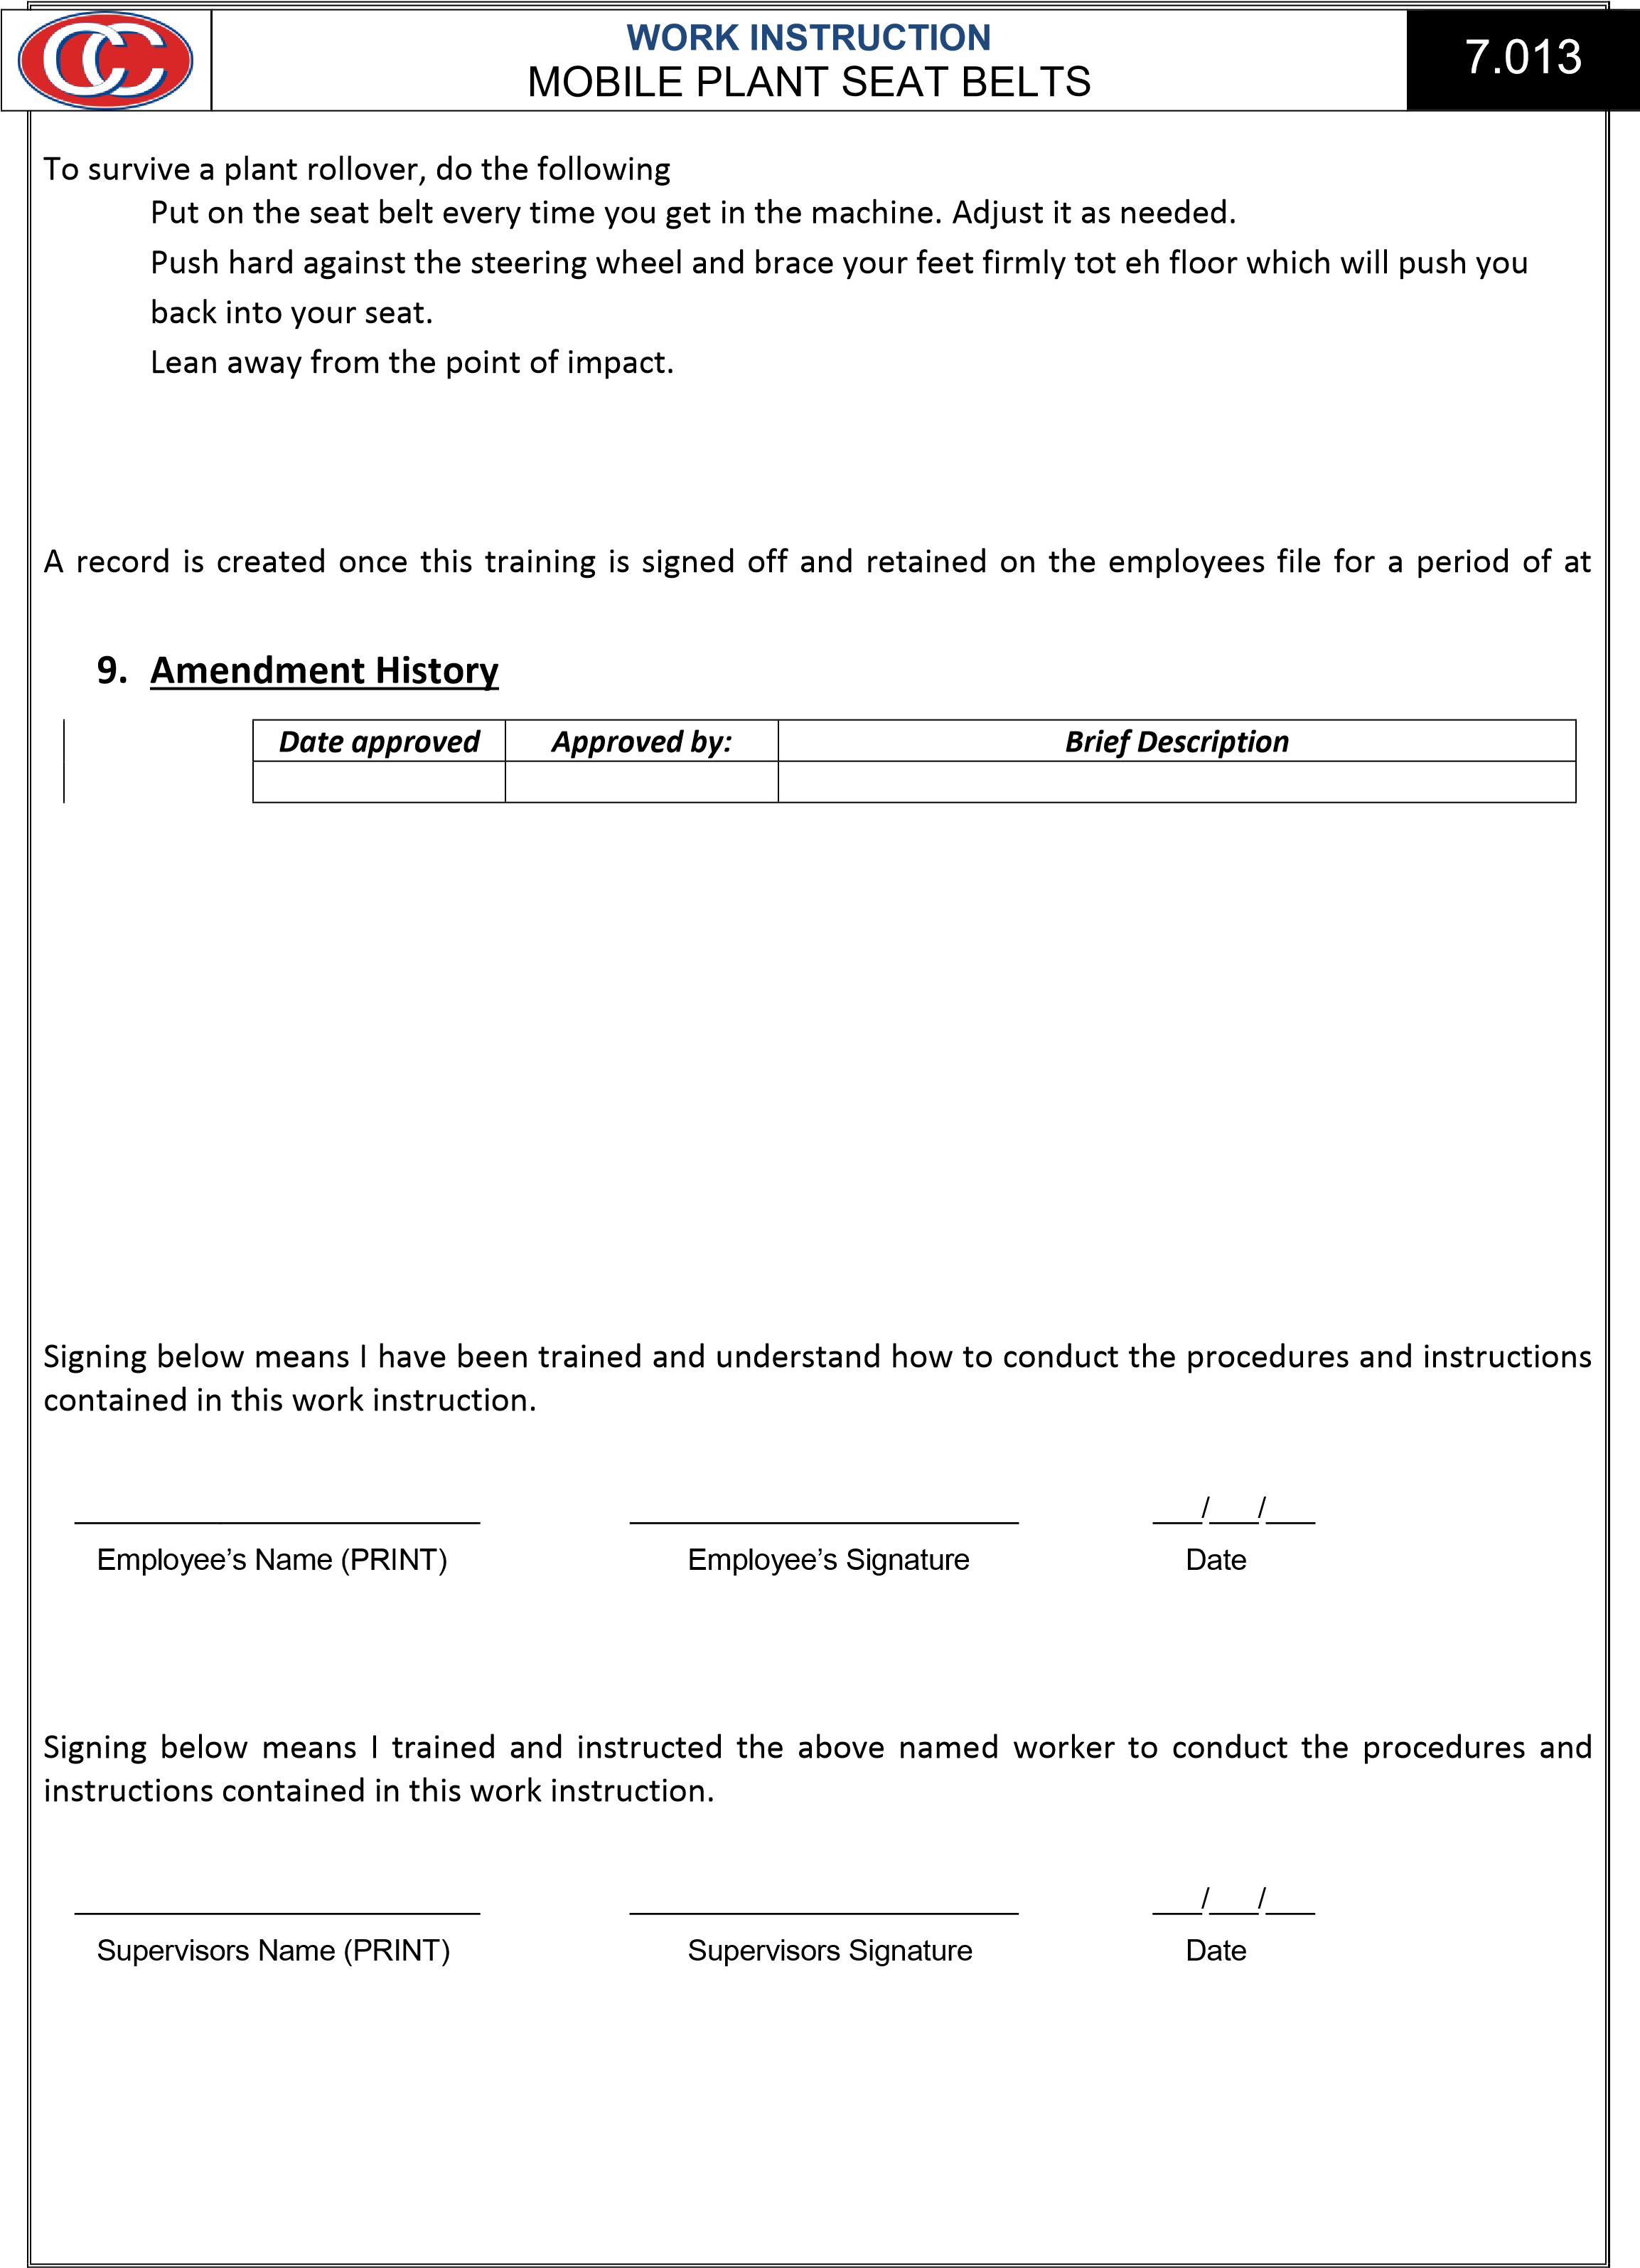
1. 2.
3.

8. Records
least 5 years.
Revision #

10. Sign Off
Worker
Supervisor/Trainer

IMS | Document | Author | Issued | Amended | Revision | Page 2 of 2
WI | Mobile Plant Seat Belts | K.C. | 9/8/19 | n/a | 0 | Page 2 of 2

