End of Defects Liability Checklist

Instructions to the Assessor
The candidate will review the instructions to make good defects and compare actual construction conditions presented by the contractor to verify if the defects have been remedied.
The candidate will use this End of Defects Liability Checklist template to document their review.
Before the candidate commences with their review:
- Review and discuss the contents of this checklist with the candidate.
- Address any questions or clarifications they may have about the task or this checklist.
- Contextualise this checklist to match the required conditions for the project the candidate is undertaking. E.g., for projects with multiple trade contracts, the final certificate may be issued for each contract.
After the candidate completes their review:
- They will submit to you their completed this End of Defects Liability Checklist.
- Review the candidate’s responses in their submission against the conditions they reviewed for this task.
- Confirm if the candidate has checked each item below correctly.
For example, if the candidate ticked YES for an item here, the assessor will review this against the actual document, and they will confirm if the item is really addressed in the workplace documents submitted.
- Record your assessment of the candidate’s review under the Assessor’s Marking Checklist column.
For each checklist, item:
  - Tick YES if the candidate’s finding is the same as yours in your assessment.
  - Tick NO if the candidate’s finding is different from yours in your assessment.
Provide written constructive comments as these will give the candidate guidance on how to improve their performance in this workplace assessment task.
- Complete and sign the Assessor’s Declaration section. Your signature must be handwritten.

Instructions to the Candidate
Use this End of Defects Liability Checklist template to document your review of terms of defects liability period in the contract.
Before starting your review, discuss the contents of this checklist with your assessor. Your assessor will provide you with additional instructions on how to go about your review.
Ensure you have completed all fields in this checklist before submitting it to your assessor.
END OF DEFECTS LIABILITY CHECKLIST
Candidate name | Dawei Yang
Workplace/organisation | Dawn construction
Date of review | 14/02/2023

Details of the Building and Construction Project
Name of building and construction project | two stoey house
Overview of this project
Project site address | lot 16 dell st Rochdale QLD 4123
State/territory | QLO

Instructions to make good defects | inspection on site

Checklist items: | YES/NO | Comments | Assessor’s Marking Checklist
- Construction certification has been submitted | YES  NO |  | Did the candidate correctly check this item against the doc reviewed?  YES NO  Comments:
- Certificate of Practical Completion submitted | YES  NO |  | Did the candidate correctly check this item against the doc reviewed?  YES NO  Comments:
- Statement of Compliance submitted | YES  NO |  | Did the candidate correctly check this item against the doc reviewed?  YES NO  Comments:

Checklist items: | YES/NO | Comments | Assessor’s Marking Checklist
- Site inspection conducted | YES  NO |  | Did the candidate correctly check this item against the doc reviewed?  YES NO  Comments:
- Asset testing and repairs have been carried out | YES  NO |  | Did the candidate correctly check this item against the doc reviewed?  YES NO  Comments:
- Site restoration completed | YES  NO |  | Did the candidate correctly check this item against the doc reviewed?  YES NO  Comments:
- Surplus material removed from construction site | YES  NO |  | Did the candidate correctly check this item against the doc reviewed?  YES NO  Comments:
- Health and Safety inspection certificates received | YES  NO |  | Did the candidate correctly check this item against the doc reviewed?  YES NO  Comments:
- Release notices from relevant authorities have been received | YES  NO |  | Did the candidate correctly check this item against the doc reviewed?  YES NO  Comments:

Checklist items: | YES/NO | Comments | Assessor’s Marking Checklist
- End of Defects Liability Period has expired | YES  NO |  | Did the candidate correctly check this item against the doc reviewed?  YES NO  Comments:

Assessor Declaration
By signing here, I confirm that I have reviewed and assessed the candidate’s responses in this checklist against the workplace documents they reviewed for this task.
I confirm that the responses I provided under the Assessor’s Marking Checklist are true and accurately reflect the candidate’s performance in this workplace task.
Assessor’s signature | 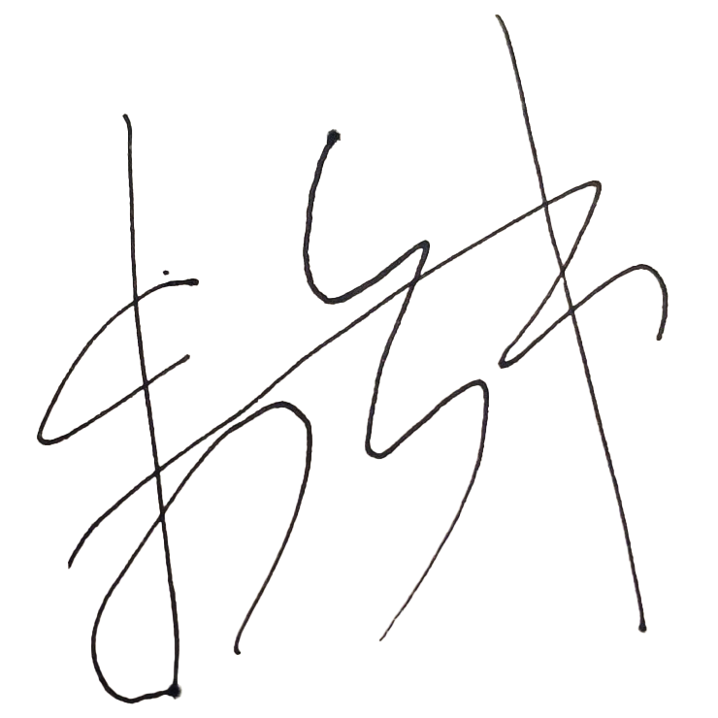
Assessor’s name | Yanzhong Zhu
Date signed | 14/02/23

END OF POLICIES AND PROCEDURES CHECKLIST

