BSBOHS201A
Participate in OHS processes
ASSESSMENT SUMMARY

The assessment activities for BSBOHS201A Participate in OHS processes cover all aspects of the unit of competency required. To demonstrate competence in this unit, a participant must undertake all tasks and complete them satisfactorily and consistently. For Apprentices and Trainees, this includes employer completion of the Employer Record Book (ERB).

Participants must read all the information given before starting any assessment task. The assessment tasks are intended to be equitable, fair and flexible. If a participant has any questions or requires alternative arrangements to be made such requests should be directed to their Trainer/Assessor, who should note such arrangements in the ‘Assessor Comments’ on the affected assessment. If a participant feels they are not yet ready to be assessed, they should discuss their options with their Trainer/Assessor.

To satisfactorily complete the assessment, the participant is required to answer all questions correctly and demonstrate their skills to industry standards. If a participant does not answer some questions or perform some tasks, they will be deemed ‘Not Satisfactory’ for the task and ‘Not Yet Competent’ for the unit of competency. The Trainer/Assessor is able to provide the participant with additional information on interpreting the assessment outcomes and provide guidance on the participant’s options. Should a participant still be deemed ‘Not Satisfactory’ they will have the opportunity to undertake a supplementary assessment or appeal the result.

By signing the cover page for each assessment item, the participant acknowledges they understand the assessment instructions and requirements and consent to being assessed. The participant also verifies and assures the RTO that the work submitted is their own work.

Participant Name | Tahlulah Tillett

Task | Assessment Results
Theory Exam | Satisfactory | Not Yet Satisfactory
Practical Assessment | Satisfactory | Not Yet Satisfactory
Outcome for Unit of Competency | Competent | Not Yet Competent

Assessor Name
Assessor Signature | 
Unit Competence Determination Date | Click here to enter a date.

BSBOHS201A
Participate in OHS processes

THEORY EXAM INSTRUCTIONS

- This exam will occur under standard assessment conditions.
  - An oral examination may be allowed under certain circumstances, whereby the Participant’s answers will be documented by a party other than the Participant. This must be acknowledged in writing (e.g. FT001 and Assessor Comments)
- Participants must provide enough detail in their responses to demonstrate their knowledge and skills.
- Please fill in the details below, providing your name, signature and date of assessment.
  - Your signature acknowledges that this is your own work.
- Assessors are to complete marking in pen of a different colour to the Participant.
- If a Participant initially answers a question incorrectly but modifies their response, they must follow the instructions below:
  - If a Participant changes their response in writing, they must put their initials next to the written change.
  - If a Participant changes their response verbally, this must be noted on the exam paper by the assessor.

Participant name | Tahlulah Tillett
Participant signature | 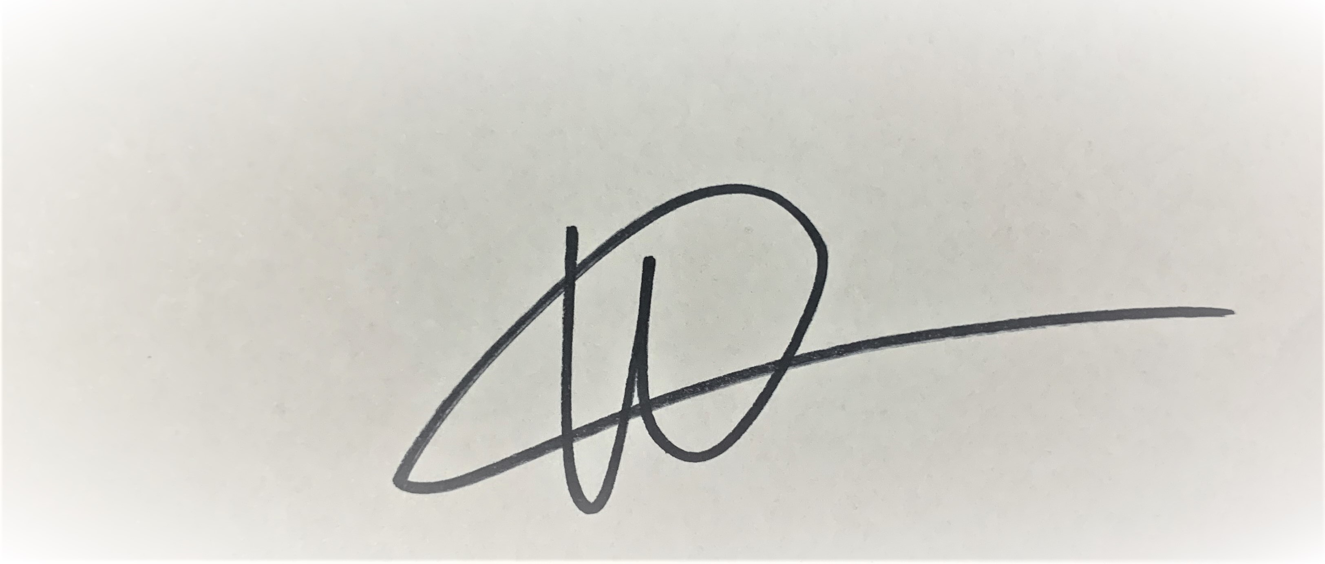
Date | 3/03/2020

Assessor name
Assessor signature
Date | Click here to enter a date.

Number of questions | Number of questions answered correctly | Task outcome (Tick)
24 |  | Satisfactory | Not Yet Satisfactory
ASSESSOR Comments
- Match the terms and definitions by writing the appropriate letter next to each number in the centre column.

Answer | Terms |  | Answers | Definition
 | 1 | PRA | 1 - F | A | Outline the requirements of the work to be undertaken.
 | 2 | JSA | 2 - E | B | Outline what to do in the event of fires and other accidents
 | 3 | Plans and specifications | 3 - A | C | Contains important information about hazardous materials or chemicals.
 | 4 | Manufacturer specifications | 4 - D | D | Outlines how tools and equipment should be used (e.g. lubricant levels, maintenance requirements).
 | 5 | SDS | 5 - C | E | Identifies hazards and potential hazards that may be encountered while working.
 | 6 | Emergency procedures | 6 - B | F | A personal assessment of risk

- For each of the hazards identified below, describe the injuries/damage they may cause (i.e. to fellow workers, other people and/or animals) and suggest a suitable control measure.
Answer | Hazard | Injuries or damage | Control measure
 | Hazardous chemical | Injuries or damage that can occur from a hazardous chemical include respiratory damage, skin rashes and checmical burns | Ensure all hazardous chemicals are clearly labelled and make sure they are stored safely and correctly
 | Noise | Injuries or damage that can occure from excessive noise is hearing damage, headaches, and fatigue | Make sure correct PPE is work when performing tasks
 | Manual handling | Manual handling injruies can include muscles strain and sprains | Make sure correct technique is being used when bending over and ask for help when needed

- Who should you speak to if you find problems (e.g. hazards, accidents and emergencies)?

Answer | Supervisor, Site / Project Manager or Health & Safey Representative using the correct report form supplied by the organisation

- What action should be taken if plant, tools and/or equipment are found to be defective? Tick your response.

Answer | Choice | Possible Answers
 |  | Report, Record
 |  | Stop, Report, Record
 |  | Stop, Tag, Report, Record
 |  | Stop, Fix, Report, Record

- Which legislation relates to safety in the workplace? Tick your response.

Answer | Choice | Possible Answers
 |  | Occupational Health and Safety Act 2015
 |  | Work Health and Safety Act 2011
 |  | Safety Act 1900
 |  | Safety and Health Act 2011

- True or False (Tick your response): Employers are required by legislation to implement safety measures which are reasonably practicable.

Answer |  | True
 |  | False

- True or False (Tick your response): Workers are required by legislation to follow reasonable employer directives (e.g. to undertake first aid and/or fire safety training).

Answer |  | True
 |  | False

- The following symbols appear under the heading ‘Required PPE’ on an SDS. What do the symbols represent?

Answer | Symbol | Meaning
 |  | PPE Requiered – Longs to be worn
 |  | PPE Requiered – Gloves to be worn
 |  | PPE Requiered – Safety glasses and goggles to be worn
 |  | PPE Requiered – Respirator to be worn

- Describe the meaning and use of the signs displayed below.

Answer | Sign | Meaning
 |  | First Aid - Location of the First Aid Kit
 |  | Do Not Enter - Warns off unauthorised persons from entering the area
 |  | Fire Extinguisher - Location of fire fighting facilities

Refer to the Risk Matrix below when responding to Q10. to Q12.

Matrix | A:  Death or permanent disability | B:  Serious injury | C:  Lost time injury | D:  Casualty Treatment | E:  First Aid
1: Very Likely | E | E | H | H | M
2: Likely | E | H | H | M | M
3: Possible | H | H | M | M | L
4: Unlikely | H | M | M | L | L
5: Very Unlikely | M | M | L | L | L

E: Extreme | H: High | M: Medium | L: Low

- Which rating is designated for the highest risk and which rating is used for the lowest risk?

Answer | Highest Risk: E - Extreme  Lowest Risk: L - Low

- What is the risk rating for the following circumstances: An event which is possible and would require low-level hospital treatment.

Answer | Medium

- What are the factors that would lead to a risk rating of E: Extreme?

Answer | An incident causing permanent disability or death  Natural Disasters

- When should safety checks be undertaken on machinery and equipment? Tick your response.

Answer | Choice | Possible Answers
 |  | Before operation
 |  | After operation
 |  | Both before and after operation

- Order the elements of the hierarchy of control, from 1 to 6 (i.e. most effective to least effective).

Answer | Label (1 – 6) | Element
 | 3 | Isolate the hazard
 | 6 | Provide and use Personal Protective Equipment (PPE)
 | 1 | Eliminate the hazard
 | 4 | Control the hazard by engineering means
 | 5 | Control the hazard by administrative means
 | 2 | Substitute the hazard

- Why is elimination the best method of hazard control and PPE considered the least effective?

Answer | Assessing and coming up with a solution for the task elimates the hazard that was involved.  PPE is least effective because there is no elimination because it relies on human behaviour

- If you were to replace a flammable solvent with a water-based solvent, what category of control measure would that be under the hierarchy of control?

Answer | Eliminate the rish

- In the diagram below a person is lifting a tool box.
Filling in the table, indicate how each body part should be used/placed.

F. Hands
E. Knees
D. Shoulders
C. Feet
B. Back
A. Neck
Answer | Area of body (Letter) | How it should be placed
 | D | Level
 | A | Upright
 | F | Good grip
 | B | Natural curve
 | E | Bent
 | C | Flat, facing load

- In a medical emergency, what is the first step in the DRSABCD action plan that you need to follow?

Answer | D – Danger check

- In the event of a fire emergency, what should you do?
Fill in the table below to explain the acronym R.A.C.E.

Answer | Letter | Meaning
 | R | Remove people from immediate danger
 | A | Alert people of emergency
 | C | Confine fire and smoke
 | E | Evacuate to the assembly area

- What should you do as part of the clean up process? Tick all that apply.

Answer | Choice | Possible Answers
 |  | Store all plant, tools and equipment without cleaning
 |  | Maintain plant, tools and equipment
 |  | Dispose of materials that cannot be reused or recycled
 |  | Report faults in logbook and/or site records
 |  | Clean all plant, tools and equipment before storage

- Read the scenario below and complete the Hazard Report Form.

SCENARIO
Today at 10:45am a delivery truck reversed into a car park (located at 54 Standish Street, Salisbury) to deliver gardening materials. There was nobody in the car park to guide the driver and he backed into a number of drums of diesel located to the left of the photograph (below). One drum was pierced and its contents erupted from the container.

The marked area on the photo represents the diesel spill, measuring 3m x 4m.



HAZARD REPORT FORM

GENERAL
Date | Tuesday 3/03/2020
Submitted by | Tahlulah Tillett
HAZARD DETAILS
Location | 54 Standish Road, Sailbury
Description of issue | Truck reversed into a drums of filled with diesel and one of the drums was pierced and its contents erupted from the container.
Risk class | Extreme | High | Medium |  |  | Low
CONTROL MEASURES
Corrective action required | Advise the Supervisor and or WHS Manager  Identify risk area and make others aware of the hazard  Adress and eliminate the hazard  Complete and necessary forms and paperwork
Person to action | Trcuk Drive |  |  | When | Immediately  Within 24 hours  Within 7 days

Answer

- Who would you submit a hazard report form to?

Answer | WHS Manager and or Supervisor

- Who would approve proposed risk controls and organise the required resources for implementation of the risk control?

Answer | WHS Manager

- Identify one (1) way you can assess if risk controls have been effective.

Answer | Complete regular reviews to ensure all procedures are up to standard and are effective when necessary

