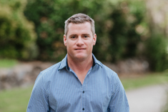
Adrian Wyatt
Site Manager
0421 618 310
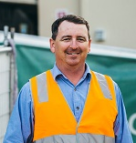
Josh MacPherson
Foreman
0419 797 981

Josh MacPherson
Foreman
0419 797 981

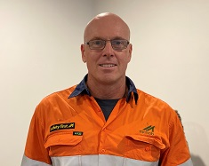
Ric Henderson
Logistics Manager
0490 785 772


Clinton Guest
HSE Advisor
0421 972 020

