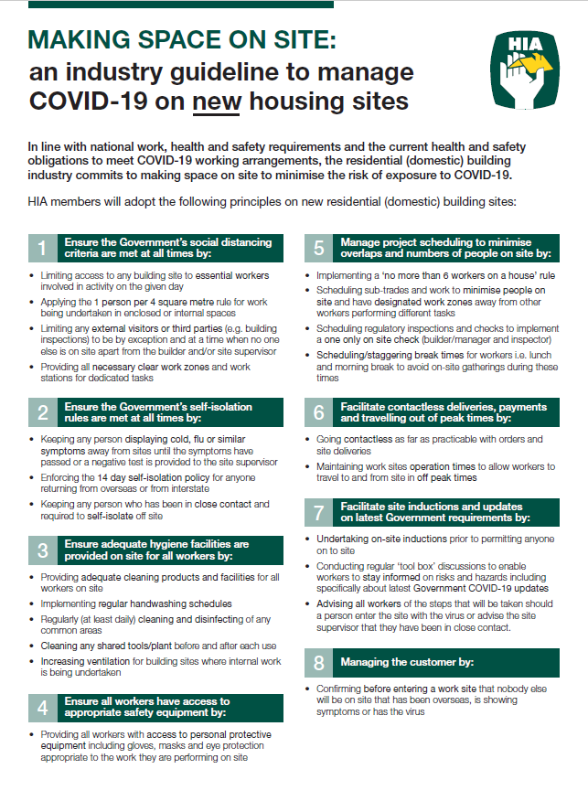

Code of Conduct and Site Rules
All subcontractors and workers on site must ensure the following:

- Will check all plans, specifications and variations prior to commencing any work. All work must be carried out as per the issued documentation, “construction plans” and council approval requirements.
- Complete the works in a professional, expeditious, safe and workmanlike manner.
- Agrees that access to the site is limited to the approved crossing, sediment barriers must be maintained at all times and not to be removed or damaged
- No dogs or alcohol are allowed on site or around the site address
- Will be mindful of noise including bad language onsite and smoking will be prohibited on all jobs
- All rubbish relating to the trade (including food scraps, containers and material waste) will be placed in the designated rubbish compounds.
- Ensure enclosed footwear is worn at all times.
- Will not drive at an unsafe speed or in any inconsiderable manner within the site limits at the job address and suburb
- Ensure that workers have received training in the use of plant and equipment and are familiar with hazards and risks associated with their use.
- Ensure a licensed electrician has inspected and tested all construction wiring, switchboards, RCDs and transportable structures following the initial installation and at 6 months intervals afterwards.
- Use a platform ladder with a large and stable work surface where possible ensuring 3 points of contact when ascending, descending or standing on a ladder
- Before using or storing any hazardous substances, will provide a copy of the respective MSDS to the principal contractor
- Ensure that all incidents and injuries are reported to the supervisor and are recorded on the incident and injury report
- The works and all materials used in doing the works will be fit for the specified purpose or result
- All work will comply with building codes and will meet the conditions of any relevant development consent or complying development certificate
- Will ensure all staff have completed a general safety induction course and holds appropriate safety induction cards
- Will ensure work areas to be kept clean and access ways free from hazards at all times
- Will ensure no person without specific approval is to alter or remove any plant, equipment or safety device on site. This includes scaffolds, handrails, barricades, signage, guards, etc
- If working 2m or above will require a means of fall protection
- A spotter will guide vehicles or equipment reversing onto or off the site, so that workers aren’t driving blindly into areas where there may be pedestrians or traffic

Lot 269, Huntington Rise Stage 6, (5) Windsor Circuit, Maudsland QLD 4210
1 | Photo Checklist
2 | Colours
3 | Variations
4 | Fire Ant Log
5 | Construction Plans (x2)  Engineering Plans  Estate Plan

Work Health and Safety Pack for Meter Box

Photo Checklist
Could you please send photos at the following stages to info@lunicdevelopments.com.

This will assist with rectifications for certifiers and future maintenance and defects.

If possible, all construction photos should be clear of rubbish, toilets, pedestrians, cars etc.

Pre-site Stage
Install Builders signage  We will need photos of the below (if applicable)  - Power services to site and position  (green box or overheads)  - Water Connection to site and position  (advise if water meter is installed and if upstand pipe is visible)  - Sewer Connection Points  - Rubbish onsite  - Fencing | Construction issues in the area that we should be aware of  - Schools, bus stops, crossings  - Power lines at the front of the property  - Asbestos  - Neighbouring Properties (vacant, BTB or other builders constructing)  - Access for deliveries  - Stormwater runoff – to street or rear of property  - Damage to existing driveways, footpaths, crossover, power/NBN/water lids  - Trees  - Gas  - Demolitions of existing structures  - Major cracks to neighbour properties (concrete fencing, BTB)
Slab Stage
Please only send when slab is poured - 3 Photos needed
- 1 x Site Signage
- 2 x slab

Frame Stage
5 x Photos needed
- 1 x Site Signage
- 4 x Elevation – 1 photos of each side of the property

Fixing Stage
15 Photos (minimum needed)
All doors need to be closed when photos are taken including the garage door

- 1 x Site Signage
- 4 x Elevation – 1 photos of each side of the property
- Hallways
- Bathrooms and Ensuite and WC
- All bedrooms
- Kitchen
- Entry including front door

Practical Completion Stage
20 x Photos minimum. The more the better  - 1 x Site Signage  - 4 x Elevation – 1 photos of each side of the property  - Entry including front door  - Hallways  - Master Bedroom  - Master Ensuite including Toilet  - Master Robe  - Bedrooms (all)  - Bedroom Robes (all)  - Bathroom(s) including Toilet  - Kitchen  - Blinds in each room  - Laundry | - Oven/Cooktop  - Dishwasher  - Hot Water System  - Floor of garage  - Driveway finish  - Letterbox  - Fencing  - Retaining walls

HANDOVER Stage
20 x Photos minimum. The more the better  - 1 x Site Signage  - 4 x Elevation – 1 photos of each side of the property  - Entry including front door  - Hallways  - Master Bedroom  - Master Ensuite including Toilet  - Master Robe  - Bedrooms (all)  - Bedroom Robes (all)  - Bathroom(s) including Toilet  - Kitchen  - Blinds in each room  - Laundry | - Oven/Cooktop  - Dishwasher  - Hot Water System  - Floor of garage  - Driveway finish  - Letterbox  - Fencing  - Retaining walls



WORK HEALTH AND SAFETY
MANAGEMENT PLAN
(ADDRESS OF JOB)

Please do not remove this Plan from the Construction Site. This Plan must be kept onsite until Handover.

THIS PAGE HAS BEEN INTENTIONALLY LEFT BLANK
(JOB ADDRESS)

Key Contacts

Principal Contractor | Lunic Developments Pty Ltd
Construction Manager | Dave Bird
Site Supervisor
Site Supervisor Phone | 0427873960
Postal Address | PO BOX 274 Ormeau 4208
Phone | 0413244546
Email | info@lunicdevelopments.com
ABN | 19 617 452 785
QBCC Licence Number
Duration of Protect | 296 calendar days
Commencement Date

Emergency Contacts

Police, Fire, Ambulance | 000
SES | 13 25 00
Poisons Helpline | 13 11 26
Energex | 13 19 62
Translation Service | 13 14 50
Biosecurity (lost livestock) | 13 25 23
Health Advice | 13 43 5 84
Dial before you Dig | 1100

Closest Job Site Hospital

Hospital | - Sunshine Coast - Sunshine Coast University Hospital, 6 Doherty Street, Birtinya – Phone 07 5202 0000  - Metro North - The Royal Brisbane and Women's Hospital, Royal Brisbane & Women's Hospital Butterfield Street, Herston – Phone 07 3646 8111  - Metro South –  - Logan Hospital, Cnr Armstrong and Loganlea Roads, Meadowbrook – Phone 07 3299 8899  - Ipswich Hospital, Chelmsford Avenue, Ipswich – Phone 07 3810 1111  - Redland Hospital - Weippin Street, Cleveland – Phone 07 3488 3111  - Gold Coast - Gold Coast University Hospital, 1 Hospital Boulevard, Southport Qld 4215 Phone 1300 744 284
Roles and Responsibilities
Lunic Developments has overall responsibility for the safe conduct of all work activities carried out on behalf of the business. The roles and responsibilities of workers are listed below.

BUSINESS OWNER/DIRECTOR
The owner/director/manager is responsible for WHS in the workplace. Duties include:
- Implementing the WHS procedures  - observing all legal WHS requirements  - ensuring that all works are conducted in a  manner without risk to workers’ WHS  - planning to do all work safely  - participating in the planning and design stages of trade activities  - identifying WHS training required for an activity  - ensuring workers undertake identified WHS training | - communicating and consulting with workers  - investigating hazard reports and ensuring that corrective actions are undertaken  - assisting in rehabilitation and return to work initiatives  - ensuring that appropriate resources and processes are available to ensure WHS  - ensuring that a system is in place that enables workers to receive and respond in a timely manner to information regarding incidents, hazards and risks.

MANAGER/SUPERVISOR OR LEADING HAND
The supervisor or leading hand is responsible for operational safety in the workplace. Duties include:
- making decisions about WHS that may affect work activities and/or others  - ensuring legal WHS requirements are met in the workplace  - actioning safety reports and carrying out workplace inspections  - facilitating the preparation of SWMS (including those for trades)  - ensuring safe work practices at all times | - conducting site inductions, toolbox talks and daily team briefings  - participating in accident or incident investigations  - leading by example and promoting WHS at every opportunity  - supervising and ensuring compliance with safe work procedures.

WORKER/SUB CONTRACTOR
Every individual worker is responsible for:
- conducting their allocated tasks in a safe manner and in accordance with their training and experience  - giving due consideration to the safety of all others  - co-operating in matters of WHS  - leaving their work site in a safe condition | - complying with the SWMS and is encouraged to participate in the development of all SWMS for high risk construction work  - complying with the site safety rules (including those set down by the principal contractor) in the site induction.

Work Health and Safety Policy
Lunic Developments believe that the well-being of people employed at work, or people affected by our work, is a priority and must be considered during all work performed on our behalf.

People are our most important asset and work health and safety is everyone’s responsibility.

The safety of the public is given equal priority to that of our workers.

The objectives of this policy are to, as far as reasonably practicable:
- achieve a safe and incident free workplace
- consider WHS in project planning and work activities
- involve workers and subcontractors in the decision-making process through regular communication and consultation
- ensure workers and subcontractors identify and control risks in the workplace
- monitor and review the elimination or control of potential risks
- enhance workers’ WHS knowledge through a program of education and training.
- The success of our WHS management depends on:
- the commitment of all persons to achieve the policy objectives
- planning work activities, with due consideration given to WHS
- undertaking the risk management process in an effective manner
- communication and consultation between our workers and subcontractors.

Lunic Developments are committed to fulfilling the objectives of this policy and expect the same of all workers and subcontractors working on our behalf.

Dave Bird
Founding Director

19/03/2021

Consultation and Communication

Lunic Developments promotes active participation of all workers in WHS decisions. We consult with workers and give them the opportunity, encouragement, and training to be involved in WHS matters affecting the organisation and their own work.

Lunic Developments will consult with you directly through toolbox talks, through FRD employees or via electronic means such as email, web meetings or other forums. We will discuss such things as:
- hazard and risk identification
- control measures for managing hazards and risks
- the development of safe work method statements or risk assessments
- site safety rules
- site induction
- changes to site conditions
- the welfare facilities
- the purchase of new or used plant and equipment or new substances and materials
- the development and review of safety policies and procedures
- emergency procedures

Sub-Contractor Commitment
As a sub-contractor to Lunic Developments, you have committed that you and your staff will:

Plant and Equipment
- Ensure that workers have received training in the use of plant and equipment and are familiar with hazards and risks associated with their use.
- Carry out regular inspection and maintenance of all plant and equipment used.
- Ensure that plant and equipment is inspected and maintained in accordance with the relevant standards and manufacturer’s recommendations. Document the inspection and maintenance history of each item and make it available with the relevant plant or equipment.
- Ensure that workers have received training in the use of plant and equipment and are familiar with hazards and risks associated with their use.
- Carry out regular inspection and maintenance of all plant and equipment used.
- Ensure that plant and equipment is inspected and maintained in accordance with the relevant standards and manufacturer’s recommendations. Document the inspection and maintenance history of each item and make it available with the relevant plant or equipment.

Electrical
- Get a licensed electrician to provide temporary electrical installations used in connection with construction work in accordance with AS/NZS 3012.
- Get a licensed electrician to inspect and test all construction wiring, switchboards, RCDs, and transportable structures following the initial installation and at 6 months intervals afterwards.
- Prior to the initial introduction on site, inspect, test and tag new equipment before placing it into service.
- Inspect, test and tag portable electrical equipment, including power tools, flexible cords and extension leads by a competent person or a licensed electrician, on at least a three-monthly basis.
- Get a competent person to inspect and test RCDs by doing a push-button test daily for portable RCDs or monthly for fixed RCDs and trip time test 3 monthly for portable RCDs or 12 monthly for fixed RCDs.
- Withdraw non-compliant plant and equipment from service immediately. Label it with suitable warnings against further use (eg DO NOT USE). If sent for repairs, re-test it and tag it once returned to site.
- Record inspections of all electrical equipment on an electrical equipment register and make it readily available.

Hazardous Chemicals
- Provide all workers involved with hazardous chemicals with information and instruction on their use and handling. Ensure that workers are trained.
- Advise the Supervisor of the hazardous chemicals you will be bringing into the workplace and ensure that the risk controls are implemented as detailed in the safety data sheet.
- Use a hazardous chemicals register to record all products classified as hazardous.
- Upon request, make available for inspection on site a current safety data sheet (within five years of the date of issue) for hazardous chemicals that are to be used for the work activity.

Working at Heights
- Use a platform ladder with a large and stable work surface where possible
- Ladder must be rated industrial with a minimum of 120kg load rating
- Place ladder evenly on a firm, non-slip surface and secure to a support (top/bottom). Ladder should be placed at a 75 degree to the horizontal
- Keep 3 points of contact when ascending, descending, or standing on a ladder
- Workers must not stand higher than the second tread below the top plate of any ladder, use a ladder when using tools requiring force or operation with two hands or use ladder to work over other people
- Subcontractors who work at 2m or above must provide additional fall prevention

Excavations and Trenches
- Warning signs and barricades to be erected around excavations. All trenches 1m deep or greater need a 900mm barricade effected and should be covered or backfilled as soon as possible
- Know where underground services are located before you dig. Do not rely solely on plans
- Inspect open excavations regularly especially after rain or high temperatures
- Never allow anyone to work in trenches alone

Hazard Reporting
- Ensure that all hazards that do not have a risk control measure are reported to the supervisor and the principal contractor immediately.
- Record the details of any additional hazards in a site diary or in the site-specific risk assessment

Injury and Accident Reporting
- Ensure that all incidents and injuries are reported to the supervisor and are recorded on the incident and injury report
- Record all incidents in the incident and injury report and provide a copy to the principal contractor upon request.
- Notify the authorities if an incident or injury results in a person being killed or if it could be defined
as a ‘serious incident’. Authorities also require that the place of work is ‘not to be disturbed’ except by actions relating to emergency rescue.

Engaging additional sub-contractors
If additional subcontractors are engaged to undertake work on our behalf, the following steps must be taken.

Collect and record the organisational and copies of the following:
- Relevant Insurances
- Construction Induction Training Cards
- Licences where applicable.

Ensure that an agreed SWMS is prepared and implemented where high risk construction work is being undertaken (refer to SWMS Section).

THIS PAGE HAS BEEN INTENTIONALLY LEFT BLANK
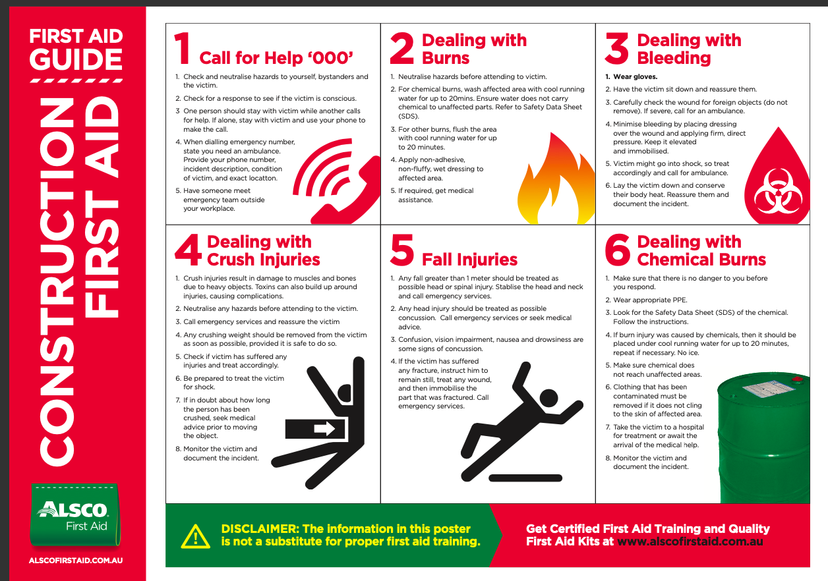

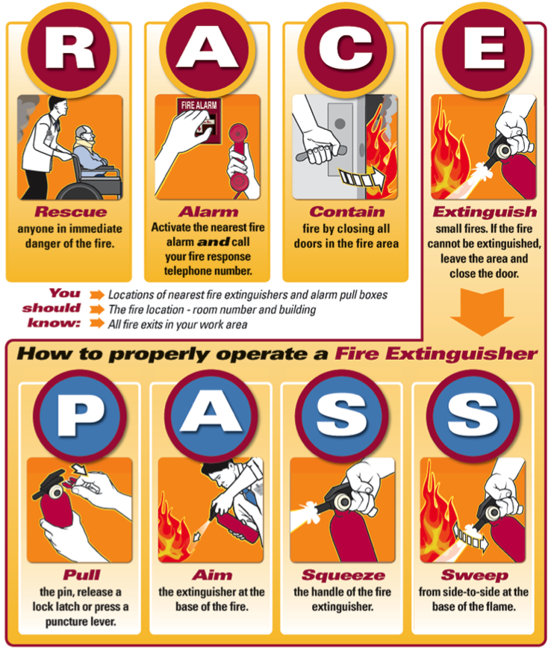

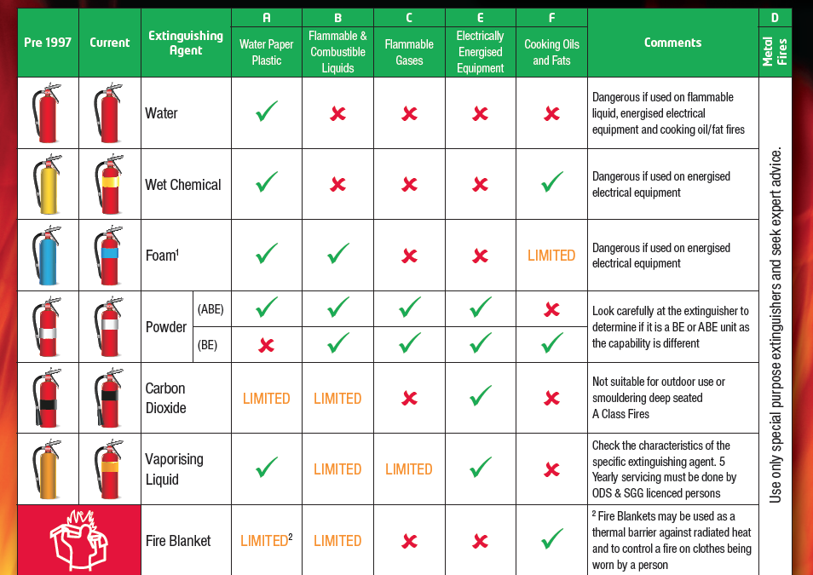

EVACUATION DIAGRAM

(ADDRESS OF SITE)

EMERGENCY EXIT DOORS
EMERGENCY ASSEMBLY POINT

(ILLUSTRATION PURPOSES ONLY – insert site plan)

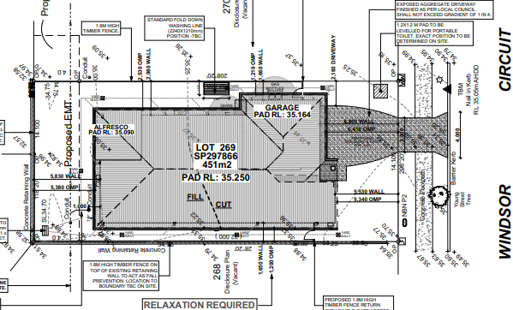



THIS PAGE HAS BEEN INTENTIONALLY LEFT BLANK

Incident and Injury Report

Lot 269, Huntington Rise Stage 6, (5) Windsor Circuit, Maudsland QLD 4210Please complete, take photograph and email to admin@frdhomes.com.au and gavan@frdhomes.com.au.

Details of Injury
Date and Time of Incident
Nature of Incident
Name of Person Injured
Occupation
Date of Birth
Employer
Telephone
Activity person was engaged in
Exact site location of accident
Nature of injury
Body location of injury | 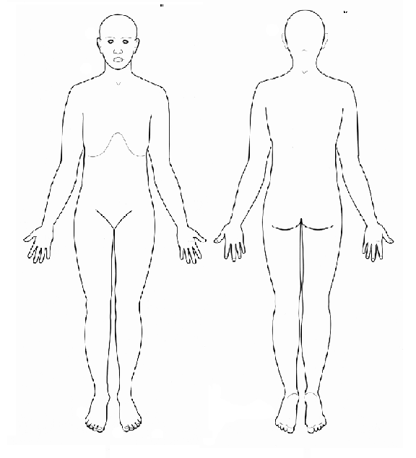
Treatment given on site
Name of treating person
Name of doctor or hospital
Witness
Name of Witness
Witness Contact
Details of Incident
Name of Person completing report
Phone of Person completing report
Description of Incident
Immediate response actions

Incident and Injury Report

Lot 269, Huntington Rise Stage 6, (5) Windsor Circuit, Maudsland QLD 4210
Please complete, take photograph and email to admin@frdhomes.com.au and gavan@frdhomes.com.au.

Details of Injury
Date and Time of Incident
Nature of Incident
Name of Person Injured
Occupation
Date of Birth
Employer
Telephone
Activity person was engaged in
Exact site location of accident
Nature of injury
Body location of injury
Treatment given on site
Name of treating person
Name of doctor or hospital
Witness
Name of Witness
Witness Contact
Details of Incident
Name of Person completing report
Phone of Person completing report
Description of Incident
Immediate response actions

