22nd April
Unit 3/1 Links Court
Quotation for additional items in unit 3 at Villas on Main;
Item | Description | Photo | Client Price Inclusive of GST
Shed | Space saver reverse shed, including & concrete slab  *Available in Classic Cream or Monument | 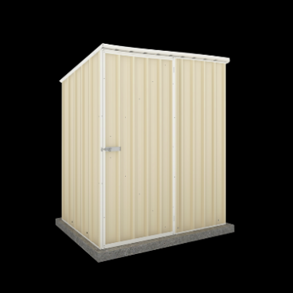 | $1,650.00
Solar panels 3.6 KW | 3.6KW solar power | 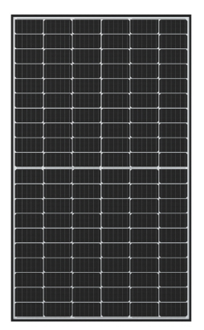 | $3,624.50
Crime Safe door to Garage | 140 Series crimesafe laundry door | 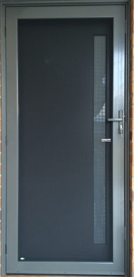 | $1,067.00
Epoxy Flooring | White flooring with black flecks throughout garage | 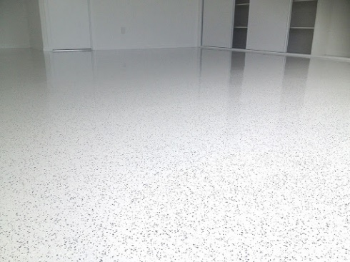 | $2,600.00
TV and power point to Garage. | Garage |  | $445.00
Air Conditioning Bedroom 2 | Split system Air Con, including all associated work including making good. |  | $2,700.00
Sun Screen | 2 x posts 100 x 100 + 2 side rails and 1 x sunscreen with 65 x 16 slats in powder coated Jasper | 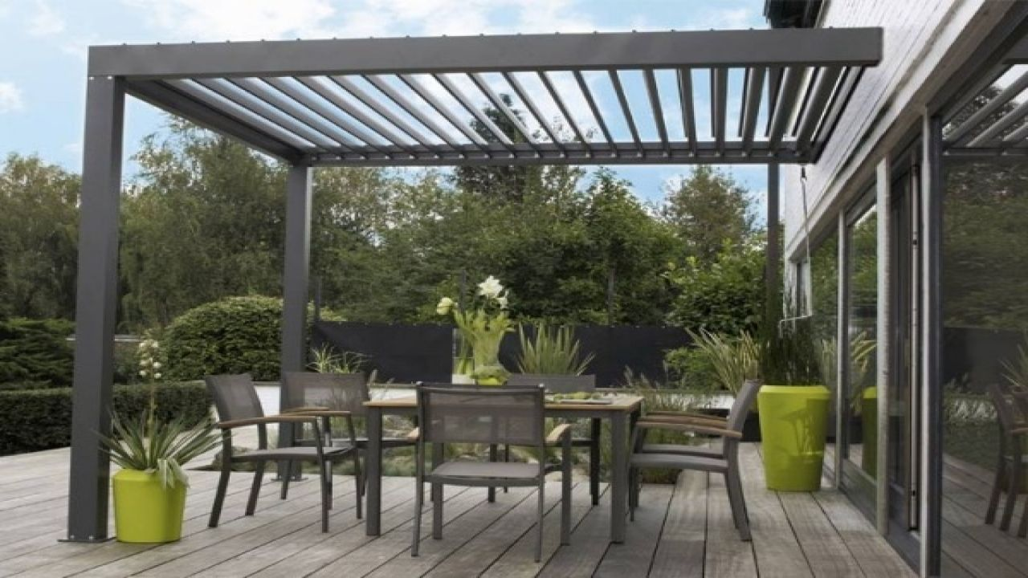*Concept Image only | $1,800.00
Block Out Blinds | • 2 x chain Roller blinds in in textured fabric, white trim/ brackets, including stainless steel chain front Bedroom 2 & Bedroom 1 (Highlight Windows)  •Panel Glide blinds in texture block out Fabric with white track  • S/D Living Room x 4 panels stacking to LH side  • S/D Bedroom 1 x 3 panels stacking to RH side | 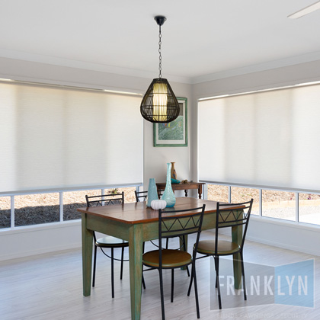  Roller Blind:  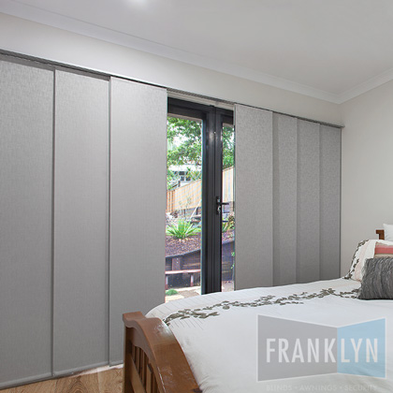  Panel Blind: | $1,315.00
Zipscreen channel awning | Back Alfresco fitted between existing steel posts in (2x2 weave) 95% shade mesh fabric (range of colours)  *Colour of frame in anodised silver to match windows and fabric in blue to match external colour. | 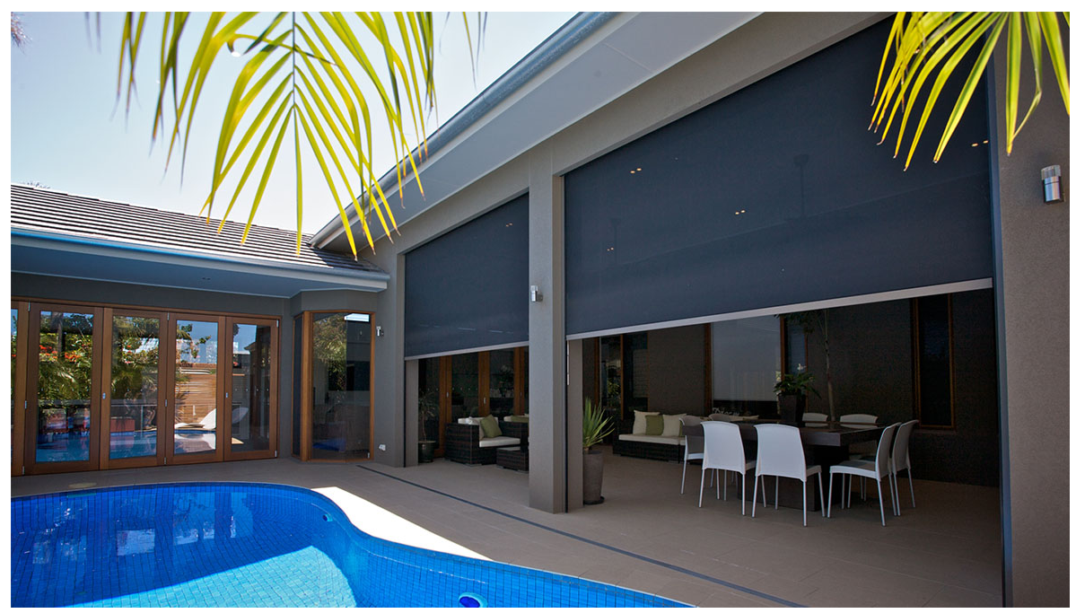 | $1,089.00
Extra cost for motorised awning | Extra cost Awning to be motorised [Acmeda Motor (7-year warranty) and 5 channel remote control (5-year warranty)] |  | $660.00
Zipscreen channel awning same as above | Fitted in proposed sunscreen in front of Bedroom 1  *Colour of frame in anodised silver to match windows and fabric in blue to match external colour. | 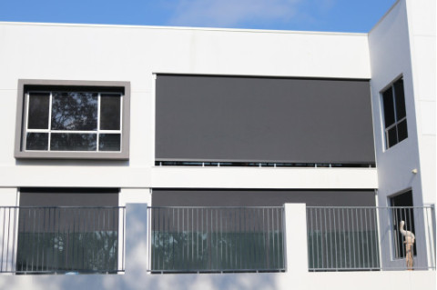 | $900.00
Extra cost for motorised awning | Extra cost for motorised awning as above [Note: you will not need an additional remote for this awning if both are motorised as they can be programmed onto the same remote |  | $640.00
 |  |  | $18,490.50

Kind Regards,
Win Constructions Queenland Pty Ltd

