ASSESSMENT FOR

Student name | Kevin Larney
Date of assessment submission

Trainer/Assessor’s name | Tui
Date of assessment marking
Outcome for unit | Competent  Not Yet Competent

TASK INSTRUCTIONS

- As part of the assessment for this unit of competency, you are required to complete a series of activities.
- Some of these activities will require you to provide a response within this document, others will require you to gather evidence to demonstrate your knowledge and skills.
- At all times, the responses in your assessment must reference Australian (Queensland or Federal) documentation, including legislation, regulations, codes of practice, standards and guidance publications.

ACTIVITIES

Draw a simple concept plan for a proposed landscape design which includes a retaining wall.

Response
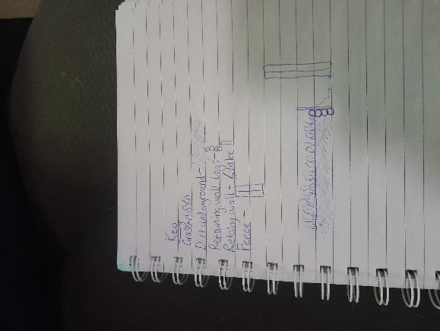

Outcome for Activity 1 | Satisfactory  Not satisfactory
Trainer/Assessor comments

Identify/list the detail on the landscape plan shown.

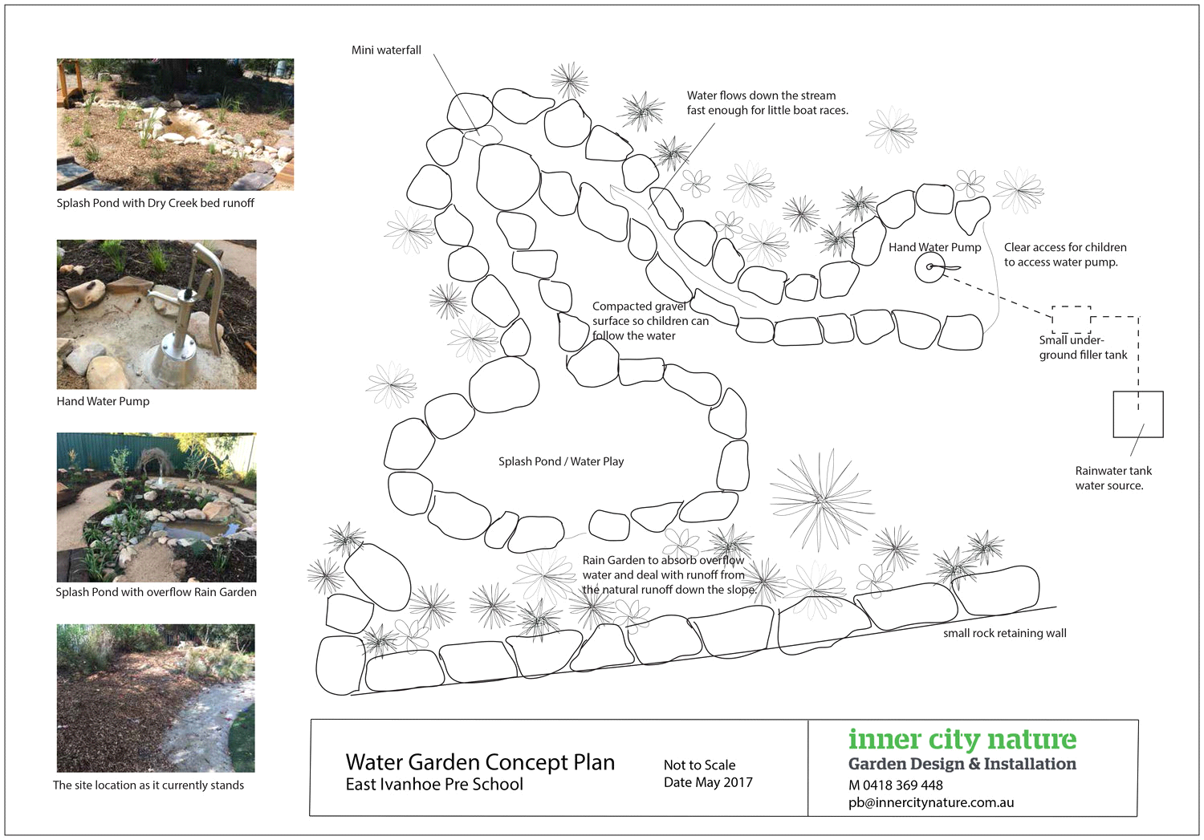

Response
Mini waterfall, water flows down the stream fast enough for little boat races, hand water pump, clear access for children to access water pump, small under ground filler tank, rainwater tank water sources, splash pond/water play, compacted gravel surface so children can follow the water, small rock retaining wall, rain garden to absorb overflow water and deal with runoff from the natural runoff down the slope.

Outcome for Activity 2 | Satisfactory  Not satisfactory
Trainer/Assessor comments

List the materials required to complete the retaining wall, by using the wall and water feature construction plan shown.

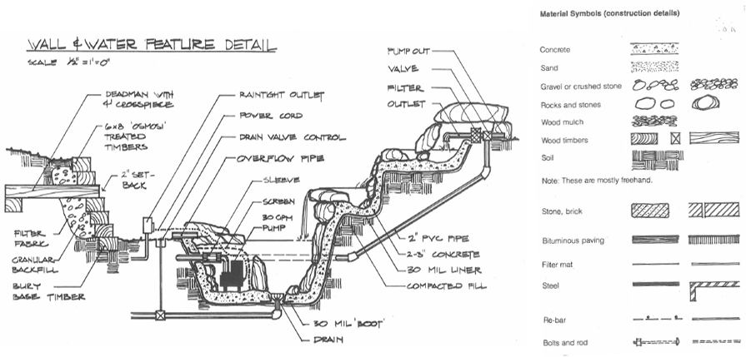

Response
Concrete, sand, gravel or crushed stone, rocks and stones, wood mulch, wood timbers, soil, stone, brick, bituminous paving, filter mat, steel, re-bar, bolts and rod.

Outcome for Activity 3 | Satisfactory  Not satisfactory
Trainer/Assessor comments

Identify the requirements of your local council with regards to retaining walls.

Response
The requirements of Brisbane city council are a retaining wall must have permits and approvals, design and engineering, property boundaries and access, drainage and professional consultation.

Outcome for Activity 4 | Satisfactory  Not satisfactory
Trainer/Assessor comments

What strategies could you implement to address environmental impacts, including:
- Spillages
- Dust
- Site cleanliness
- Noise

Impact | Strategy
- Spillages | Implement spill containment measures such as bunding or barriers around storage areas.  Regularly inspect equipment and storage tanks for leaks or weaknesses.
- Dust | Utilize water suppression techniques such as spraying or misting to keep dust levels down.  Cover piles of materials to prevent windblown dust.
- Site cleanliness | Establish and enforce strict waste management practices, including proper disposal and recycling.  Provide adequate trash receptacles and recycling bins throughout the site.
- Noise | Use quieter equipment and machinery where possible.  Erect sound barriers or acoustic enclosures around noisy equipment.

Outcome for Activity 5 | Satisfactory  Not satisfactory
Trainer/Assessor comments

List the components for four (4) common surface drainage systems used in landscape construction.

System | Components
- Spoon | PVC or metal spoon drain  Gravel or aggregate bedding  Geotextile fabric (optional)  End caps or outlet fittings
- Channel and grate | Pre-formed plastic or metal channel drain  Grate or grate cover (can be plastic, metal, or decorative materials like stone or composite)  End caps or outlet fittings  Connecting pipes (if necessary)
- Pit | Pre-cast concrete or plastic pit or catch basin  Grate cover or solid lid (for access and protection)  Outlet fitting or pipe connection  Geotextile fabric (optional, for filtration)
- Contour | Excavated contour or swale in the landscape  Soil grading or shaping to direct water flow  Vegetation or erosion control measures (such as grass, shrubs, or ground cover)  Optional stone or gravel lining (for stabilization and filtration)

Outcome for Activity 6 | Satisfactory  Not satisfactory
Trainer/Assessor comments

List the advantages and disadvantages of drainage behind and through the built wall (as shown).

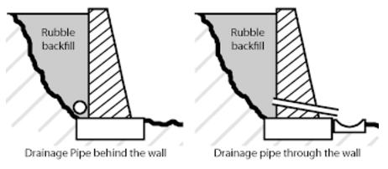

Drainage pipe behind the wall
Advantages
Water management, prevents damage, improved stability, aesthetic appeal
Disadvantages
Installation complexity, regular maintenance, high cost, limited effectiveness

Drainage pipe through the wall
Advantages
Direct water removal, enhanced protection, simplified installation, effective in certain conditions
Disadvantages
Visibility, vulnerability to damage, limited design options, maintenance requirements

Outcome for Activity 7 | Satisfactory  Not satisfactory
Trainer/Assessor comments

Explain the following terms:
- Batter
- Angle of repose

Term | Definition
- Batter | In construction and engineering, the term "batter" refers to the inclination or slope of a wall or structure. It describes the angle at which a wall leans back from the vertical. Battering a wall provides stability and resistance to forces such as wind, soil pressure, or seismic activity.
- Angle of repose | The angle of repose is the steepest angle at which a material remains stable without sliding or collapsing. It is the natural angle that loose granular materials, such as sand, gravel, or soil, will settle into when poured onto a surface.

Outcome for Activity 8 | Satisfactory  Not satisfactory
Trainer/Assessor comments

Describe what is happening the in sketched diagram and the photograph shown below.

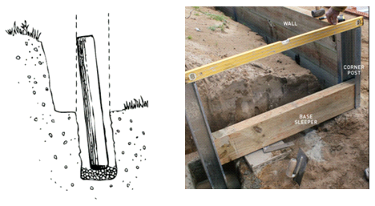

 | Description
- Sketched diagram | Vertical support beam fixed within a hole ready for concrete to be poured.
- Photograph | Two corner posts fixed in place with concrete to support base sleeper with spirit level on top to check level.

Outcome for Activity 9 | Satisfactory  Not satisfactory
Trainer/Assessor comments

Have team members take photos and videos of your involvement with retaining wall projects.

Identify each photo / video with a letter label and describe each photo / video in the table below. Submit the photo / video files along with this workbook.

Advantages
A
B
C
D
E
F
G
H
I
J
K
L
M
N
O
P
Q
R
S
T
U
V
W
X
Y
Z

Outcome for Activity 10 | Satisfactory  Not satisfactory
Trainer/Assessor comments

