CPCCBC4010B
Apply structural principles to residential low rise constructions

CPCCBC4011B
Apply structural principles to commercial low rise constructions

THEORY EXAM INSTRUCTIONS

- This exam will occur under standard assessment conditions.
  - An oral examination may be allowed under certain circumstances.
Answers will be documented and FT003 (Oral examination declaration form) must be completed.
- Participants must provide enough detail in their responses to demonstrate their knowledge and skills.
- Please fill in the details below, providing your name, signature and date of assessment.
  - Your signature acknowledges that this is your own work.
- If a participant initially answers a question incorrectly but modifies their response, they must follow the instructions below:
  - If a participant changes their response in writing, they must put their initials next to the written change.
  - If a participant changes their response verbally, this must be noted on the exam paper by the assessor.

Participant name | Angelo Navarro Tolentino
Participant signature | 

Assessor name
Assessor signature | 

Date | 12/06/2018

Number of questions | Number of questions answered correctly | Satisfactory?
134 |  | Yes | No
Assessor Comments
- What are the four (4) primary loads which a structure must resist?

Answer | The forces on a building include:  1. Dead Loads  2. Live Loads  3. Negative and Positive Wind Loads  4. Hydrostatic pressure from water pressure in the ground

Refer to the table shown below to respond to Q2. to Q3.

Live loads for floors as per building usage | Uniformly distributed load (kPa or kN/m²)
Houses | 1.5
Flats, motel bedrooms, apartments | 2.0
Offices | 3.0
Workshops | 5.0
Parking, vehicle >2.5t | 5.0
Hospitals, school assembly areas with fixed seating | 3.0
Dance halls, bars, lounges | 5.0

- Calculate the live load of a dance hall measuring 23m x 8m.
Show your calculations.

Answer | (23x8)sqm = 184sqm = Area of Dance Hall  Dance Hall UD: = 5.0 KN/sqm  LL= (184sqm)(5.0kN/sqm) = 920kN ANS.

- Calculate the live load of a commercial office premises floor measuring 33m x 11m. Show your calculations.

Answer | (33x11)sqm = 363sqm = Area of office  Office UDL = 3.0 kN/sqm  LL= (363sqm)(3.0kN/sqm)=1089 kN

- What happens when wind flows around a building?

Answer | When wind flows around the surface of a building, the flow typically splits as it flows over and around the building. In addition, it adds on to the external forces that the building is exposed to.

- Explain the difference in pressure exerted by wind on a building, as compared to a wind vortex.
What must be done to the building structure to prevent it being blown away?

Answer | Wind loads are very different to dead loads and live loads. Wind loads typically act laterally. In contrast, wind vortex on walls of buildings may act down on roofs.  To prevent the structure from being blown, a structure must have:  1. Careful placement of bracing  2. Roof materials tied down to the external load bearing walls to prevent uplift.  3. Tie down rods which connect the roof wall and floor or footing and metal strapping rated to resist the know wind region effects.

- What are some of the factors to be considered for wind loadings?

Answer | When a building a structure, one should consider the following wind loading factors:  1. The shape of the building  2. Opening in roof or walls  3. Flat vertical planes

- Explain the term ‘load path’ in reference to a building.

Answer | A ‘load path’ is simply the direction in which each consecutive load will pass through connected members. The sequence commences at the highest point of the structure working all the way down to the footing system, ultimately transferring the total load of the structure to the foundation.

Please refer to the information below in responding to Q8. to Q14.

There is a building 21 metres long x 10 metres wide x 8 metres high with a 25⁰ pitched gable roof.
The rafter line on the metal clad roof measures 5.5 metres on the rafter line, that is, from the fascia/gutter line up to the ridge line.

The wind load rates are as follows:
- Windward wall is 21 metres long x 8 metres high with a wind load rate of +1.5KN/m²;
- Leeward wall 21 metres long x 8 metres high with a wind load rate of -0.8kN/m²;
- Windward roof with a wind load rate of +0.8kN/m²; and
- Leeward roof with a wind load rate of -1.5kN/m²

- What is the wind load rate for the windward wall? Tick your response.

Answer | Choice | Possible Answers
 | ☒ | +1.5kN/m²
 | ☐ | -1.5kN/m²
 | ☐ | +0.8kN/m²
 | ☐ | -0.8kN/m²

- What is the wind load rate for the leeward wall? Tick your response.

Answer | Choice | Possible Answers
 | ☐ | +1.5kN/m²
 | ☐ | -1.5kN/m²
 | ☐ | +0.8kN/m²
 | ☒ | -0.8kN/m²

- What is the wind load of the windward wall (Area of wall x wind load rate)? Tick your response.

Answer | Choice | Possible Answers
 | ☐ | -252kN
 | ☐ | 134.4kN
 | ☒ | 252kN
 | ☐ | 86.4kN

- What is the wind load for the leeward wall (Area of wall x wind load rate)? Tick your response.

Answer | Choice | Possible Answers
 | ☒ | -134.4kN
 | ☐ | -94.2kN
 | ☐ | 252kN
 | ☐ | 134.4kN

- What is the wind load rate for the windward roof? Tick your response.

Answer | Choice | Possible Answers
 | ☒ | +0.8kN/m²
 | ☐ | -43.2kN/m²
 | ☐ | -1.5kN/m²
 | ☐ | +1.5kN/m²

- What is the wind load for the leeward roof? (Area of roof x wind load rate). Tick your response.

Answer | Choice | Possible Answers
 | ☐ | -173.25kN
 | ☐ | 92.4kN
 | ☐ | 173.25kN
 | ☒ | -134.4kN

- What is the wind load for the windward roof? (Area of roof x wind load rate). Tick your response.

Answer | Choice | Possible Answers
 | ☐ | 252kN
 | ☐ | -92.4kN
 | ☒ | -252kN
 | ☐ | 92.4kN

- What are the main structural principles that apply to residential and commercial low rise structure erection and demolition?

Answer | - Loads and loading  - Section properties  - Behaviour of structural materials  - Performance of beams  - Performance of columns  - Performance of roof trusses  - Principles of formwork  - Solution of force systems  - Wind bracing

- How is the classification of a building (or part of a building) determined?

Answer | The classification of a building or a part of a building is determined by the purpose for which it is designed, constructed or adapted to be used.

- Refer to the BCA A3.2 building classes and give the classification definition for the classes of buildings listed in the table below.

Answer | Class | Classification definition
 | 1 | One or more buildings which in association Constitute: a. Class 1a –a single dwelling b. Class 1b – boarding house, hostel
 | 2 | A building containing 2 or more sole-occupancy units each being a separate dwelling
 | 3 | A residential building, other than a building of class 1 or 2, which is a common place of long term or transient living for a number of unrelated persons
 | 4 | A dwelling in a building which is Class 5,6,7,8 or 9 if it is the only dwelling in the building
 | 5 | An office building used for professional or commercial purposes, excluding buildings of Class 6,7,8 or 9
 | 6 | A shop or other building for the sale of goods by retail or the supply of services direct to the public
 | 7 | A building which is Class 7a or Class 7b
 | 8 | A laboratory or building for production, assembling, altering, repairing, packing, finishing, or cleaning of goods for sale
 | 9 | A building of public nature: Class 9a-health care building, Class 9b-an assembly building, Class 9c-aged care building
 | 10 | A non-habitable building or structure: Class 10a – non-habitable building, Class 10b-fence,mast, pool, Class 10c -Shelter

- What is the purpose of understanding loads on a building?

Answer | In any building design, the strength and stability of an overall building and its individual components must be considered. Loads are involved in the structural calculations of a building.

- Forces are represented as vectors and have three (3) properties.
Name these properties.

Answer | 1. Magnitude – the size of the force  2. Direction – the direction of the force  3. Position – the body effect by the force

- How can you best visualise where a building’s loads are being transmitted (felt) on the structural elements of the building?

Answer | You can visualise which portion of the building’s load is transmitted to which structural element by following the load paths.

- What do the structural members of a building consist of?

Answer | Structural members consists of:  1. Beams  2 Columns  3. Retaining Walls  4. Floors  5. Wind Bracing

- What are the two (2) main principles of structural effectiveness for structural members when considering the shape and type of material to use?

Answer | 1. Mechanical Properties  2. Section Properties

- Explain the beam types listed in the table below.

Answer | Type | Explanation
 | Simply supported beam | Simply supported beams are supported at each end only. If downwards pressure is applied bending would occur at the middle of the beam
 | Continuously supported beam | Continuously supported beams are supported by three or more support points. They deflect less than simple beams of the same span because the positive and negative bending cancel each other out. Generally 20% more efficient than a simple span
 | Cantilevered beams | Cantilever beams overhang their supports. The cantilever section of the beam cannot support the same loads as the back span which is the section of beam between the supports. A typical allowance for the amount of cantilever in a beam is 30% of the back span therefore a 45 m beam could have a cantilever section 15 m long.

- Explain the terms listed in the table below.

Answer | Term | Explanation
 | Strength | This is the resistance it is able to offer to the load that will just cause fracture, for example, the resistance that 1mm^2 of section can offer to the load that will just cause fracture.
 | Hardness | This is the degree of resistance to indentation or abrasion.
 | Toughness | The resistance to the fracture of a material by repeated bending or twisting after its yield point has been passed.
 | Elasticity | This is the ability of a material to deform with loading and then returns to its original shape when removed.
 | Plasticity | The opposite of elasticity. If a material deforms when loaded and does not return to its original shape when the load is removed, permanent deformation occurs. This is called plastic behaviour.
 | Ductility | The property which enables a material to be drawn out in the direction of its length. It is a valuable property because a ductile material will not fail suddenly or snap off suddenly without giving some warning by lengthening before it fails.
 | Brittleness | The property which causes a material to break or snap off without any noticeable lengthening. It is the reverse of ductility – often caused by fatigue.
 | Malleability | A material can be hammered or otherwise worked into various shapes. In some ways this property is similar to ductility.

- Discuss the terms compression, tension and shear forces when applied to materials and structural members of a building.

Answer | Term | Explanation
 | Compression | An axial stress that tends to cause a body to become shorter along the direction of the applied force.
 | Tension | An axial stress that tends to cause a body to become longer along the direction of applied force.
 | Shear | Vertical shear forces are generated in a beam by the applied loads and by the support reaction. The reactions push up while the load pushed down.

- What is a column and how does it transmit load forces?

Answer | Columns are vertical support members. They are also referred to as pillars, posts, stachions, and struts. A column generally pick up load from halfway to its neighbours. It also carries the loads the come from the floors above.

- Is a column, stump or post in compression, tension or shear?
Explain your answer.

Answer | In a column, with a large axial load, the difference in length does not apply. The whole column is in compression. Many of the materials used for columns are weak in tension. Shear is also out of the question because it is also not designed for lateral loads.

- Explain the letters ‘CHS’ and ‘SHS’ with reference to columns, pillars, posts/stumps and stanchions as vertical (usually steel or concrete pipe) support members subjected to compressive loads.

Answer | The most efficient shape for a column is the circular hollow section (CHS). On the other hand, the second most efficient shape is the square hollow section (SHS).

- Explain the terms listed in the table below with relation to structural performance of columns.

Answer | Term | Explanation
 | Axially load column | When the load is central to the centre of gravity axis, it produces a direct compressive stress within the column. Axially loaded columns are sometimes referred to as “concentric columns”
 | Non-axially loaded column | When the load is off-centre the column is called an ‘eccentric column’. This results in bending and compressive stress being applied to the column.
 | Buckling | Buckling is a major consideration in designing all compression members. Buckling is deformation at right angles to the direction of the applied load.
 | Slenderness ratio | The maximum load a column can be allowed to support depends on the slenderness ratio and the material from which the column is made.
 | End fixity and effective length | The way in which a column buckles is affected by how rigidly it is connected to other members at the top and the bottom. The term for the type of end fixing is end fixity and this affects the way a column buckles.

- How will bearers, joists, lintels, beams or girders transmit load forces?

Answer | Loads will be transmitted through tributary area. Loads applied to different parts will be transferred to the building foundations. The structure should provide a safe path for this load transfer so in order to design a structural element, you must determine the loads transferred to it by other building or structural elements.

- How do floor boards transmit load forces? Explain with reference to residential and commercial low rise structures.

Answer | Floor boards will be carried by the slab which is over the columns. A column generally pick up load from halfway to its neighbours. It also carries the loads that comes from the floors above.

- How do walls, floors, and roofs transmit load forces?

Answer | Walls, floors and roofs are considered to be dead loads. Like other structural components, they will transmit their load forces to the structural members of the building through tributary area. To note, walls, floor, and roofs are considered as either distributed and or point loads.

- Explain what load imposition from torsion (twisting) can do to a building’s structure.

Answer | Torsion is the twisting or wrenching of a body by the exertion of forces tending to turn one end or part about a longitudinal axis while the other is held fast or turned in the opposite direction. The presence of torsion can affect the current equilibrium of the structure and make it fail. With its presence, it is highly necessary for one to provide additional and appropriate reinforcements or change the design of the structure for it to be able to handle loads imposed from torsion.

- Explain what retaining walls are and what is critical to their sufficiency of structure.

Answer | A retaining wall is a wall built to hold back soil. It is required to support soil where a sloping site requires excavation and either there is insufficient room or it is impractical to batter the soil. Retaining walls must be:  - One metre high must and designed by a qualified structural engineer  - Able to resist soil pressures to be a stable structure

- Draw two separate hand sketches to explain the difference between a batter and a retaining wall.

Answer
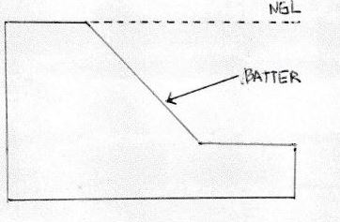

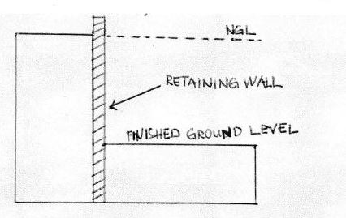

- Explain the differences between an inclined retaining wall, a gravity retaining wall and a cantilevered retaining wall.

Answer | An inclined retaining wall leans into the excavated soil and is constructed at an angle between 45 and 80 degrees. Gravity retaining walls retain on its own weight to resist overturning forces from the soil. A cantilever retaining wall is the most complex of the three types and must be carefully designed by an engineer. It relies upon the correct placement of steel reinforcement and varying thickness of concrete to resist the compressive and tensile forces exerted on the wall by soil pressures.

- What is a ground level concrete slab floor?

Answer | It is a large flat stretch of concrete, usually between 100-500mm thick which forms the foundation of the structure. Ground slabs are poured directly into the excavated trenches in the ground and rely on the existing ground for support.

- What is a slab subfloor made of?

Answer | Slab subfloors are primarily made of concrete, though other materials like steel mesh or rebar are also incorporated to add strength. To improve stability, the slab typically sits on a bedding of building sand and will require a plastic vapour barrier.

- What should you consider when selecting the type of slab floor?

Answer | It is important to take into consideration the type of flooring, the laying of pipes and reinforcement. The type of flooring in a house must be adequately supported by the flooring structure below.

- Name and describe each of the general soil classifications that are followed in Australia.

Answer | Class A - This denotes very 'stable' ground - mostly sand and rock, not affected by moisture  Class S - Slightly reactive soil, slight movement due to moisture  Class M - Moderately reactive soil, moderate movement due to moisture  Class H - Highly reactive soil, a high amount of movement due to moisture  Class E - Extremely reactive soil, extreme movement due to moisture  Class P - 'Problem' soil, which experiences land slip, mine subsidence and so forth. If you are building on Class P site you will typically need to consult an engineer.

- What purpose does the soil report serve? Who prepares a soil report?
Which Australian Standard (AS) will be relevant to the soil report?

Answer | A soil report determined the soil classification, soil bearing capacity, and the type of footing system and slab. The structural engineer prepares the soil report. For soil reports, AS 2870 is the relevant standard.

- There are many different types of on-the-ground concrete slabs. Write a brief description for those listed in the table below.

Answer | Term | Explanation
 | Slab on ground | This is the simplest type of slab. It incorporates stiffening beams made from pre-poured concrete in trenches around the outside of the slab, and has a slab thickness of 100mm.
 | Stiffened raft slab | Similar to the slab on the ground, but also has pre-poured concrete beams set in channels through the middle of the slab, creating a kind of supporting grid of concrete on the base of the slab. Most slabs in Australia are stiffened raft slabs.
 | Waffle raft slab  (aka waffle pod slab) | These slabs are constructed entirely above the ground by pouring concrete over a grid of polystyrene blocks known as 'void forms'. Waffle raft slabs are generally suitable for sites with less reactive soil, use about 30% less concrete and 20% less steel than a stiffened raft slab, and are generally cheaper and easier to install than other types (even in bad weather). These types of slab are only suitable for very flat ground. On sloping ground or with more complex designs, a stiffened raft slab is normally the better option. Waffle raft slabs are suited to lightly and moderately reactive clay sites in particular, because they're not embedded in the ground like stiffened raft slabs.
 | Pier and slab | On sites with more reactive soils, it's common for concrete piers to be sunken into the soil to improve stability. This is normally done by digging holes at intervals and depths determined by an engineer, then pouring concrete into them and attaching the slab to these piers.

- Briefly explain how a concrete slab sub-floor is installed.

Answer | For a standard slab on the ground, first the site is scraped back to the soil, keeping it as level as possible and ridding it of all plant matter. Then, formwork is put up around the edges of the slab to prevent the concrete from spreading. Trenches are dug around the edges for all stiffening beams, and bedding sand is laid down to level things out. A plastic vapour barrier is used to coat the site and prevent dampness from rising through the slab. Rebar or mesh is then spread out to cover the area. In some situations a layer of gravel may be laid down to provide a solid base. The concrete is then poured on top, spread out and levelled.

- Where are ground-level concrete slab sub-floors used?
What are the advantages and disadvantages concrete slab sub floors over conventional timber or steel sub-floor framing on stumps/posts with strip or sheet flooring?

Answer | Ground slabs are very common these days and can be found almost anywhere in Australia where there is ready access to concrete. These foundations are generally used to support heavier building materials like brick and steel.  Advantages:  - Extremely durable and hardy base for a floor  - Typically well insulated, because the underside of the floor is not exposed  - No maintenance once the concrete has cured  Disadvantages:  - Impossible to access piping once the slab has cured  - Cracks can cause major structural damage, and may be unrepairable  - Can increase unwanted noise

- Explain the terms listed in the table below.

Answer | Term | Explanation
 | Foundation movement | The slab must be designed and constructed to make sure that it is strong and stiff enough to oppose stresses. It is necessary to have a method of regulating the moisture content of the foundation soils so that the overall stress is minimised.
 | Slab bending | The type of bending will determine where steel reinforcement needs to be placed in the concrete slab.
 | Stiffening beams | The design of the arrangement of the stiffening beams is influenced by the reactivity of the foundation soils.

- Buildings are usually designed to support the vertical loads created by dead and live loads. They also need to be able to resist lateral loads from wind and vortex loads. In building we use numerous techniques to overcome this problem.
Briefly explain the three common cable bracing techniques and sketch diagrams to explain your answer.

Answer | Knee bracing: Formed by inserting diagonal structural members into rectangular areas of a structural frame, helping to stabilise the frame.  K-Brace: Braces connect to the columns at mid height. This frame has more flexibility for the provision of openings and results in the least bending in floor beams.  Cross Bracing: Uses two diagonal members crossing each other. These only need to be resistant to tension, one brace acting to resist sideways forces at a time depending on the direction of loading.

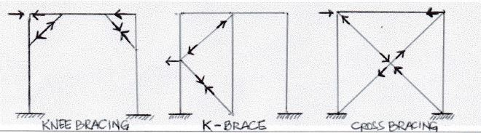

- Different bracing systems are used in residential and commercial construction which when operating together contribute to bracing a building against lateral wind, vortex and other forces.
Explain the bracing systems listed in the table below.

Answer | Term | Explanation
 | Rigid frame | A steel or reinforced concrete frame with rigid joints will resist changes resulting from forces in different directions.
 | Shear wall | A wood, concrete or masonry wall will resist changes in shape. The wall will transfer lateral loads to the foundations.
 | Braced frame | The frame is timber or steel and is braced with diagonal members.
 | Horizontal floor | A rigid floor structure is like a deep flat beam. The floor transfers lateral loads to the shear walls and to the braced or rigid frames.
 | Lift shaft with solid walls | Most office blocks made are made stiff by using an internal concrete shaft as a stiff central core to which all the floors are rigidly fixed. The floors act as horizontal diaphragms which transfer the stiffness from the core to the whole building.
 | Theory of triangulation | Triangulation involves the use of triangular shapes to give stability to structures. Usually there types of structures offer no resistance to bending moments when a force is applied.

- What are important considerations when undertaking demolition work?

Answer | It is important that any demolition work of existing structures is done in accordance with legislative and planning requirements. Safe work practices are a vital part of the demolition process.  In addition, one must refer to the code of practice for demolition works

- What must be included in an application for a permit to demolish or remove a building?

Answer | The Australian Building Codes Board (ABCB) oversees building legislation, including the Building Act 1993 which details the procedure for demolition:  - 1. You must get a demolition permit  - Assistance to complete the application process by a building surveyor  - Get a planning permit (if within a heritage overlay)

- Describe the process of applying for a demolition permit using a simple flow diagram.

Answer
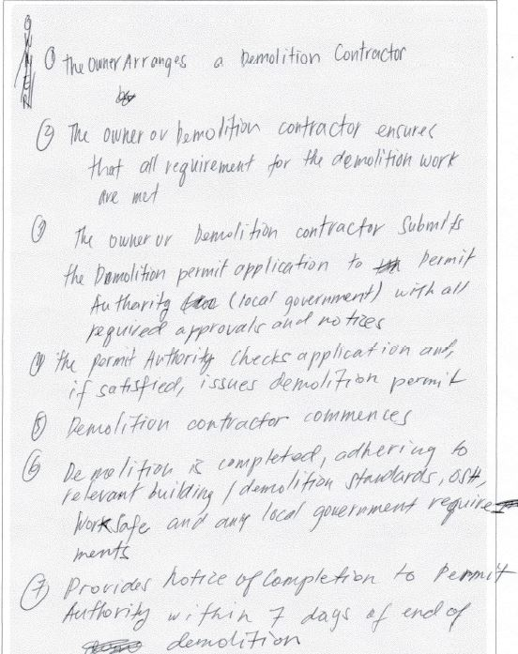

- Name the primary Australian Standard and codes of practice to be followed when performing demolition of structures.

Answer | The demolition work code of practice

- When performing demolishing what are some of the agencies which might be accessed for information and guidance?

Answer | You will need to seek advice from your local WHS regulator or building regulator.

- Name some of the people included in the construction process, from professionals involved in building design to specialist tradespeople.

Answer | 1. Architects  2. Engineers  3. Drafts people  4. Building Surveyors  5. Land Surveyors  6. Quantity Surveyors

- Who would you consult to gain insight to using the right sized and right shaped materials for a project?

Answer | To gain insight using the right sized and right shaped materials, one should consult the Architect and Structural Engineer of the project.

- Briefly describe the role of an architect.

Answer | Architects are people who design buildings and in many cases also supervises their construction. They help you to set available and realistic budget, guide you through the planning process and obtain competitive quotes and manage consultants.

- Briefly describe the role of a structural engineer.

Answer | Involved in designing structures such as buildings, bridges, tunnels, etc. The majority of structural engineers work primarily as consultants to architects or design-build contractors.

- What is the difference between a building surveyor and a land surveyor?

Answer | Building surveyors provide professional advice on property and construction which spans across residential, commercial, industrial, leisure and agriculture projects. They work on the design and development of new buildings as well as the restoration and maintenance of existing ones.  On the other hand, land surveyors assess the surrounding terrain and landscape for the purpose of development. They commonly use specialised technology and equipment to do this as many of today’s building and tunnelling projects that are so complex,

- What is a quantity surveyor and work do they perform?

Answer | They are professionals working within the construction industry concerned with construction cost and contracts. Services provided by a quantity surveyor may include: cost planning and commercial management throughout the entire life cycle of the project from inception to post-completion.

- Name some of the building approval plans that will be necessary to see a project through its construction.

Answer | 1. Building approvals  2. Contract plans  3. Design and Specifications  4. Engineer footing designs and specifications  5. Original contour survey plan  6. Registered plans  7. Retaining wall  8. Site plans  9. Soil investigation reports  10. Structural floor, wall and roof systems  11. Underpinning, rock anchors and shoring designs and specifications

- What is a land title and what would you expect it to contain?

Answer | It is an official record of who owns a piece of land. It can also include information about mortgages, covenants, caveats and easements. It contains:  1. A plan with lot number  2. Name of owner  3. Reference numbers  4. Certificate stamp

- Why would you need a construction permit or building permit?

Answer | A permit is required in most jurisdictions for:  1. New Construction  2. Adding onto pre-existing structures  3. Major renovations

- What is a building permit and what does it show and record?

Answer | It is the document which shows that your plans have been approved by a building surveyor.  It shows the ff:  1. Occupation Permit  2. Progress Payments  3. Relevant Dates  4. Building Surveyor  5. Inspection Dates  6. Paperwork you are required to comply with

- What other permits could be required? Give two examples.

Answer | 1. Asset protection – this includes payment of a bond to cover repair to council assets and is approved prior to beginning construction.  2. Road opening – required prior to installing crossovers. Crossover are pieces of timber placed on san in the foot path so that trucks do not damage the footpath.

- What would be reasonable to expect to see in a project specification?

Answer | Project specification contain all the written information that accompanies the plans.  The sections included in a project specification include descriptions about:  1. The job  2. The site  3. The proprietor  4. Other parties in the contract arrangement

- What is a sub-division plan and what is its purpose?

Answer | The plan of the subdivision is prepared for a planning approval prior to the development of the land. It is a good source of information relating to adjoining properties.

- What would a site plan tell you?

Answer | A site plans shows a bird’s eye view of the building site which:  1. Shows the location of a structure on a block of land  2. Minimises the risk of building on the wrong block of land  3. I usually drawn to smaller scale than that of a floor plan  4. Is adequate at a 1:500 scale  5. Is informative when looking at adjoining properties

- Explain what a floor plan will tell you.

Answer | Floor plans will detail the following:  1. All horizontal dimensions such as room size and wall thickness  2. Size and location of windows and doors  3. Location of fixtures and fittings  4. Any particular requirements in a room such as floor coverings  5. An indication of the materials used for wall construction  6. The overall floor areas

- What is the purpose of a cross sectional drawing?

Answer | Purpose:  1. To show more detailing by having a bigger scale than floor plans  2. To indicate the type of structural materials

- What information would you expect Municipal (Council) drainage plans and Water Authority documentation to provide you?

Answer | Drainage plans will provide details of legal points of discharge for stormwater drainage. On the other hand, water authority documentation such as a sewer plan provides details of plumbing fixtures, drainage lines and points of attachment to existing buildings on a site.

- Briefly discuss the purpose of footing design and name the Australian Standard (AS) which applies for low rise commercial building projects.

Answer | Purpose of footing design:  1. Knowing the footing depth and width  2. Information on slabs and stiffening beams  3. Information on the type and positioning of steel reinforcement  AS 2879 – 2006 is applied for low rise commercial building projects

- What are contour plans? Describe their purpose in building and construction projects.

Answer | Contour plans are a graphical representation of the lay of the land and show the degree of slope on a site.  Purpose in building and construction projects:  1. Cut and fill needed  2. Height of retaining walls  3. Overall finished height of buildings

- What is a site condition report and what is its purpose?

Answer | The site condition report is a record of details about:  - the existing site  - buildings on adjacent boundaries and setbacks of structures  - condition of fences  - vegetation on the site on the boundaries  - location of services. (water, gas, electricity and telephone lines.

- What does the AS3959 refer to?

Answer | AS 3959 refers to the construction of building in bushfire-prone areas.

- Australia is zoned into four regions for high winds. What and where are these regions?

Answer | Region A – Normal: Located at central Australia and Hobart  Region B – Intermediate: Located in the shorelines from Perth to Brisbane  Region C – Tropical Cyclones: Located in the shorelines halfway of Perth and Broome  Region D – Severe Tropical Cyclones; Located on shorelines from Broome to Brisbane

- The acceleration coefficient is a number which indicates the expected severity of the earthquake ground movement. Which Australian Standard should be referenced for this information?

Answer | AS 1170.4

- What defines an alpine area in Australia?

Answer | Alpine areas are defined as 1,200 m or more above Australian height datum (AHD) for NSW, ACT, and Victoria and 900m or more above AHD for Tasmania.

- Where in the Building Code of Australia (BCA) can you find information relating to alpine and sub-alpine areas in which the snow loads could play a significant part in design and construction?

Answer | BCA, Section G4 – Ancillary Provisions

- What can we reference when intending to use new and emerging building technologies in the construction of a building?

Answer | Any new technology must satisfy performance requirements and this can be determined by using the following assessment methods:  1. Documentary evidence  2. Verification methods  3. Expert Judgement  4. Comparison to deemed to satisfy provisions

- What are some of the critical considerations to be made about footings and the transfer of loads from the building to its footing foundations?

Answer | Always set out your footings in accordance with the building plan  1. Pressure of foundation soils  2. Footings selection, size and type  3. Stump materials  4. Pier and beam

- What codes and standards should be checked to ensure footings specified within the building plan are compliant?

Answer | 1. BCA Volumes – Section 3.2.4.5  2. AS 1684 – Residential timber framed construction  3. AS 2870 – 1996 Residential slabs and footings – construction  4. AS/NZS 2904 : 1995 Damp-proof courses and flashings  5. AS 3660.1 – 1995 Protection of new buildings from subterranean termites

- Name the relevant Australian Standard for protection against subterranean termites.

Answer | The Australia Standard AS 3660.1-1995 ‘Protection of new buildings from subterranean termites’

- What should be considered when constructing a floor system?

Answer | It is important to take into consideration the type of flooring, the laying of pipes and reinforcement. The type of flooring in a house must be adequately supported by the flooring structure below.  Floor system components include:  1. Concrete subfloors  2. Drill or driven piles  3. Mass concrete piers  4. Reinforced concrete piers and beams  5. Screw piles  6. Waffle pod slab

- When designing and installing a concrete residential slab and footings what Australian Standard applies?

Answer | Australian Standard AS 2870 – 1996 ‘Residential Slab and footings’

- What are bearers in a sub floor framing system?

Answer | Bearers are the first of the sub-floor frame members to be installed. They are positioned over stumps, piers or other supports. In most cases they are timber, however, a wide variety of engineered timber products are available. As well, mild steel and cold-formed steel sections may be used to achieve greater spans.

- What are floor joists in a sub-floor framing system?

Answer | Floor joists are the next series of members for the sub-floor frame. They are supported by the bearers.  Typically the floor joists run over the tops of bearers, however, they may be attached to the sides of bearers. Like bearers, floor joists may be single span or continuous span. They can be made of timber or steel.

- Sketch free hand compact simple drawing in section to show the following floor system components of the external load bearing wall and bottom plate, joist and bearer to include:
- Wall frame
- Sheet flooring
- Floor joist
- Bearer
- Brick pier with stump cap

Answer
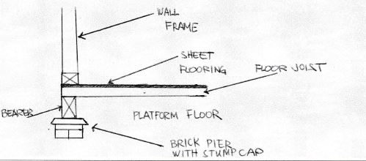

- What is a strip timber flooring system (also sometimes referred to as a fitted floor)?

Answer | Fitted floors (cut-in floors) are installed after walls have been erected and after roofing, wall cladding, doors and windows have been installed.  Where boards are laid parallel with walls, a minimum 10 mm gap shall be provided between the board adjacent to the bottom plate and the bottom plate.

- Explain the benefit or otherwise of a platform floor.

Answer | A platform floor provides a working platform for the builder as the floor is laid before erecting the wall and roof framing.  The platform floor:  - should be protected from getting wet by rain and/or wet trades  - are laid with the face grain of the plies at right angles to the line of the supporting joists  - Edges of sheets, unless tongued and grooved, are joined over noggings between joists. Noggings (70 x 35 mm sections) are set flush with the top of the joists

- Briefly explain drilled or driven piles as a footing system for commercial/industrial type buildings.

Answer | Driven piles are a deep foundation element that is a pre-manufactured structural shape and can provide a wide range of capacities. There are a variety of driven pile types, including h-piles and pipe piles. Driven piles provide excellent quality control because they can be physically inspected prior to installation and during installation. Driven piles are installed using an impact or vibratory hammer.

- Which section of the Building Code of Australia addresses piling as a foundation system?

Answer | The Building Code of Australia Volume 1:  BCA Vol. 1, B1.4 Determination of structural resistance of materials and forms of construction  Piling: AS 2159

- Explain the term ‘screw piles’. What must preface to approve the use of screw piles as a foundation system?

Answer | Power driven galvanised steel columns are an alternative pier system to timber piles. The piles have a helix auger on the ends, which enables the pile to drill itself into the ground.  This engineered system requires an accreditation certificate to ensure acceptance by building authorities.

- What does a concrete pier typically consist of?

Answer | A concrete pier typically consists of a:  - round or square concrete pillar  - footer piece which serves to spread the load carried by the pier  - footer is placed below the frost line and top end above the ground surface  - the concrete pier top is typically equipped with a frame or bracket which support structures upright beams are attached  - effective for most soil types in areas which have little or no earthquake or hurricane activity

- Where could you use a bulk pier and beam system?

Answer | Bulk pier (and beam systems) are satisfactory where good bearing soil is located between 800 mm and 1,200 mm below the NGL. Bulk piers are excavated using a simple backhoe and the excavation is usually 1 metre x 1 metre in area and extends to the founding depth (800 - 1,200 mm). Piers are normally located at 3 - 5 metre centres.

- What is the construction method for bulk pier and beam?

Answer | Construction method for bulk pier and beam:  - Excavate the pier holes. The number, location and spacing will be shown on the design engineer's drawings.  - Pour concrete in the piers. The concrete is poured to approximately 500 mm below the NGL or FGL. No reinforcement is required in the pier holes. The concrete would be 20 MPa compressive strength.  - Excavate the strip footing. After three days, excavate the strip footing (or concrete beams) between the piers. These concrete beams will be excavated around the entire perimeter of the house.  - Position steel reinforcement for the beam.  - Pour the beam

- Name the framing system shown below.

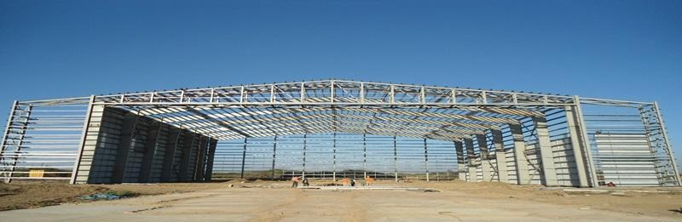

Answer | Portal Frame Construction

- Name the framing system shown below.

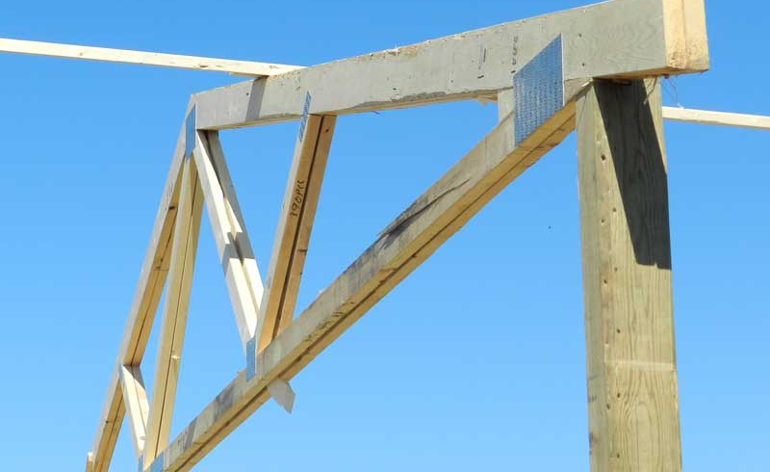

Answer | Post and Truss Construction

- Name the building system shown below.

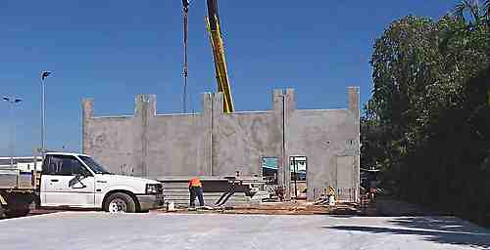

Answer | Tilt-Slab Construction

- Which section of the Building Code of Australia addresses masonry components for a building?

Answer | Masonry components can be found in Vol. 1 of the BCA

- What are masonry coatings?

Answer | Masonry coating is a two component cement-based waterproof coating designed to seal masonry and concrete surfaces.

- A ‘wythe’ or ‘leaf’ is the building and masonry term given to the width of a single brick or concrete block unit. A brick or block masonry wall might incorporate any of cavity brick, single-leaf masonry (brick or block) or lightweight autoclaved (aerated) concrete block (AAC). The cavity between ‘wythes’ can be anything from 50mm to 110mm.
Draw freehand sketches of the following and label your sketches:
- A single masonry wall founded on a cavity brick base with engaged pier,
- A cavity brick masonry wall with 50mm cavity
- A brick veneer and timber framed wall with 50mm cavity
- A masonry retaining wall one (1) metre high

Answer
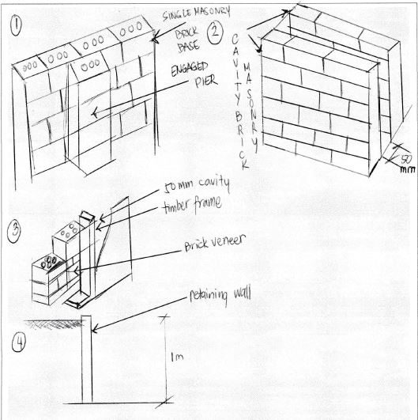

- What is cladding? What BCA section and Australian Standard address specific aspects of cladding?

Answer | Cladding is a non-loadbearing skin or layer attached to the outside of a home to shed water and protect the building from the effects of weather. It is a key element in the aesthetic appeal of the home and directly influences both building cost and property value.  BCA Volume 2. - Part 3.5.3 Wall cladding

- Explain timber cladding systems like chamfer boards and weatherboards.

Answer | Chamferboard is a form of weatherboarding which in turn is the cladding of a house consisting of long thin timber boards that overlap one another, horizontally on the outside of the wall. They usually have a tongued and grooved joint arranged to link the boards together.  Weatherboards are external cladding in residential single and medium-density homes, including alterations and additions, where a cost-effective traditional or contemporary weatherboard look is required. Ideal for full wrap or composite construction designs on either timber or light gauge steel framed homes.

- Describe plywood cladding.

Answer | Exterior plywood cladding is available in various veneer grades and profiles. Plywood should comply with AS 2271 'Plywood and Blockboard for Exterior Use'. If a plywood cladding is structural, the manufacturer will indicate the stress grade. Plywood cladding can also provide structural bracing and roof hold-down resistance.  Plywood has standard tolerances on length, width, squareness, thickness and edge straightness. Plywood can be treated for protection against insect and fungal attacks

- Describe exterior hardboard cladding.

Answer | Exterior hardboard cladding that is manufactured for use as an exterior cladding must comply with AS 2858. The manufacturers' guidelines should be consulted when using hardboard sheet cladding as structural bracing or for diagonal or vertical applications.

- Many additional services can be installed in a building and the building plans and relevant standards and codes must be identified and adhered to ensure appropriate allowances are made for the installation of these services.
Name some of the services that can fall under this scope of additional installations.

Answer | Some to those services include:  - Dusting for heating and cooling  - Electrical, electronic and communication systems  - Extractive vacuum and exhaust systems  - Passive and active fire detection and prevention systems  - Plumbing and drainage  - Powered systems for operating doors and windows  - Smoke control and containment systems

- What is a roof system? Name some roof types and what a roof might be built from.

Answer | A roof system is the structure that forms the roof of a building.  Types of roof systems include:  - Box gable  - Dual pitch roof  - Dutch gable  - Dutch hip  - Gable end  - Hip and valley  - North light  - skillion  In Australia the roof system may be made up of:  - a timber frame roof built on-site  - a prefabricated truss roof in which major components are constructed in a factory and then assembled on-site

- Draw simple line diagrams to represent a gable roof, a hipped roof, hip and valley roof and a skillion roof.

Answer
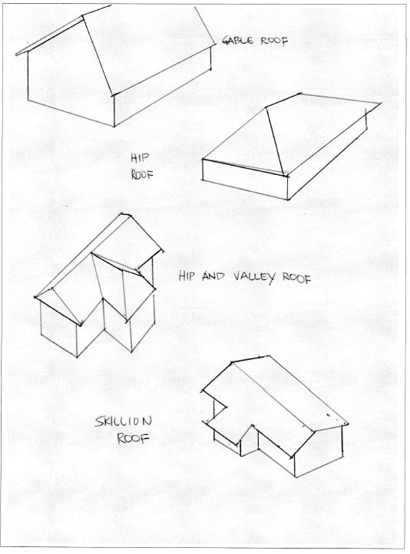

- Name at least eight (8) practical advantages of using prefabricated roof trusses.

Answer | The advantages of trusses include the following:  - They are strong, but light to erect  - They can be made to suit most roof shapes  - There is less on-site fabrication, therefore less site labour is required  - They are less affected by bad weather  - Factory production allows automated production  - Better quality control is possible  - Trusses make maximum structural use of the timber  - Trusses are capable of long spans  - Internal walls are usually non-load bearing, therefore lighter weight internal walls are possible

- What is roof cladding? What are the two most common materials used in Australia?

Answer | Roof cladding is the material used to protect the building from the extremes of the weather. The two most common options are roof tiles and metal roof sheeting.

- What pitch of roof should roof tiles be applied? Are there exceptions?

Answer | Roof tiles are particularly suited to the Australian climate, which generally does not have high winds or snow loads. These elements are most likely to reduce the life of roof tiles. Roof tiles can generally be used on roofs of 15º or greater pitch, however, some materials and methods of manufacture require 25º or greater pitch.

- Describe the materials listed in the table below.

Answer | Term | Description
 | Terracotta tile | The tile is formed in wet clay and then fired to give a hard, long-life roofing product. They come in a number of profiles. Terracotta tiles have a roof life greater than 50 years in most environments, however, salt atmospheres sometimes cause premature fretting.
 | Concrete tile | Concrete roof tiles are generally modelled on terracotta tiles. Modern concrete tiles have roof lives approaching those of terracotta. They are stable, warp-free and have the same basic profiles as terracotta tiles. The colour on the concrete tiles is an applied coating. Although some colours fade quickly (within five years), most of the popular red/brown/charcoal colours have long colour retention.
 | Slate tile | These are a naturally occurring rock.
 | Fibre cement shingles | Fibre cement shingles are slate-like products manufactured from fibre-reinforced. cement
 | Timber shingle/shake | Timber shingles/shakes are made of sawn or split timber boards.
 | Aluminium or steel pressed tile | These are metal that is shaped to imitate a tile. They are often covered with coloured sand glued to the metal.

- Devise a useful roof framing checklist for ensuring the quality of the roof frame once it is installed.

Answer | Quality Procedure – Checklist  1. Rise and pitch of roof against plan  2. Correct propping of ridge, hips, valleys, rafters and purlins at correct centres  3. Adequate collar ties  4. Line of rafter, hips and valleys  5. Support to strutting beams  6. Fascia and barge boards  7. All tie-downs and fixings  8. Ceiling joist and alignment with rafters  9. Hanging beams  10. Trimmers for location  11. Trimming to manhole

- Describe the intent of wall systems and the materials they are typically made from.
What part of the BCA and the AS reference wall systems?

Answer | Wall systems intend to:  1. Provide structural support to roof systems  2. Allow for installation of services  3. Provide a means to apply external and internal linings  Materials used for wall systems include:  1. Cavity brick  2. Concrete block  3. Structural steel  4. Timber

- Explain the purpose of bracing.

Answer | Bracing is attached to studs to provide lateral support to wall framing. Metal straps, timber or sheet bracing can be used for bracing.  - Bracing enables framework to resist horizontal forces (load resistance of live, dead, wind loads) particularly wind loads as buildings must transmit the load through the structure to the foundation.  - The bracing action requires bracing units to be installed at 90 degrees to the surfaces facing the wind  - Permanent bracing is constructed into wall, sub-floor supports in vertical planes and must be designed for each storey  - Temporary bracing supports wind and construction loads on the building and must be equivalent to 60% of permanent bracing required  - Normal wall bracing is wall framing using sheet materials (plywood, plasterboard, fibre cement. The maximum amount that can be resisted by nominal wall bracing is 50% of the total racking forces.

- You are to provide a pictorial sketch with labels to show a common timber stud or steel wall and ceiling frame and include the following members:
- Hanging Beam
- Ceiling joists
- Top plate
- Lintel
- Common stud
- Jamb stud
- Jack stud
- Nogging
- Bottom plate
- Timber or metal bracing
- Sheet flooring
- Floor joists
- Bearers
- Stumps

Answer

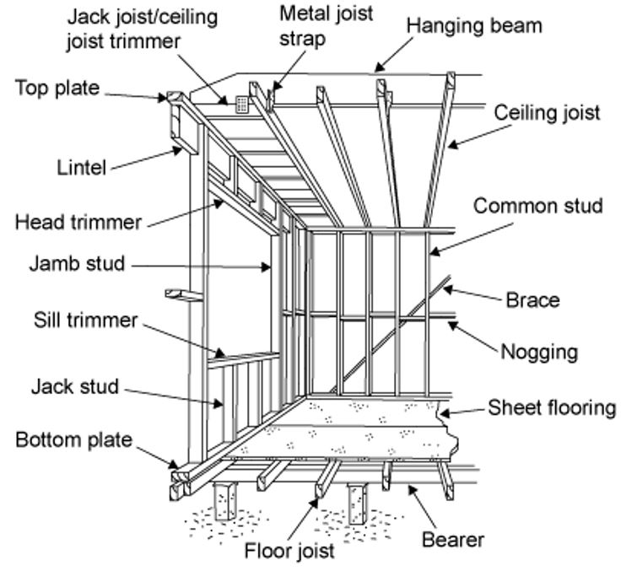

- Name the relevant volume and part in the Building Code of Australia (BCA) as well as the two (2) relevant Australian Standards that apply to the design, application and installation of timber framing for residential housing.

Answer | BCA Volume 2. - Part 3.4.3 Timber Framing  - AS 1684.2 — Residential timber-framed construction — Non-cyclonic areas.  - AS 1684.4 — Residential timber-framed construction — Simplified — Non-cyclonic areas.

- What might be a typical checklist to be used for ensuring the quality of the frame members and the frame as a whole?

Answer | Quality Procedure Checklist  1. Walls for plumb, square, straight and level  2. top and bottom plates have a tight fit on studs  3. bracing and tie-downs in accordance with plan  4. nogging at correct centres and support for fixtures  5. corner blocking  6. wall tied together  7. room sizes and ceiling heights with plan  8. window and door clearances and openings  9. jamb studs to all openings  10. concentrated load bearing studs  11. lintels for adequate bearing  12. block under studs if timber floor  13. any excessive notching  14. provisions for plumbing services and fixtures  15. safety of frame  16. adequacy of temporary bracing

- What is sarking? What purpose does it serve?

Answer | Sarking is a waterproof, vapour-permeable, flexible sheet material fixed directly behind timber cladding or under flooring material.  It directs any water that may have penetrated the cladding back to the outside of the structure and provides a draught proof barrier to keep wind-driven rain or dust out of the wall cavity. Sarking is not a substitute for well-chosen and properly installed cladding and should never be regarded as the principal means of weatherproofing.

- What is flashing?

Answer | Flashings are used at corners and vertical joints and around openings to ensure that water is prevented from penetrating the wall frame cavity. As flashing does not extend fully behind the cladding, non-permeable materials may be used.

You are to refer to the roof section diagram below in responding to Q116. to Q122.

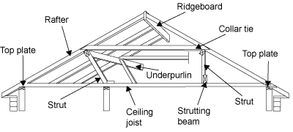

- What is a ceiling joist?

Answer | They provide the structure onto which ceiling is fixed they are the member that connects or ties the lower ends of rafter couples (pairs). Therefore, they prevent the rafters spreading and causing the roof to sag or collapse.

- What is the purpose of a hanging beam?

Answer | The function of a hanging beam is to reduce the span of the ceiling joists. This allows for a more economic joist size and consistent section. Hanging beams must only support ceiling joists and the attached ceiling materials.

- What is the purpose of roof struts?

Answer | The struts are needed in the roof frame to transfer the loads from under purlins and other beams to the load bearing walls.

- What is the ridge board in a conventional framed roof?

Answer | The ridge board in a conventional framed roof is not so much a structural member as a set-out member. It makes sure that rafter couples meet a consistent height giving a horizontal ridgeline free from sags. Ridge boards locate and stabilise rafter ends.

- What function do rafters perform in a roof?

Answer | The rafters give the roof its required slope and provide the structure onto which the roof covering is fixed.

- Explain the role of under purlins in a conventional roof frame system.

Answer | In a conventional roof frame the under purlins support the underside of the rafters. This allows for the most economic rafter size and prevents the roof from sagging and collapsing.

- What are collar ties used for in a conventional roof frame system?

Answer | They supplement the ceiling joists and prevent the couples spreading. Where the rafter span is such that it requires support from under purlins, collar ties are fitted to opposing common rafters at a point immediately above the under purlins.

- What advantages can be gained from installing roof trusses as against a conventional stick framed roof?

Answer | The advantages of trusses include the following:  - They are strong, but light to erect  - They can be made to suit most roof shapes  - There is less on-site fabrication, therefore less site labour is required  - They are less affected by bad weather  - Factory production allows automated production  - Better quality control is possible  - Trusses make maximum structural use of the timber  - Trusses are capable of long spans  - Internal walls are usually non-load bearing, therefore lighter weight internal walls are possible

- What must the design of a timber roof truss adhere to?

Answer | Requirements in accordance with plan:  The design of a timber roof truss must accord with engineering principles and with AS 1720.1. This includes the wind design. AS 4440-1997 “Installation of nail plated timber roof trusses’” provides details for correct practices when installing roof trusses.  Trusses are usually spaced at regular intervals, typically 600 mm, 900 mm or 1,200 mm apart depending on the mass of the roofing material and local practice.

- Discuss timber cladding and reference the relevant Australian Standard as it applies to the specific cladding. Be sure to name what part of the BCA deals with cladding.

Answer | There are a range of timber species, sizes and profiles including:  - Hardwood (AS 2796 'Seasoned hardwood - Milled products' sets out the grades and tolerances for hardwood , AS 082 and AS 083 set out the grades for unseasoned sawn weatherboards)  - Cypress pine(AS 093 'Unseasoned cypress pine - Milled weatherboards (Chamferboard)' sets out grades and tolerances for cypress pine. Manufacturers' literature can also be referred to)  - Preserved treated pine (AS 1784 'Preservative treated cladding milled from Australian grown conifers' sets out grades and tolerances for treated pine, AS 1495 sets out grades and tolerances for preservative treated radiata pine cladding)  - Imported timbers (The most commonly used imported cladding timber is western red cedar. Other imported timbers include redwood and Baltic pine. There is no Australian Standard to govern the grades and tolerances of imported timbers.  Note:  Always refer to the following codes and standards  BCA Volume 2. - Part 3.5.3 Wall cladding

- What must be checked when installing skylights, windows and doors?

Answer | One must always check against the building’s plan and then supervise installation to ensure it is compliant with standards/accepted industry construction.

- What is the relevant Australian Standard to be referenced for glazing of windows and doors?

Answer | AS 1288

- Write a descriptive interpretation of the extract of the window schedule shown below.

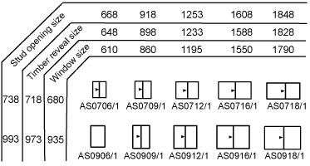

Answer | Window frame manufacturers produce a range of readily available frames. Their sizes are detailed on a schedule. A typical schedule details the appearance of the window frame when viewed from the outside. It also shows the finished height and width of the frame

- Illustrate by sketch the correct positioning of flashings and sarking for timber cladding.
Your sketches should reflect the use of weatherboard stops for installation of timber chamfer boards or timber weather boards where the internal and external corner joins has the cladding butting up to the weatherboard stop.
Alternate installations still require flashings and sarking for man-made manufactured boards such as HardiePlank or PrimeLine in which case sketches would reflect the use of internal and external corner jointers supplied by the manufacturer.

Answer

- Briefly describe each of the building materials listed below and outline the related construction methods used for low rise commercial projects.

Answer | Term | Explanation
 | Brick veneer construction | Brick veneer construction is used over timber-framed and lightweight section steel-framed and lightweight section steel-framed construction
 | Cavity brick construction | Cavity brick construction involves a cavity wall that is composed of two wythes of masonry, separated by a cavity of varying dimension  The masonry wythes may consist of :  1. Solid Brick  2. Structural Clay Tile  3. Conrete Masonry Units  4. Bonded together with masonry ties
 | Earth wall construction | Rammed earth construction is a technique for building walls, foundation, and floors using natural raw materials such as earth, chalk, lime or gravel.
 | Autoclaved aerated concrete block construction | Also known as lightweight concrete construction. The is concrete that has been manufactured to contain lots of closed air pockets.
 | Pole frame construction | A method of building and designing structures, using steel or steel-reinforced precast concrete or using laminated timber.  Typically seen in:  1. Warehouses  2. Barns
 | Portal frame construction | A method of building and designing structures, using steel or steel-reinforced precast concrete or using laminated timber.  Typically seen in:  1. Warehouses  2. Barns
 | Post and beam construction | Consists of:  1. Simply Supported beams – support at each end only  2. Continuously supported beam – supported by three or more support points  3. Cantilever beams – beams that overhang their supports
 | Post and truss construction | A roof truss mostly wooden with two principal rafters and two vertical queen posts with a restraining tie beam at the bottom and straining beam at the top
 | Single leaf concrete masonry construction | Guideline provided by the Concrete Masonry Association of Australia (CMAA). Design Manual contains:  1. Material Properties  2. Earthquake loading on building  3. Typical details of components
 | Tilt panel or tilt slab construction | A pre-cast concrete system of building walls. Traditional pre-cast concrete products are made in a factory, and then have to be delivered to the site. Tilt slabs are poured on site.

