CPCCBC4012B
Read and interpret plans and specifications

THEORY EXAM INSTRUCTIONS

- This exam will occur under standard assessment conditions.
  - An oral examination may be allowed under certain circumstances.
Answers will be documented and FT003 (Oral examination declaration form) must be completed.
- Participants must provide enough detail in their responses to demonstrate their knowledge and skills.
- Please fill in the details below, providing your name, signature and date of assessment.
  - Your signature acknowledges that this is your own work.
- If a participant initially answers a question incorrectly but modifies their response, they must follow the instructions below:
  - If a participant changes their response in writing, they must put their initials next to the written change.
  - If a participant changes their response verbally, this must be noted on the exam paper by the assessor.

Participant name | Ravenska Isabella
Participant signature | 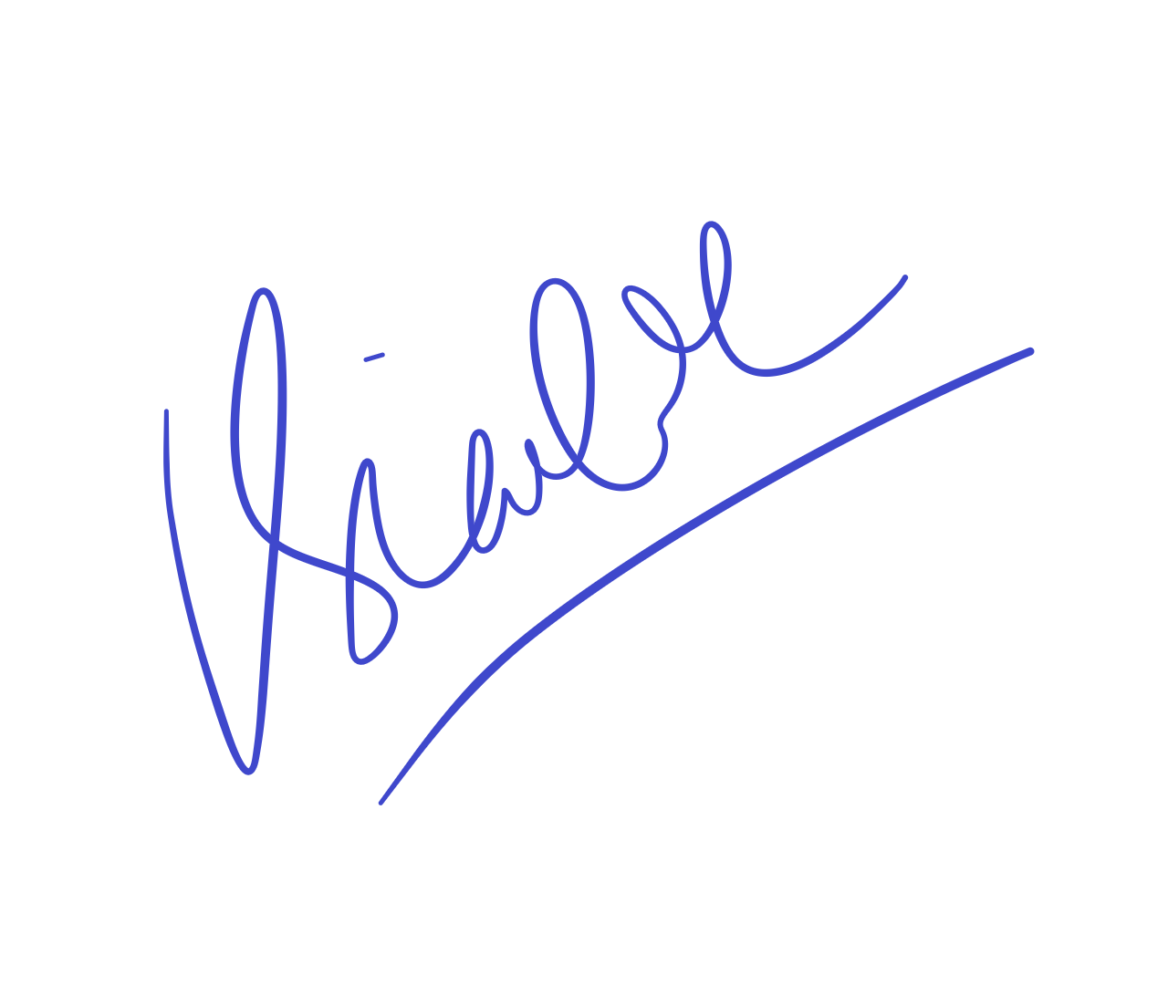

Assessor name
Assessor signature | 

Date | 19/03/2010

Number of questions | Number of questions answered correctly | Satisfactory?
87 |  | Yes | No
Assessor Comments
- Plans and specifications are used to inform which of the following processes? Tick all that apply.

Answer | Choice | Possible Answers
 |  | Building contracts
 |  | Development applications
 |  | Estimation
 |  | Planning
 |  | Supervisory tasks
 |  | Tenders

- Which compass direction is always shown on plans and drawings?

Answer | North Point

- What information is provided on a location plan?

Answer | A location plan is required so that you can correctly identify your building site  Location Plan details the:  Lot number/s  Deposit plan numbers  North pointScale (usually 1:5000)

- What detail does a site or block plan contain?

Answer | A Site or Block Plan is usually gives the following information:  - Outline of site boundaries showing location of proposed building and existing dwellings  - Street frontage names  - Major geological and topographical features (trees and vegetation)  - Datum points, contours and slopes  - Driveways, stormwater drainage, easements and right of carriage  - Soil and surface water drains, pipe sizes  - Service runs from the house to mains - utility services location (sewer, water, gas, electricity)  - Details of paving and retaining walls

- What do floor plans identify?

Answer | Shows detail of the proposed structure, such as rooms, positions of fixtures, floor coverings

- What is a landscape plan and what information might it provide?

Answer | Shows details of plants, paths, garden layouts and retaining walls  Position of fixturtes  Type of flooring.  Shows soft and hard landscaping details like retaining walls and path

- What are elevation views? What do they provide to the plan reader?

Answer | View of the proposed structure from its sides (i.e. from north, south, east and west).  In most cases elevation and plan views cannot show sufficient information to enable a builder or tradesman to see how various structural parts are to be built or assembled. The section is a view of the house after it has been cut vertically at some point. Like the floor plan it shows the size and thickness of structural members and relationships between spaces.

- What is a section?

Answer | A section is a vertical view (slice) through the building. The direction of section lines or arrows is usually shown on the plan to help interpret the sectional view.

- What are detailed drawings?

Answer | Detailed drawings are used to illustrate the particular method of construction or finish required

- What are specifications?

Answer | Specifications set out the minimum standards or codes necessary to obtain relevant sizes for all structural components. Specifications may also detail the fixtures and fittings. It will not indicate utilities such as water and electricity

- Explain the meaning of the abbreviations in the table below.

Answer | Abbreviation | Meaning
 | ACRYL | Acrylic
 | AS | Australian Standard
 | ASSD | Assumed Datum
 | B | Basin
 | BN | Bull Nose
 | BTH | Bath
 | BWK | Brickwork
 | CB | Concrete Block
 | CF | Concrete Floor
 | CG | Clear Glass
 | CJ | Ceiling Joist
 | CORR | Corrugated
 | CWT | Cold Water Tank
 | DG | Double Glazing
 | DH | Double Hung
 | DPC | Damp Proof Course
 | DSB | Distribution, Switch Board
 | DW | Dishwasher
 | EJ | Expansion Joint
 | FPBD | Fibrous Plaster Board
 | FFL | Finished Floor Level
 | FHR | Fire Hose Reel
 | GPO | General Purpose Outlet
 | HBD | Hardboard
 | HTR | Heater
 | HWD | Hardwood

- Name each of the drawing symbol images shown in the table below.

Answer | Name | Image
 | Cavity brick | 
 | Brick Wall | 
 | timber stud veneer | 
 | Window – in cavity wall | 
 | Window – in single wall | 
 | Single leaves opening 90 deg | 
 | Two leaves each opening 90 deg door swing double | 
 | Door sliding into pocket | 
 | Door sliding exposed on wall | 
 | Socket outlet – power general | 

- Identify what the following window symbols represent on elevations.

Answer | Item | Drawing
 | Hinged at side | 
 | Hinged at Top | 
 | Sliding horizontally | 
 | Fixed | 

- What does a clouded area on a plan indicate?

Answer | Revision

- An amendment to specifications could relate to which of the following? Tick all that apply.

Answer | Choice | Possible Answers
 |  | Contact details of all construction crew members
 |  | Materials or products used
 |  | Methods of carrying out specified work

Refer to the title block below to respond to Q16. to Q18.

Source: http://www.dtwd.wa.gov.au/sites/default/files/teachingproducts/BC1934_CCBY.PDF

- On what date was an amendment made to the window details?

Answer | 05/10/2011

- True or False (Tick your response): Details of the window in Q16. should also be reflected in the specifications and confirmed with the client.

Answer |  | True
 |  | False

- What amendment occurred on 08/11/2011?

Answer | Bed 3 robe related

Refer to the site plan below to respond to Q19. to Q26.



- What structure is being built on this site? Tick your response.

Answer | Choice | Possible Answers
 |  | Residence
 |  | Road
 |  | Shed
 |  | Water meter

- What is the Lot number of this site?

Answer | 16

- What is the size of this lot?

Answer | 3653m2

- Is the shed at the north-east of the proposed structure to be removed or retained? Tick your response.

Answer | Choice | Possible Answers
 |  | Removed
 |  | Retained

- True or False (Tick your response): The sewer is at the eastern boundary of the property.

Answer |  | True
 |  | False

- True or False (Tick your response): The driveway is located to the south of the proposed property.

Answer |  | True
 |  | False

- What size is the easement on the eastern boundary of the site?

Answer | 5 m

- True or False (Tick your response): The stormwater drain is constructed from PVC pipe.

Answer |  | True
 |  | False

Refer to the contour plan below to respond to Q27. to Q28.



- What is the level at the northernmost point of the site?

Answer | 3.94

- Which end of the site has the lowest level? Tick your response.

Answer | Choice | Possible Answers
 |  | East
 |  | West

Refer to the sectional drawing below to respond to Q29. to Q49.


- Give a brief description about the building from the detail available in the sectional drawing. Is it the same structure proposed in Q19. to Q26. ?

Answer | It’s the same structure proposed in the site plan, as identified by drawing number WD 9733

- Who is the client?

Answer | H&M Smith

- Where is this project to be built?

Answer | Lot 16 Glenvalley Road Richmond

- What are the contact details for the draftsman?

Answer | Joe 0413113113  18 fairview rd,richmond

- What sheet number is this drawing?

Answer | 5 of 7

- What timber is required for loading and non-load bearing walls?

Answer | Timber weatherboards

- What spacing is recommended for common studs?

Answer | Max 600

- What type of roof truss is to be installed?

Answer | Scissor trusses at 900 spacing  Top chord 30 deg bottom chord 20 deg  Every truss strapped to a wall plate

- What centres are the trusses positioned at?

Answer | 900mm centre

- What size are the veranda posts?

Answer | 90x90

- What timber species are the veranda posts to come from?

Answer | Oregon

- What pitch is the roof?

Answer | 30 deg

- What size are the noggings and at what spacing?

Answer | 35x70 1350 max

- What size are the ceiling joists?

Answer | 240

- What timber is used for roof battens and what spacing?

Answer | 35x70 900 max spacing

- What thickness is the plasterboard sheeting?

Answer | 10mm

- What type of flooring is to be installed?

Answer | plywood

- What is the roof cladding material?

Answer | colorbond

- Where will you find information about the footings?

Answer | Section a-a refer to engineers drawing

- What do the letters ‘DAR’ refer when timber ordering?

Answer | Dressed treated pine

- Explain what ‘240 x 63 LVL’ refers to on the sectional drawing. What do the letters ‘LVL’ refer to?

Answer | Laminated veneer lumber measuring 240 millimeters x 63 millimeters. The LVL product is used as the starting joist between family room and verandah.

Refer to the drawing below to respond to Q50. to Q65.



- What is the number of the drawing?

Answer | 2

- What is the Job Number?

Answer | 00R-112

- What is the scale of the drawing?

Answer | 1:100

- What does the drawing show?

Answer | North, south, east , west Elevation

- Which view shows the front of the house?

Answer | East Elevation

- How many motor vehicles can be parked in the garage?

Answer | 2

- What are the window and doors made from?

Answer | Aluminium framed windows and timber door

- What is the size of the eaves?

Answer | 450mm

- What are the eaves lined with?

Answer | Hardiflex sheeting

- What type of roof structure is the roof built from?

Answer | Timber framed roof trusses at 600

- Which Clause of the NCC should be read for more detail about roof structure in Q59. ?

Answer | NCC volume 2: clause 3.11.16

- Which Australian Standard should be read for more detail about the roof structure in Q59. ?

Answer | AS 1720

- What is the roof cladding materials made from?

Answer | Concrete roof tiles

- Which Clause of the NCC should be read for more detail about the roof cladding materials in Q62. ?

Answer | Concrete roof tiles

- Which Australian Standard should be read for more detail about the roof cladding materials in Q62. ?

Answer | AS 2019

- What is the roof pitch?

Answer | 22.5 deg slope

- Identify one (1) regulatory body you may need to submit plans to for approval?

Answer | Local council

- Briefly describe the approval process and timeframes for an approval through the regulatory body in Q66.

Answer | 6 days to 3 months

- What is a prime cost (PC) item? Give an example.

Answer | A PC item is:  - An amount of money included in a contract sum to purchase a specified item such as tiles, taps, doors or bathroom fittings  - An agreed estimated amount is included at contract signing but the specific products are not selected until a later stage  - A builder must estimate the cost of such items at or above the lowest amount these items could reasonably cost  For example if a client selects a more expensive door than allowed by the PC item, say a $500 door compared with a $440 PC amount, a variation will be required to cover the additional $60. If the PC item varies, so will the final contract sum

- What is a provisional sum (PS) item? Give an example.

Answer | A provisional sum is:  - An amount of money included in contract sum to cover work and/or materials, not detailed when entering the contract  - Typically builders will include a PS for site work costs  - The builder is legally required to take reasonable steps to ensure an accurate site works cost estimate but unforeseen events mean that the provisional sum is exceeded which is added to the contract sum  For example a building site may seem sandy and clean with minimal siteworks required, however, there may be large limestone rocks/tree trunks concealed below the surface which only emerge once siteworks commence, causing cost overrun.

Refer to the Bill of Quantities below to respond to Q70. to Q76.




Source: http://organizedbuilders.com.au/sites/default/files/BOQ-Summary.pdf

- True or False (Tick your response): This Bill of Quantities represents a job for a two-storey house.

Answer |  | True
 |  | False

- Identify two (2) materials being used for the floors?

Answer | May include carpet, vinyl and floating floor

- True or False (Tick your response): A landscaper has been contracted for this job.

Answer |  | True
 |  | False

- How much does the contracted plasterer cost?

Answer | $12,900

- How much do the kitchen appliances cost?

Answer | $2,700

- What percentage of the total cost does the fixing stage represent of the building contract?

Answer | 23%

- What percentage of the total cost does the completion stage represent of the building contract?

Answer | 17%

Refer to the Purchase Order below to respond to Q77. to Q82.


Source: http://organizedbuilders.com.au/sites/default/files/Databuild-Bill-of-Quantities.pdf

- How many Pine F5 90 x 45 studs (2.4m long) are required?

Answer | 100

- If the material in Q77. increased in cost to $2.75 each, what would be the total cost for this material?

Answer | $275

- How many sheet of ply are required in total (i.e. all sizes)?

Answer | 13 sheets

- What material has the highest total cost?

Answer | Pine 90x45 mgp 10 (long lengths)

- How many metres are required of the material in Q80. ?

Answer | 322.5m

- What beam is identified as being a better option than F17?

Answer | E14

Refer to the labour chart below to respond to Q83. to Q86.


Source: https://www.archsd.gov.hk/media/89170/sor2013_vol1_builders_works_2013_11_04.pdf

- Based on the hourly rates given, which is the least expensive trade to contract?

Answer | Asphalter (road construction)

- If the trade in Q83. were to be contracted for two (2) hours’ work, how much would this cost?

Answer | $107.4x2 = $214.80

- Based on the hourly rates given, which is the most expensive trade to contract?

Answer | Bar Bender and Fixer

- If the trade in Q85. were to be contracted for six (6) hours’ work, how much would this cost?

Answer | 214.3 x 6 = $1285.80

- Name the building legislation (Act and Regulations) that apply within your jurisdiction and should be referenced when reading plans and building contracts.

Answer | Building Regulation 2006 and building act

