BSBWHS411
Implement and monitor WHS policies, procedures and programs

ASSESSMENT SUMMARY

The assessment activities for BSBWHS411 Implement and monitor WHS policies, procedures and programs cover all aspects of the unit of competency. For Apprentices/Trainees, this includes supervisor completion of the Apprentice/Trainee Record (ATR).

Participants must read all the information given before starting any assessment task. The assessment tasks are intended to be fair, flexible, valid and reliable. If a Participant has any questions or requires alternative arrangements to be made such requests should be directed to their Trainer/Assessor, who should note such arrangements in the ‘Assessor Comments’ on the affected assessment. If a Participant feels they are not yet ready to be assessed, they should discuss their options with their Trainer/Assessor.

To satisfactorily complete the assessment, the Participant is required to answer all questions correctly and demonstrate their skills to industry standards. If a Participant does not answer all questions or perform all tasks, they will be deemed ‘Not Satisfactory’ for the task and ‘Not Yet Competent’ for the unit of competency.

The Trainer/Assessor can provide the Participant with additional information on interpreting the assessment outcomes and guide the Participant’s options. If a Participant is still deemed ‘Not Satisfactory’ they will have the opportunity to undertake a supplementary assessment or appeal the result as per the process in the Student Handbook.

By signing below, the Participant acknowledges:
- They understand the assessment instructions and requirements, and consent to being assessed.
- The work submitted is to be their own work – with the work of/with others needing to be clearly acknowledged and documented.
- They consent to any photo/video recording of their work that occurs during assessment.

Participant name | Luke Wallace
Participant signature | 

Pre-requisite unit(s) to be achieved and authenticated prior to undertaking assessment
Not applicable

Task | Date completed | Assessment Results
Theory Exam | Select Date. | Satisfactory | Not Satisfactory
Practical Assessment | Select Date. | Satisfactory | Not Satisfactory
Outcome for BSBWHS411 | Select Date. | Competent | Not Yet Competent

Evidence requirements checklist (ticked by assessor and evidence supplied to RTO)
Theory Exam  Practical Assessment | Completed team WHS training need  Additional workplace WHS hazard/risk assessment and incident reporting documents completed and submitted as evidence

Assessor Name
Assessor Signature

BSBWHS411
Implement and monitor WHS policies, procedures and programs

THEORY EXAM

Participant name | Luke Wallace

FOR THE PARTICIPANT
Instructions
- You will complete written questions as outlined on the following pages. You must attempt all questions and provide enough detail in your responses to demonstrate your knowledge.
- It is anticipated that you should complete this assessment within two (2) hours, but additional time may be allowed upon negotiation with the Assessor.
- You must complete all questions unassisted by the Assessor or other personnel but may refer to reference material as needed. All questions must be answered correctly for a ‘Satisfactory’ assessment outcome to be awarded.
  - An oral examination may be allowed under certain circumstances, whereby your answers will be documented by another party.
  - Any written questions that are incomplete, or not answered satisfactorily will need to be completed again after further training support.
    - If you answer a question incorrectly but modify your response, put your initials next to the written change (or the Assessor must initial a verbal change).
Resources required
Pen

FOR THE ASSESSOR
Instructions
- Where oral examination has occurred, ensure that this is acknowledged in writing (e.g. FT001 and Assessor Comments)
- All questions must be satisfactorily demonstrated by the Participant for a Satisfactory determination (indicated by an Assessor tick to the right of the question).
- Assessors are to complete marking in pen of a different colour to the Participant.
- If the Participant verbally modifies their response, write in the modified response verbatim and put your initials next to the written change.

ASSESSOR COMMENTS
As necessary, outline:
- Details on reattempts, alternative arrangements or reasonable adjustments made.
- Where a Participant is deemed ‘Not Satisfactory’, provide recommendations for future training.

- What is the purpose for consultation mechanisms to effectively manage health and safety risks in the workplace? Include in your answer three (3) different consultation mechanisms available in your industry.

Answer  1.  2.  3. | Toolbox talks to address daily risks and reinforce safety practices  Regular meetings with workers and managers to review incidents and develop control measures  Feedback systems for reporting hazards and suggestions of improvement site wide  Regular checks of the site to find potential hazards, followed by discussions with workers on how to fix them

- Respond to the key elements of each of the following legislation as they apply to your industry.

Answer | Legislation | Provisions applicable to industry
 | WHS Act | Sets the framework for managing risks and protecting worker The WHS Act sets out the primary duty of care for employers to ensure the health and safety of workers by providing a safe work environment, safe systems of work, and necessary training.
 | WHS Regulations | The WHS Regulations provide more specific requirements on how to comply with the duties set out in the WHS Act. In the civil construction industry Provide specific guidelines for safety practice  s
 | Codes of Practice | Practical guidance on how to achieve health and safety standards

- Consider a scenario where your supervisor has asked you to prepare and communicate information about hazard identification and risk assessment to the team. Describe two (2) methods and tools you would use to achieve this and ensure the information is easily accessible.

Answer  1.  2. | Using prestart and toolbox talks  From emails and visual aspects

- How would you determine whether the methods and tools used in Q3. were effective in communicating the information.

Answer | Ask for general feedback from the team to evaluate what worked and what could be improved. Ask open ended questions to see if the team were paying attention

- What are the benefits of using mentoring for WHS focused learning to support the training for a worker wanting to progress to a team leader role?

Answer | it provides personalized guidance, allowing the worker to learn specific safety practices and leadership skills from an experienced mentor. This one-on-one support helps build confidence and ensures the worker understands both the safety regulations and the responsibilities of leading a team. Mentoring also allows for real-world experience, where the worker can observe and practice how to manage safety issues on-site, making the learning more practical and relevant. Additionally, mentoring helps develop communication and problem-solving skills, which are essential for a team leader, especially in managing safety risks and ensuring the well-being of the team

Read the following extract from the Safe Work and Return to Work Awards 2017 to respond to Q6.

Decmil Australia
Category four – Most significant improvement to work health and safety performance

After identifying a culture of poor reporting around minor incidents, hazard observations and near miss events, Decmil Australia made improvements to its operations and safety system including:
- communicating the importance of incident/near miss reporting
- reviewing targeted inspections, specific to each project
- implementing a behavioural based safety program
- providing hazard identification cards and setting measures for the entire team.
These changes are sustained, monitored and evaluated through Decmil's SHIELD program (Safety and Health in Every Level at Decmil). The company's health, safety and environment achievements since 2014 include:
- 500 days lost time incident free in April 2017
- seven months recordable incident free on 10 June 2017 for the QGC Project team (current QGC Project TRIFR is 0.00)

- improved communications and successful adoption of the new processes by employees including incident and near miss reporting.
Decmil Queensland Gas Company team

- Why is ‘near-miss reporting’ important and why did changes mentioned in the extract lead to the company winning the award for “Most significant improvement to work health and safety performance”?

Answer | Near miss reporting is crucial as it helps identify and mitigate potential hazards before they resulted in accidents. The proactive approach on communication, implementation and reviewing led to an enhanced safe work culture and performance.  The changes at Decmil led to the company winning the award because they focused on improving safety by encouraging everyone to report incidents and hazards. They made safety a priority with better inspections, a new safety program, and tools like hazard identification cards. The SHIELD program helped track and improve these changes, leading to fewer incidents and better overall safety, which contributed to the company’s success and recognition

- You have been asked to present WHS information to new site inductees at your workplace. Write notes to support your presentation ensuring you cover relevant policies and procedures, the need for these, who can assist if there are issues and where documents are located.

Answer | Introduction to WHS  Safety is our top priority. It is essential for ensuring a safe working environment for everyone on-site.  All workers must understand and follow workplace health and safety (WHS) policies and procedures to minimise risks and prevent accidents Relevant policies and procedures  The need for WHS policies and procedures  These policies and procedures help reduce workplace accidents and injuries.  They ensure that all workers are aware of the risks and know what to do to keep themselves and their colleagues safe.  Following these guidelines helps maintain legal compliance and protects the company from potential liabilities.  Who can assist with WHS issues  Site Supervisor/Manager: Available to address any safety concerns or provide guidance on WHS matters.  Health and Safety Representative: If you feel that your concerns aren’t being addressed, you can approach the HSR for support.  WHS Officer: For more specific safety issues, the WHS officer can provide expert advice and assistance.  Where to locate WHS documents onsite  All WHS policies, procedures, and safety documents can be found: on the company’s internal website or document management system.  In the site office, where printed copies of important safety documents are displayed.  In the site safety manual, which is available to all workers  Reiterate key take home points

- Your team must dispose of old diesel drums. Complete the following Risk management Plan using information from the SDS in Handout 1.

Answer | Risk Management Plan
 | Completed by: Luke Wallace |  |  | Date: 17/01/2025
 | Hazard identification
 | Hazard: Spillage during disposal
 | Risk Assessment
 | What harm could the hazard cause? | Environmental contamination
 | What harm could the hazard cause? | Flammability
 | What is the likelihood of this happening? | Low
 | What is the likelihood of this happening? | Low
 | Persons at risk | Workers handling drums
 | Existing control measures | PPE, Inspection of drums, SDS
 | Consequence | Fire, Environmental harm, health issues
 | Likelihood | Likely
 | Outcome | Potential to harm persons and the environment
 | Control measures
 | Elimination | Ensure drums are sealed. avoid personal contact. No smoking
 | Substitution | Use mechanical handling to avoid physical handling
 | Isolation | Barriers and safety signage
 | Engineering | ventilation
 | Engineering | Spill kit
 | Administrative or PPE | Recommended PPE from SDS,
 | Preferred control option | Correct ventilation
 | Preferred control option | Mechanical handling, minimise personal contact, barriers, No ignition sources, PPE
 | Implementation
 | Associated activities | Resources required | Person/s responsible |  | Sign off and date
 | Inspect drums | Spill kit | Supervisor
 | Dispose of drums | PPE | workers
 |  | Regulated waste bin
 | Review Scheduled review date:
 | Are control measures in place? yes
 | Are controls eliminating/minimising risk? yes
 | Are there any new problems with the risk? no

- How would you communicate the information collected in the previous question with your work team to ensure worker safety?

Answer | Gather all workers and communicate key hazards, risks and controls in place with a safety toolbox  Site signage and available SDS  Regular checkins  Written instructions  One oo one discussions

- When discussing site safety with the team this morning, concerns were shared around the ‘slips’ hazard when entering the site office.
The team suggested the consequence is a back injury which is quite serious, but the risk rating is only low. They are of the opinion that it should be medium or high risk.
As per company procedure and legal requirement, you, as team leader must advise the WHS committee of this consultation, request a review and advise of consultation outcomes. How would you go about this?

Answer | Notify the safety team and upper management. Arrange a meeting Ask to review and provide the team with the outcome

- Workplace procedures require that you send an email to the WHS committee to ensure your request for a review of the team findings relating to slip hazard at the site office is received in writing. Complete the email below with your request.

Answer | 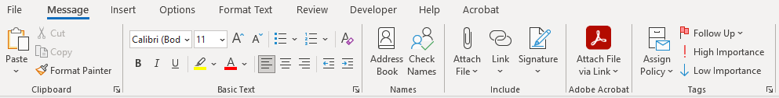  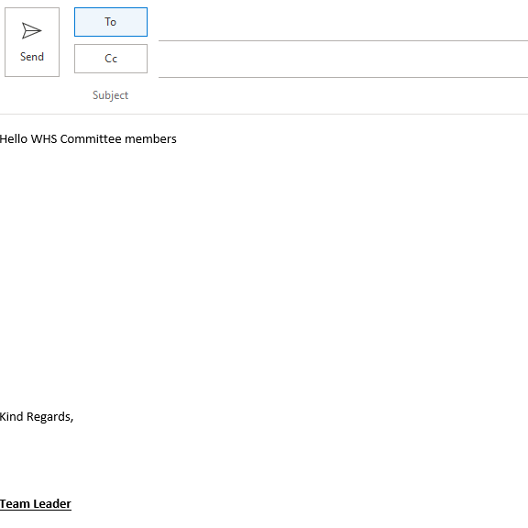  Following the discussion with the team, We are suggesting a reassessment and review to better reflect the severity of potential injuries around the slip hazard when entering the office. We believe that the current risk rating “low” isn’t sufficient as there is a greater potential for injury.  [Grab your reader’s attention with a great quote from the document or use this space to emphasize a key point. To place this text box anywhere on the page, just drag it.]

You have received the following email in response to your email to the WHS committee. Read this to respond to Q12.

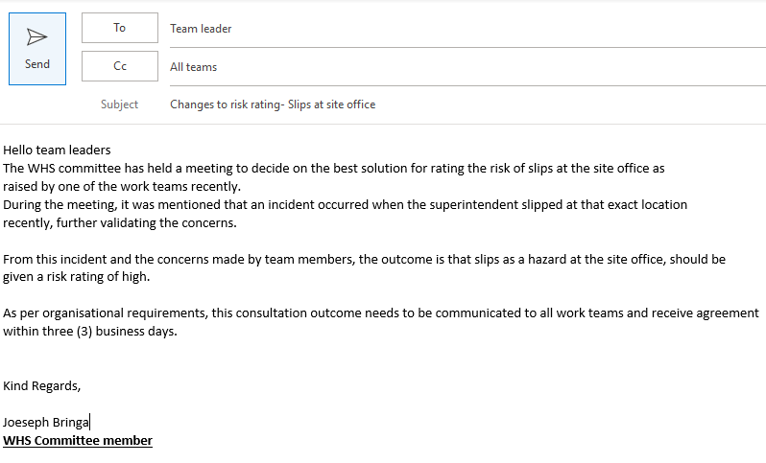

- Write a memo for the notice board to all team members about contacting you regarding their agreement to the changes mentioned.

Answer | Memo
Following a recent safety review and a related incident, the WHS committee has upgraded the risk rating for the slips at the site office to high.

Please review the changes and contact me with your feedback

You have collected all responses and calculated 85% of the workers agree with the changes to be made to the risk rating for slips at the site office. It has also been suggested that non-slip flooring be implemented to address the concerns.

- How will you communicate the results and the recommendations in a way to meet workplace reporting and recording requirements?

Answer | Record the results in a document which can be captured with a sign on toolbox talk and distributed in an email.

- Considering safety training held at your workplace, what methods would you apply to train relevant workers in the following?

Answer  First aid  Drug use and work  Manual handling  Using SDS  Emergency  Procedure  Fatigue  Managing | External training  Site induction and onboarding  Tool box talk In house training and field demonstrations  Toolbox talk  Induction and Drills and simulations  Toolbox talk, induction

Read the following team training record showing training that new workers have received, to respond to Q15. and Q16.
Team member | General Construction Induction training (White Card) | Site induction | Manual Handling | Emergency response | First Aid
Jeremy Still
Henry Oppenheim
Jules Freeman
Jake Monet
Antony Johns
Silvia Haack
Fred Hollows
Imogen Flank
Xavier French
Martin Short

- HR have provided you with the team training record for a new team you will be leading for a construction project. View the team training record above and explain what training must be prioritised and why.

Answer | Prioritize everyone having a white card then completing site inductions followed by manual handling  Based on the team training record, the following training must be prioritised:  Site Induction:  Priority: This is essential for all workers who have not completed it yet, particularly Antony Johns, Silvia Haack, Imogen Flank, Xavier French, and Martin Short.  Why: Site induction is crucial for introducing workers to site-specific safety rules, procedures, and hazards. Ensuring all workers complete this training will help prevent accidents and ensure they understand their responsibilities and the site's specific risks.  First Aid:  Priority: Jules Freeman and Jeremy Still are missing first aid training.  Why: First aid is critical to have trained personnel on-site in case of any medical emergencies. Ensuring a good number of workers are trained in first aid helps provide immediate assistance until medical help arrives.  These training modules should be prioritised as they directly impact worker safety and preparedness on the construction site. Ensuring everyone has completed these basic yet critical training courses is essential for maintaining a safe work environment

- Complete the table using information from the training records to clarify the number of new employees requiring specific training.

Answer | Number of employees requiring training | White card | Site induction | Manual Handling | Emergency response | First aid
 | Number of employees requiring training | 4 | 5 | 3 | 6 | 4

- How will you ascertain which of the new employees will require first aid and fire warden training?

Answer | Liaise with the safety team based on job roles and responsibilities.

- Site inductions are held face to face every five (5) days by a WHS officer to meet the demands of this large site. What discussion will you need to have and with whom to confirm and book the team members into their site inductions? How will you consult/confirm details with these persons?

Answer | Discuss with the WHS officer the availability and confirm bookings for all team members via phone or email.  Once the inductions are confirmed, I would send a follow-up email to all team members with the scheduled induction dates and times, including any instructions they need to follow. Additionally, I would make sure the WHS officer and HR team are updated with the final list of participants

- Why would coaching be a good method of training regarding the use and purpose of Safety Data Sheets?

Answer | It’s an interactive way of learning, where employees can engage and ask questions ensuring they understand.  Through coaching, workers can receive direct guidance on how to locate and interpret key details in the SDS, such as hazard identification, first aid measures, and emergency response procedures.

- What is the importance of maintenance and storage of WHS incident records? Include in your response two (2) specific incident records you have maintained and how this was achieved.

Answer | Maintaining WHS incident records ensures compliance with company and workplace health and safety laws.  A 30t excavator had a small hydraulic oil spill from a split in a line on the boom of the machine. I Notified the safety and enviro team which we tracked in the incident register and wrote it in my diary. Photographs accompanied by a statement from the operator were also logged in the system  A grader operator was placing material on a pad. He went to exit out of his machine and slid off the step causing him to fall down the steps and on his feet. The incident was reported to the safety team in which the work area had stopped, incident report was done and was tracked in the system

- How do you keep up to date on changes to WHS laws, and related organisational policies and procedures relevant to your role?

Answer | Through toolbox talks, internal email updates and management meetings, communicating with the safety team.  Regular Training and Workshops: I attend WHS training sessions and workshops that are offered by the company or external providers. These help me stay informed about any new laws or regulations that impact my role.  Company Communications: I regularly check internal communication channels, such as emails, memos, and the company intranet, for updates on WHS policies and procedures.  Industry Updates: I subscribe to industry newsletters, safety publications, and follow relevant regulatory bodies or associations to receive updates on WHS laws.  Consulting with WHS Officers or Supervisors: I regularly consult with the WHS officer or my supervisor to discuss any recent changes or updates in WHS laws or company policies.

BSBWHS411
Implement and monitor WHS policies, procedures and programs

PRACTICAL ASSESSMENT

Participant name | Luke Wallace

FOR THE PARTICIPANT
Instructions
- The tasks outlined on the following pages will require performance of normal workplace activities, as a result of a structured activity set by an Observer in the workplace or a simulated activity set by your Assessor/Observer.
- The timeframe for these tasks will be established by your Assessor/Observer, in consideration of location conditions and industry requirements.
- You must complete all tasks unassisted by the Assessor or other personnel, unless the steps note this assistance.
- You must attempt all tasks (and itemised steps) for a ‘Satisfactory’ assessment outcome to be awarded.
  - For any observation conducted that is incomplete, or without satisfactory performance, the observation will need to be completed again after further training support.

FOR THE ASSESSOR/OBSERVER
Instructions
- The following observation record should be used to judge and record your observations of the Participant as they complete the task(s) set. You must record your observations of the Participant’s performance.
  - For each occasion, indicate the task performed and whether it was a simulation or workplace-based task.
    - Any simulated assessment must ensure the Participant still performs under workplace conditions which reflect industry standards.
  - In the comments, provide clear detail regarding the task that the Participant was required to do (e.g. PPE used, materials handled, attachments connected, plant types).
- All steps must be satisfactorily demonstrated by the Participant for a ‘Satisfactory’ determination (indicated by an Assessor tick to the right of each itemised step, or an Observer tick to the right of each itemised step, and confirmation by an Assessor in the Assessor Comments).
  - Where you have determined that one or more task steps have not been satisfactorily demonstrated, provide the Participant with additional support and outline details of such assistance in the Assessor/Observer Comments. Allow the Participant two (2) further opportunities to demonstrate the task again to allow an opportunity for a ‘Satisfactory’ assessment outcome to be achieved.
  - If after three (3) attempts the Assessor determines that the Participant cannot demonstrate the required steps, a ‘Not Satisfactory’ outcome is to be determined.

TASK OUTCOME
Task | Date | Task Type (Tick) | Location | Task outcome (Tick)
 |  |  |  | Satisfactory | Not Satisfactory
Task 1 |  | Workplace  Simulation

ASSESSOR COMMENTS: GENERAL
As necessary, outline:
- Details on reattempts, alternative arrangements or reasonable adjustments made.
- Where a Participant is deemed ‘Not Satisfactory’, provide recommendations for future training.

ASSESSOR COMMENTS: PRACTICAL TASK 1
Individual student (as named on cover page)
Multiple students [ All from Attendance Report, Specific students involved – identify students]
Task | Provide detail
1.1A. | Specify method used to share information and workplace polices/procedures shared:
1.1B. | Specify which identified hazards and controls were shared with team:
1.2A. | Specify method used to share the importance of consultation for managing WHS risks:
1.2C. | Specify issue raised through consultation:
1.2D. 1.2C. | Specify method of reporting issues upward:
1.2E. | Assessor describe how participant shared information with work team:
1.3C. | Specify type of training and method of training agreed on for one (1) participant:
1.3D. | Specify training arrangements made for one (1) team member:
1.3E. | Specify workplace learning opportunities provided for three (3) team members:
1.4B. | Specify procedure followed to report a hazard or incident:
1.5D. | Specify methods used to keep up-to-date:

BSBWHS411
Implement and monitor WHS policies, procedures and programs

Practical Task 1
Description of task:
The participant must demonstrate the ability to effectively implement and monitor the work health and safety (WHS) policies, procedures and programs for a team in one (1) work area in an organisation including demonstrating and providing evidence of the following:
- confirming and documenting team training needs to meet workplace and legislated requirements
- consult with stakeholders and make arrangements to meet WHS training needs of team members
- provide workplace training opportunities to team and individuals to support achievement of identified WHS training needs
- communicate information to work team about WHS laws, workplace policies, procedures and programs, the importance of consultation mechanisms, hazards and risk assessment including in the communication where information can be accessed
- adhere to workplace policies and procedures to apply consultation mechanisms for managing work area hazards, reporting issues raised and communicating both upward and downward throughout consultation to outcome
- manage monitor and report on hazards, controlling risks according to workplace procedures and legislated requirements
- identify and report inadequacies in existing risk controls monitoring outcomes of reports on inadequacies
- complete and maintain WHS incident records in work area
- use aggregate information and data from work area records to meet workplace recordkeeping requirements

These tasks may be simulated or real. The Participant is to gather evidence of how they have completed each component of the Practical Task, which is to be submitted with this Practical Assessment sheet. The Observer is to provide detailed comments on the tasks completed by the Participant (on the Observer Comments, overleaf). The Assessor is to verify the Observer’s comments, noting their findings in the Assessor Comments (on the back of the Practical Assessment cover page) and provide the assessment outcome.
Resources required:
Work team, workplace policies and procedures, WHS documents, records and recording documents, HR training records, access to current state regulator and legislation.
Observer details
Name of observer:
Role of observer
(Confirm suitability to sign)
Email address of observer
Signature of observer:
Date: | Select Date.

When completing the task, did the Participant: | Tick if satisfactorily completed.  Provide comments if left unticked.
1 Provide information to work team about WHS policies and procedures
- Locate and share with work team workplace and state appropriate and current WHS legislation and related workplace policies and procedures.
- Share information to work team about identified site hazards and outcomes of risk assessment and control.
- Communicate information in a way that was logically presented, clear and accurate.
- Communicate information using structure and language suitable for audience.
- Use questioning and active listening to clarify understanding and make the audience feel at ease during face to face communications.
- Use written format during WHS presentation that apply appropriate structure, layout and language to ensure the information is understandable by the audience.
2 Implement and monitor work team consultative arrangements for managing WHS
- Share information with team and demonstrate the importance of consultation mechanisms for the management of WHS risks using methods that are easy to understand.
- Adhere to workplace procedures for consultation by asking work team for opinions and information relating to the management of work area hazards.
- Manage issues raised through consultation using questioning, responding, explaining, clarifying and expanding on ideas and information as required, evaluating choices and determining severity based on workplace and legislated WHS requirements for determining risk levels and the hierarchy of controls.
- Communicate and report on potential new hazard upward according to site requirements.
- Communicate the outcomes of reporting upward with work team within acceptable workplace timeframes using appropriate verbal and written communication.
3 Implement and monitor organisational procedures for providing WHS training to work team
- Access relevant HR records to determine white card, site induction, qualifications and licences held by team members.
- Complete a table or relevant workplace document to demonstrate team members training needs to meet work and legislated requirements. (Evidence of document is required.)
- Discuss training needs and methods of training available with individual team members, discussing and agreeing on training required and method to be applied.
- Discuss and arrange training for team member with relevant stakeholder.(internal/external).
- Organise workplace learning opportunities for workers requiring or requesting specified WHS training.
4 Implement and monitor organisational procedures and legal requirements for identifying hazards, and assessing and controlling risks
- Consistently use workplace documents and follow procedures to identify and report on hazards in work area.
- Use workplace documents and undertake hazard and incident reporting according to workplace requirements to meet WHS legislation.
- Adhere to workplace requirements to control risks using the hierarchy of control measures.
- Identify, report and monitor outcomes of reports on inadequacies in existing risk controls using the hierarchy of control measures according to WHS laws.
- Use approved processes to monitor outcomes of reports on inadequacies, as required, to ensure prompt organisational response.
5. Implement and monitor organisational procedures for maintaining WHS records
- Complete and maintain WHS incident and near-miss records related to work area according to work place policies and procedures, and WHS laws.
- Use near-miss and historical data to determine risk levels when applying risk assessment.
- Apply appropriate procedures for incident response, investigation, notification and reporting
- Keep up to date on changes to WHS laws, and related organisational policies and procedures relevant to own role.

OBSERVER COMMENTS

