TOOLBOX TALK.

WORKING AT HEIGHTS USING A SCISSOR LIFT.

The information in the toolbox talk is for the operation of a scissor lift. A scissor lift is a work platform consisting of a work basket (platform), lifting mechanism and chassis that can raise and lower people and materials. It is not a boom-type elevating work platform. Scissor lifts are hydraulically raised and lowered on linked; folding supports that draw together to lift the work platform.
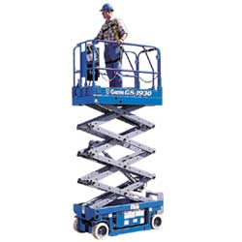
Qualifications and Training Requirements
Persons required to operate Scissor Lifts must be properly trained and experienced. They must understand the manufacturer’s recommendations and be aware of any limitations or special features. There is no legal requirement to hold a licence for scissor lift operation. A Yellow Card is evidence of training carried out under the guidelines of the Elevating Work Platform Association. Operating a scissor lift is a High Risk Construction activity as it involves the use of Movement of Mobile Powered Plant and also the possibility of work at a height of over 2 metres and as such a Safe Work Method Statement has to be prepared for the work before it begins.

Pre Work Checks
Always perform a pre-work check of the Scissor Lift and perform pre-operational checks as per manufacturer’s instructions before use.
- Check the scissor lift for the last date of service and the next due date.
- Check the load rating. (do not overload with personnel and materials)
- Check for any signs of damage, hydraulic leaks and the general condition of railings, treads and barriers.
- Always ensure log book is completed before operation and replaced in protective sleeve and left with the vehicle at all times.
- Check all warning devices including lights and horns.
- If any faults are detected then you should immediately place an ‘Out of Service – Do Not Use Tag’ on the machine, notify your supervisor and enter the fault into the log book.
- Assessment of the ground area should be undertaken, ground conditions should be checked for suitability of the scissor lift movement and if required stabilisation of the vehicle should be assessed by a competent person.

Operational considerations and precautions for Operators.
- Check environmental conditions prior to use. (wind conditions and EWP Rating when outdoors)
- An emergency rescue procedure must be in place with all personnel having a full understanding before the scissor lift is used.
- Non necessary personnel should be kept clear of the work area. If required, or if there is a risk of persons walking near or under the scissor lift the work area should be barricaded to prevent entry into the drop zone and signage is to be in place.
- The Scissor lift should be operated at safe speeds on surfaces suitable to the type chosen for the task.
- Prior to moving the Scissor Lift, check the ground for any obstructions, obstacle, penetrations or overhead hazards. Materials and equipment could have been put into the scissor lift’s travel path without you knowing, or they could be obscuring a hazard.
- All tools on the Scissor lift must be properly secured to prevent the items falling.
- Ensure when loading the Scissor lift that the maximum weights are not exceeded.
- All guards rails and access doors must be closed prior to the work platform being raised and or work commencing.
- Report any faults during operation to your supervisor immediately and do not continue use. Place the Scissor lift out of service using the ‘Do Not Use- Out of Service” tags.
- Do not attempt to use the scissor lift as a crane or lifting device. Handrails are not designed as lifting points. This may result in the EWP overturing, operators being crushed or the plant being damaged.
- Make sure you keep both feet firmly on the floor of the platform. Do not use steps, ladders, boxes or other objects on the platform in order to gain extra height. Never stand on the handrails.
Failure to observe these instructions at all times could lead to serious injury or death.
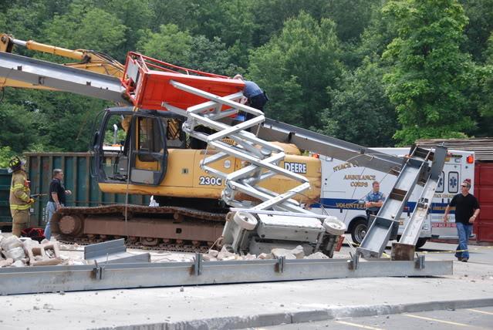

Toolbox Talk Questions

1 | Do I need training to operate a scissor lift? | Yes | No
2 | Do tools and equipment need to be secured in the scissor lift when it is moving? | Yes | No
3 | Do the doors have to be closed before I start raising the platform? | Yes | No
4 | Can I rest items on the scissor lift rails if they are not too heavy? | Yes | No
5 | Prior to moving the Scissor Lift, I should check the ground for any obstructions, obstacle, penetrations or overhead hazards | True | False
6 | What should I do if I suspect the scissor lift is faulty in some way?  ____________________________________________________________________________________________________________________________________________________________________________________________________________________________

Acknowledgment Receipt

I have read and understand the information provided to me

_______________________________ ___ ___________________________ ___/___/___
Employee’s Name (PRINT) Employee’s Signature Date

_____________________________ __ __________________________ ___/___/___
Trainer's Name (PRINT) Trainer’s Signature Date

This completed record must be saved to WHS file folder
Checklist to be completed before working in a scissor lift.

JOB SITE________________________________

DATE___________________________________

NAME__________________________________

SIGNED_________________________________

- Work has been planned. Plans have been issued.
- Ground/surface is suitable for a scissor lift.
- Weather and conditions are suitable to use a scissor lift.
- Others in work area have been consulted.
- Ensure spotter understands the work to be carried out.
- Exclusion zone and signage has been erected.
- Scissor lift has been inspected and is in good working order. Complete prestart logbook.
- Inspect crush protection is in working order.
- Ensure manual hydraulic release works, and the spotter knows how to use it.

This completed record must be saved to WHS file folder

Monitoring risk control measures
& effectiveness.

TETHERING TOOLS
JOB SITE________________________________

DATE___________________________________

NAME__________________________________

SIGNED_________________________________

- Are the tethers appropriate?_________________
- Are the tethers working? (Keeping tools secured to the scissor?)_________________________________________________
- Can tool tethering be improved?_____________________________
- If “YES” how?_____________________________________________
- Is there another way to secure tools?__________________________
- Are tethers in good condition? (no tears or cuts?)____________________________________
- Comments to improve tethering: ____________________________________________________________________________________________________________________________________________________________________________________________________________________________________

This completed record must be saved to WHS file folder.

